1. The scientist who contributed to the study of electromagnetism and electrochemistry was:

A. Alessandro Volta

B. Thomas Edison

C. Michael Faraday

D. Nikola Tesla

2. Which one of these is the fastest human sense:

A. Sight

B. Smell

C. Taste

D. Hearing (Explanation: A person can recognize a sound in as little as 0.05 seconds)

E. Touch

3. The blood of mammals is red, the blood of insects is yellow in color, and the blood of lobster is ______

A. Green

B. Blue (Explanation: Due to the presence of hemocyanin, which contains copper)

C. Purple

D. Black

4. About ____ of the world’s population lives in the Northern Hemisphere.

A. 90%

B. 80%

C. 70%

D. 60%

5. Who was the first one to discover the number zero (0)?

A. Babylonians

B. Mayans

C. Indians

D. All of the above

6. Who invented a weapon called “burning-glasses” to burn Roman ships attacking Syracuse?

A. Pythagoras

B. Euclid

C. Hippocrates

D. Archimedes

7. Leonardo da Vinci’s nationality was ________ (type in: Italian)

8. You can’t fold a normal piece of paper more than 7 times.

True

False

Not proven

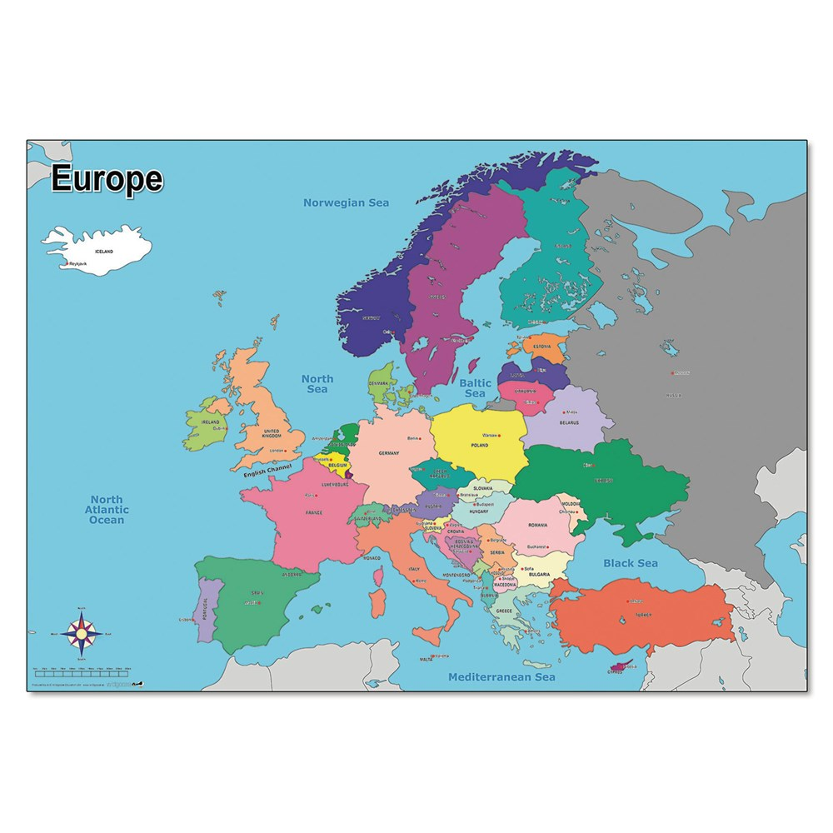9. Where is the Black Sea? (The users have to drag and point the exact position required on the map)

10. Which video has the most views on YouTube? ___________ (type in: Despacito)

11. The easternmost province of Vietnam’s mainland is __________ (type in: Phu Yen or Phú Yên)

12. Vietnam’s Four Holy Beasts are:

A. Dragon, Unicorn, Tortoise, Phoenix

B. Dragon, Griffin, Tortoise, Phoenix

C. Cow, Cat, Dragon, Unicorn

D. Dragon, Tiger, Monkey, Phoenix

13. The famous Hanoi’s Hoan Kiem Lake is associated with a myth about King _______ (type in: Le Loi or Lê Lợi)

14. How many tones are there in the Vietnamese language?

A. 4

B. 5

C. 6

D. 7

15. How many different ethnic groups are there inhabiting Vietnam?

A. 53

B. 54

C. 55

D. 56