

Epic Game

A java developed game



VÅR 2023

Innhold

Introduction 2

Save progression and Database 2

Game UI 2

Player Panel 3

Setting up Linux 3

Setting up a database 3

Switching from Windows Apache to Linux 3

Time Schedule 4

Epic Game 5

Network diagram 5

Project 6

Kartlegging av lovverk 6

Risikoanalyse og tiltaksplan 6

Egenevaluering 6

Kilder 6

# Introduction

Epic Game is a single-player multiple choice game. Every decision and choice you make affect the ending you experience. The language used to create Epic Game is java, everything from the UI to the design are all written in one language. The game also has a built-in saving system that allows you to continue your progression later.

## Save progression and Database

To enjoy everything the game has to offer, the game has built-in saving system. To get started, write in your desired name and press enter. Remember the name you wrote in, as it will be important to relocate your progress within the database.

## Game UI

The start screen consists of Weapon, HP and several buttons that each have a function. The button on the top right corner saves the progression, it saves your name, your whereabouts, HP and weapon and saves it in the database. The other 4 aligned in the center are your choices. Each bring you to a room with different choices to choose from.

## Et bilde som inneholder tekst, enhet, måler Automatisk generert beskrivelsePlayer Panel

The player panel consist of Name, Hp, Weapon and the save button. The Hp and Weapon are bound to change throughout the game, you will gain and lose Hp. There are bosses/monsters that will drain your hp, aiming to kill you and there will be food and drinks that will help you recover.



## Setting up Linux

When February started, I decided to switch from XAMPP to LAMP. One of the reasons as to why, are for example the security Linux has, in comparison to XAMPP. LAMP not only provides more security but also allows for customizing and it is easy to set up.

## MySQL Tutorial 2 : Create and Delete Table in Ubuntu Linux - YouTubeSetting up a database

Setting up a database in Linux was quite simple, the only con of setting it up was the installation time and the problem solving. There were some difficulties to access the database from another pc, but by testing and some research, the problem therefore solved itself. The first thing I noticed when switching from XAMPP to LAMP, was the difference of how to access the database, although LAMP has a more difficult way to view your database, the OS, overlay, and security makes up for it. Overall, I would think that the switch would benefit me and my game way more, in comparison to XAMPP.

## Et bilde som inneholder tekst, bord Automatisk generert beskrivelseSwitching from Windows Apache to Linux

Now that I have decided to switch the OS to Linux, naturally I would have to switch over to Linux Apache as well. As of now, I would get no use in setting up Apache, the reasoning for that is simply because I utilize java to make my game. The goal is to eventually finish my website where I plan to store and change info, depending on who logs in.

## Time Schedule



## Epic Game



## Network diagram



## Project



## Setting up SSH

By setting up SSH, I’m able to save myself some time. I can access my server pc without having to connect the server pc to a screen and keyboard. With SSH installed, I can log into the server pc and use the terminal within my own pc. To further save time, I’ve decided to make a .bat file and run the commands used to start the connection between the computers.

## Et bilde som inneholder tekst, Font, skjermbilde Automatisk generert beskrivelseErrors with installing SSH

When I tried to install SSH, I met some long-lasting problems. The error message I kept getting was bad owner or permission in the folder where SSH lies. Even though I tried to search up the problem and fix the problem, there was nothing that helped. The way I solved this was by deleting the existing files. By deleting the existing files, I am enabling a new start and new host.

# Changing static ip-address via terminal

To change your ip-address, I did the following. Enter ls /etc/netplan/ in the terminal and memorize it. Accessed the ethernet by doing ip a and paying attention to the word in the middle of the red circle. Therefore, entered and change the ip address by copying the line starting with sudo nano. By doing this, I accessed the network file, making it possible to change my ip address and such. When entering the sudo nano command I access this display.

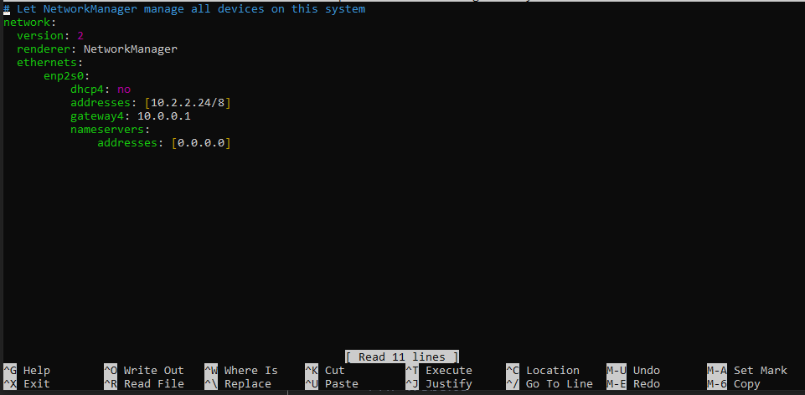

When I entered the command, I got this display. Most of the things here were already empty, therefore copied what I was supposed to write. The only exception is, that I paste my own ethernet name under ethernets and customized everything else to my own need. For instance, I want my IP address to be 10.2.2.24 and use 255.0.0.0 as a netmask, I do so by changing the numbers in addresses and doing / either 8 16 or 32 depending on my desired netmask.

# PHP website

To further build my semester task, I’ve chosen to make a website to display my database information. If you have access to the database, you can choose who has access and who doesn’t. If you do have access, you can look at how many users have created an account on your website and the number of users that have saved their game progression. If you don’t have access on the other hand, you can only access the game progression of different players.

## Kartlegging av lovverk

Click on the following picture:



## 

## Risikoanalyse og tiltaksplan

Click on the following picture:



## Egen evaluering

Throughout this project, I’ve been met with several complications and problems. All the errors and complications I’ve been met with, I’ve searched up and or asked for helped from my classmates. By doing this, I’m not only learning but I’ve grown to understand it as well.

In this project, I’ve learned how to set up a LAMPP server and host it in a separate machine with another OS. I’ve done so by hosting my website and saving my database in a separate machine. I think this will make it easier for me longer down the road.

I would say that my overall performance in this project would be quite good. I’ve finished all the necessary work and developed my game and website to my fullest extent. Although I didn’t completely focus for several days in a row, I still managed to finish it as best as possible.

If I was to do my project all over again. I would start documenting earlier so I could catch on faster. I found myself a little lost after some time of not going through the code. I should’ve worked evenly throughout the year so I wouldn’t struggle so much with catching up to my work.

## Kilder

[www.stackoverflow.com](http://www.stackoverflow.com)

[www.w3schools.com](http://www.w3schools.com)