Game Design Document

Fill up the Following document

1. Write the title of your project.

Do not touch Ground!

1. What is the goal of the game?

Do not touch ground.

1. Write a brief story of your game?

So, there is this kid who likes to not touch the ground so he decided to parkour on non-ground stuff and imagine lava is below him.

1. Which are the playing characters of this game?

* Playing characters are the ones which respond to the user based on the input from the user
* Cars, monkeys, dinos, wizards etc, are the playing characters in the game.

|  |  |  |
| --- | --- | --- |
| Number | Character Name | What can this character do? |
| 1 | Kid | Jump |
| 2 |  |  |
| 3 |  |  |
| 4 |  |  |
| 5 |  |  |
| 6 |  |  |
| 7 |  |  |
| 8 |  |  |

1. Which are the Non Playing Characters of this game?

* Non Playing characters are the ones which don't have an action or a behaviour when the user interacts with the game.
* Hurdles, stones, bananas, coins, etc are non playing characters in the game.

|  |  |  |
| --- | --- | --- |
| Number | Character Name | What can this character do? |
| 1 | Bench | Nothing |
| 2 | Garbage Bin | Nothing |
| 3 | Bike | Nothing |
| 4 | Bus Sign | Nothing |
| 5 | Lava | Flows Up |
| 6 |  |  |
| 7 |  |  |
| 8 |  |  |

Draw your imagination of this game. What does this game look like?

* Draw the game either on your computer or on paper,
* Add images of scenes of the game to show each of the playing and non-playing characters at least once.

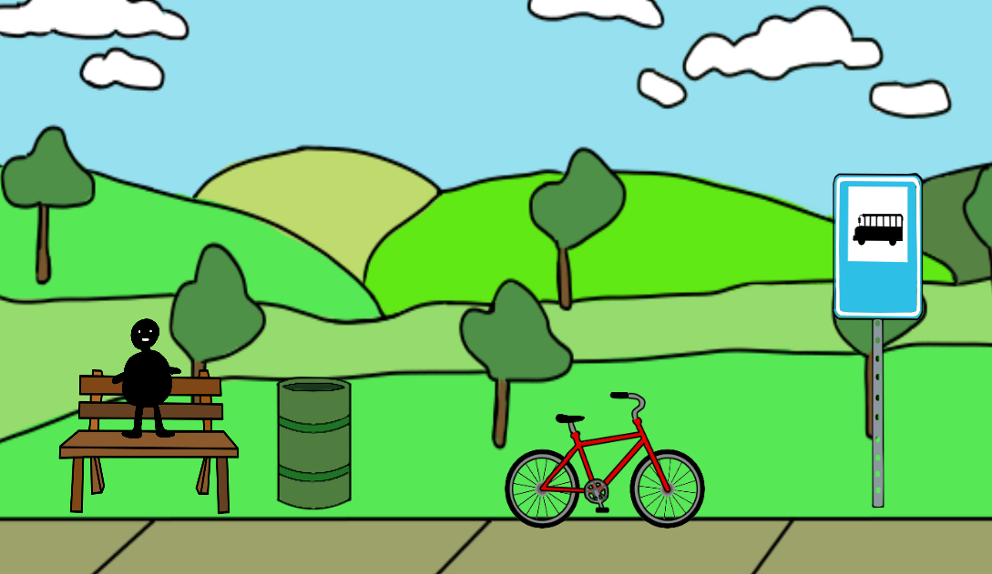

How do you plan to make your game engaging?

I will make jumps to different objects equally as hard as the others.