1. API đăng kí tài khoản: <http://localhost:3000/api/register-user>

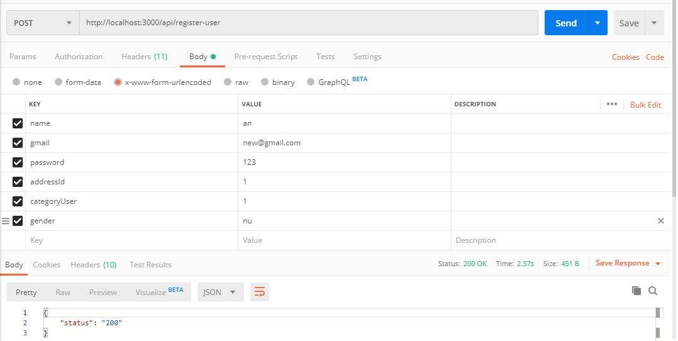

1. API login: <http://localhost:3000/api/login>

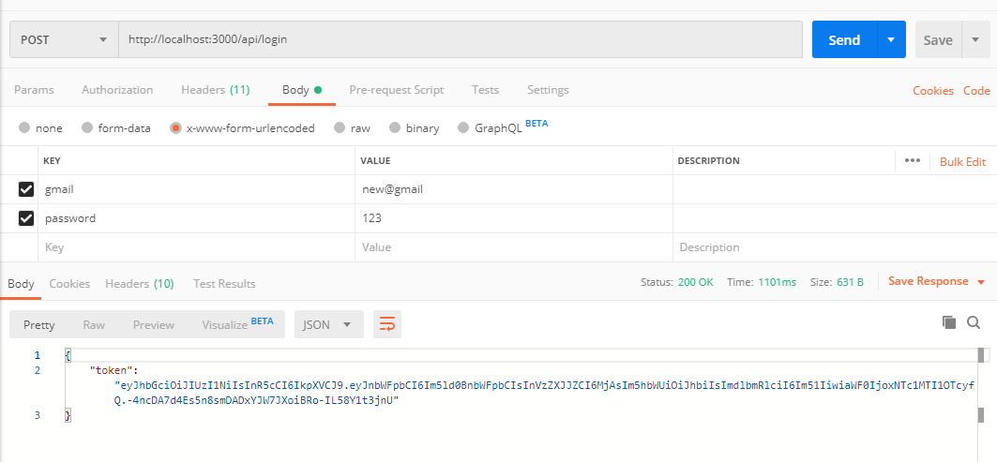

1. 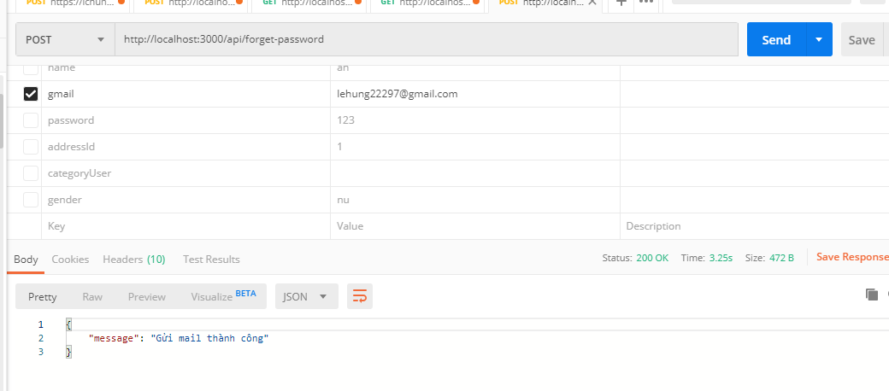API forget password: <http://localhost:3000/api/forget-password>
2. API update password khi quên mật khẩu: <http://localhost:3000/api/update-new-password?email=lehung22297@gmail.com&key=pfGpcLxeY5nhdQ36GUfiaDY2W8vt78MfNyTXL8uUTuyFASmazvsLKwqGgbPBm1IEdUY8IOdCyfmqZv7vQLm8M4nHIlUGGCJM4QSs>

