1. 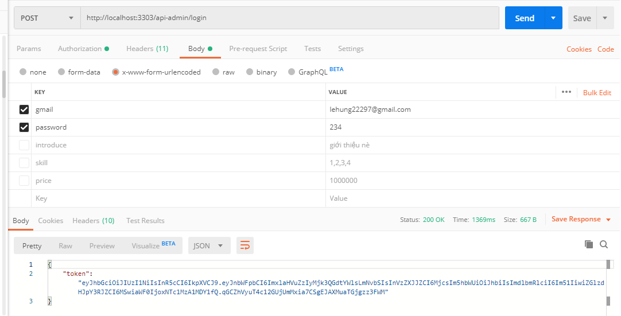API login admin: <http://localhost:3303/api-admin/login>
2. API get profile admin: <http://localhost:3303/api-admin/profile>

