**Temperature Dataset length**

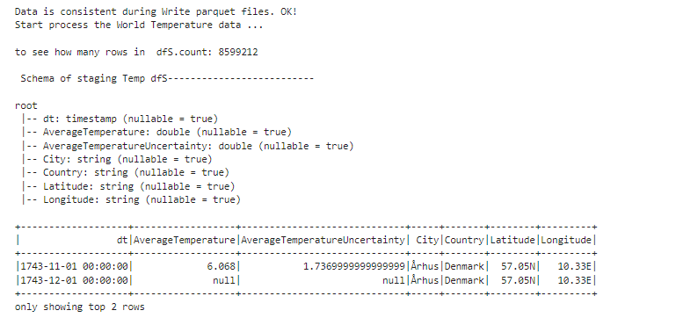

**Immigration Datasets length (length for only first data file)**

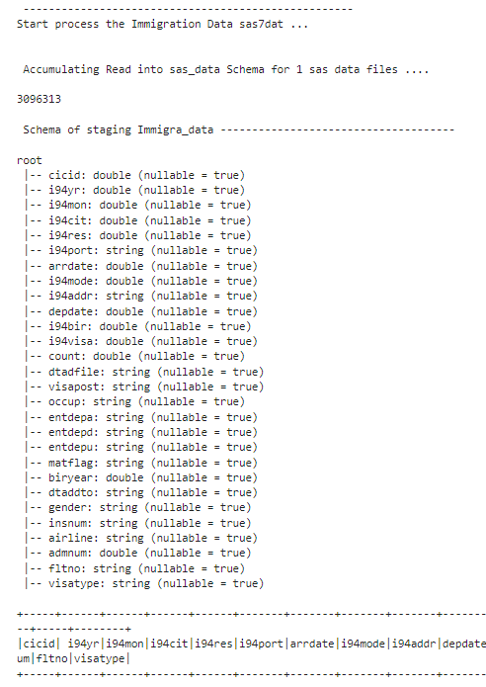

**Sql TEST run for count Immration case, group by Foregin Born in uscites**

