**INTERNATIONAL UNIVERSITY VIETNAM NATIONAL UNIVERSITY, HCM CITY**

|  |  |
| --- | --- |
|  |  |

**School of Computer Science & Engineering**

**POKEMON GAME**

**Course: Object–Oriented Programming**

**Group members:**

Hà Minh Trí ITCSIU22194

Nguyễn Anh Trí ITCSIU22152

Phan Đức Trí ITCSIU22151

Đỗ Hùng Việt ITCSIU22197

**Contents:**

1. **Introduction**
2. **Objective**
3. **Tools Used**
4. **Property of Game**
5. **Goal**
6. **Rule**
7. **UML Diagram**
8. **Methodology**
9. **Gameplay**
10. **Design**
11. **Demo**
12. **Conclusion**
13. **Result**
14. **Limitation**
15. **References**
16. **Introduction**
17. **Objectives**

Pokemon is a famous Japanese media franchise consisting of famous video games, animated series and films, etc… One of the most famous Pokemon is Charizard - a lizard Pokemon. We use its baby model Charmander (Figure 1.1) as the main character for this game. Our team is all impressed by the gameplay of Mario. So we made a game influenced by Mario but added more Pokemons as enemies to make the difference.

Figure 1.1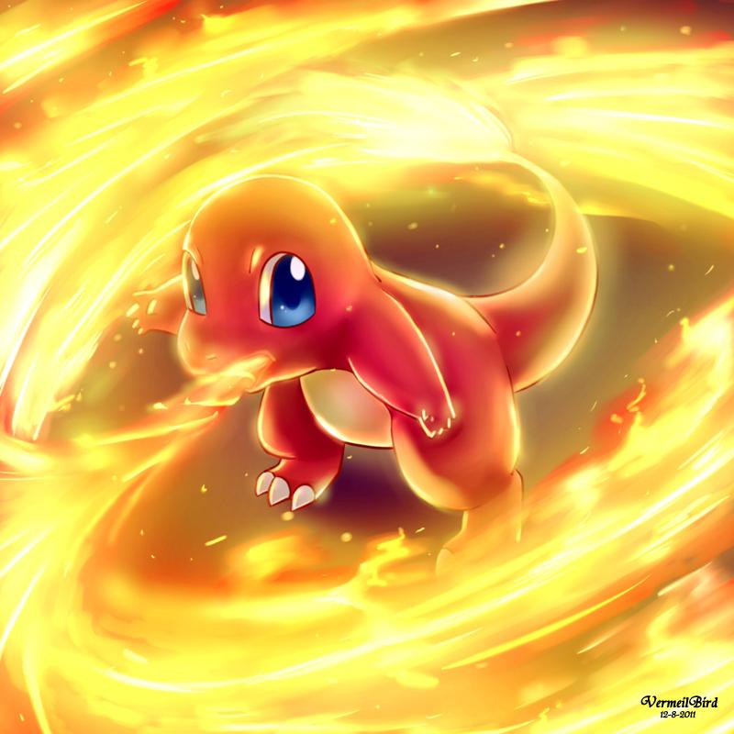

The project aims to recreate a fully playable game based on the original Mario game but modified as an RPG game. In short, this project aims to:

- Create a redesigned game to entertain.

- Practicing OOP techniques.

- Have a brief look at game development, code optimization, and project management.

- Evaluate the ability to build more features on the base program.

1. **Tools Used**

- IDEs for programming and debugging: eclipse

- Project management: Google Drive, GitHub

- Communication: Discord, Messenger

- Map generator: GIMP

1. **Property of Game**
2. **Goal**

The aim of this game is just like Mario. You need to pass through the end of the map. However, we decided to make this game a little challenging so we added enemies that can hit the player. We designed a total of 2 levels.

1. **Rule**

Preventing yourself from falling off the edge and keeping the health point slider above 0.

Destroyed boxes can drop items to help you recover your health and energy.

Deafeting all the enemies.

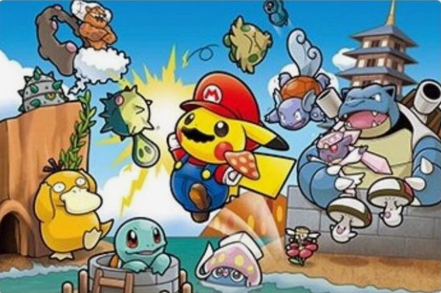

Figure 2.1

1. **UML Diagram**

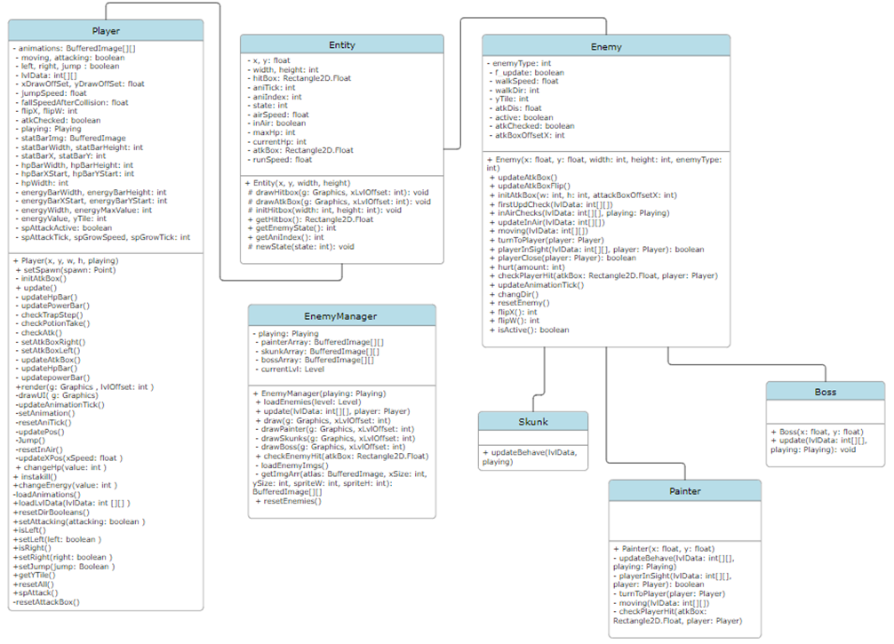

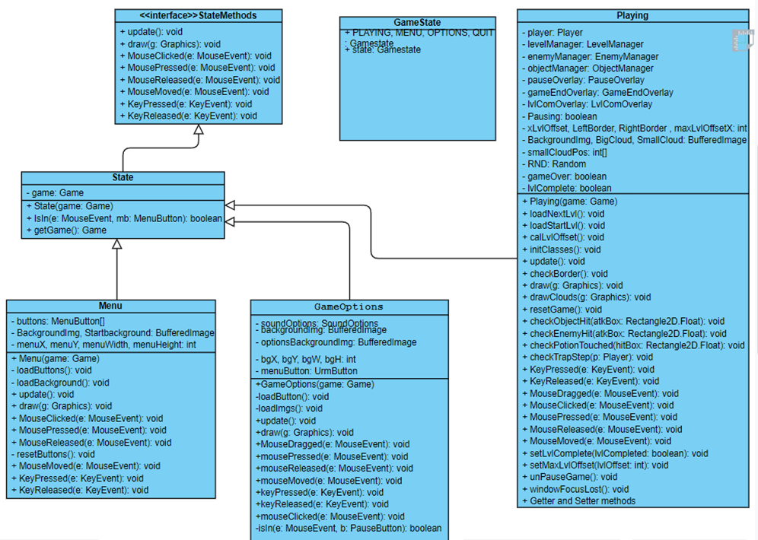

1. **Methodology**
2. **Gameplay**

The gameplay is simple: You as Charmander are spawned on the map (Figure 4.1), and the player can only move left-right and jump. In this game, you have to defeat all the enemies. Only Victreebel (Figure 4.2) cannot be hit so you just need to avoid all of its attacks. It is also the one that has a long-range attack. You can hit the enemies consecutively by using strike (Figure 4.3) and while the enemies are under your attack, they cannot move or hit you. Another type of attack you can use is quick strike but it will consume a little energy. The player must clear all the monsters except Victreebel to move on to the next level. The player can destroy the boxes (Figure 4.4) along the path to get useful items (Figure 4.5):

* Red potion: Restore health
* Blue potion: Restore energy

After finishing the first level (Figure 4.6), the player has to face an extremely long map. This map is not only longer but also has a new enemy to make the game more difficult. It’s extremely hard to pass the seconde level.

The player uses ‘A’ and “D’ keys to move left and right, respectively. ‘Spacebar’ is used to jump. Clicking the mouse to attack the enemies.

Figure 4.1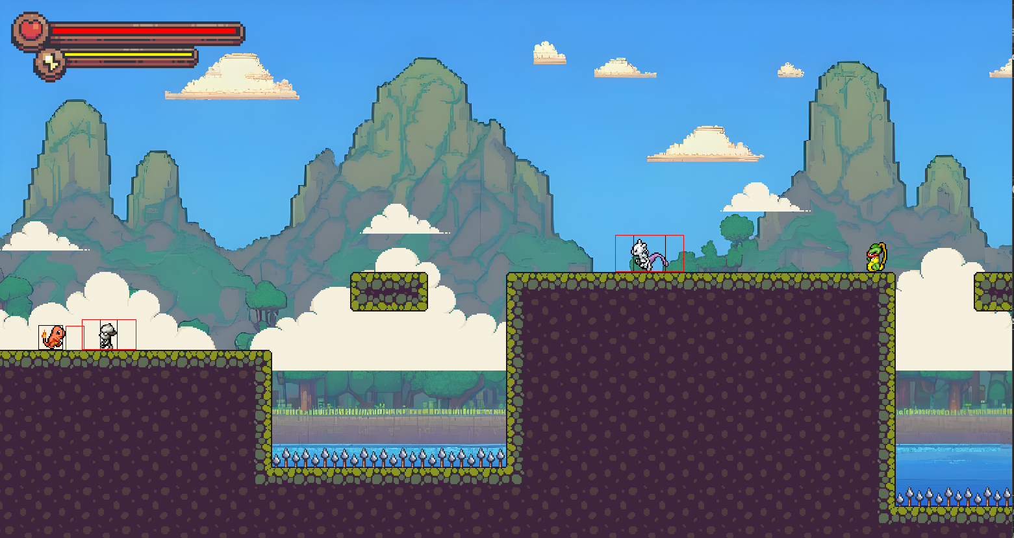

Figure 4.2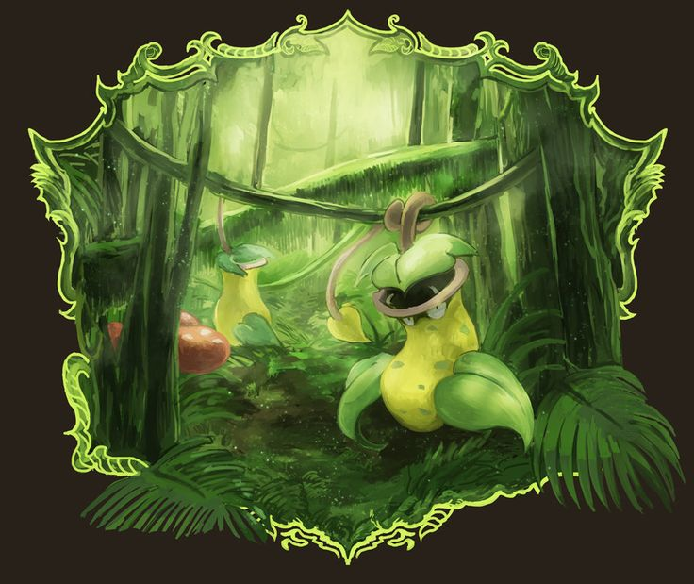



Figure 4.3

Figure 4.4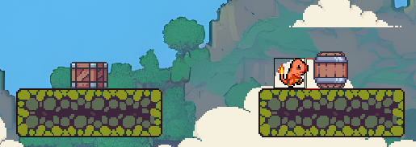

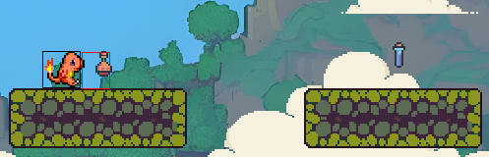

Figure 4.5

Figure 4.6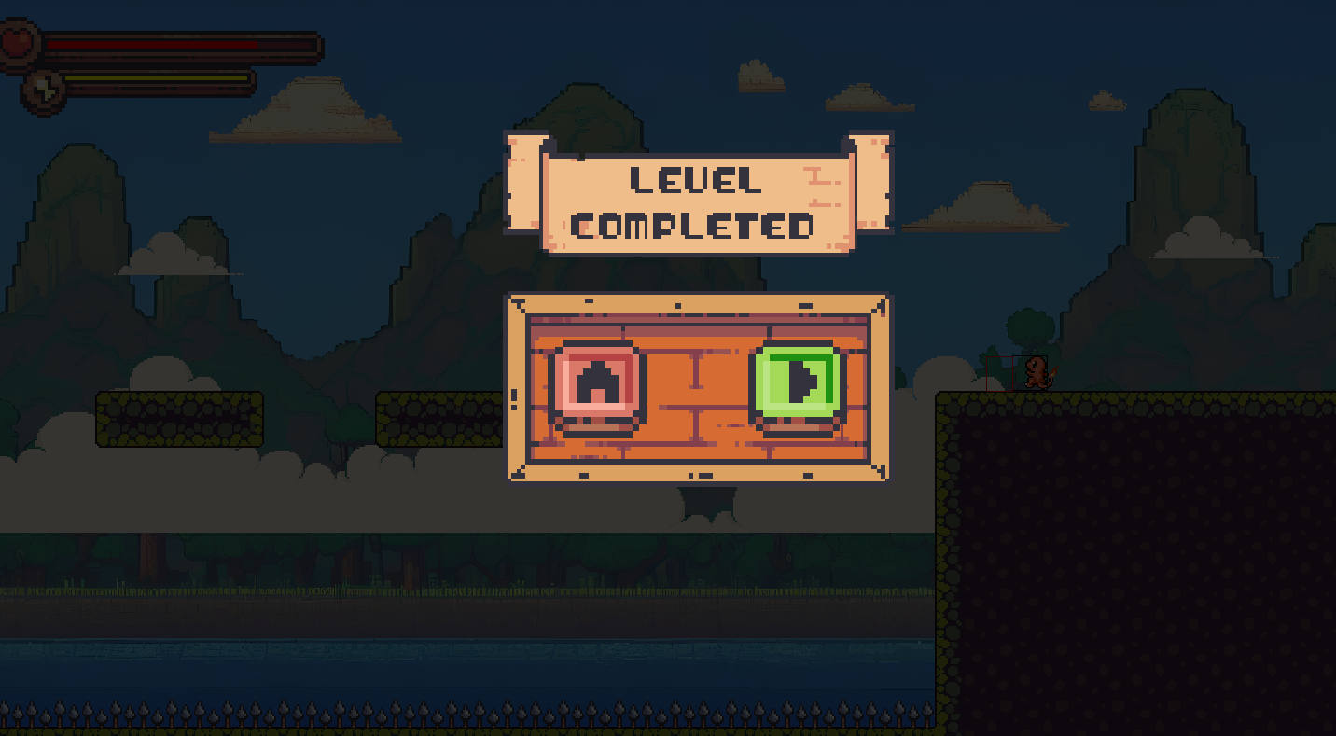

1. **Design**

Our first idea for this game is to make its gameplay the same as Pokemon Mystery Dungeon. So, we use the sprites of the said game for the main character and its enemies (Figure 4,6). The sprites we found on this web are very useful because it has a lot of sprites in any direction so we do not have to spend so much time to do so.

We tried to design some sprites ourselves but we could not have the models satisfy us. Therefore, we found some online sources so we could have the design material match with our game and we changed a little bit to make the difference (Figure 4.7).

Figure 4.6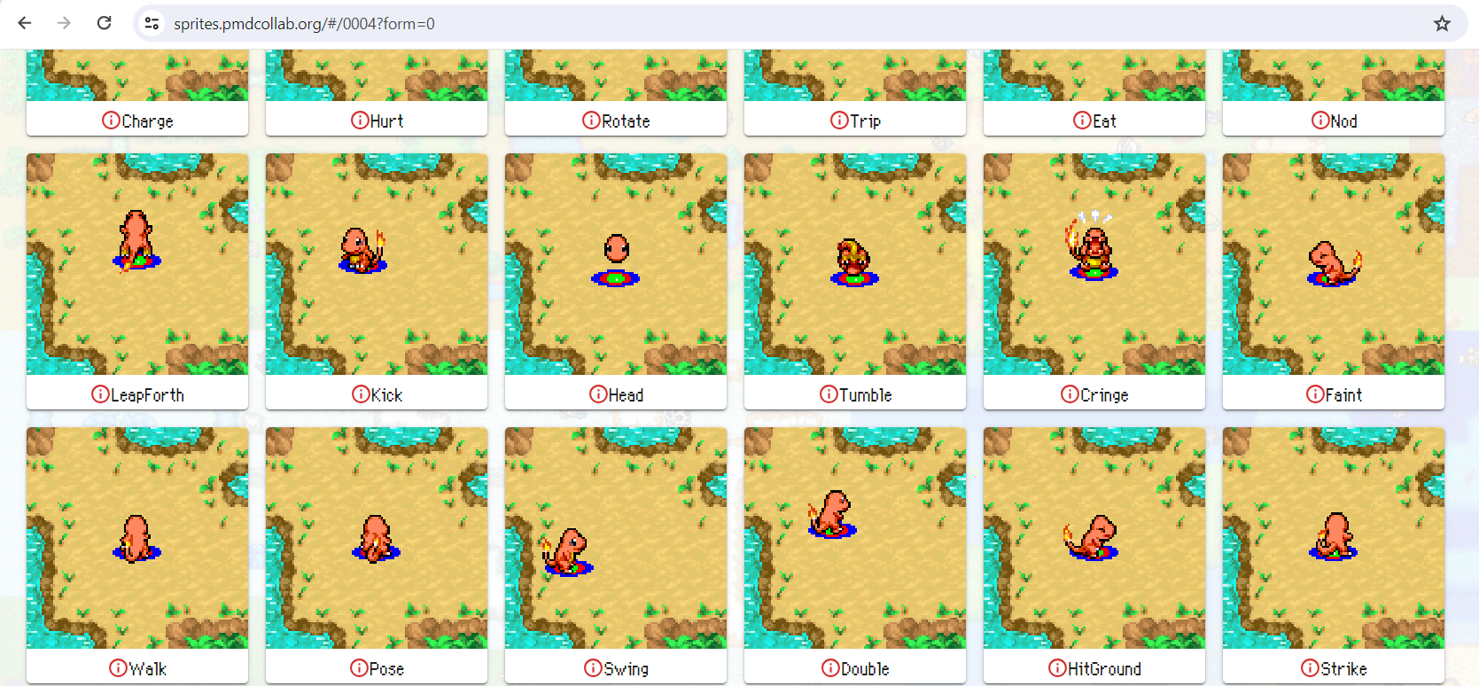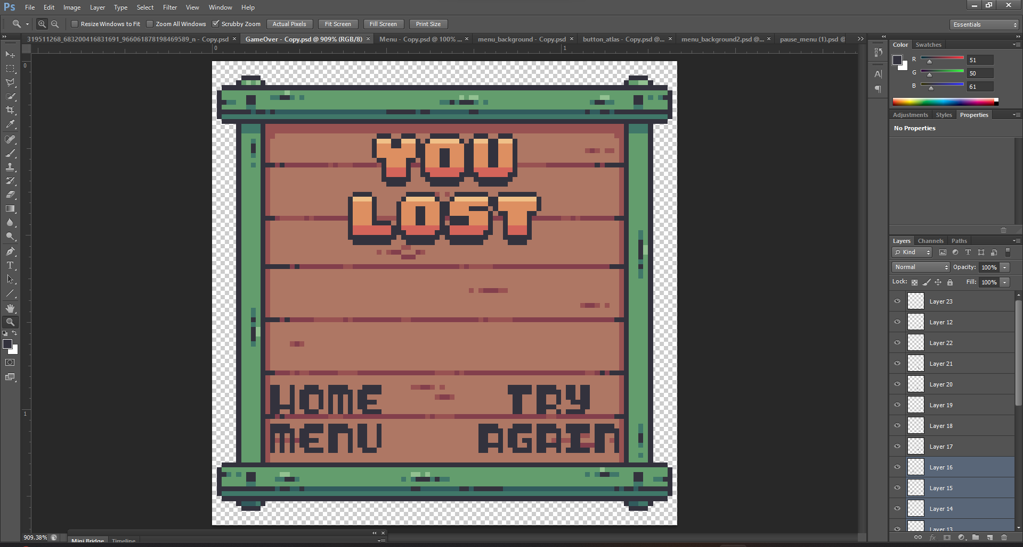

Figure 4.7

1. **Demo**

We tried to make various sprites of Pokemons to prevent the game from being boring. We found and made a lot of sprites but some of them did not work for us (Figure 5.1). In our first discussion, we chose Pikachu as the main character since it is the signature of the Anime (Figure 5.2). However, we struggled to make it work.

Figure 5.1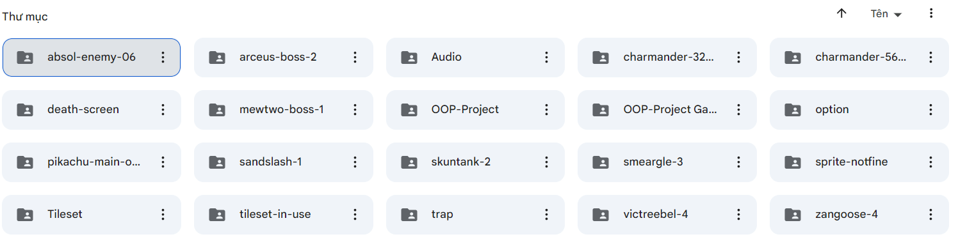

Figure 5.2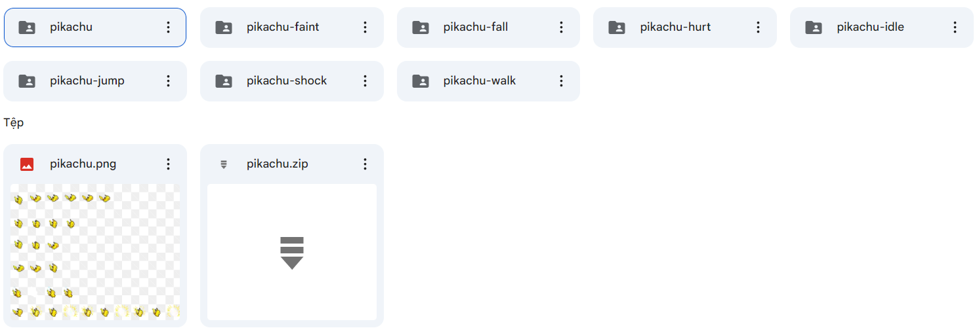

We also made some maps for different levels (Figure 5.3) but we excluded them.

Figure 5.3

1. **Conclusion**
2. **Result**

Our group project has been built with basic rules based on the principle of the OOP method. The combination of classes works effectively. Due to limited knowledge and time, our game had some problems that we could not fix on time.

1. **Limitation**

The movement of the character is not as smooth as we expected.

We did not find the perfect sound for our game.

We did not work well on GitHub.

We should include the shooting mode to make the game more interesting.

1. **References**

https://www.youtube.com/playlist?list=PL4rzdwizLaxYmltJQRjq18a9gsSyEQQ-0

<https://sprites.pmdcollab.org/>