Eberswalde University for Sustainable Development (HNEE)  
Faculty of Forest and Environment

Nguyen Duc Viet

**Comparison of burn severity indices and post-fire assessment of vegetation regeneration in Thuan Chau, Son La, Viet Nam using Sentinel-2 satellite images**

Project report  
on the course of – Advanced Remote Sensing and Forest Change Detection

Lecturer: Prof. Dr. Jan-Peter Mund

Eberswalde, 12.2021

# Abstract

Forest fire is the cause of serious impact to the ecosystem due to partial or total loss of vegetation cover, leading to soil erosion and forest regeneration. Remote sensing approaches have proof an opportunity to increase accuracy and be more practical compared to traditional field work. Thuan Chau district, Son La, Vietnam affected seriously by a forest fire, especially from 16th to 21st April 2019. However, there has been very little research performed in this region. Therefore, this study aims to examine the burn severity map and post-fire vegetation regrowth using Sentinel-2 multi-spectral satellite images. For mapping burn severity map, three commonly used reflectance indices of Normalized Burn Ratio (dNBR), Relativized Burn Ratio (RBR), and Relativized dNBR (RdNBR) are calculated and compared its accuracy based on the MODIS and VIIRS active fire points. The RdNBR has shown its high accuracy with 62.6%, followed by dNBR with 53.67% and RBR with 46.18%. Hence, RdNBR burn severity map was considered more accurate, however, RdNBR burnt map presented many areas specified as burnt areas that have no active fire points recorded. Results of this study have shown the rapid decrease in NDVI values right after the fire, showing the significant impact of the fire. On the other hand, a high regeneration rate was also observed via NDVI values helping the forest reach its initial state. The burn severity map is well correlated with the NDVI values, where the area with the most significant NDVI decline matches the high severity area. The results from this study may contribute to forest fire monitoring and post-fire forest management. Further research with field surveys or high-resolution remote sensing could help for a more accurate assessment.

# List of figures

**Figure 1**. The study area of Thuan Chau district. 4

**Figure 2**. Research approach as a flowchart describing the process of analyzing. (Atmospheric correction and Pan-sharpening was carried out by Sen2Cor and SNAP, while R programming was used for other processing and analysis. Mapping was created by QGIS.) 5

**Figure 3**. Burn severity maps based on dNBR, RBR and RdNBR indices calculated from Sentinel-2 images. 11

**Figure 4**. The area of each severity level of burn severity indices. 12

**Figure 5**. Burnt area maps generated from grouping burn severity classes overlaid with active fire points from FIRMS NASA. 13

**Figure 6**. Percentage of the active fire points within burnt and unburnt area maps derived from several burnt severity indices. 13

**Figure 7**. Mean NDVI by burn severity class from 12th April 2019 to 1st April 2021. 15

# list of tables

**Table 1.** Metadata of images used in this study. 6

**Table 2**. Basic characteristics of Sentinel-2 image. 8

**Table 3**. Threshold classifying burn severity 9

**Table 4**. Area of burnt and unburnt class. 14

**Table 5**. statistic of NDVI for the area of interest over the study period. 14

**Table 6**. Relationship between vegetation regeneration expressed by the mean NDVI with burn severity level (derived from the dNBR). 15

# List of Equations

**Equation 1.** NBR calculation. 8

**Equation 2**. dNBR calculation. 8

**Equation 3**. RBR calculation. 9

**Equation 4**. RdNBR calculation. 9

**Equation 5**. NDVI calculation. 10

# list of abbreviations

NDVI Normalized Difference Vegetation Index

NBR Normalized Burn Ratio

dNBR differenced Normalized Burn Ratio

RBR Relativized Burn Ratio

RdNBR Relativized differenced Normalized Burn Ratio

CA Coastal aerosol

VRE Vegetation [red edge](https://en.wikipedia.org/wiki/Red_edge)

NIR Near-infrared

NNIR Narrow near-infrared

WA Water vapour

AOI Area of interest

DEM Digital Elevation Model

TOA Top of atmosphere

USGS United States Geological Survey

NASA National Aeronautics and Space Administration

EO Earth Observation

GIS Geographic Information Systems

# Table of contents

Abstract ii

List of figures iii

list of tables iv

List of Equations v

list of abbreviations vi

Table of contents vii

1. Introduction 1

1.1 Objectives 3

2. the study area 4

3. Material and method 5

3.1. Data preparation 6

3.2. Candidate fire severity indices 8

3.3. Burn severity map 9

3.4. Post-fire vegetation regeneration assessment 10

4. results and discussion 11

4.1. Burn severity map 11

4.2. Post-fire vegetation regeneration assessment 14

5. Conclusion 16

References 17

# 1. Introduction

Fire is an integral component of many ecosystems. It is considered a significant natural occurrence that plays a critical role in the distribution, organization, and evolution of terrestrial ecosystems (Evangelides & Nobajas, 2020)c. However, forest fires are the cause of serious impact to the ecosystem due to partial or total loss of vegetation cover, leading to soil erosion and forest regeneration. Deforestation releases dangerous greenhouse gases other than carbon dioxide, contributing to climate change and posing a risk to humanity (Konkathi & Shetty, 2021)c.

Therefore, it is necessary to identify changes in both quantity and quality of forests after fire for forest management and protection to know the effects of forest fires on spatial and temporal levels (Morgan et al., 2014)c. The severity of a fire's impact on the soil and vegetation is referred to as burn severity. Fire severity mapping can aid in a better understanding of fire's ecological effects and reveal the factors that influence wildfire behavior. For ecological and climate change research, as well as operational fire management and future planning, accurate and consistent fire severity mapping at appropriate temporal and spatial scales is a valuable resource (Gibson et al., 2020)c. Also, in this context, several post-fire rehabilitation programs have been proposed. Those have primarily focused on determining the need for, prescribing, and implementing emergency therapies to reduce dangers to life or property, or stabilizing and preventing future unacceptable damage of natural and cultural resources as a result of a fire. As the ecological riches of wildland areas are recognized and valued, such programs are becoming more significant, and the longer-term effects of post-fire treatments on the environment and ecological recovery are becoming increasingly important in the post-fire treatment decision-making process (Ireland & Petropoulos, 2015)c.

For fire severity determination, field methods are often time-consuming and costly, since the effects of fire often span a large extent in both space and time. Meanwhile, the remote sensing method becomes an effective method to estimate the fire level based on the before and after images of the fire. Wildfires cause changes in the composition and moisture content of the vegetation on the soil surface and the occurrence of ash and coal (Rogan & Franklin, 2001)c. This alters the electromagnetic spectrum reflected from the surface recorded in the sensors located on the satellites based on their multi-spectral properties and the ability to provide fire information that cannot be provided by the field method.

In remote sensing fire severity mapping investigations, image differencing approaches based on multi-temporal change detection (e.g., between pre- and post-fire photos) have been widely used (Gibson et al., 2020). Numerous indices have been used and compared, including the differenced Normalised Burn Ratio (dNBR), Normalized Difference Vegetation Index (NDVI), Relativized Burn Ratio (RBR), Relativized dNBR (RdNBR). The differenced Normalised Burn Ratio (dNBR) is the most often used index, and it has been proved to give the reasonable mapping of the spatial variance in severity within a single fire across a variety of vegetation communities. Relativizing the dNBR (RdNBR) with the pre-fire NBR has been demonstrated to enhance accuracy in heterogeneous landscapes, especially for higher severity classes. The NBR has been thresholded into severity classes, which has served as the foundation for a small number of national fire severity mapping initiatives (Gibson et al., 2020). These spectral indices are calculated from the near-infrared (NIR) channel and the shortwave infrared (SWIR) channel are less affected by atmospheric transmission, which can be used to determine the loss of plant cover, the appearance of coal, ash, and decrease in humidity, canopy area due to decrease in surface reflectivity in the NIR channel and increase in the SWIR channel after burning compared to before burning (Key and Benson, 2006).

For post-fire vegetation assessment, traditional approaches are often expensive and time-consuming, and they are frequently limited by the large spatial extent and limited accessibility of fire-affected areas. To characterize post-fire vegetation recovery, several image processing techniques have been investigated. The use of vegetative indices (VI) has undoubtedly received the greatest attention. Their use is largely predicated on the premise that when chlorophyll-containing foliage is burned by fire, the ratio of red to near-infrared (NIR) reflectance for green vegetation changes. Following that, a spectral index sensitive to the red and NIR parts of the electromagnetic radiation spectrum can be utilized to identify and quantify vegetation change. In forest regeneration investigations, the Normalised Difference Vegetation Index (NDVI) is likely the most extensively used index. (Ireland & Petropoulos, 2015).

Sentinel 2 was launched in 2015, and by mid-2016, two twin polar-orbiting satellites were operational, capable of repeat coverage every 5 days at the equator and 2–3 days at mid-latitudes. Sentinel 2's coverage is restricted to the latitudes 56° south and 84° north. In comparison to other moderate resolution sensors like Landsat TM (30 m resolution), Sentinel 2 imagery offers possible improvements in accuracy and cloud contamination issues for application in broad-scale fire severity mapping (Gibson et al., 2020). Sentinel-2 data provides new features including a wide capture range, less geometrical distortion, higher spatial resolution, and completely free of charge.

In April 2019, especially from 16th to 21st in Thuan Chau district, Son La province, Vietnam, there was a forest fire causing significant damage. However, very little work has been conducted examining burn severity and monitoring post-fire vegetation regrowth.

In this context, the aims of the present study are to assess forest fire severity and vegetation regeneration in the Thuan Chau district from April 2019 to April 2021, as well as compare different reflectance indices for burnt severity mapping. The most widely used fire severity indices, such as the differenced normalized burn ratio (dNBR), relativized burn ratio (RBR), and relativized dNBR (RdNBR), are calculated and evaluated based on their accuracy regarding active fire sites reported by MODIS and VIIRS. Besides, NDVI was used for assessing the post-fire vegetation regrowth, also the relationship between vegetation regeneration to burn severity is taken into consideration. The research results might contribute to the development of a standard method for burn severity mapping for each specific area from the free remote sensing image data source, serving post-fire management activities.

## 1.1 Objectives

In this study, some specific tasks are performed:

1. Acquiring, investigating, pre-processing Sentinel-2 image of pre-and post-fire,
2. Acquiring MODIS and VIIRS data of active fire points,
3. Calculation of NDVI, NBR, dNBR, RBR and RdNBR indices,
4. Mapping burn severity based on dNBR, RBR and RdNBR,
5. Accuracy assessment of burn severity map based on active fire points,
6. Post-fire vegetation assessment based on NDVI.

# 2. the study area

This research considers the forest fire area of Thuan Chau district, Son La province, Viet Nam, as the study area. Thuan Chau district (Son La province) is located in northwest Vietnam, approximately 300 km west of Hanoi (Fig. 1). It stretches between latitudes 21o11'51" N and 21o37'52" N, and longitudes 103o19'20" E and 103o59'50" E, with a total area of 1533.8 km2. The slope in the research region ranges from 0 to 75.9o, with a mean of 24.2o. The district's elevation ranges from 140 to 1839 m above sea level, with a mean of 874.8 m and a standard deviation of 296.4 m (Ngoc Thach et al., 2018)c.

The climate of the district is tropical monsoon, with two distinct seasons: dry and rainy. The wet season lasts from April to September, whereas the dry season lasts from October to March. The lowest average temperature is 14oC, the maximum is 26oC, and the annual average temperature is roughly 21.4oC. The district's average total annual rainfall is 1372 mm, with rainfall during the rainy season accounting for up to 80% of total rainfall.

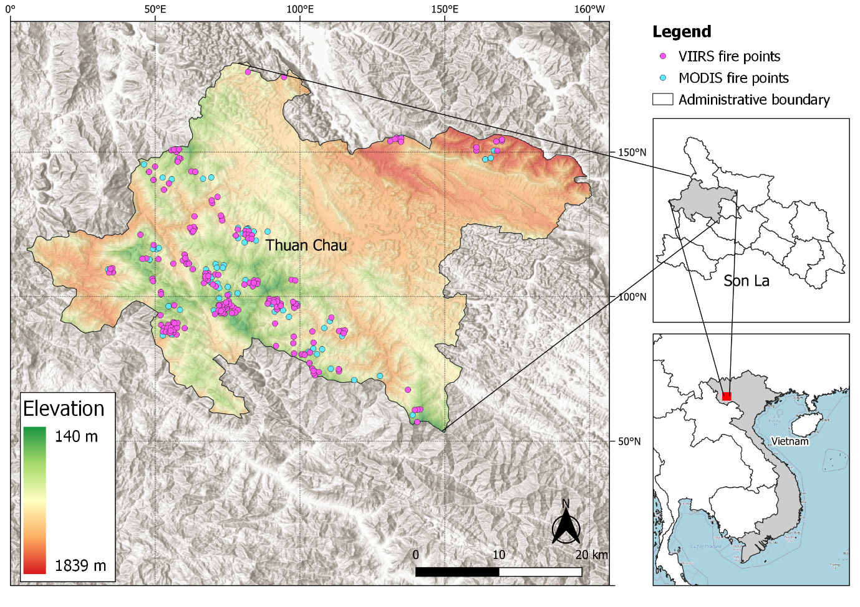

**Figure 1**. The study area of Thuan Chau district.

# 3. Material and method

This section describes the data acquisition and preprocessing procedures and analysis methodologies used. Three independent datasets, namely Sentinel, GIS data, and MODIS, VIIRS active fire data were used for burn severity mapping, post-fire vegetation assessment and accuracy assessment. The flow diagram outlines the methodology can be found in Fig. 2.

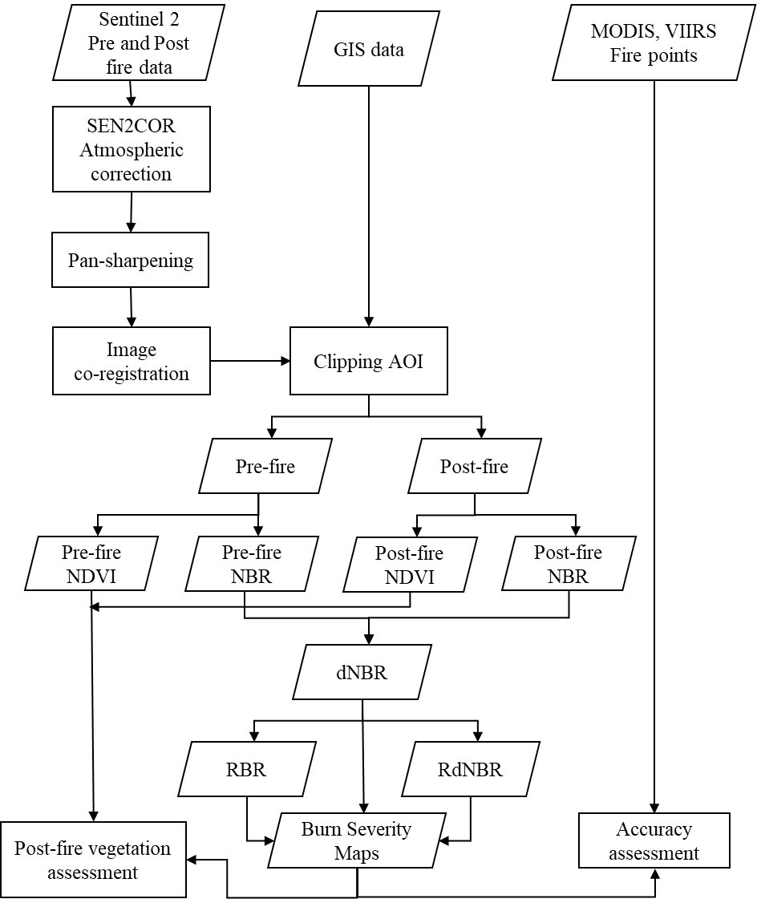

**Figure 2**. Research approach as a flowchart describing the process of analyzing. (Atmospheric correction and Pan-sharpening was carried out by Sen2Cor and SNAP, while R programming was used for other processing and analysis. Mapping was created by QGIS.)

## 3.1. Data preparation

In this study, there are 04 Sentinel satellite images of the Thuan Chau district were collected (Table 1). Sentinel-2 imagery with low cloud cover (<3%), as close as possible to the start and end date of the fire were obtained from the website https://earthexplorer.usgs.gov/ provided by The United States Geological Survey (USGS). Seasonal changes in both spectral radiation (e.g. Sun elevation angle, Sun-Earth distance, meteorological circumstances) and surface reflection were minimized by selecting images around the same dates in different years. In particular, a pre-fire image acquired on 12th April 2019, while 03 post-fire images were obtained on 22nd April 2019, 12th March 2020, and 1st April 2021.

**Table 1.** Metadata of images used in this study.

|  |  |  |  |  |
| --- | --- | --- | --- | --- |
|  | Sentinel 2 | | | |
| 2019 pre-fire | 2019 post-fire | 2020 post-fire | 2021 post-fire |
| Entity ID | L1C_T48QUJ_A010955_20190412T034932 | L1C_T48QUJ_A011098_20190422T034525 | L1C_T48QUJ_A024654_20200312T033828 | L1C_T48QUJ_A021251_20210401T035039 |
| Vendor Product ID | S2B_MSIL1C_20190412T033739_N0207_R061_T48QUJ_20190412T085928 | S2B_MSIL1C_20190422T033539_N0207_R061_T48QUJ_20190422T071443 | S2A_MSIL1C_20200312T033531_N0209_R061_T48QUJ_20200312T064237 | S2B_MSIL1C_20210401T033539_N0300_R061_T48QUJ_20210401T072308 |
| Platform | Sentinel-2B | Sentinel-2B | Sentinel-2A | Sentinel-2B |
| Acquisition Date | 2019-04-12 | 2019-04-22 | 2020-03-12 | 2021-04-01 |
| Processing Date | 2019-04-12 | 2019-04-22 | 2020-03-12 | 2021-04-01 |
| Processing level | LEVEL-1C | LEVEL-1C | LEVEL-1C | LEVEL-1C |
| Orbit Direction | Descending | Descending | Descending | Descending |
| Cloud Cover | 0.57240 | 2.68730 | 0.00000 | 0.18430 |
| Sensor | MSI | MSI | MSI | MSI |
| Projection | UTM | UTM | UTM | UTM |
| UTM Zone | 48N | 48N | 48N | 48 |
| Datum | WGS84 | WGS84 | WGS84 | WGS84 |
| Ellipsoid | WGS84 | WGS84 | WGS84 | WGS84 |
| Sun Azimuth | 122.50623895 | 115.11928255 | 137.70602987 | 128.85396100 |
| Sun Zenith | 21.888761593 | 19.441936199 | 31.729332173 | 25.024066951 |
| Spatial Resolution | 10, 20, 60m | 10, 20, 60m | 10, 20, 60m | 10, 20, 60m |

The four acquired Sentinel images are processed at level L1C top-of-atmosphere (TOA) reflectance data which includes radiometric and geometric corrections along with orthorectification to generate highly accurate geolocated products (*USGS EROS Archive - Sentinel-2*, 02-Dec-21). Table 1 and Table 2 provide metadata and detailed parameters of the spectral bands of the used satellite images.

The atmospheric correction process aims to remove the effects of the atmosphere influencing the signal measured by a satellite sensor (Hoepffner & Zibordi, 2009)c. The 04 images were atmospherically corrected using the Sen2Cor version 2.9 which is a processor for generating level 2A products from TOA reflectance Level-1C input image. The processor performs the atmospheric-, terrain and cirrus correction (Sen2Cor – STEP, 02-Dec-21)c.

Pan-sharpening is the process to create higher spatial resolution multispectral images by fusing a higher spatial resolution band with low spatial resolution MS imagery. The Sentinel 2 SWIR band (12) was pan-sharpened from 20 m to 10 m resolution with band 2 as a higher resolution band, using SNAP application version 8.0.8 and nearest-neighbor interpolation.

Image co-registration is performed when studying time-series analysis, basically to understand change during the period of time. The goal of co-registration is to align the pictures spatially so that each feature in one image overlaps exactly with its footprint in any other image in the time series. In this study, the 03 post-fire images were co-registered based on the pre-fire image as the reference image, using package RStoolbox in the R programming language.

After preprocessing steps, the images were cropped to the area of interest of Thuan Chau district for further analysis. Due to low cloud coverage of the 04 images, also the cloud area was optically determined absent in the area of interest, therefore the cloud masking process was not performed in this study.

As no fire occurrence data was available, for accuracy assessment of the burn severity map, the study used the active fire points acquired by Moderate Resolution Imaging Spectroradiometer

(MODIS) Terra satellite (MOD14_NRT) and SUOMI NPP Visible Infrared Imaging Radiometer Suite (VIIRS) (VNP14IMGTDL_NRT) products data were downloaded from FIRMS NASA website (<https://firms.modaps.eosdis.nasa.gov>) (Fig. 1).

**Table 2**. Basic characteristics of Sentinel-2 image.

|  |  |  |
| --- | --- | --- |
| Bands | wavelength (nm) | resolution (m) |
| 1 - CA | 433 - 453 | 60 |
| 2 - Blue | 458 - 523 | 10 |
| 3 - Green | 543 - 578 | 10 |
| 4 - Red | 650 - 680 | 10 |
| 5 - VRE | 698 - 713 | 20 |
| 6 - VRE | 733 - 748 | 20 |
| 7 - VRE | 773 - 793 | 20 |
| 8 - NIR | 785 - 900 | 10 |
| 8A - NNIR | 855 - 875 | 20 |
| 9 - WA | 935 - 955 | 60 |
| 10 - Cirrus | 1360 - 1390 | 60 |
| 11 - SWIR | 1565 - 1655 | 20 |
| 12 - SWIR | 2100 - 2280 | 20 |

## 3.2. Candidate fire severity indices

The following candidate fire severity indices were generated for each pair of pre- and post-fire images: differenced normalised burn ratio (dNBR), Relativized Burn Ratio (RBR), and relativised dNBR (RdNBR). Initially, Normalized Burn Ratio (NBR) was calculated using the following equation (Eq. 1) for both pre-fire and post-fire:

**Equation 1.** NBR calculation.

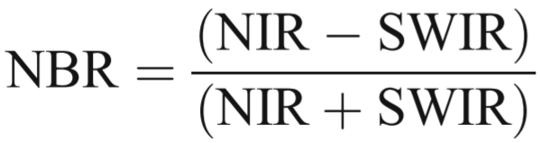

The NBR value ranges from -1 to +1 with maximum values for vegetation and minimum values for burnt areas. The dNBR was calculated from pre-fire NBR and post-fire NBR (Eq. 2). The higher dNBR values refer to higher burn severity.

**Equation 2**. dNBR calculation.



Relativized Burn Ratio (RBR) was derived based on the ratio of dNBR and adjusted pre-fire NBR (Eq. 3). The denominator was added a value of 1.001 to make sure that it will not tend to zero (Parks et al., 2014)c.

**Equation 3**. RBR calculation.

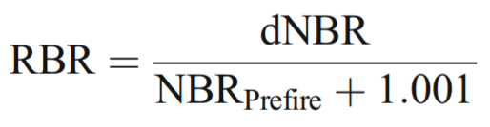

The Relativized differenced Normalized Burn ratio (RdNBR) was a distinct dNBR variant that takes into account the relative amount of pre-fire shift by dividing dNBR with the pre-fire NBR value (Konkathi & Shetty, 2021). RdNBR was derived using Eq. 4.

**Equation 4**. RdNBR calculation.

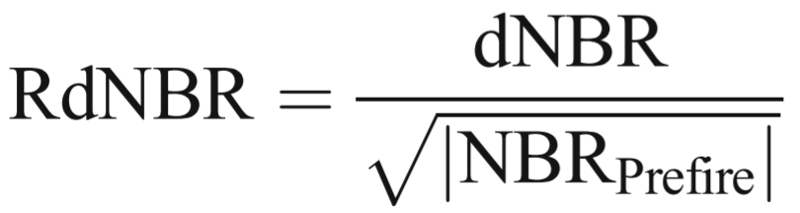

## 3.3. Burn severity map

The burn severity analysis was used to map the regions based on how much damage they sustained from the fire. The burn severity map was executed by segregating three indices of dNBR, RBR and RdNBR into different fire severity levels proposed by the United States Geological Survey (USGS, 2004) (Table 3).

**Table 3**. Threshold classifying burn severity

|  |  |  |
| --- | --- | --- |
| No. | Severity level | Range |
| 1 | High Enhanced Regrowth | -0.5 to -0.25 |
| 2 | Low Enhanced Regrowth | -0.25 to -0.1 |
| 3 | Unburned | -0.1 to 0.1 |
| 4 | Low Severity | 0.1 to 0.27 |
| 5 | Moderate-low Severity | 0.27 to 0.44 |
| 6 | Moderate-high Severity | 0.44 to 0.66 |
| 7 | High Severity | 0.66 to 1.3 |

## 3.4. Post-fire vegetation regeneration assessment

Assessment of the vegetation recovery was executed based on multi-temporal analysis of NDVI, which was computed from the red, and near-infrared spectral bands of each Sentinel image as Eq.5.

**Equation 5**. NDVI calculation.

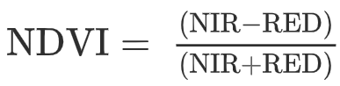

NDVI is an index related to the amount of photosynthetically active vegetation exposed to the sensor within each pixel. NDVI values range from -1 to +1, with zero value indicating an absence of vegetation, and typical NDVI values for vegetated areas are in general above 0.1. This index has a strong relationship with change detection in canopy cover and above-ground biomass in a wide range of ecosystems (Ireland & Petropoulos, 2015). Analysis of the regeneration process was done by comparing the pre-fire NDVI to the post-fire NDVI. Also, the mean NDVI values within each burn severity level were extracted in different years, allowing to evaluate the spatial and temporal NDVI regeneration dynamics.

All analysis of burn severity and post-fire assessment were performed using the R studio application version 1.3.1093 with R programing language running in the background.

# 4. results and discussion

## 4.1. Burn severity map

The burn severity map based on dNBR, RBR and RdNBR was depicted in Fig.3. The area of each severity class for all indices was represented in Fig.4.

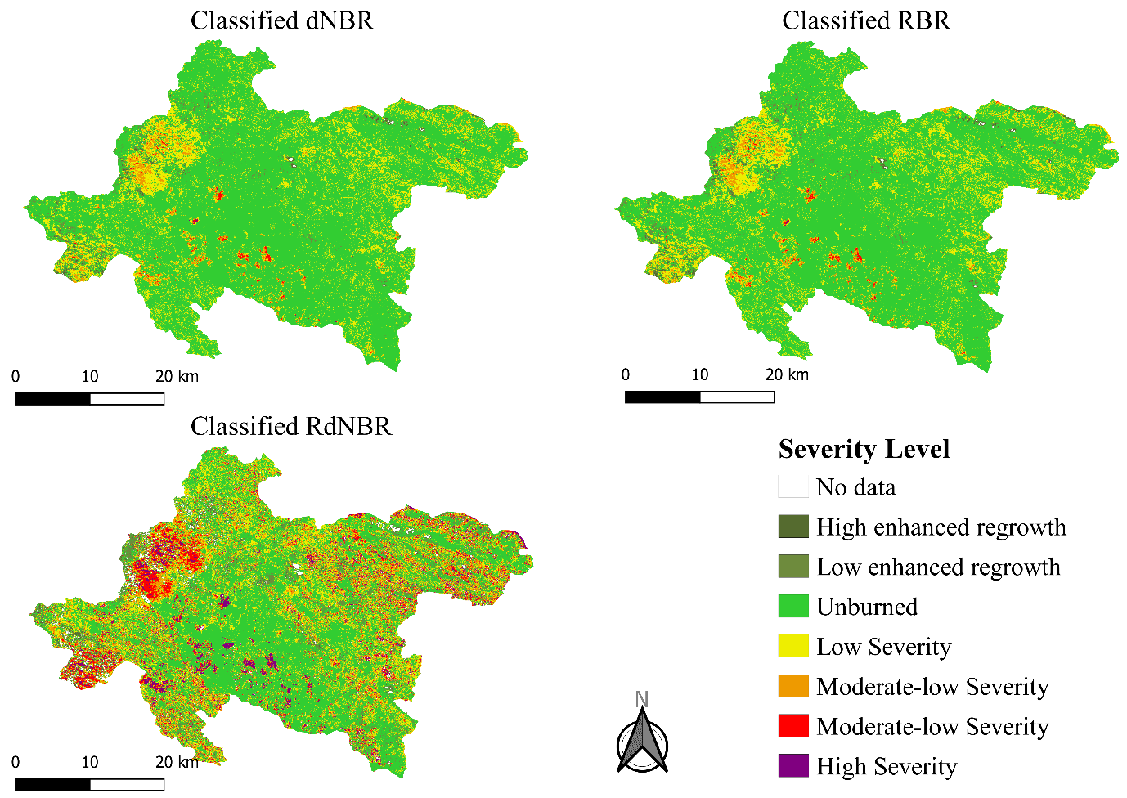

**Figure 3**. Burn severity maps based on dNBR, RBR and RdNBR indices calculated from Sentinel-2 images.

It can be seen that very little regrowth has been captured within the fire period. In terms of high severity class, RdNBR shows the highest area of 7039 ha, while dNBR and RBR indices observed significantly lower value of 459 and 52 ha, correspondingly. This trend is also observed in low severity, moderate-low severity and moderate-high severity, where RdNBR indicated the highest area, followed by dNBR and RBR, respectively. In contrast, 75204 ha is the lowest value in the class of unburnt, which is classified by RdNBR indices. The values for dNBR and RBR are 112917 and 121089, respectively.

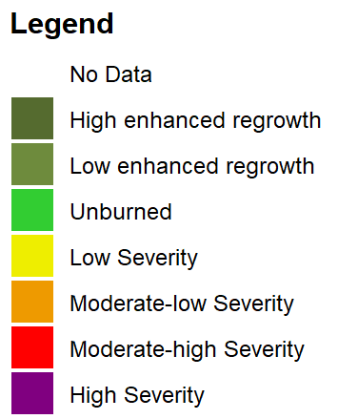

**Figure 4**. The area of each severity level of burn severity indices.

For accuracy assessment of the burnt severity maps, the effect of fire from low severity to high severity were exclusively taken into consideration, therefore they were grouped into the burnt area. On the other hand, the effect of fire from high enhanced regrowth to unburned was neglected and classified into the unburnt area. Sequentially, the burnt map with burnt and unburnt classes was overlaid with active fire points during the study period (Fig. 5). The accuracy of these abovementioned severity maps was assessed based on active fire points derived from the FIRMS NASA website, which provides hotspot locations of fire events. The percentage of active fire points falling within burnt and unburnt classes were extracted for accuracy assessment (Fig. 6).

It can be observed that the RdNBR index presents the highest accuracy with 62.6% fire points falling in the burnt area. The opposite is RBR with 46.18%. Whereas in the terms of dNBR, 52.67% fire points were observed in burnt areas, and 47.33% for the unburnt area.

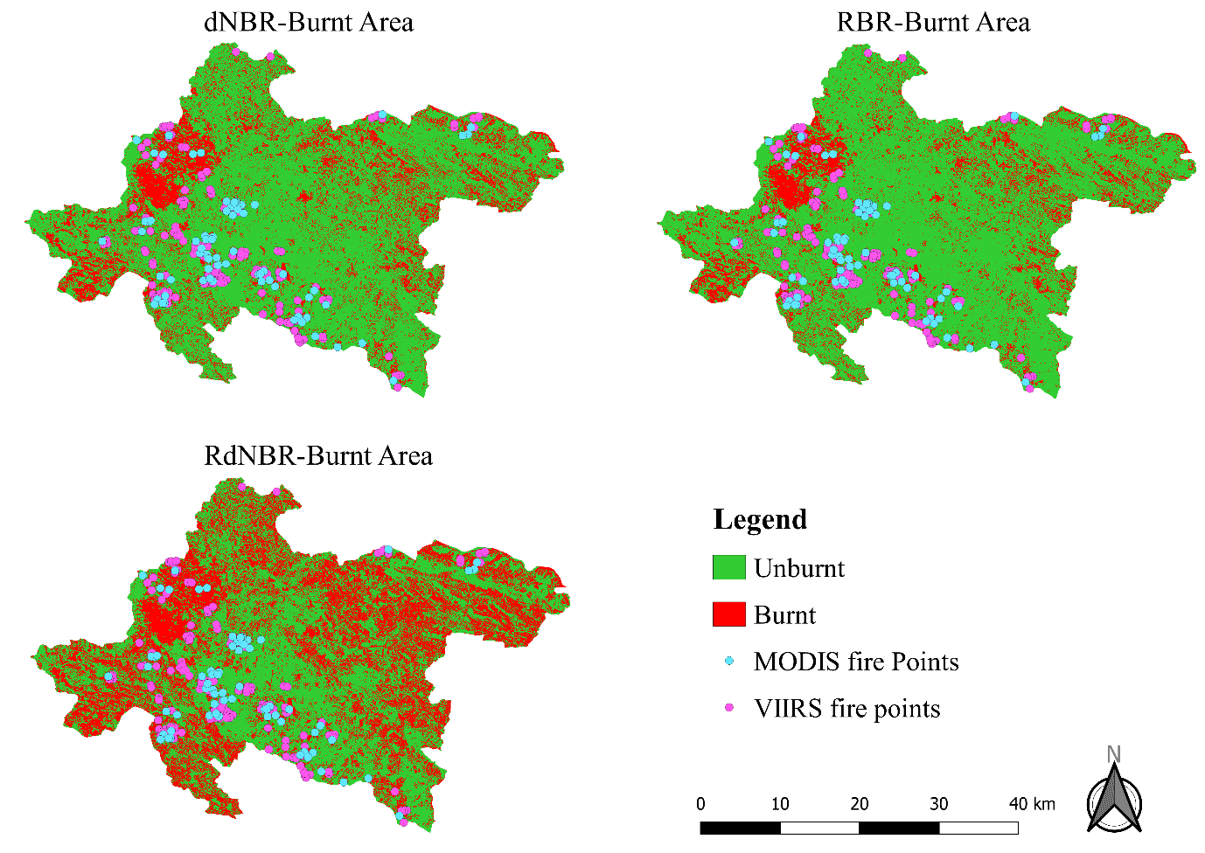

**Figure 5**. Burnt area maps generated from grouping burn severity classes overlaid with active fire points from FIRMS NASA.

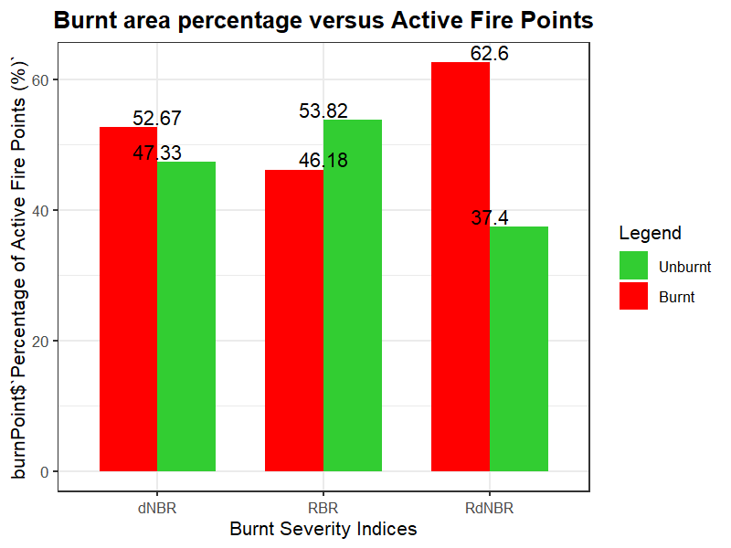

**Figure 6**. Percentage of the active fire points within burnt and unburnt area maps derived from several burnt severity indices.

From these results, it is obvious that RdNBR shows the greatest agreement with the reference fire points. However, it is true that the burnt area defined by RdNBR was far beyond the other indices (Table 4). In detail, there was 42% area of Thuan Chau district defined as burnt area by RdNBR index, compared to only 23.3 and 18.8% by dNBR and RBR, correspondingly. It leads to the fact that it is easier for the fire point falling into burnt areas rather than unburnt areas. Indeed, many areas in the East side of the RdNBR burnt map (Fig.5) was determined as burnt area, but there are very few fire hotspots were recorded in that area.

**Table 4**. Area of burnt and unburnt class.

|  |  |  |  |
| --- | --- | --- | --- |
| Burn area class | dNBR | RBR | RdNBR |
| Burnt | 23.3 | 18.8 | 42 |
| Unburnt | 76.7 | 81.6 | 58 |

## 4.2. Post-fire vegetation regeneration assessment

The descriptive statistics for NDVI are represented in table 5. The minimum NDVI of -0.299 and -0.649 on the 12th and 22nd, respectively, depicted the impact of the fire. However, the mean NDVI seems to be problematic when increasing from 0.285 to 0.342 after the fire.

**Table 5**. statistic of NDVI for the area of interest over the study period.

|  |  |  |  |  |  |
| --- | --- | --- | --- | --- | --- |
| Period | Date | Minimum  NDVI | Maximum  NDVI | Mean  NDVI | NDVI standard deviation |
| prefire | 12-Apr-19 | -0.299 | 0.631 | 0.285 | 0.076 |
| postfire | 22-Apr-19 | -0.649 | 0.999 | 0.342 | 0.154 |
| 12-Mar-20 | -0.329 | 0.787 | 0.320 | 0.054 |
| 01-Apr-21 | -0.028 | 0.607 | 0.322 | 0.033 |

The dNBR-based burn severity was used in cooperation with NDVI data for vegetation regeneration analysis. Table 6 and Fig. 7 illustrate the association between vegetation regeneration and burn severity. Table 6 describes the mean NDVI values within each burn severity level.

**Table 6**. Relationship between vegetation regeneration expressed by the mean NDVI with burn severity level (derived from the dNBR).

|  |  |  |  |  |  |  |  |  |
| --- | --- | --- | --- | --- | --- | --- | --- | --- |
| Period | Date | High enhanced regrowth | Low  Enhanced  regrowth | Unburned | Low  Severity | Moderate- low  Severity | Moderate- high  Severity | High  Severity |
| prefire | 12-Apr-19 | 0.187 | 0.282 | 0.326 | 0.264 | 0.339 | 0.363 | 0.368 |
| postfire | 22-Apr-19 | 0.356 | 0.422 | 0.538 | 0.332 | 0.214 | 0.171 | 0.128 |
| 12-Mar-20 | 0.234 | 0.279 | 0.347 | 0.251 | 0.340 | 0.367 | 0.398 |
| 01-Apr-21 | 0.272 | 0.309 | 0.329 | 0.281 | 0.349 | 0.364 | 0.362 |

**Figure 7**. Mean NDVI by burn severity class from 12th April 2019 to 1st April 2021.

As expected, the greatest difference in mean NDVI was observed in the high severity class where mean NDVI values decreased from 0.368 on 12th April to 0.128 on 22nd April. Which was followed by moderate-high class with a decrease of 0.192 over the same period. The area of moderate-low severity experienced a smaller decrease of 0.125 in mean NDVI, roughly one-third of the decrease was noticed in the high severity.

# 5. Conclusion

In this study, burn severity analysis and post-fire vegetation assessment in Thuan Chau, Son La, Vietnam were accomplished using Sentinel-2 multi-spectral satellite images in the period of 2 years.

There were three reflectance indices, namely differenced Normalized Burn Ratio (dNBR), Relativized Burn Ratio (RBR) and Relativized differenced Normalized Burn Ratio (RdNBR) used for mapping burn severity. To do so, these indices were categorized into various severity levels proposed by the United States Geological Survey. The levels of low severity to high severity were considered as burnt areas and the rest as unburnt areas. Then, the burnt area maps with two classes of burnt and unburnt were validated using active fire points (MODIS and VIIRS). The RdNBR has shown its high accuracy with 62.6%, followed by dNBR with 53.67% and RBR with 46.18%. However, RdNBR burnt map (Fig. 5) presented many areas specified as the burnt area that have no active fire points recorded. Further research may should develop a more accurate method for burn severity accuracy assessment.

Results of this study have shown the rapid decrease in NDVI values right after the fire, showing the significant impact of the fire. On the other hand, a high regeneration rate was also observed via NDVI values helping the forest reach its initial state. The burn severity map is well correlated with the NDVI values, where the area with the most significant NDVI decline matches the high severity area. Field surveys or high-resolution remote sensing could help for a more accurate assessment.

References

Evangelides, C., & Nobajas, A. (2020). Red-Edge Normalised Difference Vegetation Index (NDVI705) from Sentinel-2 imagery to assess post-fire regeneration. *Remote Sensing Applications: Society and Environment*, *17*, 100283. https://doi.org/10.1016/j.rsase.2019.100283

Gibson, R., Danaher, T., Hehir, W., & Collins, L. (2020). A remote sensing approach to mapping fire severity in south-eastern Australia using sentinel 2 and random forest. *Remote Sensing of Environment*, *240*, 111702. https://doi.org/10.1016/j.rse.2020.111702

Ireland, G., & Petropoulos, G. P. (2015). Exploring the relationships between post-fire vegetation regeneration dynamics, topography and burn severity: A case study from the Montane Cordillera Ecozones of Western Canada. *Applied Geography*, *56*, 232–248. https://doi.org/10.1016/j.apgeog.2014.11.016

Konkathi, P., & Shetty, A. (2021). Inter comparison of post-fire burn severity indices of Landsat-8 and Sentinel-2 imagery using Google Earth Engine. *Earth Science Informatics*, *14*(2), 645–653. https://doi.org/10.1007/s12145-020-00566-2

Morgan, P., Keane, R. E., Dillon, G. K., Jain, T. B., Hudak, A. T., Karau, E. C., Sikkink, P. G., Holden, Z. A., & Strand, E. K. (2014). Challenges of assessing fire and burn severity using field measures, remote sensing and modelling. *International Journal of Wildland Fire*, *23*(8), 1045. https://doi.org/10.1071/WF13058

Ngoc Thach, N., Bao-Toan Ngo, D., Xuan-Canh, P., Hong-Thi, N., Hang Thi, B., Nhat-Duc, H., & Dieu, T. B. (2018). Spatial pattern assessment of tropical forest fire danger at Thuan Chau area (Vietnam) using GIS-based advanced machine learning algorithms: A comparative study. *Ecological Informatics*, *46*, 74–85. https://doi.org/10.1016/j.ecoinf.2018.05.009

Parks, S., Dillon, G., & Miller, C. (2014). A New Metric for Quantifying Burn Severity: The Relativized Burn Ratio. *Remote Sensing*, *6*(3), 1827–1844. https://doi.org/10.3390/rs6031827

Rogan, J., & Franklin, J. (2001). Mapping Wildfire Burn Severity in Southern California Forests and Shrublands Using Enhanced Thematic Mapper Imagery. *Geocarto International*, *16*(4), 91–106. https://doi.org/10.1080/10106040108542218

*USGS EROS Archive - Sentinel-2.* (02-Dec-21). https://www.usgs.gov/centers/eros/science/usgs-eros-archive-sentinel-2?qt-science_center_objects=0#qt-science_center_objects

USGS, (2004). *Reviewed and Updated National Burn Severity Mapping Project Mission Statement,  
Summary of Working Group Meeting Results*. NPS-USGS NATIONAL BURN SEVERITY  
MAPPING PROJECT WORKING GROUP