TRƯỜNG ĐẠI HỌC FPT
PHÂN HIỆU : TP. HỒ CHÍ MINH



FINAL REPORT
Banking System

Course: DBI202-Introduction to Databases
Lecturer: DanhNT16

Group members :
SE190534 – Hoàng Quốc Việt
SE190138 – Nguyễn Anh Kỳ
SE191088 – Đinh Xuân Long

Thành Phố Hồ Chí Minh - 2025


Introduction

In the digital era, traditional banking operations relying on paper-based records and manual processes face challenges such as inefficiency, high operational costs, data errors, and security risks. To address these issues, the Banking System is designed to streamline customer management, account handling, transaction processing, loan services, and repayment schedules. This system is tailored for a modern financial institution, serving individual customers, businesses, and branch operations.

This report focuses on analyzing different approaches to data organization, evaluating their strengths and weaknesses, identifying suitable use cases, selecting the most appropriate solution for the Banking System, and finally presenting the key entities and attributes that form the foundation of this project.


SUMMARY – REASONS FOR CHOOSING THE CONTENT
  - During the course Introduction to Databases (DBI202), the group chose the topic "Banking System" to apply theoretical knowledge to a complex real-life system that requires high accuracy.
  - Reason for choosing this content:
  - High practicality: Banking is a typical environment that requires a tight database system, with many entities and constraints between data.
  - Comprehensive application of DBI202 knowledge: The topic covers important aspects such as ERD design, normalization, key constraints, SQL queries, and report generation.
  - Application scalability: The data structure can be easily extended to financial systems, e-wallets, or credit management systems.
  - Develop practical skills: Help teams gain a deeper understanding of data organization, ensuring integrity, reducing redundancy, and optimizing queries.
  - Objective of the report:
  - Analyze and model data for banking system.
  - Design appropriate tables, keys, and logical constraints.
  - Create realistic sample data and write SQL queries for statistics.
  - Present, evaluate results and applicability of the system.
PROBLEM STATEMENT
In traditional banking operations, manual data storage and processing often causes:
- Errors, duplication, and difficulty in controlling information.
- Lack of connectivity between departments (customers, branches, employees).
- Time-consuming when synthesizing reports or retrieving data.
Topic objective:
Building a relational database for comprehensive management:
- Customer
- Account
- Transaction
- Loan
- Repayment Schedule
- Branch
- Staff
System oriented:
- Ensure ACID transactions (safe, consistent, sustainable).
- Reduce data redundancy through normalization.
- Flexible query and reporting support using SQL.


ERD (ENTITY RELATIONSHIP DIAGRAM)
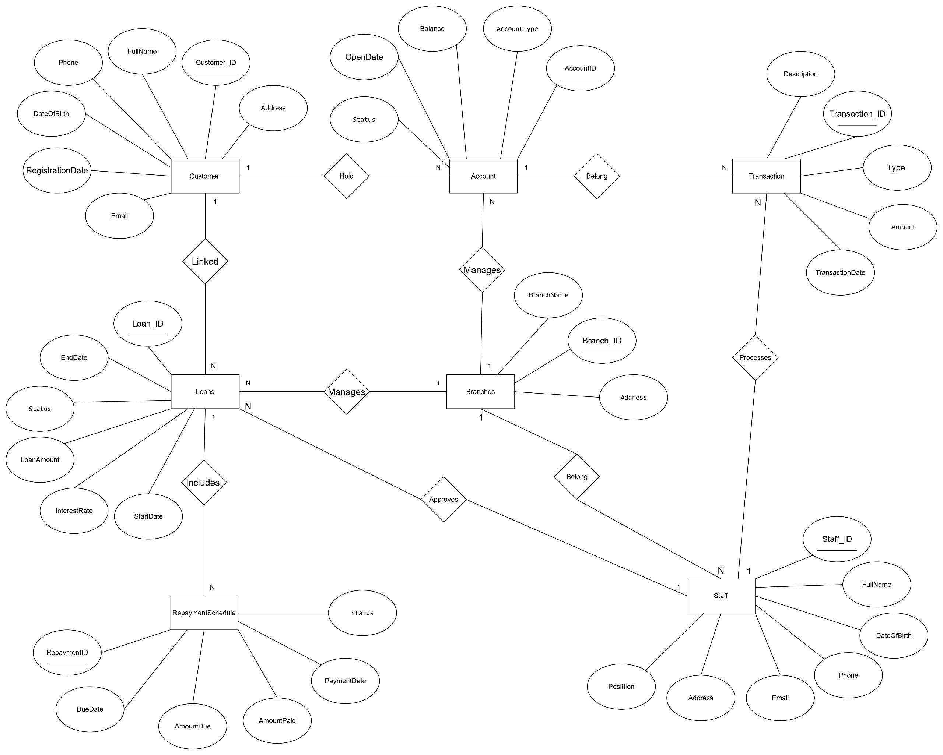

The Levels Of Relationship Between Entities
- Customer – Account:
  - 1 Customer ↔ N Accounts
o A customer can open multiple accounts, but an account belongs to only one customer.
- Account – Transaction:
  - 1 Account ↔ N Transactions
o An account can have many transactions, but each transaction belongs to exactly one account.
- Customer – Loan:
  - 1 Customer ↔ N Loans
o A customer can borrow many loans, but each loan is associated with 1 customer.

- Loan – Repayment_Schedule:
  - 1 Loan ↔ N RepaymentSchedules
o A loan has multiple repayment periods, but a repayment schedule is associated with only one loan.
- Branch – Account / Loan / Staff:
  - 1 Branch ↔ N Accounts
  - 1 Branch ↔ N Loans
  - 1 Branch ↔ N Staff
o One branch manages many accounts, many loans and many employees.
- Staff – Loan:
  - 1 Staff ↔ N Loans
o One loan officer can approve multiple loans, but each loan is managed by one officer.
- Staff – Transaction:
  - 1 Staff ↔ N Transactions (as Processor)
o One employee can process multiple transactions, but each transaction is processed by one employee.
- Transaction – Account (Related_Account_ID ko có ràng buộc khóa ngoại nữa):
  - 1 Transaction ↔ 1 Account (via Account_ID)
- In case of “Transfer” transaction, the system can record an additional account link (Related_Account_ID) to show the receiving account.


DATABASE

CUSTOMER

Attribute | Key | Data Type | Constraint
Customer_ID | PK | INT | PRIMARY KEY
FullName |  | NVARCHAR(50) | NOT NULL
Email |  | NVARCHAR(50) | UNIQUE, NOT NULL
Phone |  | NVARCHAR(20) | UNIQUE, NOT NULL
Address |  | NVARCHAR(100) | NULL
DateOfBirth |  | DATE | NULL
RegistrationDate |  | DATE | DEFAULT GETDATE()

ACCOUNT
Attribute | Key | Data Type | Constraint
Account_ID | PK | VARCHAR(20) | PRIMARY KEY
Customer_ID | FK | INT | FOREIGN KEY → Customer(Customer_ID)
Branch_ID | FK | INT | FOREIGN KEY → Branch(Branch_ID)
AccountType |  | NVARCHAR(50) | NOT NULL, CHECK (AccountType IN (‘Saving’,‘Checking’))
Balance |  | DECIMAL(20) | DEFAULT 0
OpenDate |  | DATE | DEFAULT GETDATE()
Status |  | NVARCHAR(20) | CHECK (Status IN (‘Active’,‘Closed’,‘Suspended’))

TRANSACTION
Attribute | Key | Data Type | Constraint
Transaction_ID | PK | INT | PRIMARY KEY
Account_ID | FK | VARCHAR(20) | FOREIGN KEY → Account(Account_ID)
TransactionDate |  | DATETIME | DEFAULT GETDATE()
Amount |  | DECIMAL(15) | NOT NULL, CHECK (Amount > 0)
Type |  | NVARCHAR(20) | NOT NULL, CHECK (Type IN(‘Deposit’,‘Withdraw’,‘Transfer’))
Description |  | NVARCHAR(255) | NULL
Processor_Staff_ID | FK | INT | FOREIGN KEY → Staff(Staff_ID)
Related_Account_ID |  | VARCHAR(20) | NULL

LOANS
Attribute | Key | Data Type | Constraint
Loan_ID | PK | INT | PRIMARY KEY
Customer_ID | FK | INT | FOREIGN KEY → Customer(Customer_ID)
Branch_ID | FK | INT | FOREIGN KEY → Branch(Branch_ID)
LoanAmount |  | DECIMAL(15) | NOT NULL, CHECK (LoanAmount > 0)
InterestRate |  | DECIMAL(5) | NULL
StartDate |  | DATE | NOT NULL
EndDate |  | DATE | NULL
Status |  | NVARCHAR(20) | CHECK (Status IN (‘Pending’,‘Approved’,‘Rejected’,‘Active’,‘Closed’))
Staff_ID | FK | INT | FOREIGN KEY → Staff(Staff_ID)
REPAYMENTSCHEDULE
Attribute | Key | Data Type | Constraint
Schedule_ID | PK | INT | PRIMARY KEY
Loan_ID | FK | INT | FOREIGN KEY → Loan(Loan_ID)
DueDate |  | DATE | NOT NULL
AmountDue |  | DECIMAL(15) | CHECK (AmountDue > 0)
AmountPaid |  | DECIMAL(15) | DEFAULT 0
PaymentDate |  | DATE | NULL
Status |  | NVARCHAR(20) | CHECK (Status IN (‘Pending’,‘Paid’,‘Overdue’))

BRANCHES
Attribute | Key | Data Type | Constraint
Branch_ID | PK | INT | PRIMARY KEY
Address |  | NVARCHAR(200) | NOT NULL
BrandName |  | NVARCHAR(100) | NOT NULL

STAFF

ATTRIBUTE | KEY | DATA TYPE | CONSTRAINT
STAFF_ID | PK | INT | PRIMARY KEY
FULLNAME |  | NVARCHAR(100) | NOT NULL
BRANCH_ID | FK | INT | FOREIGN KEY → Branch(Branch_ID)
DATEOFBIRTH |  | DATE | NULL
PHONE |  | NVARCHAR(20) | UNIQUE, NOT NULL
EMAIL |  | NVARCHAR(100) | UNIQUE, NOT NULL
ADDRESS |  | NVARCHAR(200) | NULL
POSITION |  | NVARCHAR(50) | NOT NULL, CHECK (Position IN (‘TELLER’,‘LOAN OFFICER’,‘MANAGER’,‘ADMIN’))


Database Diagram
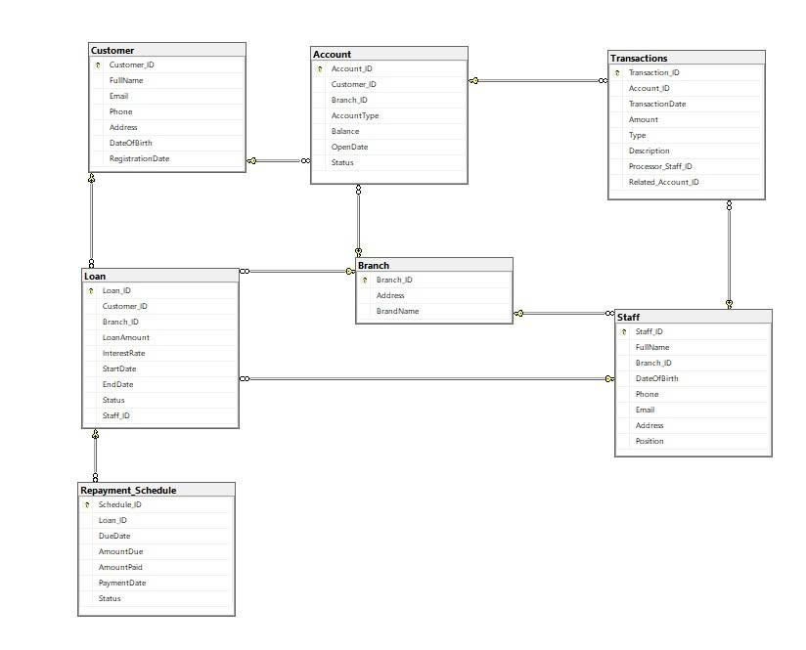

Insert Data

INSERT DATA FOR Branch

INSERT INTO Branch (Branch_ID, Address, BrandName)
VALUES (101, N'123 Trần Hưng Đạo, Hà Nội', N'Hà Nội Branch');
INSERT INTO Branch (Branch_ID, Address, BrandName)
VALUES (102, N'456 Lê Lợi, TP HCM', N'Sài Gòn Branch');
INSERT INTO Branch (Branch_ID, Address, BrandName)
VALUES (103, N'789 Bạch Đằng, Đà Nẵng', N'Đà Nẵng Branch');
INSERT INTO Branch (Branch_ID, Address, BrandName)
VALUES (104, N'12 Hai Bà Trưng, Hải Phòng', N'Hải Phòng Branch');
INSERT INTO Branch (Branch_ID, Address, BrandName)
VALUES (105, N'99 Nguyễn Huệ, Cần Thơ', N'Cần Thơ Branch');


INSERT DATA FOR Customer

INSERT INTO Customer (Customer_ID, FullName, Email, Phone, Address, DateOfBirth)
VALUES (101, N'Nguyễn Văn A', 'a.nguyen@example.com', '0901234567', N'Hà Nội', '1990-05-10');
INSERT INTO Customer (Customer_ID, FullName, Email, Phone, Address, DateOfBirth)
VALUES (102, N'Trần Thị B', 'b.tran@example.com', '0912345678', N'Hồ Chí Minh', '1985-11-20');
INSERT INTO Customer (Customer_ID, FullName, Email, Phone, Address, DateOfBirth)
VALUES (103, N'Lê Văn C', 'c.le@example.com', '0923456789', N'Đà Nẵng', '1995-03-15');
INSERT INTO Customer (Customer_ID, FullName, Email, Phone, Address, DateOfBirth)
VALUES (104, N'Phạm Thị D', 'd.pham@example.com', '0934567890', N'Hải Phòng', '1992-12-01');
INSERT INTO Customer (Customer_ID, FullName, Email, Phone, Address, DateOfBirth)
VALUES (105, N'Hoàng Văn E', 'e.hoang@example.com', '0945678901', N'Cần Thơ', '1998-07-22');

INSERT DATA FOR Staff

INSERT INTO Staff (Staff_ID, FullName, Branch_ID, DateOfBirth, Phone, Email, Address, Position)
VALUES (101, N'Ngô Minh Quân', 101, '1980-03-12', '0951111111', 'quan.ngo@example.com', N'Hà Nội', 'Manager');
INSERT INTO Staff (Staff_ID, FullName, Branch_ID, DateOfBirth, Phone, Email, Address, Position)
VALUES (102, N'Lý Thu Hằng', 101, '1990-09-05', '0952222222', 'hang.ly@example.com', N'Hà Nội', 'Manager');
INSERT INTO Staff (Staff_ID, FullName, Branch_ID, DateOfBirth, Phone, Email, Address, Position)
VALUES (103, N'Võ Minh Tú', 102, '1988-11-23', '0953333333', 'tu.vo@example.com', N'Hồ Chí Minh', 'Loan Officer');
INSERT INTO Staff (Staff_ID, FullName, Branch_ID, DateOfBirth, Phone, Email, Address, Position)
VALUES (104, N'Nguyễn Lan Anh', 103, '1995-02-10', '0954444444', 'lananh.nguyen@example.com', N'Đà Nẵng', 'Admin');
INSERT INTO Staff (Staff_ID, FullName, Branch_ID, DateOfBirth, Phone, Email, Address, Position)
VALUES (105, N'Trần Quốc Phong', 104, '1985-08-18', '0955555555', 'phong.tran@example.com', N'Hải Phòng', 'Teller');

INSERT DATA FOR Account

INSERT INTO Account (Account_ID, Customer_ID, Branch_ID, AccountType, Balance, Status)
VALUES ('HN101', 101, 101, 'Saving', 15000000, 'Active');
INSERT INTO Account (Account_ID, Customer_ID, Branch_ID, AccountType, Balance, Status)
VALUES ('HN102', 102, 101, 'Checking', 5000000, 'Active');
INSERT INTO Account (Account_ID, Customer_ID, Branch_ID, AccountType, Balance, Status)
VALUES ('SG103', 102, 102, 'Saving', 20000000, 'Active');
INSERT INTO Account (Account_ID, Customer_ID, Branch_ID, AccountType, Balance, Status)
VALUES ('DN104', 104, 103, 'Checking', 1000000, 'Suspended');
INSERT INTO Account (Account_ID, Customer_ID, Branch_ID, AccountType, Balance, Status)
VALUES ('HP105', 105, 104, 'Saving', 12000000, 'Active');

INSERT DATA FOR Loan


INSERT INTO Loan (Loan_ID, Customer_ID, Branch_ID, LoanAmount, InterestRate, StartDate, EndDate, Status, Staff_ID)
VALUES (101, 101, 102, 80000000, 7.5, '2024-01-01', '2026-01-01', 'Pending', 103);
INSERT INTO Loan (Loan_ID, Customer_ID, Branch_ID, LoanAmount, InterestRate, StartDate, EndDate, Status, Staff_ID)
VALUES (102, 103, 102, 50000000, 6.8, '2023-06-15', '2026-06-15', 'Pending', 103);
INSERT INTO Loan (Loan_ID, Customer_ID, Branch_ID, LoanAmount, InterestRate, StartDate, EndDate, Status, Staff_ID)
VALUES (103, 102, 101, 30000000, 8.0, '2024-03-10', '2025-03-10', 'Pending', 103);
INSERT INTO Loan (Loan_ID, Customer_ID, Branch_ID, LoanAmount, InterestRate, StartDate, EndDate, Status, Staff_ID)
VALUES (104, 103, 103, 70000000, 7.2, '2024-05-01', '2027-05-01', 'Pending', 103);
INSERT INTO Loan (Loan_ID, Customer_ID, Branch_ID, LoanAmount, InterestRate, StartDate, EndDate, Status, Staff_ID)
VALUES (105, 102, 101, 25000000, 8.9, '2024-09-01', '2025-09-01', 'Closed', 103);

INSERT DATA FOR Transactions

INSERT INTO Transactions (Transaction_ID, Account_ID, Amount, Type, Description, Processor_Staff_ID, Related_Account_ID)
VALUES (101, 'HN101', 2000000, 'Deposit', N'Nạp tiền tiết kiệm', 101, NULL);
INSERT INTO Transactions (Transaction_ID, Account_ID, Amount, Type, Description, Processor_Staff_ID, Related_Account_ID)
VALUES (102, 'HN102', 1000000, 'Withdraw', N'Rút tiền tiêu dùng', NULL, NULL);
INSERT INTO Transactions (Transaction_ID, Account_ID, Amount, Type, Description, Processor_Staff_ID, Related_Account_ID)
VALUES (103, 'SG103', 500000, 'Transfer', N'Chuyển khoản nội bộ đến HN102', 101, 'HN102');
INSERT INTO Transactions (Transaction_ID, Account_ID, Amount, Type, Description, Processor_Staff_ID, Related_Account_ID)
VALUES (104, 'DN104', 10000000, 'Deposit', N'Nạp tiền tiết kiệm định kỳ', NULL, NULL);
INSERT INTO Transactions (Transaction_ID, Account_ID, Amount, Type, Description, Processor_Staff_ID, Related_Account_ID)
VALUES (105, 'HP105', 500000, 'Withdraw', N'Rút tiền mặt tại quầy', 102, NULL);

INSERT DATA FOR Repayment_Schedule

INSERT INTO Repayment_Schedule (Schedule_ID, Loan_ID, DueDate, AmountDue, AmountPaid, PaymentDate, Status)
VALUES (101, 101, '2024-06-30', 20000000, 20000000, '2024-06-29', 'Paid');
INSERT INTO Repayment_Schedule (Schedule_ID, Loan_ID, DueDate, AmountDue, AmountPaid, PaymentDate, Status)
VALUES (102, 102, '2025-06-30', 20000000, 0, NULL, 'Pending');
INSERT INTO Repayment_Schedule (Schedule_ID, Loan_ID, DueDate, AmountDue, AmountPaid, PaymentDate, Status)
VALUES (103, 103, '2024-12-31', 10000000, 5000000, '2024-12-15', 'Pending');
INSERT INTO Repayment_Schedule (Schedule_ID, Loan_ID, DueDate, AmountDue, AmountPaid, PaymentDate, Status)
VALUES (104, 104, '2024-09-15', 15000000, 0, NULL, 'Pending');
INSERT INTO Repayment_Schedule (Schedule_ID, Loan_ID, DueDate, AmountDue, AmountPaid, PaymentDate, Status)

VALUES (105, 105, '2025-01-31', 25000000, 25000000, '2025-01-30', 'Paid');


SQL QUERIES & RESULTS

Account balance summary.

SELECT C.Customer_ID, C.FullName, COUNT(A.Account_ID) AS NumberAccount, SUM(A.Balance) AS BalanceSummary FROM dbo.Customer C
LEFT JOIN dbo.Account A ON C.Customer_ID = A.Customer_ID
WHERE A.Status = 'Active'
GROUP BY C.Customer_ID, C.FullName
ORDER BY BalanceSummary DESC;

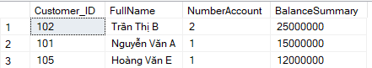

Transaction history report.

SELECT
C.Customer_ID,
C.FullName,
A.Account_ID,
A.Balance,
T.Transaction_ID,
T.TransactionDate,
T.Related_Account_ID,
T.Amount,
T.Type,
T.Description,
T.Processor_Staff_ID,
S.FullName AS StaffName,
S.Position
FROM dbo.Customer C
LEFT JOIN dbo.Account A
ON C.Customer_ID = A.Customer_ID
LEFT JOIN dbo.Transactions T
ON A.Account_ID = T.Account_ID
LEFT JOIN dbo.Staff S
ON T.Processor_Staff_ID = S.Staff_ID
WHERE A.Balance IS NOT NULL
ORDER BY T.Amount DESC;



Loan repayment report.
SELECT
L.Loan_ID,
C.FullName AS CustomerName,
B.BrandName AS Branch,
L.LoanAmount,
L.InterestRate,
L.StartDate,
L.EndDate,
L.Status AS LoanStatus,
RS.Schedule_ID,
RS.DueDate,
RS.AmountDue,
RS.AmountPaid,
(RS.AmountDue - RS.AmountPaid) AS OutstandingAmount,
RS.PaymentDate,
RS.Status AS RepaymentStatus
FROM Loan L
JOIN Customer C ON L.Customer_ID = C.Customer_ID
JOIN Branch B ON L.Branch_ID = B.Branch_ID
LEFT JOIN Repayment_Schedule RS ON L.Loan_ID = RS.Loan_ID
ORDER BY L.Loan_ID;

Branch financial performance.

SELECT
B.Branch_ID,
B.BrandName AS BranchName,
COUNT(DISTINCT A.Account_ID) AS TotalAccounts,
COUNT(DISTINCT L.Loan_ID) AS TotalLoans,
ISNULL(SUM(A.Balance), 0) AS TotalDeposits,
ISNULL(SUM(L.LoanAmount), 0) AS TotalLoanIssued,
(ISNULL(SUM(A.Balance), 0) - ISNULL(SUM(L.LoanAmount), 0)) AS NetBalance
FROM Branch B
LEFT JOIN Account A ON B.Branch_ID = A.Branch_ID
LEFT JOIN Loan L ON B.Branch_ID = L.Branch_ID
GROUP BY B.Branch_ID, B.BrandName
ORDER BY NetBalance DESC;

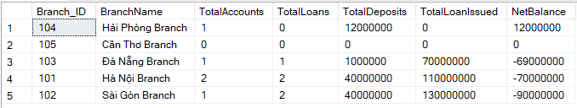


Conclusion
The Structured Data Model (Relational Database) is the most suitable choice for Banking Systems because:
• Clear data relationships: Customer ↔ Account ↔ Transaction; Customer ↔ Loans ↔ Repayment; Branch ↔ Account; Branch ↔ Staff; Staff ↔ Transactions & Loan approvals.
• Ensures data integrity: for example, no Transaction exists without an Account, and no Loan Repayment exists without a Loan.
• Provides safe ACID transactions: guarantees consistency during money transfers, loan disbursements, and repayment updates.
• SQL is powerful for reporting and analytics: enables comprehensive insights such as total branch balances, transaction histories, repayment reports, staff workload, and overall financial performance by branch.
This report has examined various data organization approaches, comparing their advantages and limitations in real-world applications. Based on the requirements of the Banking System, the Relational Database Model (RDBMS) is selected as the most suitable solution. It ensures data integrity through constraints, supports complex SQL queries for auditing and reporting, and provides operational reliability with strong transaction guarantees under the ACID model.
By automating key banking processes such as customer account management, deposits, withdrawals, transfers, loan management, repayment scheduling, and staff responsibility tracking, the system reduces errors, increases efficiency, and enhances both customer experience and branch operations.
The structured approach of RDBMS outperforms alternatives such as NoSQL and Semi-structured models, which are less suited for the highly regulated, relationship-heavy, and transaction-intensive nature of banking. This implementation ensures a robust, secure, and scalable foundation for modern banking services.

GROUP CONTRIBUTIONS

MSSV | Member | Tasks | Contribution
SE190534 | Hoàng Quốc Việt | Draw ERD, make diagram, write query | 50%
SE190138 | Nguyễn Anh Kỳ | Wirte report, compose content | 25%
SE191088 | Đinh Xuân Long | Wirte report, repare presentation | 25%
Total |  |  | 100%

