FPT UNIVERSITY
CAMPUS: HO CHI MINH CITY



PROJECT REPORT
MOVEIT DATA BREACH 2023

Course: IAO202-Information Assurance Overview
Lecturer: NinhTV2
Class: IA1901

Group members :
SE190534 – Hoàng Quốc Việt
SE190138 – Nguyễn Anh Kỳ
SE190378 – Huỳnh Phúc Nguyên Chương

Ho Chi Minh City - 2025

PROJECT REPORT
MOVEit Data Breach 2023 — Risk Analysis and Mitigation Framework
(According to NIST SP 800-30 & ISO/IEC 27001 standards)

1. Problem Definition
1.1 Introduce the topic and the reason for choosing it
As organizations today increasingly rely on Managed File Transfer (MFT) solutions to exchange sensitive data, data security becomes a top priority.
Progress Software's MOVEit Transfer is one of the popular MFT platforms, used by thousands of government organizations, banks, hospitals, universities, and businesses to transfer sensitive information such as personal information (PII), financial, and medical data (PHI).

In May 2023, MOVEit Transfer was severely exploited by the CL0P ransomware group, through a zero-day SQL Injection vulnerability – CVE-2023-34362. This vulnerability allowed the installation of a LEMURLOOT web shell, unauthorized access to the database, and the theft of a large amount of sensitive information.
The incident quickly spread, becoming one of the most serious data breaches of 2023, affecting millions of individuals and thousands of organizations globally.

Choosing the MOVEit incident as a topic gave the research team a practical example of:
- Supply chain attack.
- Zero-day vulnerability management in MFT environments;
• Apply security standards (CIA triad, NIST SP 800-30, ISO 27001) in risk assessment and treatment.
1.2 Incident context
About the MOVEit system
MOVEit Transfer provides three core elements:
- Confidentiality: encrypts data in storage and transmission.
- Integrity: ensures that data is not modified without authorization.
- Compliance: supports security standards such as GDPR, HIPAA, ISO 27001.
MOVEit is often installed on-premises in customer environments, so a vulnerability in the software means each affected server becomes a separate attack point.
Attack summary
According to CISA, IC3/FBI, and Progress Software Advisories:
- The CL0P group exploited an unpatched SQL Injection vulnerability in MOVEit Transfer.
- Installed the LEMURLOOT web shell to maintain access.
- Read configuration files, extracted credentials, compressed and uploaded data to their servers.
- Deleted logs and user accounts to conceal activity.
Impact scale
- Over 2,600 organizations affected (BBC, British Airways, Shell, PwC, U.S. Department of Energy,…).
- About 93 million personal records leaked by early 2024.
- Damages reached hundreds of millions of USD due to disruptions, compensation, and litigation.

2. Risk Analysis
Applied frameworks: NIST SP 800-30 Rev.1 & CIA Triad
2.1 Methodology
Component | Description
Framework | NIST SP 800-30 (2012) – Risk Assessment Guide
Scoring | Likelihood (1–5), Impact (1–5), Risk Score = L×I
Security Model | CIA Triad – Confidentiality, Integrity, Availability
Risk Levels | Low (1–6), Medium (7–12), High (13–20), Critical (21–25)
Process | Identify → Analyze → Treat → Communicate → Maintain

2.2 Assessment of Key Vulnerabilities
1️. CVE-2023-34362 – SQL Injection (Unauthenticated)
- Cause:
The MOVEit Transfer application used dynamic SQL processing mechanisms without applying parameterized queries or secure Object-Relational Mapping (ORM).
HTTP request parameters were concatenated directly into SQL statements without validation (input validation).
This flaw was located in the file upload and user management modules — which operated even before authentication (unauthenticated).
This allowed attackers to send malicious payloads without a valid account.
- Mechanism: attackers sent requests containing SQL payloads, wrote to the database, and uploaded a web shell.
The attack unfolded in several steps:
- Reconnaissance:
Attackers or botnets scanned the Internet for endpoints such as /moveitisapi.dll or /human.aspx, which belong to MOVEit Transfer.
→ Identify vulnerable versions (pre-May 2023).
- Injection Payload:
Attackers sent HTTP requests with parameters containing injected SQL payloads (e.g., ' UNION SELECT ... INTO OUTFILE 'c:\inetpub\wwwroot\lemurloot.aspx'--).
- Web Shell Upload:
Exploiting SQL query write capabilities (via INTO OUTFILE or xp_cmdshell), attackers created the LEMURLOOT web shell file, allowing remote command execution.
- Privilege Escalation & Data Exfiltration:
Through the web shell, attackers accessed the application’s database, extracted configuration files containing plaintext credentials, queried and downloaded user data, then compressed, encrypted, and sent it to C2 servers.
- Cleanup:
Deleted logs, temporary files, and temporary system accounts to avoid detection.
- CIA Impact:
  - Confidentiality: High – Attackers had full access to databases containing PII, PHI, financial data, and sensitive files. Data was exfiltrated on a large scale.
  - Integrity: Medium – Attackers could modify or delete records, change user permissions, or create backdoor accounts.
  - Availability: Medium–High – Data exfiltration and log deletion caused access errors and short-term downtime across multiple servers.
- Likelihood: 5, Impact: 5 → Risk Score = 25 (Critical).
This risk level is rated “Critical Unauthenticated SQLi” by CISA and MITRE, with global impact.
Interdependency: Exploitation was only possible because public-facing servers lacked WAF protection, and weak credentials allowed privilege escalation.
→ Therefore, CVE-2023-34362 is the core exploit in the “Exposure → Exploit → Escalation” chain.
Detection Difficulty
- SQL payloads could be encoded or hidden in HTTP POST requests, making IDS/WAF detection difficult without specific signatures.
- Web shell were named similarly to system files (human2.aspx, index.aspx) and encoded in Base64.
- Many organizations only discovered the breach after stolen data was published or leaked by CL0P on the dark web.
→ Detection difficulty: Very High (High Stealth, Low Visibility).

- Technical Recommendations
- Remediation & Isolation:
  - Apply patches (Progress Patch May–June 2023).
  - Isolate compromised servers, check logs and hash integrity.
- Secure Coding Practices:
  - Apply parameterized queries or secure ORM (Entity Framework, Hibernate).
  - Implement query whitelisting: only allow pre-approved SQL queries defined in source code.
- Database Hardening:
  - Database user isolation: each app runs with minimum privileges (SELECT/INSERT only); disable ALTER, DROP, DELETE.
  - Disable xp_cmdshell, OUTFILE, and file write permissions from SQL.
- Preventive Controls:
  - Enable WAF with SQLi-specific signatures (ModSecurity, Cloudflare Rules).
  - Deploy SIEM correlation rules for anomalous query behavior.
- Monitoring & Incident Response:
  - Integrate alerts into SOC/UEBA for unauthorized login detection.
  - Implement patch automation pipelines to shorten zero-day response time.

2️. Public-Facing Servers (No Patch / No WAF)
- Cause: The vulnerability could only be exploited because MOVEit systems were publicly exposed to the Internet without Web Application Firewalls (WAF) or external authentication layers.
- Mechanism: botnets automatically scanned and exploited large numbers of MOVEit hosts.
- CIA Impact:
  - Confidentiality: High — large-scale data exposure across victims.
  - Integrity: Medium — attackers could insert or modify files if write permissions existed.
  - Availability: High – simultaneous service disruptions caused downtime and investigation costs.
- Likelihood: 5, Impact: 4 → Risk Score = 20 (High).
- Recommendations: deploy WAF, restrict access via VPN, enable automated patch management. Integrate asset discovery and vulnerability scanners (Nessus, Qualys) to regularly detect unpatched public hosts.

3️. Weak or Over-Privileged Service Accounts
- Cause: Service accounts had excessive privileges and stored credentials in configuration files.
- Mechanism: attackers read configuration files, captured credentials, and directly accessed databases.
- CIA Impact:
  - Confidentiality: High — direct access to data stores.
  - Integrity: High — modification or deletion of record
  - Availability: Medium — not immediately disruptive, but could be used for destructive actions.
- Likelihood: 4, Impact: 4 → Risk Score = 16 (High).
- Recommendations: enforce least privilege, MFA, secrets vault, PAM, periodic access reviews. Enable UEBA to monitor abnormal logins and implement credential rotation.

Summary Evaluation:
CVE-2023-34362 is the central point of the entire MOVEit 2023 incident, where the other two vulnerabilities (public exposure & weak credentials) acted as supporting factors.
This is a typical example of how a single web application flaw can trigger a global supply chain incident when:
- No strong network control layers exist (WAF/VPN).
- Credential and access management are weak.

4. Interdependency of Key Vulnerabilities
The three vulnerabilities assessed in section 2.2 do not exist independently but have causal and amplifying relationships in a single attack chain.
In MOVEit, CVE-2023-34362 played the central role, while the other two acted as the “enabler” (expanding the attack surface) and the “amplifier” (increasing impact).
The MOVEit 2023 event demonstrates a three-stage attack chain:
Attack Stage | Corresponding Vulnerability | Detailed Description
1️. Exposure | Public-Facing Servers (No WAF / No Patch) | Publicly deployed MOVEit servers without WAF or patches expanded the attack surface. CL0P’s botnets scanned the Internet to locate exploitable MOVEit endpoints.
2️. Exploit | CVE-2023-34362 – SQL Injection | After identifying targets, attackers executed malicious SQL payloads to write data into databases and deploy the LEMURLOOT web shell.
3️. Escalation & Persistence | Weak / Over-Privileged Service Accounts | Once initial access was gained, attackers exploited high-privileged credentials (stored in config files or reused across services) to escalate privileges, move laterally, and maintain long-term persistence.
These three weaknesses formed a linked vulnerability chain, where one flaw enabled the next.
Specifically:
- Public-facing servers = increased likelihood, serving as enablers rather than direct causes, due to Internet exposure and missing WAF/patches.
- CVE-2023-34362 = the primary attack vector, the specific vulnerability exploited for entry.
- Weak credentials / over-privileged accounts = impact amplifier, enabling escalation, persistence, and greater damage.
As a result, organizations faced compound risk, where total impact exceeded the sum of individual vulnerabilities.
If only one issue (e.g., SQLi) were patched, the remaining weaknesses could still enable exploitation.
Therefore, risk mitigation must be multi-layered (defense-in-depth), including:
- WAF & patch automation to remove initial exposure.
- Query parameterization and database user isolation to neutralize SQLi vectors.
- Credential governance (PAM, MFA, UEBA) to reduce post-compromise damage.

2.3 Risk Analysis Conclusion
The greatest risk lies in the loss of confidentiality, leading to financial and reputational damage.
Applying both the CIA Triad and NIST SP 800-30 enables:
- Identification of the most vulnerable factors (C, I, A).
- Evidence-based mitigation planning.
- Continuous monitoring and long-term improvement.

3. Proposed Solution
Standards Applied: ISO 27001:2022 & NIST CSF
3.1 Objectives
- Prevent recurrence of MOVEit 2023-style attacks.
- Enhance early detection and response capability.
- Maintain Confidentiality – Integrity – Availability.

3.2 Technical Measures
Vulnerability | Main Mitigation | Related Standard
CVE-2023-34362 – SQL Injection | Parameterized queries / ORM, vá lỗi, WAF rules, SIEM monitoring, DAST/SAST trong SDLC | NIST CSF (PR.IP-12), ISO 27001 A.14
Public-Facing Servers (No WAF) | VPN/reverse proxy, patch automation, IDS/IPS, logging tập trung | NIST CSF (PR.AC, DE.CM), ISO 27001 A.13
Weak Service Credentials | Least Privilege, MFA, Secrets Vault, PAM, UEBA | ISO 27001 A.9, NIST CSF (PR.AC, DE.AE)

3.3 Summary and Future Direction
The MOVEit 2023 incident shows that:
- A small vulnerability in a critical application can lead to global consequences.
- Both technical and governance measures are required for holistic security.
- Applying standards like ISO 27001, NIST CSF, and NIST SP 800-30 helps organizations transition from reactive to proactive cybersecurity posture.

4. AI Usage Reflection
4.1 The Role of AI in the Project
During this report, the team used AI tools (ChatGPT, Copilot, Perplexity) to:
- Summarize documents and standardize technical language.
- Map standards (NIST SP 800-30, ISO 27001) to the MOVEit case.
- Generate analytical tables, charts, and risk assessment frameworks.
4.2 Verification and Adjustment
- Cross-check: validated AI-generated information with official sources (CISA, NIST, Progress).
- Human verification: each team member validated their assigned section.
- Scholarly refinement: ensured academic tone and avoided AI-style redundancy.
- AI Ethics: adhered to transparency and accountability principles — AI acted as a support tool, not a replacement for human expertise.

Code Analysis

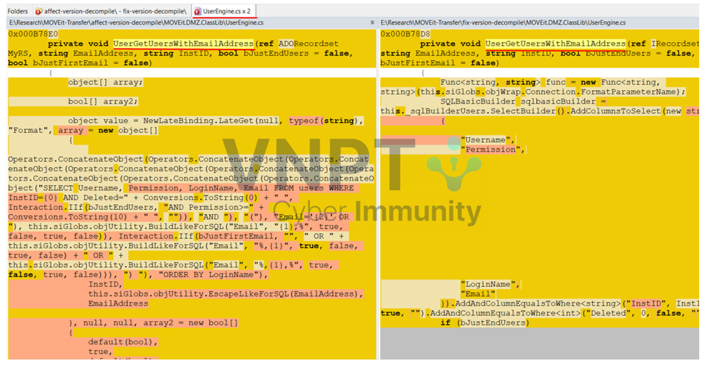

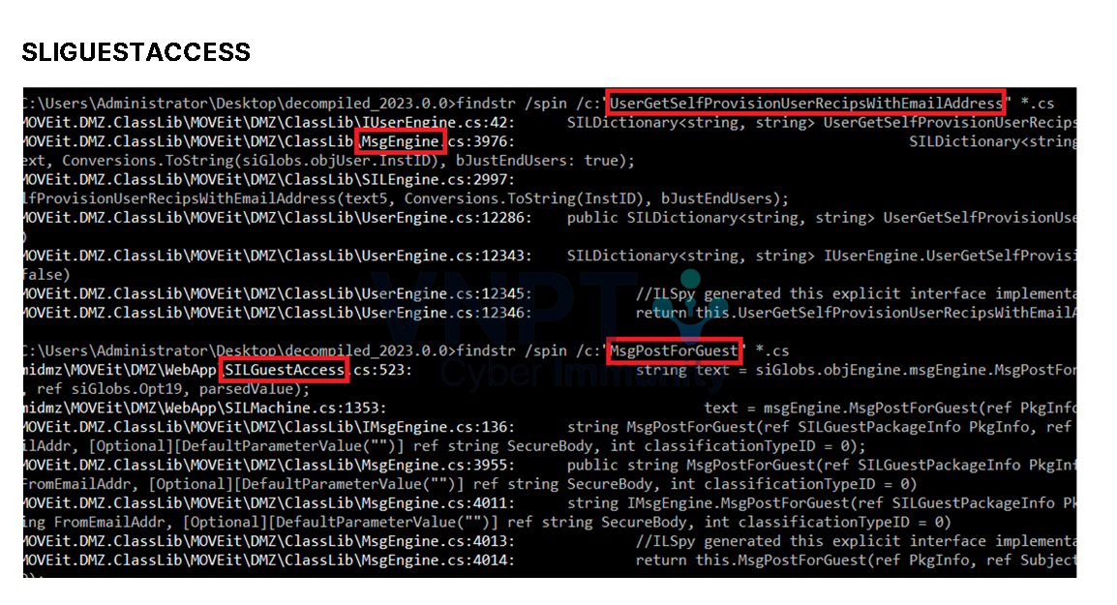

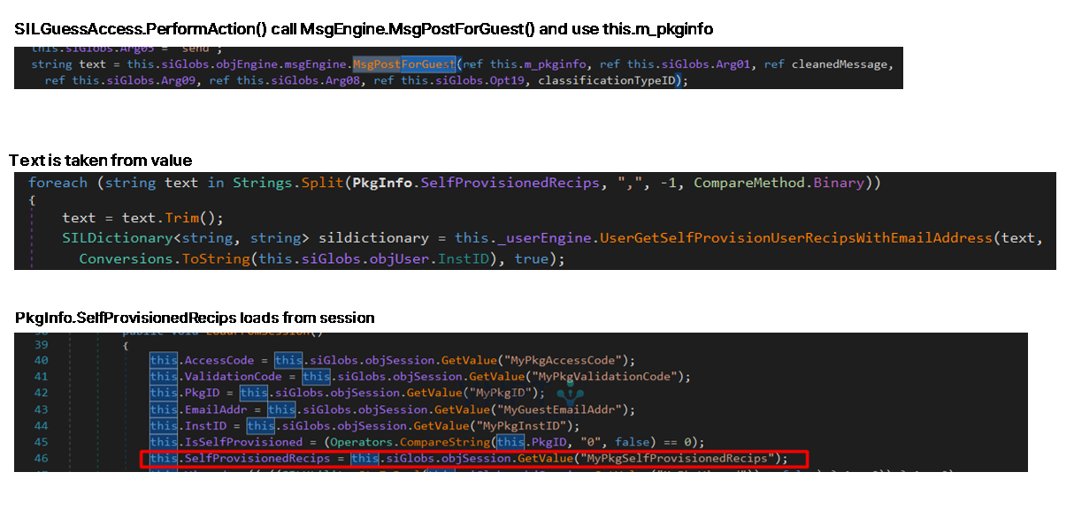

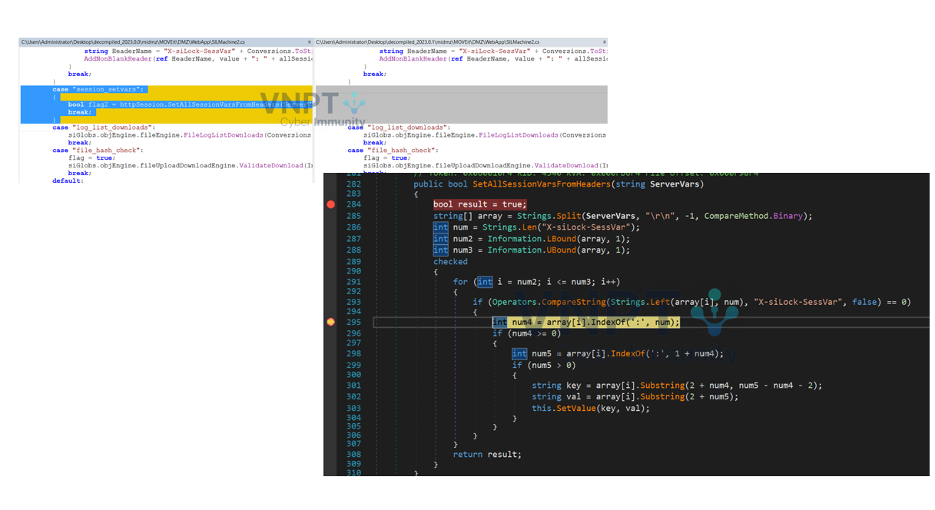

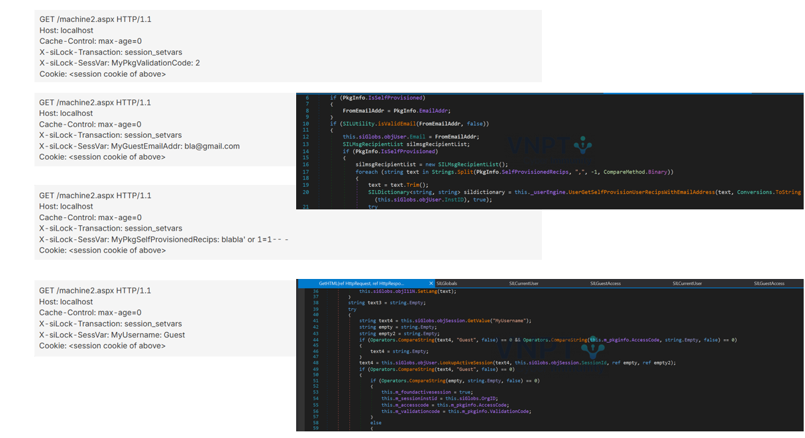

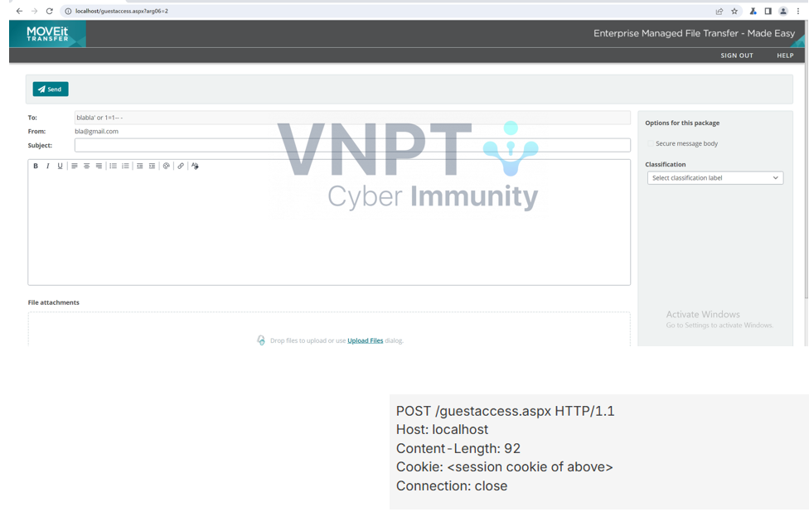

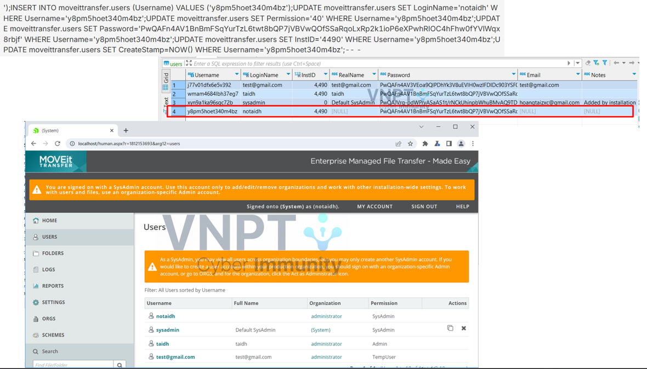

5. Conclusion & Future Work
The MOVEit 2023 incident exemplifies:
- The far-reaching impact of zero-day vulnerabilities in software supply chains.
- The necessity of standardized cybersecurity risk governance.
Key Lessions:
- Web application security must be prioritized throughout the software lifecycle.
- Continuous monitoring and rapid response minimize damage.
- Formalized ISMS management yields long-term effectiveness.
Future Development:
- Expand research into AI-driven threat detection (UEBA, SOAR).
- Apply machine learning for IOC analysis.
- Propose a Zero Trust Architecture (ZTA) framework for MFT systems.

References (Selected):
- https://csrc.nist.gov/pubs/sp/800/40/r4/final?utm
- https://www.censinet.com/perspectives/iso-27001-and-nist-csf-control-mapping-checklist
- https://veza.com/blog/access-control-compliance-guide-2025
- https://csrc.nist.gov/pubs/sp/800/40/r4/final
- https://www.techtarget.com/whatis/definition/Confidentiality-integrity-and-availability-CIA
- https://www.sailpoint.com/identity-library/cia-triad
- https://www.cisa.gov/sites/default/files/2023-06/aa23-158a-stopransomware-cl0p-ransomware-gang-exploits-moveit-vulnerability_5.pdf
- https://www.progress.com/trust-center/moveit-transfer-and-moveit-cloud-vulnerability
- https://www.rapid7.com/blog/post/2023/06/14/etr-cve-2023-34362-moveit-vulnerability-timeline-of-events/
- https://www.cisa.gov/news-events/news/cisa-and-fbi-release-advisory-cl0p-ransomware-gang-exploiting-moveit-vulnerability
- govinfo.gov – US Courts MDL Filing
- https://www.cisa.gov/stopransomware
- https://www.hhs.gov/sites/default/files/critical-vulnerability-moveit- transfer-software-sector-alert.pdf
- https://www.ic3.gov/CSA/2023/230607.pdf
- https://www.cisa.gov/news-events/cybersecurity-advisories/aa23-158a

