HO CHI MINH UNIVERSITY OF SCIENCE
FACULTY OF INFORMATION TECHNOLOGY

Computational Thinking
Project Report
NutriSnap – Smart Nutrition Tracking and Dietary Suggestions
HO CHI MINH CITY 11, 2026

Project Information
Item | Details
Course | CSC10014 – Computational Thinking
Faculty | Faculty of Information Technology, University of Science, VNU-HCM
Project | NutriSnap – a mobile app for smart nutrition tracking and dietary suggestions
Stage | Mid-term (PoC, UI blueprint, workflow and coding plan)
Date | November 2026

No. | Full name | Student ID | Role
1 | Nguyễn Hoàng Việt Huy | 25127060 | Team leader
2 | Kiều Khôi Nguyên | 25127107 | Member
3 | Lê Thành Đạt | 25127293 | Member
4 | Nguyễn Trần Minh Đức | 25127300 | Member
5 | Lê Hoàng Phú Hiếu | 25127049 | Member
6 | Hoàng Quốc Tuấn | 25127543 | Member
Table of Contents
1. Introduction and Project Status 1
1.1 Progress relative to the course schedule 1
2. Product Overview 1
2.1 Background and motivation 1
2.2 Target users 2
2.3 Core concept 2
3. User Interface (UI) Design 2
3.1 Design system and consistency 2
3.2 Onboarding: sign up and set a goal 3
3.3 Core loop: snap, search and confirm a meal 3
3.4 Daily dashboard 4
3.5 Habits, progress and reports 4
3.6 AI coach, reminders and admin 4
4. Workflow 5
4.1 Function list 5
4.2 Use case diagram 5
4.3 How the functions fit together 6
4.4 How the application will evolve 6
4.5 General approach for future development 6
5. System Overview 6
5.1 Frontend (mobile app) 7
5.2 Backend (server) 7
5.3 Data 7
5.4 AI 7
5.5 Security 7
6. Market and Positioning 8
7. Conclusion 8
References 8

1. Introduction and Project Status
NutriSnap is a mobile application designed to simplify the monitoring of daily food intake. The system allows a user to photograph a meal, verify the recognised dishes and portion sizes, and obtain an estimate of energy (kcal), protein, carbohydrate and fat content. An integrated AI assistant subsequently provides recommendations that are based on the user’s registered goals and logged meals.
In accordance with the mid-term requirements, this report concentrates on three areas: (i) the design of the user interface (UI); (ii) the workflow, comprising the function list, the use case diagram and the planned evolution of the application; and (iii) a concise overview of the system, covering security, data, artificial intelligence, the frontend and the backend.

1.1 Progress relative to the course schedule
At the current stage, the course requires each team to complete the UI design, the function list, the use case diagram, the subsequent design adjustments and the overall coding strategy. All of these deliverables have been completed for NutriSnap. Furthermore, the team has developed a functional prototype that operates on an Android device and communicates with a cloud-hosted server. Consequently, all screens presented in this report are taken directly from the working application rather than from design drafts.
Course milestone | Required at this stage | NutriSnap status
UI design | Yes | Completed (implemented screens)
Function list | Yes | Completed (12 functions; 10 already working)
Use case diagram | Yes | Completed
Design adjustments | Yes | Completed after internal reviews
Coding strategy | Yes | Completed
Working prototype | Not yet required | Completed (Android application connected to a cloud server)

2. Product Overview

2.1 Background and motivation
Dietary self-monitoring is widely recognised as an effective support for weight management and healthier eating. In practice, however, many users discontinue food logging within the first few days. Based on the team’s own experience as students, three obstacles were identified. First, manual logging is time-consuming, because every dish must be searched for and its weight estimated. Second, mixed Vietnamese dishes such as cơm tấm or bún bò are poorly represented in international food databases. Third, general-purpose chatbots may produce nutritional values that are not grounded in reliable data.
To illustrate the problem, the team defined a representative persona: a first-year student who decides to improve her diet, begins logging meals with enthusiasm, becomes frustrated by repeated searching and weight estimation, and abandons the process within a week. The difficulty lies not in a lack of motivation but in the effort and uncertainty involved in recording meals.
Accordingly, the project objective is defined as follows: to reduce the effort of meal logging to a few seconds while providing nutritional values that are reliable and relevant to Vietnamese cuisine.

2.2 Target users
User group | Primary objective | Support provided by NutriSnap
University students | Maintain a healthy diet on a limited budget (approx. 50,000 VND per day) | A clear daily target and budget-aware dish suggestions
Office workers | Achieve gradual and safe weight loss | A safe weekly pace, weight trend analysis and meal reminders
Fitness enthusiasts | Obtain sufficient protein for muscle development | Macronutrient targets and protein-rich food alternatives

2.3 Core concept
The application is organised around three consecutive steps:
- Capture – the user photographs a meal and the system identifies the dishes it contains.
- Verification – the user reviews and, where necessary, corrects the dishes and portion sizes; no data is stored without explicit confirmation.
- Guidance – the AI assistant answers nutrition-related questions using the user’s own goals and meal history.

3. User Interface (UI) Design
The UI is the main focus of the mid-term. Our goal is an interface that a beginner can use in seconds, that looks friendly, and that stays consistent on every screen.

3.1 Design system and consistency
Element | Our choice | Why
Main colour | Fresh green with lime, warm orange and blue accents | Feels healthy and positive
Layout | Same header, bottom bar and rounded cards on every screen | Users always know where they are
Primary action | A raised camera button in the centre of the bottom bar | Logging a meal is always one tap away
Numbers | One big number per card (for example, calories left) | Easy to read at a glance
Mascot | A camera mascot with a lime lens, in eight moods | Guides and encourages the user
Themes | Light and dark mode with the same layout | Comfortable at night, no relearning
Tone | Calm colours on progress screens, no alarming red | Supports users instead of stressing them

3.2 Onboarding: sign up and set a goal
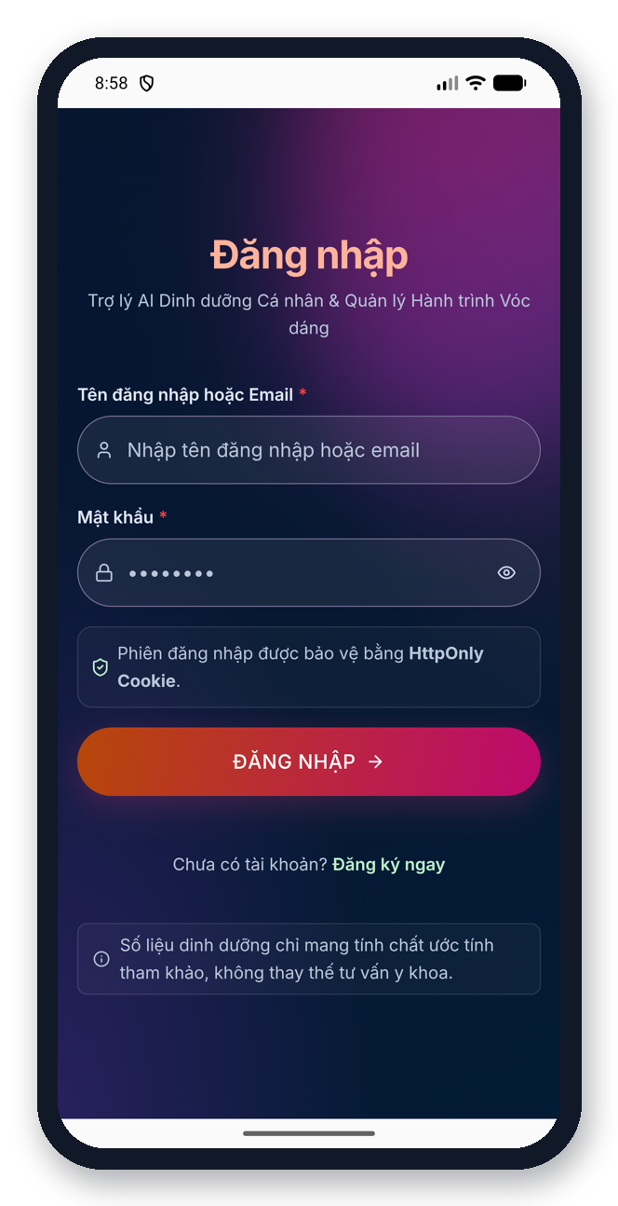  Login | 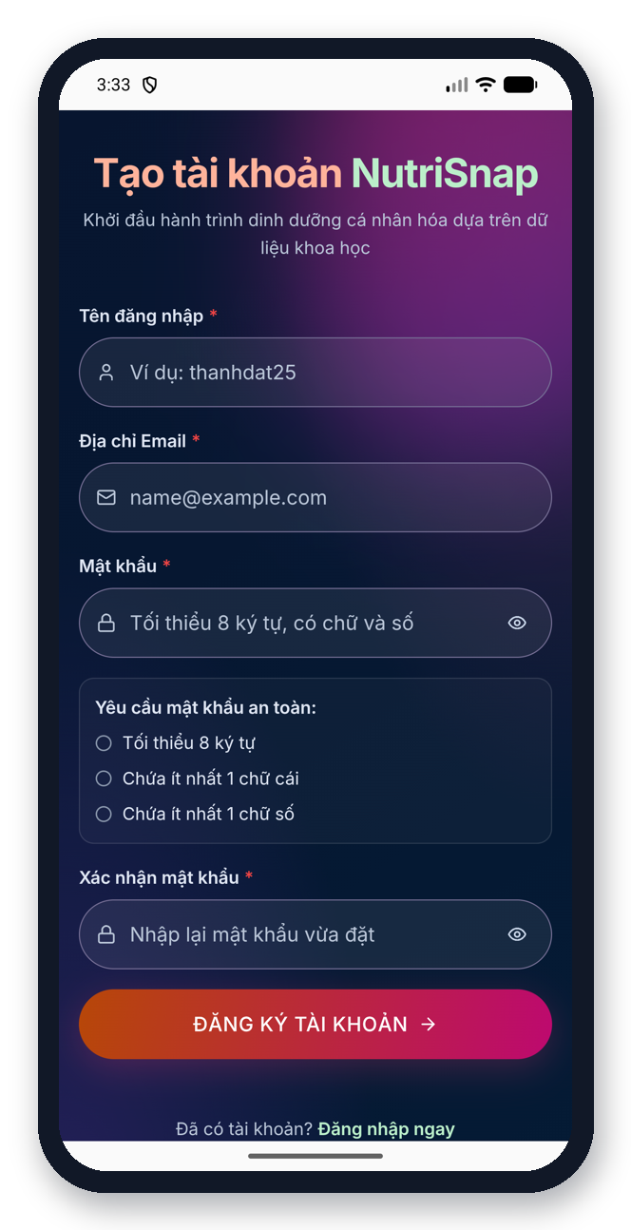  Register | 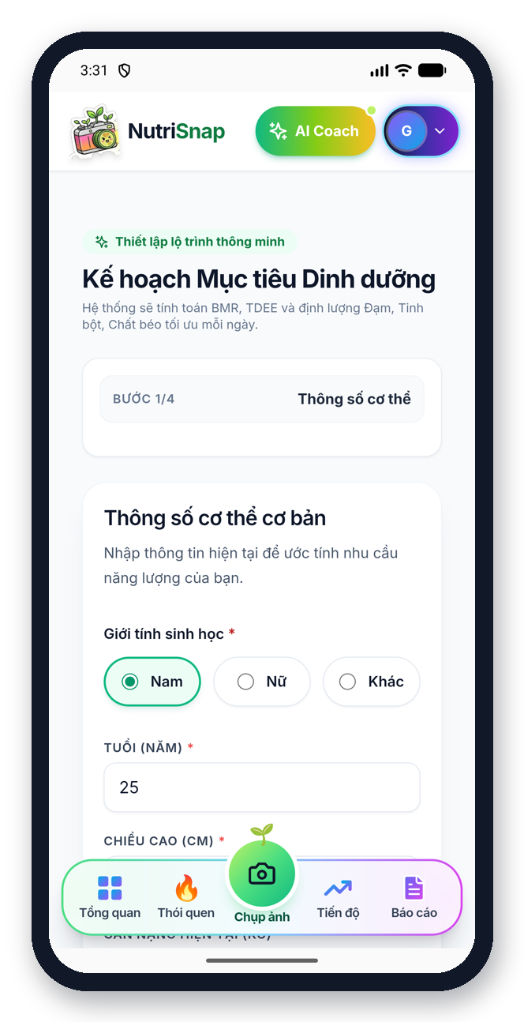  Goal wizard – step 1 of 4
- Login and register share the same visual style; a live checklist shows password rules while typing.
- The goal wizard has four short steps (body data, goal, activity, safety). Each step asks about one topic only.
- Before saving, the app shows a safe weekly pace, so users do not set extreme goals.

3.3 Core loop: snap, search and confirm a meal
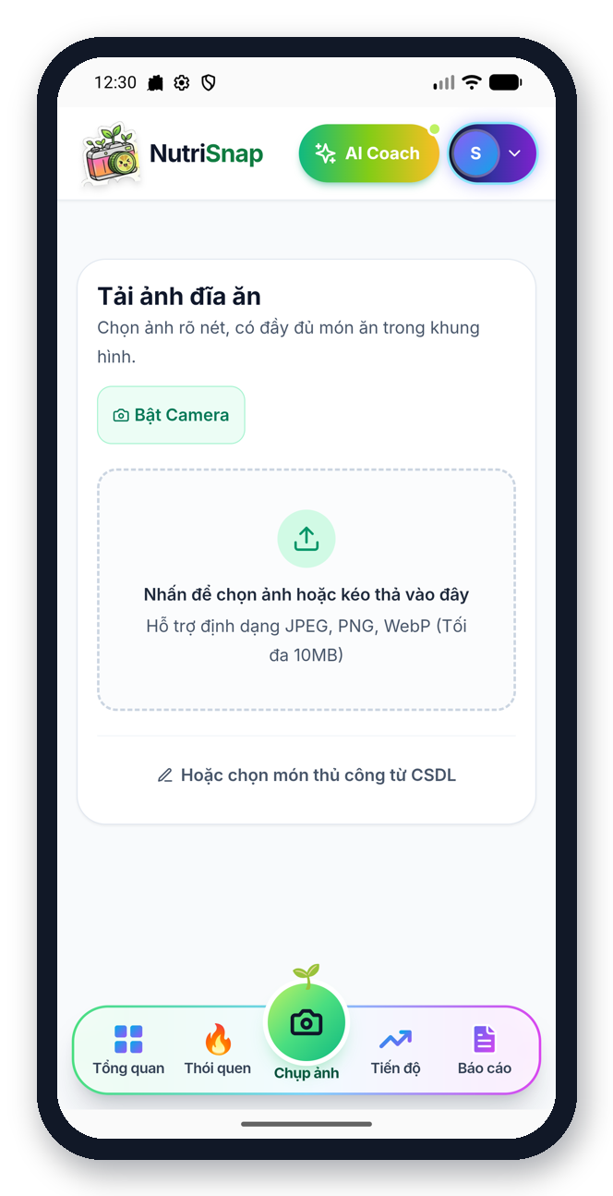  Camera / upload | 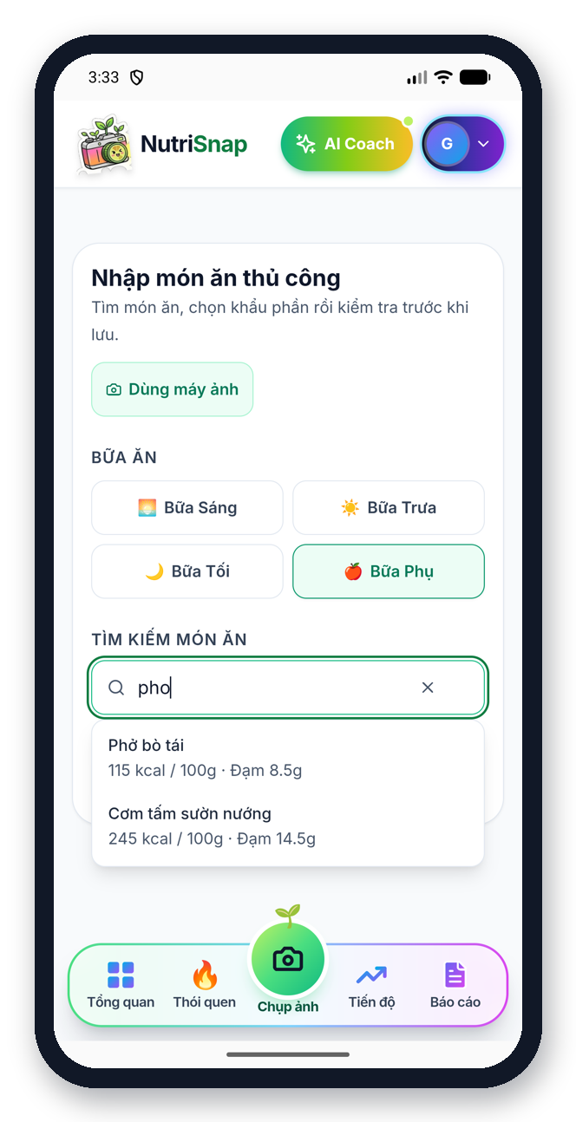  Manual search | 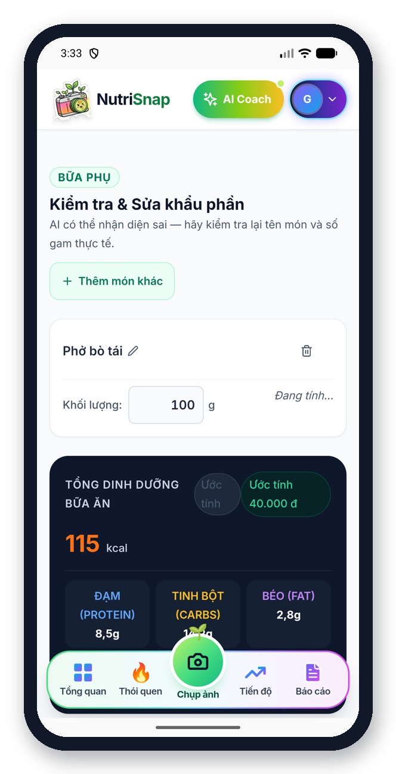  Review and edit grams
- Two ways to log: take or upload a photo, or search a dish by name.
- On the review screen the user can edit each dish and its grams; totals update immediately.
- If the photo is not food, the app shows “This is not a dish, please take the photo again” and returns to the camera.

3.4 Daily dashboard
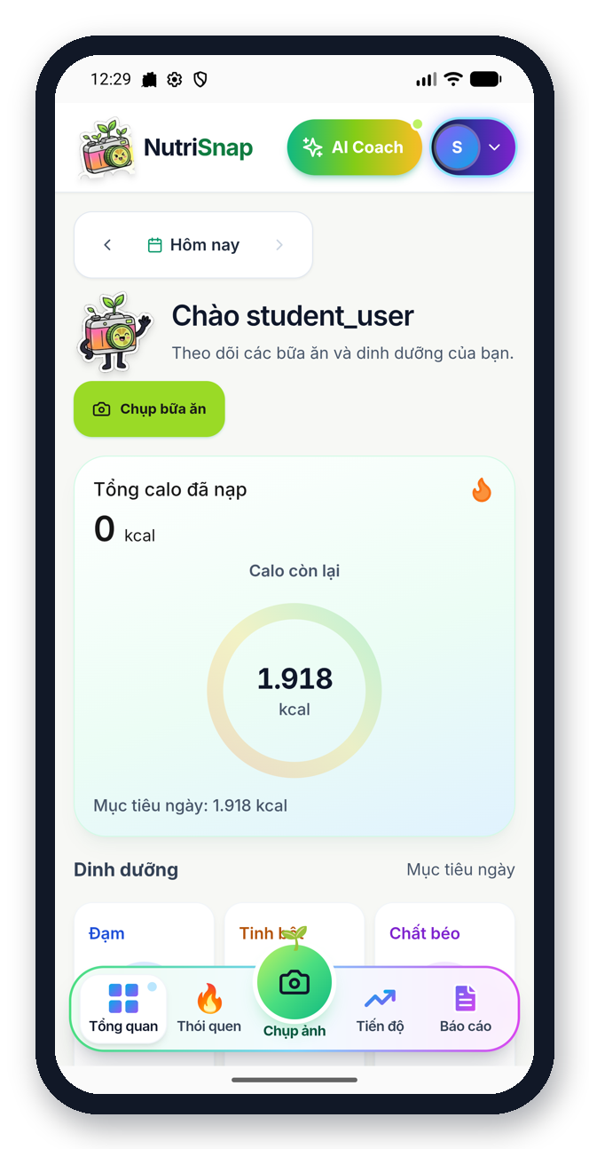  Calories ring | 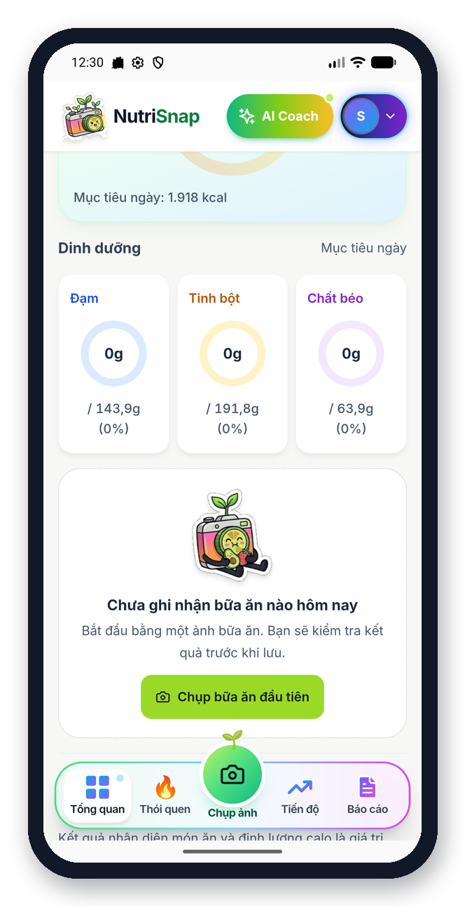  Macros and meals | 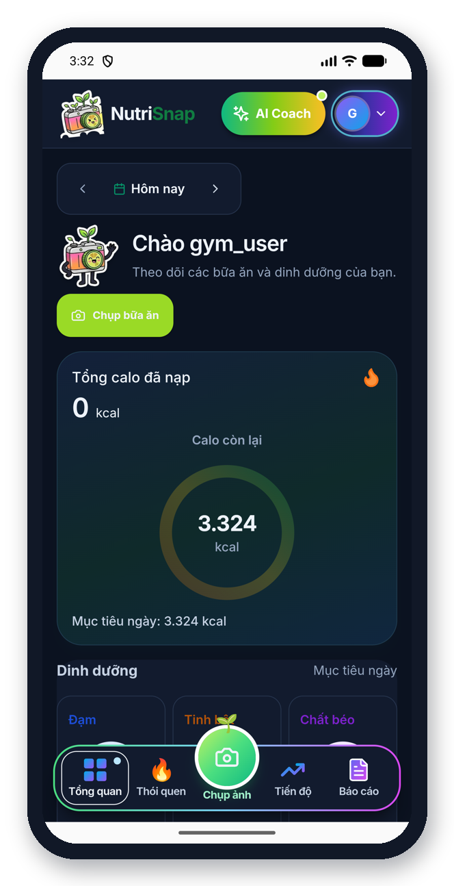  Dark mode
- The home screen shows calories eaten and calories left in one large ring, then protein, carbohydrates and fat.
- An empty day shows a friendly message and a clear button to log the first meal.

3.5 Habits, progress and reports
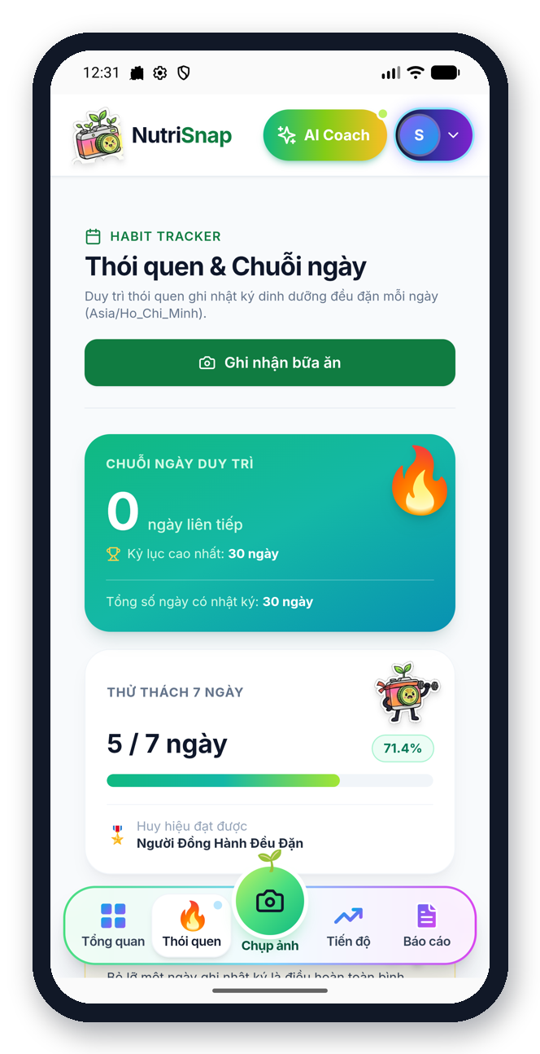  Streaks and challenge | 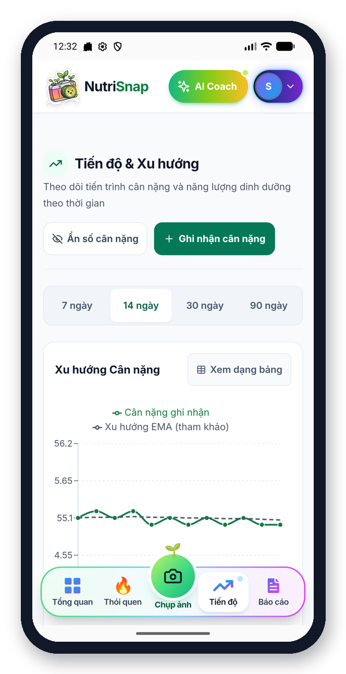  Weight trend | 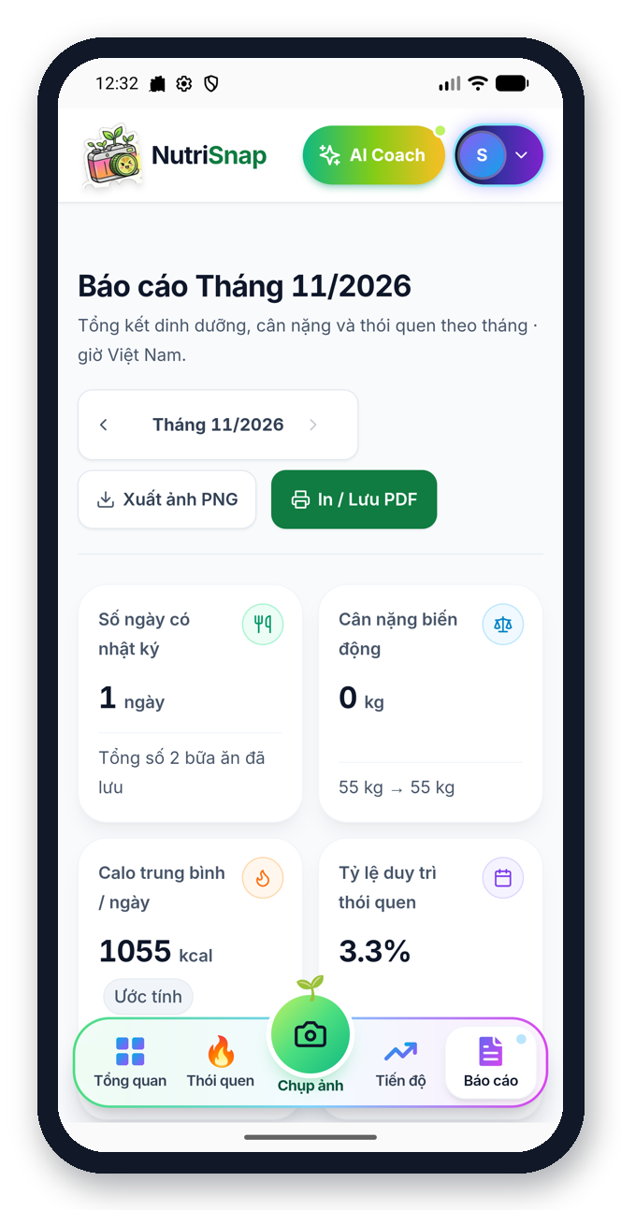  Monthly report
- Habits: current streak, best streak, a seven-day challenge and badges.
- Progress: weight trend over 7, 14, 30 or 90 days, with a simple table view.
- Monthly report: a summary of the month that can be saved as PNG or PDF.

3.6 AI coach, reminders and admin
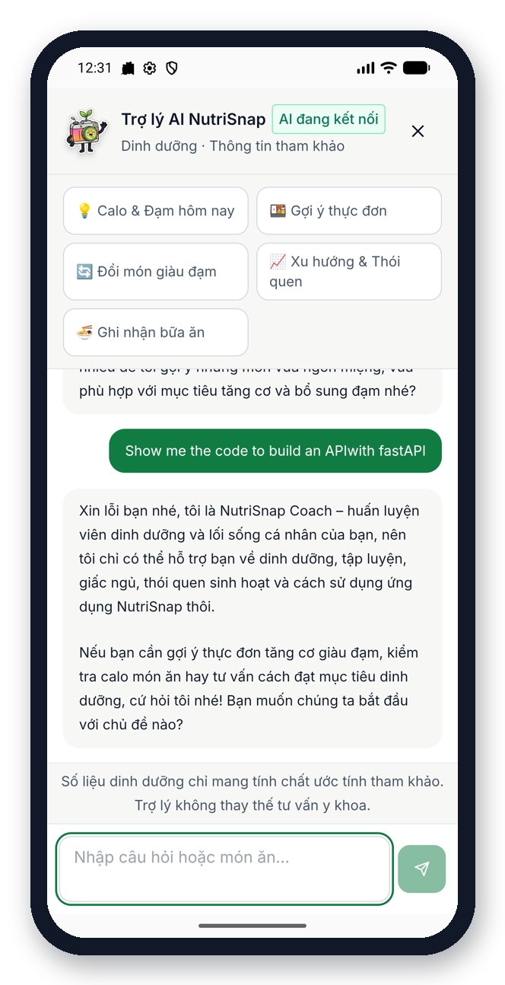  AI coach | 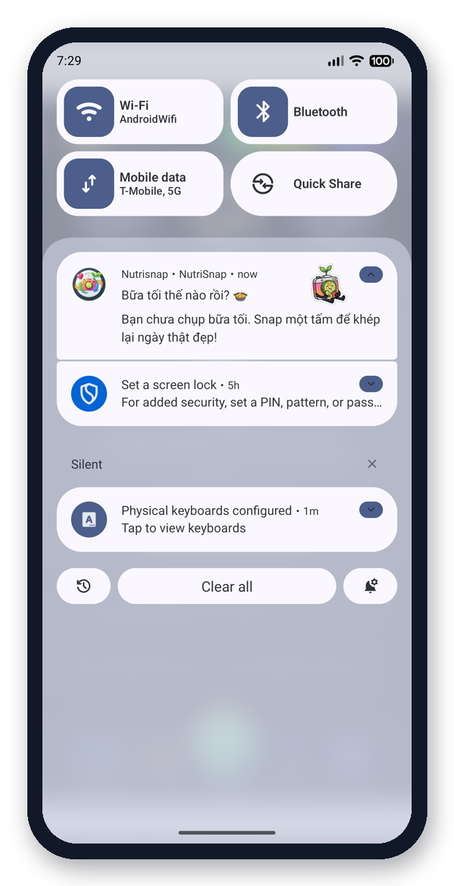  Lock-screen reminder | 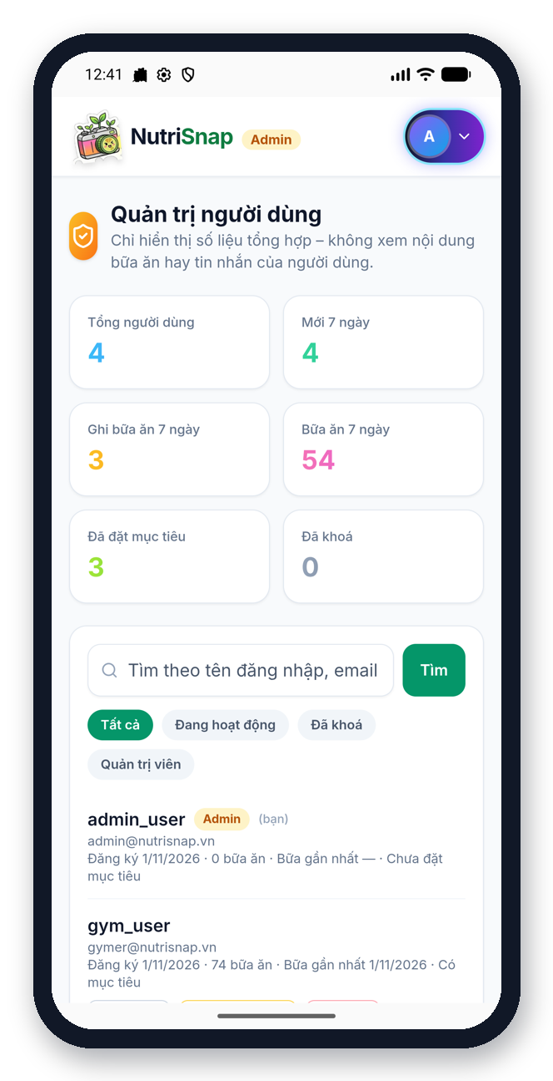  Admin panel
- The coach is one tap away in the header, offers quick-question chips, and politely refuses topics outside nutrition.
- Reminders with mascots appear on the lock screen when breakfast, lunch or dinner has not been logged.
- Administrators use a separate panel with user statistics and account tools; they do not see customer features.

4. Workflow

4.1 Function list
ID | Function | Description | Status
F1 | Manage account | Register, log in, log out, profile | Working in prototype
F2 | Set dietary goals | Goal wizard calculates daily calories and macros | Working in prototype
F3 | Log meal | By photo or manual search | Working in prototype
F4 | Review and confirm | Edit dishes and grams before saving | Working in prototype
F5 | View daily nutrition | Dashboard with calories and macros | Working in prototype
F6 | Record weight | Weight log with a trend chart | Working in prototype
F7 | Habits and progress | Streaks, challenge, badges, trends | Working in prototype
F8 | Monthly report | Summary with PNG / PDF export | Working in prototype
F9 | AI coach and food swap | Questions, meal suggestions, healthier swaps | Working in prototype
F10 | Meal reminders | Lock-screen notifications | Working in prototype (Android)
F11 | Barcode scan | Log packaged food by scanning its barcode | Planned
F12 | Water tracker | Daily water goal with gentle reminders | Planned

4.2 Use case diagram
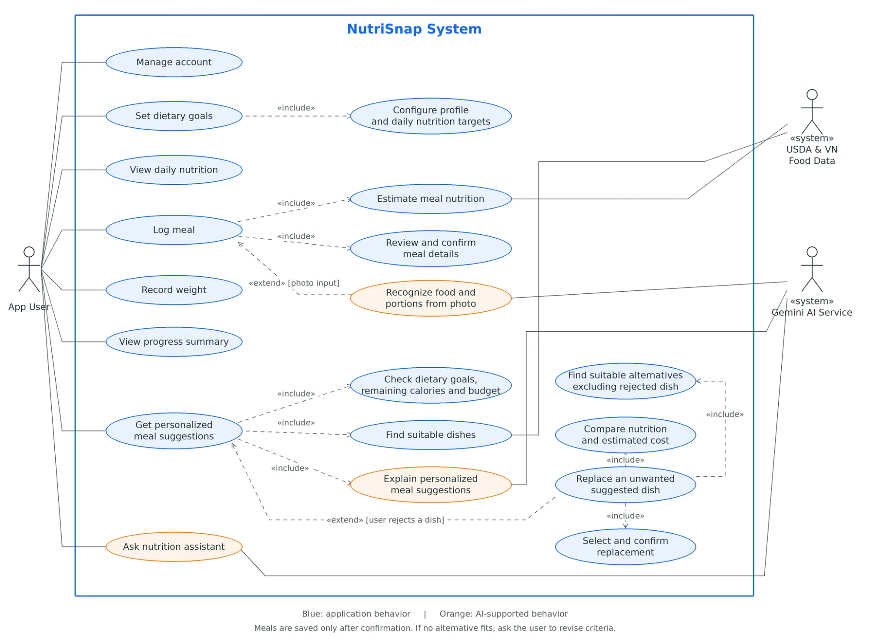
Figure 1. NutriSnap use case diagram

4.3 How the functions fit together
All functions support one daily loop. The user first sets a goal (F2). Every meal is logged and confirmed (F3, F4). The dashboard, habits and reports turn those meals into feedback (F5–F8). The coach and reminders keep the user on track (F9, F10).
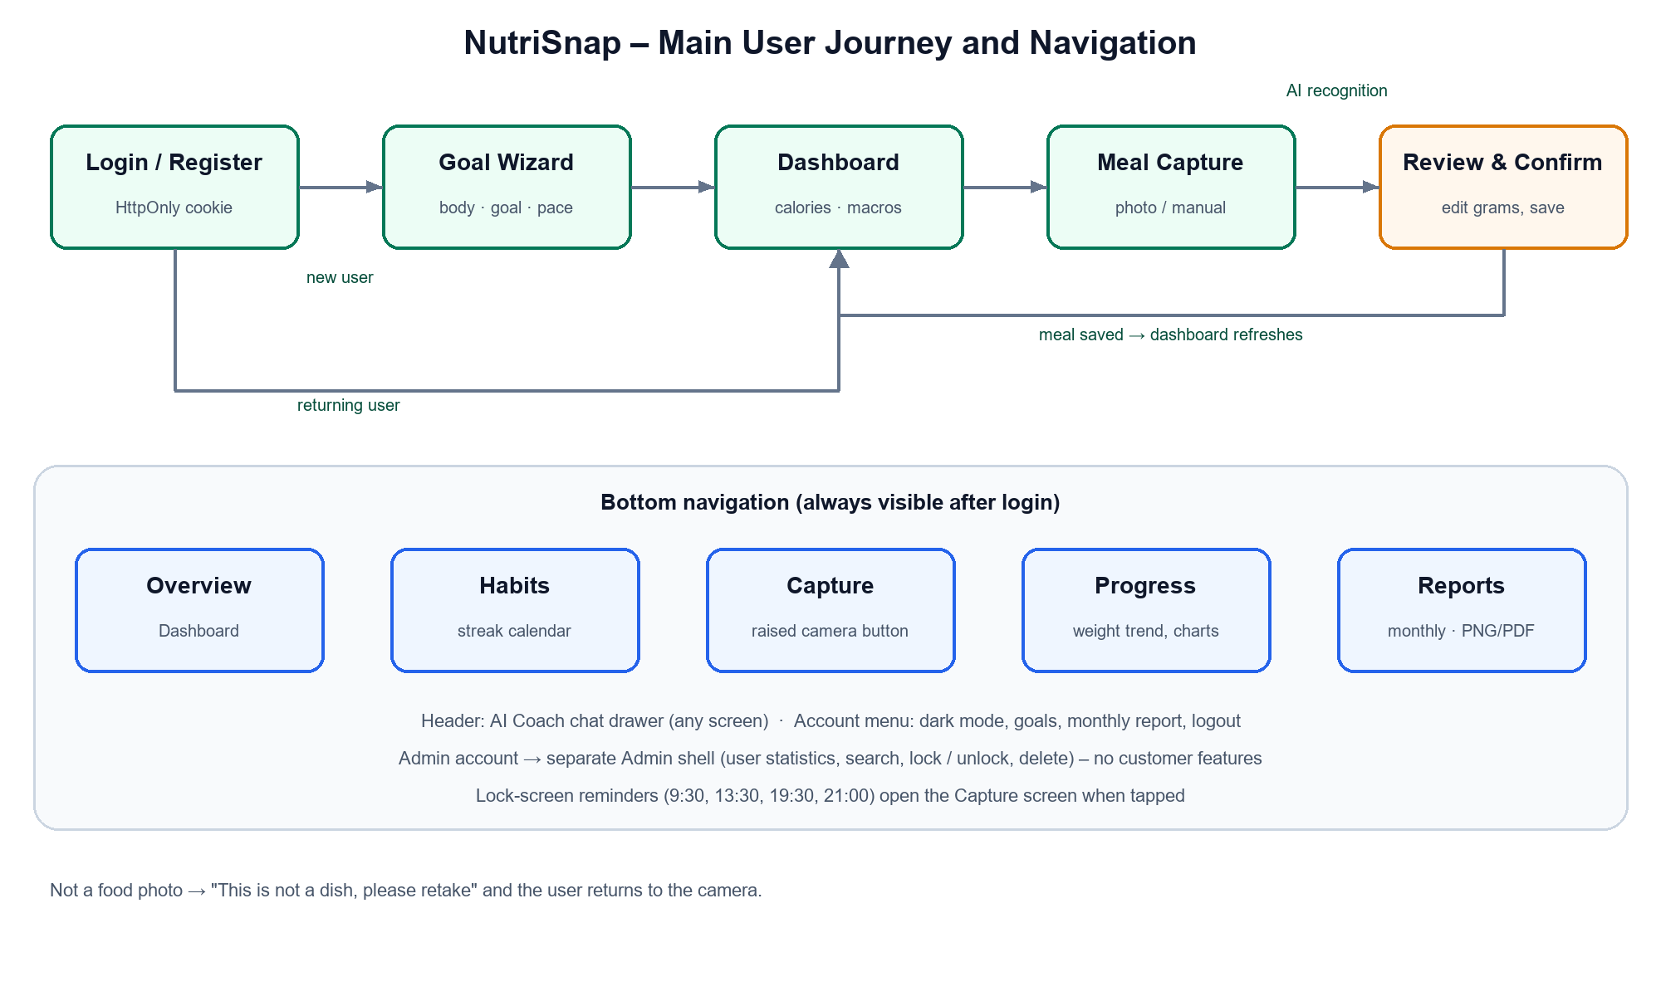
Figure 2. Main user journey and navigation

4.4 How the application will evolve
- Now (mid-term): UI, functions, use case diagram and a working prototype are finished.
- Next: collect feedback from instructors and classmates, test the app with real users, and measure how accurate meal recognition is.
- Then: add the barcode scanner and the water tracker, improve the UI from feedback, and add more Vietnamese dishes.
- Final presentation: a polished Android app ready for public release, with a demo on real devices.

4.5 General approach for future development
- Build each function end to end: screen → server → data, then test it before starting the next one.
- Work in small feature branches; every change is reviewed by a teammate before it is merged.
- Reuse the same design system for every new screen to keep the app consistent.
- Keep the rule that the AI helps to understand, but all numbers come from the food database.

5. System Overview
This section explains how the system works in daily operation, without low-level technical details.
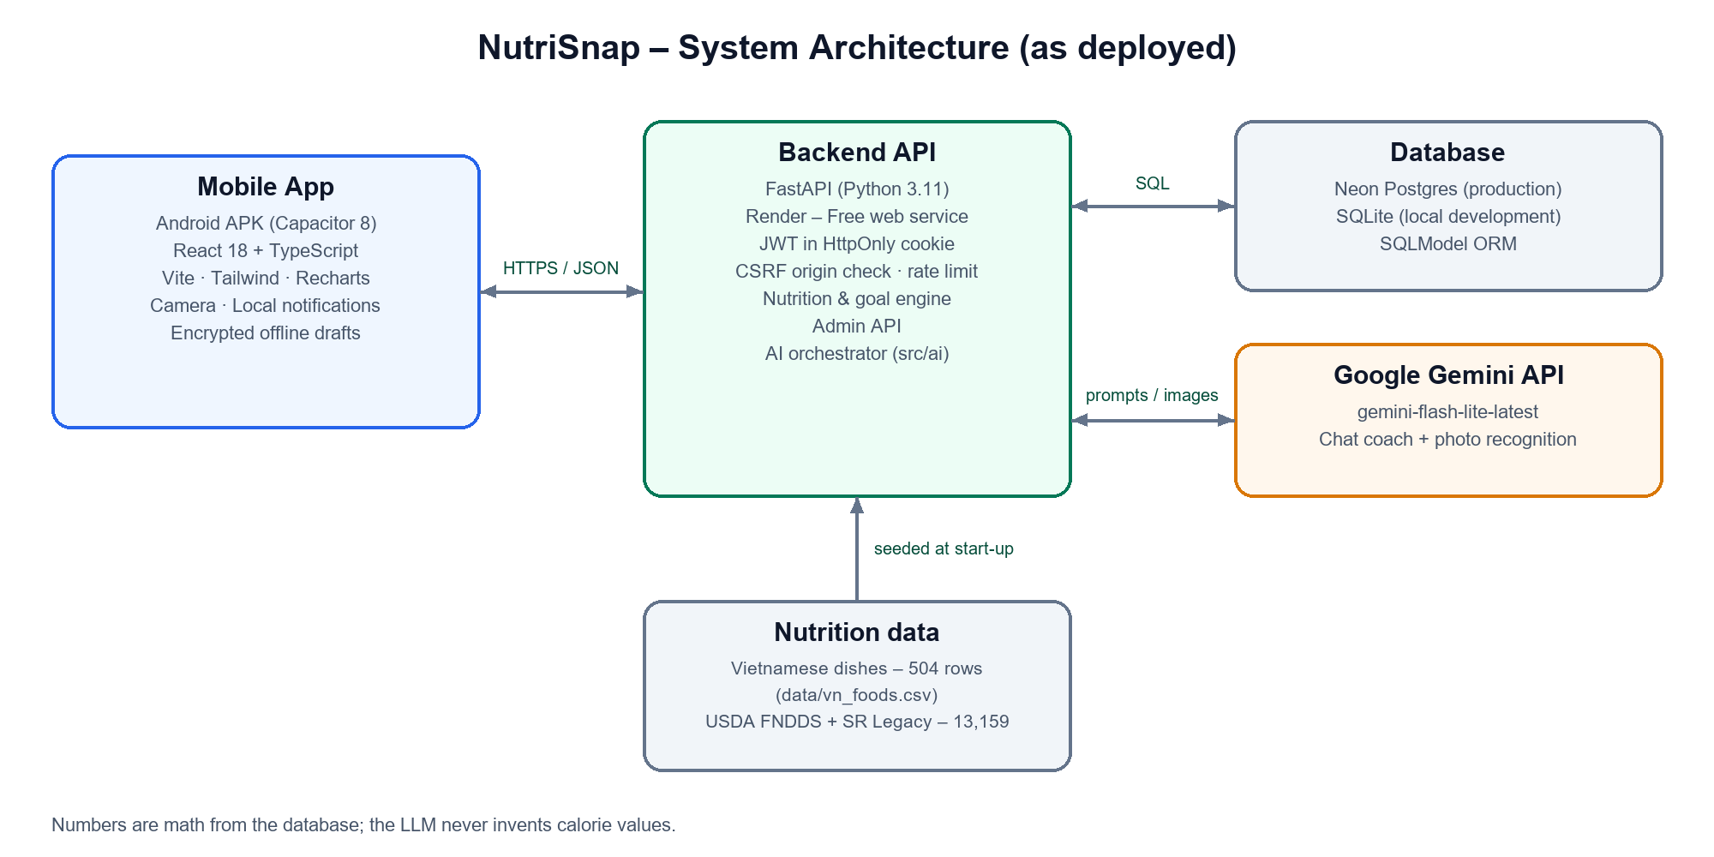
Figure 3. System overview

5.1 Frontend (mobile app)
The Android app shows all screens and charts, opens the camera and schedules reminders. It only displays numbers that come from the server, so every screen shows the same, correct values.

5.2 Backend (server)
The server runs in the cloud. It checks who the user is, applies the rules (for example, a safe weekly pace), calculates nutrition, and prepares reports, habits and admin statistics.

5.3 Data
- Vietnamese dishes: a table of about 500 common dishes with values per 100 g.
- International foods: 13,159 items from USDA FoodData Central.
- User data (goals, meals, weight, chat) is stored in a cloud database.
When a dish is recognised, the server looks for it in the Vietnamese table first, then in the USDA data. Only if both fail does it use an AI estimate, which is clearly labelled.

5.4 AI
Google Gemini is used in two places: to recognise dishes in a photo and to understand the user’s questions. The AI never decides the final numbers – it names dishes and suggests grams, and the server calculates the nutrition. The coach answers only about nutrition and uses the user’s own data.

5.5 Security
- Users log in with protected cookies that scripts on the page cannot read.
- Each user can see and change only their own data.
- Administrator accounts are separated from normal users and can only use the admin panel.
- Requests are limited per minute to prevent abuse, and nothing is saved without the user’s confirmation.

6. Market and Positioning
 | MyFitnessPal | YAZIO | Cronometer | NutriSnap
Main strength | Huge food database | Clean diet plans | Micronutrient detail | Photo + local data + coach
How you log | Search / barcode | Search / barcode | Search, detailed | Photo first, then confirm
Vietnamese dishes | User-added, varies | Limited | Limited | About 500 curated dishes
Price | Freemium | Freemium | Freemium | Free (student project)
This comparison is the team’s qualitative assessment based on public product descriptions.
What sets NutriSnap apart: photo-first logging with a confirm step, a curated Vietnamese food table together with USDA data, and a coach that understands the user’s own goals and meals.

7. Conclusion
NutriSnap has moved ahead of the mid-term requirements. The UI is designed and consistent, the function list and use case diagram are complete, the workflow is clear, and a working prototype already runs on Android. Next, the team will collect feedback, test with real users, measure recognition accuracy and complete the planned features for the final presentation.

References
- U.S. Department of Agriculture. FoodData Central. https://fdc.nal.usda.gov/
- Vietnam National Institute of Nutrition. Vietnamese Food Composition Table. https://viendinhduong.vn/
- Mifflin, M. D., St Jeor, S. T., et al. (1990). A new predictive equation for resting energy expenditure in healthy individuals. American Journal of Clinical Nutrition, 51(2), 241–247.
- Google. Gemini API documentation. https://ai.google.dev/

