
NATIONAL UNIVERSITY OF HO CHI MINH CITY INTERNATIONAL UNIVERSITY

STATISTICAL LEARNING-LAB

Student Name: Nguyễn Viết Huy – ITDSIU24021
Date of Birth: 17/03/2006
Department: Data Science

Lecturer: Le Quoc Huy
Ho Chi Minh, 2026

IT171IU Lab 1 Report

Statistical Learning & Introduction to Python
Student: Nguyễn Viết Huy Student ID: ITDSIU24021
Class/Group: Not provided in the conversation - replace this before final submission.

Submission package status
This report follows Section 6 of the supplied handout: notebook + report + README, with a figures folder. The only item that still requires the student's live environment is the Google Colab Task 0 screenshot, which is explicitly marked as a placeholder. The notebook should also be run from top to bottom in Colab before final submission because Exercises 3-6 require the ISLP data resources.

Task 0 - Environment check
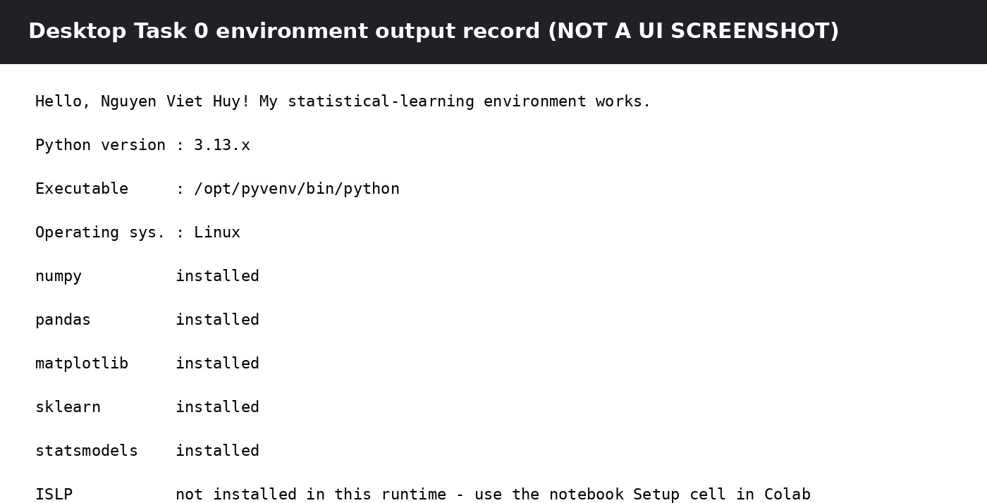

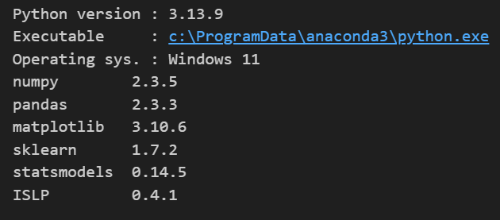

Exercise 1 - NumPy warm-up

M | [[2,4,6,8,10],[12,14,16,18,20],[22,24,26,28,30],[32,34,36,38,40]]
Shape / ndim / dtype | (4, 5) / 2 / int64
Second row | [12, 14, 16, 18, 20]
Last column | [10, 20, 30, 40]
Rows 2-3, cols 1-3 | [[12,14,16],[22,24,26]]
Row means | [6, 16, 26, 36]
Column std (population) | [11.1803, 11.1803, 11.1803, 11.1803, 11.1803]
Interpretation: a slice such as M[:2, :2] is a view, so changing it also changes M. Using .copy() creates an independent array, so the original M is unchanged.
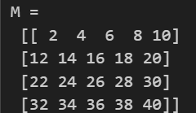

Exercise 2 - Random numbers, correlation and saved figure
Using rng = np.random.default_rng(2026), the sample correlation is 0.982033. Re-running with the fixed seed reproduces the same random values; removing the seed makes the values and correlation vary.
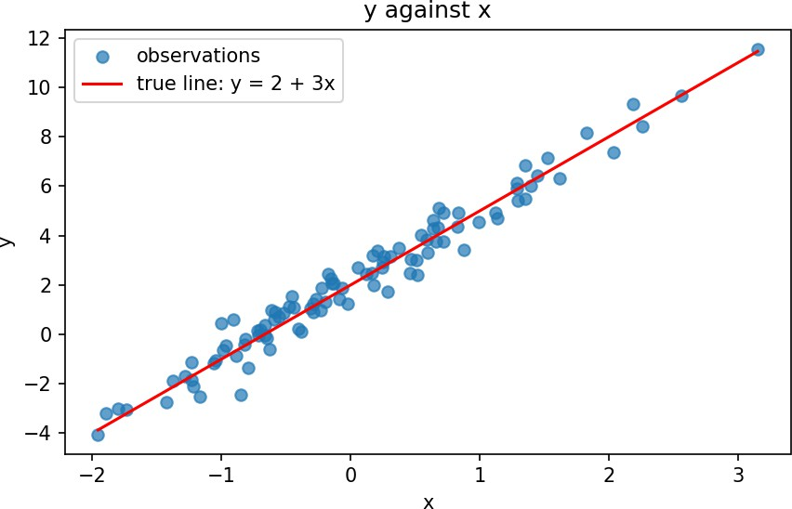

Exercise 3 - Cleaning the Auto data
The supplied ISLP Auto data has 397 raw observations, with 5 rows containing missing horsepower values; dropping those rows leaves 392 observations. Quantitative variables are mpg, cylinders, displacement, horsepower, weight, acceleration and year. Qualitative variables are origin and name. Origin is mapped to America / Europe / Japan.

Variable | Min | Max | Mean | SD
mpg | 9.0 | 46.6 | 23.445918 | 7.805007
cylinders | 3 | 8 | 5.471939 | 1.705783
displacement | 68 | 455 | 194.411990 | 104.644004
horsepower | 46 | 230 | 104.469388 | 38.491160
weight | 1613 | 5140 | 2977.584184 | 849.402560
acceleration | 8.0 | 24.8 | 15.541327 | 2.758864
year | 70 | 82 | 75.979592 | 3.683737
Source note: these figures match the documented ISLP Auto dataset summary (392 cleaned observations).

Exercise 4 - Subsetting rows with iloc[]

Variable | Range | Mean | SD
mpg | 35.6 | 24.374763 | 7.872565
cylinders | 5 | 5.381703 | 1.658135
displacement | 387.0 | 187.880126 | 100.169973
horsepower | 184 | 101.003155 | 36.003208
weight | 3348 | 2938.854890 | 811.640668
acceleration | 16.3 | 15.704101 | 2.719913
year | 12 | 77.123028 | 3.127158
Interpretation: removing observations 10-85 changes the sample composition and therefore shifts several means and standard deviations. In particular, the remaining data have a higher mean MPG and later model year on average.

Exercise 5 - Graphical exploration
Three findings: (1) MPG decreases as weight, horsepower and displacement increase; (2) MPG differs across origins and cylinder counts; (3) several predictor relationships show curvature, so a perfectly linear relationship is not adequate for every pair. These variables therefore look useful for predicting MPG, especially weight, horsepower, displacement, cylinders and origin.

Exercise 6 - College data set
The College data set contains 777 colleges and 18 original variables. There are 565 private colleges and 212 public colleges. Defining Elite = Yes when Top10perc > 50 gives 78 elite colleges and 699 non-elite colleges.

Selected item | Result
Rows x original variables | 777 x 18
Private = Yes | 565
Private = No | 212
Elite = Yes (Top10perc > 50) | 78
Elite = No | 699
Histogram summary: Applications (Apps) is strongly right-skewed; Top10perc is also right-skewed; Outstate shows a broad tuition distribution; Grad.Rate is concentrated around the middle/high range and contains some values above 100 in the original data.
The notebook includes the required box plots of Outstate versus Private and Elite, and a 2 x 2 histogram grid. Run these cells in Colab so the plots are generated from the ISLP College dataset.

Exercise 7 - Loops and string formatting
The solution uses a for-loop over the seven quantitative Auto variables and prints mean, sample standard deviation and above-mean share with the requested f-string field widths and formatting.

Exercise 8 - Bias and variance simulation (bonus)
At x0 = 1, the simulation gives the following estimated (Bias^2, Variance): d=1 (1.164601, 0.012882), d=3 (0.444027, 0.025758), d=5 (0.007140, 0.014458), d=10 (0.000048, 0.023726), d=15 (0.000180,
0.033119). The general pattern illustrates decreasing bias with more flexible polynomials and increased variance at higher degrees.
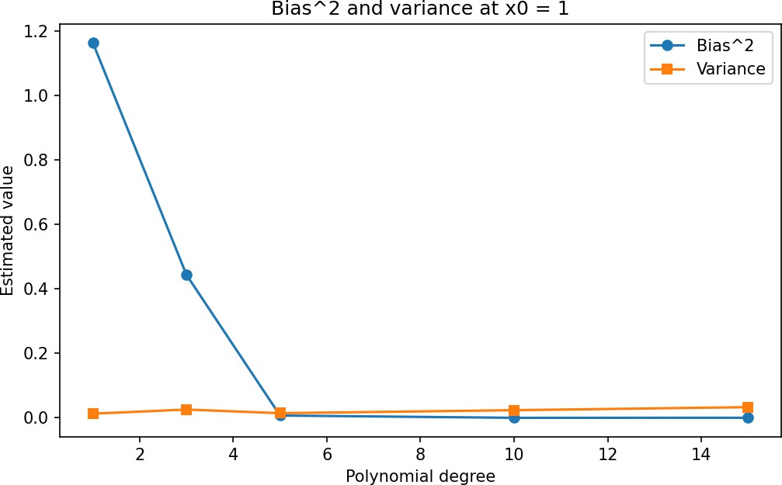

Exercise 9 - Choosing K for KNN (bonus)
For the exact random simulation in the notebook, the minimum test error occurs at K = 90, with test error 0.126. The training error is lowest for very small K, while the test error is more stable because larger K smooths the decision boundary.
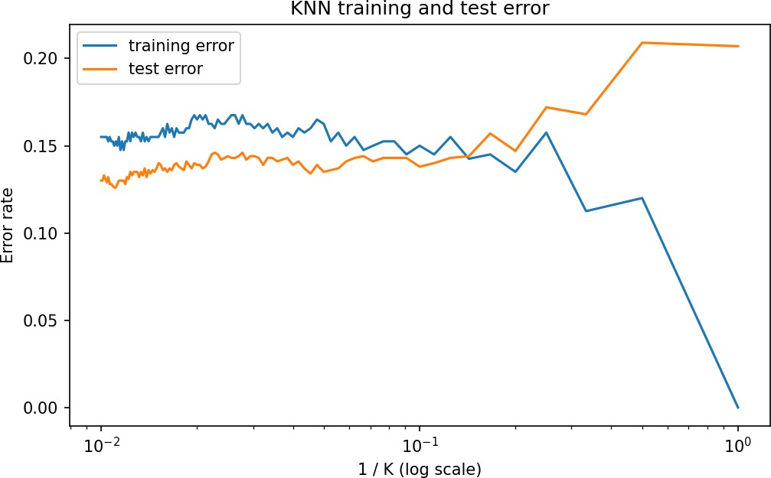

Section 6 checklist

Required file/item | Status
Completed notebook with all ✍ cells filled | Prepared; final Colab Run All still required
IT171IU_Lab01_Report.pdf | Included
README.md | Included
Task 0 desktop screenshot | Included
Task 0 Google Colab screenshot | Placeholder - must be replaced by student
One GitHub/Drive submission link | Must be created by student
Data references used for the key numerical checks: ISLP Auto dataset documentation and standard College dataset summary/solutions. The notebook itself retains the handout's original setup instructions for obtaining the datasets.

