LAB 3 REPORT

Classification
Logistic Regression · LDA/QDA · Naive Bayes · KNN · ROC/AUC · Poisson Regression

Student information | Details
Full name | Nguyễn Viết Huy
Student ID | ITDSIU24021
Course | IT171IU – Statistical Learning
Class/group | Lab Group 1
Notebook | IT171IU_Lab03_NguyenVietHuy_ITDSIU24021.ipynb

Purpose and approach
This lab compares probabilistic and generative classification methods, nearest-neighbour classification, threshold-based evaluation, ROC/AUC, and Poisson regression for counts. The notebook follows the assigned datasets and split definitions and prints the confusion matrices and numeric metrics at execution time.

Completion and verification status
- Solution code is filled for Exercises 1–8, including the two optional challenge exercises. Written interpretations are included after the exercises and in the three checkpoint sections.
- All Python code cells were syntax-checked. The breast-cancer and wine exercises were independently executed using the scikit-learn fallback datasets already available in the notebook.
- A full top-to-bottom run could not be performed in the offline authoring runtime because `ISLP` is missing and package downloads are blocked. The `Weekly`, `Auto`, `Default`, `Caravan`, and `Bikeshare` cells must be run in Colab before submission; the notebook’s output is the authoritative source for those numeric results.

Main interpretation reminders
- Training accuracy is usually optimistic because the same observations were used to fit and evaluate the model. Use a held-out test set for an honest estimate.
- For imbalanced classification, accuracy alone can be misleading. Sensitivity, specificity, confusion matrices, and ROC/AUC provide additional information.
- Standardise numeric predictors before KNN because Euclidean distance is affected by scale.

Exercises 1–4: conclusions and how to read the outputs

Exercise 1 – Weekly stock-market data
The code prints descriptive statistics and the numeric correlation matrix, plots `Volume` against `Year`, fits logistic regression using `Lag1`–`Lag5` and `Volume`, and displays a confusion matrix. In the standard Weekly data, `Lag2` is the predictor that is typically significant at the 5% level; check its p-value in the actual run. The confusion matrix is presented with predicted labels in rows and actual labels in columns, so diagonal cells are correct predictions and off-diagonal cells are mistakes.

Exercise 2 – test performance on Weekly
The training period is 1990–2008 and the test period is 2009–2010; `Lag2` is the sole predictor. The notebook prints confusion matrices and accuracy/error rates for logistic regression, LDA, QDA, naive Bayes, and KNN with K=1. It also explores K=1–25. Because the K sweep is ranked on the same test period, that exploratory “best K” should not be described as an independent unbiased estimate.

Exercise 3 – high versus low MPG
The target is `mpg01 = 1` when MPG is above the dataset median. The box plots compare cylinders, displacement, horsepower, and weight by MPG class. In general, weight, horsepower, displacement, and cylinders separate the classes: higher-MPG cars tend to be lighter and lower-powered. The result table prints test error for LDA, QDA, logistic regression, naive Bayes and several standardised KNN models; use the sorted table to identify the lowest error on the specified split.

Exercise 4 – Default validation set
The code compares logistic models with `income + balance` and `income + balance + student` over three random validation splits. Changes in validation error should be compared with split-to-split variation. Exponentiating the student coefficient gives the student/non-student odds ratio while holding income and balance fixed. An adjusted, conditional relationship may differ from the overall default rate because student status is associated with balance; students can have a lower conditional probability at the same balance while a higher marginal rate if their balances are higher on average.
Numeric results for Exercises 1–4 are generated by the completed notebook when run in an environment with `ISLP`; they are not fabricated in this report because the required package was unavailable locally.

Before submitting
- Open the notebook in Google Colab and select Runtime → Run all.
- Confirm the ISLP installation and all ISLP-dependent datasets load successfully.
- Review actual model output for Exercises 1–4 and 6–7; save the notebook with outputs visible.
- Keep this report and README in the submission folder and submit one share link as instructed by the course.
AI assistance note: AI assistance was used to draft/debug code and written explanations. The student should review the complete work and disclose assistance according to the instructor’s policy.

Exercise 5 – breast-cancer diagnosis
The fallback data contain 569 observations, of which 37.3% are malignant. The split is 70/30, stratified by diagnosis, with `random_state=1`. Here 1 means malignant and 0 means benign; the confusion matrices below use actual classes in rows and predicted classes in columns.

Test confusion matrices at threshold 0.5
Model | Confusion matrix [[actual benign → predicted benign, predicted malignant], [actual malignant → predicted benign, predicted malignant]] | Accuracy
Logistic regression | [[106, 1], [6, 58]] | 95.9%
LDA | [[105, 2], [11, 53]] | 92.4%

High-sensitivity threshold analysis
A threshold was selected from five-fold out-of-fold training probabilities, targeting 100% sensitivity in those training predictions, then evaluated on the untouched test split. This yields a threshold of approximately 0.004832. On the test split, sensitivity is 98.44% and specificity is 70.09%. The resulting test confusion matrix is: TN=75, FP=32, FN=1, TP=63. This highlights the expected trade-off: the lower threshold catches more malignant tumours, but increases false positives.
Metric | Logistic regression | LDA
Test AUC | 0.9877 | 0.9841
AUC interpretation | Excellent class ranking on this split | Excellent class ranking on this split

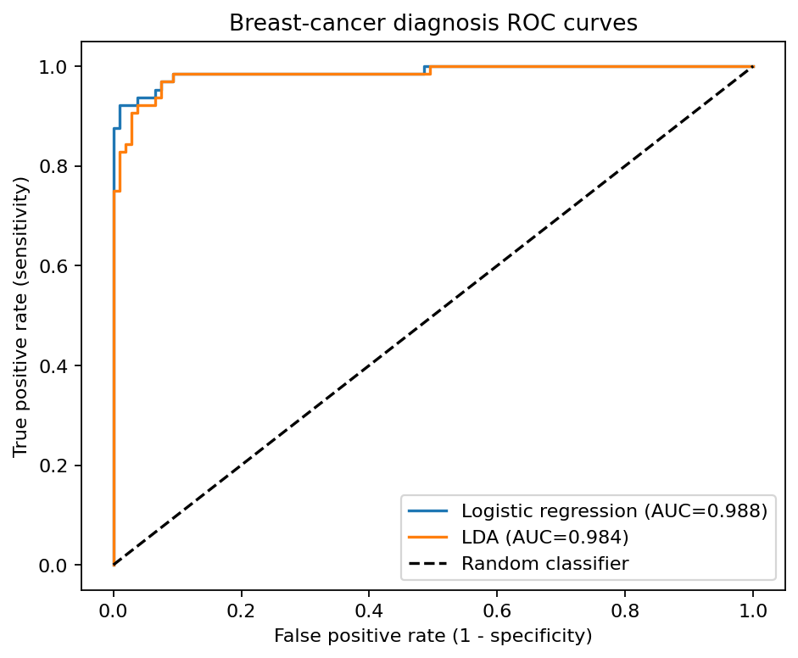
Figure 1. Test ROC curves for logistic regression and LDA.

Exercises 6–8: conclusions

Exercise 6 – Poisson model for Bikeshare
For each Poisson coefficient, `exp(beta)` is a multiplicative effect on the expected rider count, holding the other variables constant. `exp(beta_workingday)` compares working and non-working days; `exp(beta_temp)` is the expected count multiplier for a one-unit increase in normalised temperature; exponentiated weather coefficients compare each level with the reference weather category. A linear regression can produce negative fitted counts because its predictions are unconstrained, while a Poisson GLM with log link predicts `exp(Xβ)`, which is positive. The completed cell prints the requested June, 8 am, working-day, `temp=0.6`, clear-weather predictions and the count of negative linear-model fits when run with `ISLP`.

Exercise 7 – one-predictor LDA by hand (bonus)
The code calculates class priors, within-class means, pooled variance, and both class discriminant functions for `Lag2`. It then compares manual test predictions against scikit-learn LDA. Identical output should be `True` with zero mismatches; any difference should be investigated before submission.

Exercise 8 – wine classification (bonus)
Five-fold stratified cross-validation with standardisation gave the following results on the scikit-learn wine dataset. QDA had the highest mean cross-validation accuracy for this fixed fold setup. This is a data- and split-specific comparison, not a universal claim that QDA is always best.
Method | Mean CV accuracy | Std. across folds
QDA | 0.9889 | 0.0136
Multinomial logistic regression | 0.9833 | 0.0136
LDA | 0.9830 | 0.0139
KNN (K=5) | 0.9717 | 0.0181

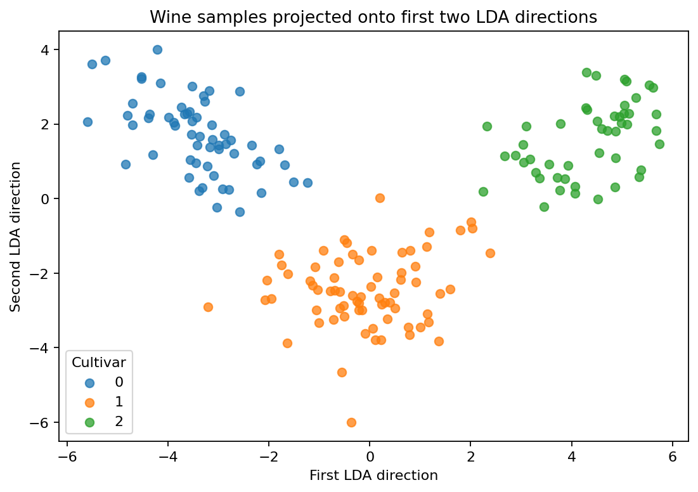
Figure 2. Wine observations projected onto the first two LDA directions.

