INTERNATIONAL UNIVERSITY – VNU-HCMC

LAB 5 REPORT
Linear Model Selection & Regularization
ISLP Chapter 6 | IT171IU Statistical Learning

Student detail | Information
Full name | Nguyễn Viết Huy
Student ID | ITDSIU24021
Class / group | IT171IU – Lab Group 1
Lab title | Linear Model Selection & Regularization

Work completed
- Completed solution code for Exercises 1–8, including the optional challenge exercises.
- Added written interpretations for the two checkpoints and each exercise.
- Prepared plots for the simulated polynomial lasso paths, forward-selection training/test error, and diabetes ridge/lasso paths.
- Compared the diabetes lasso entry order against the three predictors from Lab 2, Exercise 7: bmi, bp, and s5.

Execution and verification status
Important limitation: the preparation runtime had no network access to package servers or GitHub, so it could not install ISLP or l0bnb. The complete notebook could not be executed end-to-end here. The self-contained simulation and scikit-learn diabetes sections were checked independently; Hitters, College, and Boston results must be generated by running the notebook in Google Colab before submission.
Area | Status
Exercise 1 – simulated polynomial data | Forward-Cp criterion and lasso CV independently checked locally; final ISLP Stepwise cell should be verified in Colab.
Exercise 2 – College | Solution code completed; ISLP dataset run pending.
Exercise 3 – synthetic 20-predictor data | Forward path independently checked; best test MSE at 13 predictors in the local validation run.
Exercise 4 – Boston | Solution code completed; ISLP dataset run pending.
Exercise 5 – diabetes | Executed with scikit-learn diabetes data; coefficient paths and 10-fold CV results available.
Exercises 6–8 – Hitters | Solution code completed; ISLP Hitters data run pending.

1. Checkpoint answers

Subset selection
- The in-sample MSE forward path selects all 19 Hitters predictors because adding terms cannot increase training RSS in nested least-squares models.
- The Cp penalty favours a smaller model. The standard ISLP Hitters reference run selects 10 terms: Assists, AtBat, CAtBat, CRBI, CRuns, CWalks, Division, Hits, PutOuts, and Walks.
- Training MSE decreases as the model grows; cross-validated MSE can rise or fall because it measures prediction on held-out data and reflects the bias–variance trade-off.
- `path[3]` is the fourth solution in the l0bnb path. It is a dictionary with coefficient vector `B`, intercept `B0`, penalty `lambda_0`, fit/objective quantity `M`, and `Time_exceeded`. The index does not mean exactly three nonzero coefficients.

Ridge and lasso
- The lab text states that the CV-tuned lasso sets 6 of 19 coefficients to zero, leaving 13 nonzero coefficients. The notebook prints the retained variable names when executed.
- Scaling should be part of the estimator being cross-validated so each training fold estimates its own means and standard deviations. A subtlety: `Pipeline(StandardScaler, ElasticNetCV)` fits the scaler before ElasticNetCV performs its internal CV; a GridSearchCV around a full scaler-plus-ElasticNet pipeline is stricter and is used in the exercise solutions.
- Compare the minimum CV MSE values printed for ridge and lasso. When their errors are close, sparsity and interpretability may favour lasso; ridge may be preferable when correlated predictors should all remain in the model.

2. Exercise 1 – simulated polynomial response
The data were generated with n = 100 and a fixed NumPy random seed. A local independent implementation of the forward Cp criterion was used to sanity-check the expected selection pattern; the notebook itself uses the ISLP Stepwise API and should be run in Colab to confirm its package-specific output.
Response | Forward Cp terms (local check) | Lasso alpha | Lasso nonzero terms (original units)
Cubic: 3 + 2X - 0.5X² + 0.8X³ + ε | X3, X1, X2, X10 | 0.006731 | X1 1.8119; X2 -0.5798; X3 0.8788; X4 -0.0461; X5 0.0051; X10 0.0003
Seventh power: 3 + 7X⁷ + ε | X7, X9, X4 | 0.797589 | X5 0.0405; X7 6.9854

Interpretation: the cubic case recovers the three meaningful powers with coefficients close to the generating values; the extra X10 term is effectively zero. For the seventh-power response, Cp identifies X7 and the fitted coefficient is close to 7. Lasso is sparse in the second case, retaining X7 as the dominant signal term.
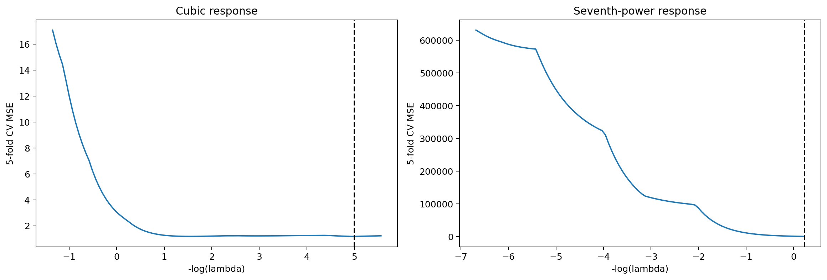
Figure 1. Five-fold CV error across the lasso penalty for the two simulated responses (local independent check).

3. Exercise 3 – training versus test error
The exercise generated 1,000 observations and 20 predictors. The first 100 observations form the training set and the remaining 900 form the test set. Seven coefficients were set to zero in the data-generating process.
Result | Local validation
True nonzero predictors | x1, x3, x4, x6, x7, x9, x10, x12, x13, x15, x16, x18, x19
Minimum test MSE | 1.0823
Model size at minimum test MSE | 13 predictors
Predictors in selected 13-term model | x1, x9, x18, x16, x6, x7, x13, x10, x12, x4, x8, x19, x3

Interpretation: training MSE falls as predictors are added, but test MSE reaches its minimum at 13 terms and then rises slightly. The model chosen by test MSE contains x8 (a zero-coefficient predictor) and does not include x15 (a true signal predictor). This illustrates that forward selection can be unstable with only 100 training observations, even when the underlying model is sparse.
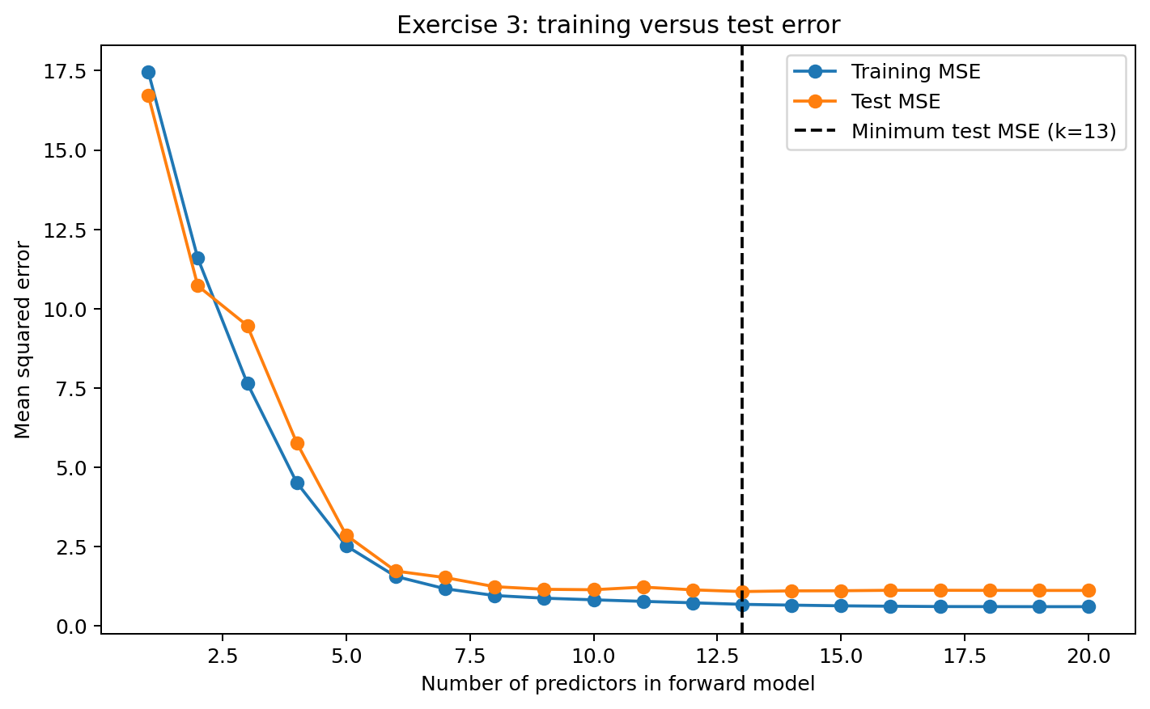
Figure 2. Forward-selection training and test MSE by model size (local run of the same greedy forward procedure).

4. Exercise 5 – diabetes ridge and lasso paths
This exercise used the scikit-learn diabetes dataset through the notebook loader, with `progression` as the response and the ten standard predictors. Predictors were standardised for the coefficient paths.
Method | Selected lambda (alpha) | 10-fold CV MSE
Least squares | — | 3017.3674
Ridge | 26.5609 | 3011.2760
Lasso | 0.4037 | 3010.0612

Lasso entry order
As lambda decreases, the local coefficient-path check gives this order:
bmi → s5 → bp → s3 → sex → s6 → s1 → s4 → age → s2
The first three variables are bmi, s5, and bp. Lab 2, Exercise 7 used bmi, bp, and s5, so the same three predictors enter first, although bp and s5 appear in the opposite order in this path.
Interpretation: both ridge and lasso have slightly lower ten-fold CV MSE than least squares in this run. Lasso has the lowest of the three by a small margin and produces a sparse path; this is a predictive comparison, not a causal or clinical conclusion.
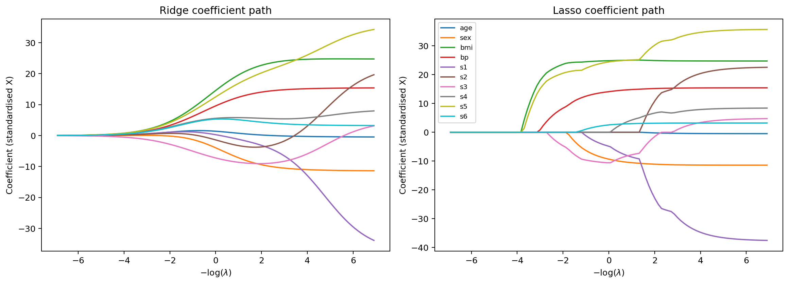
Figure 3. Ridge and lasso coefficient paths for the ten diabetes predictors.

5. Remaining exercise methods and Colab verification
Exercise | Completed implementation | Output still to verify in Colab
2 – College applications | Train/test split; least squares; CV-tuned ridge and lasso; CV-tuned PCR and PLS; null-model comparison. | Test MSE, null-relative test R², best penalties/component counts.
4 – Boston crime | Training-only CV for forward selection, ridge, lasso and PCR; untouched test set for final comparison. | CV/test MSEs, selected features, and the final method chosen by training CV.
6 – Standardisation | Ridge coefficient comparison with and without StandardScaler; response-unit comparison. | Hitters-specific coefficient differences. The ISLP Hitters Salary values are in thousands of dollars; the code forms the equivalent dollar scale by multiplying by 1,000.
7 – Closed-form ridge (bonus) | NumPy solution compared with scikit-learn Ridge at three lambda values; L2 norms compared. | Maximum numerical difference and the three coefficient norms.
8 – Elastic net (bonus) | ElasticNetCV searches l1_ratio in {0.1, 0.3, 0.5, 0.7, 0.9, 1.0}; reports selected variables and CV MSE. | Chosen mixing ratio, alpha, number of retained variables and CV-error comparison.

Before submitting
- Upload the notebook to Google Colab and run the setup cell with internet access so ISLP and l0bnb can be installed.
- Choose Runtime → Restart session and run all. Confirm the Hitters, College and Boston data load and every cell completes without errors.
- Save the notebook with all outputs visible. Check the dynamic variable lists and numeric tables against the report; update the report if the full Colab run changes any version-dependent values.
- Keep the notebook, PDF report and README in one folder. Share a GitHub repository or Google Drive folder link with the instructor using the course submission form.
AI-use disclosure: AI assistance was used to draft and check code, explanations and report formatting. The student should review the work and follow the instructor’s AI-use policy.

