

**ONLINE SHOPPING SYSTEM**

**Software Requirement Specification**

**(Version 0.2 – 19/09/2022)**

Member:

Trần Trung Việt - HE153481

Nguyễn Trung Hiếu - HE160326

Trần Công Minh - HE161354

Lê Sỹ Thái - HE160614

Vũ Hoàng Anh - 163109

– Hanoi, September 2022 –

**Table of Contents**

I. Overview 4

1. Introduction 4

2. System Functions 5

3. Common Requirements 8

II. Functional Requirements 9

2.1. Home page 9

2.2. Register 9

2.3. Register for seller 10

2.4. Login 10

2.5. Forgot Password 11

2.6. View User Profile 12

2.7. Change Password 13

2.8. Display List Products (For user) 13

2.9. View Product Detail (For user) 14

2.10. Add to cart 15

2.11. View cart 15

2.12. Delete Product in Cart 16

2.13. CheckOut 16

2.13. Place Order 16

2.14. View order 17

2.14. View Order Detail 17

2.15. Feedback 18

2.16. View Feedback (For user) 18

2.17. Blogs List 18

2.17. Blogs Detail 19

2.18. Notification 20

2.19. Mask all as read 21

2.20. Introduciton 21

2.21. Recruitment 22

2.22. Admin Dashboard 24

2.23. List of Account (Admin) 25

2.24. Account Information (Admin) 26

2.25. Search (Admin) 27

2.26. Seller Dashboard (Seller) 28

2.27. Manager Order (Seller) 30

2.28. Manager Product (Seller) 31

2.29. Add new Product (Seller) 32

2.30. Edit Product 34

2.31. Delete product 36

2.32. Manage Feedback List (Seller) 36

2.33. Feedback Detail 37

2.34. Reply Feedback 38

# I. Overview

## 1. Introduction

This project is aimed at developing an online shop system which supports for the online shopping & product online selling for the shop or any independent organization who want to sell online. This system support for the below types of user:

• Guest: unregistered users

• Customer: they are registered users who are actual customers or potential customers

• Seller: the sale members of the organization

• Admin: the organization leader/manager, acts as the system administrator

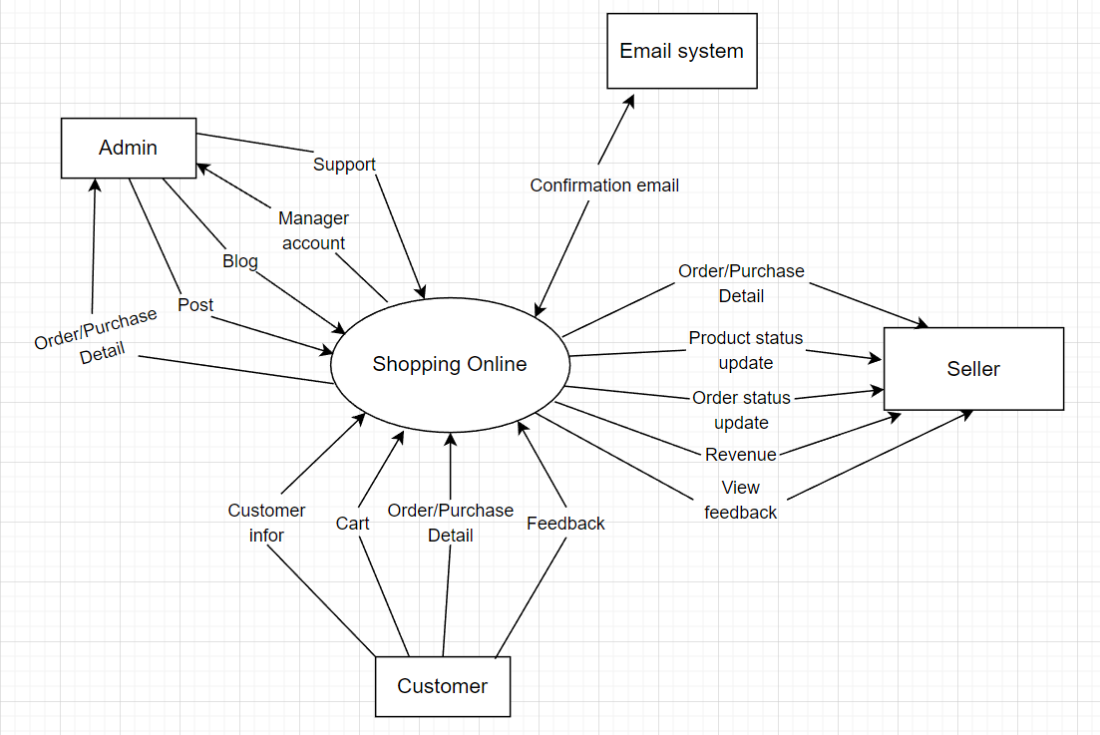

*Figure 1.1: Context Diagram For Online Shopping System*

## 2. System Functions

#### a. Screen Flow

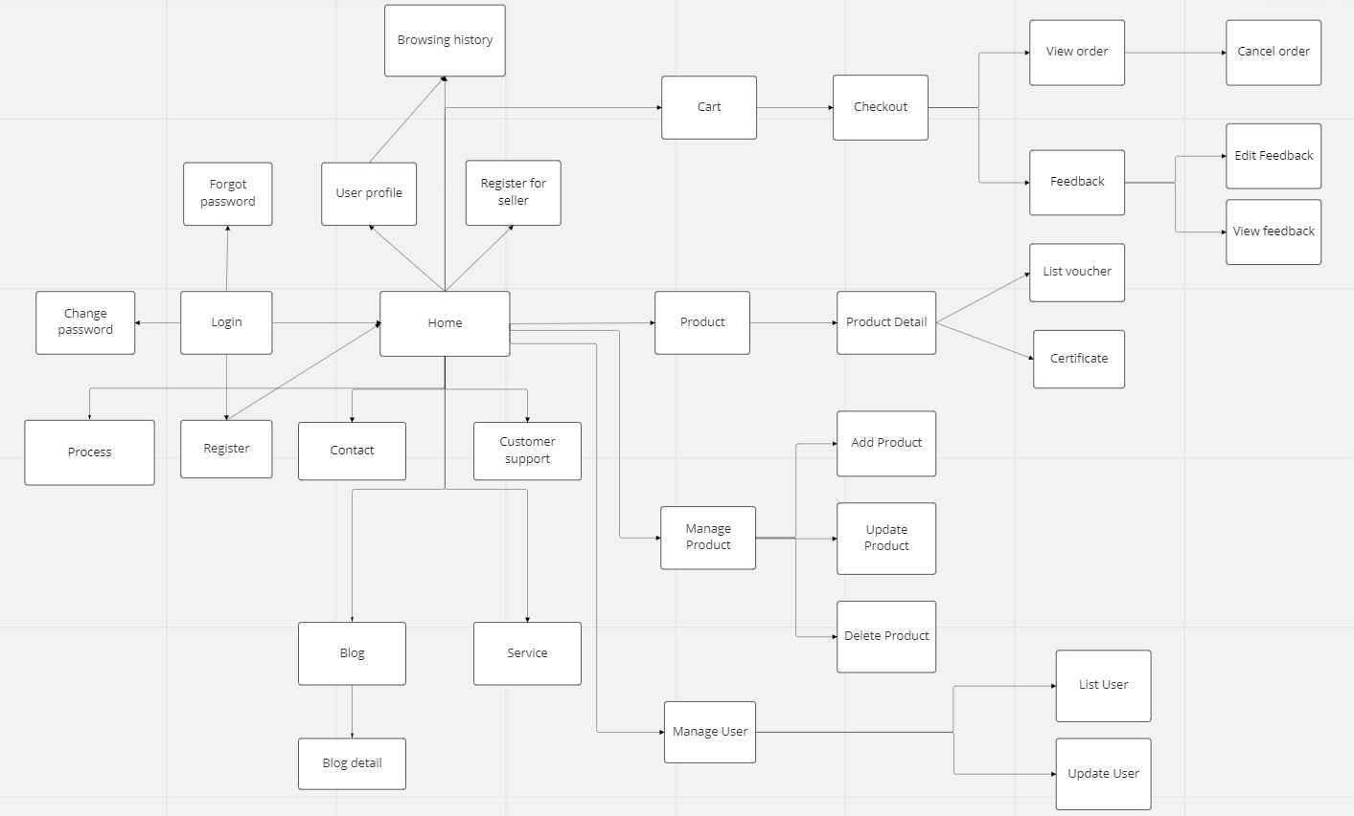

*Figure 1.2: Screen Flow For Online Shopping System*

#### b. Screen Details

|  |  |  |  |
| --- | --- | --- | --- |
| **#** | **Feature** | **Screen** | **Description** |
| 1 | Show category | Home page | User can see a list of product categories. |
| 2 | Show product | Home page | Users can see a list of the latest products, or on sale |
| 3 | Search (For user) | Home page | Allows users to search for categories, products, product types by name |
| 4 | Login | Login | Allow users to access the system |
| 5 | Register | Register | Allow users to register for a new account to access the system |
| 6 | Update profile | User profile | Allow users to update personal information |
| 7 | Change password | User profile | Allow users to change their personal password |
| 8 | Add address | User profile | Allow users to add an address to receive goods |
| 9 | Reset password | Reset password | The user requests to get new password |
| 10 | Add to cart | Product detail | The user will add the product to be purchased to the cart |
| 11 | View cart | Cart | User can see all the products that have been added in the cart |
| 12 | View order | My order (Customer) | User can see all their created orders |
| 13 | Cancel order | My order (Customer) | Users can cancel orders that don't want to buy |
| **#** | **Feature** | **Screen** | **Description** |  | **Feature** | **Screen** | **Description** |
| 14 | Order history | My order (Customer) | Users can view transaction history of all orders |
| 15 | View detailed statistics | Admin dashboard | Allows administrators to view detailed statistics, revenue, transaction history, .. |
| 16 | See a list of all accounts | List user (Admin) | Admin can see all user information in the system (seller, customer) |
| 17 | Search (For admin) | List user (Admin) | Admin can search for users by name |
| 18 | View detailed statistics | Seller dashboard | Allows seller to view post statistics, products, customers, revenue, feedback & new customer trends |
| 19 | Add product | Add product (Seller) | Seller can add new products to the shop's product list |
| 20 | Edit product | Update product (Seller) | Seller can change the information of the product |
| 21 | Delete product | Update product (Seller) | Seller can delete product when the shop no longer sell it |
| 22 | Update order status | List order (Seller) | Seller can update the status of orders (wait for confirmation, delivery, delivered, canceled) |
| 23 | Delete order | List order (Seller) | Seller can delete order when order is canceled |
| 24 | View list product | List product (Seller) | The seller can see a list of all the products of the store |
| 25 | Product status update | List product (Seller) | The seller can update product status (In stock, out of stock) |
| 26 | View list category | List category (Seller) | Seller can see the list of categories currently in the shop |
| 27 | Add category | Add category (Seller) | Seller can add new categories to the shop's category list |
| 28 | Edit category | Update category (Seller) | Seller can edit category name |
| 29 | Delete category | Update category (Seller) | Seller can delete categories |
| 30 | Feedback | Feedback | Allow users to give their own feedback on the product |
| 31 | View Vouchers | My vouchers (User) | Allows users to view all available discount codes |
| 32 | Contact the administrator | Contact us | Users can contact the administrator |
| 33 | Request for support | Supporting | Users can request support from admin, sales manager |
| 34 | Place order | Checkout | Allow users to order products they want to buy |
| 35 | View list blog | Blog | Show the posts pagination the post search box, post categories, five featured posts |
| 36 | View blog detail | Blog detail | Show post details, post categories, five featured posts. The Blogs List page is shown when the user clicks on a post category |

#### c. User Authorization

|  |  |  |  |  |
| --- | --- | --- | --- | --- |
| **Screen** | **Role1** | **Role2** | **Role3** | **Role4** |
| Home page | X | X | X | X |
| Register | X | X | X |  |
| Register for seller |  | X | X |  |
| Login |  | X | X | X |
| Forgot password |  | X | X |  |
| Use profile |  | X | X | X |
| Add addresses |  | X |  |  |
| Change password |  | X | X |  |
| Admin dashboard |  |  |  | X |
| Seller dashboard |  |  | X |  |
| List of account |  |  |  | X |
| Account information |  |  | X | X |
| Product list |  |  | X | X |
| Category list |  |  | X | X |
| Add product |  |  | X |  |
| Edit product |  |  | X |  |
| Add category |  |  | X |  |
| Edit category |  |  | X |  |
| Search | X | X | X | X |
| Product status update |  |  | X |  |
| Update order status |  |  | X |  |
| View product detail | X | X | X | X |
| View shopping cart |  | X | X | X |
| Check out |  | X | X | X |
| View order |  | X | X | X |
| Cancel order |  | X | X | X |
| Feedback |  | X |  |  |
| View feedback | X | X | X | X |
| Feedback detail | X | X | X | X |
| Check bill |  | X | X |  |
| Supporting |  |  | X | X |
| List vouchers | X | X |  |  |
| Blogs list | X |  | X | X |
| Blogs detail | X | X | X | X |
| Posts list | X | X | X | X |
| Post detail | X | X | X | X |
| Contact | X | X | X | X |
| Certificate | X | X | X | X |
| Service | X | X | X |  |
| Report page |  | X |  |  |
| Browsing history |  | X |  |  |
| Delivery method |  | X |  |  |
| Chat |  | X | X | X |

In which:

* Role1: Guest
* Role2: Customer
* Role3: Seller
* Role4: Admin

#### d. Non-Screen Functions

|  |  |  |  |
| --- | --- | --- | --- |
| **#** | **Feature** | **System Function** | **Description** |
| 1 | Remember Me | Login | System store user’s login account and password in cookies for future re-login |
| 2 | … |  |  |

## 3. Common Requirements

# II. Functional Requirements

### 2.1. Home page

* Function trigger: The user visits the website's address then goes to the home page.
* Function description:
  + Actors/Roles: Guest, Customer
  + Purpose: Showcase feature product to customer
* Screen layout:

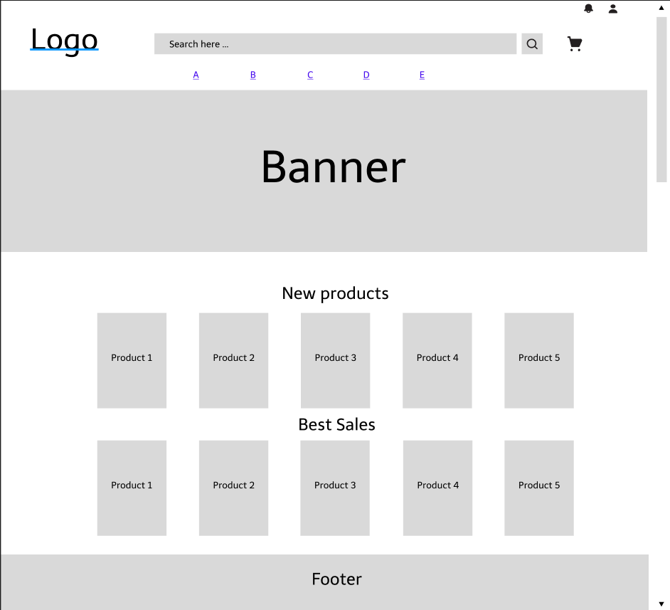

*Figure 2.1: Homepage screen*

* Function Details: Customers after accessing the website by following the link can view product information, categories, banners, latest products, discounts, brands, search for products, ...

### 2.2. Register

* Function trigger: After the user hovers over the person icon on the home page and chooses to register, the system will take the user to the Register page.
* Function description:
  + Actors/Roles: Guest
  + Purpose: Provide a form for customer to register an account.
  + Interface: There are pictures to welcome customers.
  + Data processing: Save email, username, password to data management system.
* Screen layout:

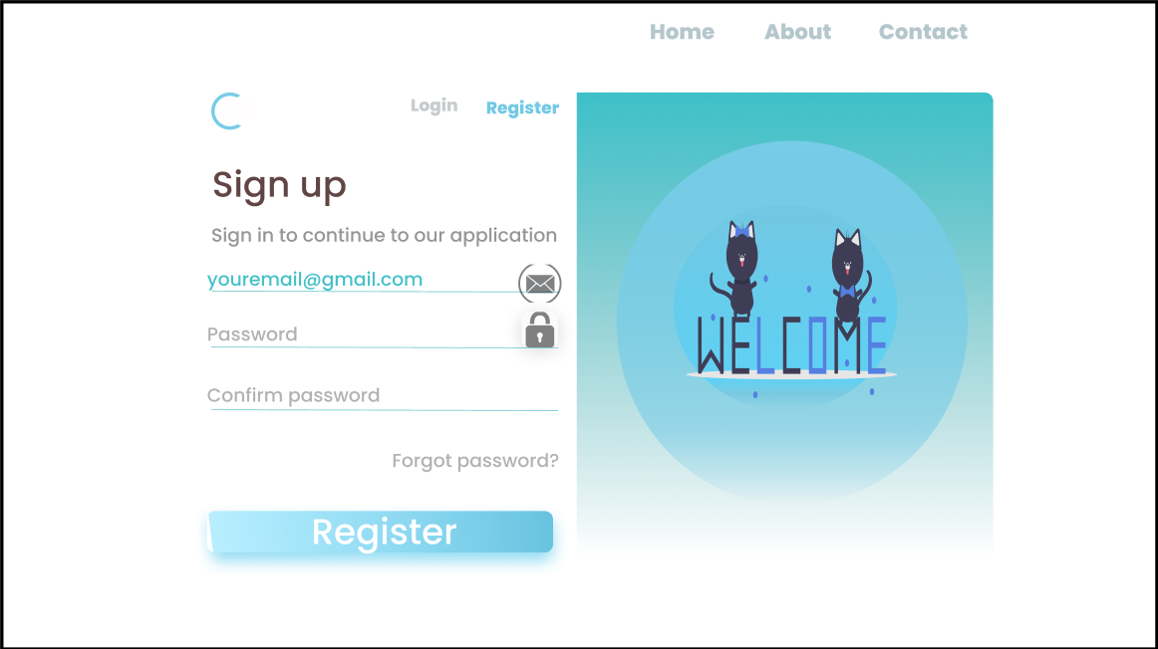

*Figure 2.2: Register screen*

* Function Details: Users register a new account by email, set a password for their account then click the Register button.

### 2.3. Register for seller

* Function trigger: When the user clicks the button Become a seller, the system will go to the page Register to become a seller.
* Function description:
  + Actors/roles: Customer
  + Purpose: For users who want to become product sellers.
  + Data processing: Update account status from Customer to Seller.
* Screen layout:

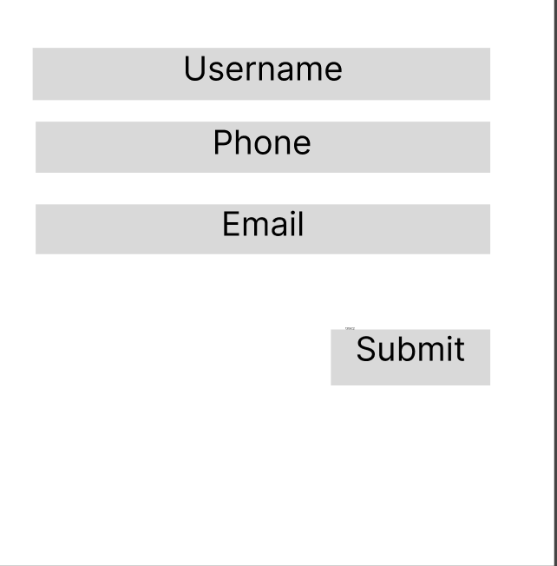

* Function Details: Register information to become a seller.

### 2.4. Login

* Function trigger: After the user hovers over the person icon on the home page and chooses to login, the system will take the user to the Login page.
* Function description:
  + Actors/Roles: Guest, Customer
  + Purpose: Allow users to login to the system to access more functions
  + Interface: There are header, wallpapers, website logos
  + Data processing: Check if the user has entered the wrong username or password, if wrong will display a message asking to re-enter. If entered correctly redirect the user to the Homepage.
* Screen layout:

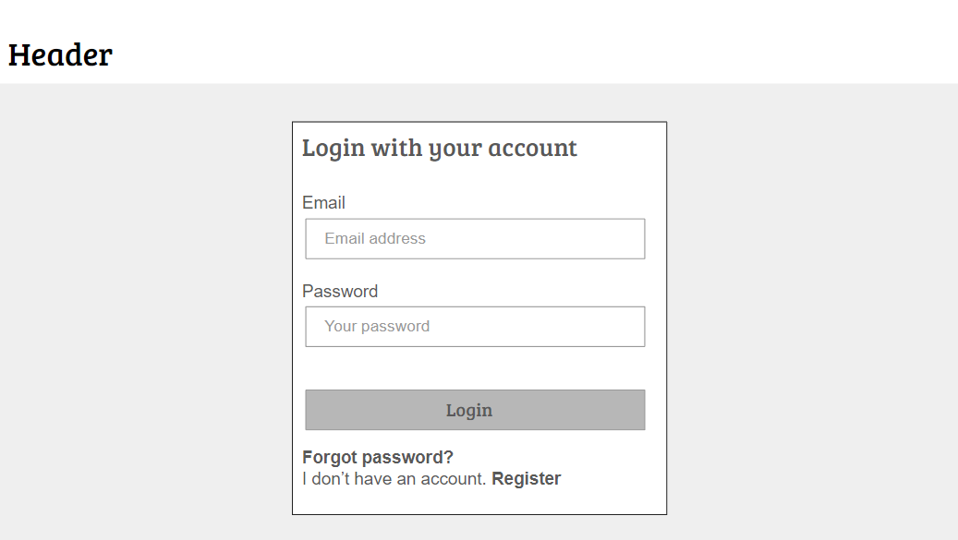

*Figure 2.4: Login screen*

* Function Details: User enters their email/username and password, then clicks the Login button to enter the homepage of the Website.

### 2.5. Forgot Password

* Function trigger: When user clicks to forgot password in Login screen.
* Function description:
  + Actors/Roles: Customer, Seller, Admin
  + Purpose: Users can change their passwords when they forget their old one
  + Data processing: Check the email of the user entered to see if it matches the registered email, if it is, the new password will be sent to the customer's email, if not, it will be required to re-enter.
* Screen layout:

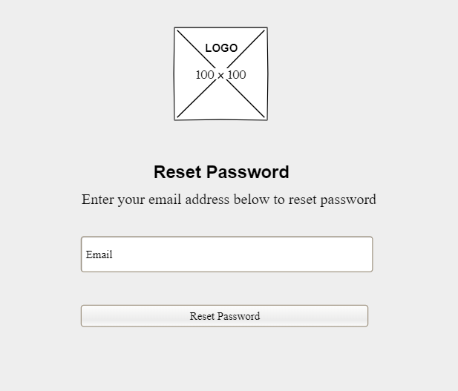

*Figure 2.5: Reset Password screen*

* Function Details: Users enter the email they used to register for an account, then the system will send a new password to the email and delete the old password.

### 2.6. View User Profile

* Function trigger: The user logs into the site, after that hovers over the person icon in the upper right corner and selects View profile.
* Function description:
  + Actors/Roles: Customer, Seller, Admin .
  + Purpose: Users can see their account’s detailed information.
  + Interface: There's a profile picture on the left side of the screen, details information in the middle, and About us on the right.
* Screen layout:

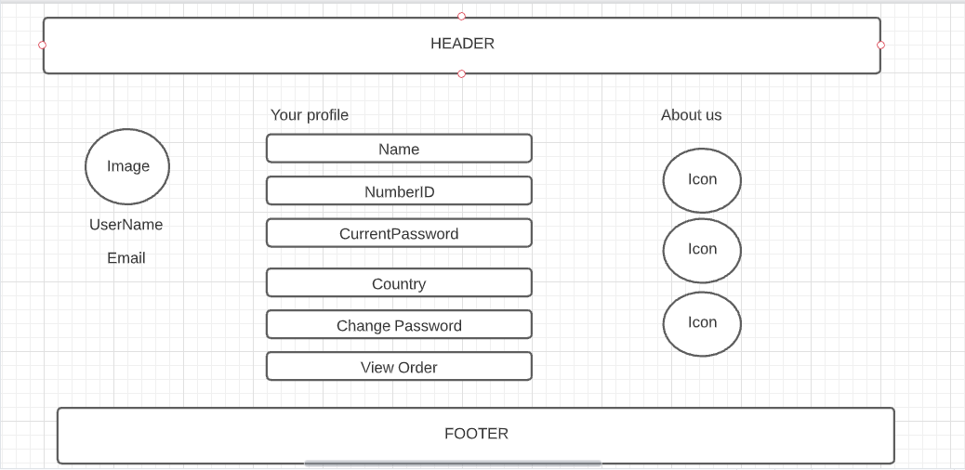

*Figure 2.6. User Profile screen*

* Function Details: Users can view their personal information.

### 2.7. Change Password

* Function trigger: When the user wants to change the account password.
* Function description:
  + Actors/roles: Customer, Seller, Admin
  + Purpose: User can change password.
  + Interface: Display form including: Current Password, New Password, Confirm New Password.
  + Data processing: Update client's current password.
* Screen layout:

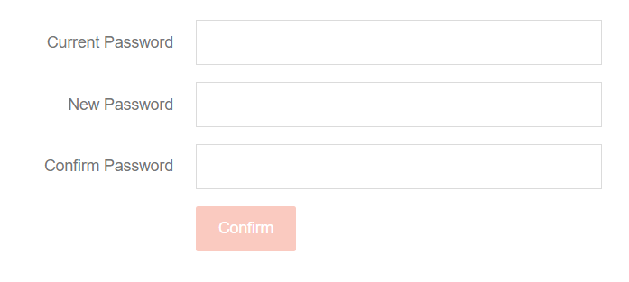

*Figure 2.7. Change Passowrd screen*

* Function Details: provide explanation for the data, validation, business logics, functionalities (for both normal cases and abnormal cases), etc. of the function so that the reader can image how it work

### 2.8. Display List Products (For user)

* Function trigger: Users visit the website then click on the product category name on the Home page or search for the product by name.
* Function description:
  + Actors/roles: Guest, Customer
  + Purpose: Allows users to filter product information, sort, view all available products, latest products, best sellers.
  + Interface: There is a search filter on the left side of the screen, the product list in the middle of the screen.
  + Data processing: The system will search according to the information provided by the user (retrieved from the search filter, product name, category).
* Screen layout:

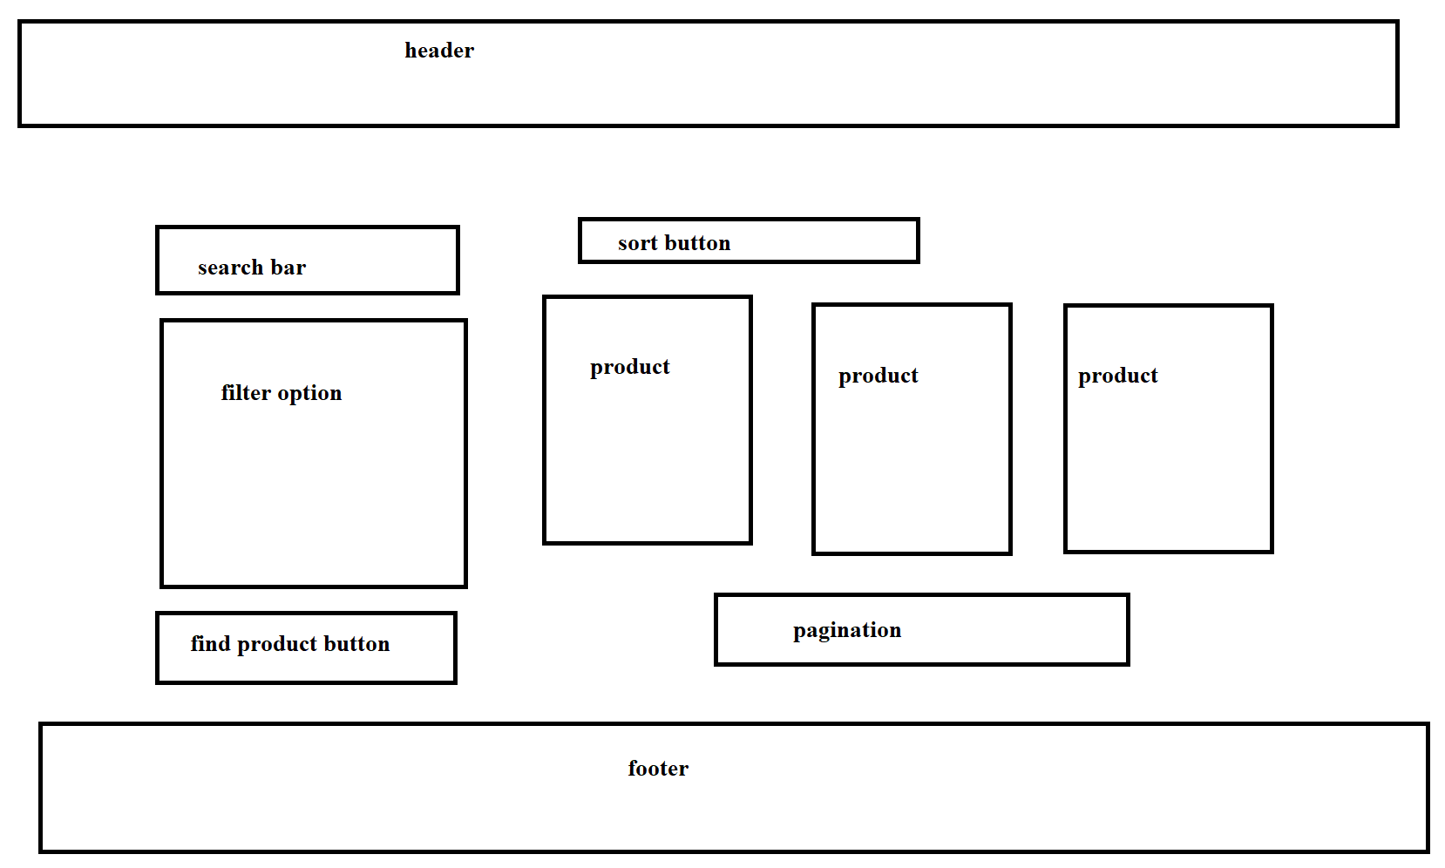

*Figure 2.8. Change Passowrd screen*

* Function Details: Display a detailed list of products for users to see.

### 2.9. View Product Detail (For user)

* Function trigger: User click on a Product in Product List.
* Function description:
  + Actors/roles: Guest, Customer.
  + Purpose: User can view all the detail information of a Product.
  + Interface: Title bar, product image on the left side of the screen, on the right side of the screen is the product name, price, quantity selection, 2 Add to Cart and Buy now buttons. Product description below.
  + Data processing: Get the number and size of products that the user chooses to save to the cart.
* Screen layout:

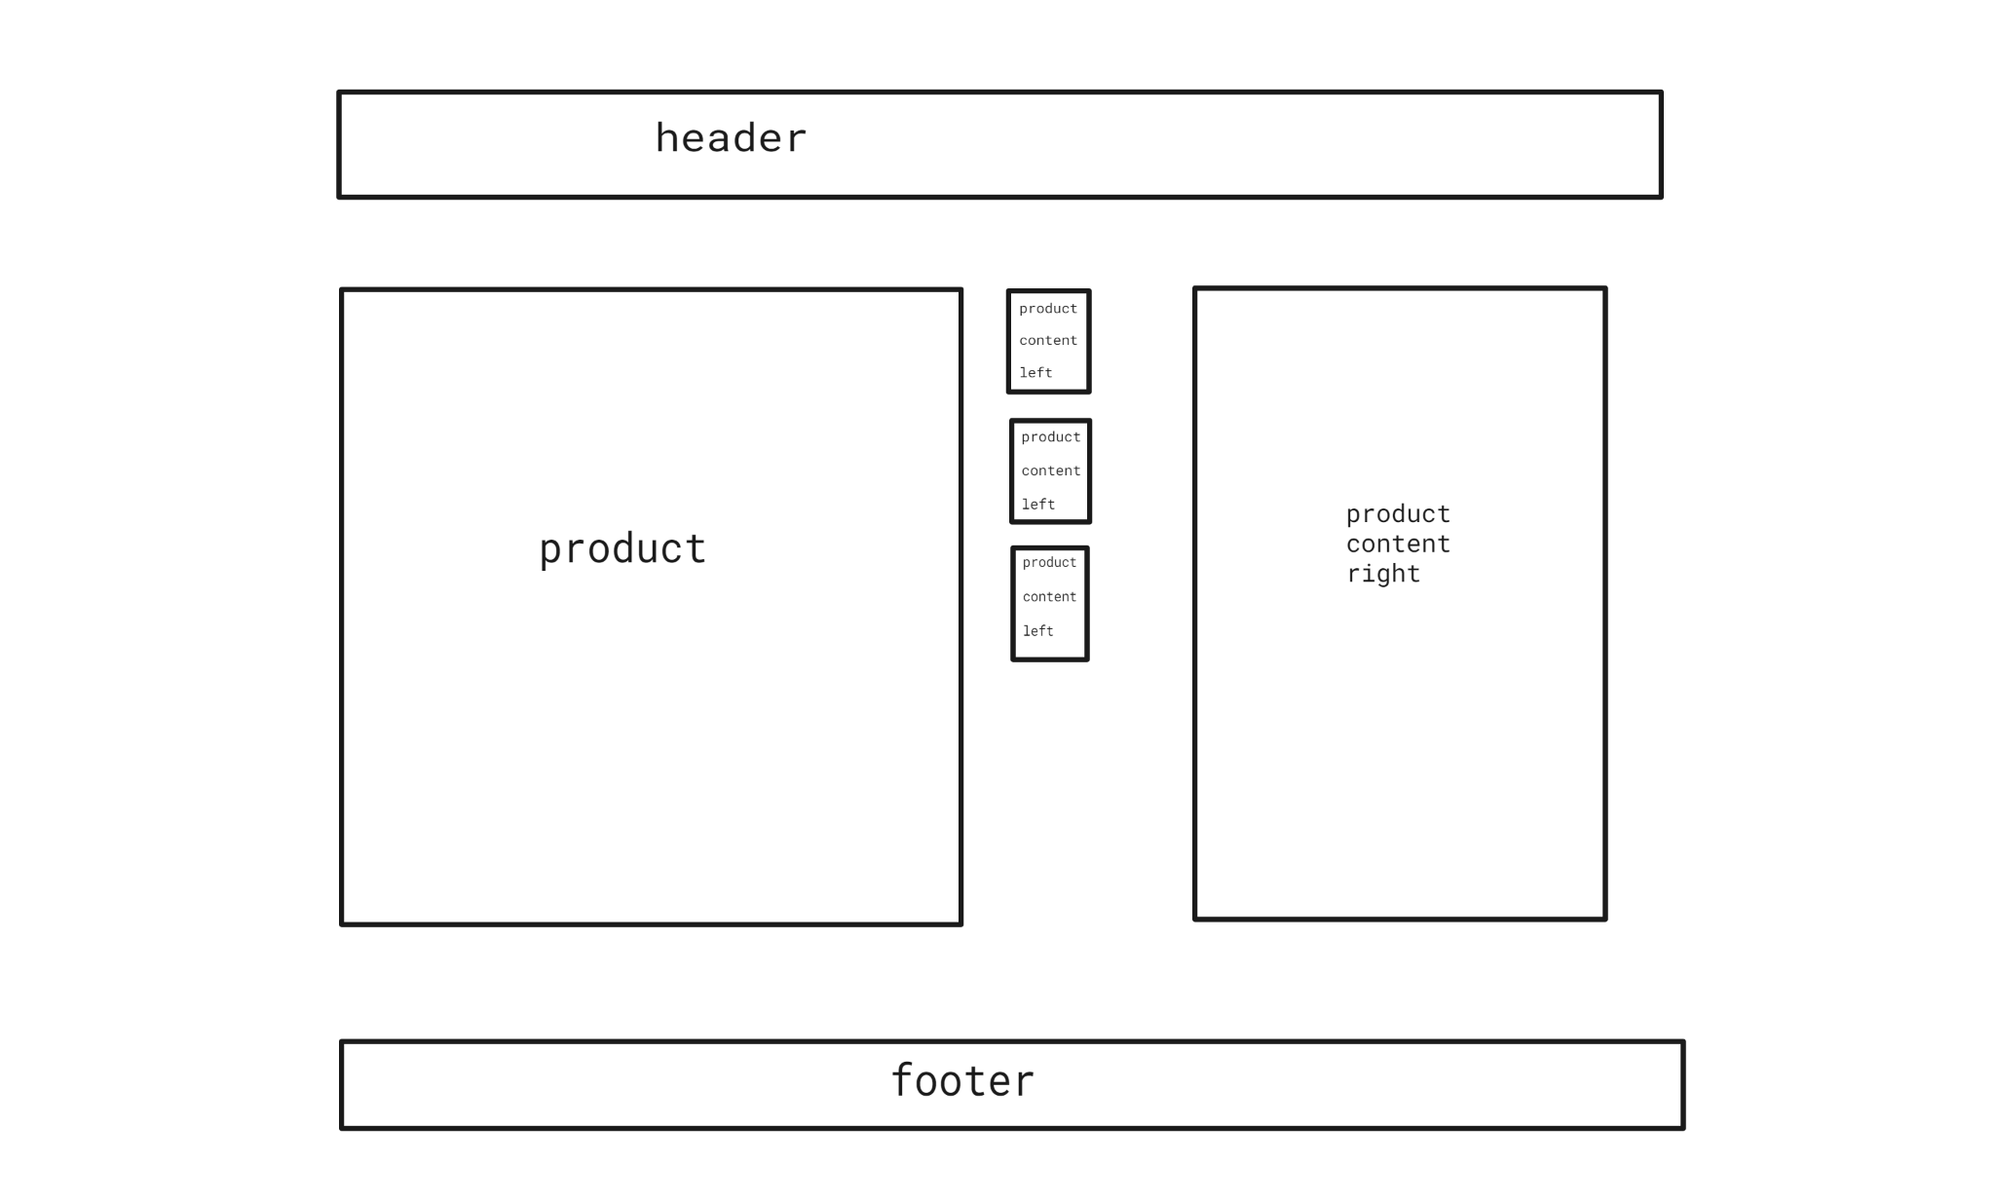

*Figure 2.9. Product Detail screen*

* Function Details: Display detailed information of the product to the user.

### 2.10. Add to cart

* Function trigger: The user wants to save the product to the cart but has not paid for the product yet.
* Function description:
  + Actors/roles: Guest, Customer.
  + Purpose: Let the user add products to the cart.
  + Interface: Have a button Add to cart.
  + Data processing: System storage to cookies.
* Screen layout:

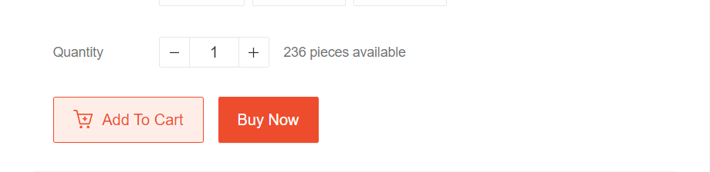

*Figure 2.10. Add To Cart screen*

* Function Details: Store to Cart.

### 2.11. View cart

* Function trigger: When the user clicks on the Cart icon, the system will take the user to the Cart shopping detail page.
* Function description:
  + Actors/roles: Guest, Customer.
  + Purpose: View all products added to cart.
  + Interface: There is a small product image, name, quantity, product price, a form to enter the delivery address, an invoice stating the total amount of the order. 1 button to return to Products page and 1 button to Checkout.
  + Data processing: Calculate the total amount of the order.
* Screen layout:

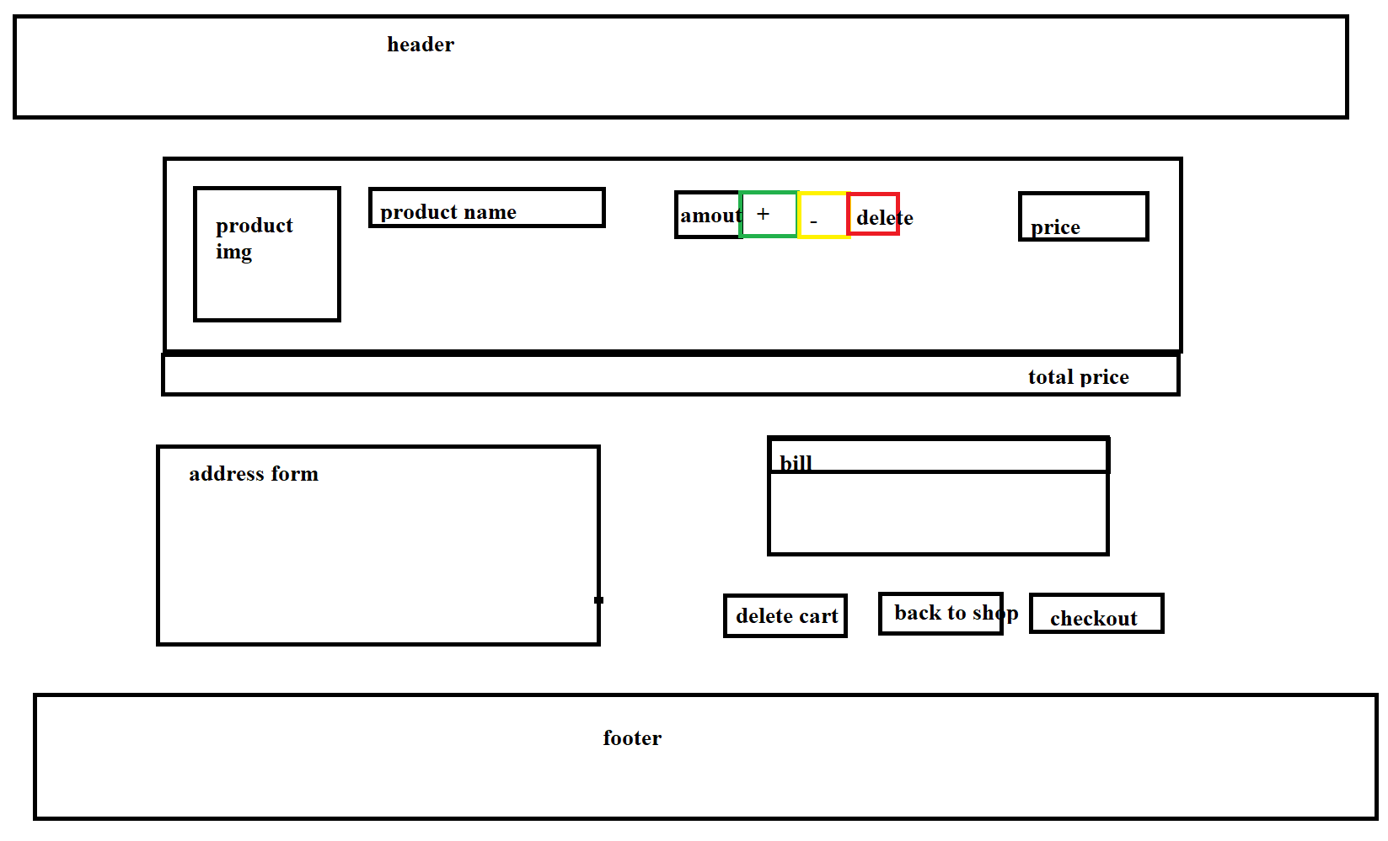

*Figure 2.11. Shopping Cart screen*

* Function Details: Show the user the list of products in the cart.

### 2.12. Delete Product in Cart

* Function trigger: When the user does not want to pay for the product, press the Delete button to remove it from the cart.
* Function description:
  + Actors/roles: Guest, Customer.
  + Purpose: User wants to remove product from cart.
  + Data processing: Delete products stored in cookies.
* Screen layout: mockup prototype of the screen, sample below is for Manage Products screen

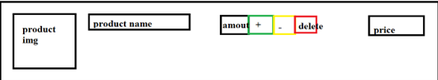

*Figure 2.12. Delete Product*

* Function Details: Remove product from cart.

### 2.13. CheckOut

* Function trigger: User wants to order product.
* Function description:
  + Actors/roles: Customer.
  + Purpose: Create product orders.
* Screen layout:



*Figure 2.13. CheckOut*

* Function Details: Create product orders.

### 2.13. Place Order

* Function trigger: User wants to pay for the order.
* Function description:
  + Actors/roles: Customer.
  + Purpose: Payment processing for orders.
* Screen layout:

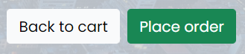

*Figure 2.13. Place Order*

* Function Details: Payment order.

### 2.14. View order

* Function trigger: User wants to view his order by clicking View My Orders on Profile page.
* Function description:
  + Aactors/roles: Customer.
  + Purpose: Double check the orders.
* Screen layout:

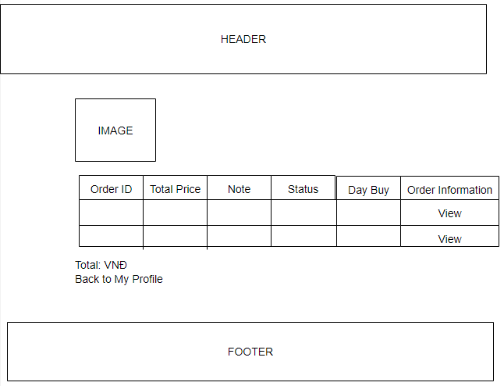

*Figure 2.14. View Order screen*

* Function Details: Displays a list of orders that have been placed.

### 2.14. View Order Detail

* Function trigger: Users log-in to the website, access My Orders page and click View button.
* Function description:
  + Actors/roles: Customer.
  + Purpose: See the order detailed information.
* Screen layout:

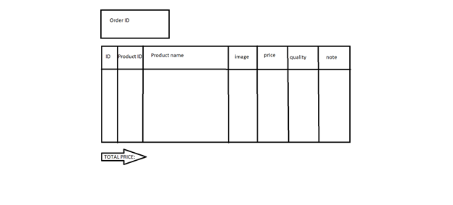

*Figure 2.14. View Order Detail screen*

* Function Details: Display details of products included in the order.

### 2.15. Feedback

* Function trigger: When the user receives the goods, click on My order and then click on Feedback and evaluate.
* Function description:
  + Actors/roles: Customer.
  + Purpose: Customer writes and send a Feedback about a Product.
* Screen layout:

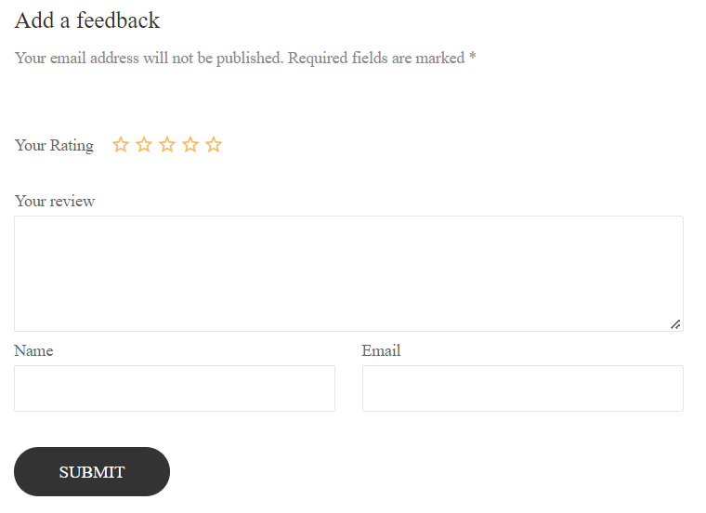

*Figure 2.15. Feedback screen*

* Function Details: Allows users to submit product feedback reviews after receiving the item.

### 2.16. View Feedback (For user)

* Function trigger: Customers click on the product they want to see, scroll down to see the feedback of other users.
* Function description:
  + Actors/roles: Guest, Customer.
  + Purpose: See all comments by other users.
* Screen layout:
* Function Details: Show users all comments, star reviews from other customers.

### 2.17. Blogs List

* Function trigger: User click Blogs on menu bar in Homepage.
* Function description:
  + Aactors/roles: Guest, Customer.
  + Purpose: Customer views the list of all Blogs.
  + Interface: There are pictures and intro.
* Screen layout:

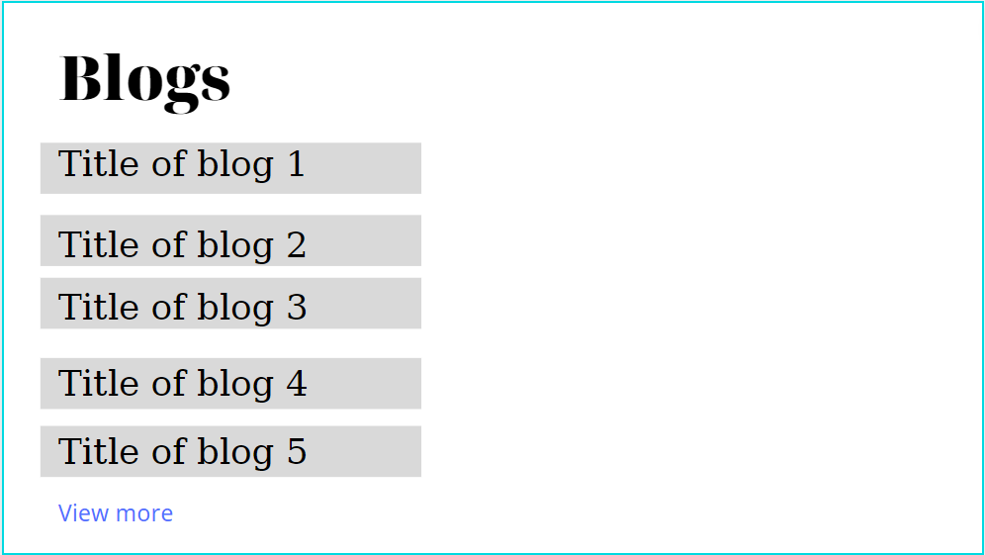

*Figure 2.17. Blogs screen*

* Function Details: Display list of all Blogs.

### 2.17. Blogs Detail

* Function trigger: User click Blogs on menu bar in Homepage, then click on Blogs they want to see detail.
* Function description:
  + Aactors/roles: Guest, Customer.
  + Purpose: Customer views the Detail information of 1 Blog.
  + Interface: There are pictures, title of Blogs, intro, author.
* Screen layout:

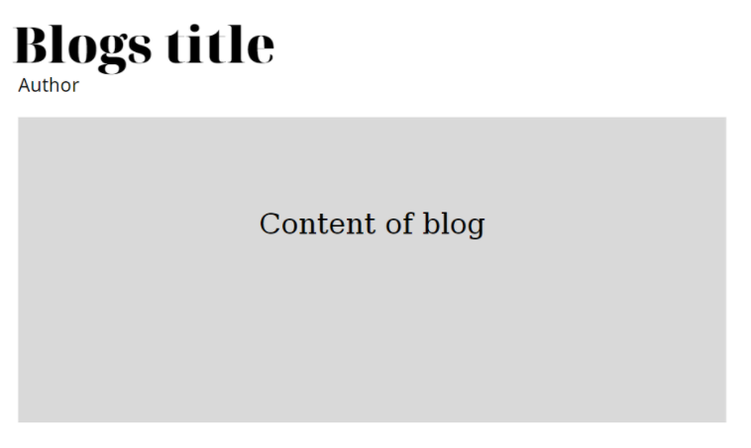

*Figure 2.18. Blogs Detail screen*

* Function Details: Display detail of 1 Blogs.

### 2.18. Notification

* Function trigger: User logs in to the site, clicks the bell and clicks the "View All" link, or looks at the Notifications section of the Profile.
* Function description:
  + Aactors/roles: Customer, Seller, Admin.
  + Purpose: User views the list of all Notifications.
* Screen layout:

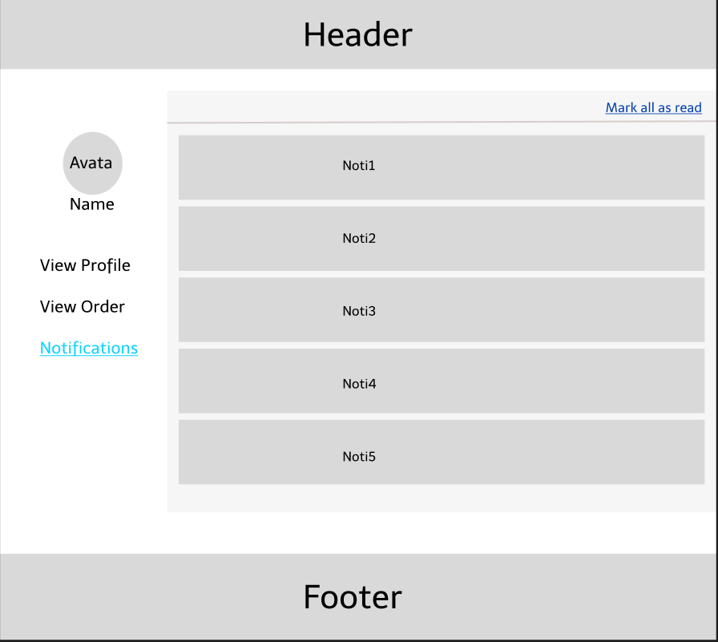

*Figure 2.18. View Notifications screen*

* Function Details: Display list of all Notifications.

### 2.19. Mask all as read

* Function trigger: User logs-in the website, clicks on the text “Mark all as read”.
* Function description:
  + Aactors/roles: Customer, Seller, Admin.
  + Purpose: Let users mark all notifications as read.
* Screen layout:
* Function Details: Display list of all Blogs.

### 2.20. Introduciton

* Function trigger: User click About on menu bar in Homepage screen.
* Function description:
  + Aactors/roles: Guest, Customer.
  + Purpose: Customer views the list of all Blogs.
  + Interface: There are pictures, intro, Google Map.
* Screen layout:

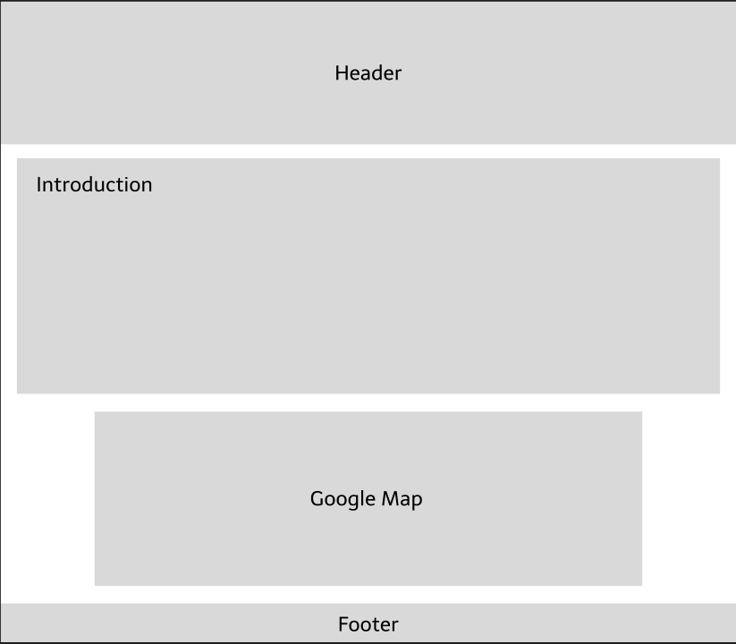

*Figure 2.20. Blogs screen*

* Function Details: Display list of all Blogs.

### 2.21. Recruitment

* Function trigger: The user clicks Recruitment on the menu bar in the About screen, then clicks on the job posting link to switch to viewing the recruitment information.
* Function description:
  + Aactors/roles: Guest, Customer.
  + Purpose: Users can view job postings.
  + Interface: There are pictures, job postings.
* Screen layout:

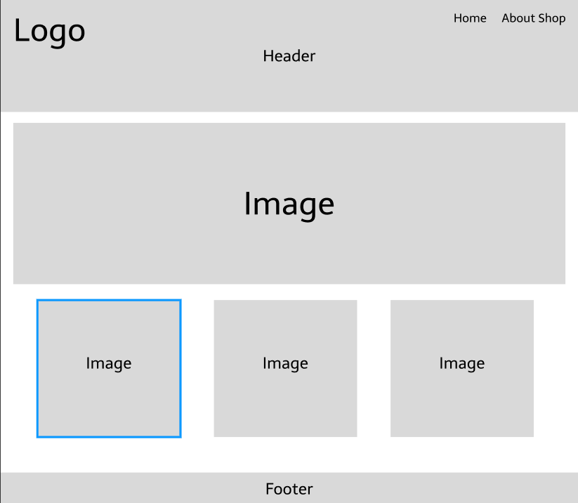

*Figure 2.21.1. Main Recruitment screen*

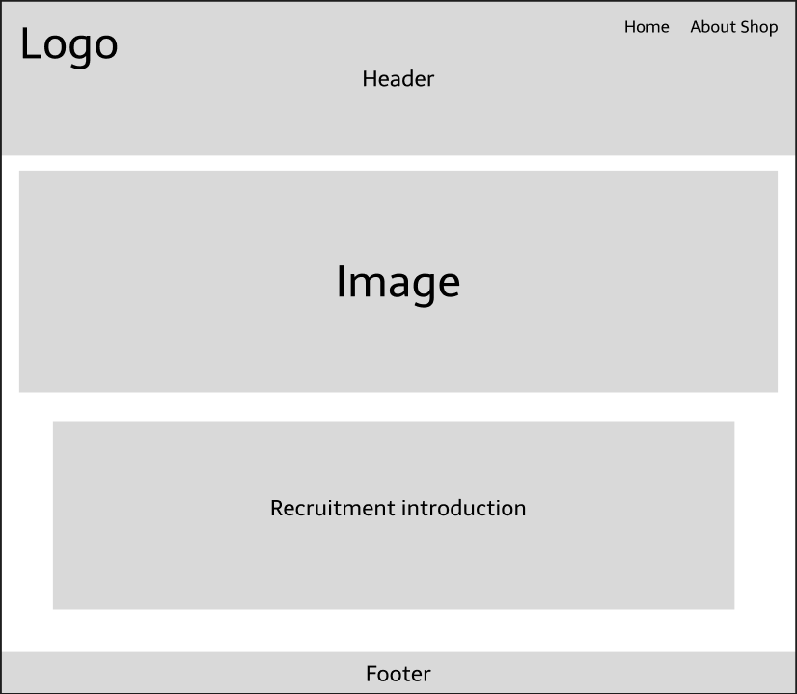

*Figure 2.21.2. Recruitment Detail screen*

* Function Details: Show details of recruitment information.

### 2.22. Admin Dashboard

* Function trigger: Admin login successfully then access the management page.
* Function description:
  + Actors/roles: Admin
  + Purpose: Allow admin can view detailed statistics, revenue, website visitors.
* Screen layout:

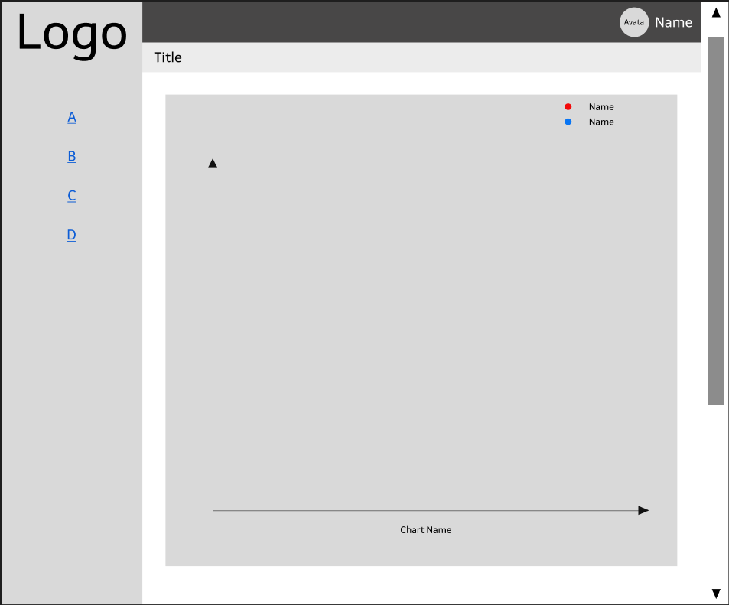

*Figure 2.22. Admin Dashboard screen*

* Function Details: View detailed statistics, website visitors, revenue.

### 2.23. List of Account (Admin)

* Function trigger: Admin login successfully then access the View Account page.
* Function description:
  + Actors/roles: Admin
  + Purpose: Admin successfully login to the management page and click on the View Account button.
* Screen layout:

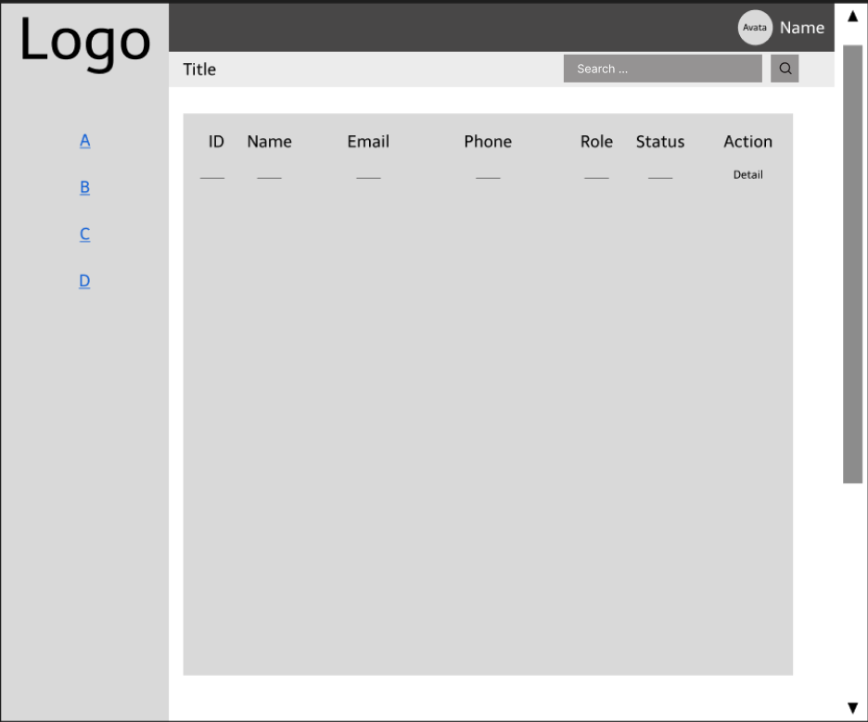

*Figure 2.23. List Account screen*

* Function Details: View the list of accounts registered on the system.

### 2.24. Account Information (Admin)

* Function trigger: When the admin is on the View Account page, click on the Individual icon to view the user's details..
* Function description:
  + Actors/roles: Admin.
  + Purpose: Allows administrators to view detailed account information of customers, seller, other admins or personal information.
* Screen layout:

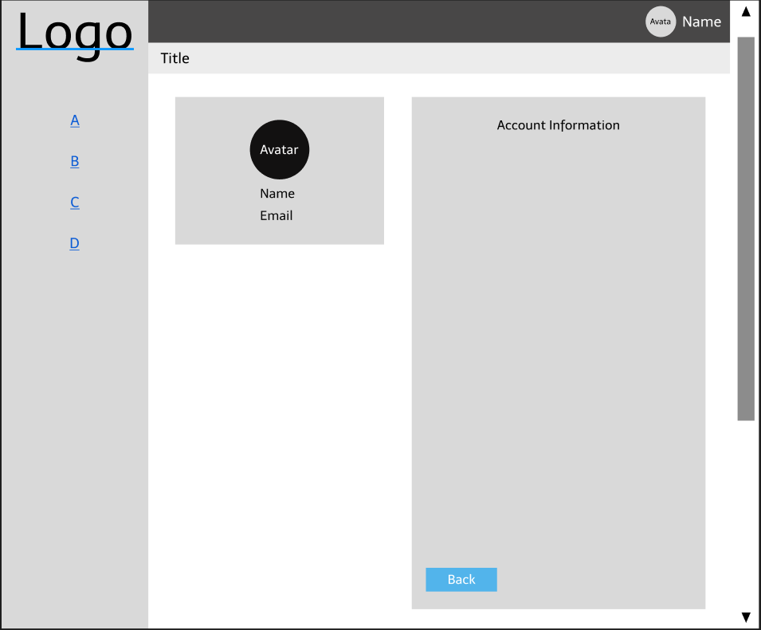

*Figure 2.24. Account Information screen*

* Function Details: View detailed account information of customers, sellers, admin.

### 2.25. Search (Admin)

* Function trigger: Admin enter the account name in the Search bar and click the magnifying glass button on the upper right hand side of the screen.
* Function description:
  + Actors/roles: Admin.
  + Purpose: Allow admin to search user's account name when there are too many accounts stored in the system.
* Screen layout:



*Figure 2.25. User's Account Search by Name*

* Function Details: User Account Search.

### 2.26. Seller Dashboard (Seller)

* Function trigger: When Seller clicks on My Dashboard on the homepage.
* Function description:
  + Actors/roles: Seller.
  + Purpose: Allow merchants to log in to Seller Dashboard to view store statistics.
* Screen layout:

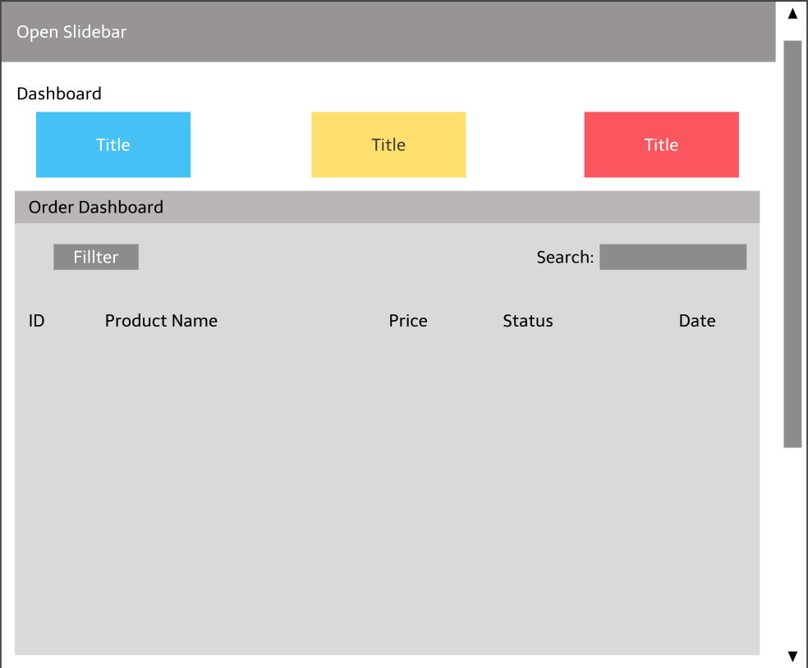

*Figure 2.26.1. Seller Dashboard screen*

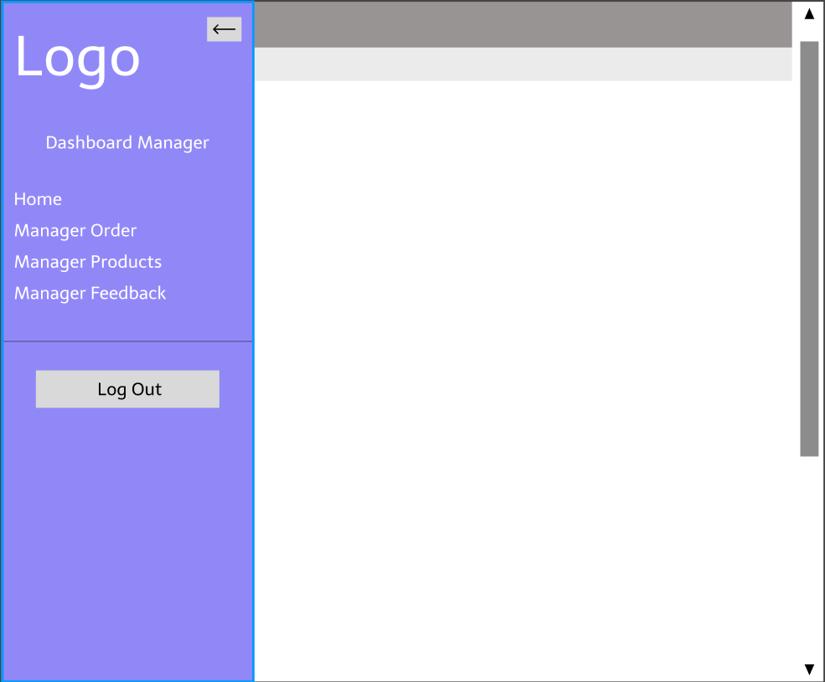

*Figure 2.26.2. Open Slidebar on Seller Dashboard*

* Function Details: Displaying the Main Dashboard panel, Seller clicks the Open Sidebar button to open tasks such as Manage Orders, Manage Products, View User Feedback or Log Out.

### 2.27. Manager Order (Seller)

* Function trigger: When the seller clicks Manage Orders in the Slidebar.
* Function description:
  + Actors/roles: Seller.
  + Purpose: Allows the seller to view the list of orders.
* Screen layout:

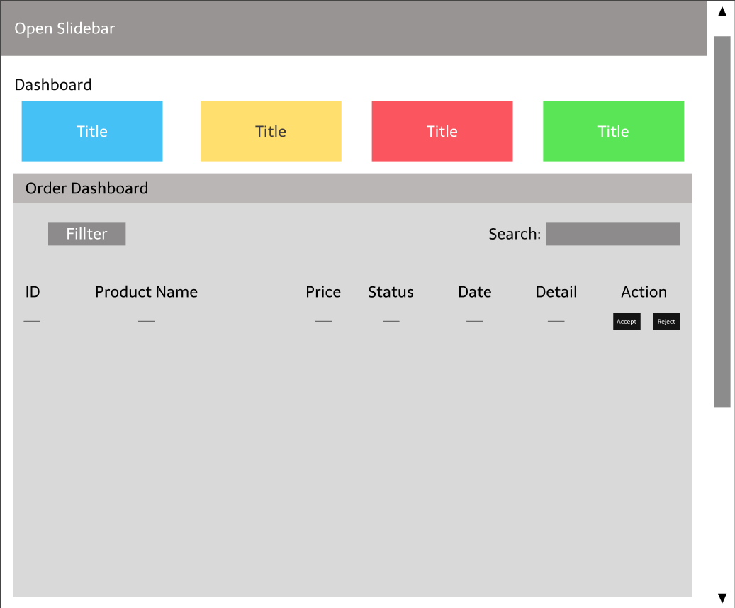

*Figure 2.27. Order Dashboard screen*

* Function Details: View store revenue, order list, order status update, search.

### 2.28. Manager Product (Seller)

* Function trigger: When the seller clicks Manage Product in the Slidebar.
* Function description:
  + Actors/roles: Seller.
  + Purpose: Allows the seller to view the list of products.
* Screen layout:

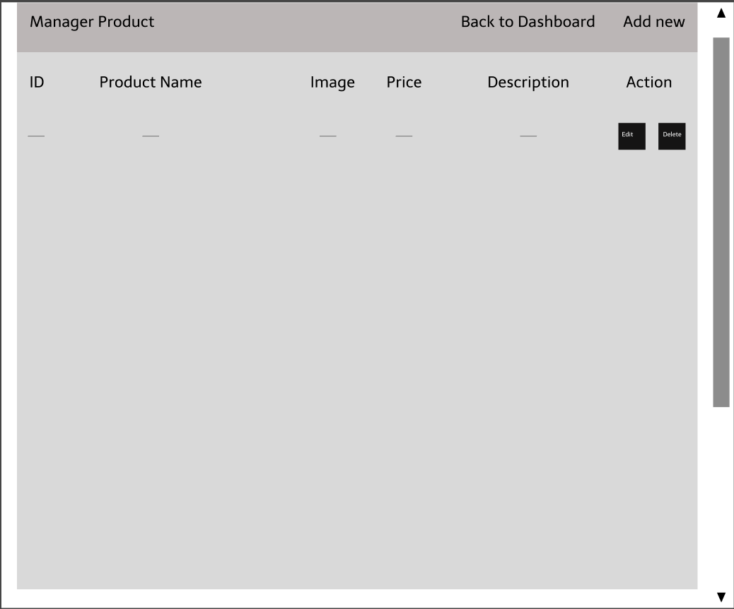

*Figure 2.28. Manager Products screen*

* Function Details: Show a list of products currently in the store.

### 2.29. Add new Product (Seller)

* Function trigger: When the seller clicks the Add New button on the top right side of the screen.
* Function description:
  + Actors/roles: Seller.
  + Purpose: Allow sellers to post new products.
* Screen layout:

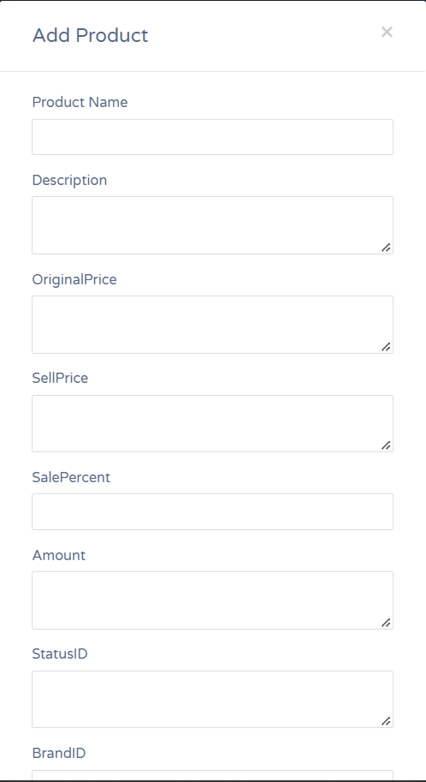

*Figure 2.29. Add new Product screen*

* Function Details: Add a new product to the list of existing products.

### 2.30. Edit Product

* Function trigger: When the seller clicks the Edit button in the Actions section.
* Function description:
  + Actors/roles: Seller.
  + Purpose: Allows sellers to edit product information.
* Screen layout:

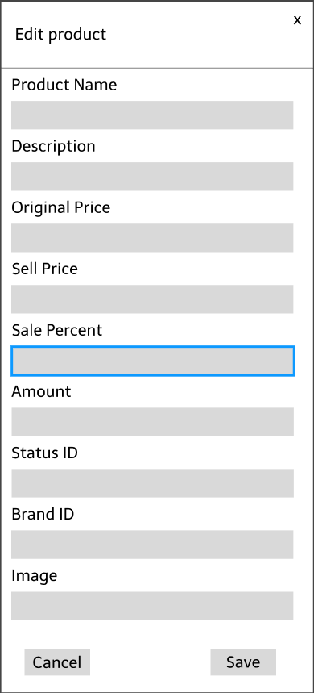

*Figure 2.30. Edit Product screen*

* Function Details: Update product information.

### 2.31. Delete product

* Function trigger: When the seller clicks the Delete button in the Actions section.
* Function description:
  + Actors/roles: Seller.
  + Purpose: Allow users to remove products from the list.
  + Data processing: The system sends a message asking to confirm Delete the product.
* Screen layout:



*Figure 2.31. Delete Product*

* Function Details: Delete product.

### 2.32. Manage Feedback List (Seller)

* Function trigger: When the seller clicks Manage Feedback in the Slidebar.
* Function description:
  + Actors/roles: Seller.
  + Purpose: Show seller all star reviews and user feedback on the product.
* Screen layout:

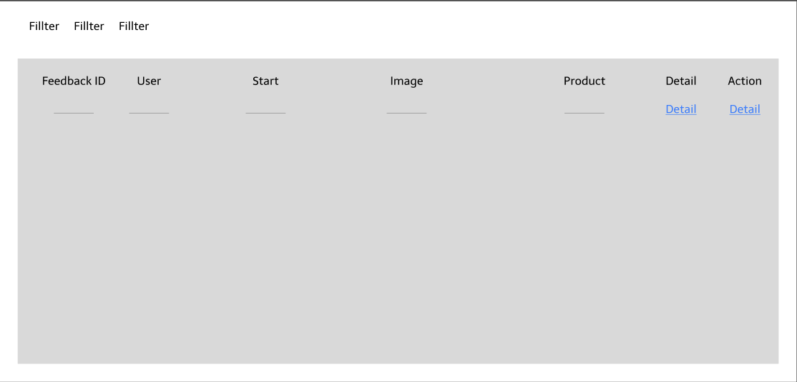

*Figure 2.32. List Feedback screen*

* Function Details: Displays all user feedback reviews about the product, can be sorted by Star rating, by time, alphabetically by username, ..

### 2.33. Feedback Detail

* Function trigger: When the seller clicks button Detail in the Action sesions.
* Function description:
  + Actors/roles: Seller.
  + Purpose: Display details of user feedback for products so seller can view and respond..
* Screen layout:

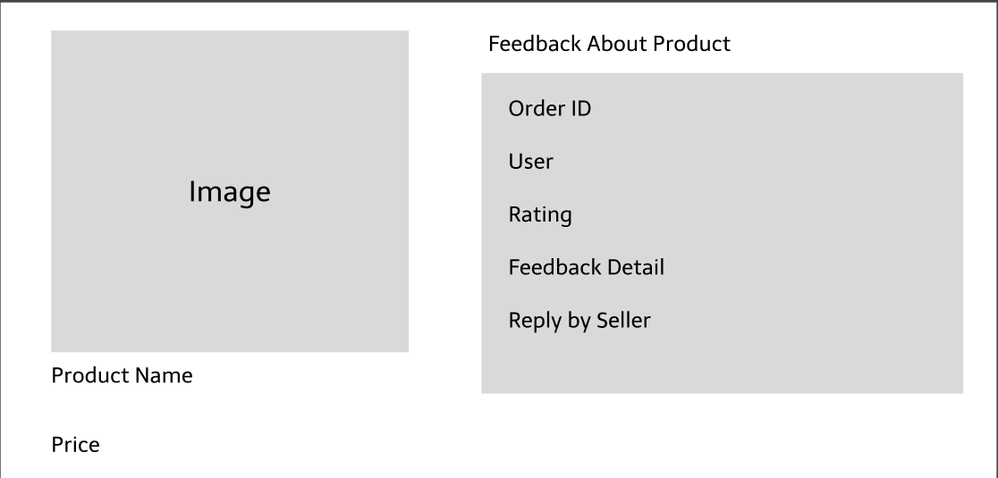

*Figure 2.33. Feedbakc Detail screen*

* Function Details: Show response details when seller clicks Detail button.

### 2.34. Reply Feedback

* Function trigger: When the user clicks the Reply button in the Actions section, the system directs the user to the Feedback reply page.
* Function description:
  + Actors/roles: Seller.
  + Purpose: Let merchants see and respond to user feedback.
  + Data processing: The system records the seller’s answer and updates the data and then returns the message to the user.
* Screen layout:

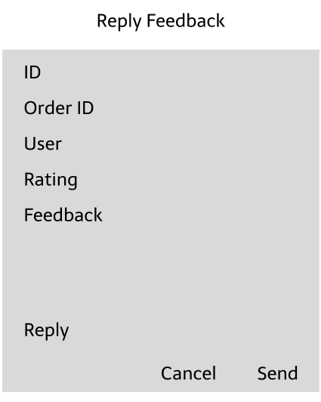

*Figure 2.34. Feedbakc Detail screen*

* Function Details: Send a reply message or update a reply message.