Operating Systems:

The Big Note – A Hartman Production
Really enjoying the big note? Buy me a coffee ☕

Chapter 1 - Computer Systems Overview:

Computer Systems Overview:

Operating Systems and the Components it Uses:
Operating systems exploit the hardware resources of one or more processors. They provide a set of services to system users and manage secondary memory and input/output (I/O) devices. The basic elements used by an operating system are the processor, I/O modules, main memory, and system bus.
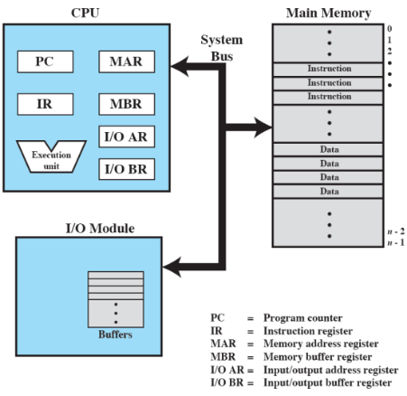
- The processor controls the operation of the computer, performs the data processing functions, and is referred to as the central processing unit (CPU).
- The main memory is volatile. The contents of the memory are lost when the computer is shut down and the main memory is referred to as real memory or primary memory.
- Input/output (I/O) modules move data between the computer and external environments such as storage, communications equipment, and terminals.
- The system bus provides for communication among processors, main memory, and I/O modules.
The figure above is the top-level view of the computer components used by the operating system.

Microprocessors, GPUs, DSPs, and SoC:
Microprocessors are an invention that brought about desktop and handheld computing. They are processors on a single chip and are the fastest general-purpose processor. There are also multiprocessors where each chip (socket) contains multiple processors (cores).
Graphical processing units (GPUs) provide efficient computation on arrays of data using single instruction multiple data (SIMD) techniques. GPUs are used for general numerical processing and typically handle physics simulations for games and computations on large spreadsheets.
Digital signal processors (DSPs) deal with streaming signals such as audio or video. They are embedded in devices like modems. DSPs also handle encoding/decoding speech and video (codecs) and support for encryption and security.
System on a chip (SoC) devices have components such as DSPs, GPUs, codecs, and main memory in addition to the CPUs and are on the same chip. To satisfy the requirements of handheld devices, the microprocessor is giving way to the SoC.

Instruction Execution:
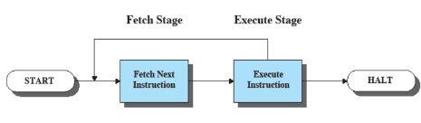
A program consists of a set of instructions stored in memory. There are two steps the processor follows:
- The processor reads (fetches) instructions from memory
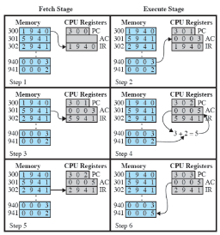
- The processor executes each instruction
The processor fetches the instructions from the memory, then the program counter (PC) holds the address of the instruction to be fetched next. The PC is incremented after each fetch. The fetched instruction is loaded into the instruction register (IR). The processor interprets the instructions and performs the required actions.

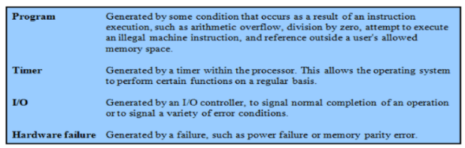
Interrupts:
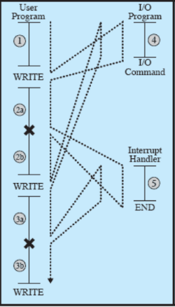
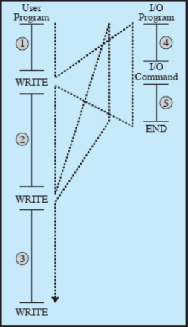
Interrupts are events that will interrupt the normal sequencing of the processor. To improve processor utilization, most I/O devices are slower than the processor. The processor must pause to wait for the device which is a wasteful use of the processor. To the right are the classes of interrupts.
To the right is the flow of control without interrupts (right) and with interrupts via a short I/O wait (left).

Transfer of Control via Interrupts:
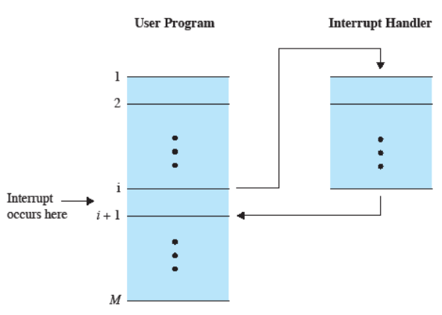

Instruction Cycle with Interrupts:
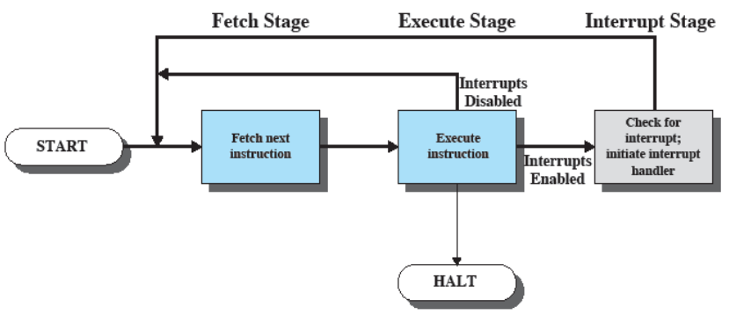

Program Timing with Short I/O Wait:
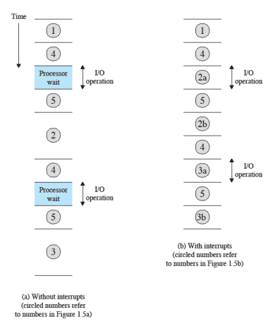

Program Timing with Long I/O Wait:
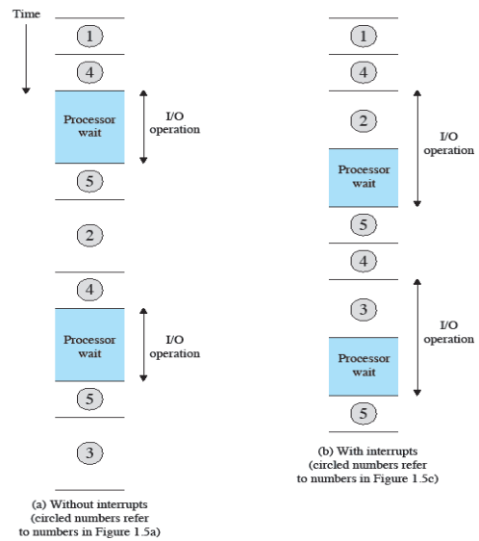

Simple Interrupt Processing:
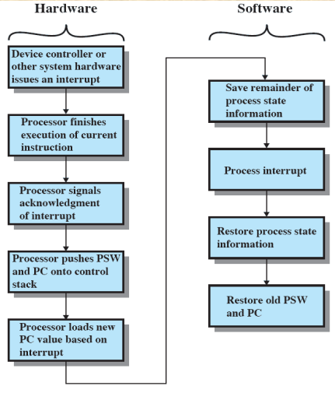

Multiple Interrupts:
Interrupts can occur while other interrupts are being processed (e.g. receiving data from a communications line and printing results at the same time). There are two approaches to handling this:
- Disable interrupts while an interrupt is being processed
- Use a priority scheme
The transfer of control with multiple interrupts can be done with sequential ordering or nested ordering.
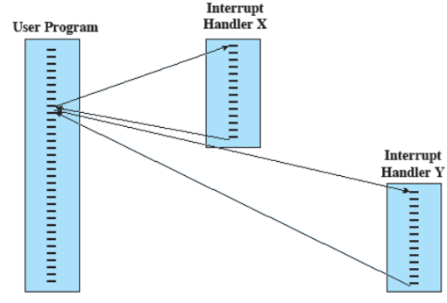
With sequential ordering, the flow of events is as follows:
- X interrupts at t=10
- While X is being processed, Y interrupts
- Interrupts are disabled while X is being processed
- After interrupt handler X completes, interrupts are enabled before resuming the user program
- At t=10, Y is processed
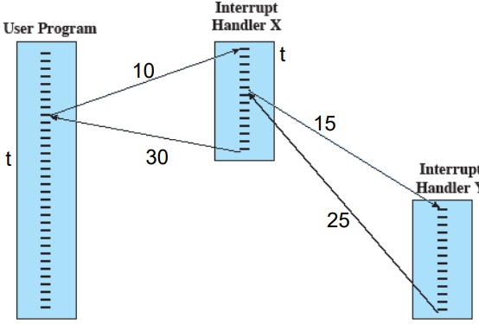
With nested ordering, the flow of events is as follows:
- X: priority = 2
- Y: priority = 5
- X interrupts at t=10
- Y interrupts at t=15
- Y will be given priority
- When Y completes, X resumes
- When X completes, user program continues

Memory:

Memory Hierarchy:
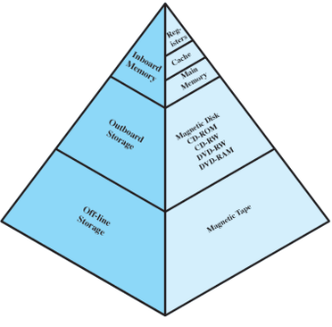
The 3 major constraints on memory are amount, speed, and expense. Memory must be able to keep up with the processor and the cost of memory must be reasonable in relation to the other components. Access time speed increasing will correlate to a greater cost per bit. Additionally, greater capacity correlates to a smaller cost per bit but slower access speed.
Going down the memory hierarchy is as follows:
- Decreasing cost per bit
- Increasing capacity
- Increasing access time
- Decreasing frequency of access to the memory by the processor

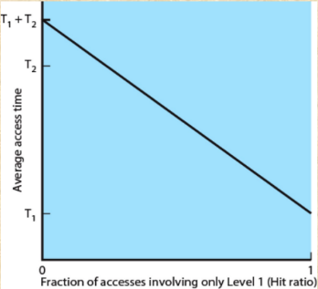
Performance of a Simple Two-Level Memory:
H refers to the hit ratio (fraction of all memory accesses that are found in level 1). Consider the scenario that the access time to level 1 is 0.1$μ$s and access time to level 2 is 1$μ$s. Suppose 95% of the memory accesses are found in the cache (H=0.95), the average time to access a byte is:
$0.95×0.1+0.05×\left(0.1+1\right)=0.15μs$

Secondary Memory:
Secondary memory is also referred to as auxiliary memory. It is external, nonvolatile, and used to store program and data files.

Cache Memory:
Cache memory is invisible to the operating system. It interacts with other memory management hardware. The processor must access memory at least once per instruction cycle (fetch instruction) so the processor execution is limited by memory cycle time.
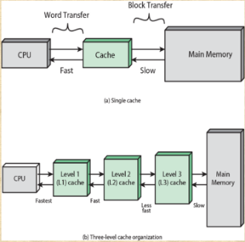
Cache memory exploits the principle of locality with a small and fast memory. Locality of reference (principle of locality) is the tendency of a processor to access the same set of memory locations repetitively over a short period of time. There are two basic types of reference locality: temporal locality and spatial locality. Temporal locality refers to the reuse of specific data and/or resources within relatively small time durations. Spatial locality refers to the use of data elements within relatively close storage locations. Sequential locality is a special case of spatial locality which occurs when data elements are arranged and accessed linearly (e.g. traversing elements in a one-dimensional array).
Cache principles are to contain a copy of a portion of main memory, have the processor first check the cache, and if not found in the cache, a block of memory is read into the cache.

Direct Memory Access (DMA):
Direct memory access (DMA) is performed by a separate module on the system bus or incorporated into an I/O module. Data is transferred between the storage device and memory. When the processor wishes to read or write data, it issues a command to the DMA module containing the following:
- Whether a read or write is requested
- The address of the I/O device involved
- The starting location in memory to read/write
- The number of words to be read/written
DMA transfers the entire block of data (one word at a time) directly to and from memory without going through the processor. The processor is involved only at the beginning and end of the transfer. The processor executes more slowly during a transfer when the processor access to the bus is required (not an interrupt, the processor waits for one bus cycle). DMA is more efficient than interrupt-driven or programmed I/O (transfer data from a device to another device using CPU).

Multiprocessor and Multicore:

Symmetric Multiprocessors (SMP):
Symmetric multiprocessors (SMPs) are stand-alone computer systems with the following characteristics:
- Two or more similar processors of comparable capability are used
- The processors share the same main memory and are interconnected by a bus or other internal connection scheme
- The processors share access to I/O devices
- All processors can perform the same functions
- The system is controlled by an integrated operating system that provides interaction between processors and their programs at the job, task, file, and data element levels
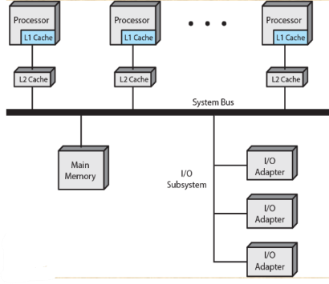
The advantages of SMP are performance (a system with multiple processors will yield greater performance if work can be done in parallel), scaling (vendors can offer a range of products with different price and performance characteristics), availability (the failure of a single processor doesn’t halt the machine), and incremental growth (an additional processor can be added to enhance performance).
The organization of SMP can be seen to the right.

Multicore Computer:
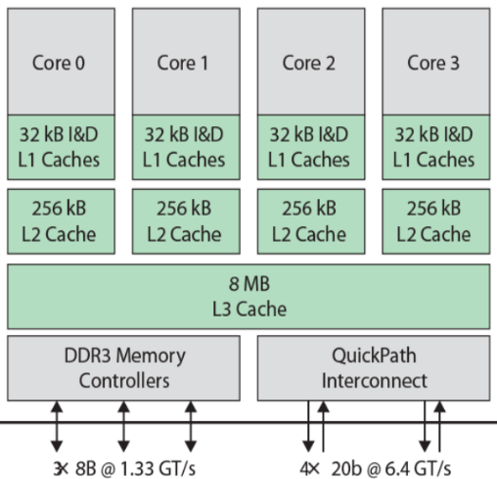
Multicore computers are also known as chip multiprocessors. They combine two or more processors (cores) on a single piece of silicon (die). Each core consists of all the components of an independent processor. In addition, multicore chips also include L2 cache and in some cases L3 cache.

Intel Core i7:
The Intel Core i7 supports two forms of external communications to other chips. DDR3 memory controllers bring the memory controller for the DDR (double data rate) main memory onto the chip. With the memory controller on the chip the front-side bus is eliminated. QuickPath Interconnect (QPI) enables high-speed communications among connected processor chips.

Chapter 2 – Introduction to the Process:

Operating System:
Operating systems are programs that control the execution of application programs. They are an interface between applications and hardware. The main objectives of an operating system are convenience, efficiency, and the ability to evolve.
The services involved in an operating system are:

- Program development
- Program execution
- Access I/O devices
- Controlled access to files
- System access
- Error detection and response
- Accounting

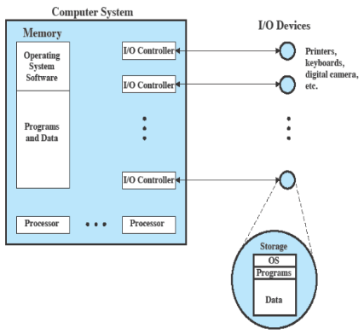
Computers are a set of resources for movement, storage, and processing of data. The operating system is responsible for managing these resources.
The operating system functions in the same way as ordinary computer software. It is a program, or suite of programs which are executed by the processor. The operating system frequently relinquishes control and must depend on the processor to allow it to regain control.
There are two modes of operation: user mode and kernel mode.

Batch Processing:
Batch processing is executing a set of computer programs such as each is completed before the next program of the set is started without manual intervention. Data is collected into batches of files.

Uniprogramming (Single Batch):
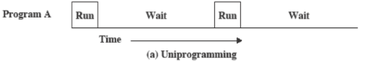
Uniprogramming is where the processor spends a certain amount of time executing, until it reaches an I/O instruction. It must wait until that I/O instruction concludes before proceeding.

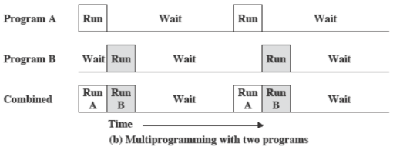
Multiprogramming:
There must be enough memory to hold the operating system (resident monitor) and one user program. When one job needs to wait for the I/O, the processor can switch to the other job, which is likely not waiting for I/O.
Multiprogramming is also known as multitasking and is when memory is expanded to hold three, four, or more programs and switch among all of them.

Time-Sharing Systems:
Time-sharing systems can be used to handle multiple interactive jobs. The processor time is shared among multiple users who simultaneously access the system through terminals, with the operating system interleaving the execution of each user program in a short burst or quantum of computation.

Process:
Processes are fundamental to the structure of operating systems. A process can be defined as a program in execution, an instance of a running program, the entity that can be assigned to (and executed on) a processor, or a unit of activity characterized by a single sequential thread of execution, a current state, and an associated set of system resources.
A process contains three components:
- An executable program
- The associated data needed by the program (variables, workspace buffers, etc...)
- The execution context (or “process state”) of the program
The execution context is essential. It is the internal data by which the operating system is able to supervise and control the process. It includes the contents of the various process registers and information such as the priority of the process and whether or not the process is waiting for the completion of a particular I/O event.

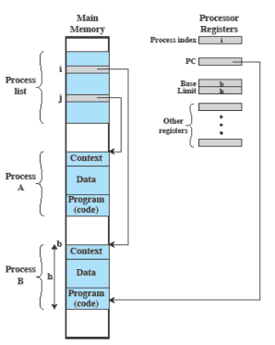
Process Management:
The entire state of the process at any instant is contained in its context. New features can be designed and incorporated into the operating system by expanding the context to include any new information needed to support the feature.
The operating system manages application execution. Resources are made available to multiple applications and the processor is switched among those applications so all will appear to be progressing allowing the processor and I/O devices to be used efficiently.
There are two essential elements of a process:
- The program code which may be shared with other processes that are executing the same program
- A set of data associated with that code
When the processor begins to execute the program code, the executing entity is referred to as a process. While the program is executing, this process can be uniquely characterized by a number of elements, including:

- Identifier
- State
- Priority
- Program Counter
- Memory Pointers
- Context Data
- I/O Status Information
- Accounting Information

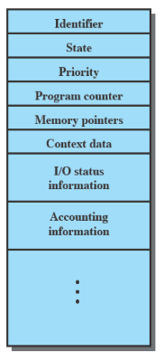
The process control block contains the process elements. It is possible to interrupt a running process and later resume execution as if the interruption had not occurred. The process control block is created and managed by the operating system and is a key tool that allows support for multiple processes.
Process states involve the trace and the dispatcher. The trace lists the sequence of instructions that execute for that process, and the behavior of the processor can be characterized by showing how the traces of the various processes are interleaved. The dispatcher is a small program that switches the processor from one process to another.

Process Execution:

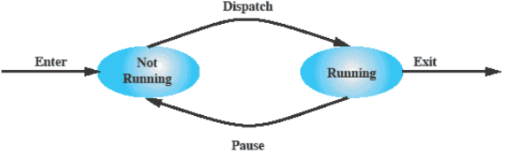
Two-State Process Model:
In the two-state process model, a process may be in one of two states: running or not-running. Processes in the not-running state are queued and handled one-by-one.

Process Creation:
Reasons for process creation are listed below:
New Batch Job | The OS is provided with a batch job control stream, usually on tape or disk. When the OS is prepared to take on new work, it will read the next sequence of job control commands.
Interactive Logon | A user at a terminal logs-onto the system.
Created by OS to Provide a Service | The OS can create a process to perform a function on behalf of a user program, without the user having to wait (e.g. a process to control printing).
Spawned by Existing Process | For purposes of modularity or to exploit parallelism, a user program can dictate the creation of a number of processes.
Process spawning is when the operating system creates a process at the explicit request of another process. A parent process is the original creating process and a child process is the new process.

Process Termination:
There must be a means for a process to indicate its completion. A batch job should include a HALT instruction or an explicit operating system service call for termination. For an interactive application, the action of the user will indicate when the process is completed (e.g. logging off or quitting an application).

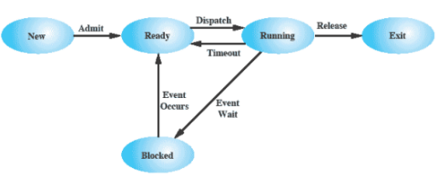
Five-State Process Model:
The two-state process model can be evolved to include processes waiting for events to occur before going back into the ready state.
This model has two queues, a ready queue and a blocked queue. Processes are taken from both queues one-by-one.

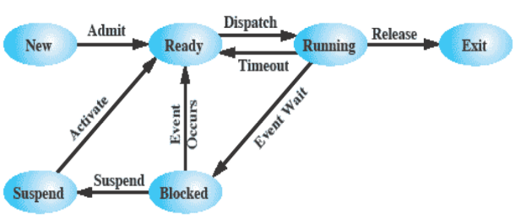
Suspended Processes:
Swapping involves moving part or all of a process from main memory to disk. When none of the processes in main memory are in the ready state, the operating system swaps one of the blocked processes out onto disk and into a suspended queue.
The five-state process model can be further evolved to include the suspended state.
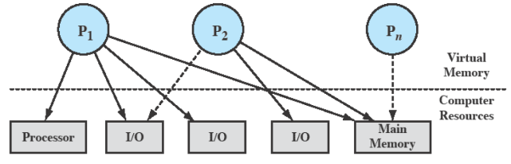
A suspended process is not immediately avaiable for execution. The process was placed in a suspended state by an agent; either itself, a parent process, or the operating system for the purpose of preventing its execution. The process may not be removed from this state until the agent explicitly orders the removal. The process also may or may not be waiting on an event.

Modes of Execution:
There are two modes of execution:
- User Mode
  - Less-privileged mode
  - User programs typically execute in this mode
- System Mode
  - More privileged mode
  - Also referred to as control mode or kernel mode
  - Kernel of the operating system

Chapter 3 – Intro to C++:

Introduction to C++:

Motivation and Background:
C++ is an immensely powerful language. It allows you to use all the features of modern, object-oriented programming, while still remaining very close to the hardware. Unlike Java, C#, Python, etc…, there is no barrier or runtime environment between the programmer and the operating system. This is both good and bad.

File Structure:
There are user-friendly IDEs in the world for C++ development (Qt, Visual Studio, Eclipse, etc). However, none of them are required. C++ is defined only on the assumption that there exists a file system.

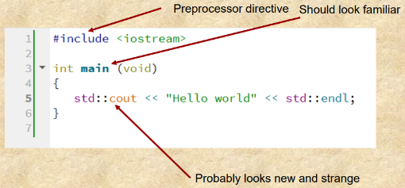
Source Files:
To the right is the classic simplest C++ program.
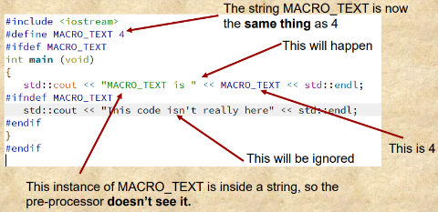
Line 1 is a pre-processor directive. Most C++ files start with a set of pre-processor directives which can be identified by the # sign. The pre-processor is not part of the C++ language. It’s a different program that essentially modifies the text of the code.
Different preprocessors have different features, but there are several directives which can be counted on. To the right is a slightly different program which shows them all.
The below table includes the meaning of the various directives.
Directive | Meaning
#include | This is for code re-use and modularity. It means, “Put the text of the file identified in the <angle brackets> into this current file”. Usually, the other files have .h extension. Built-in modules have no extension.
#define | Allows definition of file-wide constants. It does a text replace of the first thing with the second thing. It’s very crude. If you don’t specify the second thing, it just means “define this name”
#ifdef | If the name is defined, then include what follows as part of the file. Otherwise, pretend it’s not there.
#ifndef | If the name is not defined, then include what follows as part of the file. Otherwise, pretend it’s not there.
#endif | Terminate previous #ifdef or #ifndef

Header Files:
The #include directive is almost always used to bring in header files, which have .h or .hpp extension. Header files are used for the declaration of variables, classes, functions, and macros. They should never be used for the definition of a variable, class, or function.

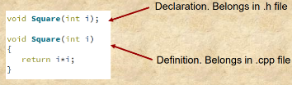
Declaration vs Definition:
The distinction of declaration vs definition probably seems strange if previously exposed to Java/C#/Python, etc. A declaration tells the compiler about a thing:
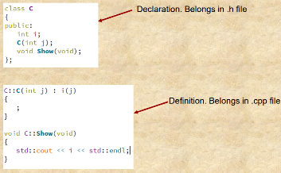
- “A class with these members exists”
- “A function with this name and these parameters exists”
- “A variable with this name and this type exists”
That’s all it is for. It doesn’t actually make any of those things.
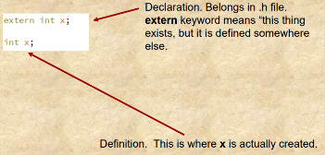
Functions, member functions (methods) and variables can be used once declared but must be defined once and only once by link time.
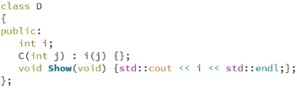
Inline function definitions are the exception. An example can be seen to the right. This probably looks more familiar as it’s in a similar format to Java/C#. It is very different however in C++ as what it actually is doing is inserting the code of the function wherever it’s being called. This should only be used for very short functions. Almost always declarations and definitions should be kept separate.
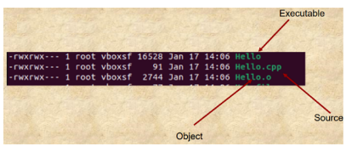

Compilation:
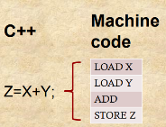
To the right is an example of what shows after compiling. Officially, a source file, after the pre-processor is a compilation unit. The compiler comes next to make an object file.
Compilers turn high level languages into machine code. Each line of code usually maps to several instructions.
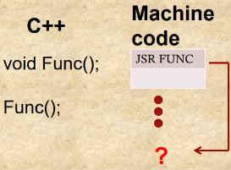
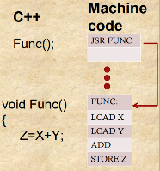
A special case is the function call, which jumps the CPU out of sequence. If the function is defined, the compiler can just jump to it. But, sometimes, the function is just declared. In these cases, the compiler can’t know where it is, so the compiler inserts a placeholder symbol indicating an undefined reference.

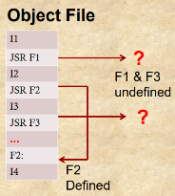
Object Files:
In the end, the compiler generates an object file, which is made of machine code. It also will contain a set of any undefined references.

Linkers:
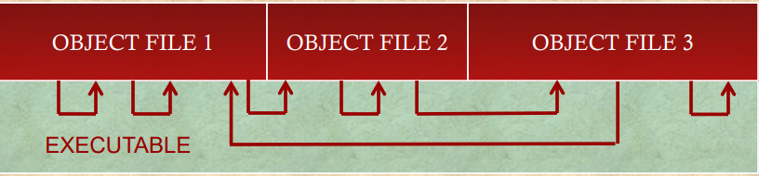
After each source file has been compiled, the collection of object files is passed to the linker. For the purposes of this class, the linker has two jobs:
- Mash all the code into one executable
- Resolve all undefined references by finding the definitions in other object files
Any reference that remains unresolved will trigger a linker error of the form “No definition for function Func was found” or “Unresolved external Func”. This is also the error thrown if a class member is declared and called without defining it.

Stream Input/Output:
To the right is a return to the first program above.
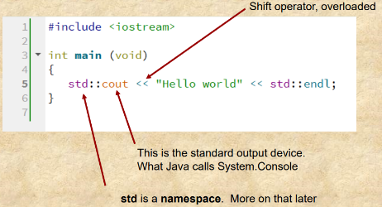
In Java, cout is comparable to System.console.write(…);
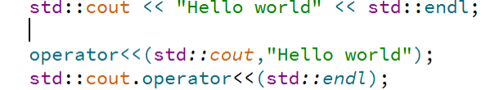
In C++ it is possible to overload operators. This means to take the basic operators that are defined in the language (+, -, *, /, <<, etc…) and define a new function that operates on some other class. In Java, every well-behaved class should have a method called toString, the C++ approach is for each class to overload the shift (<<) operator to stream itself to cout.
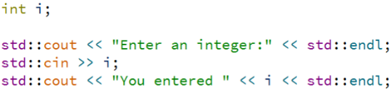
To the right is two ways of doing the same thing. Most people agree that the first way is pretty, and the second way is hideous, so the first way is typically used.
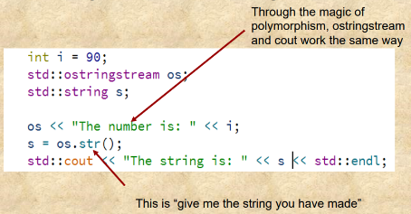
Input can also be streamed from cin. Not that when streaming in, use the right shift (>>) operator.
If wanting to make something into a string use stringstream.

Namespace std:
By now std:: has apparated all over the place. What is that?
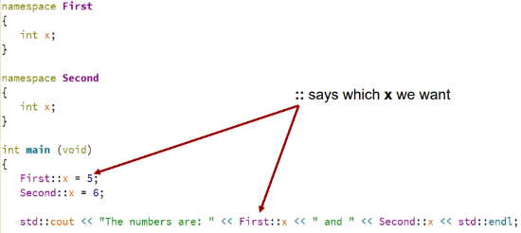
First, the :: operator is a scope resolution operator. If left::right is written, it means “I am referring to the right that was declared in namespace left”. namespace allows the developer to be sure their variable and function names won’t collide with somebody else’s.
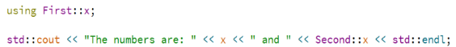
The keyword using can also be used to avoid explicitly doing the scope resolution each time.
The entire namespace can even be imported by writing “using namespace First;”. But some consider that bad form.
C++ the language is quite small. It doesn’t have a lot of things most developers would want. It doesn’t have I/O, or strings, or collections, or lots of useful things. So, std:: defines a namespace of useful stuff. Some have already been seen such as cout, string, ostringstream, etc…
std:: also defines a set of container classes. These include:
- std::list<class T>
- std::vector<class T>
- std::stack<class T>
- std::queue<class T>
- std::map<class Key, class T>
- …
Most of the time, if some kind of container is needed, std:: already has it.
The collections are all template classes. Which means they can be used with anything:
- std::vector<int> is a vector of ints
- std::vector<std::string> is a vector of std::strings
The following can even be used:
- std::vector<std::vector<int> > makes a vector of vectors (ie: a matrix) of int.
Note the space however after <int>. Without it, the compiler will see >> and think “shift”.
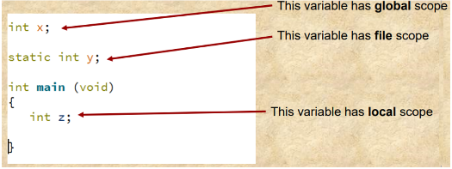

Variable Lifespan:
Probably the most powerful feature of C++, and the feature that is going to seem strangest is how C++ handles the issues of variable lifespan and (to a lesser extent) scope.
Type | Meaning
Global Scope | Every compilation unit that is linked can see this variable.
File Scope | Every function in the current compilation unit can see this variable, but nobody else.
Local Scope | Only accessible within the current block statement (curly braces {}).
Namespace Scope | Any function in the namespace can see it.
Class Scope | Any function in the class can see it.

Value Semantics:
The issue of lifespan is much trickier because C++ allows something called value semantics, which is (almost) completely absent from Java.
Suppose there’s a Java class called C that has a constructor that takes no parameters. To make an int, do “int i;”. But does “C c;” give a C? In Java, the answer is no. What is created is an undefined “reference” to a C. To actually make one, do “c = new C();”.
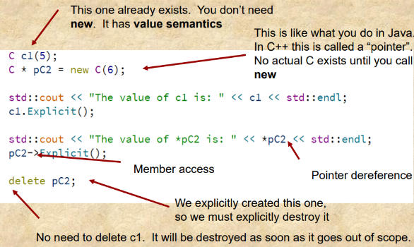
Java also has garbage collection, which means that when done with c, it can be discarded. A new one can even be made re-using the reference. The old one will just magically die. C++ does not have garbage collection. If garbage is left lying around, it’s like leaving candy wrappers on the floor. Eventually the whole floor is covered in candy wrappers. In Java, eventually, the runtime environment will come and clean up the mess but in C++, it is the developer’s job to manage the lifespan of their variables.
Consider the definition for class C below and the example to the right of using it.
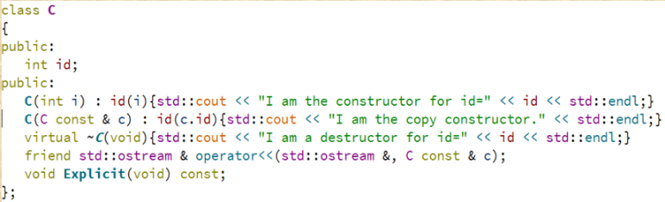

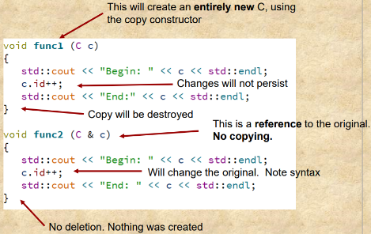
References in C++:
The first reason most people give for why Java is better than C++ is because it doesn’t have pointers. However, Java has only pointers (it just calls them references). Unfortunately, to make life more complicated, C++ also has a thing it calls references.
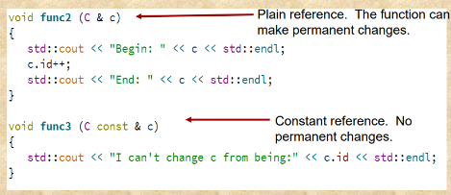
Keyword const specifies no copying, and also no changing.

std::shared_ptr:
One of the most common problems in C++ programming has to do with pointers, and forgetting to call delete, or worse, calling delete at the wrong time.
For that, there is std::shared_ptr<T> which can be used through something like this:
- std::shared_ptr<T> newT(new T());
newT acts like a pointer with built-in garbage collection. This is highly recommended if pointer semantics are needed.

Object Orientation:

Polymorphism in C++:
C++ also has all the features of a polymorphic, object-oriented language. The keyword virtual signals the compiler that a member (method) in a base class can be overridden by a member with the same signature in the derived class.
Polymorphic calls work through both pointers and references, whether const or not. The exception is if the variable has value semantics.
C++ does not have interface as in Java. However, the same thing can be accomplished with a pure virtual function (declared = 0) in the base class and multiple inheritance. A class that contains a pure virtual function is called “abstract” and cannot be instantiated. The pure virtual function must be implemented in a derived class.

Chapter 4 – Intro to Threads:

Processes and Threads:
Processes have two characteristics:
- Resource Ownership
  - Processes include a virtual address space to hold the process image and the OS performs a protection function to prevent unwanted interference between processes with respect to resources.
- Scheduling/Execution
  - An execution path is followed that may be interleaved with other processes. A process has an execution state (Running, Ready, etc…) and a dispatching priority. Processes are scheduled and dispatched by the OS.
The unit of dispatching is referred to as a thread or lightweight process. The unit of resource ownership is referred to as a process or task. Multithreading is the ability of an operating system to support multiple concurrent paths of execution within a single process.

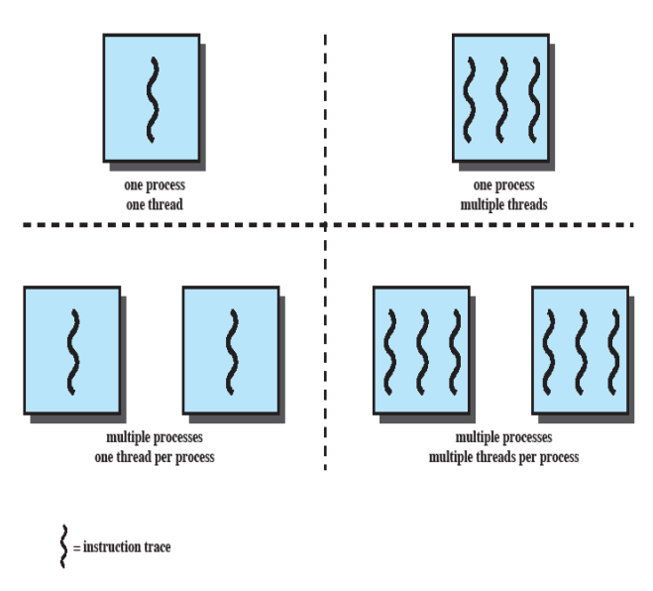
Single vs Multiple Threads:

Single Threaded Approaches:
A single thread of execution per process, in which the concept of a thread is not recognized, is referred to as a single-threaded approach. MS-DOS is an example. The left half of the figure to the right depicts single threaded approaches.

Multithreading Approaches:
The right half of the figure to the right depicts multithreaded approaches. A Java run-time environment is an example of a system of one process with multiple threads.

Processes:
Processes are the unit of resource allocation and a unit of protection. They are a virtual address space that holds the process image. Processes have protected access to processors, other processes, files, and I/O resources.
Processes are able to have one or more threads. Each thread has:
- An execution state (Running, Ready, etc…)
- Saved thread context when not running
- An execution stack
- Some per-thread static storage for local variables
- Access to the memory and resources of its process (all threads of a process share this)
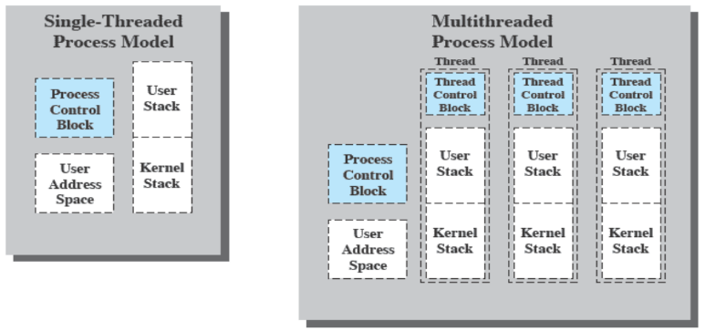
Threads have a user stack and a kernel stack. The user stack is accessible to the user, whereas the kernel stack usually has some sort of access protection. The kernel stack might contain things such as the exception/interrupt handler and things are stored in the kernel stack in a separate memory location from the user stack.

Threads:
Some benefits of threads include:
- It takes less time to create a new thread than a new process
- It takes less time to terminate a thread than a process
- Switching between two threads takes less time than switching between processes
- Threads enhance efficiency in communication between programs
Threads are often used in a single-user system for foreground and background work, asynchronous processing, speed of execution, and modular program structure.
In an OS that supports threads, scheduling and dispatching is done on a thread basis. Most of the state information dealing with execution is maintained in thread-level data structures. Suspending a process involves suspending all threads of the process and termination of a process terminates all threads within the process.
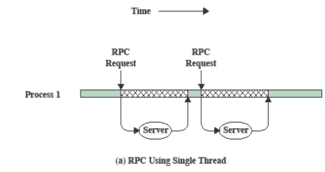
The key states for a thread are running, ready, and blocked. Thread operations associated with a change in thread state are spawn, block, unblock, and finish.
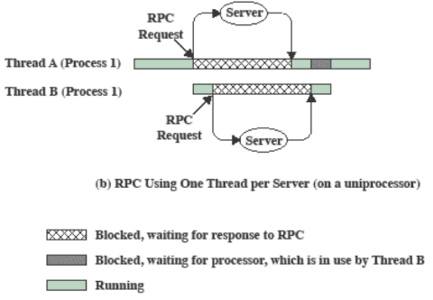
To the right are 2 diagrams showing a comparison of a remote procedure call using only a single thread (left diagram) versus using one thread per server (right diagram).

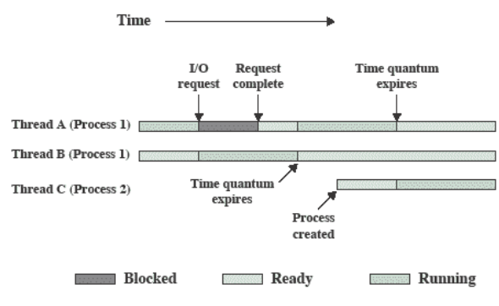
Multithreading on a Uniprocessor:
Multithreading can be done on a uniprocessor, which is a computer system that only has a single CPU which is used to execute tasks.
An example of how multithreading on a uniprocessor works is shown in the diagram to the right.

Thread Synchronization:
It is necessary to synchronize the activities of the various threads as all threads of a process share the same address space and other resources. Any alteration of a resource by one thread affects the other threads in the same process.

Types of Threads:
There are two types of threads:
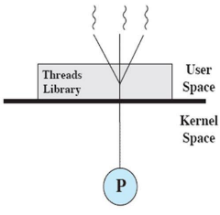
- User level threads (ULTs)
  - All thread management is done by the application
  - The kernel is not aware of the existence of threads
  - Can run on any OS
  - Thread switching doesn’t require kernel mode privileges
  - Scheduling can be application specific
- Kernel level threads (KLTs)
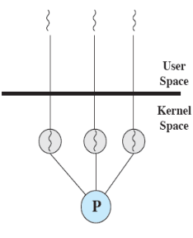
  - Thread management is done by the kernel
  - No thread management is done by the application
  - Windows is an example of this approach
  - The kernel can simultaneously schedule multiple threads from the same process on multiple processors
  - If one thread in a process is blocked, the kernel can schedule another thread of the same process
  - Kernel routines can be multithreaded
Some disadvantages of ULTs are that in a typical OS, many system calls are blocking. As a result, when a ULT executes a system call, not only is that thread blocked, but all of the threads within the process are blocked. Additionally, in a pure ULT strategy, a multithreaded application cannot take advantage of multiprocessing.
Jacketing can be used to overcome some of the disadvantages of ULTs. Jacketing converts a blocking system call into a non-blocking system call by writing an application as multiple processes rather than multiple threads.
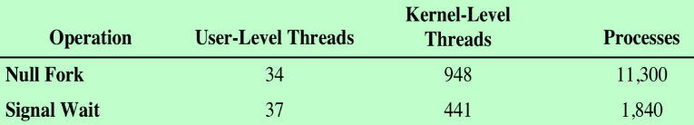
Some disadvantages of KLTs are that the transfer of control from one thread to another within the same process requires a mode switch to the kernel.
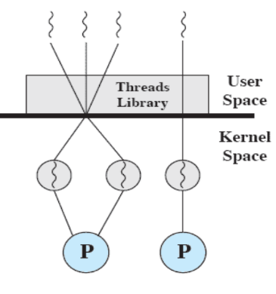
Often combined approaches are used. The thread creation is done in the user space and the bulk of the scheduling and synchronization of threads is done by the application. Solaris is an example of this.

Relationship Between Threads and Processes:
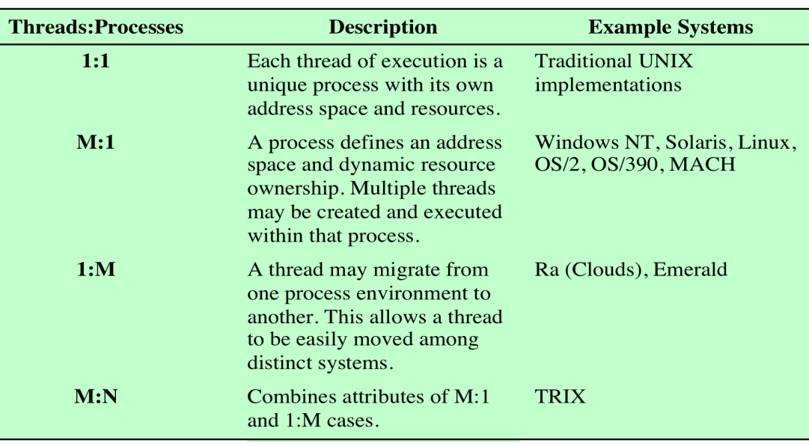

Background Processing in GUI:
Most modern, user-facing applications use some form of Graphical User Interface (GUI). Some examples with are likely familiar are GUI from Windows/Macintosh applications as well as smartphone apps for iOS, Android, etc…

GUI Controls:
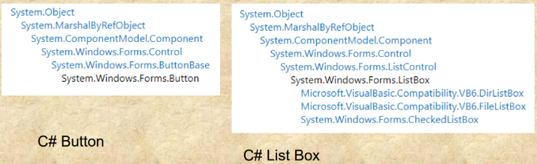
GUI environments are built in a highly object-oriented way. Functionality is abstracted as much as possible. The example to the right shows how the list box and button GUI elements are handled by the system. The path is mostly the same up until the component details themselves.
Typically, each of these controls contains a set of virtual functions that can be overloaded if needed, but also contains default behavior if not overloaded.

GUI Event Loop:
At the core of GUI programming is the event loop. The actual mechanism underlying the event loop will be discussed in a later lecture. For now, a simple model can be used.
At the time of creation, GUI programs are created as processes that have one thread. This is the UI thread. Everything that can be seen happening, happens on the UI thread. Most GUI programming involves the writing of event handlers. The job of the UI thread is to handle user input and dispatch (as needed) to the appropriate event handler.
Essentially, what’s being run on the UI thread is a giant decision tree:
- If the user does ActionA THEN HandleEventA
- If the user does ActionB THEN HandleEventB
- …
Modern development environments hide the details, so the event handlers are all that needs to be written. The thing to remember with GUI programming is that the UI thread does everything the user can see which includes stuff not written by the programmer themselves (i.e. when using defaults). Examples include moving the mouse pointer, moving the window, context switching, etc…
Nothing can be done in an event handler on the UI thread that will take a non-trivial amount of time. People often distinguish I/O constrained tasks from computationally heavy tasks. That distinction matters, but the real distinction is fast (okay for GUI) vs slow (not okay for GUI).
Unfortunately, worthwhile tasks often take non-trivial amounts of time. The work-around in GUI systems is called background processing. Instead of writing an event handler that does the work, the event handler simply starts the work.

I/O vs Computation:
I/O constrained tasks are tasks that are slow because they involve waiting for something (time, communication, user input, completion of some other job, etc…). Computationally heavy tasks are tasks that just take a long time (local database searching, large matrix operations, spreadsheet recalculations, compilation, etc…).
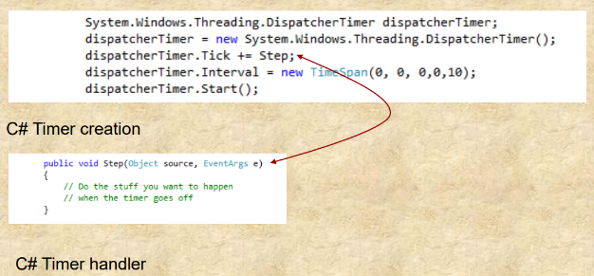
What makes I/O constrained tasks special is that the OS can support them by creating controls with appropriate handlers for both tasks. The OS can do this because it’s internals are needed to make these operations work.

I/O Bound Example (Timers):
Most GUI environments contain a built-in Timer object that generates events at regular intervals. The timer can be created, then a handler can be written to execute something when it completes.

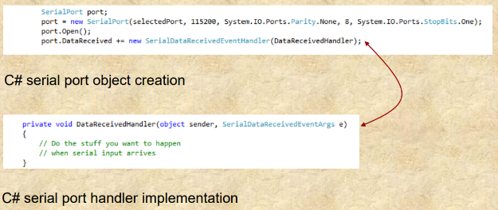
I/O Bound Example (Communication):
Communication objects (sockets, serial ports, etc…) often also have associated handlers for data reception.

Background Threads:
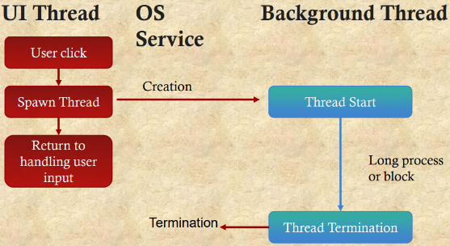
Obviously, OS designers can’t predict every problem that may arise. As a result, it’s not possible to “build-in” a control that can do every background operation. For that, background threads are used. These are threads that need to be explicitly created to handle slow tasks. Background threads are needed as non-trivial GUI programming cannot be done without them. Even I/O bound operations with built-in controls can alternatively be implemented with background threads.
Usually, the background thread will want to tell the user something (data has been received, the computation is finished, time has elapsed, etc…). The problem is this cannot be done. All user-facing elements belong to the UI thread. Modern GUI environments will kill any process that tries to update UI elements from the background thread.
A workaround can be implemented for this problem though. The UI thread can give to the background thread a reference to its own event loop. Then, the background thread can post the event it wants on the UI thread. In Java, this is done using a Runnable as can be seen below.
In C#, this operation requires a Delegate and the Invoke method. A Delegate is a kind of function pointer that wraps up the code which needs to be run on the UI thread. Invoke is sort of like Post.

Java Example using Runnable:
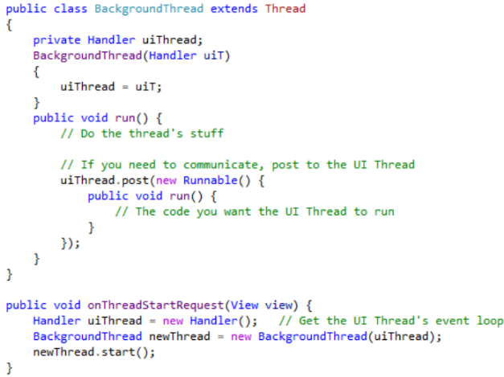

C# Example using Delegate:
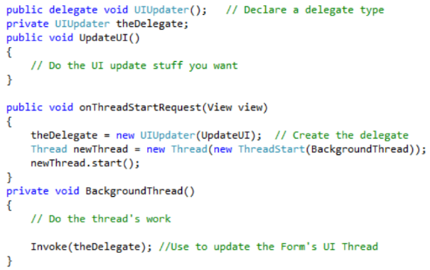

Background Workers:
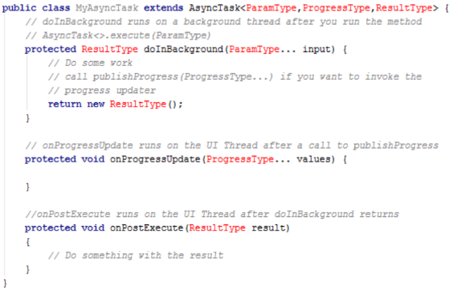
Creating a background thread and having it update the UI thread has a lot of common steps involved. The thread has to be created, a progress bar has to be created, the progress bar has to be updated, completion needs to be indicated, etc…
Java has a very useful object called AsyncTask that makes all of this easy. AsyncTask is generic and must be qualified with the types of the input parameter, the progress variable, and the result. It must be subclassed.
C# implements the BackgroundWorker class. It is almost exactly the same as AsyncTask<>. It contains DoWork (an event handler where the thread happens), ProgressChanged (an event handler in case a progress bar needs to be updated or something similar), and RunWorkerCompleted (an event handler for when it’s done). BackgroundWorker is handled in the IDE like any other control.
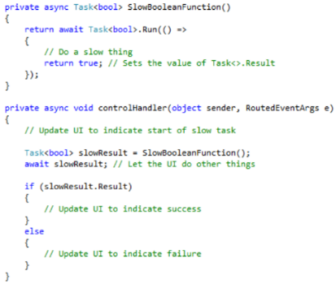
C# also contains the keyword async, with associated keyword await. Basically, the runtime environment is told “this event handler is slow to return so don’t wait for it”. The UI thread is free to do other stuff but comes back when needed to finish the job.
Async/await actually handles I/O bound and CPU bound tasks differently. Strictly speaking, only Task<>.Run is needed for CPU bound tasks. The internal details are very complicated and way beyond the scope of the course. Java also has something similar called “future”.

Android Process Model:
Android is a software stack. In one sense, Android processes are not processes. To the Linux scheduler, instances of the Dalvik VM are processes (basically). Android apps are made of Activities (dialog boxes/frames the user can see) and Services (stuff that runs in the background). The Android scheduler is obsessed with one goal: responsiveness of the front-page Activity. To maintain responsiveness, the scheduler will kill any other process based on a priority scheme.

Android Priority Stack:
The Android priority stack is as follows:
- Active Process (critical and privileged)
  - Active means an Activity the user is interacting with or a Service that is currently doing something. There’s usually only one or two and the scheduler will protect them at all costs.
- Visible Process (high)
  - Visible means the user can see it, but it doesn’t currently have the focus. It is protected by the scheduler if possible.
- Started Services (high)
  - Started Service processes means the process has registered a Service, but it’s in a blocked state. It is protected by the scheduler if possible.
- Background Process (low)
  - Background processes means the process hosts Activities that aren’t visible. The scheduler discards these if necessary.
- Empty Process (low)
  - Empty processes means the process is dead, but the process block remains allocated just in case it’s needed again. The scheduler discards these if necessary

Application Life Cycle:
All Android applications inherit from the Application class. onCreate is called when it’s first created and is used to allocate. Application instances last as long as their process lasts. onLowMemory is called by the runtime environment to ask applications to free memory. onConfigurationChanged in Android will indicate if the device is rotated giving the developer a chance to handle the event if needed.

Activity Life Cycle:
All user-facing Android applications have at least one Activity. Activities are more or less equivalent to dialog boxes, frames, screens, and so on in other GUI systems. Activities are restarted by configuration changes.
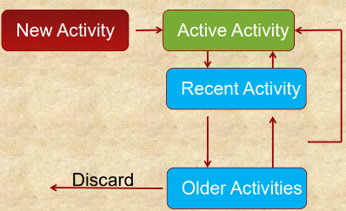
Activities are managed in a way very similar to our standard vision of the process lifecycle. In Android, this is called the Activity stack.
In the activity life cycle, Active means the activity is at the top of the stack and is receiving user input. Paused means the Activity is visible but isn’t receiving user input. Stopped means the Activity isn’t visible. It immediately becomes a candidate for termination. Inactive means the Activity isn’t anywhere in the stack and must be restarted to become Active again.
All of this is supposed to be invisible, so it’s best to remember the state of the UI during state changes. State change handlers come in pairs of onCreate and onDestroy. onCreate is called when the Activity is first created, but also if the runtime environment killed the activity and is now resurrecting it. onDestroy should run at termination, but Android doesn’t necessarily guarantee that.
An Activity is visible between onStart and onStop. onStart is called every time the Activity becomes visible. onStop should be called when it stops being visible, but Android doesn’t necessarily guarantee that. onRestart is called just before onStart, except for the first call to onStart.
An Activity is active between onResume and onPause. onResume is called every time the Activity becomes active. onPause is called when it stops being active and that is guaranteed by Android. onSaveInstanceState is called just before onPause and enables the developer to save any UI information the user will expect to see when it resumes.

Chapter 5 – Concurrency, Mutual Extension, and Synchronization:

Multiple Processes:
Operating system design is concerned with the management of processes and threads. This involves multiprogramming, multiprocessing, and distributed processing.

Concurrency:
Concurrency arises in three different contexts:
- Multiple applications – Invented to allow processing time to be shared among active applications
- Structured applications – Extension of modular design and structured programming (set of concurrent processes)
- Operating system structure – Operating systems themselves are implemented as a set of processes or threads.
Atomic operations are a function or action implemented as a sequence of one or more instructions that appears to be indivisible (no other process can see an intermediate state or interrupt the operation). The sequence of instruction is guaranteed to execute as a group, or not execute at all, having no visible effect on system state. Atomicity guarantees isolation from concurrent processes.
Critical sections are sections of code within a process that require access to shared resources and that must not be executed while another process is in a corresponding section of code.
Deadlocks are situations where two or more processes are unable to proceed because each is waiting for one of the others to do something. Livelocks are situations in which two or more processes continuously change their states in response to changes in the other processes(es) without doing any useful work.
Mutual exclusion is the requirement that when one processes is in a critical section that accesses shared resources, no other processes may be in a critical section that accesses any of those shared resources.
Race conditions are situations where multiple threads or processes read and write a shared data item and the result depends on the relative timing of their execution. The final result depends on the order of execution where the “loser” of the race is the process that updates last and will determine the final value of the variable.
Starvation is a situation where a runnable process is overlooked indefinitely by the scheduler. Although it’s able to proceed, it’s never chosen.
Interleaving and overlapping can be viewed as examples of concurrent processing. Both present the same problems.
Uniprocessors have a relative speed of execution of processes that cannot be predicted. It depends on the activities of other processes, the way the OS handles interrupts, and the scheduling policies of the OS.
Some difficulties of concurrency include the sharing of global resources, managing the allocation of resources optimally, and locating programming errors as results are not deterministic and reproducible.
Some design and management issues raised by the existence of concurrency are that the operating system must be able to keep track of various processes, allocate and de-allocate resources for each active process, protect the data and physical resources of each process against interference by other processes, and ensuring that the processes and outputs are independent of the processing speed.

Process Interactions:
Degree of Awareness | Relationship | Influence that One Process Has on the Other | Potential Control Problems
Processes unaware of each other | Competition | Results of one process independent of the action of others, and timing of process may be affected | Mutual exclusion, deadlock, starvation
Processes indirectly aware of each other (e.g. shared object) | Cooperation by sharing | Results of one process may depend on information obtained from others, and timing of process may be affected | Mutual exclusion, deadlock, starvation, data coherence
Processes directly aware of each other (have communication primitives available to them) | Cooperation by communication | Results of one process may depend on information obtained from others, and timing of process may be affected | Deadlock, starvation

Resource Competition:
Concurrent processes come into conflict when they are competing for use of the same resource (e.g. I/O devices, memory, processor time, clock, etc…). In the case of competing processes, three control problems must be faced: the need for mutual exclusion, deadlock, and starvation.
Requirements for mutual exclusion are:
/* Process n */
void PN {
while(true) {
/* preceding code */
enter_critical(Ra);
/* critical section */
exit_critical(Ra);
/* following code */
}
}
/* Process 2 */
void P2 {
while(true) {
/* preceding code */
enter_critical(Ra);
/* critical section */
exit_critical(Ra);
/* following code */
}
}
/* Process 1 */
void P1 {
while(true) {
/* preceding code */
enter_critical(Ra);
/* critical section */
exit_critical(Ra);
/* following code */
}
}
- It must be enforced
- A process that halts must do so without interfering with other processes
- No deadlock or starvation
- A process must not be denied access to a critical section when there’s no other process using it
- No assumptions are made about relative process speeds or number of processes
- A process remains inside its critical section for a finite time only
If using a uniprocessor system, disabling interrupts guarantees mutual exclusion. However, the efficiency of execution could be noticeably degraded, and this approach won’t work in a multiprocessor architecture.
Special machine instructions called compare and swap instructions (a.k.a. compare and exchange instructions) are when a compare is made between a memory value and a test value. If the values are the same, a swap occurs. This is carried out automatically.
/* program mutual exclusion - exchange */
const in n = /* number of processes */
int bolt;
void P(int i) {
int keyi = 1;
while (true) {
do {
exchange (keyi, bolt)
}
while (keyi != 0);
/* critical section */
bolt = 0;
/* remainder */
}
}
void main() {
bolt = 0;
parbegin(P(1), P(2), …, P(n));
}
/* program mutual exclusion - compare&swap */
const in n = /* number of processes */
int bolt;
void P(int i) {
while (true) {
while (compare_and_swap(bolt, 0, 1) == 1) {
/* do nothing */
}
/* critical section */
bolt = 0;
/* remainder */
}
}
void main() {
bolt = 0;
parbegin(P(1), P(2), …, P(n));
}
These special machine instructions are applicable to any number of processes on either a single processor or multiple processors sharing main memory. They are simple and easy to verify. They can also be used to support multiple critical sections where each critical sections can be defined by its own variable.
Some disadvantages to these special instructions are that busy-waiting is employed, thus while a process is waiting for access to a critical section it continues to consume processor time. Starvation is also possible when a process leaves a critical section and more than one process is waiting. Lastly, deadlock is possible.

Common Concurrency Mechanisms:
Semaphores are a mechanism where an integer value is used for signaling processes. Only three operations may be performed in a semaphore, all of which are atomic. The operations are initialize, decrement, and increment. The decrement operation may result in the blocking of a process, and the increment operation may result in the unblocking of a process. These are also known as a counting semaphore or a general semaphore. Binary semaphores take on only the values 0 and 1.
A mutex is similar to a binary semaphore. A key difference between the two is that the process that locks the mutex (sets the value to zero) must be the one to unlock it (sets the value to 1).
Condition variables are a data type that is used to block a process or thread until a particular condition is true.
Monitors are a programming language construct that encapsulates variables, access procedures, and initializes code within an abstract data type. The monitor’s variable may only be accessed via its access procedures and only one process may be actively accessing the monitor at any one time. The access procedures are critical sections. A monitor may have a queue of processes that are waiting to access it.
Event flags are a memory word used as a synchronization mechanism. Application code may associate a different event with each bit in a flag. A thread can wait for either a single event or a combination of events by checking one or multiple bits in the corresponding flag. The thread is blocked until all of the required bits are set (AND) or until at least one of the bits is set (OR).
Mailboxes/messages are a means for two processes to exchange information and that may be used for synchronization.
Spinlocks are a mutual exclusion mechanism in which a process executes in an infinite loop, waiting for the value of a lock variable to indicate availability.

Semaphores:
A semaphore is a variable that has an integer value upon which there are only three operations defined. There is no way to inspect or manipulate semaphores other than these three operations.
- May be initialized to a non-negative integer value
- The semWait operation decrements the value
- The semSignal operation increments the value
There is no way to know before a process decrements a semaphore whether it will block or not. There is also no way to know which process will continue immediately on a uniprocessor system when two processes are running concurrently. It’s also not known whether another process is waiting so the number of unblock processes may be zero or one.

Semaphore Primitives:
struct semaphore {
int count;
queueType queue;
}
void semWait(semaphore s) {
s.count--;
if (s.count < 0) {
/* place this process in s.queue */
/* block this process */
}
}
void semSignal(semaphore s) {
s.count++;
if (s.count <= 0) {
/* remove a process P from s.queue */
/* place process P on ready list */
}
}

Binary Semaphore Primitives:
struct binary_semaphore {
enum {zero, one} value;
queueType queue;
}
void semWait(binary_semaphore s) {
if (s.value == one) s.value = zero;
else {
/* place this process in s.queue */
/* block this process */
}
}
void semSignal(binary_semaphore s) {
if (s.queue is empty()) s.value = one;
else {
/* remove a process P from s.queue */
/* place process P on ready list */
}
}

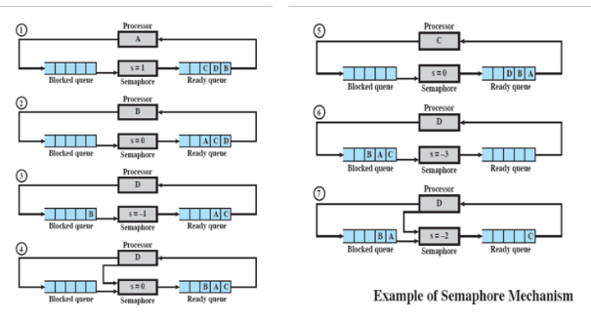
Strong/Weak Semaphores:
A queue is used to hold processes waiting on the semaphore. A strong semaphore is where the process that has been blocked the longest is released from the queue first (FIFO). A weak semaphore doesn’t specify the order in which the processes are removed from the queue.

Mutual Exclusion:
Mutual exclusion can be accomplished using semaphores as shown below:
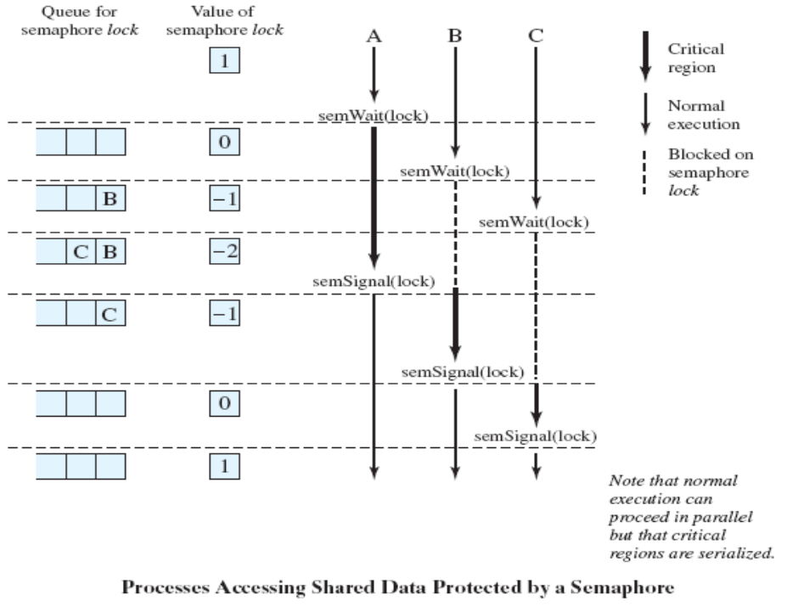
/* program mutual exclusion */
const int n = /* number of processes */
semaphore s = 1;
void P(int i) {
while (true) {
semWait(s);
/* critical section */
semSignal(s);
/* remainder */
}
}
void main() {
parbegin (P(1), P(2), …, P(n));
}

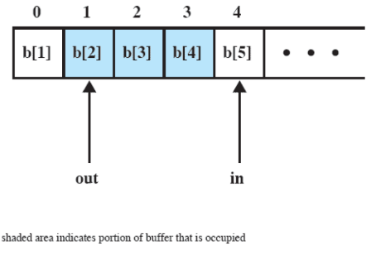
Producer/Consumer Problem:
 | Producer | Consumer | s | n | delay
1 |  |  | 1 | 0 | 0
2 | semWait(s) |  | 0 | 0 | 0
3 | n++ |  | 0 | 1 | 0
4 | if(n==1) semSignal(delay) |  | 0 | 1 | 1
5 | semSignal(s) |  | 1 | 1 | 1
6 |  | semWait(delay) | 1 | 1 | 0
7 |  | semWait(s) | 0 | 1 | 0
8 |  | n-- | 0 | 0 | 0
9 |  | semSignal(s) | 1 | 0 | 0
10 | semWait(s) |  | 0 | 0 | 0
11 | n++ |  | 0 | 1 | 0
12 | if(n==1) semSignal(delay) |  | 0 | 1 | 1
13 | semSignal(s) |  | 1 | 1 | 1
14 |  | if(n==0)semWait(delay) | 1 | 1 | 1
15 |  | semWait(s) | 0 | 1 | 1
16 |  | n-- | 0 | 0 | 1
17 |  | semSignal(s) | 1 | 0 | 1
18 |  | if(n==0)semWait(delay) | 1 | 0 | 0
19 |  | semWait(s) | 0 | 0 | 0
20 |  | n-- | 0 | -1 | 0
21 |  | semSignal(s) | 1 | -1 | 0
The general situation is that one or more producers are generating data and placing these in a buffer. A single consumer is taking items out of the buffer one at a time. Only one producer or consumer may access the buffer at any one time. The problem becomes, how can it be ensured that the producer can’t add data into the full buffer, and the consumer can’t remove data from an empty buffer?
/* program producer consumer */
int n;
binary_semaphore s = 1, delay = 0;
void producer() {
while (true) {
produce();
semWait(s);
append();
n++;
if (n == 1) semSignal(delay);
semSignal(s);
}
}
void consumer() {
semWait(delay);
while (true) {
semWait(s);
take();
n--;
semSignal(s);
consume();
if (n == 0) semWait(delay);
}
}
void main() {
n = 0;
parbegin (producer, consumer);
}
Notice that the above solution has a bug. The n variable goes below -1 because the producer increased n before the consumer could check if n was equal to 0. This made the consumer skip calling semWait(delay). Because of this, after looping back to the top of the consumer while loop, it decrements n back to 0 making it call semWait(delay). But the delay semaphore already has a signal because the producer sent one prior, so the consumer can go through the while loop again, making n go into the negatives. A solution to this problem is shown below:
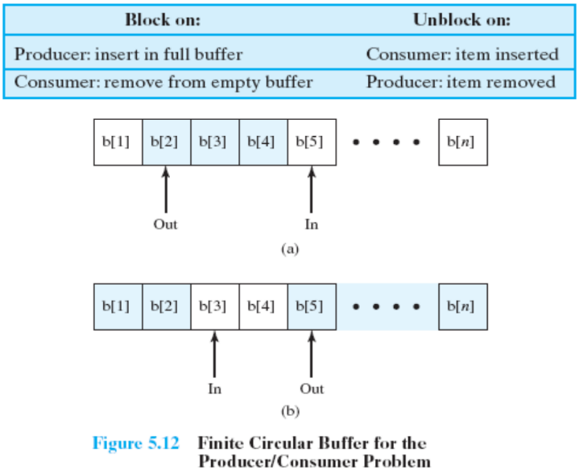
/* program producer consumer - FIXED */
int n;
binary_semaphore s = 1, delay = 0;
void producer() {
while (true) {
produce();
semWait(s);
append();
n++;
if (n == 1) semSignal(delay);
semSignal(s);
}
}
void consumer() {
int m; /* a local variable */
semWait(delay);
while (true) {
semWait(s);
take();
n--;
m = n;
semSignal(s);
consume();
if (m == 0) semWait(delay);
}
}
void main() {
n = 0;
parbegin (producer, consumer);
}
Using counting semaphores instead yields a much simpler and more elegant solution.
/* program producer consumer with counting semaphores*/
int n;
semaphore s = 1, n = 0;
void producer() {
while (true) {
produce();
semWait(s);
append();
semSignal(s);
semSignal(n);
}
}
void consumer() {
while (true) {
semWait(n);
semWait(s);
take();
semSignal(s);
consume();
}
}
void main() {
parbegin (producer, consumer);
}
It is imperative that the semWait and semSignal operations be implemented as atomic primitives. This can be implemented in hardware or firmware. Use one of the hardware-supported schemes for mutual exclusive.

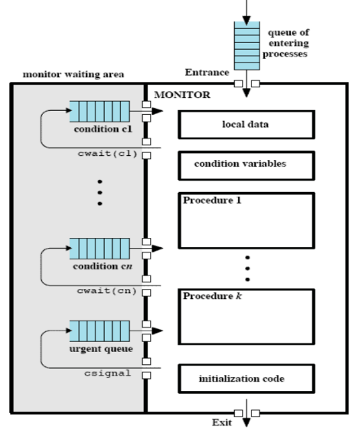
Monitors:
Monitors are a programming language construct that provides equivalent functionality to that of semaphores and is easier to control. They are implemented in a number of programming languages including concurrent Pascal, Pascal-Plus, Modula-2, Module-3, and Java. It has also been implemented as a programming library. It is a software module consisting of one or more procedures, an initialization sequence, and local data.
Using monitors, local data variables are accessible only by the monitor’s procedures and not by any external procedure. The process enters the monitor by invoking one of its procedures, and only one process may be executing in the monitor at a time.
Synchronization is achieved by the use of condition variables that are contained within the monitor and accessible only within the monitor. Condition variables are operated on by two functions:
- cwait(c): suspend execution of the calling process on condition c.
- csignal(c): resume execution of some process blocked after a cwait on the same condition.
Below is the solution to the producer consumer problem with a monitor.
/* program producer consumer – with monitor */
monitor boundedbuffer;
char buffer[N]; /* space for N items */
int nextin, nextout; /* buffer pointers */
int count; /* number of items in buffer */
cond notfull, notempty /* condition variables for synchronization */
void append (char x) {
if (count == N) cwait(notfull); /* buffer is full; avoid overflow */
buffer[nextin] = x;
nextin = (nextin + 1) % N;
count++;
/* one more item in buffer */
csignal(notempty); /* resume any waiting consumer */
}
void take (char x) {
if (count == 0) cwait(notempty); /* buffer is empty; avoid overflow */
x = buffer[nextout];
nextout = (nextout + 1) % N;
count--; /* one fewer item in buffer */
csignal(notfull); /* resume any waiting producer */
}
{ /* monitor body */
nextin = 0; nextout = 0; count = 0; /* buffer initially empty */
}
void producer() {
char x;
while (true) {
produce(x);
append(x);
}
}
void consumer() {
char x;
while (true) {
take(x);
consume(x);
}
}
void main() {
parbegin (producer, consumer);
}

Message Passing:
Most modern operating systems implement what is called “inter-process communication” based on message passing. Typically, a process (and sometimes a thread) is provided with a message queue. Messages take the form of fixed amounts of data (one int, two ints, two longs, etc…) that can be passed between processes.
Operating systems differ, but usually support some form of the following for Message Functions:
- Post(pid, msg): Place $msg$ into $pid$’s message queue and return immediately. $msg$ will be processed when the receiver gets to it.
- Send(pid, msg): Jump the queue at $pid$. Don’t return until $msg$ is processed.
- Msg=GetMsg(): Get the message at the front of the queue. Block if there’s no messages there.
- Bool PeekMsg(&msg): If there’s a message, put it into $msg$ and return true. If not, immediately return false.

Suppose the code below is used.
void wait() {
sendMsg(REQUEST,MASTER);
recvMsg();
}
void signal() {
sendMsg(YIELD,MASTER);
}
Then, define the MASTER process as below.
while(true) {
switch(recvMsg())
case REQUEST:
if (free) sendMsg();
else enqueue sender
case YIELD
if (queue empty) free=true;
else sendMsg(queue.PopHead());
}

At the heart of every GUI program, is a loop as shown below.
do {
msg = recvMsg(); // Block
} while (ProcessMsg(msg) != END);
ProcessMsg then calls the functions called “event handlers” in a giant switch() statement. Modern IDE wizards hide this, so it looks like magic, but it’s in there.

Synchronization with Different Languages:

C++ std Synchronization:
The recent C++ standard includes a large array of synchronization objects.
Atomics of type T can be declared using std::atomic<T>. Basically, the results in a variable of type T to which it’s guaranteed non-interruptible access. For example std::atomic<long> al; al=SOMETHING; is thread safe.
std::atomics also provide read-modify-write operations as can be seen below:
std::atomic<T>::fetch_add(T);
std::atomic<T>::fetch_sub(T);
std::atomic<T>::fetch_and(T);
std::atomic<T>::fetch_or(T);
std::atomic<T>::fetch_xor(T);
These shouldn’t be used however, because C++ also enables the implementation of monitors using a combination of mutex, lock, and condition_variable.

C# Windows Synchronization Elements:
Mutex (binary) provides Wait() and Release(). Semaphore (counted) also provides Wait() and Release(). C# also provides a thing called “Monitor” which is more like a Java-style Lock().

Java Synchronization:
Every Java object (even the base Object type) has a lock associated with it. The synchronized qualifier on a method can be used to require that object’s lock to be seized before running the method. Alternatively, synchronize(object) can be called which turns object’s lock into a kind of binary semaphore.

QT Synchronization:
QMutex() provides lock() and unlock(). QSemaphore() provides acquire() and release(). QReadWritteLock() allows multiple readers but only one writer and provides lockForRead(), lockForWrite(), and unlock().

Chapter 6 – Deadlocks and Starvation:

Deadlocks:
Deadlocks are the permanent blocking of a set of processes that either compete for system resource or communicate with each other. A set of processes are deadlocked when each process in the set is blocked awaiting an event that can only be triggered by another blocked process in the set. Deadlocks are permanent and there’s no efficient solution to them.
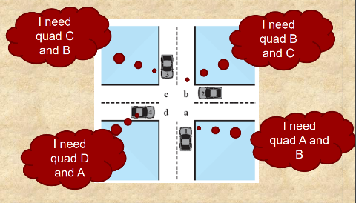
Systems can either be in an actual deadlock, or simply have the potential for deadlock. Just because a system has the potential for deadlock doesn’t mean it’s actually in a deadlock or that it will go into deadlock, just that there’s the possibility for it to go into deadlock.
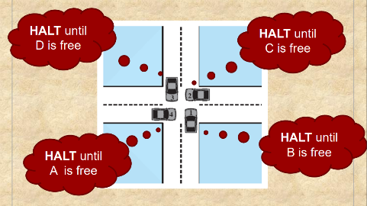
For example, the image to the right shows a system which could go into deadlock. If all cars attempt to drive through the intersection at the same time, then they would be in deadlock as shown in the image below. However, if each car drove through the intersection 1-by-1, then there would be no deadlock.
All systems with the potential for deadlock can avoid deadlock by simply having each process execute independently and synchronously.

Resource Categories:
There are two types of resource categories: reusable and consumable.
- Reusable resources can be safely used by only one process at a time and is not depleted by that use. Examples of reusable resources include processors, I/O channels, main and secondary memory, devices, etc…
- Consumable resources can be created (produced) and destroyed (consumed). Examples of consumable resources include interrupts, signals, messages, I/O buffers, etc…
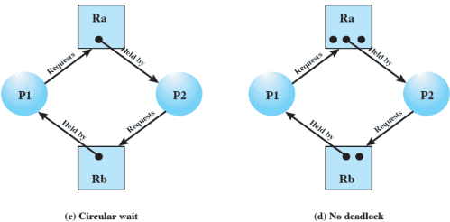

Resource Allocation Graphs:
Resource allocation graphs are used to determine if there is a deadlock in the system. It’s important to note that there may still be a potential deadlock in the system even if it’s not detected by the resource allocation graph.
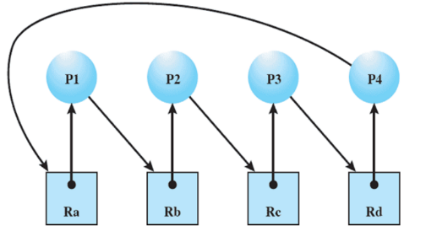
Some systems are easy to look at and determine if there’s the potential for deadlock or note (like the graph above). However, there are many systems where it is much less obvious (like the graph below).
Whenever there is a loop present in the resource allocation graph, there is a deadlock. In the example to the right, it’s easy to follow the arrows and see that the system loops forever. These loops are called a “circular wait”.

Conditions for Deadlock:
There are 4 conditions for deadlock:
- Mutual Exclusion
  - Only one process may use a resource at a time.
- Hold-and-Wait
  - A process may hold allocated resources while awaiting assignment of others.
- No Pre-emption
  - No resource can be forcibly removed from a process holding it.
- Circular Wait
  - A closed chain of processes exists, such that each process holds at least one resource needed by the next process in the chain.

Dealing with Deadlocks:
Approach | Resource Allocation Policy | Different Schemes | Major Advantages | Major Disadvantages
Prevention | Conservative; under commits resources | Requesting all resources at once | Works well for processes that perform a single burst of activity and there’s no preemption necessary | Inefficient, delays process initiation, and future resource requirements must be known by processes
Prevention | Conservative; under commits resources | Preemption | Convenient when applied to resources whose state can be saved and restored easily | Preempts more often than necessary
Prevention | Conservative; under commits resources | Resource ordering | Feasible to enforce via compile-time checks and there’s no run-time computation needed since the problem is solved in system design | Disallows incremental resource requests
Avoidance | Midway between that of detection and prevention | Manipulate to find at least one safe path | No preemption necessary | Future resource requirements must be known by OS and processes can be blocked for long periods
Detection | Liberal; requested resources are granted where possible | Invoke periodically to test for deadlock | Never delays process initiation and facilitates online handling | Inherent preemption losses

Prevention:
Deadlock prevention involves designing a system in such a way that the possibility of a deadlock is excluded. There are two main methods to do this:
- Indirect – prevent the occurrence of one of the three necessary conditions
- Direct – prevent the occurrence of a circular wait
In indirect deadlock prevention, to prevent mutual exclusion simply enforce a rule that if access to a resource requires mutual exclusion, then it must be supported by the OS. To prevent hold-and-wait, enforce a rule that requires a process to request all of its required resources at one time and block the process until all requests can be granted simultaneously. To prevent preemption, if a process holding a certain resource is denied a further request, that process must release its original resources and request them again. To prevent circular wait, define a linear ordering of resource types.

Avoidance:
Deadlock avoidance requires a decision to be made dynamically regarding whether or not the current resource allocation request will (if granted) potentially lead to a deadlock. It requires knowledge of future process requests.
There are two approaches for deadlock avoidance:
- Resource allocation denial – prevents granting an incremental resource request to a process if the allocation might lead to a deadlock
- Process initiation denial – prevents starting a process if its demands might lead to a deadlock
The advantages of deadlock avoidance are that it’s not necessary to preempt and rollback processes as in deadlock detection. It is also less restrictive than deadlock prevention.
The restrictions for deadlock avoidance are that maximum resource requirements for each process must be stated in advance, processes under consideration must be independent and with no synchronization requirements, there must be a fixed number of resources to allocate, and no process may exit while holding resources.
The deadlock avoidance algorithm (called the “Bankers Algorithm”) has 4 components.
- Resource vector R (total resources of each type)
- Resource vector V (currently available resources of each type)
- Claim matric C (requirements of each process for each resource)
- Allocation matrix A (current allocation to each process of each resource)
In the bankers algorithm, a system is defined as safe if all processes can run to completion. Before each request for resources is made, the algorithm will check that at least one process can still run to completion. If not, the request is refused. If at least one process can run to completion after the request is made, the algorithm then checks if there’s any other processes that can run to completion if the previously checked process did run to completion and returned all the resources it was using. If there’s insufficient resources, the request is refused. This check is done continuously until its verified that every single process can run to completion. If they can, then the system is safe and the resource is granted.
Note that an unsafe status is not necessarily deadlocked, it just means that a deadlock is possible.

Detection:
Deadlock detection strategies involve letting resource requests be granted whenever possible. The system will simply check for a deadlock as frequently as each resource request, or less frequently depending on how likely it is for a deadlock to occur.
The advantages of deadlock detection are that it leads to early detection, and the algorithm is relatively simple. However, the frequent checks consume considerable processor time.

Recovery Strategies:
There are 4 main recovery strategies should a deadlock occur:
- Abort all deadlocked processes
- Backup each deadlock process to some previously defined checkpoint and restart all processes
- Successively abort deadlocked processes until deadlock no longer exists
- Successively preempt resources until deadlock no longer exists

Deadlock Examples:

Example 1:
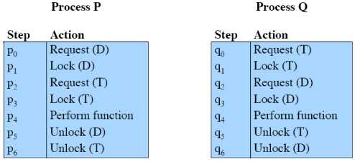
Consider the scenario to the right. Two processes are requesting the resource D and T, but in opposite order. If process P executes at the same time process Q executes, there is the potential for deadlock. Deadlock would occur when both processes have one resource (P has D and Q has T) and try to request the other resource.

Example 2:
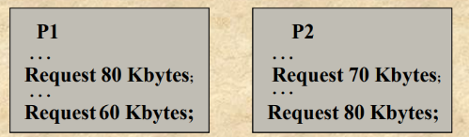
The example to the right shows two processes. The space available for allocation is 200 Kbytes so each process is able to run on it’s own without any issues. However, if P1 requests the initial 80 Kbytes, and P2 requests 70 Kbytes, the system would currently have 150 of the total 200 Kbytes in use. Therefore,
when either P1 or P2 tries to request the additional 60 or 80
Kbytes, the system will go into deadlock.

Chapter 7 – Memory Management:

Intro to Memory Mapping:

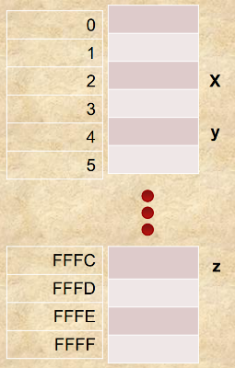
Memory Model:
The basic model of memory is just a long array of bytes. The index of each byte is the memory address. When calling a pointer, it is really the address being called and variables are just the name given to the address.
Consider the memory model to the right. If some code is written (e.g. $z=x+y$) the compiler will generate ${}_{ }^{*}{\left(\&z\right)}={}_{ }^{*}{\left(\&x\right)}+{}_{ }^{*}{\left(\&y\right)}$ or more explicitly ${}_{ }^{*}{\left(0xFFFC\right)}={}_{ }^{*}{\left(2\right)}+{}_{ }^{*}{\left(4\right)}$. In english, this translates to, “get the number at address 2, add it to the number at address 4, then put the result at address 0xFFFC”.

Simple Swapping:

Multi-Process Model:
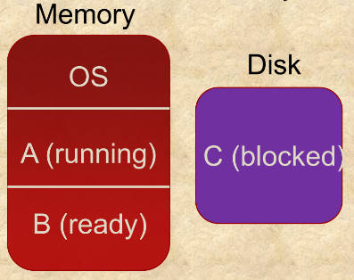
A multi-process system can swap processes to disk when they are idle or blocked. For now, assume the memory is partitioned into three parts.
Consider a scenario as shown to the right. Process A does something to unblock C, then blocks itself. Now C is ready and A is blocked so a swap can be performed. If process B then does something to unblock A and subsequently blocks itself, now C can run and A is ready, so a swap can be performed. Finally, process C unblocks B and it’s timeslice expires, so A runs and another swap is made.
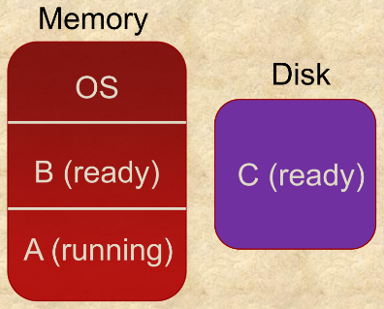
Remember that the CPU and memory are physical machines, connected by wires. Process A is in the same running state, but an entirely new space in memory and thus an entirely new place on the physical memory.
x=0; // OK, put 0 at the address of x
block.Wait();
// All the swapping happens here
y=x; // What do I do with this?
Now, consider this code where A has variables $x, y$, and a semaphore $block$.
The problem is process A is in a different place in memory the second time $x$ is referenced. Whatever $\&x$ was before the swap, it will be different after. This is called memory relocation and requires hardware support to handle in general.

Simple Swapping:
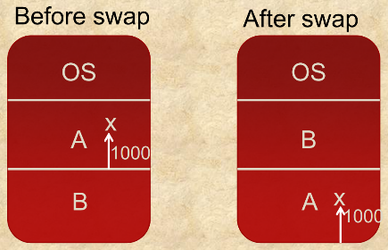
The simplest approach to solving this issue is to define variable addresses relative to some base. Remember that the model of a process includes the concepts of a process memory space, so variables are based on their location in process memory space.
If $\&x=1000$ as in the example to the right, it will remain $1000$ after a swap, but because it’s relative to the base address of the process it’s physical address will change.
There is now a distinction between logical addresses and physical addresses, where one is an address relative to the base of a process and the other maps directly to the address in physical memory.
In the example, $\&x=1000$ always. This is the logical address ($LA$) and the physical address ($PA$) changes depending on the process location. The physical address is computed by the CPU as $PA=LA+BASE$ where $BASE$ is a CPU register maintained by the operating system and updated after a context-switch.
Simple swapping is better than leaving blocked or idle processes in memory, but has flaws. These flaws are that it has memory limits, the possibility for fragmentation (dividing processes into multiple clusters), and no protection (a process can access an address outside of it’s range by simply making the $PA$ larger than the size of the process).

Paging and Virtual Memory:

Paging:
The fragmentation and protection problems of simple swapping can be fixed with paging. In a paging scheme, memory is divided into equal size blocks (pages), then processes can have as many pages as they want. Usually pages are small (0.5K-4K), so there’s no concern regarding losing fractions of a page (i.e. if a process is 3K, wasting 1K of a page isn’t really a big deal in the grand scheme of things).
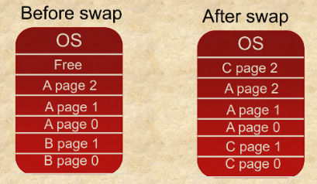
Processes can be different sizes since they can have as many pages as they want. There’s also no fragmentation since the page is indivisible.
With paging, what does $\&x$ mean? Logical addresses in simple paging systems are relative to a page base. Addresses generated by a compiler are of the form $\&x=PageNumber | Offset$. So, if the compiler places variable $x$ such that $\&x=0x1234$, it probably means the address is 234 above the bottom of process page 1.
This makes it significantly harder for the operating system to track the base however, as the amount of bases jumps into the millions. All of the page bases are contained in a page table which is managed by the operating system. So physical addresses are computed as $PA=PageTable\left(PageNum\right)+Offset$.

Virtual Memory:
So, paging solves the fragmentation and protection problems, but what about the size limit problem?
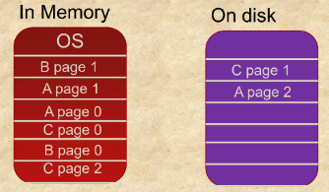
The key insight of what is called virtual memory is the idea to only swap in the pages needed. For example, in the image to the right process A and C don’t need pages 2 and 1 respectively, so those pages can simply be stored on the disk.
The operating system then manages the page table as part of a context switch.
The side effects of virtual memory are that each process thinks it has access to the entire memory space, and the memory space of each process can be bigger than the amount of physical memory on the computer.
Virtual memory introduces a new problem however. It’s not possible for a program to access memory objects that aren’t in memory currently. This results in a page fault and usually leads to a context switch as the operating system pauses the active process to bring the needed page from memory. When pages are replaced, they are done so on a least-recently-used (LRU) algorithm.

Segmentation:
A program may also be subdivided into segments that can vary in length. There’s a maximum length when subdividing into segments. Addressing then consists of the segment number and an offset. Similar to pages, segment bases are managed by the operating system.
The key difference between segmentation and paging is that pages are consistent in length whereas segment length can vary. Paging is also invisible (or at least should be) to the program, whereas segments are usually managed explicitly by the program.
Modern processors allow neither, paging only, segmentation only, or paging and segmentation.

Security Issues:
If a process declares that a portion of memory may be shared by other designated processes, then the security service of the OS must ensure that only the designated processes have access.
If a process hasn’t declared a portion of its memory to be shareable, then no other process should have access to the contents of that portion of memory.

Dynamic Memory Management:
All of these issues (paging, segmentation, and so on) have to do with managing the entire memory space allocated to the process. Operating systems also (usually) have to manage dynamic memory requests that might not be known at compilation time.
How does an operating systems manage the scenario where there’s a pile of RAM at it’s disposal and applications ask for blocks of various sizes at unpredictable times? In other words, what does $new$ really do?

Fixed Blocks:
The easiest way to manage dynamic memory is fixed blocks. The OS creates a linked-list of identical blocks of identical size. Applications requesting memory get the nearest size block that will do the job and when freed, the block just goes back into the linked list.
This is very simple and fast but has no flexibility. It also creates significant waste, as whole blocks will be given even when only a small amount of space is needed. There’s also a potential for fragmentation. If the dynamic memory has 2 1K blocks, but no 2K blocks, it will give an error when a user requests 2K of memory even though it does technically have 2K of memory.

Buddy Blocks:

Buddy blocks are a slightly more sophisticated solution which start with a large contiguous block of memory that gets subdivided until the size needed is reached. When freed, the blocks can be glued back together with the original “buddy”.
For example, if there’s 16K of dynamic memory available, and only 1K is needed, the system will divide the memory as shown in the graphic to the right.
If 3K is then requested afterwards, the 4K block will be given. If another 3K is requested, the 8K block would get split into 2 4K blocks and one of those blocks would be given. When the 1K block is freed, it combines again with the other 1K block to create a single 2K block.

Dynamic Linking and System Calls:

Process Model and Compilation:
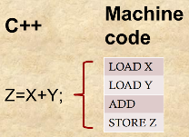
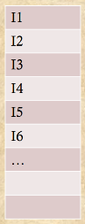
Remember the basic model of a program. A program is just a long list of instructions that execute in sequence. The process of moving from one instrument to another is called fetching.
Compilers turn high level languages into machine code. Each line of code usually maps to several instructions as shown to the right.

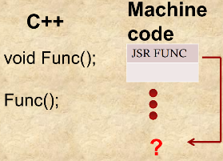
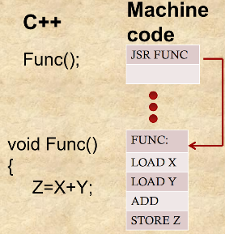
A special case is the function call which jumps the CPU out of sequence. If the function is defined, the compiler can jump to it as shown in the diagram on the right. Sometimes however, the function is just declared. In these cases, the compiler can’t know where it is as shown in the left diagram. The compiler inserts a placeholder symbol instead indicating an undefined reference.
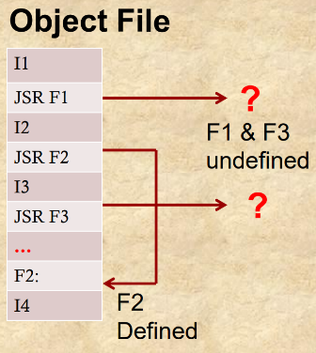
In the end, the compiler generates an object file which is made of machine code. It also contains any undefined references.
After each source file has been compiled, the collection of object files is passed to the linker. The linker has 2 jobs:
- Mash all code into one executable.
- Resolve all undefined references by finding the definitions in other object files.
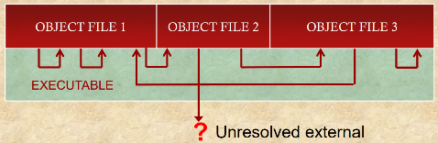
Any reference that remains unresolved will trigger a linker error in the form “No definition for Func was found” or “Unresolved external Func”. This is also the error thrown if a class member is declared and called without being defined.

Static Libraries:
How do undefined references work with static libraries? After all, $cout$ works without being defined anywhere by the programmer.

A “library” is a collection of pre-compiled functions. When a library is linked, the linker tries to resolve references by brining in functions from the library.
Commonly used things like $cout$ is in a “standard library” which is automatically linked.

System Calls:
Static libraries won’t work for system calls like $fork$, $PostMessage$, $SemaphoreWait$, etc… There are 3 reasons for this:
- Multiple copies of the Kernel are unneeded and waste space.
- All applications shouldn’t be recompiled each time the OS changes.
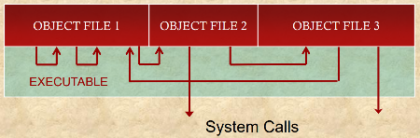
- System calls are special.
The solution is “dynamic linking” (sometimes called “late binding”). Essentially, the linker leaves system calls unresolved, and they are only resolved at run-time.
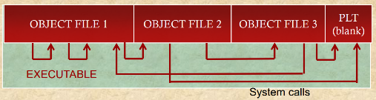
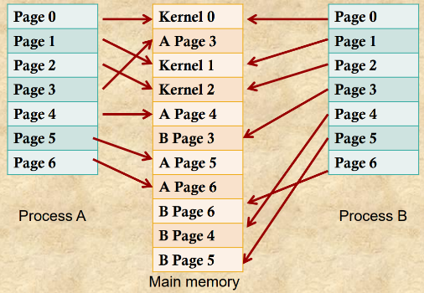
To do this, Kernel functions are not called directly. They are instead called through a lookup table of function pointers. When a new program is loaded, one of the OS’s jobs is to populate the table with the current location of the functions. This way, when the OS updates something (e.g. how $fork$ works), it can just put that new definition of the functions in the Procedure Linkage Table (PLT). This action is done by the loader.
Virtual memory is also used so that the OS can map the same code and data into each processor’s memory space. As seen in the image to the right, the first page of process A and B point towards the first page of the Kernel (which might contain the $fork$ function for example).
Weird stuff can happen when making a system call. Access to another process’s data space may be needed, access to the schedule may be needed, and the function might not return. Application programmers shouldn’t be given access to those things as they would likely misuse it.
The common solution requires special processor support and uses a software interrupt. Software interrupts cause exactly the same response as hardware interrupts, but are triggered programatically. This essentially gives the processor to the OS so it can do it’s thing.
So when a system call is made, the below occurs:
- An indirect lookup thorgh the dynamic lookup table is made
- A jump to a piece of the Kernel that hes been mapped into the memory space is made
- Some code runs that sets up the preconditions
- Software interrupt lets the OS handle the call

Practice Problems:

Semaphore Contention:

Competing Claims:

Problem 1:
Assume there are three processes (P1, P2, P3) in the system, competing for four resources: (MONITOR, NETWORK, PRINTER, USB). Each resource is protected by a semaphore that ensures mutually exclusive access to the resource (ie: a process must call USB.Wait() before using USB). The programs are as follows:
P1 Code  /* Some stuff happened above*/  MONITOR.Wait();  NETWORK.Wait();  PRINTER.Wait();  // P1 has what it needs  /* Execute critical section*/  PRINTER.Signal();  NETWORK.Signal();  MONITOR.Signal(); | P2 Code  /* Some stuff happened above*/  USB.Wait();  MONITOR.Wait();  PRINTER.Wait();  //P2 has what it needs  /* Execute critical section */  PRINTER.Signal();  MONITOR.Signal();  USB.Signal(); | P3 Code  /* Some stuff happened above*/  NETWORK.Wait();  PRINTER.Wait();  MONITOR.Wait();  //P3 has what it needs  /* Execute critical section */  MONITOR.Signal();  PRINTER.Signal();  NETWORK.Signal();
- Show, using a resource allocation graph (or by other convincing arguments) that this system contains within it the possibility of deadlock.
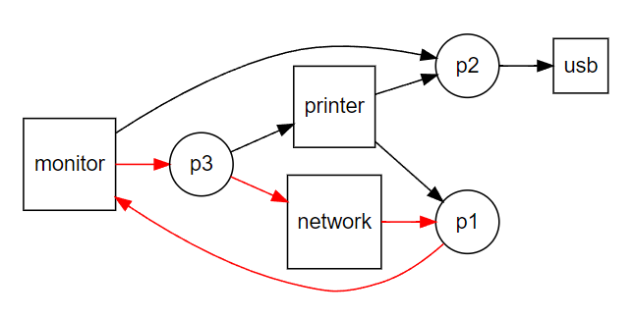
- Suggest a way to re-order the code that ensures there will not be deadlock, but preserves the necessary mutual exclusion
Enforce an order in which each process can request the resources. For example, alphabetical ordering could be enforced such that the Monitor must be called before the Network which must be called before the Printer which must be called before the USB (Monitor -> Network -> Printer -> USB). Below is the updated versions of the processes:
P1 Code  /* Some stuff happened above*/  MONITOR.Wait();  NETWORK.Wait();  PRINTER.Wait();  // P1 has what it needs  /* Execute critical section*/  PRINTER.Signal();  NETWORK.Signal();  MONITOR.Signal(); | P2 Code  /* Some stuff happened above*/  MONITOR.Wait();  PRINTER.Wait();  USB.Wait();  //P2 has what it needs  /* Execute critical section */  USB.Signal();  PRINTER.Signal();  MONITOR.Signal(); | P3 Code  /* Some stuff happened above*/  MONITOR.Wait();  NETWORK.Wait();  PRINTER.Wait();  //P3 has what it needs  /* Execute critical section */  PRINTER.Signal();  NETWORK.Signal();  MONITOR.Signal();

Problem 2:
Assume there are three processes in the system, competing for four resources (R1, R2, R3, R4). Each one is protected by a semaphore. The programs are as follows:
P1 Code  /* Some stuff happened above*/  R1.Wait();  R2.Wait();  R3.Wait();  // P1 has what it needs  /* Execute critical section*/  R3.Signal();  R2.Signal();  R1.Signal(); | P2 Code  /* Some stuff happened above*/  R4.Wait();  R2.Wait();  R3.Wait();  //P2 has what it needs  /* Execute critical section */  R3.Signal();  R2.Signal();  R4.Signal(); | P3 Code  /* Some stuff happened above*/  R3.Wait();  R2.Wait();  R1.Wait();  //P3 has what it needs  /* Execute critical section */  R1.Signal();  R2.Signal();  R3.Signal();
- Show, using a resource allocation graph (or by other convincing arguments) that this system contains within it the possibility of deadlock.
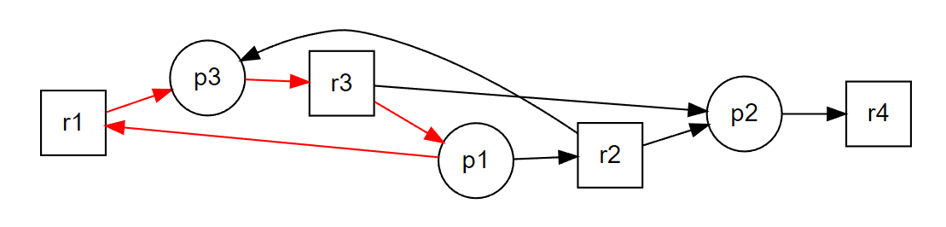
- Suggest a way to re-order the code that ensures there will not be deadlock, but preserves the necessary mutual exclusion
Enforce an order in which each process can request the resources. For example, numerical ordering could be enforced such that R1 must be called before R2 which must be called before R3 which must be called before R4 (R1 -> R2 -> R3 -> R4). Below is the updated versions of the processes:
P1 Code  /* Some stuff happened above*/  R1.Wait();  R2.Wait();  R3.Wait();  // P1 has what it needs  /* Execute critical section*/  R3.Signal();  R2.Signal();  R1.Signal(); | P2 Code  /* Some stuff happened above*/  R2.Wait();  R3.Wait();  R4.Wait();  //P2 has what it needs  /* Execute critical section */  R4.Signal();  R3.Signal();  R2.Signal(); | P3 Code  /* Some stuff happened above*/  R1.Wait();  R2.Wait();  R3.Wait();  //P3 has what it needs  /* Execute critical section */  R3.Signal();  R2.Signal();  R1.Signal();

Deadlock Avoidance:

Deadlock Avoidance:

Problem 1:
Assume the system consists of four resources, R1, R2, R3, R4. Before any process runs, there are 3 R1s, 6 R2s, 6 R3s and 5 R4s available. There are also 4 processes. P1, P2, P3, P4. At the time of interest, the state of the program looks like this:
 | Worst Case Need |  |  |  | Current Allocation
Process | R1 | R2 | R3 | R4 | R1 | R2 | R3 | R4
P1 | 1 | 2 | 2 | 3 | 0 | 2 | 2 | 1
P2 | 1 | 3 | 3 | 1 | 1 | 1 | 1 | 1
P3 | 0 | 3 | 2 | 5 | 0 | 3 | 2 | 1
P4 | 1 | 6 | 1 | 5 | 1 | 0 | 1 | 0
- Show that the system is safe in this state.
Snapshot:  Total = [3, 6, 6, 5]  Current Allocation = [2, 6, 6, 3]  Current Available = [1, 0, 0, 2] | Wants (Worst Case – Current Allocation):  P1 Wants = [1, 0, 0, 2]  P2 Wants = [0, 2, 2, 0]  P3 Wants = [0, 0, 0, 4]  P4 Wants = [0, 6, 0, 5]
Check:
Current Available satisfies P1 Wants so satisfy P1
Current Available = Current Available – P1 Wants = [0, 0, 0, 0]
Current Available = Current Available + P1 Needs = [1, 2, 2, 3]
Current Available satisfies P2 Wants so satisfy P2
Current Available = Current Available – P2 Wants = [1, 0, 0, 3]
Current Available = Current Available + P2 Needs = [2, 3, 3, 4]
Current Available satisfies P3 Wants so satisfy P3
Current Available = Current Available – P3 Wants = [2, 3, 3, 0]
Current Available = Current Available + P3 Needs = [2, 6, 5, 5]
Current Available satisfies P4 Wants so satisfy P4
Current Available = Current Available – P4 Wants = [2, 0, 5, 0]
Current Available = Current Available + P4 Needs = [3, 6, 6, 5]
Result:
All processes can be satisfied without deadlock; therefore the system is safe.
- Assume we get a request from P3 for one (1) R4. Is the system still safe?
Snapshot:  Total = [3, 6, 6, 5]  Current Allocation = [2, 6, 6, 4]  Current Available = [1, 0, 0, 1] | Wants (Worst Case – Current Allocation):  P1 Wants = [1, 0, 0, 2]  P2 Wants = [0, 2, 2, 0]  P3 Wants = [0, 0, 0, 5]  P4 Wants = [0, 6, 0, 5]
Check:
No process can be satisfied with what is currently available (after giving P3 another R4).
Result:
The system would not be safe if another R4 was given to P3.

- What possible requests can be granted without driving the system into an unsafe state?
The system could grant a request from P1 for R1 and R4. Any other requests would drive the system into an unsafe state.

Problem 2:
Assume the system consists of four resources, R1, R2, R3, R4. Before any process runs, there are 5 R1s, 4 R2s, 7 R3s and 6 R4s available. There are also four processes, P1, P2, P3, P4. At the time of interest, the state of the program looks like this:
 | Worst Case Need |  |  |  | Current Allocation
Process | R1 | R2 | R3 | R4 | R1 | R2 | R3 | R4
P1 | 3 | 4 | 6 | 4 | 2 | 1 | 4 | 3
P2 | 1 | 3 | 3 | 3 | 0 | 2 | 1 | 1
P3 | 2 | 1 | 2 | 0 | 1 | 1 | 1 | 0
P4 | 1 | 4 | 1 | 0 | 1 | 0 | 0 | 0
- Show that the system is safe in this state.
Snapshot:  Total = [5, 4, 7, 6]  Current Allocation = [4, 4, 6, 4]  Current Available = [1, 0, 1, 2] | Wants (Worst Case – Current Allocation):  P1 Wants = [1, 3, 2, 1]  P2 Wants = [1, 1, 2, 2]  P3 Wants = [1, 0, 1, 0]  P4 Wants = [0, 4, 1, 0]
Check:
Current Available satisfies P3 Wants so satisfy P3
Current Available = Current Available – P3 Wants = [0, 0, 0, 2]
Current Available = Current Available + P3 Needs = [2, 1, 2, 2]
Current Available satisfies P2 Wants so satisfy P2
Current Available = Current Available – P2 Wants = [1, 0, 0, 0]
Current Available = Current Available + P2 Needs = [2, 3, 3, 3]
Current Available satisfies P1 Wants so satisfy P1
Current Available = Current Available – P3 Wants = [1, 0, 1, 2]
Current Available = Current Available + P3 Needs = [4, 4, 7, 6]
Current Available satisfies P4 Wants so satisfy P4
Current Available = Current Available – P4 Wants = [4, 0, 6, 6]
Current Available = Current Available + P4 Needs = [5, 4, 7, 6]
Result:
All processes can be satisfied without deadlock; therefore the system is safe.
- What possible requests can be granted without driving the system into an unsafe state?
In the current snapshot, only process 3 can be satisfied, therefore only process 3’s requests can be granted without driving the system into an unsafe state.

Design Problem:
Consider the scenario in which you only have access to the below two methods:
- PostMessage(PID, Msg) // Never blocks
- m = GetMessage(); // Blocks if no message
Create a semaphore using these two methods.
class Semaphore {  Semaphore(int int);  SemThread ST;  void Wait(); // Block  void Signal(); // Don’t block  Semaphore(int int) {  ST = new SemThread(); // Create new thread  }  Wait {  PostMessage(ST, REQ); // Request access  GetMessage(); // Block until access given  }  Signal {  PostMessage(ST, YIELD); // Yield access  }  } | SemThread {  Queue; // Store blocked requesters  int n = 1; // Amount of resources available  m = GetMsg() // Block until message received  switch(m) {  case REQ: // Process requests  if (n > 0) { // Resources available  n--;  PostMsg(Sender, Grant);  }  else { // No resources available  n--;  Queue.add(Sender);  }  case YIELD:  n++;  if (n < 0) { // Requesters in queue  PostMsg(Queue.pop(), Grant);  }  }  }

