

PROJECT: Nexus Aquarium
GROUP NO: 03 BATCH: T12012E1

A. SYSTEM REQUIREMENTS:

Sr. | Item | Description
1. | Operating system | Windows 7, 8, or higher
2. | Hardware | Pentium 166 or better with 64 Megabytes of RAM or better
3. | Web Browser | Version in later of: Edge 44, Firefox 40, Chrome 55, etc…
4. | Fonts | Standard font Unicode: Arial, Tahoma, Lucida Console, Times New Roman, etc…
5. | Other requirement | A working internet connection.
Notes: Do not install IDEs (Integrated Development Environment) on the system such as MS Visual Studio, Jbuilder, Dreamweaver, etc.

B. Program Instrallation
Step 1. Copy eProjectSem01_NexusAquarium_Group03.rar from USB to your website directory (for example Drive D:\)
Or direct download from the file.
Step 2. Extract .rar file into the file you want.
Step 3 . Open folder eProjectSem01_NexusAquarium_Group03 then open folder Nexus Aquarium.
Step 4. Run index.html in Nexus Aquarium folder.(please use Chrome for website for best experience.).

* Please countiue read the next page…

C. Successful test
- The file is loaded successfully
- Homepage should be displayed as described in the documentation.

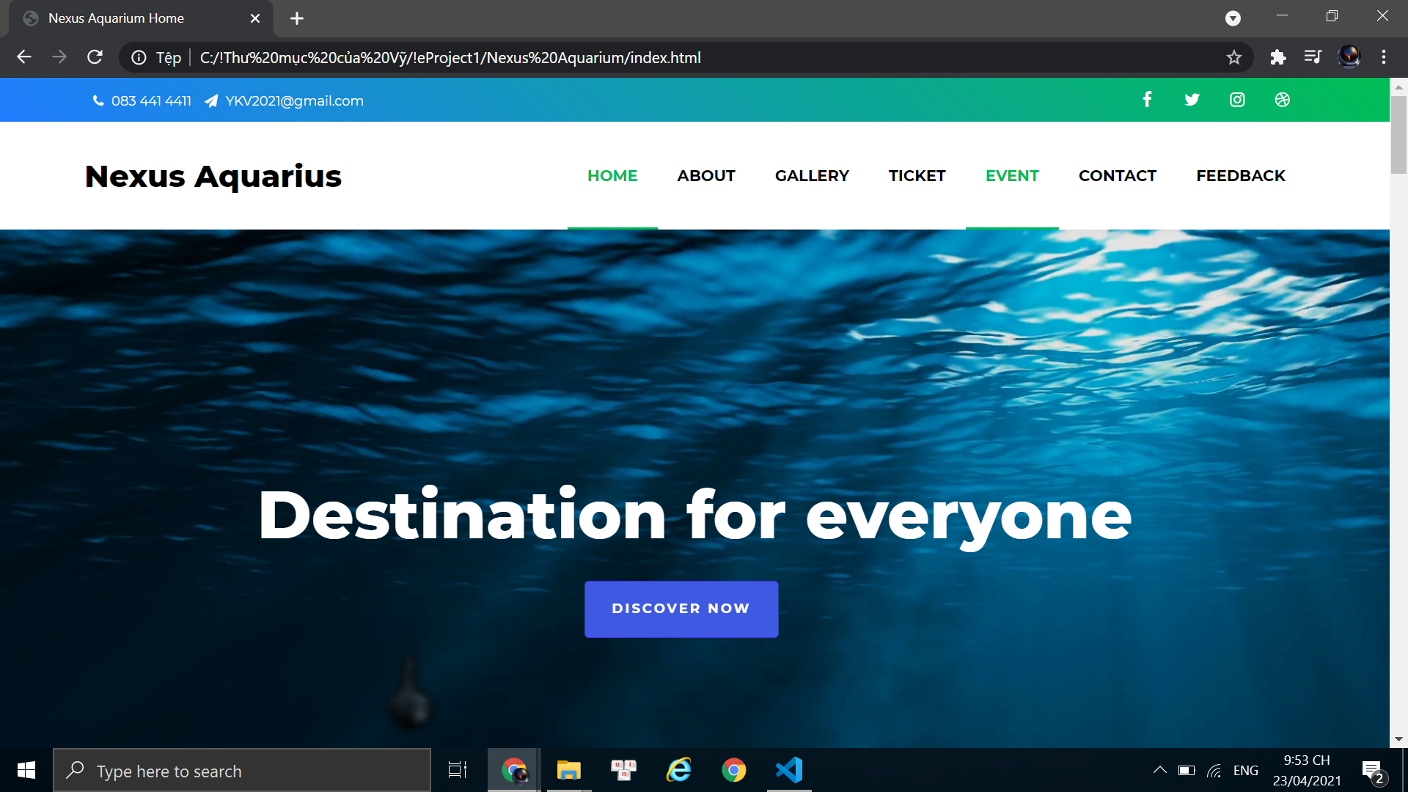

Congratulations on reading the user manual,
hope you will enjoy our website !!

