BÁO CÁO THỰC HÀNH LAB 1

LẬP TRÌNH HƯỚNG ĐỐI TƯỢNG

# 2.2. The Very First Java Programs

## 2.2.1 Write, compile the first Java application

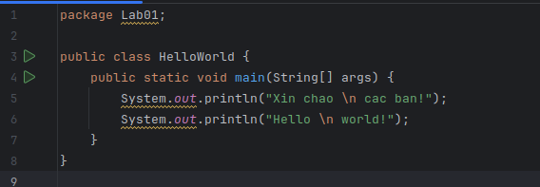

Kết quả:

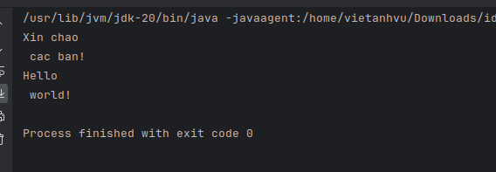

## 2.2.2 Write, compile the first dialog Java program

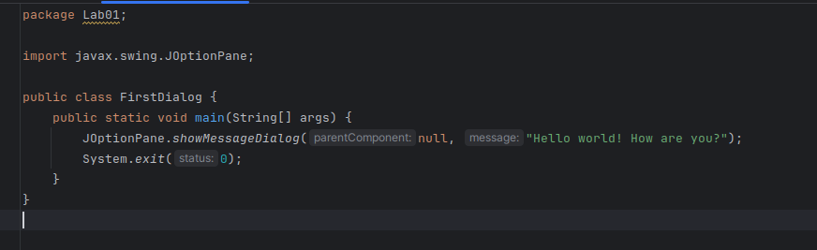

Kết quả

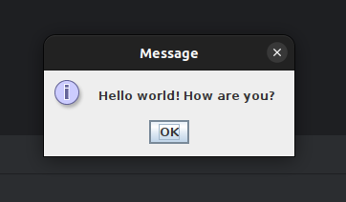

## 2.2.3 Write, compile the first input dialog Java application

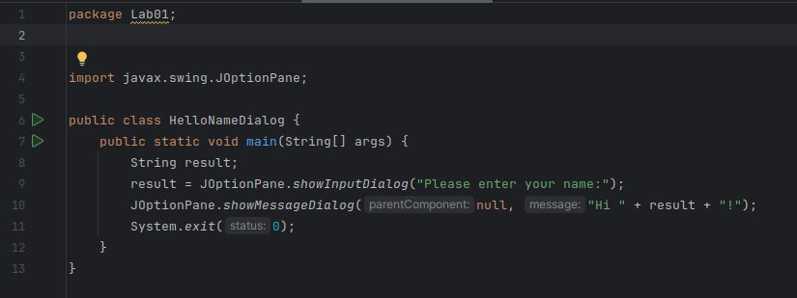

Kết quả

|  |  |
| --- | --- |
|  |  |

## 2.2.4 Write, compile, and run the following example

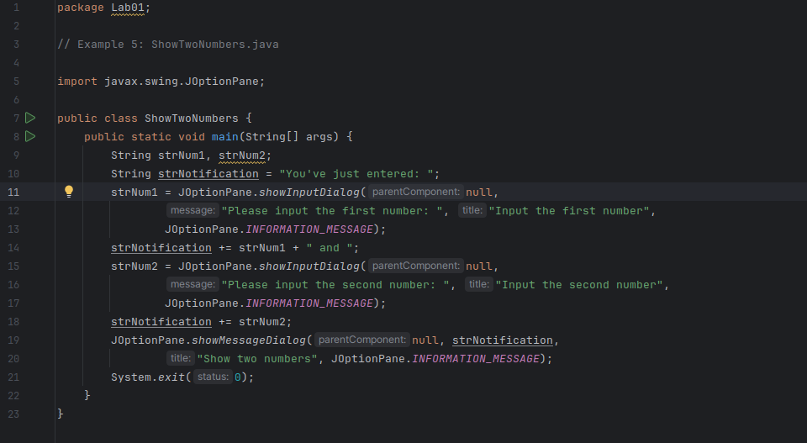

Kết quả

|  |  |  |
| --- | --- | --- |
|  |  |  |

## 2.2.5 Write a program to calculate sum, difference, product, and quotient of 2 double numbers which are entered by users.

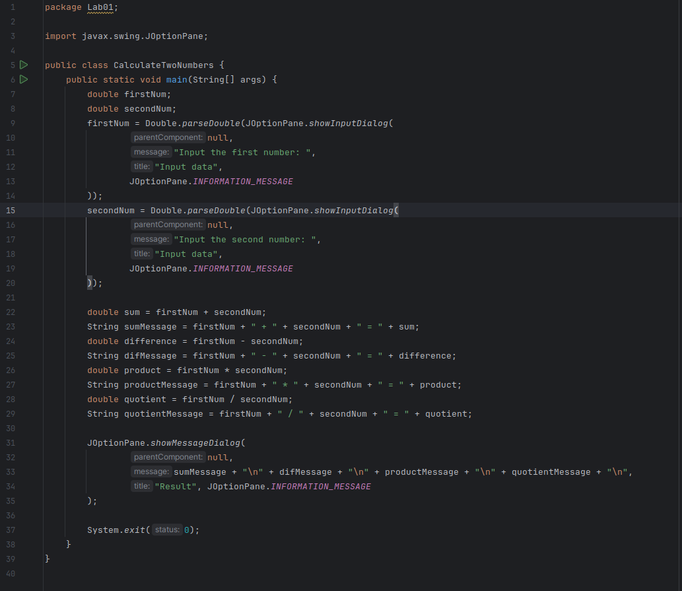

Kết quả

|  |  |  |
| --- | --- | --- |
|  |  |  |

## 2.2.6 Write a program to solve:

### The first-degree equation (linear equation) with one variable

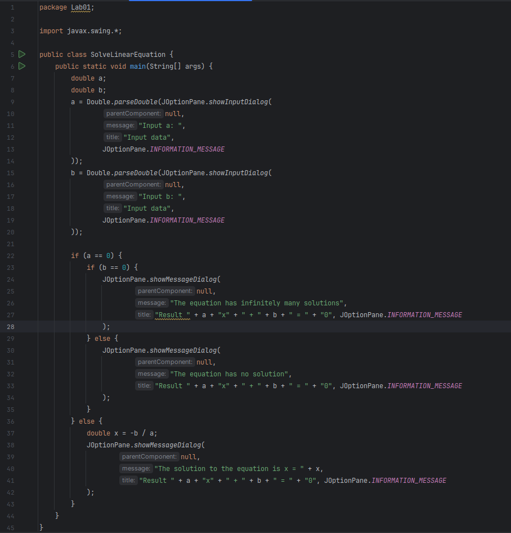

kết quả:

|  |  |  |
| --- | --- | --- |
|  |  |  |
|  |  |  |
|  |  |  |

### The system of first-degree equations (linear system) with two variables

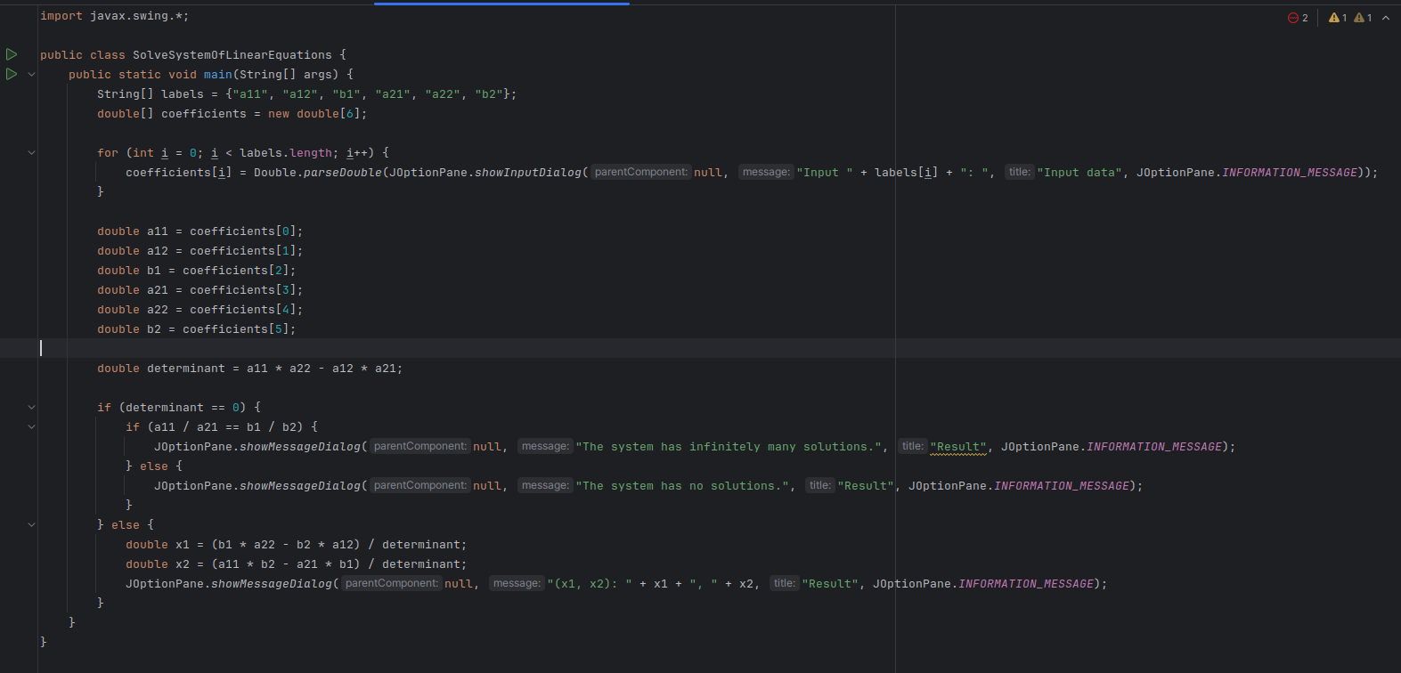

Kết quả:

|  |  |  |
| --- | --- | --- |
|  |  |  |
|  |  |  |

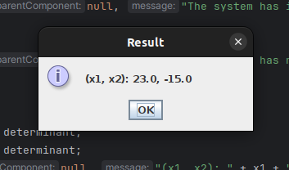

### The second-degree equation with one variable

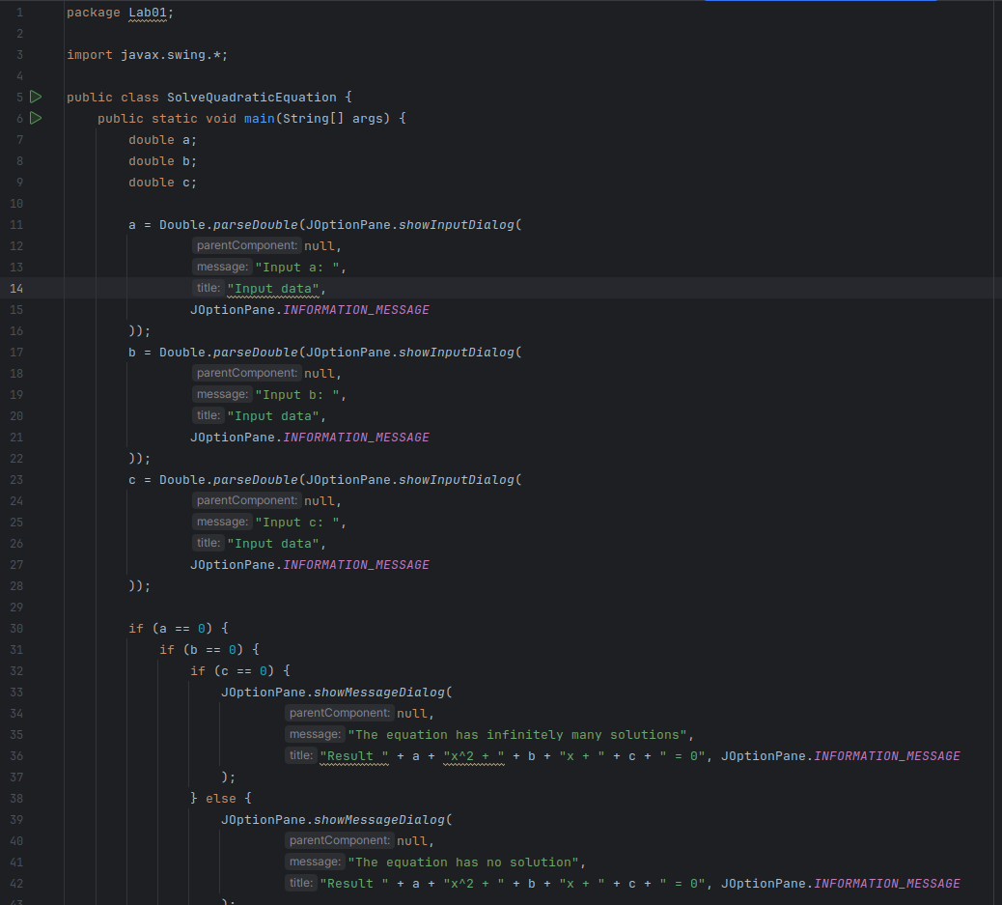

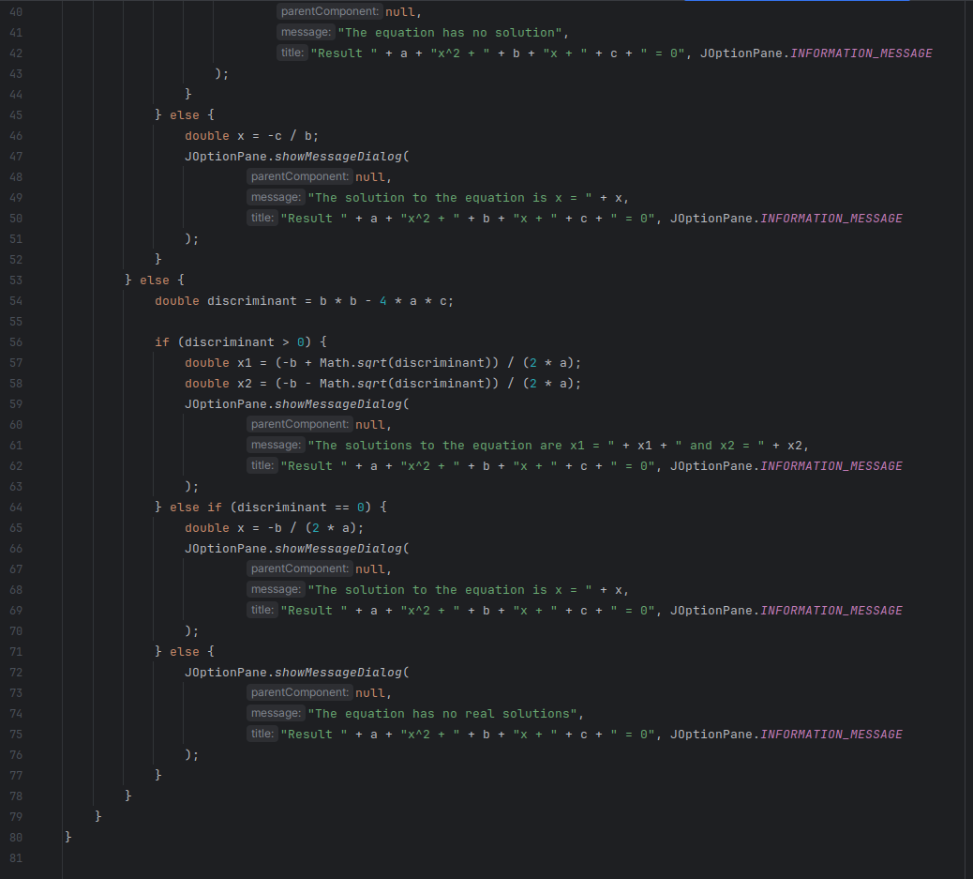

|  |  |
| --- | --- |
|  |  |

Kết quả

|  |  |  |
| --- | --- | --- |
|  |  |  |

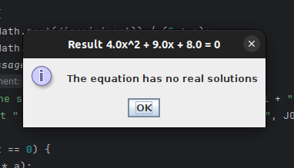

# 6. Exercises

## 6.1 Write, compile and run the ChoosingOption program:

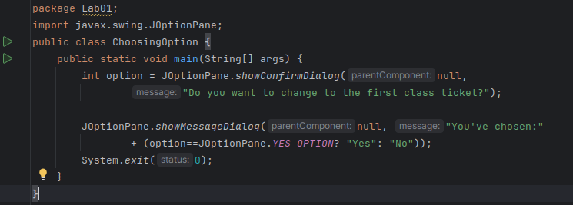

Kết quả

|  |  |
| --- | --- |
|  |  |

## 6.2. Write a program for input/output from keyboard

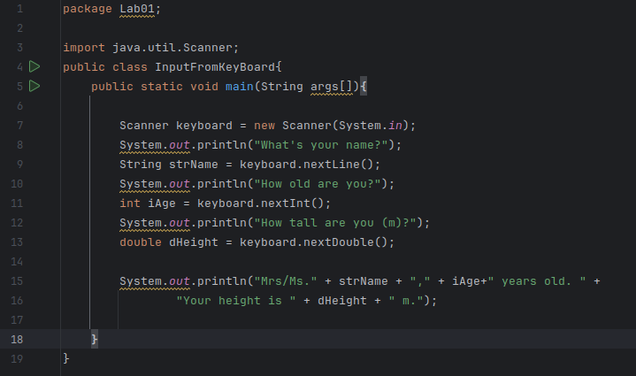

Kết quả:

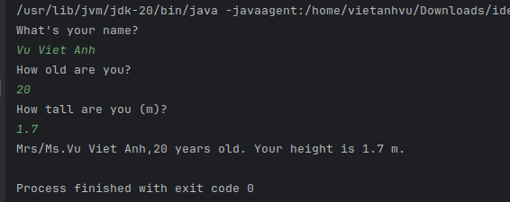

## 6.3 Write a program to display a triangle with a height of n stars (*), n is entered by users.

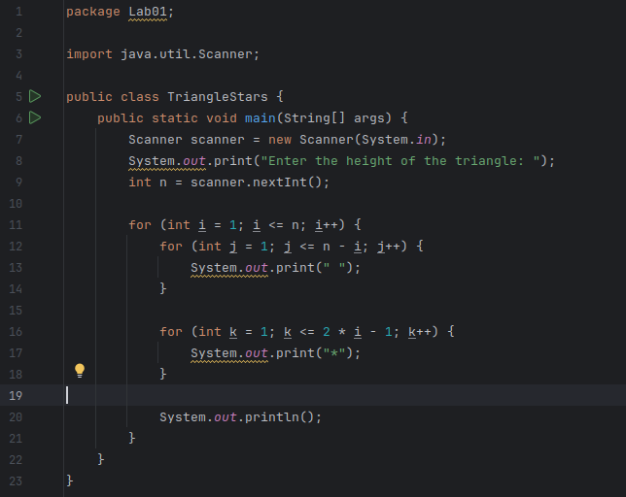

Kết quả:

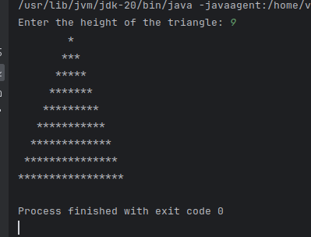

## 6.4 Write a program to display the number of days of a month, which is entered by users (both month and year). If it is an invalid month/year, ask the user to enter again.

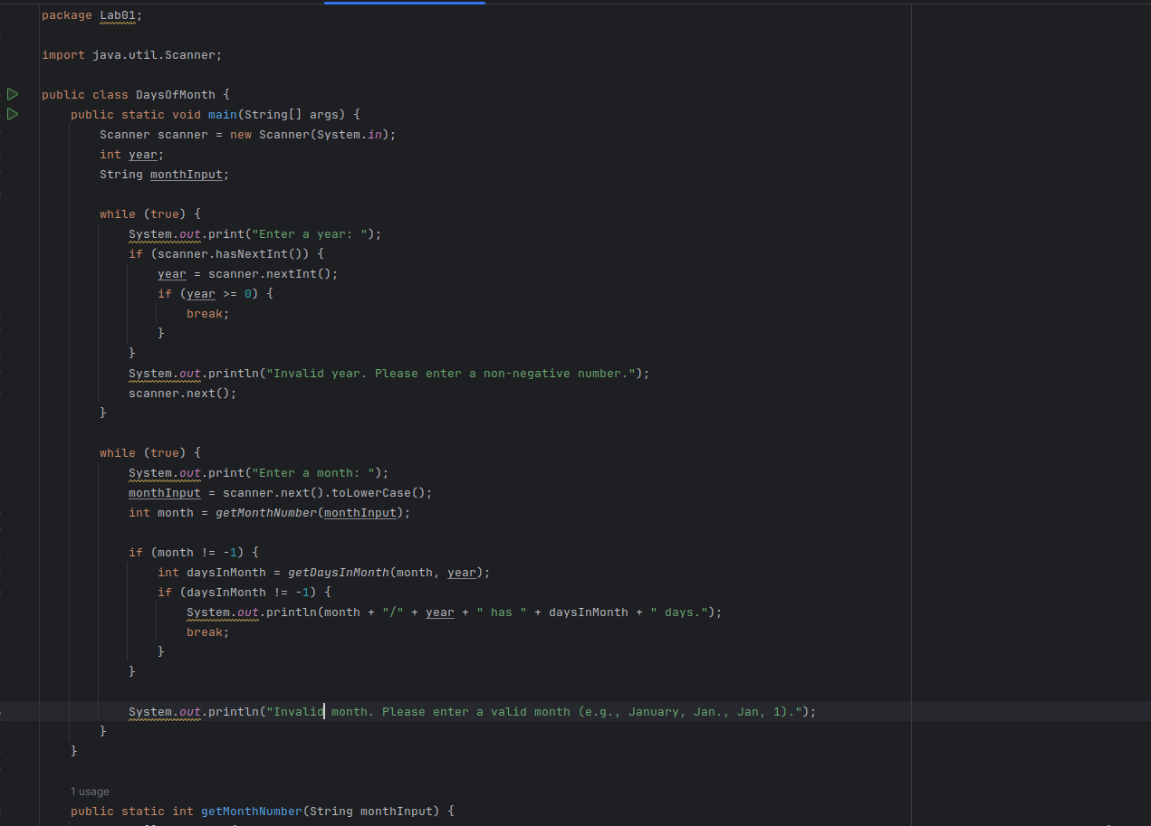

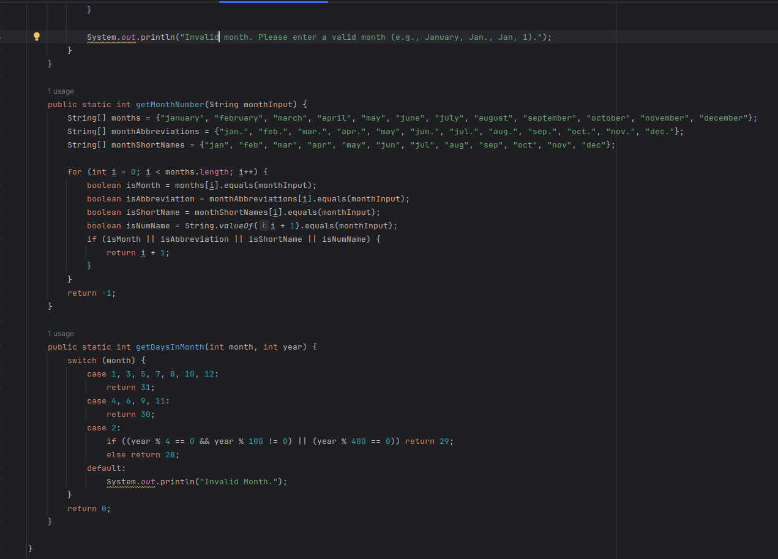

Kết quả

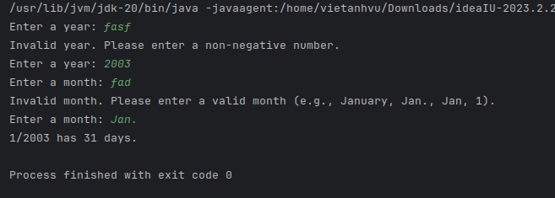

## 6.5 Write a Java program to sort a numeric array, and calculate the sum and average value of array elements.

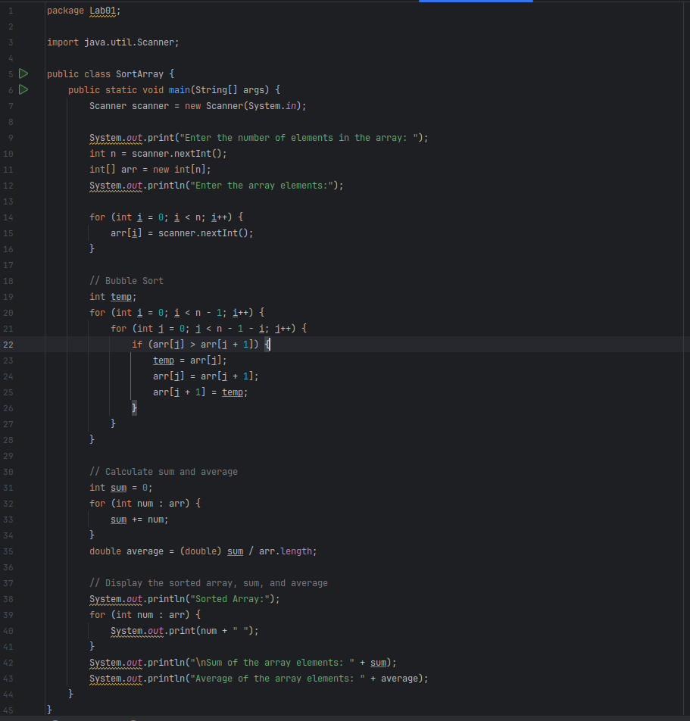

Kết quả

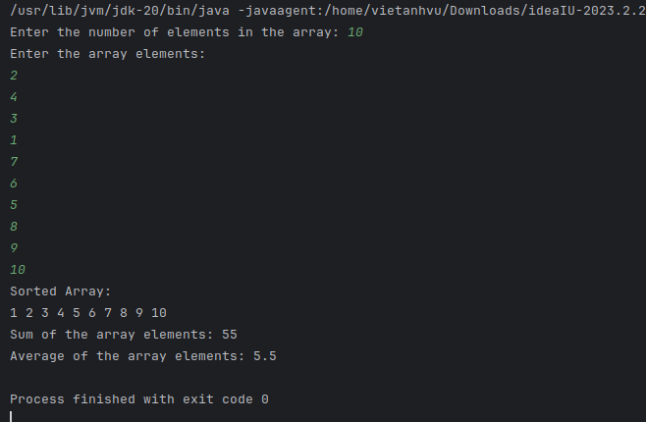

## 6.6 Write a Java program to add two matrices of the same size.

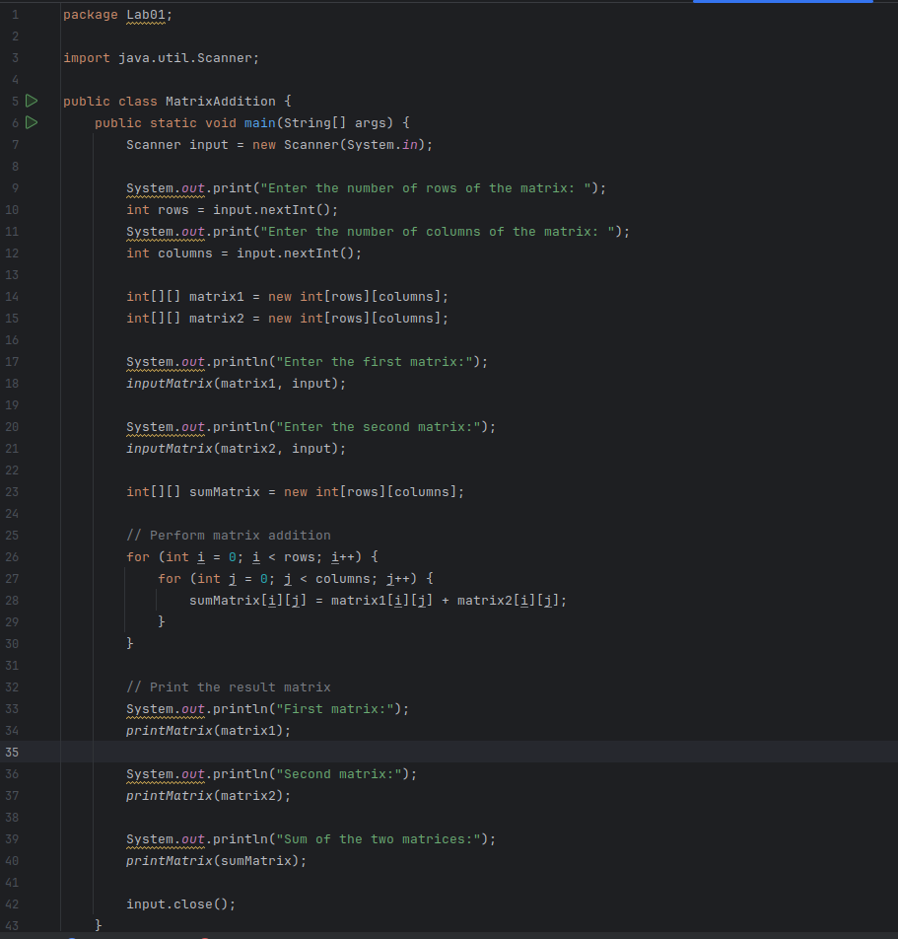

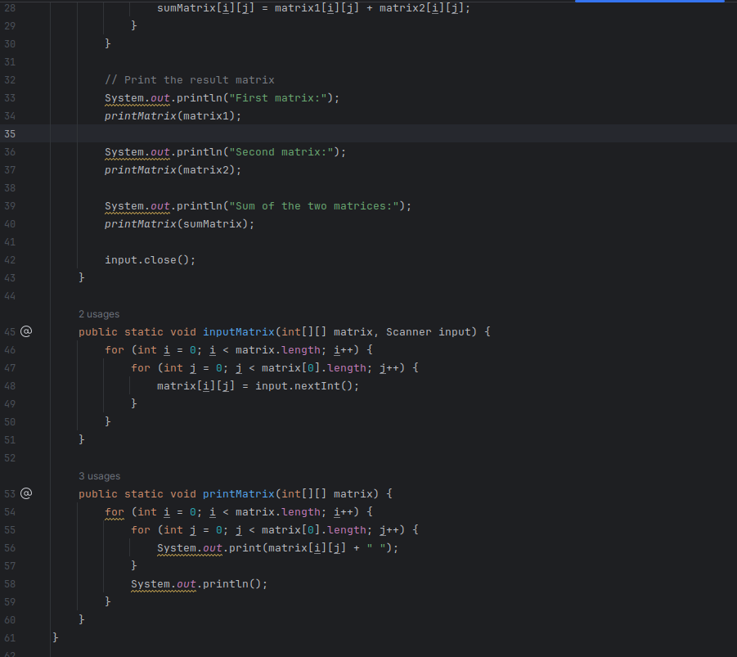

Kết quả

