Git –version

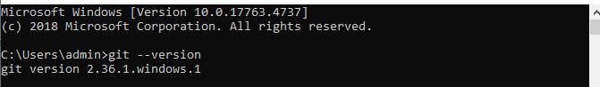

thiết lập username và email cho git.

T

Tạo respository

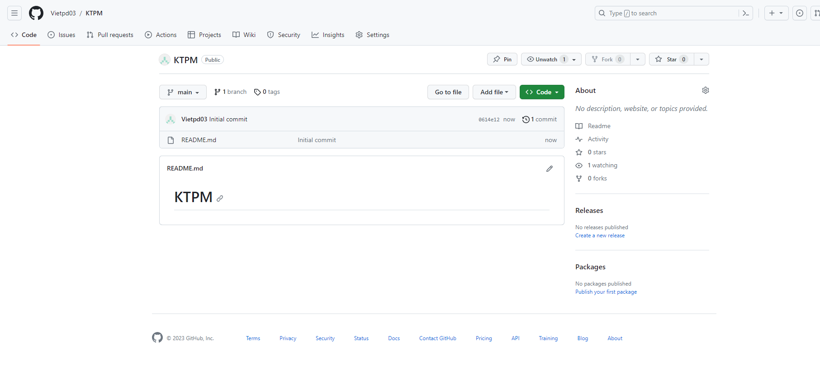

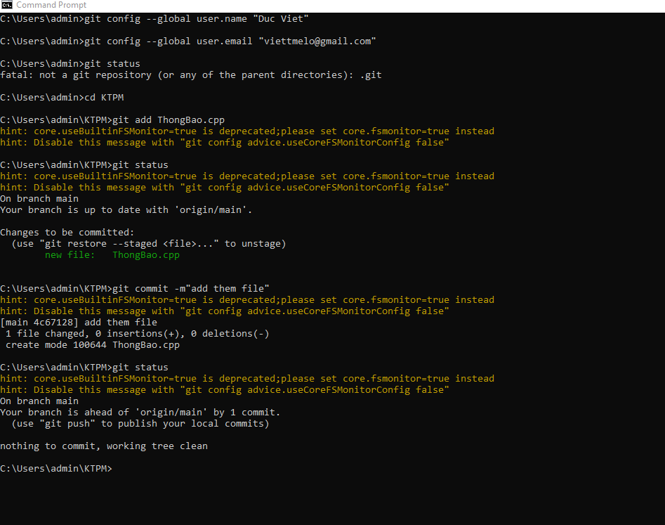

User 2 clone va sua file cpp:

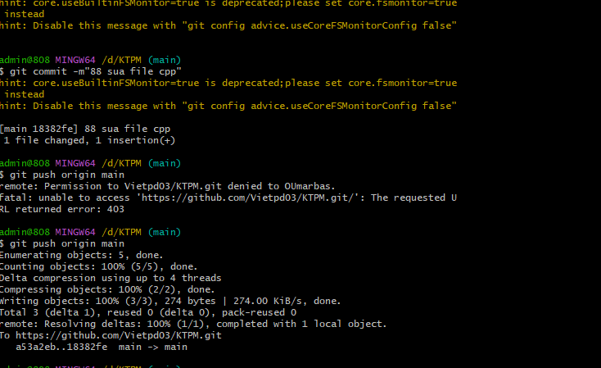

Đã them lên git

