GIT CHEAT SHEET

Git is the free and open source distributed version control system that's responsible for everything GitHub related that happens locally on your computer. This cheat sheet features the most important and commonly used Git commands for easy reference.
.

INSTALLATION & GUIS
With platform speciﬁc installers for Git, GitHub also provides the ease of staying up-to-date with the latest releases of the command line tool while providing a graphical user interface for day-to-day interaction, review, and repository synchronization.

GitHub for Windows
https://windows.github.com

GitHub for Mac
https://mac.github.com

For Linux and Solaris platforms, the latest release is available on the oﬃcial Git web site.

Git for All Platforms http://git-scm.com

SETUP
Conﬁguring user information used across all local repositories
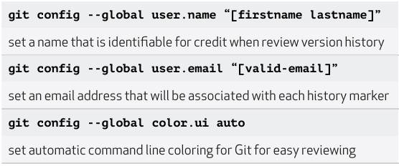

SETUP & INIT
Conﬁguring user information, initializing and cloning repositories
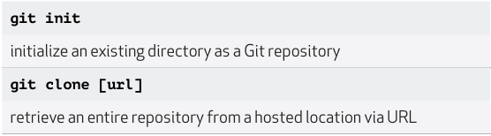
STAGE & SNAPSHOT
Working with snapshots and the Git staging area
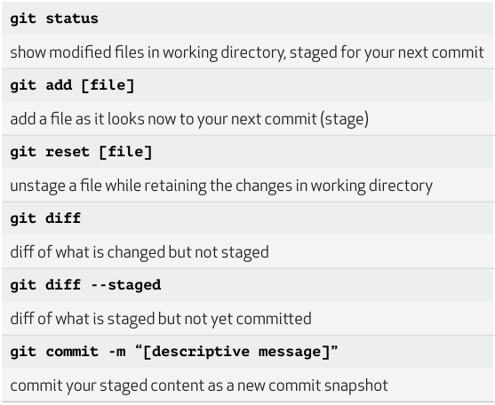

BRANCH & MERGE
Isolating work in branches, changing context, and integrating changes
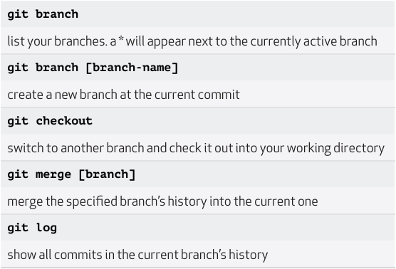

INSPECT & COMPARE
Examining logs, diﬀs and object information
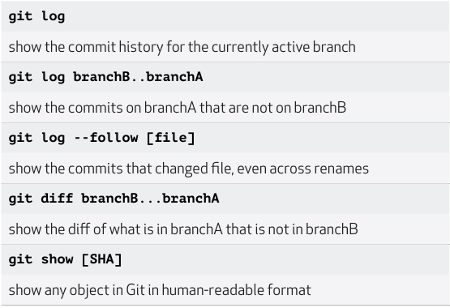

TRACKING PATH CHANGES

Versioning ﬁle removes and path changes
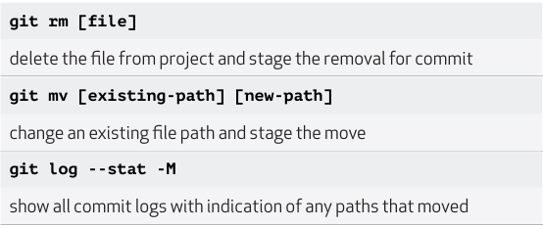
SHARE & UPDATE
Retrieving updates from another repository and updating local repos
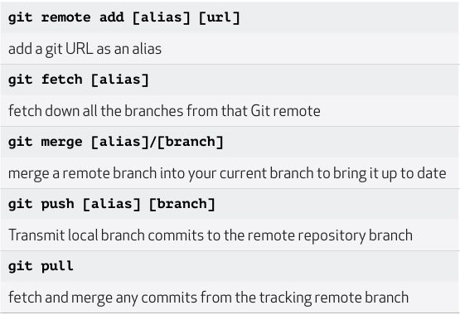

REWRITE HISTORY
Rewriting branches, updating commits and clearing history
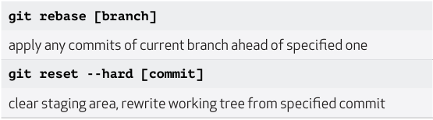

show all commit logs with indication of any paths that moved TEMPORARY COMMITS
Temporarily store modiﬁed, tracked ﬁles in order to change branches

IGNORING PATTERNS
Preventing unintentional staging or commiting of ﬁles
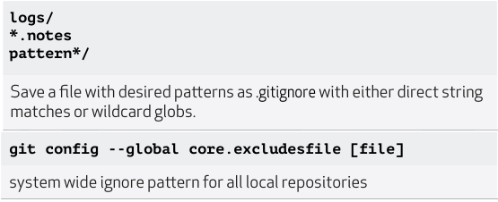

Education

Teach and learn better, together. GitHub is free for students and teach- ers. Discounts available for other educational uses.
