The AutoDoc system architecture is designed to interact with two primary actors,
distinguished by their authorization status. The first actor is the Guest, representing an
unauthenticated visitor to the application. The primary role of the Guest is limited to
interacting with the authentication interfaces to either register a new account or log into an existing one, thereby obtaining a secure session token. The second actor is the
Authenticated User. Once successfully identified by the system, this actor is granted
comprehensive access to the application’s core functionalities, encompassing personal document storage, complex machine learning conversions, and various PDF utility
operations. The AutoDoc system architecture is designed to interact with two primary

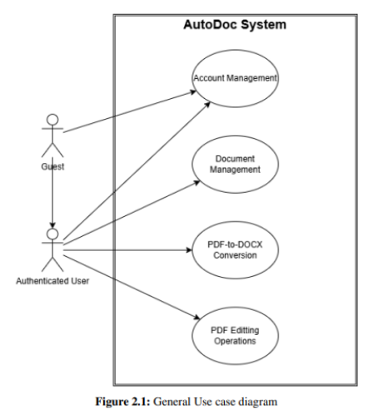
actors, distinguished by their authorization
status. The first actor is the Guest, representing an unauthenticated visitor to the application. The primary role of the Guest is limited to
interacting with the authentication interfaces to either register a new account or log into an
existing one, thereby obtaining a secure session token.

The second actor is the Authenticated User.
Once successfully identified by the system, this
actor is granted comprehensive access to the
application’s core functionalities,
encompassing personal document storage,
complex machine learning conversions, and
various PDF utility operations. The AutoDoc
system architecture is designed to interact with two primary actors, distinguished by their authorization status. The first actor is the Guest, representing an unauthenticated visitor to the application. The primary role of the Guest is limited to interacting with the
authentication interfaces to either register a new account or log into an existing one,
thereby obtaining a secure session token. The second actor is the Authenticated User.
Once successfully identified by the system, this actor is granted comprehensive access to the application’s core functionalities, encompassing personal document storage, complex machine learning conversions, and various PDF utility operations. The AutoDoc system
architecture is designed to interact with two primary actors, distinguished by their
authorization status. The first actor is the Guest, representing an unauthenticated visitor to the application. The primary role of the Guest is limited to interacting with the
authentication interfaces to either register a new account or log into an existing one,
thereby obtaining a secure session token. The second actor is the Authenticated User.
Once successfully identified by the system, this actor is granted comprehensive access to the application’s core functionalities, encompassing personal document storage, complex machine learning conversions, and various PDF utility operations.

