DOCLAYOUT-YOLO: ENHANCING DOCUMENT LAY- OUT ANALYSIS THROUGH DIVERSE SYNTHETIC DATA AND GLOBAL-TO-LOCAL ADAPTIVE PERCEPTION
Zhiyuan Zhao∗, Hengrui Kang∗, Bin Wang, Conghui He † Shanghai Artificial Intelligence Laboratory

ABSTRACT
Document Layout Analysis is crucial for real-world document understanding sys- tems, but it encounters a challenging trade-off between speed and accuracy: mul- timodal methods leveraging both text and visual features achieve higher accuracy but suffer from significant latency, whereas unimodal methods relying solely on visual features offer faster processing speeds at the expense of accuracy. To ad- dress this dilemma, we introduce DocLayout-YOLO, a novel approach that en- hances accuracy while maintaining speed advantages through document-specific optimizations in both pre-training and model design. For robust document pre- training, we introduce the Mesh-candidate BestFit algorithm, which frames doc- ument synthesis as a two-dimensional bin packing problem, generating the large- scale, diverse DocSynth-300K dataset. Pre-training on the resulting DocSynth- 300K dataset significantly improves fine-tuning performance across various doc- ument types. In terms of model optimization, we propose a Global-to-Local Con- trollable Receptive Module that is capable of better handling multi-scale varia- tions of document elements. Furthermore, to validate performance across differ- ent document types, we introduce a complex and challenging benchmark named DocStructBench. Extensive experiments on downstream datasets demonstrate that DocLayout-YOLO excels in both speed and accuracy. Code, data, and models are available at https://github.com/opendatalab/DocLayout-YOLO.

1 INTRODUCTION
With the rapid advancement of large language models and retrieval-augmented generation (RAG) research (Lewis et al., 2020; Ram et al., 2023; Edge et al., 2024), the demand for high-quality document content parsing (Wang et al., 2024b) has become increasingly critical. A central step in document parsing is Document Layout Analysis (DLA), which aims to precisely locate different types of regions (text, titles, tables, graphics, etc.) within a document. Over the past few years, DLA algorithms have made significant progress, performing well on common document types. However, when faced with diverse document formats, existing layout analysis algorithms (Huang et al., 2022; Li et al., 2022) still struggle with speed and accuracy.
Currently, there are two main approaches to document parsing: multimodal methods that combine visual and textual information, and unimodal methods that rely solely on visual features. Multi- modal methods, which typically involve pretraining on document images using unified text-image encoders, generally achieve higher accuracy but are often slower due to the complexity of their architectures. In contrast, unimodal methods, which rely only on visual features, offer faster pro- cessing speeds but tend to lack accuracy due to the absence of specialized pretraining and model design for document data. To achieve robust performance on diverse real-world documents while meeting the demands of real-time applications, this paper introduces the DocLayout-YOLO layout detection algorithm. This method leverages the strengths of both multimodal and unimodal ap- proaches to quickly and accurately identify various regions within documents. As illustrated in Fig- ure 1, DocLayout-YOLO matches the speed of the unimodal method YOLOv10 (Wang et al., 2024a)
79 DocLayout-YOLO
(FPS=85.5, mAP=78.8)
78.5
Average mAP(%) on DocStructBench
DocSynth300k Pretrain
DiT-Cascade-L
78 CRM (FPS=6.0, mAP=78.0)
77.5
YOLO-v10 (Baseline)
DINO-4scale
77 (FPS=144.9, mAP=77.4)
(FPS=26.7, mAP=77.2)
76.5 Multimodal
LayoutLMv3
DiT-Cascade-L 76
Unimodal
LayoutLMv3 YOLO-v10m 75.5
DINO-4scale
(FPS=9.0, mAP=75.3) DocLayout-YOLO
75
0 20 40 60 80 100 120 140 160
FPS (images/second)
(a) Comparison of speed (FPS) and accuracy (mAP) of DocLayout-YOLO (Ours) against ex- isting methods on the DocStructBench dataset (including Academic, Textbook, Market, and Financial documents).
(b) Detailed mAP values of DocLayout- YOLO (Ours) and other methods on D4LA, DocLayoutNet, and the four subsets of the DocStructBench dataset.
Figure 1: Comparisons between DocLayout-YOLO and existing state-of-the-art (SOTA) DLA meth- ods. DocLayout-YOLO surpasses unimodal and multimodal methods in both speed and accuracy.
and surpasses all existing methods, including the unimodal DINO-4scale (Zhang et al., 2023a) and YOLO-v10, as well as the multimodal LayoutLMv3 (Huang et al., 2022) and DiT-Cascade (Li et al., 2022), in terms of accuracy on diverse evaluation datasets. Specifically, we optimize the YOLOv10 algorithm along two dimensions: pretraining on diverse document data with visual annotations and refining the target detection network structure for document layout analysis.
We observe that multimodal layout analysis methods such as LayoutLMv3 and DiT-Cascade sig- nificantly enhance model generalization by pretraining on large-scale unsupervised document data. However, for unimodal layout analysis methods, existing datasets predominantly comprise single document types such as PubLayNet (Zhong et al., 2019) and DocBank (Li et al., 2020b). Models fine-tuned on such datasets tend to overfit to a single distribution, failing to generalize to the diverse layouts encountered in real-world scenarios. To address this, we propose an automated pipeline for constructing diverse document layout data, introducing the Mesh-candidate BestFit algorithm. This algorithm synthesizes document layouts by leveraging principles from the two-dimensional bin packing problem, using a rich set of base components (text, images, tables) to generate a large-scale, diverse pretraining corpus, DocSynth-300K.
YOLO (Jocher et al., 2023; Wang et al., 2024a), a leading algorithm in object detection, excels in both accuracy and speed on natural images. To further enhance YOLO’s performance on doc- ument images, we adapt the network to the specific characteristics of document data. In diverse documents, the scale of different elements can vary significantly, from small single-line titles to full-page paragraphs, images, and tables. To better handle these multi-scale variations, we introduce the Global-to-Local Controllable Receptive Module (GL-CRM), enabling the model to effectively detect targets of varying scales. The contributions of this paper can be summarized as follows:
• This paper proposes DocLayout-YOLO, a novel model for diverse layout analysis tasks, which leverages the large-scale and diverse document layout dataset DocSynth-300K, and incorporates the GL-CRM to enhance detection performance.
• This paper introduces the Mesh-candidate BestFit algorithm, which synthesizes diverse layout documents from various components (text, images, tables) to create the DocSynth-300K dataset. This dataset will be open-sourced to support further research in document layout analysis.
• This work designs the GL-CRM, which enhances the model’s capability to detect elements of varying scales, thereby improving detection accuracy.
• Extensive experiments are conducted on the D4LA, DocLayNet, and our in-house diverse evalua- tion datasets (DocStructBench). The proposed DocLayout-YOLO model achieves state-of-the-art mAP scores of 70.3%, 79.7%, and 78.8% respectively, along with an inference speed of 85.5 frames per second (FPS), thus enabling real-time layout analysis on diverse documents.
2 RELATED WORK
2.1 DOCUMENT LAYOUT ANALYSIS APPROACHES
Document Layout Analysis (DLA) focuses on identifying and locating different components within documents, like text and images. DLA approaches are divided into unimodal and multimodal meth- ods. Unimodal methods treat DLA as a special object detection problem, using generic off-the-shelf detectors (Ren et al., 2015; Zhong et al., 2019; Carion et al., 2020; Jocher et al., 2023; Zhang et al., 2023a). Multimodal methods improve DLA by aligning text-visual features through pre-training. For example, LayoutLM (Xu et al., 2020; 2021; Huang et al., 2022) offers a unified approach with various pre-training goals, achieving impressive results on various document tasks. DiT (Li et al., 2022) boosts performance via self-supervised pre-training on extensive document datasets. VGT (Da et al., 2023) introduces grid-based textual encoding for extracting text features.
2.2 DOCUMENT LAYOUT ANALYSIS DATASETS
Current document layout analysis datasets, such as the IIT-CDIP (Lewis et al., 2006) with 42 million low-resolution, unannotated images, and its subset RVL-CDIP (Harley et al., 2015), which catego- rizes 400,000 images into 16 classes, suffer from limitations in annotation detail. PubLayNet (Zhong et al., 2019) includes 360,000 pages from PubMed journals, significantly scaling up the dataset size for document layout analysis. DocBank (Li et al., 2020b) annotates 500,000 arXiv pages using weak supervision, while DocLayNet (Pfitzmann et al., 2022) focuses on 80,863 pages from diverse document types. D4LA (Da et al., 2023) manually annotates 11,092 images from RVL-CDIP across 27 categories, and M6Doc (Cheng et al., 2023) offers a diverse collection of 9,080 images anno- tated with 74 types but is not open source due to copyright restrictions. Additional datasets such as DEES200 (Yang et al., 2017), CHN (Li et al., 2020a), Prima-LAD (Antonacopoulos et al., 2009), and ADOPD (Gu et al., 2024) are either not open-sourced or primarily suitable for fine-tuning. As for document generation methods (Zhang et al., 2023b; Inoue et al., 2023; Hui et al., 2023; Jiang et al., 2023; Kong et al., 2022; Gupta et al., 2021), most approaches focuses on academic papers. Overall, current document layout analysis datasets have significant limitations in diversity, volume, and annotation granularity, leading to sub-optimal pre-training models.
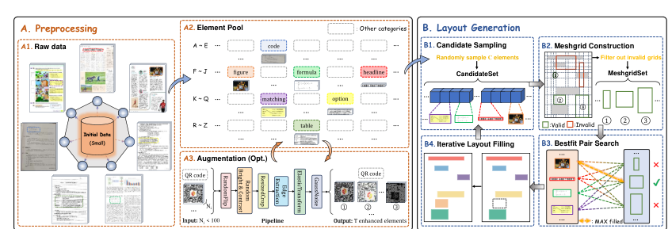
Figure 2: Illustration of Mesh-candidate BestFit. Initially, in (A) Preprocessing, a category-wise element pool is created from a small initial dataset. During (B) Layout Generation, Mesh-candidate BestFit iteratively searches for the optimal candidate-grid match.
3 DIVERSE DOCSYNTH-300K DATASET CONSTRUCTION
Existing unimodal pre-training datasets are characterized by significant homogeneity, primarily comprising academic papers. This limitation substantially hinders the generalization capabilities of pre-trained models. To enhance adaptability to diverse downstream document types, it is impera- tive to develop a more varied pre-training document dataset.
The diversity of pre-training data can be primarily manifested in two dimensions: (1) Element di- versity: This includes a variety of document elements, such as text in different font sizes, tables in various forms, and more. (2) Layout diversity: This encompasses various document layouts, including (no limited to) single-column, double-column, multi-column, and formats specific to aca- demic papers, magazines, and newspapers. In this paper, we propose a novel methodology termed Mesh-candidate BestFit, which automatically synthesizes diverse and well-organized documents by leveraging both element and layout diversity. The resulting dataset, termed DocSynth-300K, significantly enhances model performance across various real-world document types. The overall pipeline of Mesh-candidate BestFit is illustrated in Figure 2 and detailed as follows:
3.1 PREPROCESSING: ENSURING ELEMENT DIVERSITY
In the preprocessing phase, to ensure the inclusion of a diverse range of document elements, we utilize M6Doc test (Cheng et al., 2023), which consists of 74 different document elements coming from about 2800 diverse document pages, as our initial data. Consequently, we fragment the pages, extracting and constructing an element pool by each fine-grain category. Meanwhile, to maintain diversity within elements of the same category, we design an augmentation pipeline that enlarges the data pool of rare categories that have quantities less than 100 elements (Appendix A.2.2).

3.2 LAYOUT GENERATION: ENSURING LAYOUT DIVERSITY
In addressing the challenge of synthesizing diverse layouts, the most straightforward approach is random arrangement. However, random arrangement yields disorganized and confusing layouts, which severely hampers the improvement on real-world documents. Regarding the layout generation models based on Diffusion (Chen et al., 2024; Inoue et al., 2023) or GAN (Jiang et al., 2023; Gupta et al., 2021), existing methods are limited to producing homogeneous layouts such as academic papers, which is insufficient to cover various real-world document layouts.
To ensure layout diversity and consistency with real-world documents, inspired by the 2D bin- packing problem, we regard available grids built by the current layout as “bins” of different sizes and iteratively perform the best matching to generate more diverse and reasonable document layouts, balancing both the layout diversity (randomness) and aesthetics (such as fill rate and alignment). De- tailed steps of layout generation are demonstrated as follows:
1. Candidate Sampling For each blank page, a subset is obtained through stratified sampling from the element pool based on element size, serving as candidate set. Then, randomly sample an element from the candidate set and place it at a certain position on the page.
2. Meshgrid Construction Construct the meshgrid based on the layout and filter out the invalid grids that overlaps with inserted elements. Only the remaining grids will be able to participate in matching with the candidate in subsequent steps.
3. BestFit Pair Search For each candidate, traverse all grids that meet the size requirement and search for the Mesh-candidate pair with the maximum fill rate. Subsequently, remove the optimal candidate from the candidate set and update the layout.
4. Iterative Layout Filling Repeat step 2 ∼3 until no valid Mesh-candidate satisfy the size require- ment. Ultimately, random central scaling will be applied to all filled elements separately.
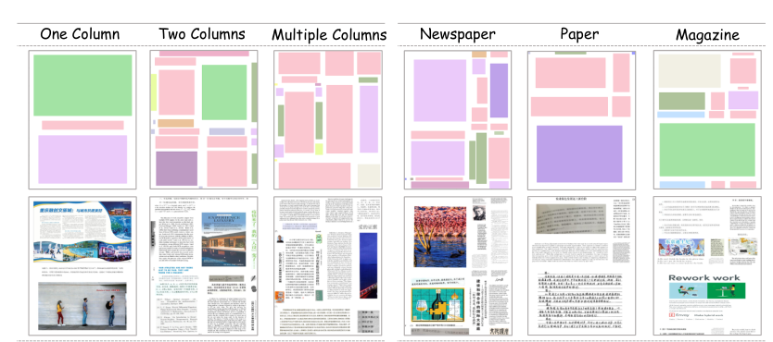
Figure 3: Examples of synthetic document data. Synthetic documents demonstrate comprehensive layout diversity (multiple layout formats) and element diversity (incorporating varied elements).
Through the above process, elements are continuously filled in at optimal positions, ultimately cre- ating a well-organized and visually appealing document image, as shown in Figure 3. The generated documents exhibit a high degree of diversity, which enables the pre-trained models to adapt to a vari- ety of real-world document types effectively. Meanwhile, quantitative analysis demonstrates that the generated document closely adheres to human design principles such as alignment and density (Ap- pendix A.3.1). The detailed algorithm of the above layout generation is shown in Algorithm 1.

4 GLOBAL-TO-LOCAL MODEL ARCHITECTURE
Unlike natural images, different elements in document images can vary significantly in scale, such as one-line title and whole-page ta- ble. To handle this scale-varying challenge, we introduce a hierarchical architecture called GL- CRM, which consists of two main components: the Controllable Receptive Module (CRM) and the Global-to-Local Design (GL). CRM flexi- bly extracts and integrates features with mul- tiple scales and granularities, while GL archi- tecture features a hierarchical perception pro- cess from global context (whole-page scale), to sub-block areas (medium-scale), and finally lo- cal semantics information.
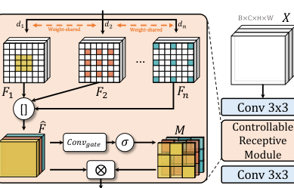
Figure 4: Illustration of Controllable Receptive Module (CRM), which extracts and fuses features of varying scales and granularities.

4.1 CONTROLLABLE RECEPTIVE MODULE
CRM is illustrated in Figure 4. To elaborate, for each layer’s feature X, we start by extracting fea- tures using a weight-shared convolution layer w with kernel size k. To capture features of different granularities, we employ a set of varying dilation rates d = [d1, d2, ..., dn]. This approach allows us to obtain a set of features of different granularities, denoted as F = [F1, F2, . . . , Fn]:
Fi = GELU(BN(Conv(X, w, di))) (1)
After extracting features F = [F1, F2, . . . , Fn] of different granularities, we proceed to integrate these features and allow the network to learn to fuse different feature components autonomously:
ˆF = Concat([F1, F2, . . . , Fn]) (2)
M = σ(GELU(BN(Convgate( ˆF)))) (3)
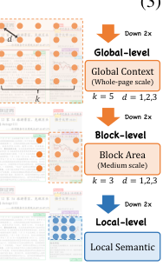
A lightweight convolutional layer Convgate with a kernel size of 1 and groups of nC is used to extract a mask M with values ranging between 0 and 1. M can be considered importance weights for different features. Finally, M is applied to the fused features ˆF, followed by a lightweight output projector Convout. Additionally, a shortcut connection is used to merge the integrated feature with the initial feature X:
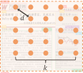
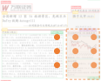
XCRM = X + GELU(BN(Convout(M ⊗ ˆF))) (4)
The CRM is plugged into the conventional CSP bottleneck (Wang et al., 2020) for extracting and enhancing features of different granularities, as shown in Figure 4. The functionality of the CRM is controlled by two parameters k and d, which control the granularity and scale of extracted features.
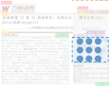
Figure 5: Illustration of Global-to-local design.

4.2 GLOBAL-TO-LOCAL DESIGN
Global-level. For the shallow stage, which contains rich texture details, we use CRM with enlarged kernel size and dilation rates (k = 5, d = 1, 2, 3). A large kernel helps capture more texture details and preserve local patterns for whole-page elements.
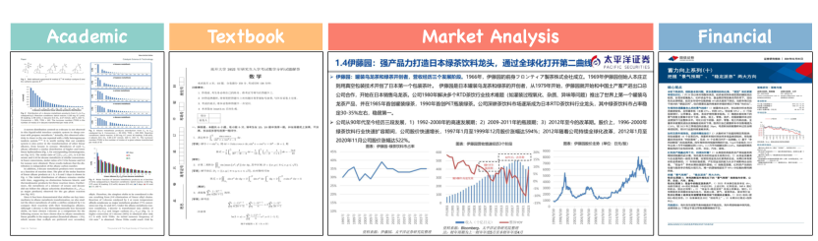
Figure 6: Examples of complex documents with different formats and structures in DocStructBench.
Block-level. For the intermediate stage, where the feature map is downsampled and texture feature is reduced, we employ CRM with smaller kernel (k = 3, d = 1, 2, 3). In this case, expanded dilation rates are sufficient for the perception of medium-scale elements, such as document sub-blocks.
Local-level. For the deep stage, where semantic information is predominant, we use a basic bottle- neck that serves as a lightweight module which focuses on local semantic information.

5.1 EXPERIMENTAL METRICS AND DATASETS
For evaluation metrics, we report COCO-style mAP (Lin et al., 2014) for accuracy and FPS (pro- cessed images per second) for speed. For evaluation datasets, experiments are conducted on the two most complex public DLA datasets D4LA (Da et al., 2023) and DocLayNet (Pfitzmann et al., 2022). D4LA consists of 11,092 noisy images annotated with 27 categories from IIT-CDIP (Lewis et al., 2006) across different 12 document types. The training set consists of 8,868 images and the testing set consists of 2,224 images. As for DocLayNet, DocLayNet contains 80,863 pages from 7 docu- ment types and is manually annotated with 11 categories. Images are split into 69,103/6,480/4,994 for training/validation/testing, respectively. DocLayNet validation set is used for evaluation.
Meanwhile, to quantitatively evaluate model performance across different document types, we cu- rate an in-house dataset termed DocStructBench, which is a comprehensive dataset designed for evaluation across various real-world scenario documents. It consists of four subsets categorized by the source of the documents: Academic, Textbooks, Market Analysis, and Financial (examples of these documents are illustrated in Figure 6). The data sources of DocStructBench are notably di- verse, encompassing a broad range of domains from various institutions, publishers, and websites. DocStructBench consists of 7,310 training images and 2,645 testing images. Each image has been manually annotated across 10 distinct categories: Title, Plain Text, Abandoned Text, Figure, Figure Caption, Table, Table Caption, Table Footnote, Isolated Formula, and Formula Caption. For exper- iments on DocStructBench, we perform training on a mixture of all four subsets and report results on each subset separately. Other details about DocStructBench can be found at Appendix A.1.

5.2 COMPARISON DLA METHODS & DATASETS
DocLayout-YOLO is compared with both multimodal and unimodal methods. Multimodal methods include LayoutLMv3 (Huang et al., 2022), DiT-Cascade (Li et al., 2022), VGT (Da et al., 2023). For unimodal comparison methods we use robust object detector DINO-4scale-R50 (Zhang et al., 2023a). For DLA pre-training datasets, we compare DocSynth-300K with public DLA pre-training datasets PubLayNet (Zhong et al., 2019) and DocBank (Li et al., 2020b).

5.3 IMPLEMENTATION DETAILS
For DocLayout-YOLO, we conduct pre-training on DocSynth-300K with image longer side resized at 1600 and use a batch size of 128 and learning rate of 0.02 for 30 epochs. For fine-tuning on DocLayNet, longer side is resized to 1120 and learning rate is set to 0.02. For fine-tuning on D4LA, the longer side is set to 1600 and learning rate is set to 0.04. For fine-tuning on DocStructBench, the
Table 1: Results of DocLayout-YOLO with different optimization strategies. Pretrain denotes DocSynth-300K pre-training. Resulting DocLayout-YOLO significantly outperforms the baseline model. ↑∆denotes improvements compared with baseline YOLO-v10 model.
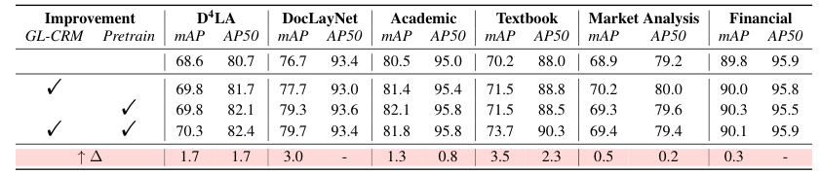
Table 2: Performance comparison on D4LA and DocLayNet. v10m++ denotes the original v10m bottleneck enhanced by our proposed GL-CRM bottleneck. Best and second best are highlighted.
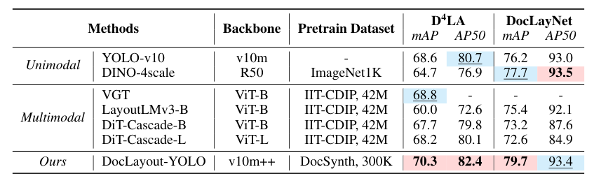
longer side is set to 1280 and learning rate is set to 0.04. Training performs with a patience of 100 epochs on 8×A100 GPUs. As for comparison models, DINO employs MMDetection (Chen et al., 2019), using a multi-scale training with an image longer side of 1280 and an AdamW optimizer at 1.0 × 10−4. LayoutLMv3 and DiT use Detectron2 Cascade R-CNN (Wu et al., 2019) training with an image longer side of 1333, SGD optimizer of 2.0 × 10−4 for 60k iterations.

5.4 MAIN RESULTS
5.4.1 EFFECTIVENESS OF PROPOSED OPTIMIZATION STRATEGIES
We start by analyzing the effects of different improvement strategies implemented in DocLayout- YOLO, with the experimental results presented in Table 1. Results indicate that (1) DocSynth-300K largely enhances performance across various document types, DocSynth-300K pre-trained model achieves 1.2 and 2.6 improvement on D4LA and DocLayNet, which encompasses multiple doc- ument types. Meanwhile, DocSynth-300K pre-trained model also leads to improvement on four subsets of DocStructBench. (2) The resulting DocLayout-YOLO achieves significant improve- ment, by combining both CRM and DocSynth-300K pre-training, the resulting DocLayout-YOLO achieves 1.7/2.6/1.3/3.5/0.5/0.3 improvements compared with baseline YOLO-v10 model.

5.4.2 COMPARISON WITH CURRENT DLA METHODS
Next, we conduct the comparison with existing DLA methods across multiple datasets. Results of D4LA and DocLayNet are shown in Table 2. We can conclude that (1) DocLayout-YOLO outper- forms robust unimodal DLA methods. For instance, it shows an improvement of 2.0 over DINO, which is the second best on DocLayNet. (2) DocLayout-YOLO also outperforms SOTA multimodal methods. For example, on the D4LA dataset, DocLayout-YOLO achieves 70.3 mAP, surpassing second-best VGT’s 68.8. Meanwhile, we conduct experiments on DocStructBench and results are presented in Table 3. DocLayout-YOLO achieves superior performance in three out of four subsets, surpassing existing SOTA unimodal (DINO) and multimodal approaches (DIT-Cascade-L). As for Market Analysis, DocLayout-YOLO is second best compared to DIT-Cascade-L, we suspect this is because DocSynth-300K pre-training is still not sufficient for most complex layouts.
Table 3: Performance comparison on DocStructBench. v10m++ denotes original v10m bottleneck enhanced by our proposed GL-CRM bottleneck. FPS is tested on the same single A100 GPU ma- chine. LayoutLMv3-BC denotes pre-trained on additional Chinese document data. ∗ denotes FPS tested under Detectron2, † denotes FPS tested under Ultralytics (Jocher et al., 2023) and ‡ denotes tested under MMDetection. Best and second best are highlighted.
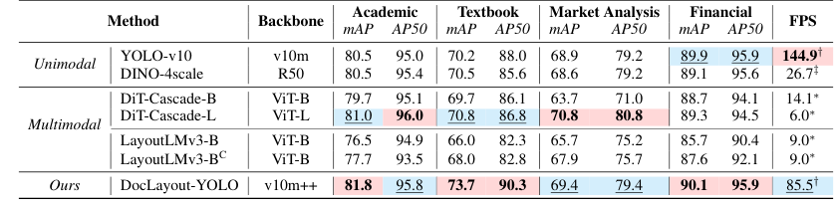
Table 4: Donwstream fine-tuning performance of different document dataset pre-trained model (baseline YOLO-v10m is utilized). baseline row indicates from scratch training results. Re- sults show that compared with public and synthetic document datasets, DocSynth-300K shows better adaptability across all document types. Best and second best are highlighted.
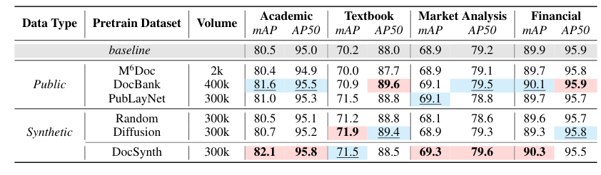
As for inference speed, we carefully evaluate the FPS of various DLA methods, and results show that (3) DocLayout-YOLO is significantly more efficient than current DLA methods. Although there is a slight decrease compared to the baseline YOLO-v10, DocLayout-YOLO still demonstrates an obvious advantage in speed. For example, compared with best multimodal methods DIT-Cascade-L, DocLayout-YOLO achieves 14.3× faster FPS. For the best unimodal method DINO, DocLayout- YOLO also shows 3.2× faster FPS.
5.5.1 COMPARISONS WITH DIFFERENT DOCUMENT SYNTHETIC METHODS
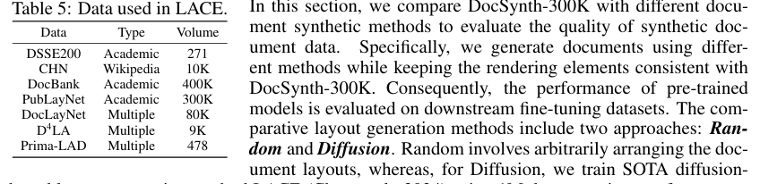
From results, we can conclude that: (1) Random layouts is unsuitable for document pre-training. Though certain improvements are observed, the performance of random layout is suboptimal due to large misalignments with real documents. (2) Diffusion layout is limited to certain document
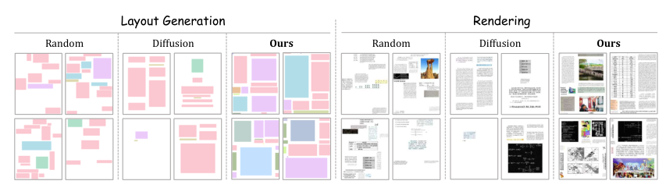
Figure 7: Visualization of generated document images using different document synthetic methods.
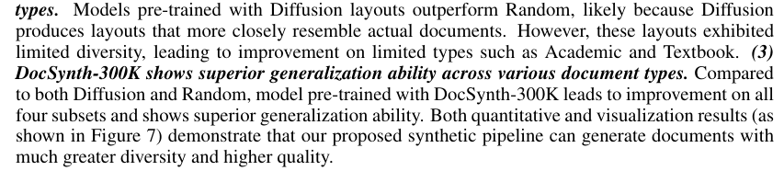
5.5.2 COMPARISONS WITH PUBLIC DOCUMENT PRE-TRAINING DATASETS
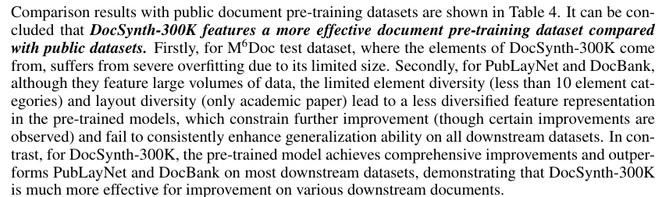
5.5.3 ABLATIONS ON EFFECTS OF GL-CRM
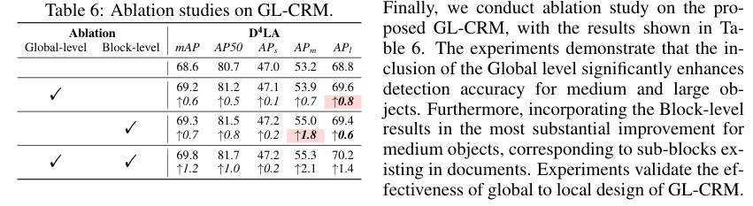

6 CONCLUSION
In this paper, we propose DocLayout-YOLO, which excels in both speed and accuracy. DocLayout- YOLO incorporates improvements from both pre-training and model optimization perspectives: For pre-training, we propose the Mesh-candidate BestFit methodology, which synthesizes a high-quality, diverse DLA pretraining dataset, DocSynth-300K. For model optimization, we introduce the GL- CRM, enhancing the network’s perception of document images from a hierarchical global-block- local manner. Experimental results on extensive downstream datasets demonstrate that DocLayout- YOLO significantly outperforms existing DLA methods in both speed and accuracy.
Apostolos Antonacopoulos, David Bridson, Christos Papadopoulos, and Stefan Pletschacher. A realistic dataset for performance evaluation of document layout analysis. In ICDAR, 2009.
Nicolas Carion, Francisco Massa, Gabriel Synnaeve, Nicolas Usunier, Alexander Kirillov, and Sergey Zagoruyko. End-to-end object detection with transformers. In ECCV, 2020.
Jian Chen, Ruiyi Zhang, Yufan Zhou, and Changyou Chen. Towards aligned layout generation via diffusion model with aesthetic constraints. arXiv preprint arXiv:2402.04754, 2024.
Kai Chen, Jiaqi Wang, Jiangmiao Pang, Yuhang Cao, Yu Xiong, Xiaoxiao Li, Shuyang Sun, Wansen Feng, Ziwei Liu, Jiarui Xu, Zheng Zhang, Dazhi Cheng, Chenchen Zhu, Tianheng Cheng, Qijie Zhao, Buyu Li, Xin Lu, Rui Zhu, Yue Wu, Jifeng Dai, Jingdong Wang, Jianping Shi, Wanli Ouyang, Chen Change Loy, and Dahua Lin. MMDetection: Open mmlab detection toolbox and benchmark. arXiv, 2019.
Hiuyi Cheng, Peirong Zhang, Sihang Wu, Jiaxin Zhang, Qiyuan Zhu, Zecheng Xie, Jing Li, Kai Ding, and Lianwen Jin. M6doc: A large-scale multi-format, multi-type, multi-layout, multi- language, multi-annotation category dataset for modern document layout analysis. In CVPR, 2023.
Cheng Da, Chuwei Luo, Qi Zheng, and Cong Yao. Vision grid transformer for document layout analysis. In ICCV, 2023.
Darren Edge, Ha Trinh, Newman Cheng, Joshua Bradley, Alex Chao, Apurva Mody, Steven Truitt, and Jonathan Larson. From local to global: A graph rag approach to query-focused summariza- tion. arXiv preprint arXiv:2404.16130, 2024.
Jiuxiang Gu, Xiangxi Shi, Jason Kuen, Lu Qi, Ruiyi Zhang, Anqi Liu, Ani Nenkova, and Tong Sun. ADoPD: A large-scale document page decomposition dataset. In ICLR, 2024.
Kamal Gupta, Justin Lazarow, Alessandro Achille, Larry Davis, Vijay Mahadevan, and Abhinav Shrivastava. Layouttransformer: Layout generation and completion with self-attention. In ICCV, 2021.
Adam W. Harley, Alex Ufkes, and Konstantinos G. Derpanis. Evaluation of deep convolutional nets for document image classification and retrieval. In ICDAR, 2015.
Yupan Huang, Tengchao Lv, Lei Cui, Yutong Lu, and Furu Wei. Layoutlmv3: Pre-training for document AI with unified text and image masking. In ACM Multimedia, 2022.
Mude Hui, Zhizheng Zhang, Xiaoyi Zhang, Wenxuan Xie, Yuwang Wang, and Yan Lu. Unifying layout generation with a decoupled diffusion model. In CVPR, 2023.
Naoto Inoue, Kotaro Kikuchi, Edgar Simo-Serra, Mayu Otani, and Kota Yamaguchi. Layoutdm: Discrete diffusion model for controllable layout generation. In CVPR, 2023.
Zhaoyun Jiang, Jiaqi Guo, Shizhao Sun, Huayu Deng, Zhongkai Wu, Vuksan Mijovic, Zijiang James Yang, Jian-Guang Lou, and Dongmei Zhang. Layoutformer++: Conditional graphic layout gen- eration via constraint serialization and decoding space restriction. In CVPR, 2023.
Glenn Jocher, Ayush Chaurasia, and Jing Qiu. Ultralytics YOLO, 2023. URL https://github. com/ultralytics/ultralytics.
Kotaro Kikuchi, Edgar Simo-Serra, Mayu Otani, and Kota Yamaguchi. Constrained graphic layout generation via latent optimization. In ACM Multimedia, 2021.
Xiang Kong, Lu Jiang, Huiwen Chang, Han Zhang, Yuan Hao, Haifeng Gong, and Irfan Essa. BLT: bidirectional layout transformer for controllable layout generation. In ECCV, 2022.
David D. Lewis, Gady Agam, Shlomo Argamon, Ophir Frieder, David A. Grossman, and Jefferson Heard. Building a test collection for complex document information processing. In SIGIR, 2006.
Patrick Lewis, Ethan Perez, Aleksandra Piktus, Fabio Petroni, Vladimir Karpukhin, Naman Goyal, Heinrich K¨uttler, Mike Lewis, Wen-tau Yih, Tim Rockt¨aschel, et al. Retrieval-augmented gener- ation for knowledge-intensive nlp tasks. In NIPS, 2020.
Jianan Li, Jimei Yang, Jianming Zhang, Chang Liu, Christina Wang, and Tingfa Xu. Attribute- conditioned layout GAN for automatic graphic design. IEEE Trans. Vis. Comput. Graph., 2021.
Junlong Li, Yiheng Xu, Tengchao Lv, Lei Cui, Cha Zhang, and Furu Wei. Dit: Self-supervised pre-training for document image transformer. In ACM Multimedia, 2022.
Kai Li, Curtis Wigington, Chris Tensmeyer, Handong Zhao, Nikolaos Barmpalios, Vlad I. Morariu, Varun Manjunatha, Tong Sun, and Yun Fu. Cross-domain document object detection: Benchmark suite and method. In CVPR, 2020a.
Minghao Li, Yiheng Xu, Lei Cui, Shaohan Huang, Furu Wei, Zhoujun Li, and Ming Zhou. Docbank: A benchmark dataset for document layout analysis. In COLING, 2020b.
Tsung-Yi Lin, Michael Maire, Serge Belongie, and et al. Microsoft coco: Common objects in context. In ECCV, 2014.
Birgit Pfitzmann, Christoph Auer, Michele Dolfi, Ahmed S. Nassar, and Peter W. J. Staar. Doclaynet: A large human-annotated dataset for document-layout segmentation. In KDD, 2022.
Ori Ram, Yoav Levine, Itay Dalmedigos, Dor Muhlgay, Amnon Shashua, Kevin Leyton-Brown, and Yoav Shoham. In-context retrieval-augmented language models. Transactions of the Association for Computational Linguistics, 11:1316–1331, 2023.
Shaoqing Ren, Kaiming He, Ross Girshick, and Jian Sun. Faster r-cnn: Towards real-time object detection with region proposal networks. NIPS, 2015.
Ao Wang, Hui Chen, Lihao Liu, Kai Chen, Zijia Lin, Jungong Han, and Guiguang Ding. Yolov10: Real-time end-to-end object detection. arXiv, 2024a.
Bin Wang, Chao Xu, Xiaomeng Zhao, Linke Ouyang, Fan Wu, Zhiyuan Zhao, Rui Xu, Kaiwen Liu, Yuan Qu, Fukai Shang, Bo Zhang, Liqun Wei, Zhihao Sui, Wei Li, Botian Shi, Yu Qiao, Dahua Lin, and Conghui He. Mineru: An open-source solution for precise document content extraction, 2024b. URL https://arxiv.org/abs/2409.18839.
Chien-Yao Wang, Hong-Yuan Mark Liao, Yueh-Hua Wu, Ping-Yang Chen, Jun-Wei Hsieh, and I- Hau Yeh. Cspnet: A new backbone that can enhance learning capability of CNN. In CVPR Workshops, 2020.
Yuxin Wu, Alexander Kirillov, Francisco Massa, Wan-Yen Lo, and Ross Girshick. Detectron2. https://github.com/facebookresearch/detectron2, 2019.
Yang Xu, Yiheng Xu, Tengchao Lv, Lei Cui, Furu Wei, Guoxin Wang, Yijuan Lu, Dinei A. F. Florˆencio, Cha Zhang, Wanxiang Che, Min Zhang, and Lidong Zhou. Layoutlmv2: Multi-modal pre-training for visually-rich document understanding. In ACL, 2021.
Yiheng Xu, Minghao Li, Lei Cui, Shaohan Huang, Furu Wei, and Ming Zhou. Layoutlm: Pre- training of text and layout for document image understanding. In KDD, 2020.
Xiao Yang, Ersin Yumer, Paul Asente, Mike Kraley, Daniel Kifer, and C Lee Giles. Learning to extract semantic structure from documents using multimodal fully convolutional neural networks. In CVPR, 2017.
Hao Zhang, Feng Li, Shilong Liu, Lei Zhang, Hang Su, Jun Zhu, Lionel M. Ni, and Heung-Yeung Shum. DINO: DETR with improved denoising anchor boxes for end-to-end object detection. In ICLR, 2023a.
Junyi Zhang, Jiaqi Guo, Shizhao Sun, Jian-Guang Lou, and Dongmei Zhang. Layoutdiffusion: Improving graphic layout generation by discrete diffusion probabilistic models. In ICCV, 2023b.
Xu Zhong, Jianbin Tang, and Antonio Jimeno-Yepes. Publaynet: Largest dataset ever for document layout analysis. In ICDAR, 2019.
In the appendix, we provide detailed information on our proposed in-house evaluation dataset Doc- StructBench (Appendix A.1), as well as details of Mesh-candidate BestFit and more visualization examples of generated documents (Appendix A.2). Next, we give a quantitative evaluation of DocSynth-300K data from a design principle perspective (Appendix A.3.1), as well as ablation stud- ies on pre-training data volume (Appendix A.3.2). Finally, the detection examples of DocLayout- YOLO on multiple kinds of real-world documents are demonstrated (Appendix A.4).
A.1 DOCSTRUCTBENCH DETAILS
Table 7: Document source and train/test split of Docstructbench.
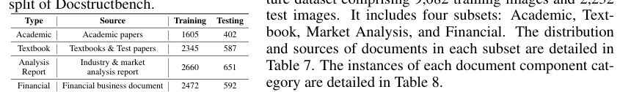
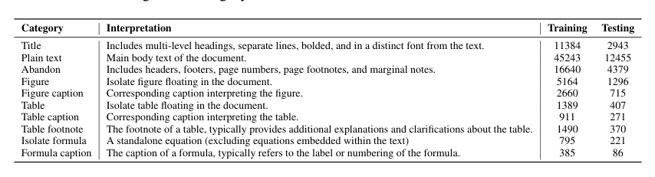
Table 8: Fine-grained category and number of instances annotated in DocStructBench.
A.2 MESH-CANDIDATE BESTFIT

A.2.1 ALGORITHM OF LAYOUT GENERATION
The algorithm of layout generation is detailed as Algorithm 1, which iteratively searches for the best matches between the candidate and all grids (bins). After the best matching pair is found, the candidate is inserted into the document and continues to iteratively search for the optimal match until the number of elements reaches a threshold N (empirically set to 15). The matching threshold frthr is set to 10−4.

A.2.2 DATA AUGMENTATION PIPELINE
In the preprocessing phase, we conduct a specifically designed augmentation pipeline for rare cate- gories that have few elements in the element pool. The details are as follows:
1. Random Flip Considering the various possibilities of text orientation in different documents, we enhance the original data with random flips in both the horizontal and vertical directions at a probability of 0.5.
2. Random Brightness & Contrast We simulate the real-world environments under a wide variety of lighting conditions and brightness levels by randomly altering the brightness and contrast of elements at a probability of 0.5.
3. Random Cropping To guide the model to concentrate more on local features, we employ a probability of 0.7 to perform random cropping on the elements within the area range of 0.5 ∼ 0.9.
4. Edge Extraction We use the Sobel filter to perform edge detection and extract the contour information within the elements with a probability of 0.2, thereby enhancing the richness of the features.
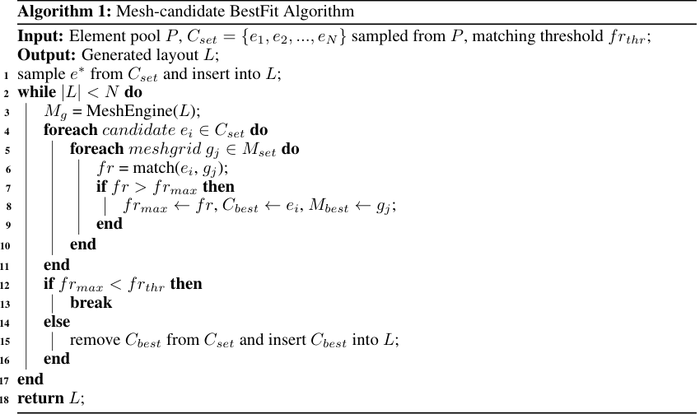
5. Elastic Transformation & Gaussian Noisification We distort and blur the original data through a slight elastic transformation and a Gaussian noise addition process to simulate jitter or resolution- induced distortion in reality.

A.2.3 OTHER DETAILS
In the layout generation phase, we iteratively perform the best matching to search for the candidate- grid pair with the highest fill rate until no valid pair satisfies the size requirement. Furthermore, we add an additional restriction, namely that the number of small elements must not exceed Mininum, since a surplus of small elements leads to a layout that does not adhere to conventional aesthetic standards. Specifically, Mininum is set to 5.

A.2.4 MORE VISUALIZATION EXAMPLES
Here, a richer visualization of the generated data is shown in Figure 8. S, M, L respectively denote small, medium, and large elements, indicating the components that are relatively abundant on the page. It is evident that the data we generate is rich in categories and possesses strong diversity. It can not only generate dense layouts containing many small elements but also produce sparse layouts composed of a few large elements, similar to the layouts generated by diffusion-based models.
A.3.1 EVALUATION OF SYNTHETIC DOCUMENT FROM DESIGN PRINCIPLE PERSPECTIVE
In this section, we quantitatively evaluate whether the synthetic document data aligns with the human design principle. The evaluation employs the Align and Density metrics, which respectively measure the aesthetic quality of layouts in terms of document alignment and density. For Align, we utilize the LayoutGAN++ (Kikuchi et al., 2021; Li et al., 2021) metric which measures the alignment of elements in the document:
N X i=1min g(∆xL
i ), g(∆xC
i ), g(∆xR
i )
g(∆yT
i ), g(∆yC
i ), g(∆yB
i )

. (5)
Lalg = where x∗
i (∗ = L, C, R), y∗
i (∗ = T, C, B) denotes the x-axis left/center/right and y-axis top/center/bottom of i-th elements in document, g(x) = −log(1 −x), and ∆x∗
i (∗ = L, C, R)
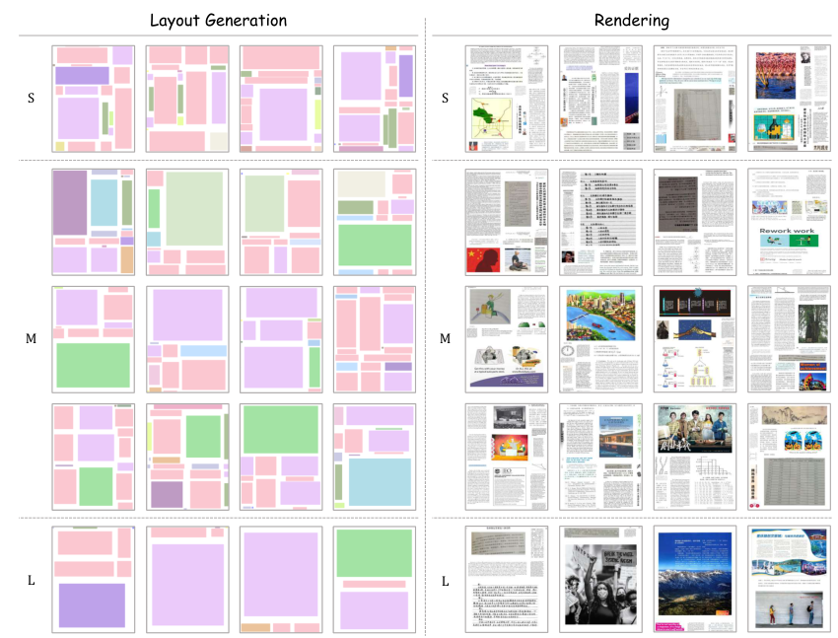
Figure 8: Visualization of generated diverse layouts and corresponding pages after rendering. S, M, L respectively denote small, medium, and large elements, indicating the components that are relatively abundant on the page.
is computed as:
∆x∗
i = min
∀j̸=i |x∗
i −x∗
j| (6)
∆y∗
i (∗= T, C, B) can be computed similarly. For Density, we calculate the ratio of filled area in
the layout:
Ldst =PN
i=1 |ei|
|L| (7)
Table 9: Quantative comparison between different layout generation methods.
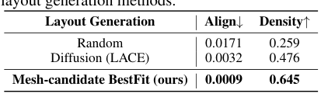

A.3.2 ABLATIONS ON PRETRAINING DATA VOLUME
We conduct ablation experiments on pre-training data volume. We pretrain basic YOLO-v10 using 0-500K Mesh-candidate BestFit generated pre-training data and fine-tune on D4LA dataset subse- quently. Results are shown in Figure 9. In our experiments, we observe a distinct correlation betw- een pre-training data volume and model performance. Specifically, for data less than 100K, there is a consis- tent improvement in model performance correlating with an increase in data volume. However, model perfor- mance shows noticeable fluctuations when the data vol- ume reaches 200K. Notably, model performance reaches its top when the data volume increases to 300K.
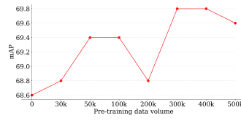
A.4 D E ETECTION XAMPLES | Figure 9: Ablations on pre-training data  volume.
In Figures 10 and Figure 11, we demonstrate the detection examples of DocLayout-YOLO after fine-tuning with the DocStructBench dataset on various types of downstream documents. Examples show that the model, fine-tuned using the DocStructBench dataset, effectively adapts to multiple document types, showcasing considerable practicality and coverage.
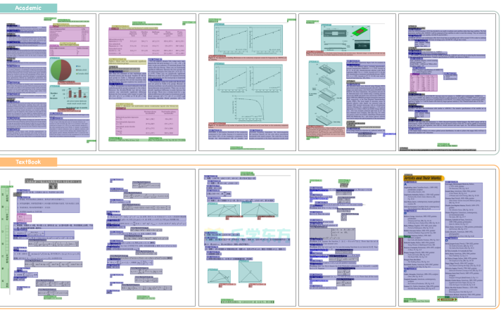
Figure 10: Detection results of DocLayout-YOLO on Academic and Textbook subsets.
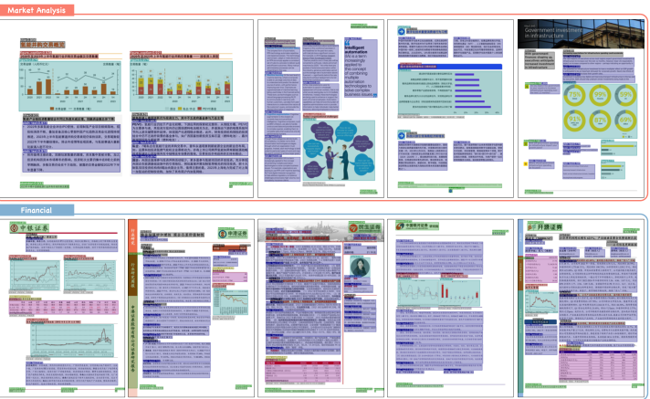
Figure 11: Detection results of DocLayout-YOLO on Market Analysis and Financial subsets.

