**Event functions in a class**

**Class: TODO (example)**

**Background**

Most of the JavaScript code for the reservation system applications are member variables and functions of classes.

The classes has also event functions but these cannot be called by this.myEventFunction. Other techniques must be used.

**Alternative solutions for member event functions**

Some different ways to handle the member event functions have been tested. None of them is especially good. Maybe there is some other way to do it. In this document is therefore not only the techniques used for the reservation system applications. Also other are presented.

The following alternatives are described

* For every member event function a global event function is defined
* The name (string) of the global variable of the class itself is a member variable
* Class with static event member functions and member data in a separate data class

**Example**

A class for a form defines a button with a click event function

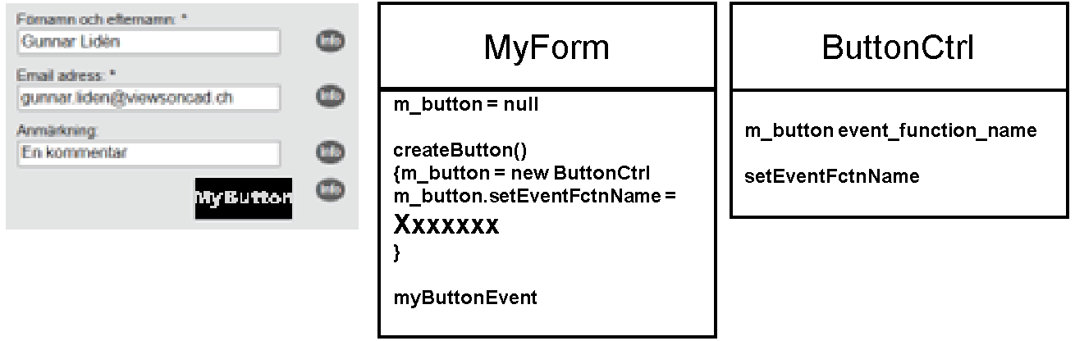

**Member event function with a global event function**

For each member event function there is a corresponding global event function. The name of the global function (string ‘myGlobalButtonEvent’) can be set with the ButtonCtrl member function SetEventFctnName. The only thing the global function does is calling the MyForm member event function (g_form.myButtonEvent)

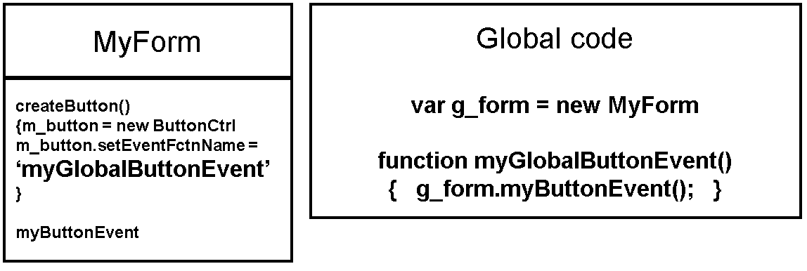

**Class with a member that is the name (string) of the object**

The class myForm is instantiated and the global variable g_form holds the value.

The class myForm has a member variable m_form_str (string) and a set function for this member variable setObjectMyFormStr(i_form_str). After the creation of the object this set function is called.

The ButtonCtrl class has the member setEventFctnName that takes the string name of the event function as input. With the string object name can the event function name be set with:

**m_form_str + ‘.’ + ‘myButtonEvent**’.

**Static class with a data class as global object**

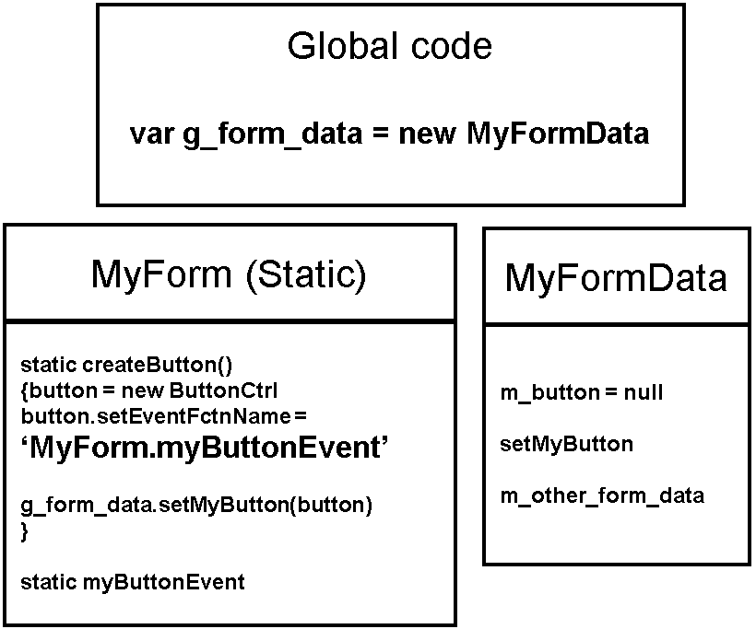

**Static class with a data class as input/output object**

