**Localization**

**Classes: DefaultText, UtilDate, InputEventReservationText (example)**

**Definition**

Localization is the process of adapting your software to meet the linguistic, cultural, and technical requirements of a specific country. This means implementing support for:

* Multiple languages
* Multiple date and time formats
* Multiple currencies

**Multiple languages**

**Implemented languages**

The first languages that the application will support are: German. English, French. Italian and Swedish. Additional languages can easily be added.

Users will be asked to check and propose new or corrected texts.

**Language global variable**

The ReservationSystem application generates HTML files that will become the part applications of the reservation system for an organization. In the header section <head> of the HTML a JavaScript language global variable (g_reservation_language) is defined that sets the language for the application

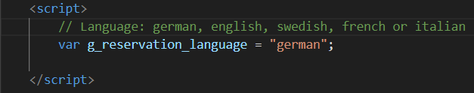

**Data class DefaultText**

The class DefaultText holds default texts for the implemented languages. For each language there is a set function. What the get function returns is determined by the global language variable (g_reservation_language).

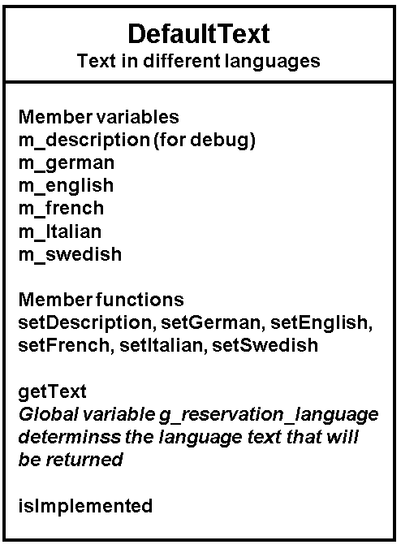

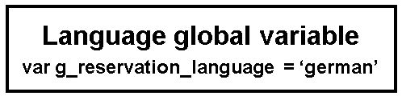

**Handling of languages in several classes**

For this application the handling of languages for menus, dialogs, message, etc. are implemented in several classes. There is for example one class ***InputEventReservation*** that creates the form below for the user to input data for a reservation (name, email address and remark). The language support for this class is implemented in the sub-class ***InputEventReservationText***.

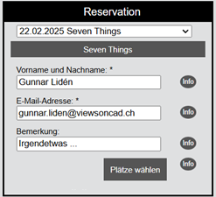

**Text handling example. Class InputEventReservationText**

The class InputEventReservationText (the constructor) sets default texts. The language is determined by the by the global language variable (g_reservation_language).

There are set functions that also makes it possible for a developer to customize the texts for an organization.

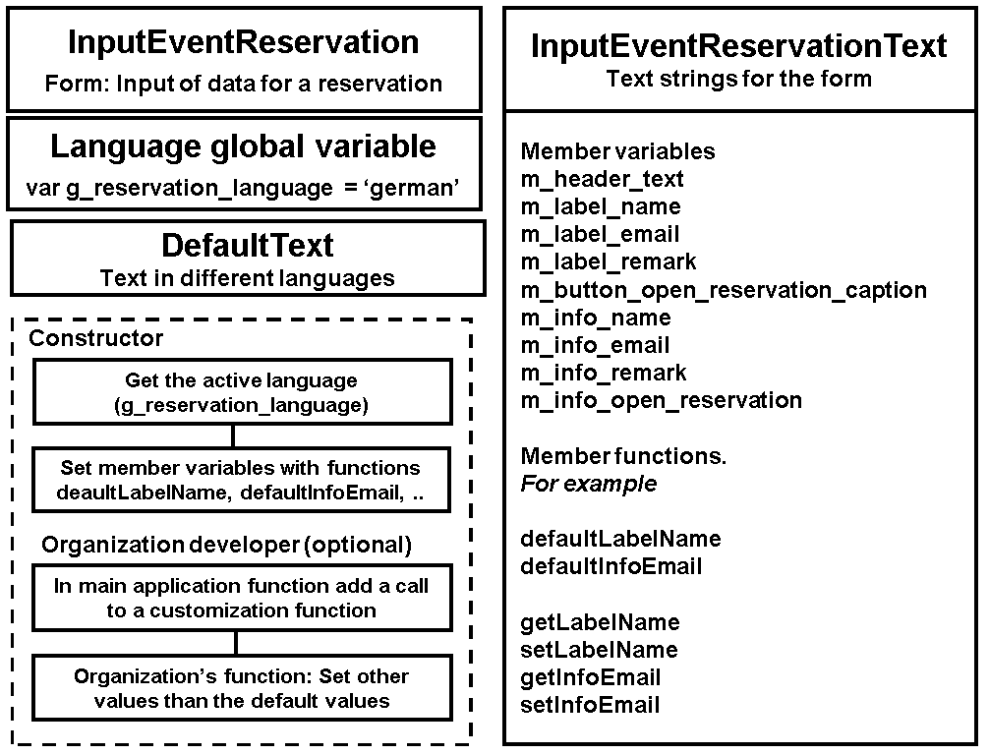

**Multiple date and time formats**

The class ***UtilDate*** has functions for different date formats.

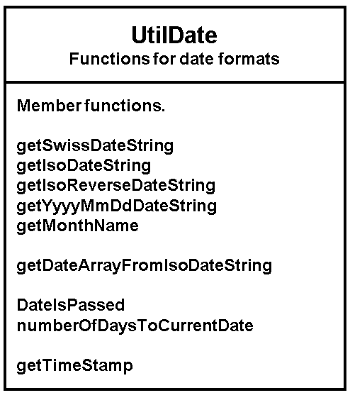

**Multiple currencies**

Nothing is yet implemented. Will be added if pay functions are added to the reservation system.