**Styles**

**Class: InputEventReservationStyle (example)**

**Definition**

Styles are fonts, colors, window sizes, ……….

**Styles for the Reservation System**

The styles for the application ReservationSystem.htm that generates HTML files for the part applications making up the reservation system is defined with a CSS file in the Styles subdirectory (ReservationSystem.css).

**Styles for the generated HTML files (part applications)**

**Styles are added with setAttribute**

In order to minimize the number of files for a reservation system no CSS files are used to set the styles for the generated applications (HTML files). It is the HTML DOM Element ***setAttribute*** that is used for this.

The function setAttribute function takes a string as input style data. Example:

'width: 10%; min-height: 15px; margin-right: 3%; margin-top:0px; '

**Handling of styles implemented in several classes**

The handling of styles are implemented in several classes. There is for example one class ***InputEventReservation*** that creates the form below for the user to input data for a reservation (name, email address and remark). The styles for this class is implemented in the sub-class ***InputEventReservationStyle***

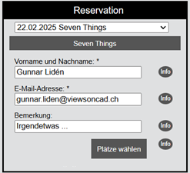

**Style handling example. Class InputEventReservationStyle**

The class InputEventReservationStyle (the constructor) sets default styles.

There are set functions that also makes it possible for a developer to customize the styles for an organization.

