# Data Science Project Proposal

## A description of the problem and a discussion of the background.

The current world crisis revolves around the invisible enemy known as the coronavirus (COVID-19). This disease has its name written in history by forcing the WHO to state it as a pandemic state as the number of infections and death tolls has been exponentially increasing. Some countries such as Italy have even gone to the stage of lockdown. There are others that are yet to be under lockdown. Based on the articles from dailymail [1]and mirror [2], it is evident that people are highly risk of being exposed to the virus with all the drastic measures such as closing of restaurants and schools are taking place.

With this in mind, I will like be doing an analysis of neighborhoods specifically in Enfield, London to identify the availability of essential amenities in the neighbourhoods than others in this crucial time. This project will also identify the neighborhoods that do not have access or have access to some amenities. This can aid Government or social volunteers to focus on the efficient resource distribution in these areas in times of need.

So, the next question is what are the essential amenities?

With reference to recommended list from the business insider article [3], the essential items are food sources that are available in grocery stores or any type of markets and medicines from pharmacies for self-care and hygiene purposes like Panadol and sanitizers.

Therefore, the **business problem** is: To identify and explore the similarities and differences in food availability and medical needs among the neighborhoods in Enfield, London based on the number of amenities (markets, pharmacies and etc.) in the times of COVID-19 outbreak.

## A description of the data and how it will be used to solve the problem.

The London borough of Enfield can be can obtained scraped from the Wikipedia table as shown below using BeautifulSoup.

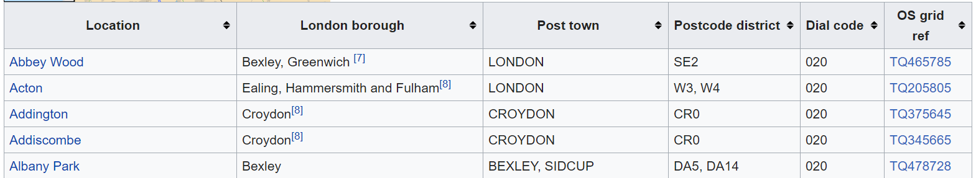

<https://en.wikipedia.org/wiki/List_of_areas_of_London>

The neighbourhoods are considered to be various locations of the Enfield corresponding to the same postcode which can be obtained from the first column in the table above. The coordinates of these neighbourhoods can be obtained through Geocoder. For each neighbourhood in Enfield, the venues can be obtained by connecting to Foursquare API surrounding 750m radius (radius subjected to changes).

After obtaining the venues, it is essential to filter out the venues by “Venue’s Category” from the data obtained through Foursquare API. Here, only the venues associated to grocery stores/markets and pharmacies are needed. The specific types of venue categories are identified from the Foursqaure website by looking for stores and markets. After filtering, the data can be then clustered through k-means to explore how similar or how different the neighbourhoods are.

# References

|  |  |
| --- | --- |
| [1] | M. Robinson, "Prince George and Princess Charlotte's school becomes the latest to send pupils home for coronavirus isolation - as NINE shut - despite advice it's 'unnecessary' - offices close and sports fixtures are cancelled across UK," Mailonline, 27 02 2020. [Online]. Available: https://www.dailymail.co.uk/news/article-8047195/Is-Britain-heading-coronavirus-lockdown-amid-confusion-dangers-Europe.html. [Accessed 14 03 2020]. |
| [2] | G. Diebelius, "Coronavirus: Entire UK cities could be placed on lockdown in bid to contain spread," Mirror, 02 03 2020. [Online]. Available: https://www.mirror.co.uk/news/uk-news/coronavirus-entire-uk-cities-could-21612813. [Accessed 14 03 2020]. |
| [3] | K. Warren, "What to buy if you’re quarantined at home during the coronavirus pandemic," Business Insider US, 11 03 2020. [Online]. Available: https://www.businessinsider.sg/what-to-buy-for-home-quarantine-coronavirus-2020-3?r=US&IR=T. [Accessed 15 03 2020]. |