**Step 1: Initialize the ReactJS Project**

**Create a new ReactJS application: Open your terminal and run the following commands to set up the project.**

**npx create-react-app pe**

**cd test01**

**Step 2: Set Up JSON Server**

* **Install JSON Server: JSON Server will help create a mock API for laptop data. Install it as a development dependency.**

**npm install -g json-server**

* **Create file db.json: Create a db.json file in the root of your project and add the provided data.**
* **Run Json server:**

**npx json-server --watch db.json --port 5000**

* **(optional) Add a Script to Run JSON Server in package.json**

**In the package.json file, you will add a script to easily start JSON Server from the terminal *without typing a long command each time*. You can add the script under the "scripts" section as follows:**

**"server": "json-server --watch db.json --port 5000"**

**Run JSON Server:**

**npm run server**

**Step 3: Install required dependencies: Install necessary packages like React Router, React Bootstrap, PropTypes, axios**

**npm install react-router-dom react-bootstrap bootstrap prop-types axios**

**Step 4: Import the bootstrap CSS file to the index.js**

**import 'bootstrap/dist/css/bootstrap.min.css’;**

**You can choose Terminal=>Split Terminal to run another server OR choose Run Both servers simultaneously follow the steps 5 bellow:**

**Step 5: Run Both Servers Simultaneously**

**To run both the React App and JSON Server simultaneously in one terminal, you can use concurrently, a tool that allows you to run multiple commands in one terminal.**

**npm install concurrently --save-dev**

**Update package.json to Add a New Script: Open your package.json and add the following script inside the "scripts" section:**

**"dev": "concurrently \"npm run server\" \"npm start\""**

**Run Both Servers Simultaneously:**

**npm run dev**

**Code:**

**Define router in Index.js**

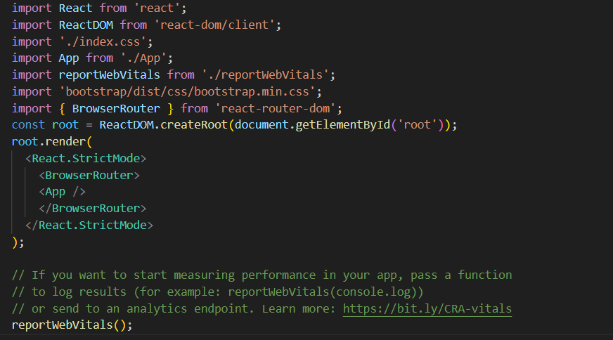

**Define router in App.js**

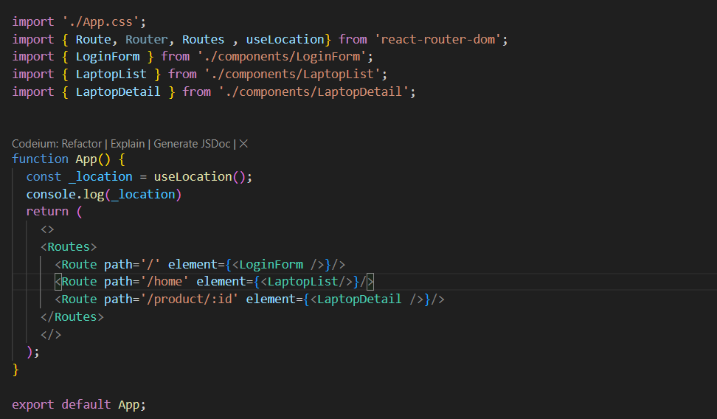

**LoginForm.jsx**

* **Use boostrap Form to handle validate with useReducer from React**
* **Use useEffect to get Accounts list when visit Login form**

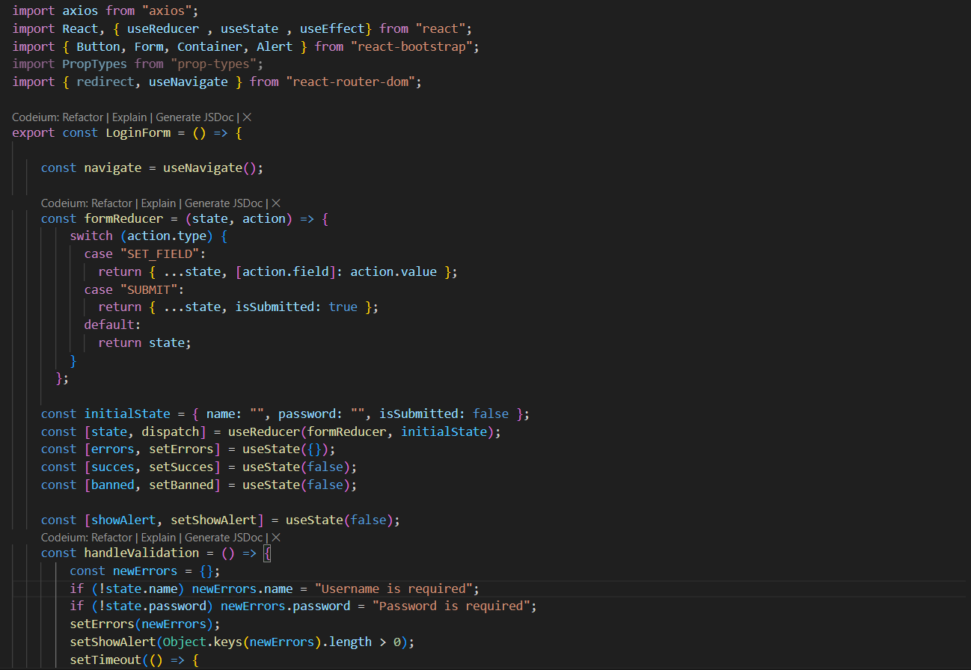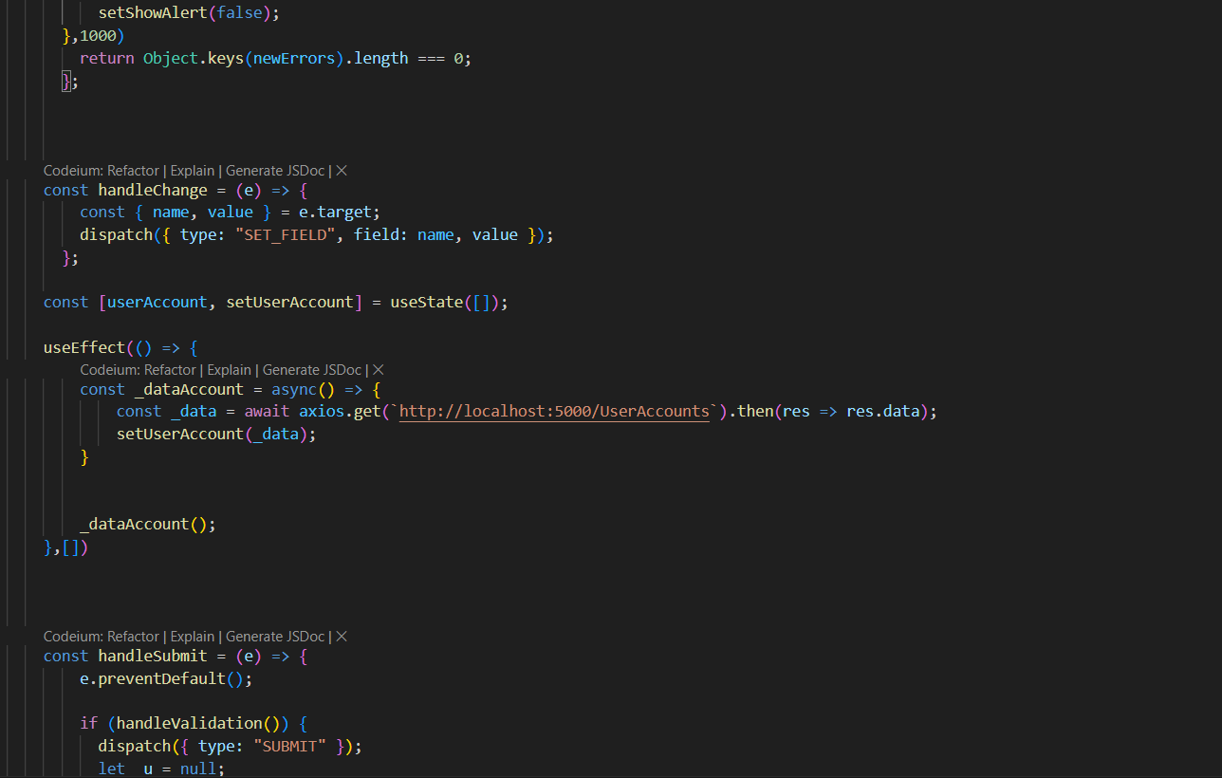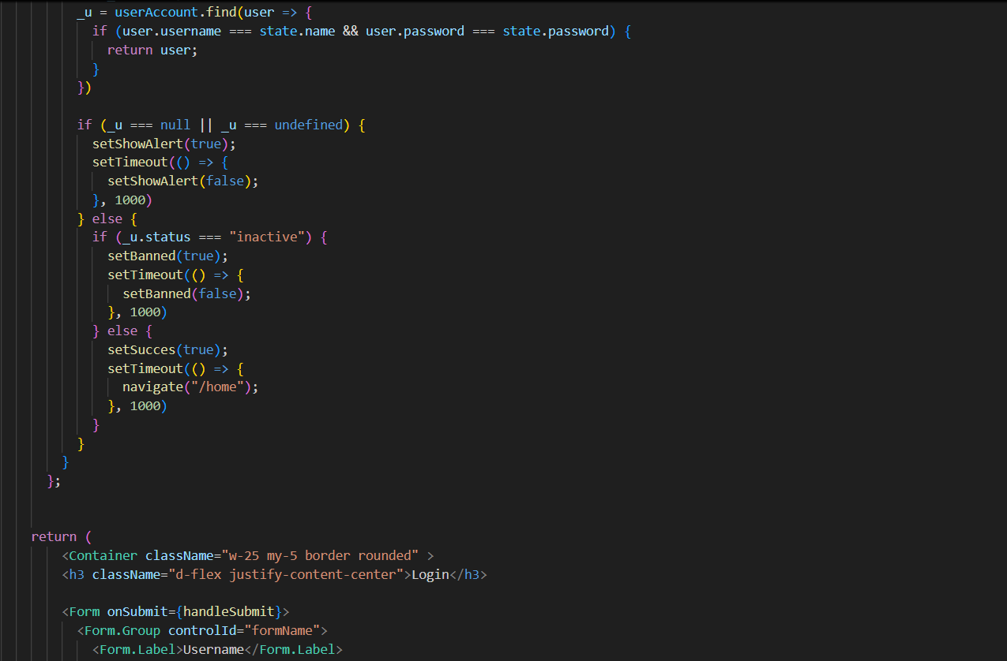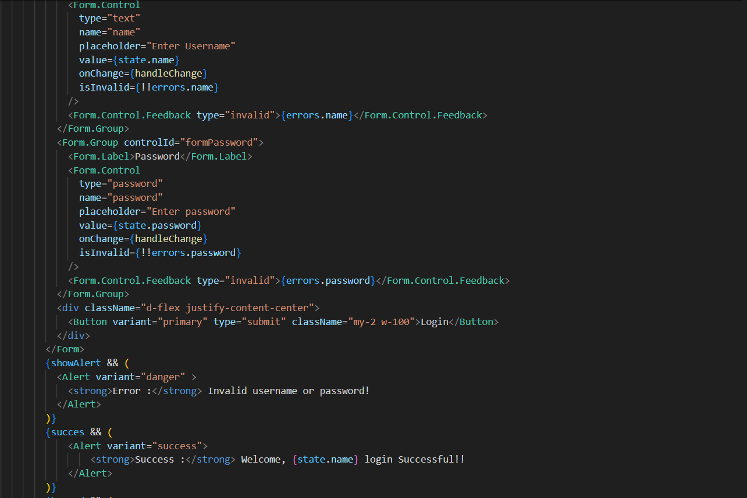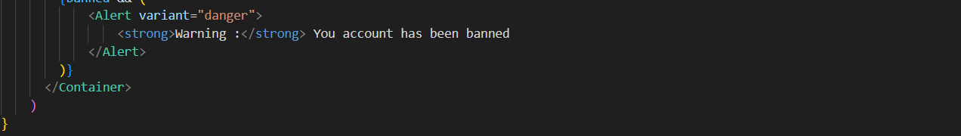

**Result:**

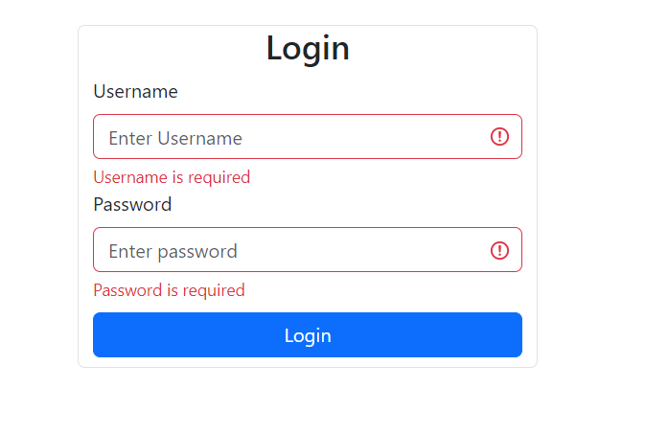

**LaptopList.jsx**

* **useEffect get Product to display**
* **use Map and Card to render Laptop card**
* **input Form with onChange to filter laptop in Search bar**

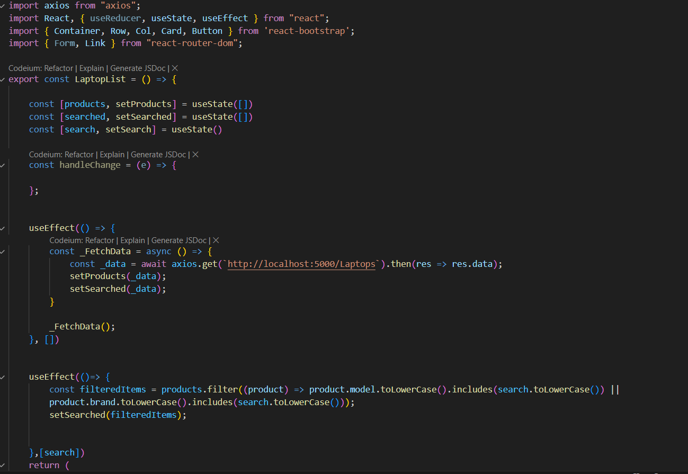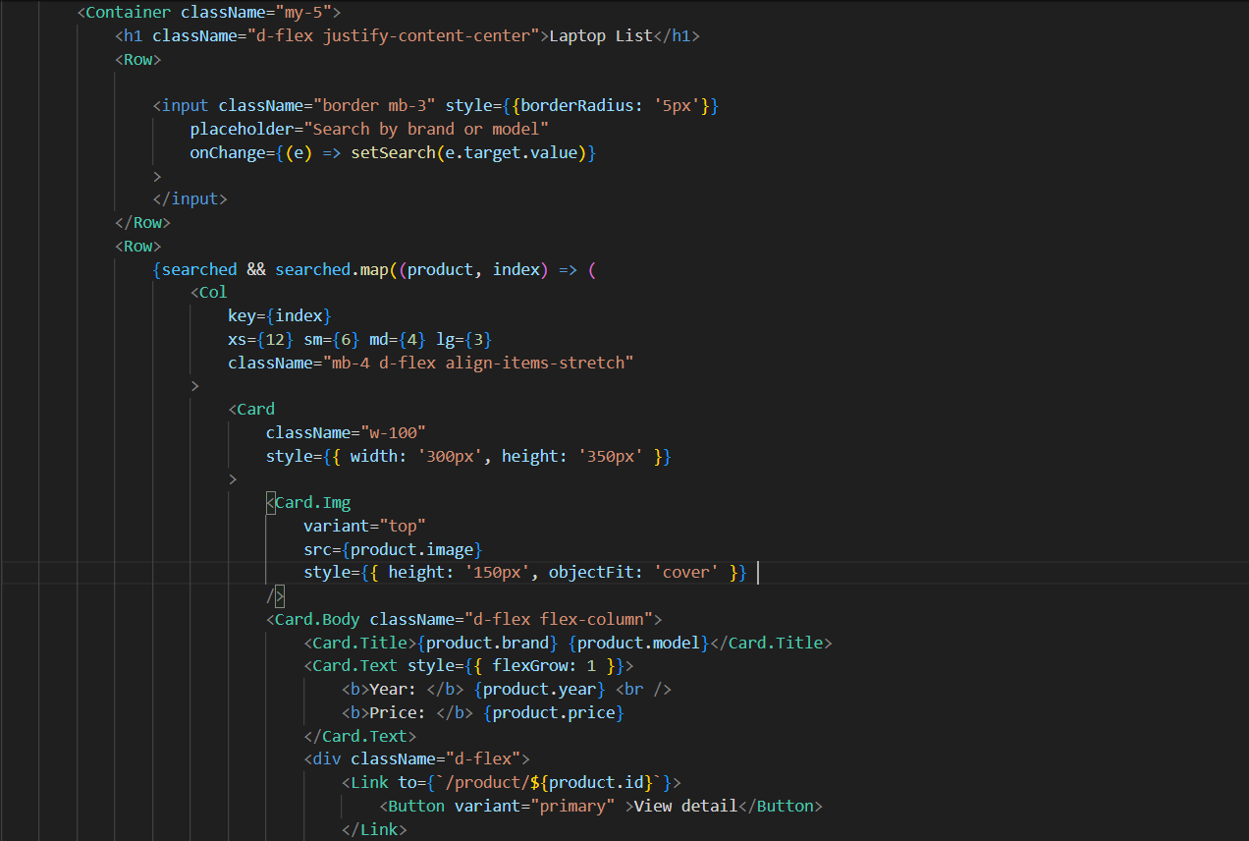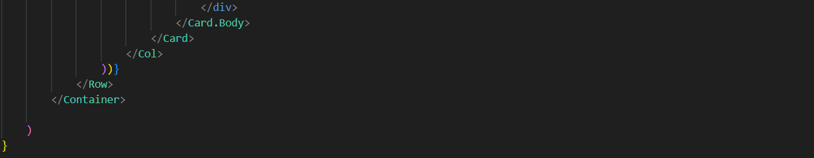

**Result:**

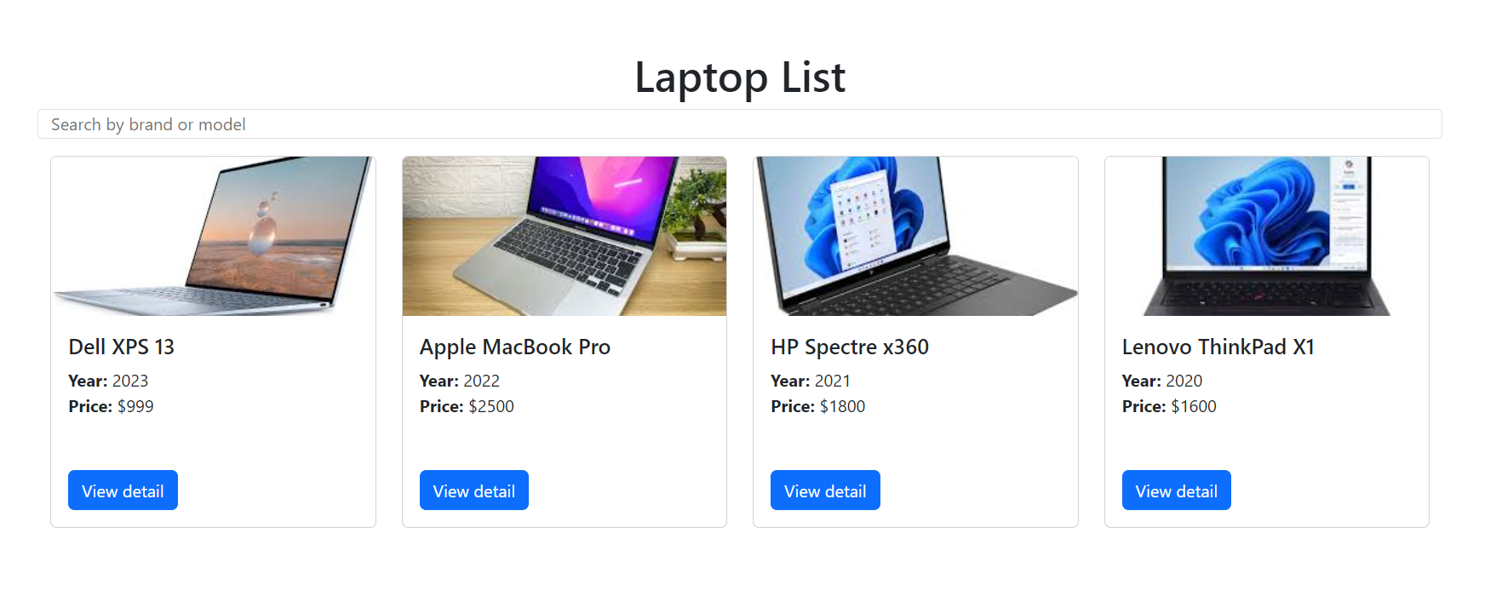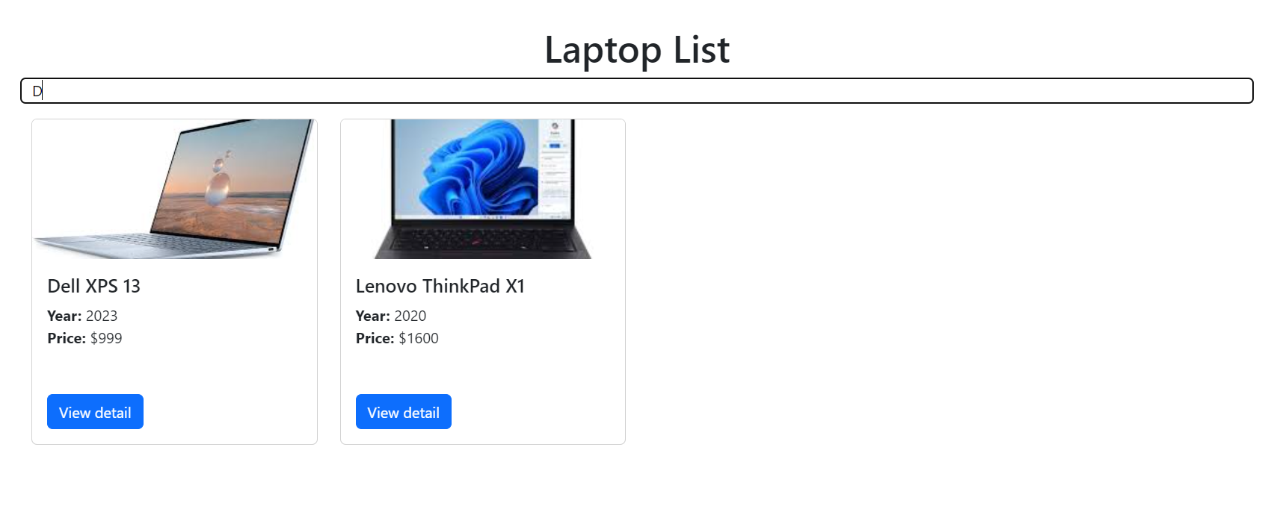

**LaptopDetail.jsx**

* **use useEffect get a single laptop first**

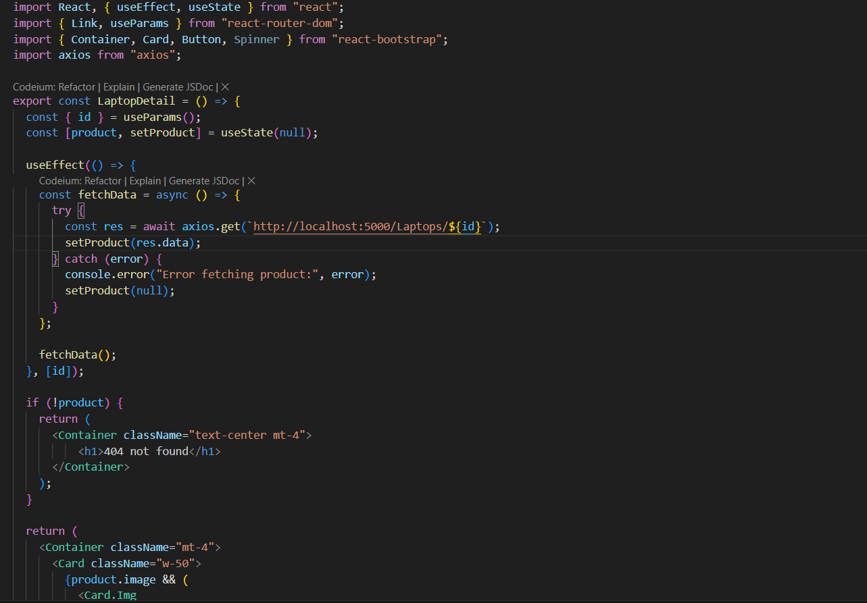

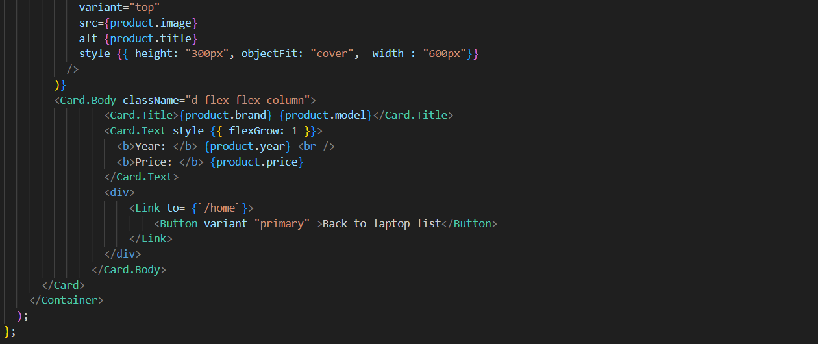

**Result:**

