**Exercise 1: Control Structures**

**Scenario 1:** The bank wants to apply a discount to loan interest rates for customers above 60 years old.

* + Question: Write a PL/SQL block that loops through all customers, checks their age, and if they are above 60, apply a 1% discount to their current loan interest rates.

**Scenario 2:** A customer can be promoted to VIP status based on their balance.

* + Question: Write a PL/SQL block that iterates through all customers and sets a flag IsVIP to TRUE for those with a balance over $10,000.

**Scenario 3:** The bank wants to send reminders to customers whose loans are due within the next 30 days.

* + Question: Write a PL/SQL block that fetches all loans due in the next 30 days and prints a reminder message for each customer.

**Scenario1:Apply 1% Discount for Customers Above 60**

CREATE TABLE Customers (

CustomerID NUMBER PRIMARY KEY,

Name VARCHAR2(100),

DOB DATE,

Balance NUMBER,

LastModified DATE

);

CREATE TABLE Loans (

LoanID NUMBER PRIMARY KEY,

CustomerID NUMBER,

LoanAmount NUMBER,

InterestRate NUMBER,

StartDate DATE,

EndDate DATE,

FOREIGN KEY (CustomerID) REFERENCES Customers(CustomerID)

);

INSERT INTO Customers (CustomerID, Name, DOB, Balance, LastModified)

VALUES (1, 'John Doe', TO_DATE('1950-05-15', 'YYYY-MM-DD'), 1000, SYSDATE);

INSERT INTO Customers (CustomerID, Name, DOB, Balance, LastModified)

VALUES (2, 'Jane Smith', TO_DATE('1990-07-20', 'YYYY-MM-DD'), 1500, SYSDATE);

INSERT INTO Loans (LoanID, CustomerID, LoanAmount, InterestRate, StartDate, EndDate)

VALUES (1, 1, 5000, 5, SYSDATE, ADD_MONTHS(SYSDATE, 60));

INSERT INTO Loans (LoanID, CustomerID, LoanAmount, InterestRate, StartDate, EndDate)

VALUES (2, 2, 8000, 6, SYSDATE, ADD_MONTHS(SYSDATE, 60));

BEGIN

FOR cust IN (

SELECT c.CustomerID, c.DOB, l.LoanID, l.InterestRate

FROM Customers c

JOIN Loans l ON c.CustomerID = l.CustomerID

)

LOOP

-- Calculate age from DOB

DECLARE

v_age NUMBER;

BEGIN

v_age := FLOOR(MONTHS_BETWEEN(SYSDATE, cust.DOB) / 12);

-- Check if customer is above 60

IF v_age > 60 THEN

-- Apply 1% discount on loan interest

UPDATE Loans

SET InterestRate = InterestRate - 1

WHERE LoanID = cust.LoanID;

-- Optional output

DBMS_OUTPUT.PUT_LINE('Applied 1% discount for Customer ID: ' || cust.CustomerID);

END IF;

END;

END LOOP;

COMMIT;

END;

/

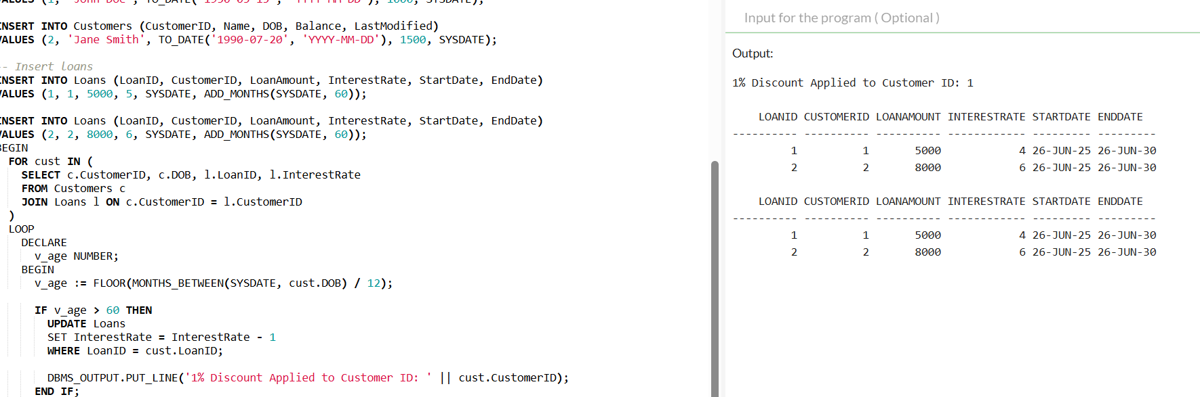

**Scenario 2: Promote to VIP if Balance > 10,000**

CREATE TABLE Customers (

CustomerID NUMBER PRIMARY KEY,

Name VARCHAR2(100),

DOB DATE,

Balance NUMBER,

LastModified DATE,

IsVIP VARCHAR2(5) DEFAULT 'FALSE'

);

INSERT INTO Customers (CustomerID, Name, DOB, Balance, LastModified)

VALUES (1, 'John Doe', TO_DATE('1985-05-15', 'YYYY-MM-DD'), 1000, SYSDATE);

INSERT INTO Customers (CustomerID, Name, DOB, Balance, LastModified)

VALUES (2, 'Jane Smith', TO_DATE('1990-07-20', 'YYYY-MM-DD'), 1500, SYSDATE);

INSERT INTO Customers (CustomerID, Name, DOB, Balance, LastModified)

VALUES (3, 'Ravi Kumar', TO_DATE('1975-01-01', 'YYYY-MM-DD'), 15000, SYSDATE);

BEGIN

FOR cust_rec IN (

SELECT CustomerID, Balance

FROM Customers

)

LOOP

IF cust_rec.Balance > 10000 THEN

UPDATE Customers

SET IsVIP = 'TRUE'

WHERE CustomerID = cust_rec.CustomerID;

DBMS_OUTPUT.PUT_LINE('Customer ' || cust_rec.CustomerID || ' promoted to VIP');

END IF;

END LOOP;

COMMIT;

END;

/

SELECT * FROM Customers;

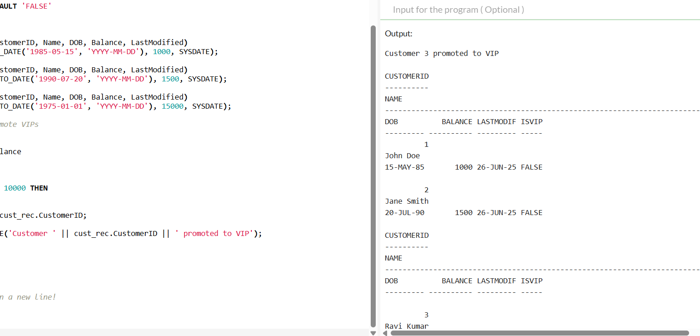

**Scenario 3: Loan Reminders for Dues Within 30 Days**

-- Step 1: Create Customers table

CREATE TABLE Customers (

CustomerID NUMBER PRIMARY KEY,

Name VARCHAR2(100),

DOB DATE,

Balance NUMBER,

LastModified DATE

);

-- Step 2: Create Loans table

CREATE TABLE Loans (

LoanID NUMBER PRIMARY KEY,

CustomerID NUMBER,

LoanAmount NUMBER,

InterestRate NUMBER,

StartDate DATE,

EndDate DATE,

FOREIGN KEY (CustomerID) REFERENCES Customers(CustomerID)

);

-- Step 3: Insert sample data

INSERT INTO Customers (CustomerID, Name, DOB, Balance, LastModified)

VALUES (1, 'John Doe', TO_DATE('1985-05-15', 'YYYY-MM-DD'), 1000, SYSDATE);

INSERT INTO Customers (CustomerID, Name, DOB, Balance, LastModified)

VALUES (2, 'Jane Smith', TO_DATE('1990-07-20', 'YYYY-MM-DD'), 1500, SYSDATE);

-- Loan ending soon (in 15 days)

INSERT INTO Loans (LoanID, CustomerID, LoanAmount, InterestRate, StartDate, EndDate)

VALUES (1, 1, 5000, 5, SYSDATE, SYSDATE + 15);

-- Loan ending later (not due soon)

INSERT INTO Loans (LoanID, CustomerID, LoanAmount, InterestRate, StartDate, EndDate)

VALUES (2, 2, 8000, 6, SYSDATE, SYSDATE + 90);

DECLARE

v_name Customers.Name%TYPE;

BEGIN

FOR loan_rec IN (

SELECT l.CustomerID, l.EndDate

FROM Loans l

WHERE l.EndDate <= SYSDATE + 30

)

LOOP

-- Get customer name

SELECT Name INTO v_name

FROM Customers

WHERE CustomerID = loan_rec.CustomerID;

-- Print reminder message

DBMS_OUTPUT.PUT_LINE('Reminder: Hey ' || v_name ||

', your loan is due on ' ||

TO_CHAR(loan_rec.EndDate, 'DD-Mon-YYYY') || '!');

END LOOP;

END;

/

