**Exercise 1:** Mocking and Stubbing Scenario: You need to test a service that depends on an external API. Use Mockito to mock the external API and stub its methods.

**ExternalApi.java**

package com.example.mockito_test;

public interface ExternalApi {

String getData();

}

**MyService.java**

package com.example.mockito_test;

public class MyService {

private ExternalApi api;

public MyService(ExternalApi api) {

this.api = api;

}

public String fetchData() {

return api.getData();

}

}

**MockStub.java**

package com.example.mockito_test;

import org.junit.jupiter.api.Test;

import static org.mockito.Mockito.*;

import static org.junit.jupiter.api.Assertions.*;

public class MockStub {

@Test

public void testExternalApi() {

ExternalApi mockApi = *mock*(ExternalApi.class);

*when*(mockApi.getData()).thenReturn("Mock Data");

MyService service = new MyService(mockApi);

String result = service.fetchData();

*assertEquals*("Mock Data", result);

}

}

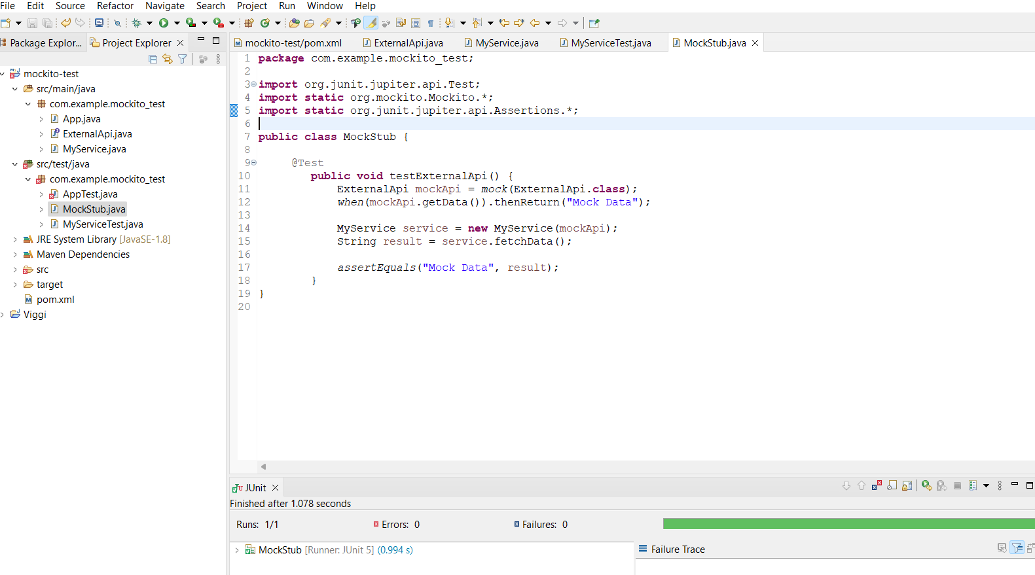**Output:**