**Creating Microservices for account and loan**   
  
**Account:**

Under src/main/java, create a package:  
com.cognizant.account.controller

Create a new class:

**AccountController.java**

package com.cognizant.account.controller;

import org.springframework.web.bind.annotation.GetMapping;

import org.springframework.web.bind.annotation.PathVariable;

import org.springframework.web.bind.annotation.RestController;

import java.util.Map;

@RestController

public class AccountController {

@GetMapping("/accounts/{number}")

public Map<String, Object> getAccountDetails(@PathVariable String number) {

return Map.*of*(

"number", number,

"type", "savings",

"balance", 234343

);

}

}

**Output:**

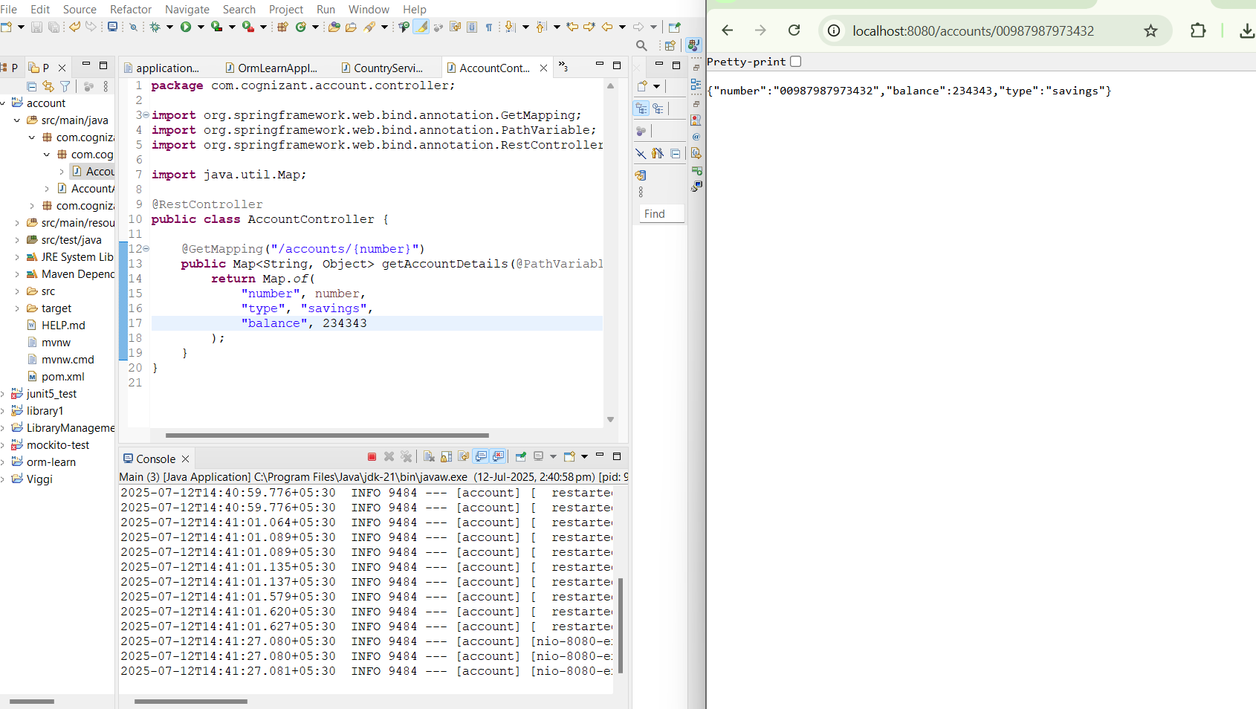

**Loan:**

Under src/main/java, create a package:  
com.cognizant.loan.controller

Create a new class:

**Application.properties**

spring.application.name=loan

server.port=8081

**LoanController.java**

package com.cognizant.loan.controller;

import org.springframework.web.bind.annotation.GetMapping;

import org.springframework.web.bind.annotation.PathVariable;

import org.springframework.web.bind.annotation.RestController;

import java.util.Map;

@RestController

public class LoanController {

@GetMapping("/loans/{number}")

public Map<String, Object> getLoanDetails(@PathVariable String number) {

return Map.*of*(

"number", number,

"type", "car",

"loan", 400000,

"emi", 3258,

"tenure", 18

);

}

}

**Output:**

