M1: CBD-Net
Implementation and results report
Oil-spill detection in Sentinel-1 SAR imagery · method 1 of 3

Method. Q. Zhu et al., “Oil spill contextual and boundary-supervised detection network based on marine SAR images,” IEEE TGRS [P24]. Official code: github.com/CUG-URS/CBDNet-main.
What this report contains. Two trained models of the same method and four tests: (A) the official SOS test split, which is leaky; (B) a leak-free group-disjoint split; (C) the external Peru dataset; and (D) the external MDOD dataset. Every table is generated from the saved metric files, and the terminal figures are excerpts of the real console logs.
1. Summary of results 3
2. Method and implementation 4
2.1 How CBD-Net works 4
2.2 Training and testing setup 4
2.3 What we changed, and two things we found in the official code 4
2.4 Code map 4
3. Metrics 5
4. Test A: SOS official split (leaky) 6
4.1 Quantitative results 6
4.2 Training 6
4.3 Qualitative results 7
5. Why the official split is leaky 8
6. Test B: SOS group-disjoint split (leak-free) 8
6.1 Quantitative results 8
6.2 Leaky vs leak-free 9
6.3 Training and qualitative results 9
7. Test C: external dataset Peru (new sea) 12
7.1 Quantitative results 12
7.2 Qualitative results 13
7.3 Findings 13
8. Test D: external dataset MDOD (look-alike false alerts) 14
8.1 Quantitative results 14
8.2 Qualitative results 15
8.3 Findings 15
9. Conclusions for M1 15
10. Reproducing these results 16

(Contents table: refreshed automatically when the PDF is made.)

1. Summary of results
Table 1. All M1 results at a glance (%, test-time augmentation unless noted).
Test | Model | Oil F1 | Oil IoU | mIoU | Precision | Recall | ECE (×100)
A. SOS official split (leaky) | official-split | 87.91 | 78.43 | 82.79 | 84.43 | 91.69 | 2.83
published [P29] |  | 87.81 | — | 82.94 | — | — | —
B. SOS group split (leak-free) | leak-free | 86.80 | 76.68 | 83.06 | 86.59 | 87.01 | 2.64
C. Peru (external, 2,013 patches) | official-split | 24.46 | 13.94 | 37.16 | 14.00 | 96.82 | 26.47
 | leak-free | 29.44 | 17.26 | 43.51 | 17.41 | 95.29 | 18.62

Table 2. MDOD (external, box labels only): share of boxes flagged as oil, and how well oil is ranked above look-alikes.
Model | Oil boxes flagged (should be high) | Look-alike boxes flagged (should be low) | AUC oil vs look-alikes (0.5 = chance)
official-split | 64.0 | 91.8–99.8 | 0.282
leak-free | 55.5 | 87.0–98.2 | 0.335

Key findings
- The reproduction succeeds. On the official SOS split our mIoU is 82.79 % (published 82.94 %) and oil F1 is 87.91 % (published 87.81 %); both gaps are within ±0.2 pp.
- The official split leaks, but the effect is small. Every official test tile has augmented copies of its sea area in training. On a leak-free split, oil IoU drops by 1.74 pp and oil F1 by 1.11 pp.
- M1 does not transfer to a new sea. On Peru, oil F1 falls to 24.5–29.4 %. Recall stays above 95 %, but precision collapses to 14.0–17.4 % because almost every dark area is called oil. The probabilities become badly calibrated (ECE ×7–9).
- M1 cannot reject look-alikes. On MDOD every look-alike class is flagged more often than real oil, and the ranking AUC is below 0.5.
- The leak-free model is the better model on both external datasets (higher F1 and lower ECE on Peru, fewer false alerts on MDOD). All results are from a single training seed.

2. Method and implementation

2.1 How CBD-Net works
- Input: one 256 × 256 SAR tile (3 channels).
- Encoder: ResNet-34 pretrained on ImageNet, with an scSE attention block after every stage. scSE re-weights both the channels and the pixel locations.
- Bottleneck: a dilated-convolution block (rates 1, 2, 4, 8) that gives wide spatial context.
- Decoder: LinkNet-style, four up-sampling blocks with additive skip connections.
- Output: a sigmoid gives an oil probability for every pixel; threshold 0.5 gives the oil mask.

2.2 Training and testing setup
Table 3. Setup used for both models (identical to the official code).
Setting | Value
Training data | SOS Sentinel-1 training tiles, 256 × 256 (3,354 official / 3,358 leak-free)
Loss | BCE + Dice (as in the released code)
Optimiser | Adam, learning rate 2 × 10⁻⁴, batch size 4
Schedule | Up to 80 epochs. After more than 3 epochs without improvement of the training loss: reload the best weights and divide the learning rate by 5. Stop after more than 6.
Augmentation | HSV jitter, shift-scale-rotate, horizontal / vertical flips, 90° rotations (official)
Testing | Official 8-way test-time augmentation (TTA): 4 rotations × flip, probabilities averaged. A single-pass result is also reported.
Parameters | 31.4 M
Hardware | NVIDIA RTX 3050 laptop GPU (4 GB), 16 GB RAM, PyTorch 2.6 (CUDA 12.4)
Training time | official split: 71 epochs, 1 h 47 min; leak-free split: 50 epochs, 1 h 18 min

2.3 What we changed, and two things we found in the official code
The network, loss and schedule are imported unchanged from the official repository. We changed only:
- np.math → math, required by NumPy 2 (identical behaviour);
- shuffle=True in the data loader (the official code uses shuffle=False);
- fixed random seeds and a per-epoch CSV log, so that runs can be repeated.
Findings in the official code:
- The official evaluation script reports precision, recall and F1 for the background class, not for oil. t1p3-Iou.py calls confusion_matrix(labels=[255, 0]), which makes index 1 the background. We report oil-class metrics as the main numbers and the official-script value separately.
- The released code trains with BCE + Dice only. The boundary loss described in the paper exists in the repository (jointloss) but is not used by default.

2.4 Code map
Table 4. Where each part of M1 lives (repository root).
Part | File | Written by
Model (CBD-Net) | third_party/CBDNet-main/networks/CBDNet.py | official authors, unchanged
Loss (BCE + Dice) | third_party/CBDNet-main/dice_bce_loss.py | official authors, unchanged
Training loop | M1_CBDNet/train_m1.py | us, following the official train.py
Data loading, augmentation | common/sos_data.py | us; augmentation copied from the official code
SOS testing and metrics | common/evaluate.py | us; shared by M1–M3
Peru test | common/evaluate_peru.py | us; shared by M1–M3
MDOD test | common/evaluate_mdod.py | us; shared by M1–M3
Reports and figures | M1_CBDNet/make_report.py, make_peru_report.py, make_mdod_report.py | us

3. Metrics
Pixels are pooled over all test tiles, as in the official SOS script. “Oil” is the positive class.
Table 5. Metric definitions (TP / FP / FN / TN = true / false positive / false negative / true negative oil pixels).
Metric | Meaning | Formula
Accuracy | share of all pixels classified correctly | (TP + TN) / all
Precision (oil) | of the pixels called oil, the share that really is oil | TP / (TP + FP)
Recall (oil) | of the real oil pixels, the share that was found | TP / (TP + FN)
F1 (oil) | balance of precision and recall | 2PR / (P + R)
IoU (oil) | overlap of predicted and true oil areas | TP / (TP + FP + FN)
mIoU | mean of oil IoU and background IoU | (IoU_oil + IoU_bg) / 2
Boundary F1 | F1 of slick outlines, within 2 pixels | —
ROC-AUC / PR-AUC | how well probabilities rank oil above non-oil (threshold-free) | area under curve
ECE | calibration: gap between predicted probability and observed frequency (15 bins); 0 = perfect | Σ (n_b/N)·|acc_b − conf_b|
Brier score | mean squared error of the probabilities | mean (p − y)²

4. Test A: SOS official split (leaky)
Run M1_cbdnet_sentinel_dicebce_s0. Trained on the 3,354 official Sentinel-1 training tiles and tested on the 839 official test tiles. Training stopped at epoch 71; the best training loss was 0.3515 at epoch 66.

4.1 Quantitative results
Table 6. Segmentation metrics on the official SOS Sentinel-1 test set.
Metric (%) | Ours, with TTA | Ours, single pass | Published [P29]
Accuracy | 91.24 | 91.08 | —
Precision (oil) | 84.43 | 84.14 | —
Recall (oil) | 91.69 | 91.57 | —
F1 (oil) | 87.91 | 87.70 | 87.81
IoU (oil) | 78.43 | 78.09 | —
IoU (background) | 87.15 | 86.92 | —
mIoU | 82.79 | 82.51 | 82.94
Boundary F1 (2 px) | 37.82 | 37.24 | —
F1 as in the official script (background class) | 93.14 | 93.00 | —

Table 7. Probability quality.
Metric | With TTA | Single pass
ROC-AUC | 0.9748 | 0.9737
PR-AUC | 0.9585 | 0.9569
ECE (15 bins) | 0.0283 | 0.0329
Brier score | 0.0639 | 0.0657

Reproduction gap: mIoU -0.15 pp and F1 +0.10 pp (target: within ±2 pp). TTA adds about 0.2–0.3 pp to every metric.

4.2 Training
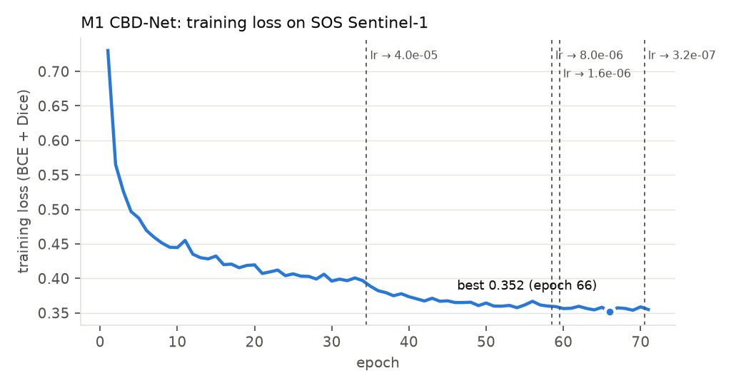
Figure 1. Training loss per epoch, official split. Dashed lines mark the learning-rate drops.
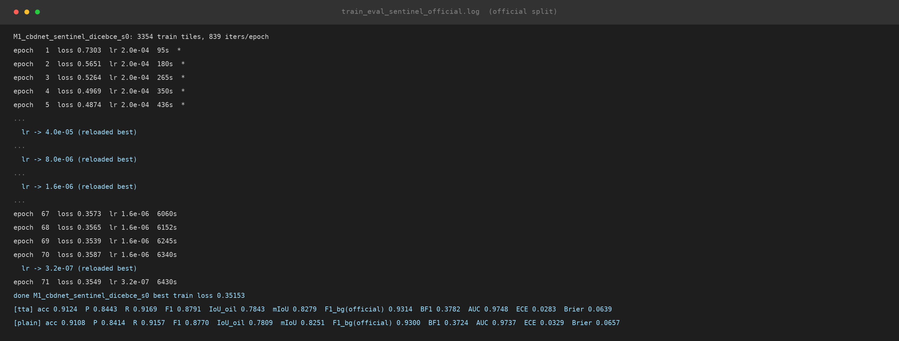
Figure 2. Console output of the official-split run (excerpt of train_eval_sentinel_official.log; “…” marks omitted epochs, * marks a new best loss). The last two lines are the test results.

4.3 Qualitative results
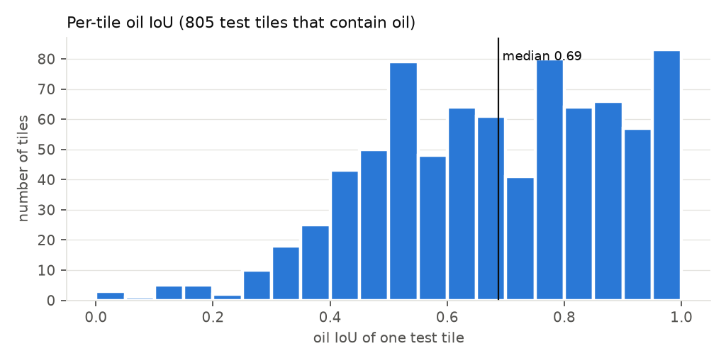
Figure 3. Per-tile oil IoU on the official test set. Median 0.69; 3 % of oil tiles score below 0.3.
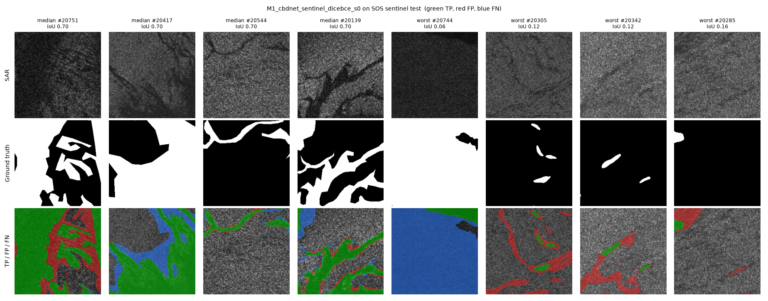
Figure 4. Four median and four worst test tiles. Green = correct oil, red = false oil, blue = missed oil.
- Large slicks are segmented well. Most errors sit on slick edges, where the ground-truth outlines are coarse polygons; this explains the low boundary F1 (37.82 %).
- The worst tiles are (a) fully dark tiles labelled as oil, which show no edge or context, and (b) thin dark streaks that the model marks as oil but the labels do not (possible look-alikes or missing labels).
- In-domain, the probabilities are already well calibrated (ECE 0.028).

5. Why the official split is leaky
SOS tile names are plain numbers with no scene information. Our near-duplicate check (template matching over all rotations and flips) found that the Sentinel-1 tiles 20001–22220 are 5 augmented versions of the same 444 sea areas: tile i and tile i + 444·k show the same area. The official test set is simply the first 839 IDs, so every official test tile has at least two augmented copies of its sea area in the training set.
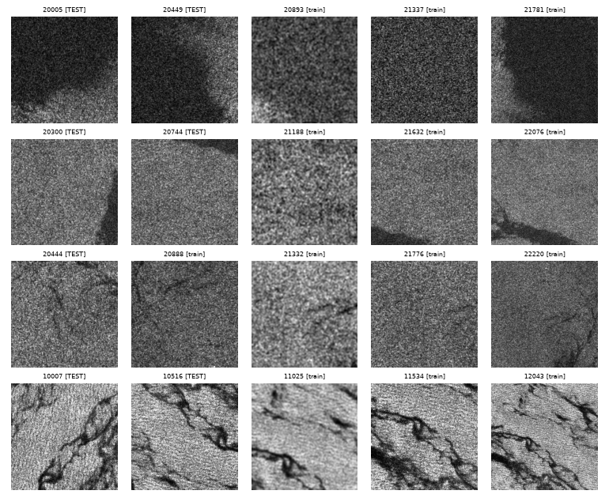
Figure 5. Examples of one sea area appearing as five different SOS tiles (IDs i, i+444, i+888, …).
Test A therefore shows that the reproduction is correct, but it does not measure performance on unseen sea areas. Test B removes this leak.

6. Test B: SOS group-disjoint split (leak-free)
Run M1_cbdnet_sentinel_dicebce_s0_groupsplit. Same model, loss, schedule and seed as Test A; only the split changes. Tiles are grouped by sea area, and whole groups are assigned to train or test, so no sea area appears in both. Train: 3,358 tiles (about the official 3,354, so training size is not a factor). Test: 835 tiles. Training stopped at epoch 50; best training loss 0.3670 at epoch 46.

6.1 Quantitative results
Table 8. All metrics on the leak-free test set.
Metric (%) | With TTA | Single pass
Accuracy | 92.16 | 91.91
Precision (oil) | 86.59 | 86.26
Recall (oil) | 87.01 | 86.47
F1 (oil) | 86.80 | 86.37
IoU (oil) | 76.68 | 76.00
IoU (background) | 89.43 | 89.12
mIoU | 83.06 | 82.56
Boundary F1 (2 px) | 45.52 | 44.65
F1 as in the official script (background class) | 94.42 | 94.25
ROC-AUC | 0.9751 | 0.9725
PR-AUC | 0.9475 | 0.9455
ECE (15 bins) | 0.0264 | 0.0324
Brier score | 0.0584 | 0.0607

6.2 Leaky vs leak-free
Table 9. Effect of removing the leak.
Metric (%, with TTA) | Test A: official (leaky) | Test B: group split (leak-free) | Difference (pp)
Oil IoU | 78.43 | 76.68 | -1.74
Oil F1 | 87.91 | 86.80 | -1.11
Precision (oil) | 84.43 | 86.59 | +2.16
Recall (oil) | 91.69 | 87.01 | -4.67
mIoU | 82.79 | 83.06 | +0.27
IoU (background) | 87.15 | 89.43 | +2.28
Accuracy | 91.24 | 92.16 | +0.91
Boundary F1 (2 px) | 37.82 | 45.52 | +7.71
ECE (×100) | 2.83 | 2.64 | -0.19
Oil share of test pixels | 34.72 | 29.64 | -5.08

- The leak inflates the oil scores only slightly: oil IoU -1.74 pp, oil F1 -1.11 pp. On unseen areas the model misses more oil (recall -4.67 pp) but raises fewer false alarms (precision +2.16 pp).
- mIoU hides the drop. The leak-free test set contains less oil (29.64 % vs 34.72 % of pixels), so background IoU rises and offsets the lower oil IoU. Oil IoU and oil F1 are the fair comparison.
- Calibration (ECE) is unchanged.

6.3 Training and qualitative results
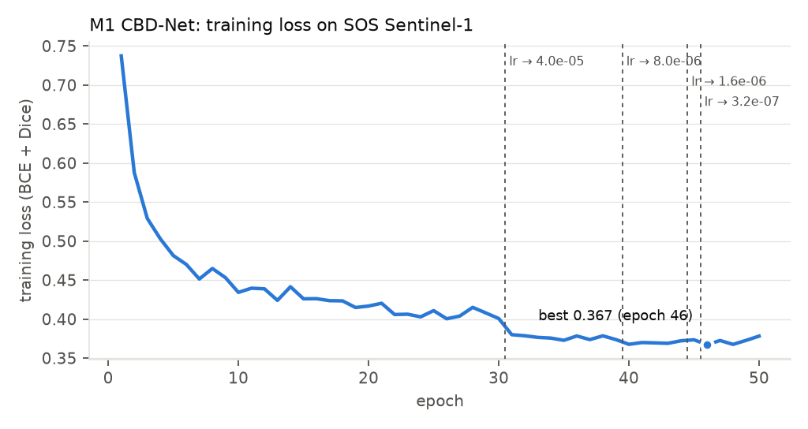
Figure 6. Training loss per epoch, leak-free split.
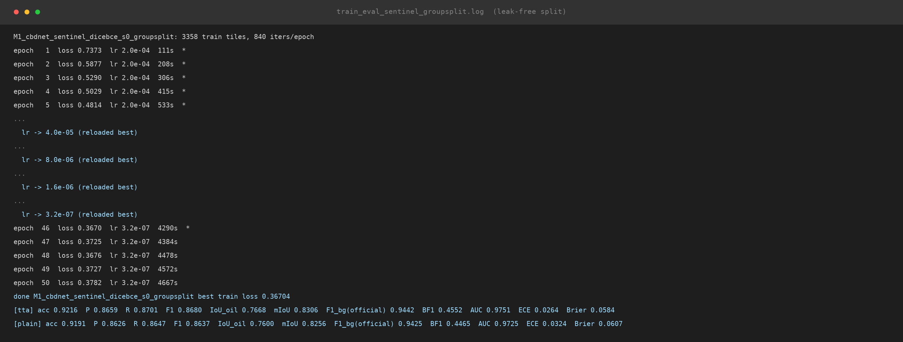
Figure 7. Console output of the leak-free run (excerpt of train_eval_sentinel_groupsplit.log).
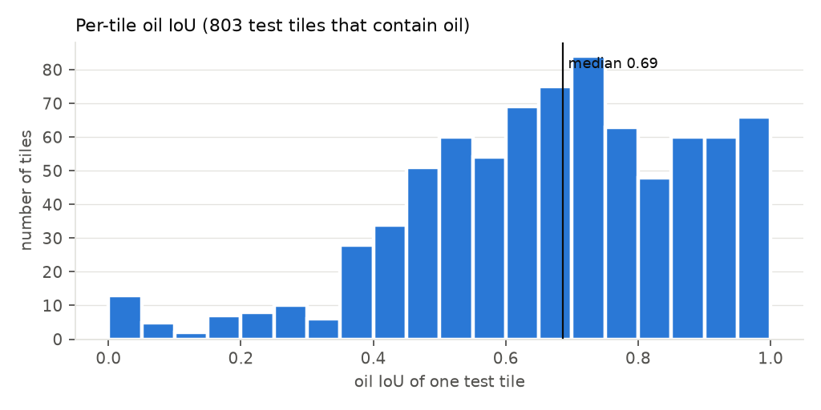
Figure 8. Per-tile oil IoU, leak-free test set. Median 0.69; 6 % of oil tiles score below 0.3.
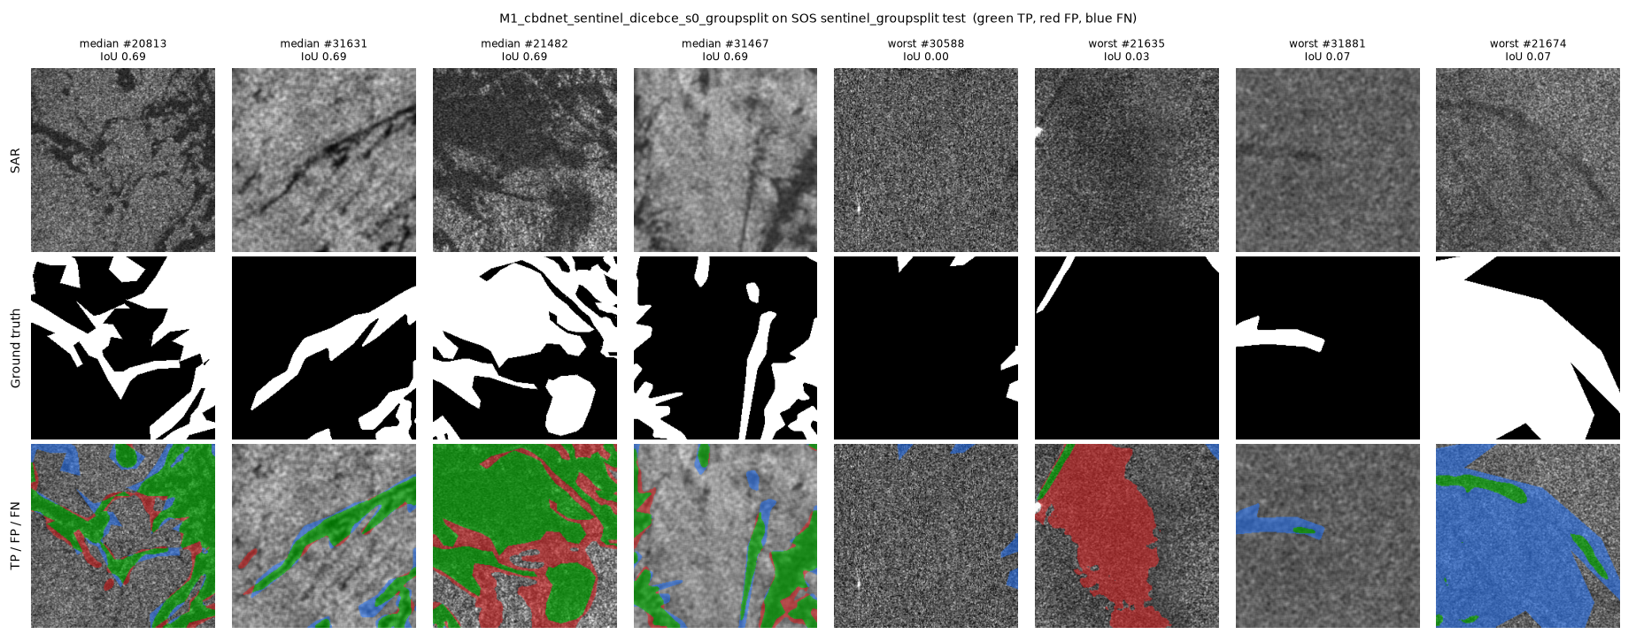
Figure 9. Four median and four worst tiles of the leak-free test set (green = correct, red = false oil, blue = missed).
- Worst tiles: (a) a large dark patch predicted as oil where only a thin strip is labelled (a possible low-wind look-alike); (b) faint thin slicks that are missed; (c) a tile labelled almost entirely as oil with no visible slick edge (label ambiguity).
Caveats. (1) One seed: differences of 1–2 pp are close to run-to-run variation, so three seeds are needed before quoting a number. (2) The groups are sea areas (crops), not the 21 original scenes, so scene-level leakage is still possible and this is a lower bound. (3) The two test sets contain different tiles, so part of any difference comes from test composition.

7. Test C: external dataset Peru (new sea)
Data. Peru oil-spill set [N22], corrected version: 2,013 Sentinel-1 patches (512 × 512) from 40 scenes never used for training. Labels: oil, look-alike, ship, land, sea. We score oil vs everything else, with the same pooled metrics and 8-way TTA as on SOS. Each patch is cut into four 256 × 256 tiles. Both models are frozen.

7.1 Quantitative results
Table 10. In-domain (SOS) vs new sea (Peru, all 2,013 patches).
Metric (%) | Official-split model: SOS | Official-split model: Peru | Leak-free model: SOS | Leak-free model: Peru
Oil F1 | 87.9 | 24.5 | 86.8 | 29.4
Oil IoU | 78.4 | 13.9 | 76.7 | 17.3
Precision (oil) | 84.4 | 14.0 | 86.6 | 17.4
Recall (oil) | 91.7 | 96.8 | 87.0 | 95.3
mIoU | 82.8 | 37.2 | 83.1 | 43.5
Accuracy | 91.2 | 62.8 | 92.2 | 71.6
ROC-AUC (×100) | 97.5 | 92.1 | 97.5 | 92.6
PR-AUC (×100) | 95.8 | 41.5 | 94.7 | 47.2
ECE (×100) | 2.8 | 26.5 | 2.6 | 18.6
Brier (×100) | 6.4 | 29.2 | 5.8 | 22.0

Table 11. What the model calls oil on Peru: share of each true class predicted as oil (%).
True class | Share of Peru pixels | Called oil: official-split model | Called oil: leak-free model
oil | 6.2 | 96.8 | 95.3
look-alike | 5.3 | 89.9 | 86.0
ship | 0.1 | 68.6 | 45.2
sea | 84.1 | 37.6 | 27.6
land | 4.3 | 14.3 | 7.7

Table 12. Peru's own scene-disjoint test subset (338 patches, 5 scenes).
Model | Oil F1 | Oil IoU | Precision | Recall | ECE (×100) | Look-alike called oil
official-split | 16.9 | 9.2 | 9.3 | 96.5 | 23.5 | 86.5
leak-free | 20.0 | 11.1 | 11.2 | 94.9 | 17.7 | 83.5

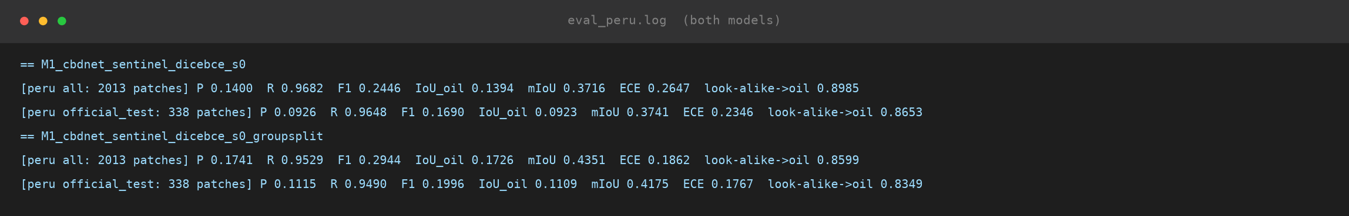
Figure 10. Console output of the Peru test, both models (eval_peru.log).

7.2 Qualitative results
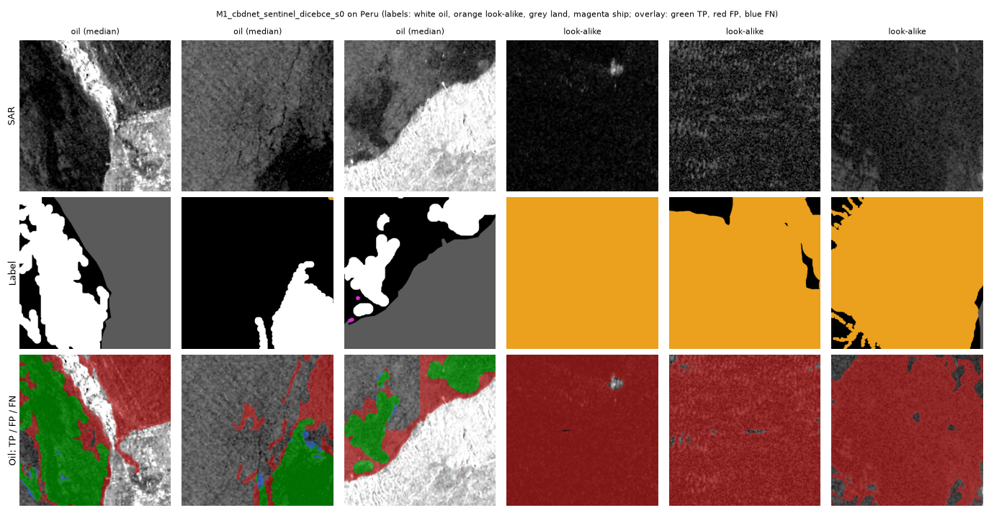
Figure 11. Peru examples, official-split model: three median oil patches and three look-alike patches. Rows: SAR, label (white = oil, orange = look-alike, grey = land, magenta = ship), prediction overlay (green = correct oil, red = false oil, blue = missed oil). The look-alike patches are predicted as oil almost everywhere.
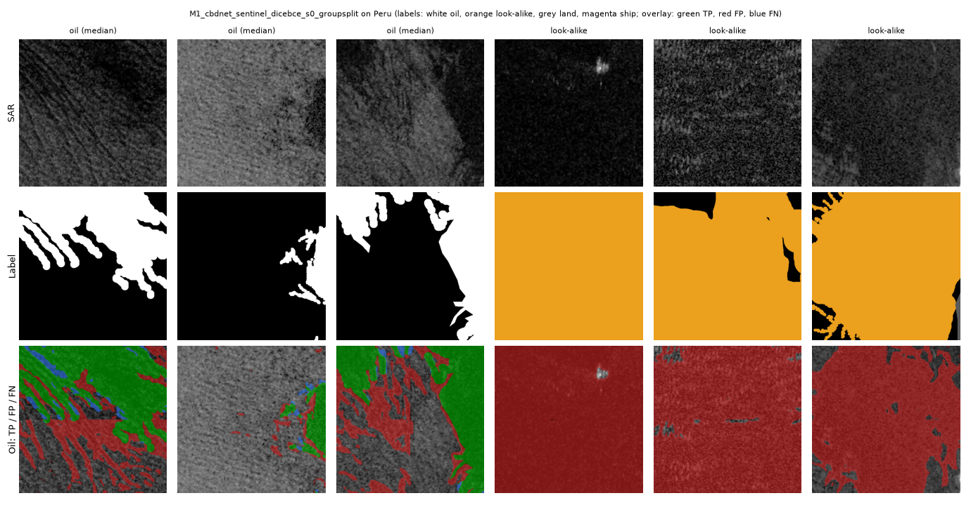
Figure 12. Peru examples, leak-free model.

7.3 Findings
- Severe drop under domain shift: oil F1 falls from about 87 % on SOS to 24.5–29.4 % on Peru.
- Recall stays high but precision collapses (14.0–17.4 %). The model calls 86.0–89.9 % of look-alike pixels oil, and about a third of open sea. Roughly 6 of every 7 oil alarms are false.
- The ranking is still good (ROC-AUC 0.92–0.93), but the 0.5 threshold and the probabilities are wrong: ECE rises from about 0.03 to 0.19–0.26. The model is confidently wrong on the new sea.
- The leak-free model transfers better: F1 +4.97 pp, ECE 0.186 vs 0.265.
- Not a data error: Peru and SOS have a similar sea brightness (median grey level 86 vs 89). Peru has lower contrast and darker oil, which is genuine domain shift.

8. Test D: external dataset MDOD (look-alike false alerts)
Data. MDOD [N05], OSF release: 4,673 full Sentinel-1 scenes with 24,940 bounding boxes in five classes: oil spill, biogenic slick, low wind, rain cell, sea ice. There are no pixel masks, so F1 and IoU cannot be computed. Instead we ask, for each box, how much of it the frozen model marks as oil.
Protocol. 400 boxes per class (seed 0; boxes smaller than 8 px skipped). Each box is enlarged to at least 256 × 256 for context and predicted in 256 × 256 tiles, single pass. The white land mask is excluded. Coverage = share of box pixels with p(oil) > 0.5. A box alerts if its coverage is at least 2 %. AUC = probability that a random oil box scores higher than a random look-alike box (0.5 = chance; below 0.5 = look-alikes score higher).

8.1 Quantitative results
Table 13. Share of boxes flagged as oil (%), per class.
Box class | Alert @2 %: official | Alert @2 %: leak-free | Alert @20 %: official | Alert @20 %: leak-free | Mean p(oil): official | Mean p(oil): leak-free
oil spill (should alert) | 64.0 | 55.5 | 42.0 | 38.5 | 0.27 | 0.25
biogenic slick | 97.0 | 93.2 | 71.2 | 57.0 | 0.36 | 0.27
low wind | 99.8 | 98.2 | 99.5 | 96.8 | 0.64 | 0.56
rain cell | 91.8 | 87.0 | 65.0 | 54.5 | 0.34 | 0.29
sea ice | 96.8 | 91.0 | 83.2 | 66.0 | 0.52 | 0.36

Table 14. Can the model rank oil boxes above look-alike boxes? (AUC; 0.5 = chance)
Oil vs | AUC (box mean): official | AUC (box mean): leak-free | AUC (box peak): official | AUC (box peak): leak-free
biogenic slick | 0.345 | 0.390 | 0.101 | 0.125
low wind | 0.155 | 0.195 | 0.036 | 0.058
rain cell | 0.379 | 0.404 | 0.207 | 0.238
sea ice | 0.250 | 0.350 | 0.097 | 0.157
all look-alikes | 0.282 | 0.335 | 0.110 | 0.144

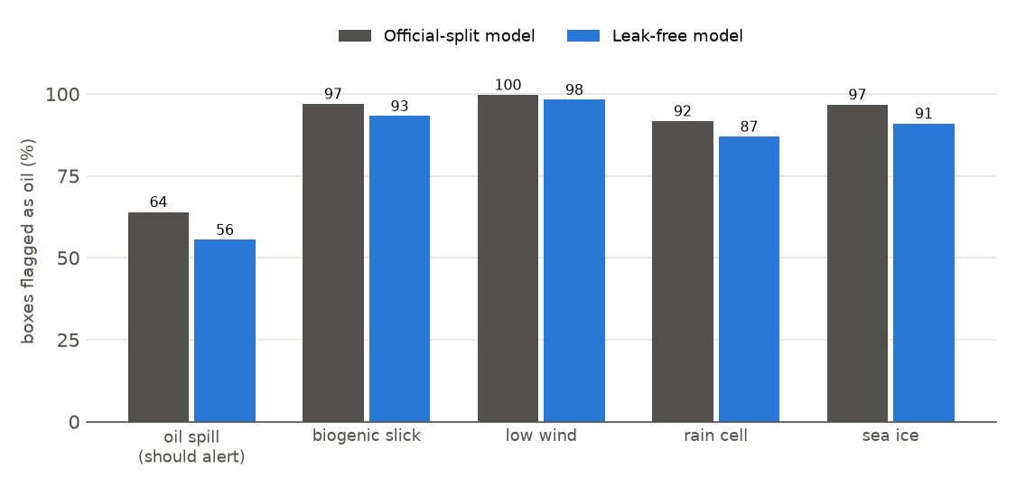
Figure 13. Share of MDOD boxes flagged as oil (coverage ≥ 2 %), per class and model.
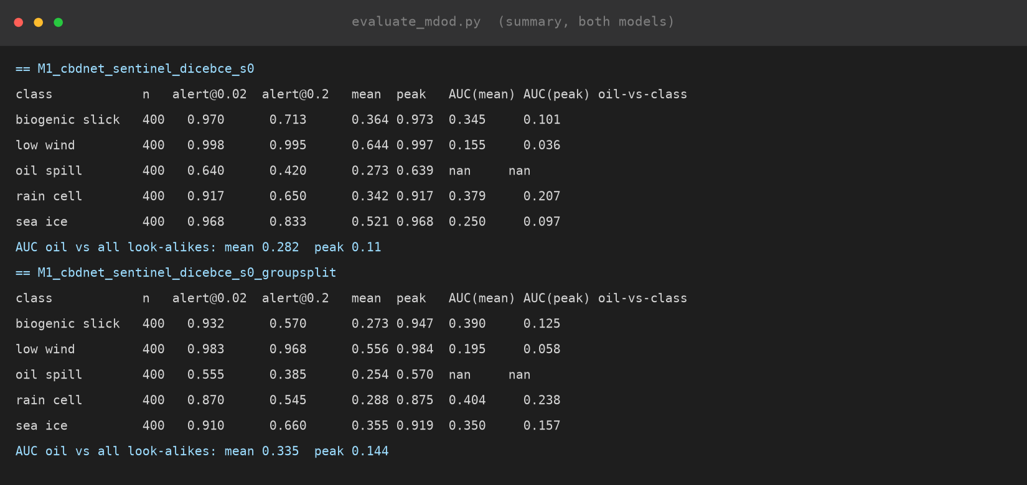
Figure 14. Console output of the MDOD test, both models (summary tables).

8.2 Qualitative results
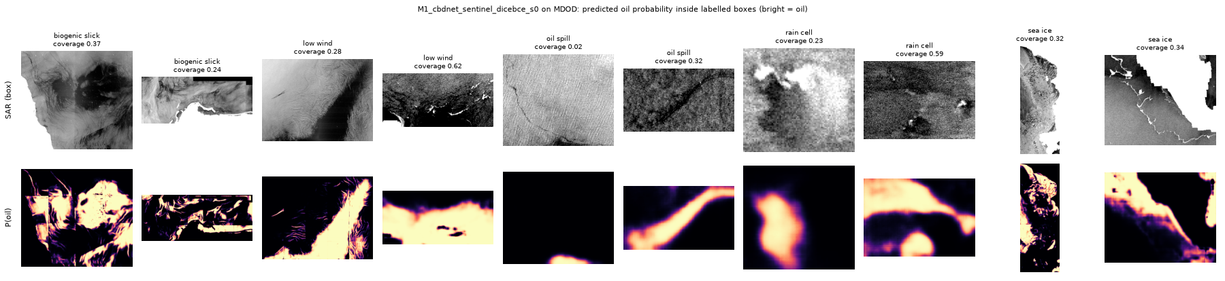
Figure 15. MDOD boxes (top) and predicted oil probability (bottom, bright = oil), official-split model.
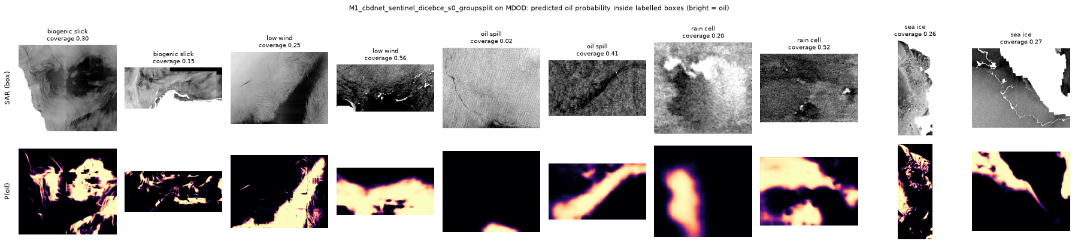
Figure 16. The same boxes, leak-free model.

8.3 Findings
- Look-alikes trigger more alerts than real oil. 87–100 % of look-alike boxes are flagged, but only 56–64 % of oil boxes. Low wind is the worst: almost every box is flagged, usually over more than half its area.
- AUC is below 0.5 for every look-alike class. M1 has learned “dark and smooth = oil”, not the shape of a slick, so large dark areas give the strongest oil signal.
- The leak-free model raises fewer false alerts (AUC 0.34 vs 0.28) but also flags less oil.
- Caveat, scale: MDOD scenes are about 10× coarser than SOS tiles, so many MDOD oil spills are thin streaks only a few pixels wide, which the model misses. Part of the low oil alert rate is this resolution mismatch. The look-alike false alerts are real at any scale.

9. Conclusions for M1
- M1 is correctly reproduced (mIoU and F1 within 0.2 pp of the published values).
- The leaky official SOS split overstates oil IoU and F1 by about 1–2 pp; this needs confirming with more seeds.
- In-domain scores (about 87 % F1) do not carry over to new seas: on Peru F1 is 24–29 %, and on MDOD look-alikes are flagged more often than oil.
- The failure mode is consistent across both external datasets: dark areas are called oil, and the probabilities become over-confident. The ranking (ROC-AUC 0.92 on Peru) is partly preserved, so re-calibration and better alert thresholds can recover part of the loss, while look-alike rejection needs extra information such as wind.
- The leak-free model is better on every external test and is the preferred M1 model for later comparisons.

10. Reproducing these results
All commands run from the repository root with the project virtual environment.
Table 15. Commands.
Step | Command
Test A: train + test + report | powershell -File M1_CBDNet\run_m1.ps1
Test B: train | python M1_CBDNet\train_m1.py --split <group split CSV>
Test B: test | python common\evaluate.py --run runs\M1_..._groupsplit --split <group split CSV>
Test C: Peru | python common\evaluate_peru.py --run runs\<run> then python M1_CBDNet\make_peru_report.py
Test D: MDOD | python common\evaluate_mdod.py --run runs\<run> then python M1_CBDNet\make_mdod_report.py
This report | python M1_CBDNet\report\make_terminal_pics.py, build_m1_report.py, then to_pdf.ps1

Trained weights: runs/M1_cbdnet_sentinel_dicebce_s0/best.pth and runs/M1_cbdnet_sentinel_dicebce_s0_groupsplit/best.pth (126 MB each). Leak-free split file: leakage_check/splits/sos_sentinel_group_s0.csv.

