M2: Improved DeepLabV3+
Implementation and results report
Oil-spill detection in Sentinel-1 SAR imagery · method 2 of 3

Method. J. Zhang, P. Yang, X. Ren, “Detection of oil spill in SAR image using an improved DeepLabV3+,” Sensors [P01]. No official code is released; we re-implemented the network from the paper.
What this report contains. The same four tests as for M1, on two trained M2 models: (A) the official SOS split (leaky); (B) the leak-free group-disjoint split; (C) the external Peru dataset; (D) the external MDOD dataset; plus (E) a direct comparison with M1. Every table is generated from the saved metric files; the terminal figures are excerpts of the real console logs.
1. Summary of results 2
2. Method and implementation 3
2.1 How the improved DeepLabV3+ works 3
2.2 Training and testing setup 3
2.3 Choices where the paper is silent 3
2.4 Code map 3
3. Test A: SOS official split (leaky) 4
4. Test B: SOS group-disjoint split (leak-free) 5
5. Test C: external dataset Peru (new sea) 8
6. Test D: external dataset MDOD (look-alike false alerts) 10
7. Test E: M1 vs M2 11
8. Reproducing these results 12

(Contents table: refreshed automatically when the PDF is made.)

1. Summary of results
Table 1. All M2 results at a glance (%, test-time augmentation unless noted), with M1 for reference.
Test | Model | Oil F1 | Oil IoU | mIoU | Precision | Recall | ECE (×100)
A. SOS official split (leaky) | M2 official-split | 88.05 | 78.65 | 83.20 | 86.64 | 89.50 | 3.16
published [P01] |  | 89.62 | — | 81.34 | — | — | —
M1 CBD-Net (ours) | M1 official-split | 87.91 | 78.43 | 82.79 | 84.43 | 91.69 | 2.83
B. SOS group split (leak-free) | M2 leak-free | 87.22 | 77.33 | 83.62 | 88.03 | 86.42 | 2.41
C. Peru (external, 2,013 patches) | M2 official-split | 22.89 | 12.92 | 35.32 | 13.01 | 94.84 | 29.55
 | M2 leak-free | 22.32 | 12.56 | 34.59 | 12.66 | 94.23 | 30.02

Table 2. MDOD (external, box labels only).
Model | Oil boxes flagged (should be high) | Look-alike boxes flagged (should be low) | AUC oil vs look-alikes (0.5 = chance)
M2 official-split | 57.0 | 91.0–99.2 | 0.293
M2 leak-free | 50.5 | 86.5–99.0 | 0.286
M1 official-split | 64.0 | 91.8–99.8 | 0.282

Key findings
- The re-implementation succeeds. mIoU 83.20 % (published 81.34 %, +1.86 pp) and oil F1 88.05 % (published 89.62 %, -1.57 pp): both within ±2 pp.
- In-domain, M2 slightly beats M1 with 5× fewer parameters (6.0 M vs 31.4 M): mIoU +0.41 pp, oil F1 +0.14 pp, boundary F1 +3.30 pp.
- The leak is small for M2 as well: oil IoU -1.32 pp and oil F1 -0.83 pp on the leak-free split.
- M2 fails on new seas exactly like M1. Peru oil F1 22.9–22.3 %, 87.4–90.4 % of look-alike pixels called oil, ECE about 0.30; on MDOD every look-alike class is flagged more often than oil (AUC < 0.5).
- The failure is shared by two different architectures, so it comes from the training data (SOS has no look-alike class), not from one model design. All results are single-seed.

2. Method and implementation

2.1 How the improved DeepLabV3+ works
- Input: one 256 × 256 SAR tile (3 channels).
- Encoder: MobileNetV2 (ImageNet weights) instead of DeepLabV3+'s usual Xception, with an scSE attention module at the input of every inverted-residual block. Output stride 16 (the last blocks use dilation).
- ASPP: 1 × 1 convolution, atrous rates 6, 12, 18 and image pooling, with scSE on the concatenated branches; 256 channels.
- Decoder: standard DeepLabV3+ decoder with a 1/4-resolution skip connection from the encoder (24 channels).
- Output: sigmoid oil probability per pixel; threshold 0.5.

2.2 Training and testing setup
Table 3. Setup used for both M2 models.
Setting | Value
Training data | SOS Sentinel-1 training tiles, 256 × 256 (3,354 official / 3,358 leak-free)
Loss | BCE + Dice (paper)
Optimiser | Adam, learning rate 1 × 10⁻³, batch size 15, 80 epochs (paper)
Schedule | Cosine decay to 0 (assumed: the paper gives no schedule). The final-epoch model is evaluated (no validation set in the official split).
Augmentation | Horizontal / vertical flips and 90° rotations (assumed)
Testing | Same as M1: 8-way test-time augmentation; single pass also reported
Size | 6.04 M parameters, 6.56 GMACs (paper: 5.84 M, 6.16 GMACs)
Hardware | NVIDIA RTX 3050 laptop GPU (4 GB), 16 GB RAM, PyTorch 2.6 (CUDA 12.4)
Training time | official split: 80 epochs, 1 h 10 min; leak-free split: 80 epochs, 1 h 12 min

2.3 Choices where the paper is silent
- Not in the paper, so assumed: ImageNet-1k weights, cSE reduction ratio 16, 256 ASPP channels, cosine learning-rate decay, flip / rotation augmentation. These choices explain the 0.2 M parameter and 0.4 GMAC difference from the paper.
- Which F1? The paper does not say whether its F1 is for the oil class. If it used the official SOS script (which scores the background class), the comparable value of ours is 93.48 %. We treat oil F1 as the fair comparison.
- Interruptions: the training saves its full state every epoch and can continue with --resume. The first official-split attempt was stopped at epoch 43 by low system memory and was restarted from scratch.

2.4 Code map
Table 4. Where each part of M2 lives (repository root).
Part | File | Written by
Model (DeepLabV3+ MobileNetV2 + scSE) | common/models.py (dlv3p_mnv2) | us, from the paper
Loss (BCE + Dice) | third_party/CBDNet-main/dice_bce_loss.py | shared with M1
Training loop | common/train.py | us; generic trainer for M2 / M3
Data loading | common/sos_data.py | shared with M1
SOS, Peru, MDOD tests | common/evaluate.py, evaluate_peru.py, evaluate_mdod.py | shared with M1
Results folders | M2_DeepLabV3Plus/make_report_m2.py | us

Metrics are identical to the M1 report (pooled pixels; accuracy, precision, recall, F1, IoU, mIoU, boundary F1, ROC-AUC, PR-AUC, ECE, Brier).

3. Test A: SOS official split (leaky)
Run M2_dlv3p_mnv2_sentinel_s0. Trained on the 3,354 official tiles, tested on the 839 official test tiles. 80 epochs; final training loss 0.3098.
Table 5. Segmentation metrics on the official SOS Sentinel-1 test set.
Metric (%) | Ours, with TTA | Ours, single pass | Published [P01] | M1 CBD-Net (TTA)
Accuracy | 91.56 | 91.43 | — | 91.24
Precision (oil) | 86.64 | 86.36 | — | 84.43
Recall (oil) | 89.50 | 89.43 | — | 91.69
F1 (oil) | 88.05 | 87.87 | 89.62 | 87.91
IoU (oil) | 78.65 | 78.36 | — | 78.43
IoU (background) | 87.76 | 87.57 | — | 87.15
mIoU | 83.20 | 82.97 | 81.34 | 82.79
Boundary F1 (2 px) | 41.12 | 40.64 | — | 37.82
F1 as in the official script (background class) | 93.48 | 93.37 | — | 93.14

Table 6. Probability quality.
Metric | With TTA | Single pass | M1 (TTA)
ROC-AUC | 0.9720 | 0.9711 | 0.9748
PR-AUC | 0.9557 | 0.9546 | 0.9585
ECE (15 bins) | 0.0316 | 0.0357 | 0.0283
Brier score | 0.0632 | 0.0647 | 0.0639

Reproduction gap: mIoU +1.86 pp, F1 -1.57 pp (target ±2 pp). The gaps are wider than for M1 (±0.2 pp), as expected for a re-implementation without code.
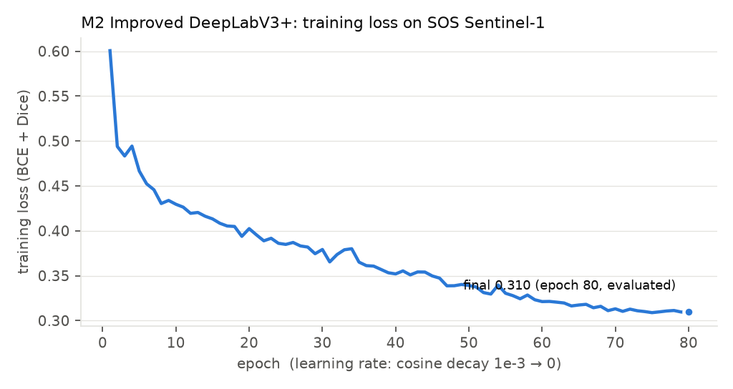
Figure 1. Training loss per epoch, official split (cosine learning-rate decay).
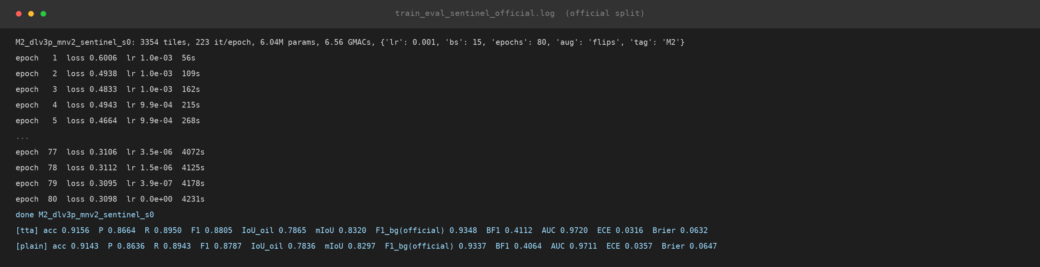
Figure 2. Console output of the official-split run (excerpt of train_eval_sentinel_official.log; “…” marks omitted epochs). The last two lines are the test results.
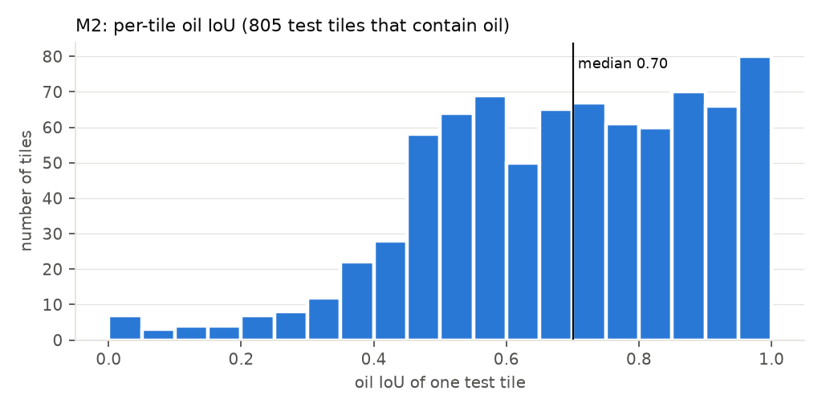
Figure 3. Per-tile oil IoU. Median 0.70; 4 % of oil tiles score below 0.3.
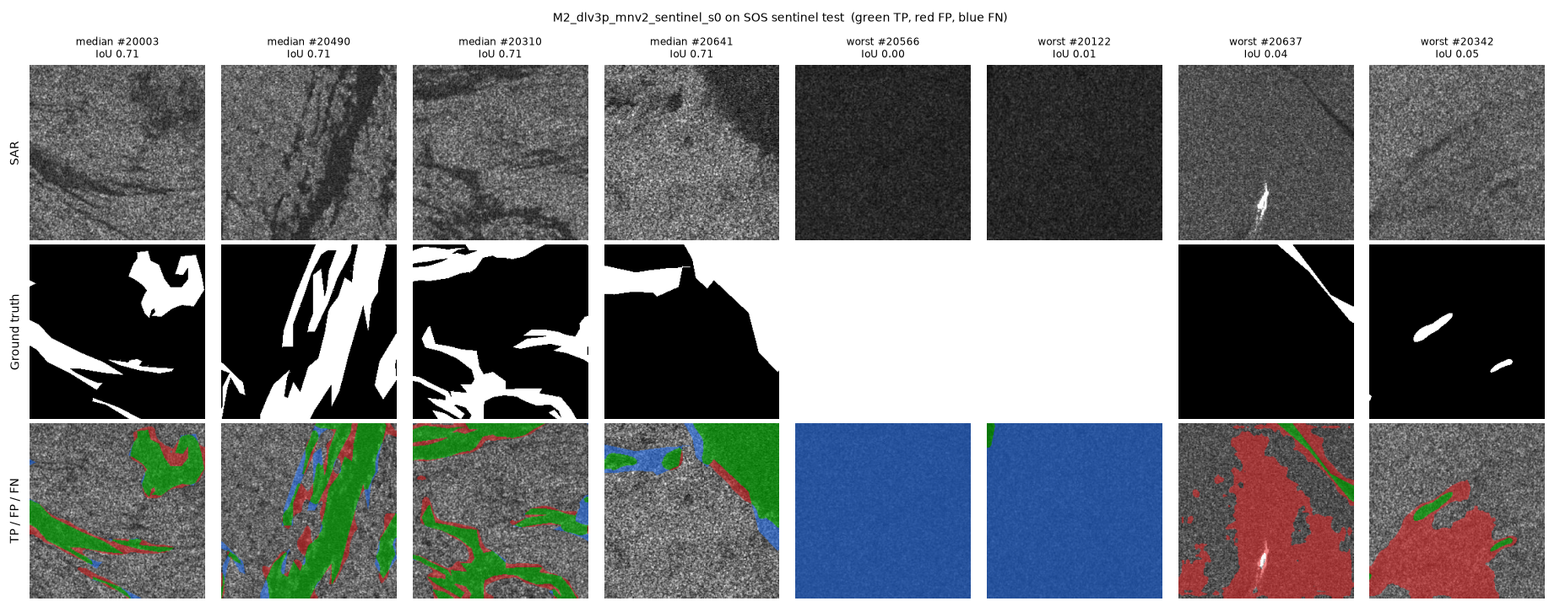
Figure 4. Four median and four worst test tiles (green = correct oil, red = false oil, blue = missed oil).
- Median tiles: slicks are found with clean shapes; errors sit on the coarse polygon edges of the labels.
- Worst tiles: (a) dark, featureless tiles labelled entirely as oil, which M2 calls sea (blue); (b) a bright ship with a dark wake where M2 predicts a large false slick (red); (c) small labelled slicks inside a larger dark area that M2 over-segments.

4. Test B: SOS group-disjoint split (leak-free)
Run M2_dlv3p_mnv2_sentinel_s0_groupsplit. The same leak-free split as M1: no sea area appears in both train (3,358 tiles) and test (835 tiles). Same recipe and seed as Test A. 80 epochs; final loss 0.3101.
Table 7. All metrics on the leak-free test set.
Metric (%) | With TTA | Single pass
Accuracy | 92.49 | 92.34
Precision (oil) | 88.03 | 87.78
Recall (oil) | 86.42 | 86.13
F1 (oil) | 87.22 | 86.95
IoU (oil) | 77.33 | 76.91
IoU (background) | 89.91 | 89.71
mIoU | 83.62 | 83.31
Boundary F1 (2 px) | 47.53 | 46.93
F1 as in the official script (background class) | 94.68 | 94.57
ROC-AUC | 0.9771 | 0.9760
PR-AUC | 0.9524 | 0.9500
ECE (15 bins) | 0.0241 | 0.0279
Brier score | 0.0554 | 0.0572

Table 8. Effect of removing the leak, with M1 on the same leak-free split.
Metric (%, TTA) | M2 official (leaky) | M2 leak-free | Difference (pp) | M1 leak-free
Oil IoU | 78.65 | 77.33 | -1.32 | 76.68
Oil F1 | 88.05 | 87.22 | -0.83 | 86.80
Precision (oil) | 86.64 | 88.03 | +1.39 | 86.59
Recall (oil) | 89.50 | 86.42 | -3.08 | 87.01
mIoU | 83.20 | 83.62 | +0.41 | 83.06
IoU (background) | 87.76 | 89.91 | +2.15 | 89.43
Accuracy | 91.56 | 92.49 | +0.93 | 92.16
Boundary F1 (2 px) | 41.12 | 47.53 | +6.41 | 45.52
ECE (×100) | 3.16 | 2.41 | -0.75 | 2.64
Oil share of test pixels | 34.72 | 29.64 | -5.08 | 29.64

- The leak inflates M2's oil scores slightly: oil IoU -1.32 pp, oil F1 -0.83 pp (M1: −1.74 / −1.11 pp). Recall falls (-3.08 pp), precision rises (+1.39 pp): the same pattern as M1.
- mIoU rises because the leak-free test set has less oil (29.6 % vs 34.7 % of pixels); oil IoU and F1 are the fair comparison.
- On the leak-free split, M2 leads M1 by +0.65 pp oil IoU and +0.41 pp F1, which is within single-seed noise.
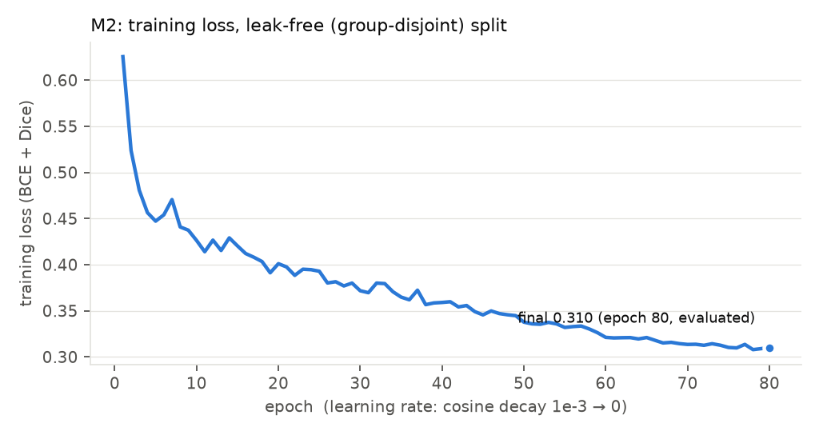
Figure 5. Training loss per epoch, leak-free split.
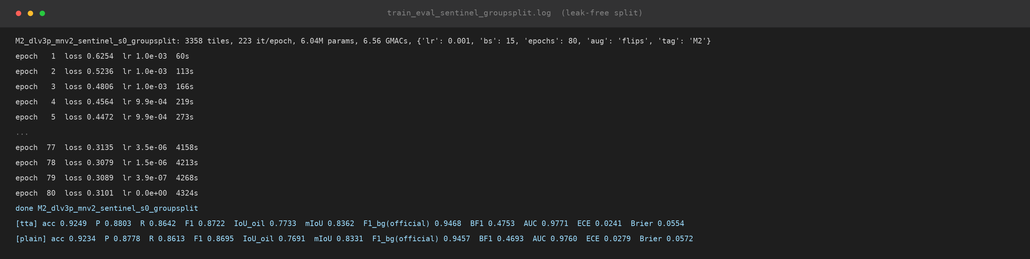
Figure 6. Console output of the leak-free run (excerpt of train_eval_sentinel_groupsplit.log).
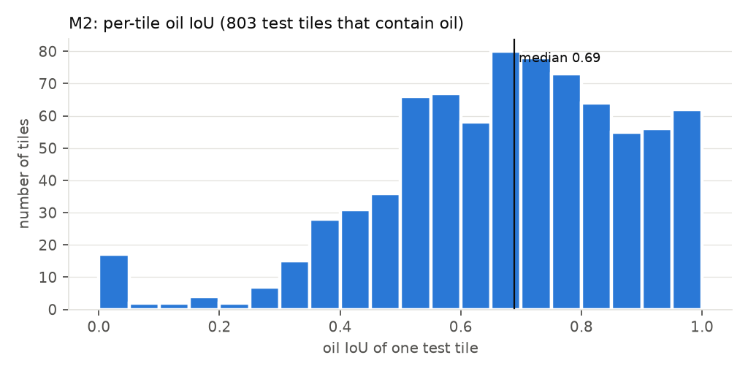
Figure 7. Per-tile oil IoU, leak-free test set. Median 0.69; 4 % of oil tiles below 0.3.
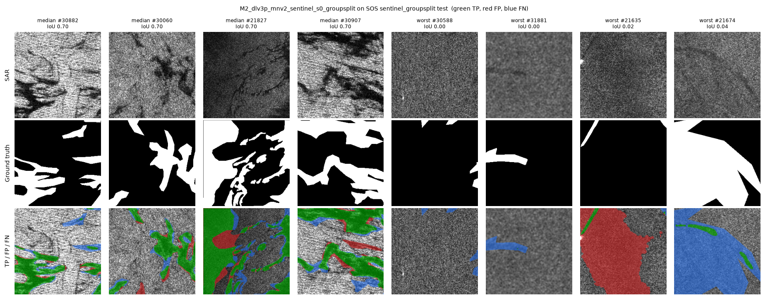
Figure 8. Four median and four worst tiles of the leak-free test set.

5. Test C: external dataset Peru (new sea)
Same protocol as for M1: all 2,013 Peru patches (40 scenes, never used for training), oil vs everything else, 8-way TTA, frozen models.
Table 9. In-domain (SOS) vs new sea (Peru, all 2,013 patches).
Metric (%) | M2 official: SOS | M2 official: Peru | M2 leak-free: SOS | M2 leak-free: Peru | M1 official: Peru
Oil F1 | 88.0 | 22.9 | 87.2 | 22.3 | 24.5
Oil IoU | 78.6 | 12.9 | 77.3 | 12.6 | 13.9
Precision (oil) | 86.6 | 13.0 | 88.0 | 12.7 | 14.0
Recall (oil) | 89.5 | 94.8 | 86.4 | 94.2 | 96.8
mIoU | 83.2 | 35.3 | 83.6 | 34.6 | 37.2
Accuracy | 91.6 | 60.2 | 92.5 | 59.2 | 62.8
ROC-AUC (×100) | 97.2 | 90.8 | 97.7 | 90.0 | 92.1
PR-AUC (×100) | 95.6 | 41.7 | 95.2 | 41.2 | 41.5
ECE (×100) | 3.2 | 29.5 | 2.4 | 30.0 | 26.5
Brier (×100) | 6.3 | 32.1 | 5.5 | 32.9 | 29.2

Table 10. Share of each true Peru class predicted as oil (%).
True class | Share of Peru pixels | Called oil: M2 official | Called oil: M2 leak-free | M1 official | M1 leak-free
oil | 6.2 | 94.8 | 94.2 | 96.8 | 95.3
look-alike | 5.3 | 87.4 | 90.4 | 89.9 | 86.0
ship | 0.1 | 61.0 | 63.9 | 68.6 | 45.2
sea | 84.1 | 40.7 | 41.8 | 37.6 | 27.6
land | 4.3 | 13.5 | 11.0 | 14.3 | 7.7

Table 11. Peru's own scene-disjoint test subset (338 patches, 5 scenes).
Model | Oil F1 | Oil IoU | Precision | Recall | ECE (×100) | Look-alike called oil
M2 official-split | 16.9 | 9.3 | 9.3 | 97.4 | 24.6 | 84.2
M2 leak-free | 16.8 | 9.2 | 9.2 | 96.2 | 24.3 | 86.4

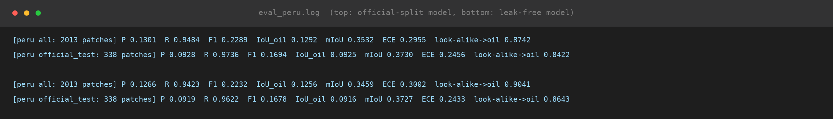
Figure 9. Console output of the Peru tests (eval_peru.log).
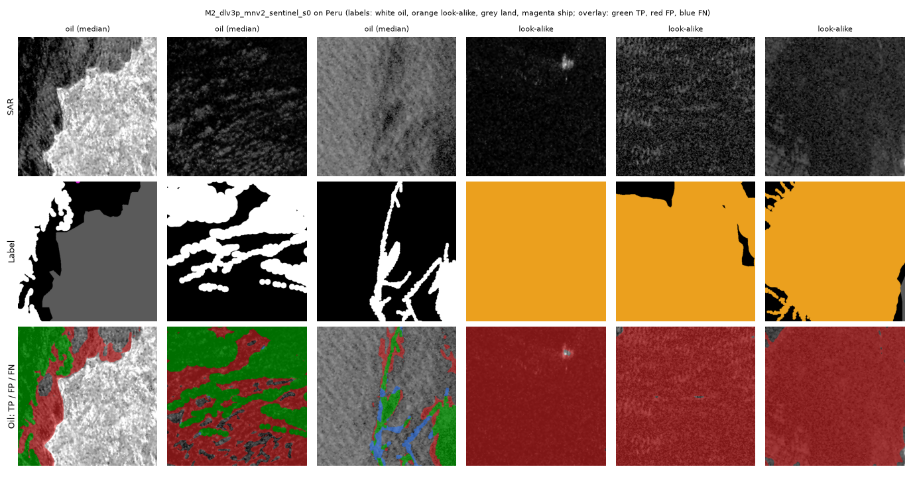
Figure 10. Peru examples, M2 official-split model: three oil patches and three look-alike patches. Rows: SAR, label (white = oil, orange = look-alike, grey = land, magenta = ship), prediction overlay (green = correct oil, red = false oil, blue = missed oil).
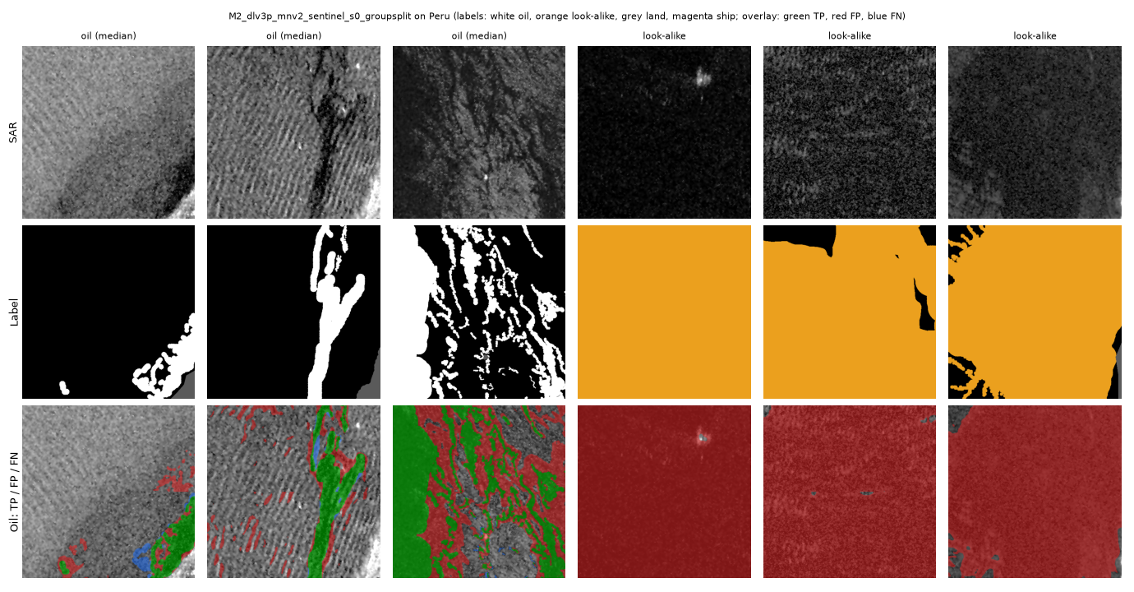
Figure 11. Peru examples, M2 leak-free model.
- M2 transfers as badly as M1: oil F1 22.9 / 22.3 % (M1: 24.5 / 29.4 %). Recall stays about 95 %, precision collapses to about 13 %.
- Look-alikes are called oil (87.4–90.4 %), and so is 41.8–40.7 % of open sea.
- Ranking partly survives (ROC-AUC 0.91), but the probabilities are over-confident: ECE 0.295 / 0.300, worse than M1 (0.265 / 0.186).
- Unlike M1, the leak-free M2 is not better on Peru. The M1 gain (+5 pp F1) may therefore be seed noise rather than an effect of the split; more seeds are needed.

6. Test D: external dataset MDOD (look-alike false alerts)
Same protocol as for M1: 400 boxes per class, single pass; a box alerts if at least 2 % of its pixels have p(oil) > 0.5. AUC = probability that a random oil box scores higher than a random look-alike box (0.5 = chance).
Table 12. Share of MDOD boxes flagged as oil (%), per class.
Box class | Alert @2 %: M2 official | Alert @2 %: M2 leak-free | Alert @20 %: M2 official | Alert @20 %: M2 leak-free | Alert @2 %: M1 official
oil spill (should alert) | 57.0 | 50.5 | 36.5 | 32.8 | 64.0
biogenic slick | 96.5 | 94.5 | 70.0 | 60.2 | 97.0
low wind | 99.2 | 99.0 | 98.2 | 97.0 | 99.8
rain cell | 91.0 | 86.5 | 54.8 | 49.0 | 91.8
sea ice | 94.8 | 92.5 | 78.0 | 72.2 | 96.8

Table 13. Can the model rank oil boxes above look-alike boxes? (AUC; 0.5 = chance)
Oil vs | AUC (mean): M2 official | AUC (mean): M2 leak-free | AUC (peak): M2 official | AUC (peak): M2 leak-free | AUC (mean): M1 official
biogenic slick | 0.334 | 0.330 | 0.100 | 0.101 | 0.345
low wind | 0.168 | 0.159 | 0.050 | 0.053 | 0.155
rain cell | 0.387 | 0.373 | 0.220 | 0.214 | 0.379
sea ice | 0.284 | 0.279 | 0.121 | 0.126 | 0.250
all look-alikes | 0.293 | 0.286 | 0.123 | 0.124 | 0.282

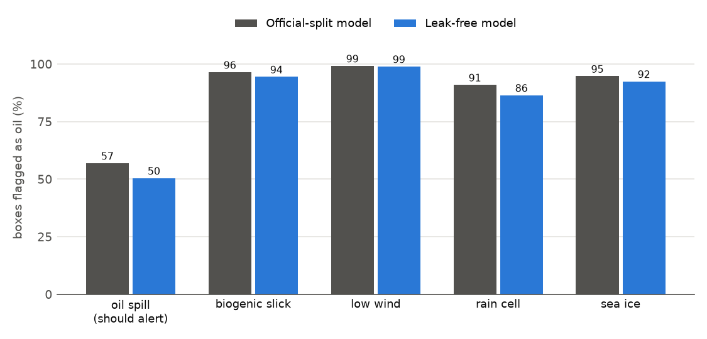
Figure 12. Share of MDOD boxes flagged as oil (coverage ≥ 2 %), M2.
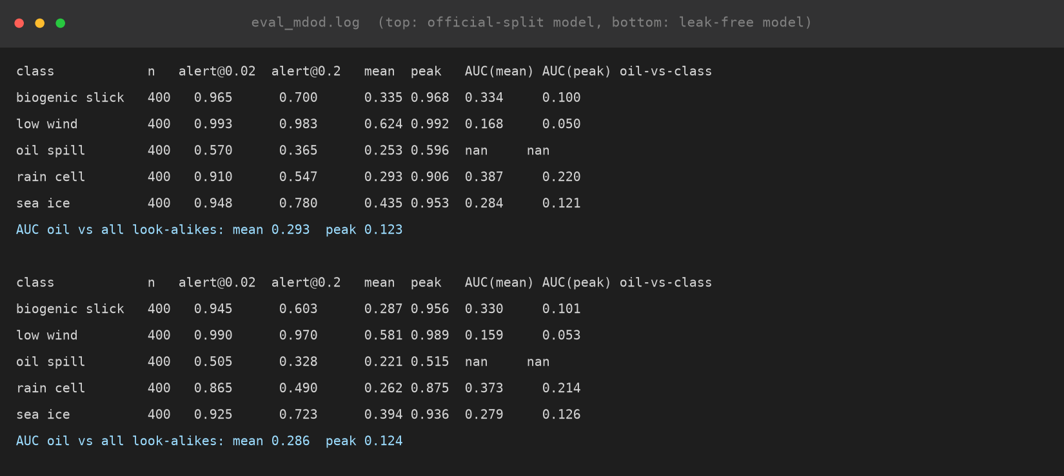
Figure 13. Console output of the MDOD tests (summary tables).
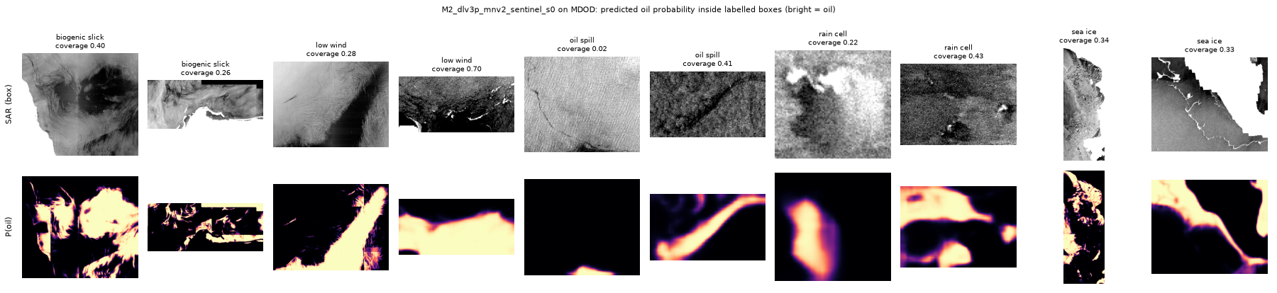
Figure 14. MDOD boxes (top) and predicted oil probability (bottom, bright = oil), M2 official-split model.
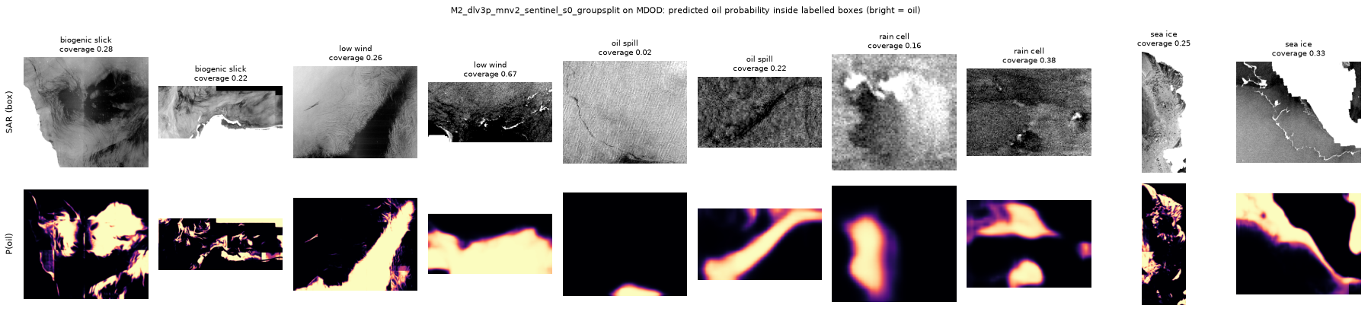
Figure 15. The same boxes, M2 leak-free model.
- Same failure as M1: 91.0–99.2 % of look-alike boxes are flagged, but only 50.5–57.0 % of oil boxes. Low wind is flagged almost always.
- AUC is below 0.5 for every look-alike class (0.29 / 0.29 overall; M1: 0.28).
- M2 flags even fewer oil boxes than M1. Scale caveat as for M1: MDOD is about 10× coarser than SOS, so many oil spills are streaks a few pixels wide.

7. Test E: M1 vs M2
Table 14. Head-to-head comparison (TTA; MDOD single pass).
Test | Metric | M1 CBD-Net | M2 DeepLabV3+ | Better
SOS official | Oil F1 (%) | 87.91 | 88.05 | M2
SOS official | mIoU (%) | 82.79 | 83.20 | M2
SOS official | Boundary F1 (%) | 37.82 | 41.12 | M2
SOS leak-free | Oil F1 (%) | 86.80 | 87.22 | M2
SOS leak-free | Oil IoU (%) | 76.68 | 77.33 | M2
Peru (official-split models) | Oil F1 (%) | 24.46 | 22.89 | M1
Peru (official-split models) | ECE (×100) | 26.47 | 29.55 | M1
Peru (leak-free models) | Oil F1 (%) | 29.44 | 22.32 | M1
MDOD (official-split models) | AUC oil vs look-alikes | 0.282 | 0.293 | M2
Size | Parameters (M) | 31.4 | 6.0 | M2

- In-domain, M2 is as good or slightly better (and 5× smaller), with clearly better boundaries.
- Out of domain, both fail in the same way, and M1 is slightly better on Peru. The gaps between the two models (0.4–6 pp) are much smaller than the in-domain-to-new-sea drop (about 60 pp F1).
- Conclusion: changing the architecture does not fix the look-alike and calibration problem. This motivates the planned contributions (calibration, alert thresholds, wind- and look-alike-aware alerting), which act on top of any model.

8. Reproducing these results
Table 15. Commands (from the repository root).
Step | Command
Test A: train | python common\train.py --arch dlv3p_mnv2 --sensor sentinel --seed 0 --resume
Test A: test | python common\evaluate.py --run runs\M2_dlv3p_mnv2_sentinel_s0 --arch dlv3p_mnv2
Test B: train | python common\train.py --arch dlv3p_mnv2 --split <group split CSV> --resume
Test B: test | python common\evaluate.py --run runs\M2_..._groupsplit --arch dlv3p_mnv2 --split <group split CSV>
Tests C, D | python common\evaluate_peru.py / evaluate_mdod.py --run runs\<run> --arch dlv3p_mnv2
Results folders | python M2_DeepLabV3Plus\make_report_m2.py
This report | python M2_DeepLabV3Plus\report\build_m2_report.py, then to_pdf.ps1

Weights: runs/M2_dlv3p_mnv2_sentinel_s0/best.pth and runs/M2_dlv3p_mnv2_sentinel_s0_groupsplit/best.pth (24 MB each).

