Datasets, implementation checks and critique of M1 and M2
Answers to the review questions · M1 CBD-Net, M2 Improved DeepLabV3+, M3 FCS-Net (coded, not trained)

1. Shape of the datasets and what they contain
Table 1. Datasets. Network input: batch × 3 × 256 × 256 image; target and output: batch × 1 × 256 × 256 oil mask / probability.
Dataset | Sensor | Images | Image size | Format | Labels | Class balance | Our use
SOS [P24] | Sentinel-1 (C-band) | 3,354 train / 839 test tiles | 256 × 256 | JPG image (3 channels) + PNG mask | binary pixel mask: 255 = oil, 0 = background | oil 29.3 % (train) / 34.7 % (test) of pixels | training + in-domain test
SOS [P24] | ALOS PALSAR (L-band) | 3,101 train / 776 test tiles | 256 × 256 | same | same | — | not used yet (same leak found)
Peru [N22] | Sentinel-1 | 2,013 patches from 40 scenes | 512 × 512 (cut into four 256 × 256 tiles) | GeoTIFF + manifest (scene, date, lat/lon) | 5-class pixel mask: oil, look-alike, sea, ship, land | oil 6.2 %, look-alike 5.3 %, ship 0.1 %, sea 84.1 %, land 4.3 % | test only (new sea, look-alikes)
MDOD [N05] | Sentinel-1 | 4,673 scenes, 24,940 boxes | about 2,900 × 1,700 | greyscale image, land = 255; COCO-style boxes | bounding boxes only (no pixel masks) | oil spill 10,763, biogenic slick 3,054, low wind 4,695, rain cell 4,658, sea ice 1,770 | test only (false alerts per look-alike type)

- SOS is smaller than its tile count: its 4,193 Sentinel-1 tiles come from 1,089 independent sea areas; each area appears as up to 5 augmented copies (crop, rotation, flip, zoom, noise).
- SOS Sentinel-1 comes from only 7 scenes (Sentinel-1A IW GRD, VV, 5 × 20 m, one spill event [P24]). The leak-free split therefore separates sea areas, not scenes: its test areas come from the same 7 scenes as training, so some scene-level similarity remains.
- SOS has no look-alike class: every dark area in a training tile is either labelled oil or is background sea. The models are never shown a dark area that is not oil, which explains the Peru and MDOD failures.
- Peru is scene-structured: median 41 patches per scene (4–161), so patches of one scene are not independent. Neighbouring patches also overlap by a 128-px strip (stride 384, verified in all 40 scenes), so overlapping pixels are counted more than once in pooled Peru metrics. Confidence intervals resample whole scenes.
- MDOD is about 10× coarser than SOS, noticeably brighter, and only has boxes, so it supports box-level alert tests, not pixel IoU. It is used as a supplementary look-alike stress test.

Rows and columns before and after cleaning
For image data a row is one image (tile) and the columns are its pixels × channels; every pixel is also one labelled sample. No image was removed from SOS or Peru: “cleaning” here means format conversion, label binarisation, tiling, and (MDOD) dropping tiny boxes.
Table 2. Dataset size before and after cleaning.
Dataset | Stage | Rows (images) | Columns per image | Label per image | Pixels (labelled samples) | What changed
SOS Sentinel-1 | as downloaded | 4,193 (3,354 train + 839 test) | 256 × 256 × 3, uint8 (3 identical greyscale channels) | 256 × 256 × 3 PNG, values {0, 255} | 4,193 × 65,536 = 274.8 M | —
 | after cleaning (model input) | 4,193 (none removed; all load) | 3 × 256 × 256 float, scaled to [−1.6, 1.6] | 1 × 256 × 256, values {0, 1} | 274.8 M | channels first; intensity scaling; mask reduced to 1 channel and binarised (≥ 0.5)
 | official split (leaky) | train 3,354 / test 839 | same | same | train 219.8 M / test 55.0 M | M3 also holds out 10 % of train for validation: 3,019 / 335 / 839
 | leak-free split | train 2,516 / val 422 / calib 420 / test 835 | same | same | train+val+calib 220.1 M / test 54.7 M | rows re-assigned by sea area (1,089 groups, none shared); M1/M2 train on train+val+calib = 3,358
Peru | as downloaded | 2,013 patches (40 scenes) | 512 × 512 × 3, uint8 GeoTIFF | 512 × 512, classes 0–4 | 2,013 × 262,144 = 527.7 M | —
 | after cleaning (model input) | 8,052 tiles (each patch cut into 4); test subset 338 patches = 1,352 tiles | 3 × 256 × 256 float, same scaling | binary target: 1 = oil, 0 = everything else (5-class label kept for per-class analysis) | 527.7 M | tiling only; none removed; used for testing only
MDOD | as downloaded | 4,673 scenes, 24,940 boxes | ≈ 2,900 × 1,700 × 1 greyscale (land = 255) | boxes: class + normalised x, y, w, h | — | —
 | after cleaning (model input) | boxes with short side < 8 px dropped; 400 per class sampled (seed 0) = 2,000 boxes | greyscale repeated to 3 channels; sliding 256 × 256 tiles, overlaps averaged | box class | — | no pixel masks, so box-level scores only; test only

Features used in training and testing
Table 3. Features. Training and testing use exactly the same input features and preprocessing.
Item | Training (SOS) | Testing (SOS, Peru, MDOD)
Input feature | SAR backscatter intensity of every pixel (greyscale 0–255, stored as 3 identical channels) | the same
Values per sample | 3 × 256 × 256 = 196,608 input values per tile (65,536 distinct pixels) | the same (Peru and MDOD are tiled to 256 × 256)
Hand-crafted features | none: each CNN learns its own features (edges, texture, shape, context) in its encoder | the same learned features
Metadata (wind, incidence angle, location, date) | not used | not used (candidate input for the contributions)
Target | per-pixel oil mask, 1 × 256 × 256, values {0, 1} | SOS: same; Peru: 1 = oil vs the rest; MDOD: box class only
Augmentation | M1: official HSV / shift / scale / flips / 90° rotations; M2, M3: flips and 90° rotations | none, or 8-way flips/rotations averaged (TTA)
Normalisation | [0, 255] → [−1.6, 1.6] (official CBD-Net scaling, used for all methods) | the same

2. Did we analyse the datasets before using them?
Table 4. Data checks.
Check | What we did | Finding | Consequence
Train/test independence (SOS) | Searched every test tile against all training tiles (8 rotations/flips, normalised cross-correlation); checked the ID structure | Tiles 20001–22220 = 5 × 444 augmented copies; the official test set is the first IDs, so 100 % of test tiles (839/839) have copies in training; 571/839 best matches fall exactly on the copy offsets (chance ≈ 0.1 %) | Built a group-disjoint (leak-free) split: 2,516 / 422 / 420 / 835 tiles, no area shared; every model trained and tested on both splits
Source scenes (SOS) | Read the dataset paper [P24] | Sentinel-1: 7 Sentinel-1A IW GRD scenes, VV, 5 × 20 m; PALSAR: 14 scenes, HH, 12.5 m; tiles split 8 : 2 at random | The leak-free split is area-disjoint, not scene-disjoint (a scene-disjoint split would leave only 1–2 scenes for testing)
Class balance (SOS) | Oil share of pixels per split | 29.3 % / 34.7 % (official), 30.6 % / 29.6 % (leak-free) | mIoU and accuracy depend on oil share, so we compare on oil IoU / F1
Label meaning (Peru) | Inspected masks, the correction log and the dataset authors' paper | all five IDs confirmed by the dataset paper (arXiv 2512.02290): 0 sea, 1 oil, 2 look-alike, 3 ship, 4 land | Only the oil class is scored as positive; look-alike false alarms reported separately
Scene structure (Peru) | Patches per scene from the manifest | 40 scenes, 4–161 patches each; largest scene 8.0 % of patches | Scene-level bootstrap for confidence intervals
Polarisation (Peru) | File names and the dataset paper | file names say VV (438 patches) or VV+VH (1,575); the paper states that only VV was kept | Same polarisation as SOS Sentinel-1 (VV)
Patch overlap (Peru) | Compared the 128-px borders of all patches within each scene | 2,285 exact 128-px overlaps, in all 40 scenes (stride 384) | Overlapping pixels count more than once in pooled metrics; no effect across splits (they are scene-disjoint)
Version and integrity (Peru) | Checked the release's checksums, audit file and version file | all 4,033 files match the official SHA-256 list; corrected release; audit clean (no duplicates, no mixed scenes); re-split after the paper (1,594 / 81 / 338 vs 1,795 / 218) | Published Peru scores use a different split: context only
Class IDs (MDOD) | Release has no class names; compared with the paper's class order and example figures | 1 biogenic slick, 2 low wind, 3 oil, 4 rain cell, 5 sea ice (inferred). Box counts per ID support 3 = oil (most boxes) and 5 = sea ice (fewest) but cannot separate 2 from 4. The release is an expanded version (the OSF page says it is actively updated): 24,940 vs 11,040 objects in the paper; no split or pixel masks | Box-level alert evaluation, 400 boxes per class
Box sizes (MDOD) | Short side of every sampled box | oil median 20 px; look-alikes 92–330 px | Size confound: class comparisons are partly size comparisons
Resolution | Compared pixel spacing | MDOD ≈ 10× coarser than SOS | Thin streaks are only a few pixels wide on MDOD
Brightness | Compared pixel intensity distributions | pixel brightness on a random sample (SOS 150 tiles, Peru 150 patches, MDOD 25 scenes, land excluded): mean / median SOS 96 / 89, Peru 88 / 85, MDOD 135 / 142 | Peru is comparable to SOS (its failure is not brightness); MDOD is a supplementary test only
Channels | Compared the three channels of every sampled image | SOS and Peru: 3 identical greyscale channels; MDOD: 1 channel | Same input format for all: greyscale repeated to 3 channels
Image / mask pairing (SOS) | Matched every image to its mask by ID | 3,354 / 3,354 train and 839 / 839 test pairs; no ID in both train and test | No missing or orphan files
Leak-free split | Checked every pair of partitions for shared sea areas | 0 shared areas in all 6 pairs; 4,193 unique tiles | The leak-free benchmark is clean

3. How the implementations work
Table 5. Implementation summary.
Step | M1 CBD-Net [P24] | M2 Improved DeepLabV3+ [P01] | M3 FCS-Net [P29]
Code source | official code, copied unchanged (2 compatibility fixes) | re-implemented from the paper (no code released) | re-implemented from the paper (no code released)
Encoder | ResNet-34 (ImageNet) + scSE after every stage | MobileNetV2 (ImageNet), output stride 16, scSE in every block | ConvNeXt-Small (ImageNet-22K) + frequency-spatial coordinate attention after every stage
Context module | dilated block (rates 1, 2, 4, 8) | ASPP (1×1, rates 6/12/18, image pooling) + scSE | strip-augmented pyramid pooling (1, 2, 3, 6 + strip pooling)
Decoder | LinkNet decoder | DeepLabV3+ decoder with 1/4-resolution skip | 4 U-Net stages
Size | 31.4 M parameters | 6.04 M parameters, 6.56 GMACs (paper: 5.84 M, 6.16) | 65.8 M parameters, 15.7 GMACs (not in paper)
Training | Adam 2e-4, batch 4, ≤ 80 epochs, plateau schedule + early stop, official augmentation, BCE + Dice | Adam 1e-3, batch 15, 80 epochs, BCE + Dice; cosine decay and flips assumed | Adam 1e-3, batch 16 (8 × 2), 80 epochs, BCE + Dice, mixed precision
Input scaling | [0, 255] → [−1.6, 1.6] (official CBD-Net) | same scaling (assumed; the paper does not state it) | same scaling (assumed; the paper does not state it)
Model kept | best training loss | final epoch (paper has no validation set) | best validation mIoU (10 % held out)
Evaluation (all) | threshold 0.5; 8-way test-time augmentation and single pass; metrics pooled over all test pixels; same evaluation code for every method | same | same (pending training)

4. Are the implementations correct? Cross-checks
Table 6. Correctness checks. Both reproductions are within ±2 pp of the published numbers.
Check | M1 | M2 | M3
Reproduction, SOS official test, mIoU | ours 82.79 vs published 82.94 (-0.15 pp) | ours 83.20 vs published 81.34 (+1.86 pp) | target 89.62 mIoU / 92.87 F1; not trained yet
Reproduction, SOS official test, F1 | ours 87.91 vs published 87.81 (+0.10 pp) | ours 88.05 vs published 89.62 (-1.57 pp) | target 89.62 mIoU / 92.87 F1; not trained yet
Official code vs authors' repository | byte-identical to github.com/CUG-URS/CBDNet-main (commit ba3aa2e) | no code released | no code released
Model size vs paper | official code (31.4 M) | 6.04 M vs 5.84 M (+3 %); 6.56 vs 6.16 GMACs | paper reports none; 65.8 M measured
Our metric code vs official script | Official script reproduced; found it reports the BACKGROUND class (labels=[255, 0]), so we report oil-class metrics and the script value separately | same | same
Overfitting check | train − test oil IoU gap +0.1 / +1.3 pp (leaky / leak-free) | +1.8 / +3.7 pp | —
Leak-free re-training | done | done | planned
Statistical check | bootstrap 95 % CIs (tile / scene / box) and paired differences | same | —
Smoke test | full runs | full runs | builds, loads weights, trains, validates, resumes (48-tile run)
Assumptions (not in paper) | none (official code); the paper's boundary loss is not used, as in the released code | cSE reduction 16, 256 ASPP channels, 48-channel skip, cosine decay, flip/rot90, input scaling [−1.6, 1.6] instead of ImageNet mean/std | CA reduction 32, real part in Eq. 2, gate design, SAPP/decoder widths, FS-CA in encoder only, cosine decay, input scaling [−1.6, 1.6]

- Limits of the checks: one training seed per model; M2 and M3 depend on the assumptions listed; the M2 paper does not say which class its F1 is for.
- M1's own paper: CBD-Net's Table III (Sentinel-1) reports mIoU 83.42 % and F1 87.87 %, trained with its joint boundary loss; the released code, used here, trains with BCE + Dice. Against it our mIoU is 0.63 pp lower and our F1 0.04 pp higher, still within ±2 pp. Its precision 91.20 % and recall 87.32 % would give F1 89.22 %, not 87.87 %, so its metrics were probably averaged differently (its text also swaps precision and recall for PALSAR). The reference used in the tables is the independent re-run in [P29].
- M2's published numbers are internally odd: an oil F1 of 89.62 % implies oil IoU ≈ 81.2 %, so mIoU 81.34 % would need background IoU ≈ 81.5 %, below oil IoU although background is ≈ 65 % of pixels (we measure 87–90 %). Their F1 and mIoU were probably computed differently, so the published F1 should not be compared directly.

5. Metrics on which the methods perform badly (targets for contributions)
Table 7. Weak points of the methods (%, except PR-AUC, ECE, MSE, R², AUC). The target is set against the best leak-free-trained method, so a contribution that reaches it beats both. M3 = pending training (coded, not trained).
Metric | Better | M1 leaky | M1 leak-free | M2 leaky | M2 leak-free | M3 | Best leak-free baseline | Contribution target (≥ 1 pp) | Why it is weak
SOS oil IoU (each model's own test set) | higher | 78.43 | 76.68 | 78.65 | 77.33 | pending | 77.33 | > 78.33 | Headline in-domain number; the leak-free value is the honest one.
SOS oil recall | higher | 91.69 | 87.01 | 89.50 | 86.42 | pending | 87.01 | > 88.01 | Missed oil; falls when the leak is removed.
SOS boundary F1 | higher | 37.82 | 45.52 | 41.12 | 47.53 | pending | 47.53 | > 48.53 | Slick outlines are poor (partly coarse polygon labels).
SOS small-spill tiles: mean IoU | higher | 41.69 | 33.47 | 37.42 | 30.81 | pending | 33.47 | > 34.47 | Thin / small slicks are the hardest tiles.
SOS oil tiles with IoU < 0.3 | lower | 3.23 | 5.60 | 4.10 | 4.23 | pending | 4.23 | < 3.23 | Share of tiles that are essentially failed.
Peru precision (oil) | higher | 14.00 | 17.41 | 13.01 | 12.66 | pending | 17.41 | > 18.41 | About 6 false-alarm pixels per true oil pixel on a new sea.
Peru F1 (oil) | higher | 24.46 | 29.44 | 22.89 | 22.32 | pending | 29.44 | > 30.44 | Transfer to a new sea collapses (≈ 87 % → 22–29 %).
Peru IoU (oil) | higher | 13.94 | 17.26 | 12.92 | 12.56 | pending | 17.26 | > 18.26 | Same failure, stricter metric.
Peru look-alike pixels called oil | lower | 89.85 | 85.99 | 87.42 | 90.41 | pending | 85.99 | < 84.99 | The core failure: SOS has no look-alike class.
Peru PR-AUC | higher | 0.415 | 0.472 | 0.417 | 0.412 | pending | 0.472 | > 0.482 | Ranking of oil vs everything else on the new sea.
Peru ECE (calibration) | lower | 0.265 | 0.186 | 0.295 | 0.300 | pending | 0.186 | < 0.176 | Probabilities are over-confident (≈ 0.03 on SOS).
Peru MSE (= Brier score) | lower | 0.292 | 0.220 | 0.321 | 0.329 | pending | 0.220 | < 0.210 | Probability error, combines calibration and accuracy.
Peru R² (probabilities vs labels) | higher | -3.999 | -2.770 | -4.500 | -4.644 | pending | -2.770 | > -2.760 | Negative: worse than predicting the average oil share everywhere.
MDOD oil boxes alerted (@ 2 %) | higher | 64.00 | 55.50 | 57.00 | 50.50 | pending | 55.50 | > 56.50 | Many real oil boxes are missed at MDOD's coarser resolution.
MDOD look-alike boxes alerted (@ 2 %, mean of 4 classes) | lower | 96.31 | 92.38 | 95.38 | 93.12 | pending | 92.38 | < 91.38 | Almost every look-alike raises an alarm.
MDOD AUC, oil vs look-alikes | higher | 0.282 | 0.335 | 0.293 | 0.286 | pending | 0.335 | > 0.345 | Below 0.5: look-alikes score higher than oil.

- Largest gaps (most room for a ≥ 1 pp gain): Peru precision, look-alike pixels called oil, Peru ECE, MDOD AUC, MDOD look-alike alert rate, SOS boundary F1 and small-spill tiles.
- Smallest gaps (hard to show +1 pp): SOS oil F1 / IoU. The SOS confidence interval is about ±1 pp, so a +1 pp claim on SOS needs CIs or several seeds.

Evaluation protocol the contributions must follow
- No SOS data is left for calibration. The leak-free models were trained on train + val + calib (3,358 tiles), so the “calib” and “val” partitions are training data. Calibrating or setting alert thresholds on them would use training data and is not allowed.
- Use Peru's own scene-disjoint split instead: fit any calibration, threshold or alert rule on Peru train (1,594 patches, 33 scenes) and report it only on Peru test (338 patches, 5 scenes). These share no scene.
- “Peru, all 2,013” includes Peru's train patches. That is valid for the frozen M1/M2 models (never trained on Peru), but any result that uses Peru train must be reported on the 338-patch test subset only.
- SOS claims under about 1 pp need more than one seed (or the confidence intervals), because each model is one training run.
- MDOD is a supplementary stress test (brightness, resolution and box-size differences), not the main evidence.

6. Critique of the methods
- Leaky benchmark. All three papers report on the official SOS split, where every test area is also in training. Removing the leak lowers oil IoU by 1.3–1.8 pp and oil F1 by 0.8–1.1 pp, and doubles M2's overfitting gap.
- No look-alike training data. SOS labels every dark area as oil or sea, so both methods learn “dark = oil”: 86–90 % of Peru look-alike pixels are called oil and MDOD look-alikes are flagged more often than oil (AUC < 0.5). Two different architectures fail the same way, so the cause is the data, not the network.
- No cross-sea test. None of the papers tests on another sea. On Peru oil F1 falls from ≈ 87 % to 22–29 %, and the ranking reverses (M1 > M2 on Peru, M2 ≥ M1 on SOS).
- No uncertainty or calibration. No paper reports confidence intervals or calibration, and only M3 reports seeds (in its ablation). On Peru the probabilities are badly over-confident (ECE 0.19–0.30), so they cannot drive alerts as they are.
- Reproducibility. M2 and M3 released no code, and key settings (attention reductions, channel widths, schedule, augmentation) are not given. M3's text contradicts itself about where its attention modules go. M1's paper describes a boundary loss that its released code does not use by default.
- Architecture claims vs evidence. On the leak-free split M2 beats M1 by only +0.41 pp F1, and on Peru it is 7 pp worse. Gains from extra attention modules on SOS do not carry over to new seas.
- Coarse labels. SOS masks are hand-drawn polygons (see section 7), which caps boundary F1 and makes pixel-exact metrics partly a measure of label noise.

Critique of the metrics
- mIoU averages in background IoU (≈ 70 % of pixels); it rose on the leak-free split while oil IoU fell. Oil IoU / F1 should lead.
- Accuracy is uninformative: predicting “no oil” everywhere gives ≈ 70 % on SOS and ≈ 94 % on Peru.
- The official SOS script's F1 is the background class (93–95 %); quoting it as oil F1 overstates performance.
- Pooled pixel metrics hide failures: large spills dominate the pixel count, while small-spill tiles score far lower (section 5).
- Precision and recall must be reported together: on Peru recall stays ≈ 95 % while precision falls to 13–17 %.
- Probabilities need calibration metrics (ECE, MSE / Brier, R²), which the papers do not report; ROC-AUC alone looks fine (≈ 0.91–0.93).
- MDOD box metrics are confounded by size (oil boxes are much smaller), so they measure alarm rates, not pixel accuracy.

7. Qualitative analysis
Overlay colours: green = correct oil (TP), red = false alarm (FP), blue = missed oil (FN).
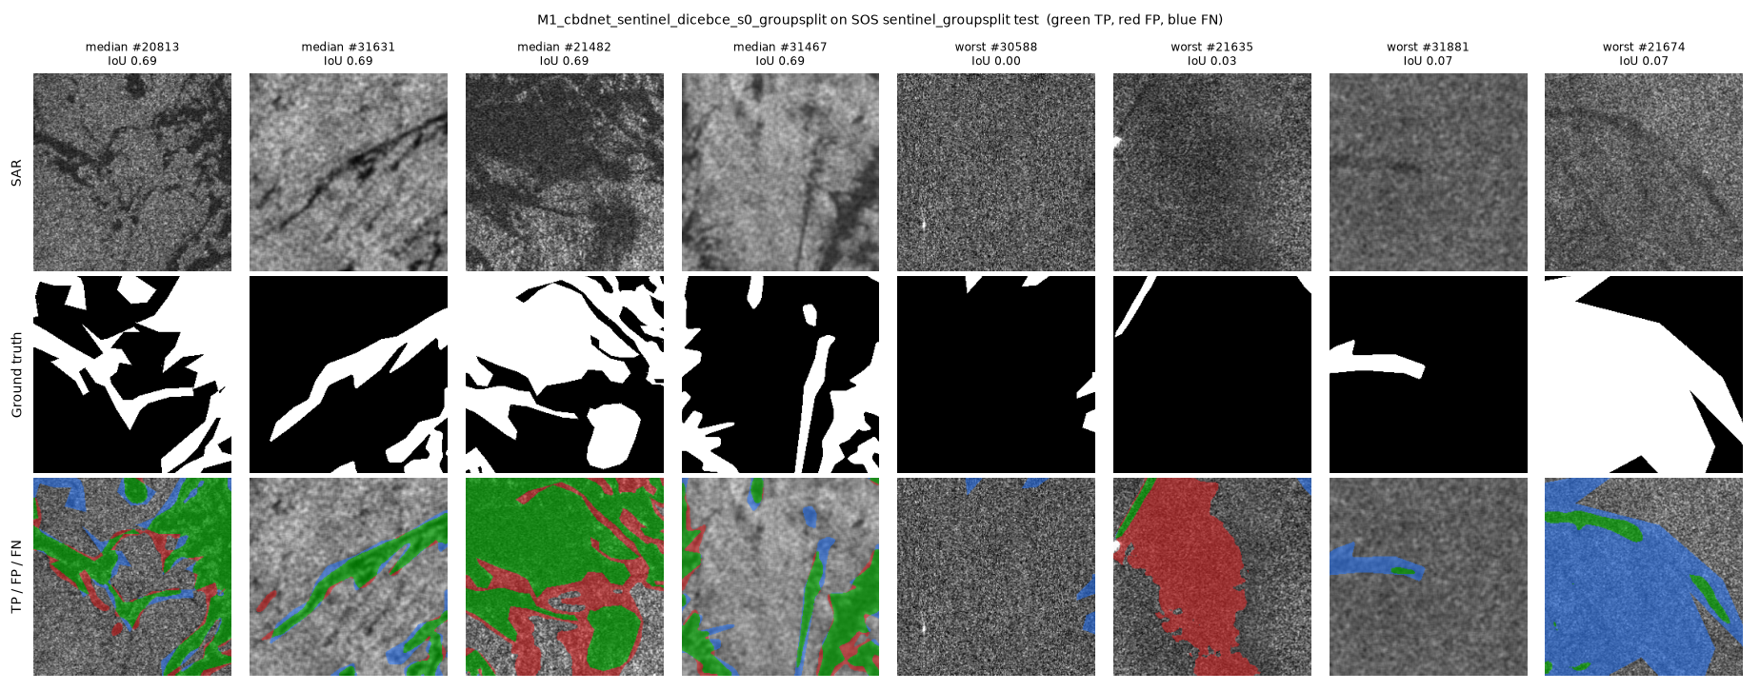
Figure 1. M1, leak-free SOS test: median tiles (left) and worst tiles (right). Failures: missed thin streaks (blue), a dark patch called oil (red), and a large labelled polygon that is barely darker than the sea.
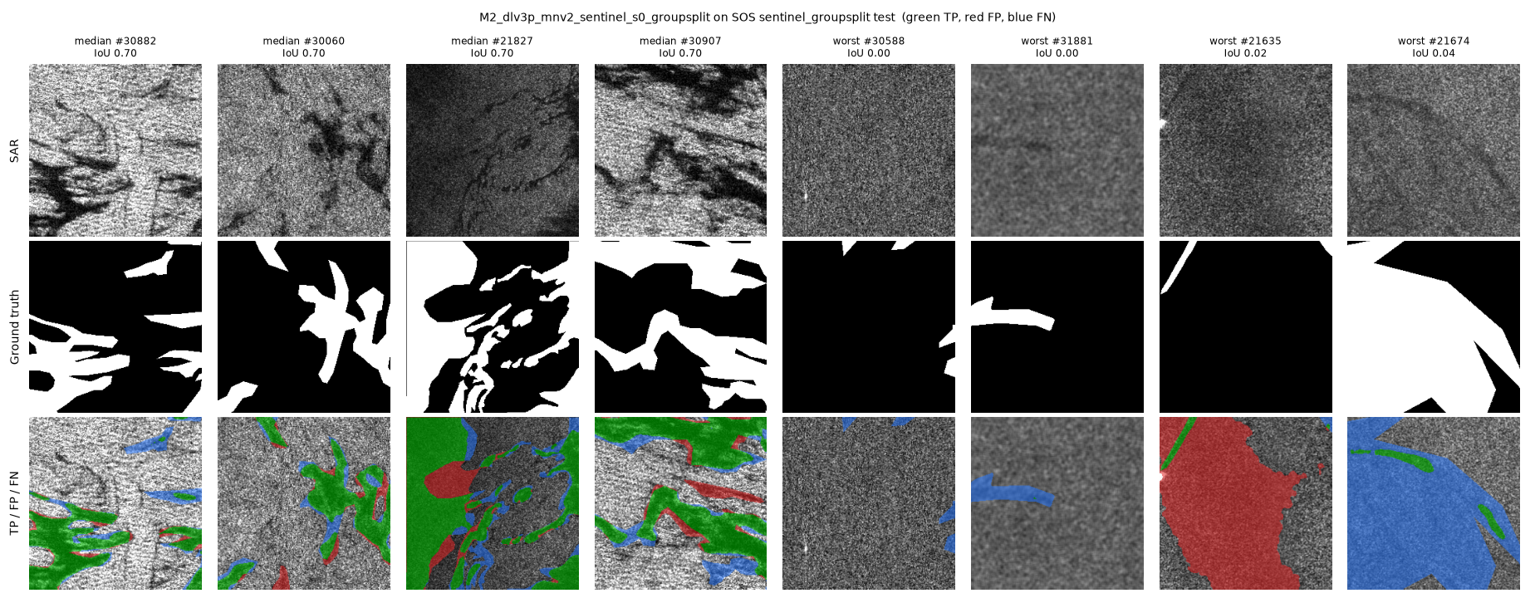
Figure 2. M2, leak-free SOS test: same layout.
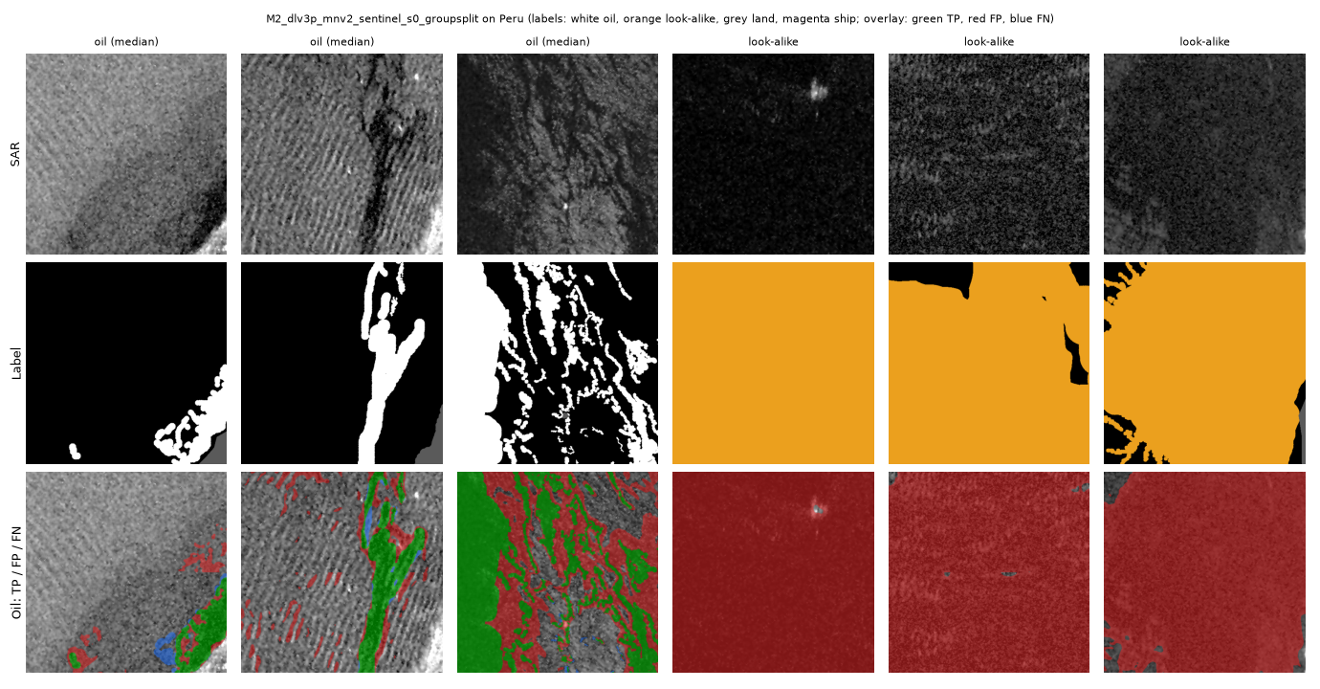
Figure 3. M2 (leak-free-trained) on Peru. Oil is found (green), but the three look-alike patches (orange label) are almost entirely called oil (red), and wind streaks near real oil raise false alarms.
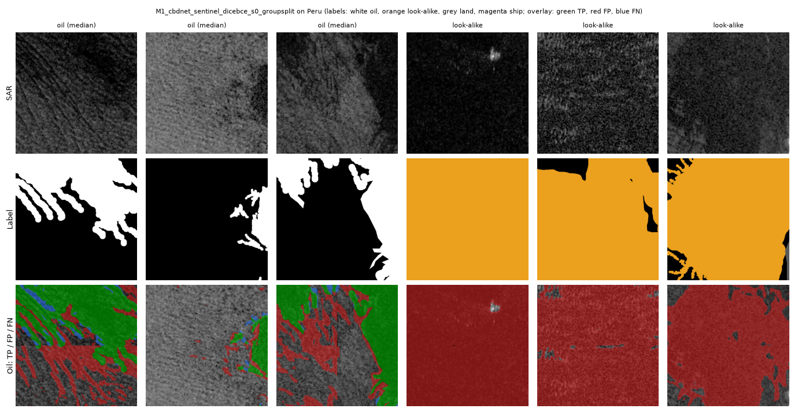
Figure 4. M1 (leak-free-trained) on Peru: same layout.
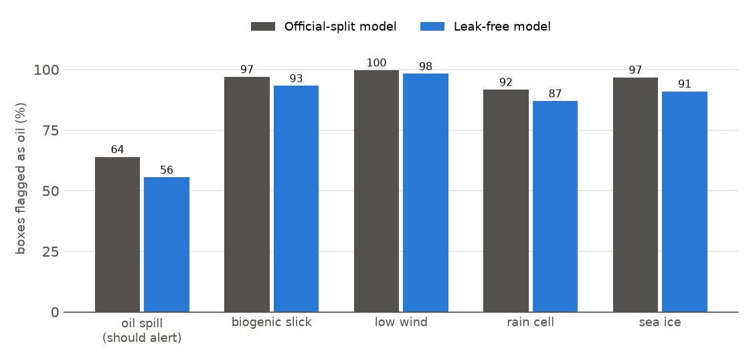
Figure 5. M1 on MDOD: share of boxes alerted, per class.
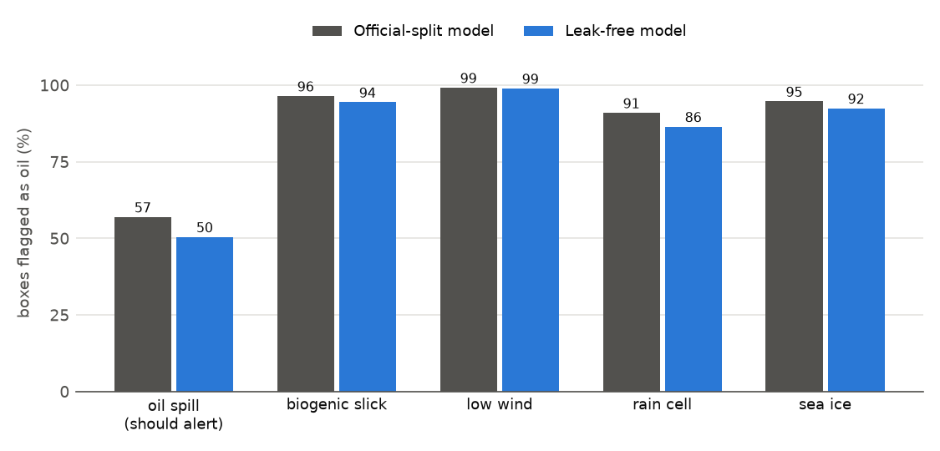
Figure 6. M2 on MDOD: share of boxes alerted, per class.

8. Accuracy, F1, MSE and R² for all three methods
Table 8. Accuracy and F1 in %, MSE and R² on the oil probabilities (TTA). M3 is coded but not trained, so its columns are pending. The papers report no accuracy, MSE or R².
Test | Model trained on | M1 Acc | M1 F1 | M1 MSE | M1 R² | M2 Acc | M2 F1 | M2 MSE | M2 R² | M3 Acc | M3 F1 | M3 MSE | M3 R²
SOS official test (leaky) | leaky split | 91.24 | 87.91 | 0.0639 | 0.718 | 91.56 | 88.05 | 0.0632 | 0.721 | pending | pending | pending | pending
SOS leak-free test | leak-free split | 92.16 | 86.80 | 0.0584 | 0.720 | 92.49 | 87.22 | 0.0554 | 0.734 | pending | pending | pending | pending
Peru, all 2,013 patches | leaky split | 62.78 | 24.46 | 0.2919 | -4.000 | 60.21 | 22.89 | 0.3211 | -4.500 | pending | pending | pending | pending
Peru, all 2,013 patches | leak-free split | 71.56 | 29.44 | 0.2201 | -2.770 | 59.17 | 22.32 | 0.3295 | -4.644 | pending | pending | pending | pending
Peru test subset (338) | leaky split | 66.75 | 16.90 | 0.2613 | -6.726 | 66.53 | 16.94 | 0.2714 | -7.025 | pending | pending | pending | pending
Peru test subset (338) | leak-free split | 73.33 | 19.96 | 0.2057 | -5.082 | 66.55 | 16.78 | 0.2760 | -7.161 | pending | pending | pending | pending
SOS official test: published | leaky split | — | 87.81 | — | — | — | 89.62 | — | — | — | 92.87 | — | —

- Accuracy is 91–93 % on SOS but only 59–73 % on Peru, below the ≈ 94 % a model would get on Peru by predicting “no oil” everywhere, because of the many look-alike false alarms. F1 shows the oil performance directly.
- R² is clearly positive on SOS (the probabilities explain most of the label variance) but strongly negative on Peru: the over-confident probabilities are worse than predicting the average oil share for every pixel. This is the domain-shift failure expressed as a regression metric.
- MSE / R² are regression metrics: they are reported because they were requested, computed on the per-pixel probabilities against the 0/1 labels. MDOD has no pixel labels, so it has no MSE or R².
All quantitative tables are in M1_CBDNet_All_Results.docx and M2_DeepLabV3Plus_All_Results.docx (same folder); overfitting, confidence intervals and metric explanations are in Analysis_Overfitting_Datasets_Metrics.docx.

