AMAZON MUSIC CLUSTERING

Project Report

By,
Vigna Prasanna

INTRODUCTION :
The goal of this project is to automatically group similar songs based on their audio characteristics using clustering techniques. By analyzing patterns in features such as tempo, energy, danceability, and more we develop a model that organizes songs into meaningful clusters, potentially representing different musical genres or moods without any prior labels.
SCOPE OF THE PROJECT :
The main scope of the project is to categorize songs from the amazon music dataset using the unsupervised Machine Learning technique K-Means clustering. Here the dataset is clustered into k clusters where the best k value is determined using the elbow method, Silhouette score and Davies-Bouldin Index and then we add cluster labels to the dataset so that streaming platforms can use this data to help listeners and artists to discover songs suited to their liking or curate playlists and so much more.
TECHNOLOGY USED :
- Programming languages : Python 3.14.2
- Code editor : Microsoft Visual Studio Code
- Python Libraries : Pandas, Sklearn, Streamlit, matplotlib, seaborn, plotly
IMPLEMENTATION :
SOURCE CODE:
import pandas as pd
import numpy as np

df = pd.read_csv(r"D:\DS\MiniProjects\Amazon Music Clustering\single_genre_artists.csv")
df.shape
df.head()
df.tail()
df.info()
100*df.isnull().sum()/df.shape[0]
df.duplicated().sum()
df.drop(columns=["id_songs","name_song","name_artists"], inplace = True)
import matplotlib.pyplot as plt
import seaborn as sns
df1 = df[["valence","tempo","duration_ms","danceability","energy","loudness","speechiness","acousticness","instrumentalness","liveness"]]
for col in df1.columns:
plt.figure(figsize = (5,5))
sns.boxplot(data = df1[col])
plt.show()
df1.hist(figsize = (20,20), bins = 30, color = "blue", edgecolor = "black")
plt.tight_layout()
plt.show()
**FEATURE SCALING**
from sklearn.preprocessing import StandardScaler
scaler = StandardScaler()

X = scaler.fit_transform(df1)
X_scaled = pd.DataFrame(X, columns = df1.columns)
X_scaled
from sklearn.cluster import KMeans
inertia = []
for k in range(2, 11):
kmeans = KMeans(n_clusters = k, max_iter = 300, n_init = 10, random_state=42)
kmeans.fit(X_scaled)
inertia.append(kmeans.inertia_)

K = range(2,11)
plt.plot(K, inertia, marker = 'o')
plt.show()
plt.savefig('elbow_plot.png')
**USING KNEELOCATOR TO FIND THE BEST K VALUE**
from kneed import KneeLocator

# Automatically find the elbow point
kl = KneeLocator(
list(K), inertia, curve="convex", direction="decreasing"
)
optimal_k = kl.elbow
print(f"The optimal number of clusters is: {optimal_k}")
optimal_inertia = inertia[list(K).index(optimal_k)]
print(f"Optimal inertia: {optimal_inertia}")
optimal_inertia = inertia[list(K).index(optimal_k)]

plt.figure(figsize=(8, 8))
plt.plot(K, inertia, marker="o", linewidth=2, label="Inertia Curve")

plt.scatter(optimal_k,optimal_inertia,color="red", s=50, zorder = 3)
plt.axvline(x = optimal_k, color = 'gray', linestyle ='--')
plt.axhline(y = optimal_inertia, color = 'gray', linestyle ='--')
plt.xlabel("Number of Clusters (K)")
plt.ylabel("Inertia")
plt.title("Elbow Method")
plt.xticks(K)
plt.show()
**K-Means Clustering**
kmeans = KMeans(n_clusters=4, random_state=42, n_init=10)
cluster_labels = kmeans.fit_predict(X_scaled)
df_og = pd.read_csv(r"D:\DS\MiniProjects\Amazon Music Clustering\single_genre_artists.csv")
df_og["Cluster_Label"] = cluster_labels
pd.set_option('display.max_columns', None)
df_og.head()
df_og.tail()
**SILHOUETTE SCORE**
from sklearn.metrics import silhouette_score

score = silhouette_score(X_scaled, cluster_labels)

print(f"Silhouette Score: {score:.4f}")
**DAVIES_BOULDIN INDEX**
from sklearn.metrics import davies_bouldin_score
db_score = davies_bouldin_score(X_scaled, cluster_labels)
print(db_score)
**CLUSTER PROFILE**
cluster_profile = df_og.groupby("Cluster_Label")[df1.columns].mean()
cluster_profile.T
cluster_names = {
0: "Party Tracks",
1: "Chill acoustic",
2: "High Speechiness",
3: "Instrumental",
}

df_og["Cluster_Name"] = df_og["Cluster_Label"].map(cluster_names)

df_og[["name_song", "Cluster_Name"]].tail()
**PCA ( Principal Component Analysis)**
from sklearn.decomposition import PCA
pca = PCA(n_components=2, random_state=42)
pca.fit_transform(X_scaled)
pca.explained_variance_ratio_

#X_pca = pca.fit_transform(X_scaled)
#df_pca = pd.DataFrame(X_pca, columns = ["PC1", "PC2"])
X_pca = pca.fit_transform(X_scaled)

pca_df = pd.DataFrame(X_pca, columns=["PC1", "PC2"])
pca_df["Cluster"] = df_og["Cluster_Label"]

plt.figure(figsize=(8, 6))
sns.scatterplot(
data=pca_df,
x="PC1",
y="PC2",
hue="Cluster",
palette="tab10",
s=40,
alpha=0.7,
)

plt.title("PCA Cluster Visualization", fontsize=15)
plt.xlabel("PC1")
plt.ylabel("PC2")
plt.legend(title="Cluster")
plt.grid(alpha=0.3)
plt.show()
scaled_plot_df = X_scaled.copy()
scaled_plot_df["Cluster_Label"] = df_og["Cluster_Label"]
scaled_cluster_means = scaled_plot_df.groupby("Cluster_Label").mean()

ax = scaled_cluster_means.T.plot(kind="bar", figsize=(14, 7), width=0.8)
plt.title("Average Feature Values per Cluster")
plt.xlabel("Audio Features")
plt.ylabel("Mean")
plt.xticks(rotation=45, ha="right")
plt.axhline(0, color="black", linewidth=0.8, linestyle="-")
plt.legend(title="Cluster Label", bbox_to_anchor=(1.05, 1), loc="upper left")
plt.grid(axis="y", alpha=0.3)
plt.tight_layout()
plt.show()
plt.figure(figsize=(12, 6))
sns.heatmap(
scaled_cluster_means,
annot=True,
fmt=".2f",
cmap="coolwarm",
linewidths=0.5,
cbar=True,
)
plt.title("Heatmap comparing features across clusters")
plt.xlabel("Audio Features")
plt.ylabel("Cluster Label")
plt.tight_layout()
plt.show()
plt.figure(figsize=(10, 6))
sns.kdeplot(
data=df_og,
x="liveness",
hue="Cluster_Label",
common_norm=False,
fill=True,
alpha=0.3,
palette="tab10"
)

plt.xlabel("Tempo")
plt.ylabel("Density")
plt.grid(alpha=0.3)
plt.show()
top_tracks_per_cluster = (
df_og.sort_values(
by=["Cluster_Name", "popularity_songs"], ascending=[True, False]
)
.groupby("Cluster_Name")
.head(5)
)
# Display the clean table
top_tracks_per_cluster[["Cluster_Name", "popularity_songs", "name_song", "name_artists"]]
**EXPORT**
df_og.to_csv("AmazonMusic_clustered_.csv", index=False)
print("DataFrame successfully exported to CSV!")

ANALYSIS :
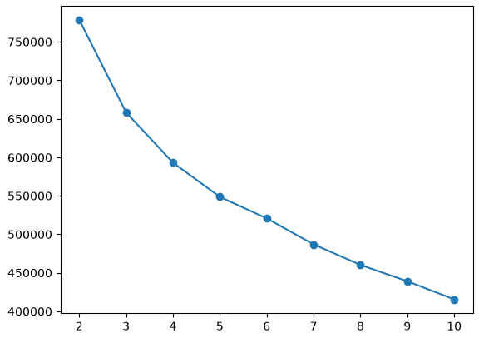

From the Elbow method plot used to identify the best K value, here the best K value is where the elbow bend is the most prominent. To verify and confirm the k value based on the results of this elbow method plot, we use the Knee Locator library to plot the best K point.
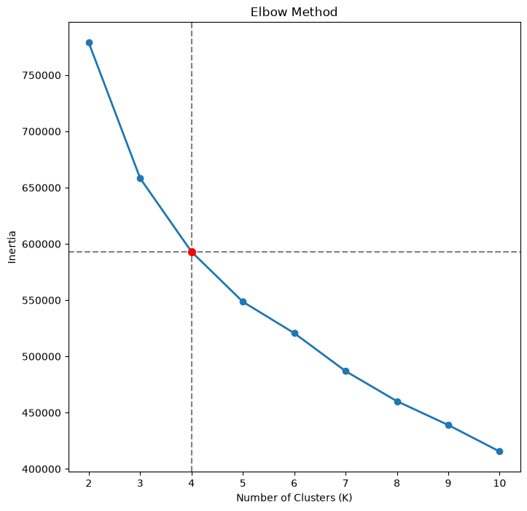
From this, we can say the best k value for K-Means clustering is 4. Hence, a K-Means clustering model is trained with K=4 and for that model, the Silhouette score is 0.2310 and the Davies-Bouldin Index is 1.5301. A higher Silhouette score means the clusters are well-seperated and a lower Davies-Bouldin Index indicates better clustering. Here the values are not the best because music categories can often overlap a lot since the genres can be alternative and it is difficult to properly separate them.
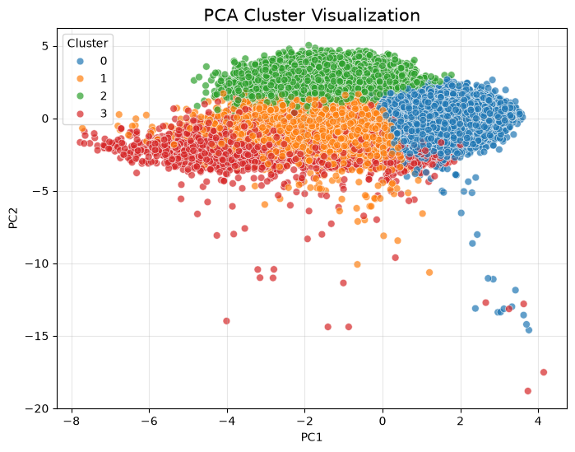
This image shows the visual representation of the clusters using the Principal Component Analysis technique which is used to reduce the dimensions of a dataset. Here only the first two components are plotted since they yielded the maximum value of information retention. We can see all 4 categories closely grouped together.

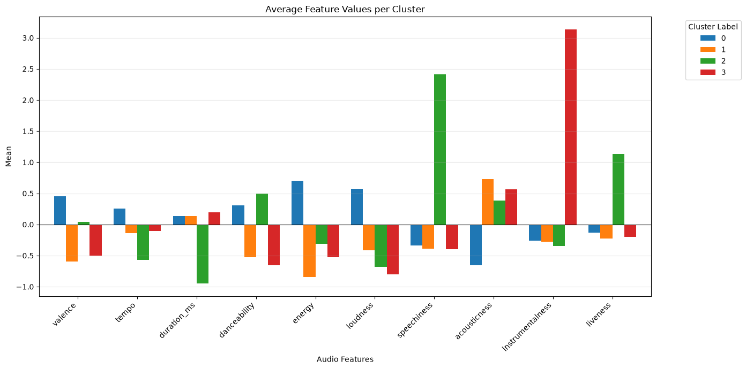
This Image shows the average features per cluster.
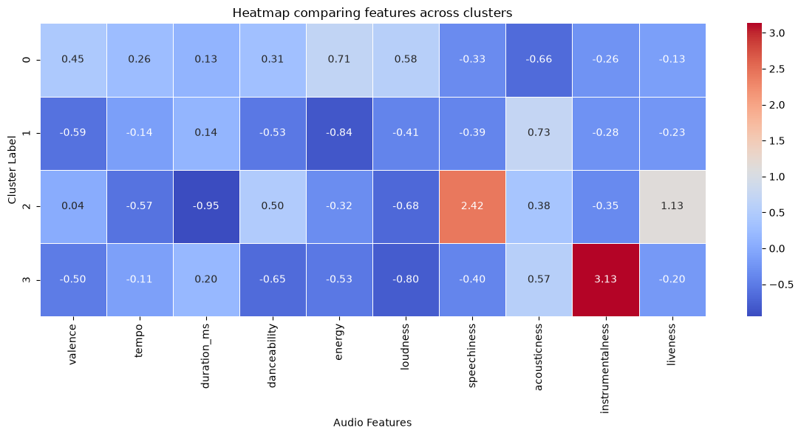
This Heatmap represents the comparison of features across clusters.

CONCLUSION :
From the insights derived above, We conclude that for this dataset, the best K value for clustering is 4 and the clustered data set along with the cluster labels can be used by streaming platforms like Amazon to categorize music and serve better to listeners who would be interested in discovering new music from the cluster they already listen to the most or for artists to identify more music in their own cluster that can inspire ideas or collaborations.

