COMMENT TOXICITY DETECTION

Project Report

By,
Vigna Prasanna

INTRODUCTION :
The objective of this project is to develop a deep learning-based comment toxicity model using Python. This model will analyze text input from online comments and predict if it is toxic or not. By accurately identifying toxic comments, the model will assist platform moderators and administrators in taking appropriate actions to mitigate the negative impact of toxic behavior, such as filtering, warning users, or initiating further review processes.
SCOPE OF THE PROJECT :
The main scope of the project is to build a Deep-learning model using tensorflow and Bi-directional LSTM that can detect Toxic comments based on the online comments dataset that have been flagged across various categories of toxicity. A streamlit application is used to provide the user an option to enter a text comment or a csv file of comments to analyze and get toxicity results.
TECHNOLOGY USED :
- Programming languages : Python 3.14.2
- Code editor : Microsoft Visual Studio Code, Google Colab (for T4 GPU)
- Python Libraries : Pandas, Sklearn, Streamlit, matplotlib, seaborn, tensorflow, re
IMPLEMENTATION :
SOURCE CODE:
import streamlit as st
import pandas as pd
import numpy as np
import tensorflow as tf
from tensorflow.keras.preprocessing.sequence import pad_sequences
from tensorflow.keras.models import load_model
import pickle
import re

st.set_page_config(
page_title="Comment Toxicity Detector",
layout="wide"
)

st.markdown("""
<style>
.main-header {
font-size: 40px;
font-weight: bold;
text-align: center;
margin-bottom: 10px;
}
.sub-header {
font-size: 18px;
color: #4B5563;
text-align: center;
margin-bottom: 30px;
}
</style>
""", unsafe_allow_html=True)

TARGET_COLS = ['toxic', 'severe_toxic', 'obscene', 'threat', 'insult', 'identity_hate']
MAX_LEN = 150

def clean_text(text):
if not isinstance(text, str):
return ""
text = text.lower()
text = re.sub(r"\n", " ", text)
text = re.sub(r"https?://\S+|www\.\S+", "", text)
text = re.sub(r"['’]", "", text)
text = re.sub(r"[^a-zA-Z\s]", " ", text)
text = re.sub(r"\s+", " ", text).strip()
return text

@st.cache_resource
def load_artifacts():
try:
model = load_model('toxicity_model.h5')
with open('tokenizer.pkl', 'rb') as f:
tokenizer = pickle.load(f)
return model, tokenizer, None
except Exception as e:
return None, None, str(e)

st.markdown("<div class='main-header'>Comment Toxicity Detector</div>", unsafe_allow_html=True)

model, tokenizer, err = load_artifacts()

if err:
st.warning("Pre-trained model weights (`toxicity_model.h5`) or tokenizer (`tokenizer.pkl`) were not found. Running in simulation mode for UI testing.")

st.header("Comment Analyzer")
st.write("Enter a comment below to identify the toxicity probability across all categories")

user_input = st.text_area(
"Enter Comment:",
height=120,
placeholder="Type or paste a comment here..."
)

if st.button("Analyze Comment", type="primary"):
if not user_input.strip():
st.write("Please enter text before running analysis.")
else:
cleaned = clean_text(user_input)

if model and tokenizer:
seq = tokenizer.texts_to_sequences([cleaned])
padded = pad_sequences(seq, maxlen=MAX_LEN, padding='post', truncating='post')
preds = model.predict(padded)[0]

threshold = 0.5
results_df = pd.DataFrame({
"Category": [c.replace('_', ' ').title() for c in TARGET_COLS],
"Probability Score": preds,

})

flagged_mask = preds >= threshold

if any(flagged_mask):
flagged_categories = [results_df.loc[i, "Category"] for i, val in enumerate(flagged_mask) if val]
st.warning(f"⚠️ **Toxic Comment**")
else:
st.success("✅ **Clean comment**")

st.markdown("Toxicity Probability Scores")
st.dataframe(
results_df.style.format({"Probability Score": "{:.2%}"}),
use_container_width=True
)

st.divider()

st.header("Bulk CSV Prediction")
st.write("Upload a CSV file containing comments to get toxicity predictions for every record.")

uploaded_file = st.file_uploader("Upload CSV File", type=["csv"])

if uploaded_file is not None:
batch_df = pd.read_csv(uploaded_file)
st.write(f"**Loaded {len(batch_df)} rows.**")
st.dataframe(batch_df.head())

if st.button("Process Batch Predictions", type="primary"):
with st.spinner("Processing batch predictions..."):
cleaned_list = [clean_text(str(t)) for t in batch_df['comment_text']]

if model and tokenizer:
seqs = tokenizer.texts_to_sequences(cleaned_list)
padded = pad_sequences(seqs, maxlen=MAX_LEN, padding='post', truncating='post')
preds = model.predict(padded)
else:
preds = np.random.uniform(0.01, 0.25, size=(len(batch_df), len(TARGET_COLS)))

for i, col in enumerate(TARGET_COLS):
batch_df[f"{col}"] = preds[:, i]

st.success("Batch Prediction Complete!")
st.markdown("Results Overview")
st.dataframe(batch_df)

ANALYSIS :
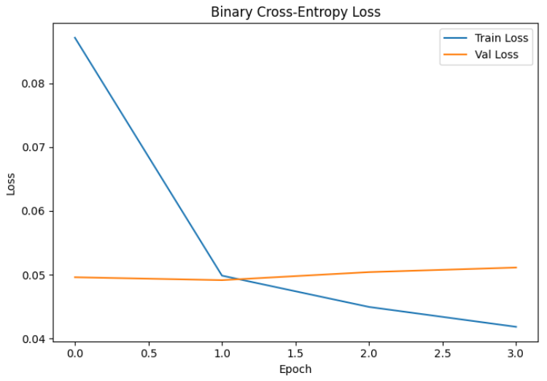
The above image shows the plot of Binary Cross Entropy (BCE) Loss for the training and validation data. We can notice that the loss decreases heavily until 1 epoch and then gradually reduces to minimum at around 4 epochs. On the other hand the Validation data stays consistent up until 1 epoch and then slowly starts increasing. This indicates that the model may be overfitting.
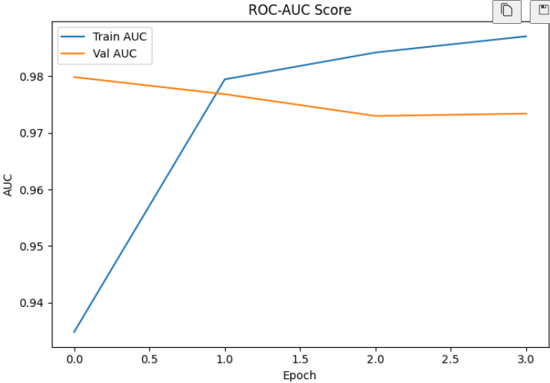
This image shows the plot of ROC_AUC score for the model. Here too we can see the score heavily increasing up until 1 epoch and then slowly rising from 1 to 4 epochs for training data. On the other hand, the testing data score goes down gradually up until 2 epochs and then almost stays flat. From this we can say that the model is overfitting, but still the training data has a good ROC-AUC score.
This model can be further improved by either fine-tuning the hyper parameters or going for a transformer based model which is more suited for this type of classification since transformers can better identify patterns and make predictions better due to their complicated architecture compared to a LSTM model.

OUTPUT:
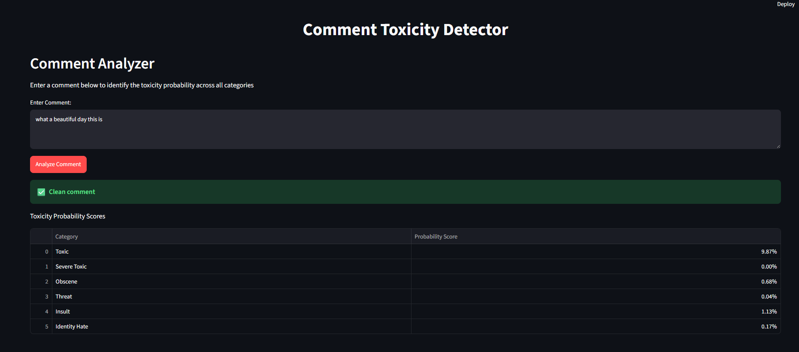
This is the streamlit application where you can enter a comment to find if it is toxic or not. Here we can see the entered comment is a clean comment and it also shows the Toxicity probability across all six categories.
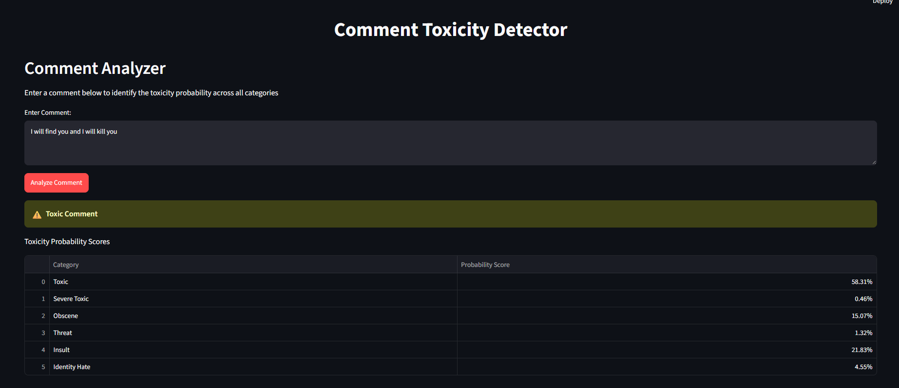
When a Toxic comment is entered, it shows the warning message indicating that this is toxic and we can see which toxicity category this belongs to from the highest score.
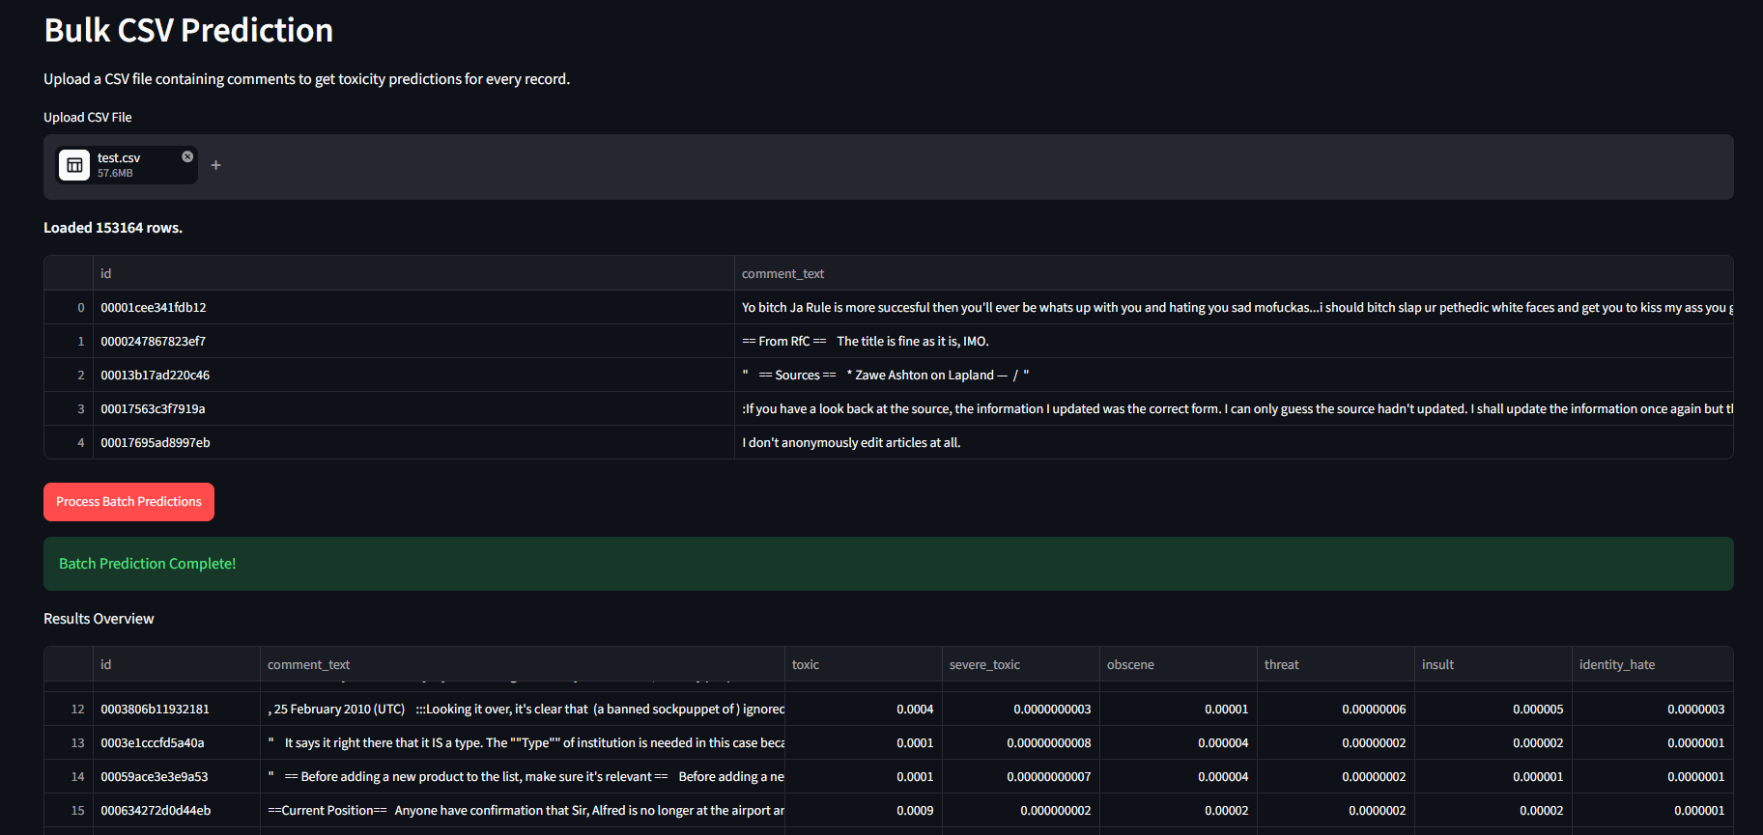
There is also an option to upload a csv file containing comments to get insights about the toxicity score where the score will be determined based on the model that was trained in this project.
CONCLUSION :
From the insights derived above, We conclude that the comment toxicity detection using Deep-Learning, we can categorize comments as toxic or non-toxic which will be useful for online moderators and administrators to reduce cyber-bullying and ban hate speech which can be harmful to users online.

