CONTENT MONETIZATION MODELER

Project Report

By,
Vigna Prasanna

INTRODUCTION :
This machine learning project predicts potential YouTube ad revenue for individual videos based on key performance metrics and contextual features. The project includes comprehensive exploratory data analysis (EDA), data cleaning, feature engineering, regression modeling, and an interactive Streamlit web application for real-time inference. As video creators and media companies increasingly rely on platforms like YouTube for income, predicting potential ad revenue becomes essential for business planning and content strategy. This project builds and evaluates multiple regression models to estimate video earnings accurately, helping stakeholders optimize strategies and forecast future revenue.
SCOPE OF THE PROJECT :
The main scope of the project is to critically analyze the ad revenues dataset for the youtube platform based on various factors like views, subscribers, likes, category etc and train 5 Machine Learning Regression models that can predict the ad revenue based on the provided inputs. We also compare and contrast the different Regression models and find which one is the best based on the evaluation metrics.
TECHNOLOGY USED :
- Programming languages : Python 3.14.2
- Code editor : Microsoft Visual Studio Code
- Python Libraries : Pandas, Sklearn, Streamlit, matplotlib, seaborn, joblib
IMPLEMENTATION :
- Cleaning the data and performing Exploratory Data Analysis.
SOURCE CODE:
import pandas as pd
import numpy as np
import warnings
warnings.filterwarnings("ignore")
df = pd.read_csv(r"D:\DS\MiniProjects\Content Monetization Modeler\youtube_ad_revenue_dataset.csv")
df.head()
df.tail()
df.shape
df.info()
df.describe()
Removing the 'video_id' column from the dataframe because this column will have no effect on revenue generation.
df.drop('video_id', axis=1, inplace=True)
df.shape
__Checking for missing values in the dataset and handling them__
100*df.isnull().sum()/df.shape[0]
import matplotlib.pyplot as plt
import seaborn as sns
numerical_columns = [
'views',
'likes',
'comments',
'watch_time_minutes',
'video_length_minutes',
'subscribers',
'ad_revenue_usd'
]

for col in numerical_columns:
plt.figure(figsize=(6,6))
sns.boxplot(df[col])
plt.title(f'Boxplot of {col}')
plt.show()
As we can see from the Boxplots, the 'Views' column has Outliers that need to be handled.
**OUTLIER HANDLING**
Q1 = df['views'].quantile(0.25)
Q3 = df['views'].quantile(0.75)
IQR = Q3 - Q1
lower_bound = Q1 - 1.5*IQR
upper_bound = Q3 + 1.5*IQR
df1 = df[(df['views']>=lower_bound) & (df['views']<=upper_bound)]
sns.boxplot(df1['views'])
plt.show()
print("New min views:", df1['views'].min())
print("New max views:", df1['views'].max())
print("Calculated lower bound:", lower_bound)
print("Calculated upper bound:", upper_bound)
sns.pairplot(df1)
df1[numerical_columns].corr()
sns.heatmap(df1[numerical_columns].corr(), annot=True, cmap='coolwarm')
Since the dependancy is only between an input feature and an output feature, it is not being handled here.
100*df1.isnull().sum()/df1.shape[0]
df1['likes'] = df1['likes'].fillna(df1['likes'].median())
df1['comments'] = df1['comments'].fillna(df1['comments'].median())
df1['watch_time_minutes'] = df1['watch_time_minutes'].fillna(df1['watch_time_minutes'].median())
100*df1.isnull().sum()/df1.shape[0]
df1.info()
df1.duplicated().sum()
df1.drop_duplicates(inplace=True)
**FEATURE ENGINEERING**
df1['month'] = pd.to_datetime(df1['date']).dt.month
df1['year'] = pd.to_datetime(df1['date']).dt.year
df1['day'] = pd.to_datetime(df1['date']).dt.day
df1['day_name'] = pd.to_datetime(df1['date']).dt.day_name()

df1['engagement_rate'] = (df1['likes']+df1['comments'])/df1['views']
df1.drop(['date'],axis=1,inplace=True)
df1.head()
df1['year'].value_counts()
df1['country'].value_counts()
df1['category'].value_counts()
df1['device'].value_counts()
dfe = pd.get_dummies(df1, columns = ['device', 'category', 'country', 'day_name'])

pd.set_option('display.max_columns', None)
dfe.head()
from sklearn.model_selection import train_test_split
X = dfe.drop(['ad_revenue_usd'], axis=1)
y = dfe['ad_revenue_usd']

X_train, X_test, y_train, y_test = train_test_split(X, y, test_size=0.2, random_state=42)
__**LINEAR REGRESSION**__
from sklearn.linear_model import LinearRegression
lr = LinearRegression()
lr.fit(X_train, y_train)
y_test_pred_lr = lr.predict(X_test)
from sklearn.metrics import r2_score, root_mean_squared_error, mean_absolute_error
lr_r2 = r2_score(y_test, y_test_pred_lr)
lr_rmse = root_mean_squared_error(y_test, y_test_pred_lr)
lr_mae = mean_absolute_error(y_test, y_test_pred_lr)
y_train_pred = lr.predict(X_train)
r2_score(y_train, y_train_pred)
**RIDGE REGRESSION**
from sklearn.linear_model import Ridge
ridge = Ridge()
ridge.fit(X_train, y_train)
y_test_pred_ridge = ridge.predict(X_test)
ridge_r2 =r2_score(y_test, y_test_pred_ridge)
ridge_rmse = root_mean_squared_error(y_test, y_test_pred_ridge)
ridge_mae = mean_absolute_error(y_test, y_test_pred_ridge)
r2_score(y_train, ridge.predict(X_train))
**RANDOM FOREST REGRESSION**
from sklearn.ensemble import RandomForestRegressor
rf = RandomForestRegressor(n_estimators=100, max_depth=10, random_state=42)
rf.fit(X_train,y_train)
y_test_pred_rf = rf.predict(X_test)
rf_r2 =r2_score(y_test, y_test_pred_rf)
rf_rmse = root_mean_squared_error(y_test, y_test_pred_rf)
rf_mae = mean_absolute_error(y_test, y_test_pred_rf)
r2_score(y_train, rf.predict(X_train))
**LASSO REGRESSION**
from sklearn.linear_model import Lasso
lasso = Lasso()
lasso.fit(X_train, y_train)
y_test_pred_lasso = lasso.predict(X_test)
lasso_r2 =r2_score(y_test, y_test_pred_lasso)
lasso_rmse = root_mean_squared_error(y_test, y_test_pred_lasso)
lasso_mae = mean_absolute_error(y_test, y_test_pred_lasso)
r2_score(y_train, lasso.predict(X_train))
**GRADIENT BOOSTING REGRESSOR**
from sklearn.ensemble import GradientBoostingRegressor
gb = GradientBoostingRegressor(n_estimators = 100, learning_rate = 0.1, max_depth = 10, random_state = 42)
gb.fit(X_train,y_train)
y_test_pred_gb = gb.predict(X_test)
gb_r2 =r2_score(y_test, y_test_pred_gb)
gb_rmse = root_mean_squared_error(y_test, y_test_pred_gb)
gb_mae = mean_absolute_error(y_test, y_test_pred_gb)
r2_score(y_train, gb.predict(X_train))
**EVALUATION**
#evalutaion_metrics = pd.DataFrame()

data = {
"Model": [
"Linear Regression",
"Lasso Regression",
"Ridge Regression",
"Gradient Boosting Regression",
"Random Forest Regression"
],
"R2_Score": [lr_r2, lasso_r2, ridge_r2, gb_r2, rf_r2],
"RMSE": [lr_rmse, lasso_rmse, ridge_rmse, gb_rmse, rf_rmse],
"MAE": [lr_mae, lasso_mae, ridge_mae, gb_mae, rf_mae],
}

# Create the DataFrame
results_df = pd.DataFrame(data)
results_df
import joblib
joblib.dump(lasso, 'youtube_lasso.pkl')
joblib.dump(rf, 'youtube_rf.pkl')
joblib.dump(lr, 'youtube_lr.pkl')
joblib.dump(gb, 'youtube_gb.pkl')
joblib.dump(ridge, 'youtube_ridge.pkl')
joblib.dump(results_df, 'evaluation_metrics.pkl')
print("model saved successfully")
joblib.dump(X.columns.tolist(), 'model_columns.pkl')
**VISUALIZATION OF THE REGRESSION MODELS AND THEIR EVALUATION METRICS**
fig, axes = plt.subplots(1, 3, figsize=(18, 5))

axes[0].barh(results_df["Model"], results_df["R2_Score"])
axes[0].set_title("R² Score")
axes[0].set_xlim(0, 1.05)

axes[1].barh(results_df["Model"], results_df["RMSE"])
axes[1].set_title("RMSE")

axes[2].barh(results_df["Model"], results_df["MAE"])
axes[2].set_title("MAE")
plt.tight_layout()
plt.show()
- Once the model training is done and the model data is all pickled, we can move ahead with building the streamlit web application that lets the user input the values and predict the revenue that could be generated.

SOURCE CODE:

import datetime
import joblib
import pandas as pd
import streamlit as st

st.set_page_config(page_title="YouTube Ad Revenue Predictor", layout="centered")

@st.cache_resource
def load_columns():
return joblib.load("model_columns.pkl")

model_columns = load_columns()

st.title("Content Monetization Modeler")

# Model selection and display of evaluation metrics
st.subheader("Model Selection")
results_df = joblib.load("evaluation_metrics.pkl")
active_model = st.selectbox("Choose Regression model", results_df["Model"].tolist())
met = results_df[results_df["Model"] == active_model].iloc[0]
col_m1, col_m2, col_m3 = st.columns(3)
col_m1.metric("R2 Score", f"{met['R2_Score']:.5f}")
col_m2.metric("RMSE", f"{met['RMSE']:,.5f}")
col_m3.metric("MAE", f"{met['MAE']:,.5f}")

# Load the specific model based on user selection
if active_model == "Lasso Regression":
model = joblib.load("youtube_lasso.pkl")
elif active_model == "Ridge Regression":
model = joblib.load("youtube_ridge.pkl")
elif active_model == "Random Forest Regression":
model = joblib.load("youtube_rf.pkl")
elif active_model == "Gradient Boosting Regression":
model = joblib.load("youtube_gb.pkl")
else:
model = joblib.load("youtube_lr.pkl")

col1, col2 = st.columns(2)

with col1:
views = st.number_input("Views", min_value=0, value=50000, step=100)
likes = st.number_input("Likes", min_value=0, value=1500, step=10)
comments = st.number_input("Comments", min_value=0, value=150, step=1)

with col2:
watch_time_minutes = st.number_input(
"Watch Time (Minutes)", min_value=0.0, value=12000.0, step=50.0
)
video_length_minutes = st.number_input(
"Video Length (Minutes)", min_value=0.0, value=12.5, step=0.5
)
subscribers = st.number_input(
"Subscribers", min_value=0, value=25000, step=100
)

col3, col4, col5 = st.columns(3)

with col3:
category = st.selectbox(
"Category",
["Gaming", "Tech", "Entertainment", "Education", "Lifestyle", "Music"],
)

with col4:
device = st.selectbox("Primary Device", ["Mobile", "Desktop", "Tablet", "TV"])

with col5:
country = st.selectbox("Target Country", ["US", "IN", "UK", "CA", "DE", "AU"])

upload_date = st.date_input("Video Upload Date", value=datetime.date.today())

upload_year = upload_date.year
upload_month = upload_date.month
upload_day = upload_date.day
upload_day_name = upload_date.strftime("%A") # e.g., 'Friday', 'Monday'

if st.button("Predict Revenue", use_container_width=True):
input_encoded = pd.DataFrame(0, index=[0], columns=model_columns)

numeric_inputs = {
"views": views,
"likes": likes,
"comments": comments,
"watch_time_minutes": watch_time_minutes,
"video_length_minutes": video_length_minutes,
"subscribers": subscribers,
"year": upload_year,
"month": upload_month,
"day": upload_day,
}

for col, val in numeric_inputs.items():
if col in input_encoded.columns:
input_encoded[col] = val

if "engagement_rate" in input_encoded.columns and views > 0:
input_encoded["engagement_rate"] = (likes + comments) / views

cat_cols_to_check = [
f"category_{category}",
f"Category_{category}",
f"device_{device}",
f"Device_{device}",
f"country_{country}",
f"Country_{country}",
f"day_name_{upload_day_name}",
]
for col in cat_cols_to_check:
if col in input_encoded.columns:
input_encoded[col] = 1

st.subheader("Input Data Sent to Model")
st.dataframe(input_encoded)

prediction = model.predict(input_encoded)
st.write(f"### Estimated Ad Revenue: ${prediction[0]:,.2f}")
st.markdown("---")

OUTPUT :
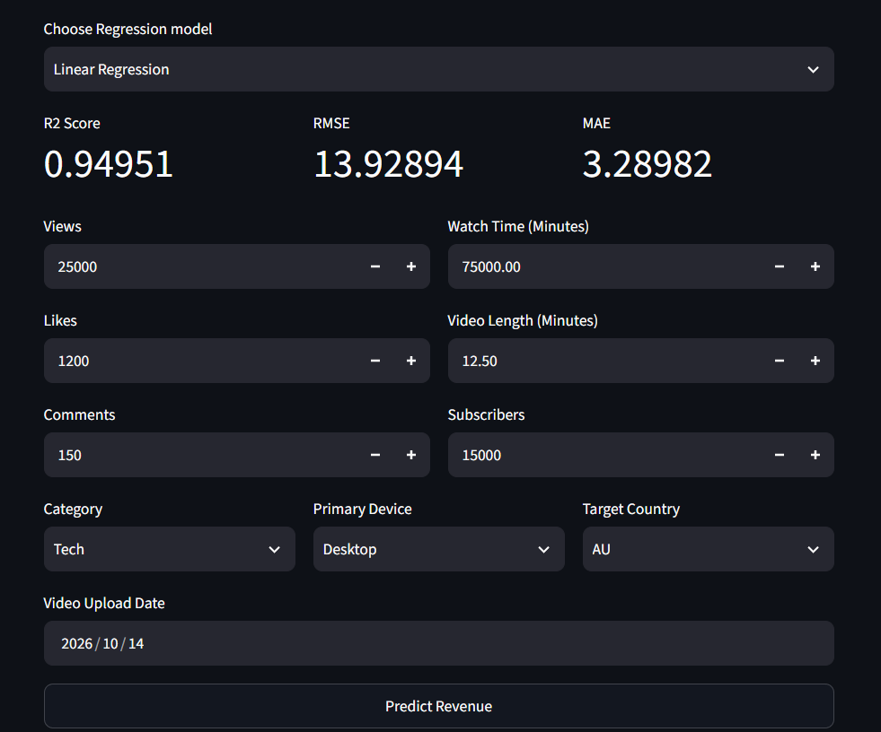
From the Drop down listbox, the user can select which model they want to use to make the prediction and the corresponding evaluation metrics are displayed right under it. The other input features can be entered in their respective input fields.
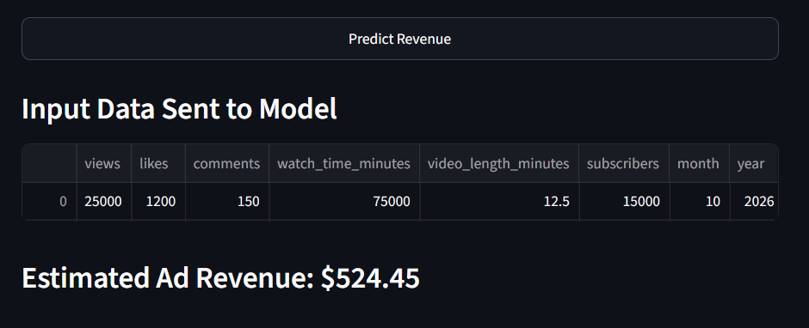
When the “Predict Revenue” button is pressed, it calculates the ad revenue using the selected Regression model and displays the output.
OBSERVATION:
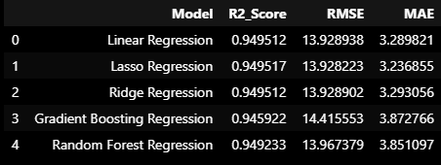
Based on the evaluation metrics of each Regression model, we can see that Lasso Regression has the highest R2 score and the lowest RMSE and MAE. Hence we can conclude that Lasso Regression model is the best suited model to predict the ad revenue for the youtube platform. A visualization of this dataframe is attached for better understanding.
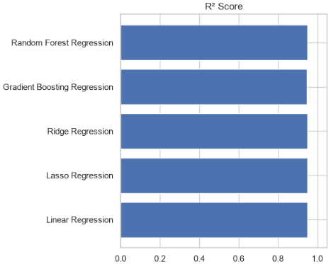
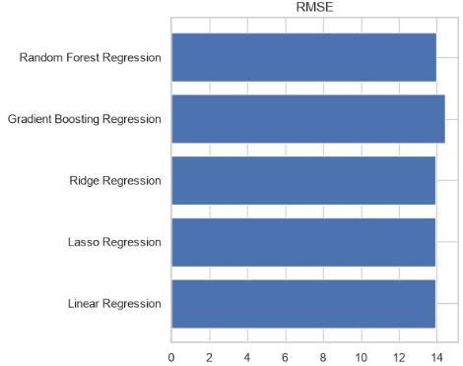
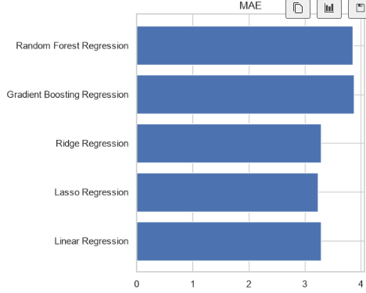
CONCLUSION :
From the insights derived above, Lasso Regression model is best suited for predicting the ad revenue for youtube since it has the lowest RMSE and MAE values and the highest R2 score. The other Regression models are also close and hence the variation in prediction wouldn’t have a drastic difference in them. Still, choosing the best model is always the first option to minimize errors in the prediction.

