PLANT DISEASE DETECTION AND TREATMENT

Project Report

By,
Vigna Prasanna

INTRODUCTION :
The objective of this project is to develop a deep learning-based Plant disease detection model using Convolutional Neural Networks. This model will analyze image input from the user and predict if it is healthy or infected and suggest treatment methods and prevention measures. By accurately identifying plant diseases, the model will assist farmers and agriculture industries in taking appropriate actions to prevent the spread of these diseases to other crops nearby and save the plants.
SCOPE OF THE PROJECT :
The main scope of the project is to build a Deep-learning model that uses Convolutional Neural networks using Pytorch and a LLM through transfer learning technique to get the treatment methods based on the type of disease identified. A streamlit application is used to provide the user an option to input an image to analyze and get the results.
TECHNOLOGY USED :
- Programming languages : Python 3.14.2
- Code editor : Microsoft Visual Studio Code, Google Colab (for T4 GPU)
- Python Libraries : Pandas, Sklearn, Streamlit, matplotlib, seaborn, torch, torchvision
IMPLEMENTATION :
SOURCE CODE:
import streamlit as st
import torch
import torch.nn as nn
from groq import Groq
from PIL import Image
from torchvision import models, transforms

MODEL_PATH = "resnet50_plant_model.pth"
CLASSES_PATH = "classes.txt"
LLM_MODEL_ID = "openai/gpt-oss-120b"

GROQ_API_KEY = "" # Replace with your actual Groq API key
DEVICE = torch.device("cuda" if torch.cuda.is_available() else "cpu")

st.set_page_config(page_title="Plant Disease Detector", layout="centered")

@st.cache_resource(show_spinner="Loading model...")
def load_model_and_classes():
with open(CLASSES_PATH, "r") as f:
class_names = [line.strip() for line in f if line.strip()]

model = models.resnet50(weights=None)
num_ftrs = model.fc.in_features
model.fc = nn.Sequential(
nn.Linear(num_ftrs, 256),
nn.ReLU(),
nn.Dropout(0.5),
nn.Linear(256, len(class_names)),
)
state_dict = torch.load(MODEL_PATH, map_location=DEVICE)
model.load_state_dict(state_dict)
model.to(DEVICE).eval()
return model, class_names

preprocess = transforms.Compose([
transforms.Resize((224, 224)),
transforms.ToTensor(),
transforms.Normalize(mean=[0.485, 0.456, 0.406], std=[0.229, 0.224, 0.225]),
])

def predict(image: Image.Image, model, class_names, top_k=3):
tensor = preprocess(image).unsqueeze(0).to(DEVICE)
with torch.no_grad():
probs = torch.softmax(model(tensor), dim=1)[0]
top_probs, top_idx = torch.topk(probs, k=min(top_k, len(class_names)))
return [(class_names[i], p.item()) for p, i in zip(top_probs, top_idx)]

def parse_label(raw_label: str):
"""'Tomato___Late_blight' -> ('Tomato', 'Late blight')"""
if "___" in raw_label:
plant, condition = raw_label.split("___", 1)
else:
plant, condition = "Unknown", raw_label
clean = lambda s: s.replace("_", " ").replace(",", ", ").strip()
return clean(plant), clean(condition)

# LLM call via Groq
def get_disease_info(plant: str, condition: str, api_key: str, model_id: str) -> str:
client = Groq(api_key=api_key)

user_prompt = (
f"Plant: {plant}\nDisease: {condition}\n\n"
"Give a response in markdown with exactly two sections:\n"
"### Description\nA short description (2-3 sentences) covering the cause and symptoms.\n"
"### Treatment\n4-6 concise bullet points covering cultural, organic, and chemical "
"treatment/prevention methods.\n"
"Keep the whole response under 200 words."
)

response = client.chat.completions.create(
model=model_id,
messages=[
{
"role": "system",
"content": "You are an expert plant pathologist and agronomist. "
"Give accurate, practical, concise advice for farmers and gardeners.",
},
{"role": "user", "content": user_prompt},
],
max_tokens=1500,
temperature=0.3,
extra_body={"reasoning_effort": "low"}, # keeps replies fast and short
)
return response.choices[0].message.content

st.title("Plant Disease Detector")
st.caption("Upload a leaf image to identify the disease and get treatment advice.")

# Load model
try:
model, class_names = load_model_and_classes()
except FileNotFoundError as e:
st.error(f"Missing file: {e.filename}. Place it in the same folder as app.py.")
st.stop()
except Exception as e:
st.error(f"Could not load the model: {e}")
st.stop()

uploaded = st.file_uploader("Upload a leaf image", type=["jpg", "jpeg", "png"])

if uploaded:
image = Image.open(uploaded).convert("RGB")
st.image(image, caption="Uploaded image", use_container_width=True)

with st.spinner("Analysing image..."):
results = predict(image, model, class_names)

top_label, top_conf = results[0]
plant, condition = parse_label(top_label)

col1, col2, col3 = st.columns(3)
col1.metric("Plant", plant)
col2.metric("Condition", condition)
col3.metric("Confidence", f"{top_conf * 100:.1f}%")

if condition.lower() == "healthy":
st.success(f"This {plant} plant is healthy. No treatment needed.")
else:
with st.spinner("Asking the LLM for details..."):
try:
info = get_disease_info(plant, condition, GROQ_API_KEY, LLM_MODEL_ID)
st.markdown(info)
except Exception as e:
st.error(f"LLM request failed: {e}")

ANALYSIS :
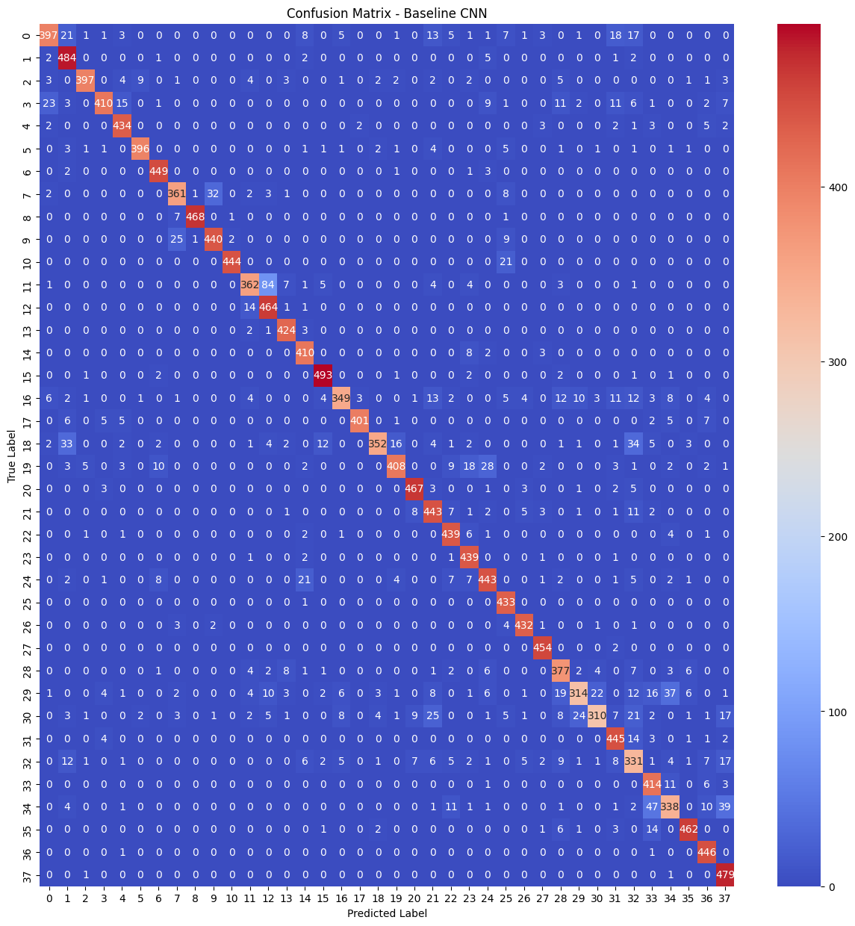
The above image shows the confusion matrix for the Baseline CNN model created. From this heatmap visualization we can see that the leading diagonal has high values and are in the region of red which means the prediction is good though we can see some misclassifications here and there in the blue squares (non-zero values).
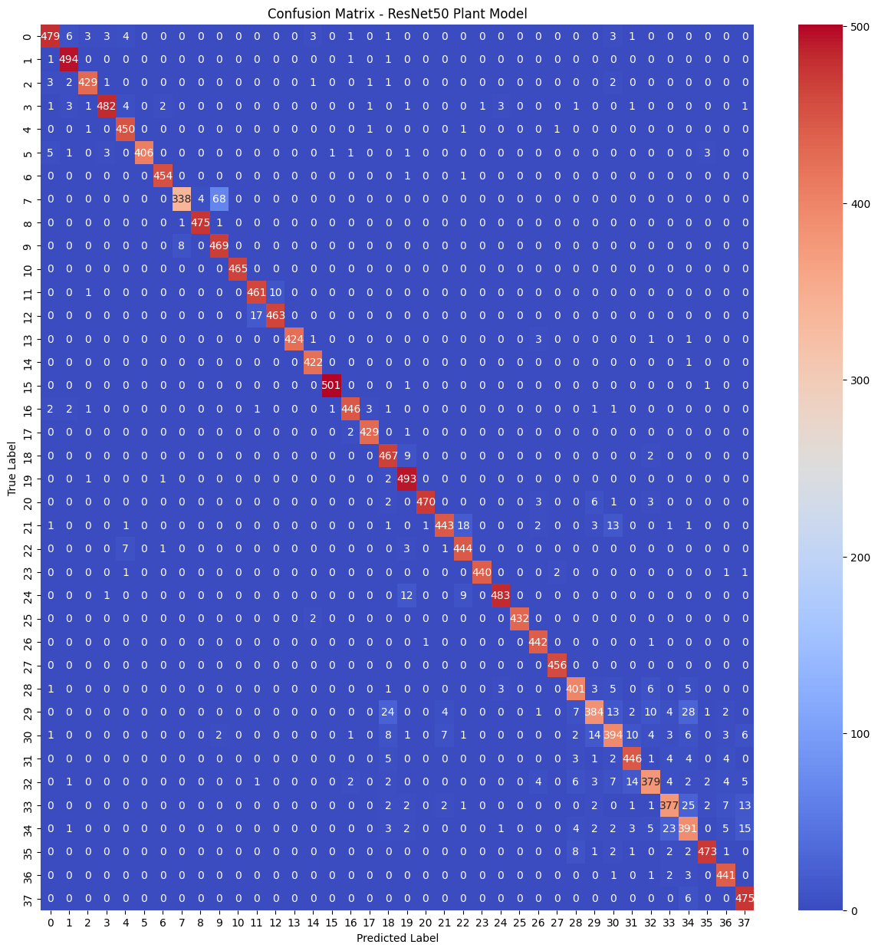
This image shows the confusion matrix of the ResNet50 model that was trained by transfer learning. Here too we can see a similar representation with good values in the leading diagonal and a few miscalculations at places. To better understand which model is better, we directly plot the accuracy score of the two models in a classic bar chart as given below.
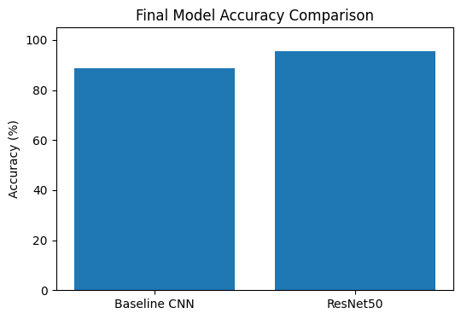
From here we can clearly see that the ResNet50 model outperforms the Baseline CNN model. So the resNet50 model is used to make the predictions in the streamlit application.

OUTPUT:
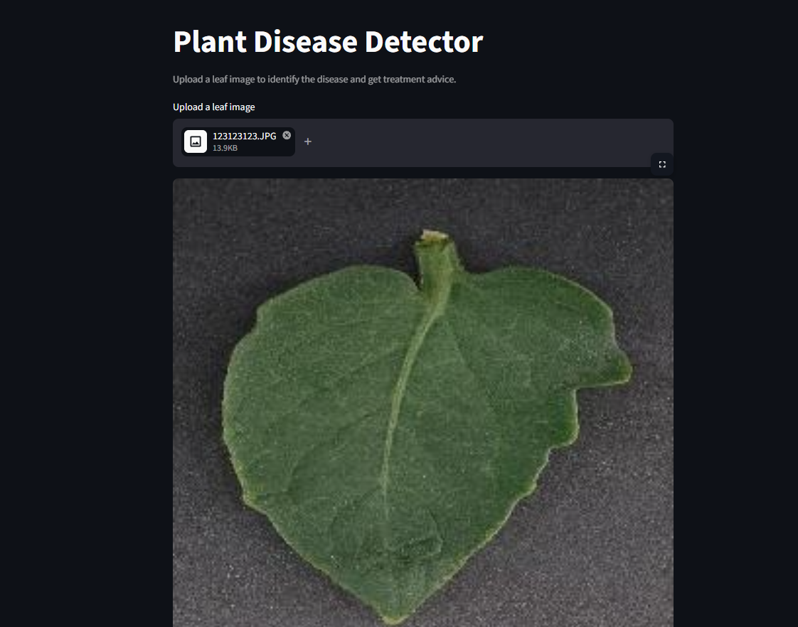
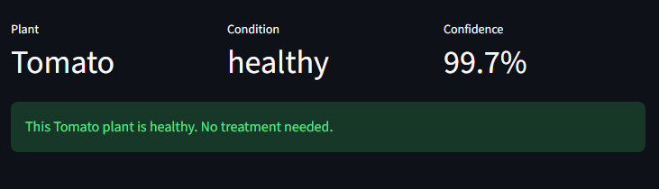
This is the streamlit application where you can upload an image to find if it is infected with a disease or not. Here we can see the entered image is healthy so no treatment is required.
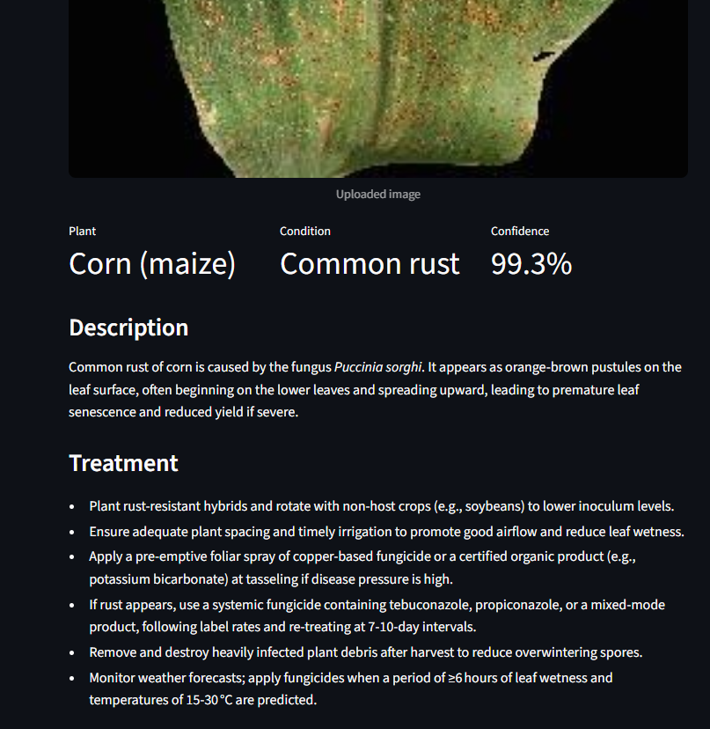
On the other hand, when a disease infected image is uploaded, we get the disease identified and a confidence score along with the description of the disease and treatment methods that are retrieved from an LLM.
CONCLUSION :
From the insights derived above, We conclude that the plant disease detection system that was built based on the ResNet50 model has higher accuracy for identifying and classifying the diseases out of the 38 categories provided during training. This will be useful for farmers and Agriculture industries to prevent the spread of plan diseases that are bound to ruin their yield.

