Knowledge Sharing Tech Community – DBMS Project Report

Submitted by  
Vignan Naidu Nallani  
B.Tech 2nd Year – Computer Science  
2025   
  
Department of Computer Science  
[MOHAN BABU UNIVERSITY], India

# Abstract

The Knowledge Sharing Tech Community DBMS project is a relational database system designed to foster collaboration among tech enthusiasts. It provides a structured platform where users can register, share technical posts, gain mentorship, participate in tech events, and contribute to discussions. The database supports critical operations such as user skill tracking, post interactions, nested queries, and content moderation.

# Table of Contents

1. 1. Abstract
2. 2. Introduction
3. 3. Problem Statement
4. 4. Objectives
5. 5. ER Diagram
6. 6. Database Schema
7. 7. Sample SQL Queries
8. 8. Features Implemented
9. 9. Conclusion
10. 10. References

# 1. Introduction

In the age of digital communities, sharing knowledge is key to collaborative learning and innovation. This project presents a robust DBMS framework tailored to support a technology-focused knowledge-sharing platform. The system enables user interactions via posts, comments, likes, mentorship connections, and event participation.

# 2. Problem Statement

While many online forums exist, they often lack structured backend systems for managing user skills, mentorship, and collaboration. This project aims to build a scalable, SQL-based system that organizes such interactions in a normalized, relational format.

# 3. Objectives

- Design a normalized relational schema for the tech community

- Enable user registration and skill management

- Support user-generated content: posts, comments, likes

- Facilitate event organization and mentorship

- Implement nested and analytical queries

- Introduce content moderation via reports

# 4. Entity-Relationship Diagram (ERD)

The following ER diagram illustrates the data model

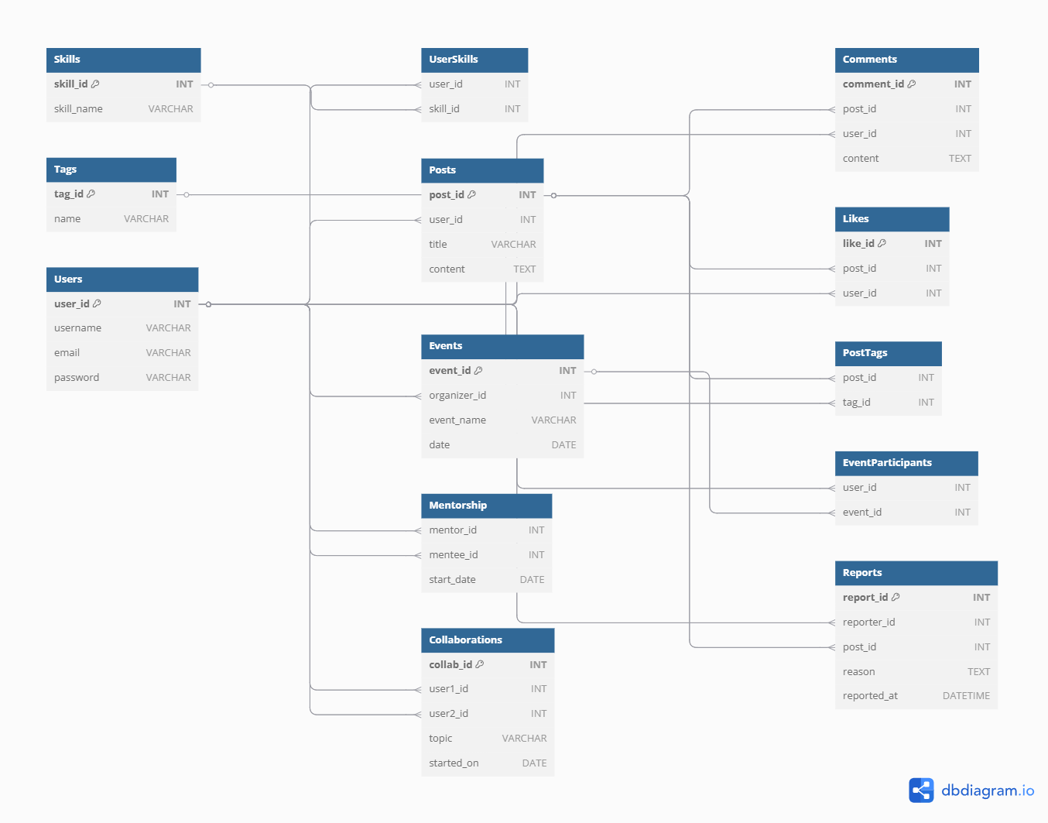

# 5. Database Schema

The database consists of 13 core tables:  
- Users, Skills, UserSkills, Posts, Comments, Likes  
- Tags, PostTags, Events, EventParticipants  
- Mentorship, Collaborations, Reports

Refer to schema.sql file for full CREATE TABLE statements.

# 6. Sample SQL Queries

Some key queries include:

- Retrieve top 5 most liked posts

- Nested query to fetch mentors with more than 3 mentees

- Get list of events participated by a user

- Moderate reported posts based on count

- Users with most collaborations in a month

See `queries/` folder for 150+ modular queries categorized by feature.

# 7. Features Implemented

- 👥 User system with skill tracking

- 📝 Post, like, comment functionality

- 🧑‍🏫 Mentorship linking

- 📅 Event participation and organization

- 🔍 Advanced SQL with joins, grouping, nested logic

- 🚨 Reporting and content moderation

# 8. Conclusion

This DBMS project offers a complete relational system to model and manage a collaborative tech community. It supports real-world operations such as user interactions, mentorship, reporting, and analytics. The modular query design and ER-based schema make it scalable and ready for real deployment.

# 9. References

- MySQL / PostgreSQL Documentation

- draw.io / dbdiagram.io (for ERD)

- Git & GitHub (for version control)

- SQL TutorialsPoint, GeeksforGeeks