RESULT
Hardware Prototype:
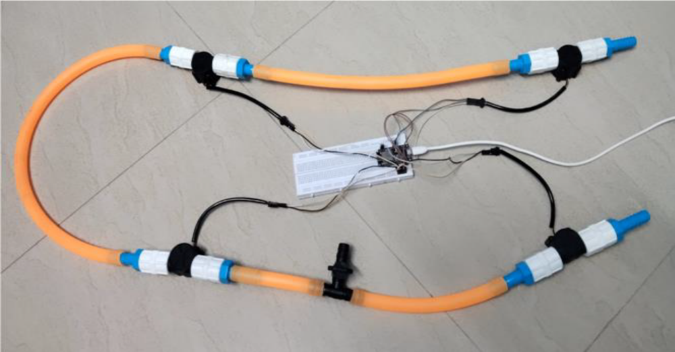

OUTPUT
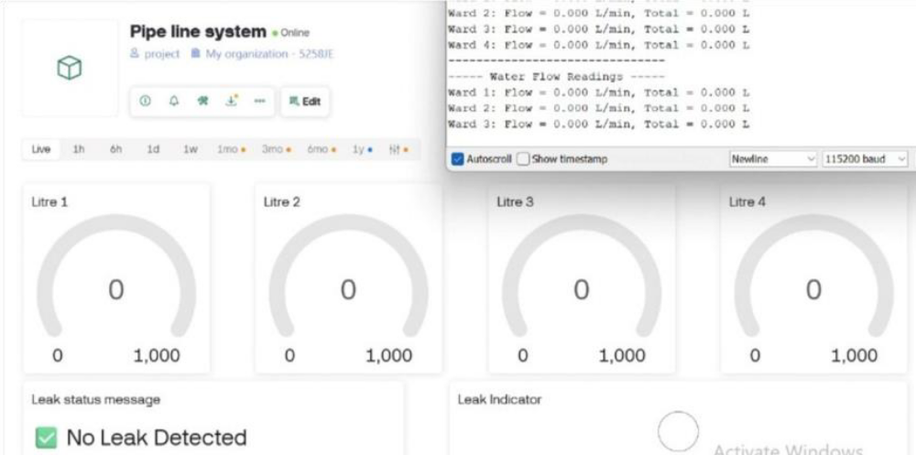
Blynk Dashboard - Initial state (no flow detected)

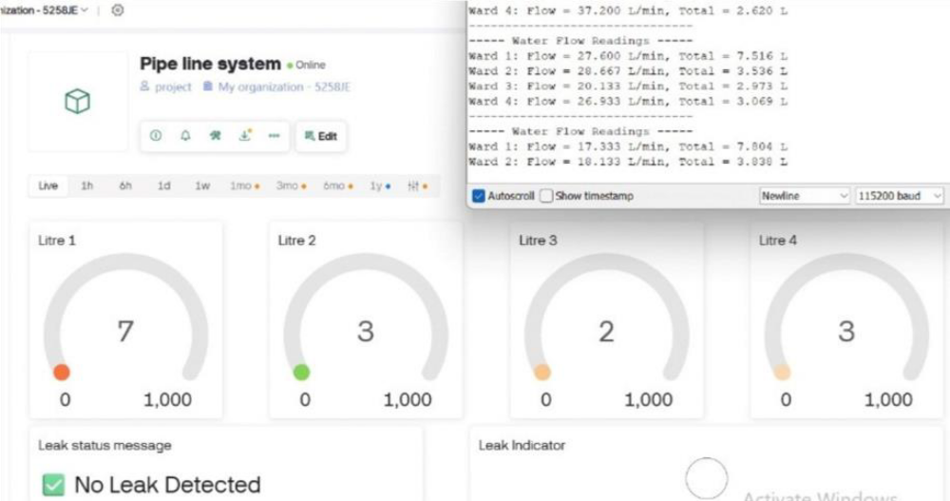
Blynk Dashboard - Real-time water flow monitoring

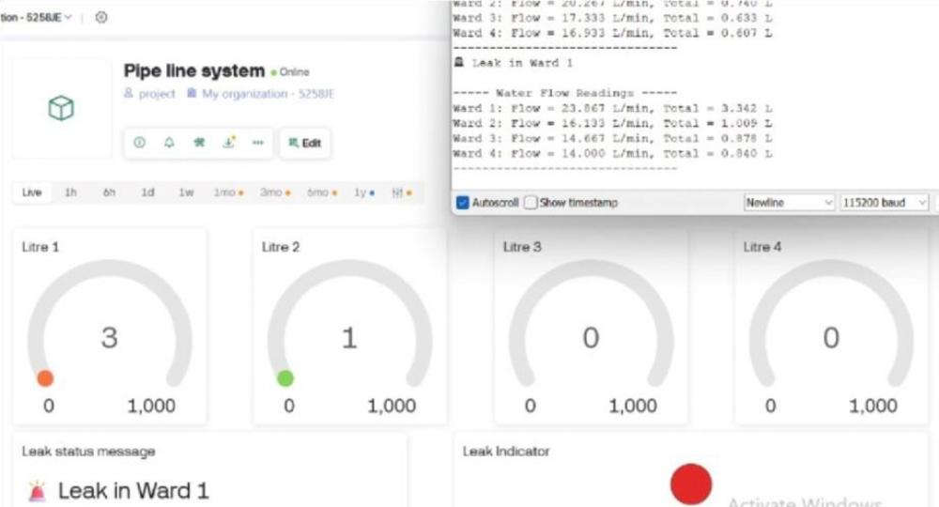
Blynk Dashboard – Leak Detected in Ward 1

