Sri Sivasubramaniya Nadar College of Engineering, Chennai

(An autonomous Institution affiliated to Anna University)

Degree & Branch | B.E. Computer Science & Engineering | Semester | V
Subject Code & Name | ICS1512 & Machine Learning Algorithms Laboratory
Academic year | 2025-2026 (Odd) | Batch:2023-2028 | Due date:

Experiment 2 : Loan Amount Prediction using Linear Regression

Git Hub:https://github.com/Vignesh-0013/Machine_Learning

Aim:
To develop and evaluate a machine learning model using Python to predict loan amounts based on applicant financial and credit-related features, utilizing Linear Regression and K-Fold Cross- Validation for performance assessment.

Libraries used:
- Numpy
- Pandas
- Matplotlib
- Scikit-learn
- Seaborn

Objective:
- To preprocess the loan dataset by handling missing values, encoding categorical variables, selecting relevant features, and splitting the data for training, validation, and testing purposes.
- To build and evaluate a Linear Regression model using K-Fold Cross-Validation, analyze performance metrics such as MSE, RMSE, MAE, and R², and interpret the results through residual and prediction plots to assess model effectiveness.

Mathematical/theoretical description of the algorithm/objective performed:
  - Handling Missing Values
Missing values can negatively impact the performance of machine learning models by:

    - Distorting statistical summaries
    - Causing errors in training algorithms
    - Leading to biased predictions
So, it’s crucial to detect and properly handle them before modeling.

There are several ways to handle missing values:
    - Missing values in a dataset can be handled using imputation techniques such as replacing them with the mean, median, or mode of the respective feature by using fillna() method in pandas
    - If a column contains a large number of missing values and does not contribute significantly to the prediction task, it can be dropped to simplify the dataset. Removing such irrelevant or incomplete features helps reduce noise and improve model efficiency.

  - Label encoding:
To train machine learning models, all input features must be in numeric format. Hence, categorical variables (like ”Yes”/”No”, ”Graduate”/”Not Graduate”) need to be converted into numbers. This process is essential for enabling algorithms to interpret and process the data correctly.
    - Categorical values can be directly replaced with numeric codes, such as mapping ”Yes” to 1 and ”No” to 0. This is useful when the categories are binary or have no specific order. It ensures compatibility with machine learning models that require numerical input.
    - If a categorical feature has more than two values, simple replacement may introduce un- intended ordinal relationships. In such cases, one-hot encoding is preferred, where each category becomes a separate binary column. This prevents the model from assuming any order or ranking between the categories.

  - Plotting:
To better understand the patterns and relationships within the dataset, various data visualiza- tion techniques are used. These plots help in identifying correlations, distributions, and outliers effectively.
    - The heatmap() function visualizes the correlation between numerical features using a colored matrix. Darker shades typically represent stronger correlations, helping identify redundant or related features. It’s a useful tool for understanding feature interdependencies before model building.

    - A histogram displays the frequency distribution of a numeric variable, showing how data is spread across ranges. It helps detect skewness, modality, and presence of outliers or missing value gaps. This is often used as a first step in understanding individual feature behavior.
    - A box plot (or whisker plot) shows the spread and central tendency of a feature using quartiles. It clearly identifies the median, interquartile range (IQR), and outliers. This makes it an excellent tool for spotting extreme values and data symmetry.

  - Standardization:
    - Standardization is a feature scaling technique that transforms data to have a mean of 0 and a standard deviation of 1. It is especially useful when features have different units or scales, ensuring all variables contribute equally to the model. Many machine learning algorithms, like logistic regression and KNN, perform better when data is standardized.
    - The formula used for standardization is:

z = x−µ
σ

    - where x is the original value, µ is the mean, and σ is the standard deviation. This process centers the data around zero and makes it easier for models to converge efficiently.
The preprocessing steps involved handling missing values, encoding categorical variables, visualiz- ing data using heatmaps, histograms, and boxplots, and addressing outliers. Additionally, feature standardization was applied to bring all variables to a common scale, ensuring better model per- formance and stability.

- Code:

loan_amount_prediction

July 29, 2025

[2]:
import numpy as np import pandas as pd
import matplotlib.pyplot as plt import seaborn as sns

[3]:
df=pd.read_csv('train.csv') df.head()

- : Customer ID Name Gender Age Income (USD) Income Stability \
0 | C-36995 | Frederica Shealy |  |  | F 56 | 1933.05 | Low
1 | C-33999 | America Calderone |  |  | M 32 | 4952.91 | Low
2 | C-3770 | Rosetta Verne |  |  | F 65 | 988.19 | High
3 | C-26480 | Zoe Chitty |  |  | F 65 | NaN | High
4 | C-23459 | Afton Venema |  |  | F 31 | 2614.77 | Low
Profession |  | Type of Employment |  |  | Location | Loan Amount | Request (USD) | \
0 Working |  | Sales staff |  |  | Semi-Urban |  | 72809.58
1 Working |  | NaN |  |  | Semi-Urban |  | 46837.47
2 Pensioner |  | NaN |  |  | Semi-Urban |  | 45593.04
3 Pensioner |  | NaN |  |  | Rural |  | 80057.92
4 Working |  | High skill tech staff |  |  | Semi-Urban |  | 113858.89
… Credit Score No. of Defaults Has Active Credit Card Property ID \
0 … | 809.44 |  | 0 |  | NaN |  | 746
1 … | 780.40 |  | 0 |  | Unpossessed |  | 608
2 … | 833.15 |  | 0 |  | Unpossessed |  | 546
3 … | 832.70 |  | 1 |  | Unpossessed |  | 890
4 … | 745.55 |  | 1 |  | Active |  | 715
Property Age Property Type Property Location Co-Applicant \
0 | 1933.05 |  | 4 | Rural |  | 1
1 | 4952.91 |  | 2 | Rural |  | 1
2 | 988.19 |  | 2 | Urban |  | 0
3 | NaN |  | 2 | Semi-Urban |  | 1
4 | 2614.77 |  | 4 | Semi-Urban |  | 1

Property Price Loan Sanction Amount (USD)
0 119933.46 54607.18

1 | 54791.00 | 37469.98
2 | 72440.58 | 36474.43
3 | 121441.51 | 56040.54
4 | 208567.91 | 74008.28

- :

- :
[5 rows x 24 columns]
df.info()
<class 'pandas.core.frame.DataFrame'> RangeIndex: 30000 entries, 0 to 29999 Data columns (total 24 columns):
# Column Non-Null Count Dtype

- Customer ID 30000 non-null object
- Name 30000 non-null object
- Gender 29947 non-null object
- Age 30000 non-null int64
- Income (USD) 25424 non-null float64
- Income Stability 28317 non-null object
- Profession 30000 non-null object
- Type of Employment 22730 non-null object
- Location 30000 non-null object
- Loan Amount Request (USD) 30000 non-null float64
- Current Loan Expenses (USD) 29828 non-null float64
- Expense Type 1 30000 non-null object
- Expense Type 2 30000 non-null object
- Dependents 27507 non-null float64
- Credit Score 28297 non-null float64
- No. of Defaults 30000 non-null int64
- Has Active Credit Card 28434 non-null object
- Property ID 30000 non-null int64
- Property Age 25150 non-null float64
- Property Type 30000 non-null int64
- Property Location 29644 non-null object
- Co-Applicant 30000 non-null int64
- Property Price 30000 non-null float64
- Loan Sanction Amount (USD) 29660 non-null float64 dtypes: float64(8), int64(5), object(11)
memory usage: 5.5+ MB
df['Co-Applicant'].unique()

- : array([ 1, 0, -999])
- :
df['Has Active Credit Card'].unique()
- : array([nan, 'Unpossessed', 'Active', 'Inactive'], dtype=object)

- :
#Removing unnecessary columns
df = df.drop(columns=["Customer ID", "Name"])

- :
# Replace -999 with NaN
df['Co-Applicant'] = df['Co-Applicant'].replace(-999, np.nan)
# Option 1: Impute missing values (e.g., assume no co-applicant)
df['Co-Applicant'] = df['Co-Applicant'].fillna(0)

- :
# Fill NaN with 'Unknown'
df['Has Active Credit Card'] = df['Has Active Credit Card'].fillna('Unknown')
# Optional: Encode as ordinal
credit_card_map = { 'Unpossessed': 0,
'Inactive': 1,
'Active': 2,
'Unknown': -1
}
df['Has Active Credit Card'] = df['Has Active Credit Card'].map(credit_card_map)

- :
df.isnull().sum()

[10]: | Gender | 53
 | Age | 0
 | Income (USD) | 4576
 | Income Stability | 1683
 | Profession | 0
 | Type of Employment | 7270
 | Location | 0
 | Loan Amount Request (USD) | 0
 | Current Loan Expenses (USD) | 172
 | Expense Type 1 | 0
 | Expense Type 2 | 0
 | Dependents | 2493
 | Credit Score | 1703
 | No. of Defaults | 0
 | Has Active Credit Card | 0
 | Property ID | 0
 | Property Age | 4850
 | Property Type | 0
 | Property Location | 356
 | Co-Applicant | 0
 | Property Price | 0
 | Loan Sanction Amount (USD) | 340
 | dtype: int64

- :
#Filling null values
df['Gender']=df['Gender'].fillna(df['Gender'].mode()[0])
df['Income (USD)']=df['Income (USD)'].fillna(df['Income (USD)'].median()) df['Income Stability']=df['Income Stability'].fillna(df['Income Stability'].
𝗌mode()[0])

- :
#Dropping this column due to presence of more null values and may categories
df['Type of Employment'].unique() df=df.drop(columns=['Type of Employment'])

- :

- :
#Current Loan Expenses (USD) – Numeric → fill with median
df['Current Loan Expenses (USD)'] = df['Current Loan Expenses (USD)'].
𝗌fillna(df['Current Loan Expenses (USD)'].median())
#Dependents – Numeric → fill with mode (likely a small integer like 1 or 2)
df['Dependents'] = df['Dependents'].fillna(df['Dependents'].mode()[0])
#Credit Score – Numeric → fill with median
df['Credit Score'] = df['Credit Score'].fillna(df['Credit Score'].median())
#Property Age – Numeric → fill with median
df['Property Age'] = df['Property Age'].fillna(df['Property Age'].median())
#Property Location – Categorical → fill with mode
df['Property Location'] = df['Property Location'].fillna(df['Property␣
𝗌Location'].mode()[0])
# Loan Sanction Amount (USD) - Numeric → fill with median
df['Loan Sanction Amount (USD)'] = df['Loan Sanction Amount (USD)'].
𝗌fillna(df['Loan Sanction Amount (USD)'].median())
df['Loan Sanction Amount (USD)'] = df['Loan Sanction Amount (USD)'].replace(0,␣
𝗌df['Loan Sanction Amount (USD)'].median())
df.isnull().sum()

- : Gender 0
Age 0
Income (USD) 0
Income Stability 0
Profession 0
Location 0
Loan Amount Request (USD) 0
Current Loan Expenses (USD) 0
Expense Type 1 0
Expense Type 2 0
Dependents 0

- :
Credit Score 0
No. of Defaults 0
Has Active Credit Card 0
Property ID 0
Property Age 0
Property Type 0
Property Location 0
Co-Applicant 0
Property Price 0
Loan Sanction Amount (USD) 0
dtype: int64
Encoding of variables with values
from sklearn.preprocessing import LabelEncoder
# List of categorical columns
cat_cols = [
'Gender', 'Income Stability', 'Profession', 'Expense Type 1', 'Expense Type 2',
'Has Active Credit Card', 'Property Type', 'Property Location','Location'
]
# Create a label encoder instance
le = LabelEncoder()
# Apply label encoding to each column
for col in cat_cols:
df[col] = le.fit_transform(df[col])

Standardization of Features
- :
from sklearn.preprocessing import StandardScaler
# Identify numeric columns (excluding categorical and target)
numeric_cols = df.select_dtypes(include=['float64', 'int64']).columns.tolist()
# Optionally exclude target column (e.g., 'Loan Sanction Amount (USD)')
numeric_cols.remove('Loan Sanction Amount (USD)')
# Initialize scaler
scaler = StandardScaler()
# Fit and transform numeric features
df[numeric_cols] = scaler.fit_transform(df[numeric_cols])

- :
df.head(10)

[17]: | Gender | Age |  | Income (USD) | Income Stability | Profession |  | Location | \
0 | -1.007092 | 0.991451 |  | -0.061266 | 0.305833 | 0.834973 |  | 0.142149
1 | 0.992958 | -0.504355 |  | 0.229972 | 0.305833 | 0.834973 |  | 0.142149
2 | -1.007092 | 1.552379 |  | -0.152389 | -3.269763 | -0.686548 |  | 0.142149
3 | -1.007092 | 1.552379 |  | -0.033357 | -3.269763 | -0.686548 |  | -1.762481
4 | -1.007092 | -0.566680 |  | 0.004480 | 0.305833 | 0.834973 |  | 0.142149
5 | -1.007092 | 1.240752 |  | -0.128594 | 0.305833 | -0.306168 |  | -1.762481
6 | 0.992958 | 0.181223 |  | -0.019940 | 0.305833 | 0.834973 |  | 0.142149
7 | -1.007092 | 0.305874 |  | -0.033357 | 0.305833 | -0.306168 |  | 0.142149
8 | -1.007092 | -0.130403 |  | -0.122697 | 0.305833 | 0.834973 |  | -1.762481
9 | 0.992958 | -1.376908 |  | -0.098577 | 0.305833 | 0.834973 |  | -1.762481
Loan Amount Request (USD) Current Loan Expenses (USD) Expense Type 1 \
0 | -0.269027 |  |  |  | -0.660358 |  | -0.749241
1 | -0.705269 |  |  |  | 0.392886 |  | -0.749241
2 | -0.726171 |  |  |  | -0.946193 |  | -0.749241
3 | -0.147279 |  |  |  | -0.422775 |  | -0.749241
4 | 0.420461 |  |  |  | 0.374693 |  | -0.749241
5 | -0.913593 |  |  |  | -0.906788 |  | -0.749241
6 | 1.070530 |  |  |  | 1.227526 |  | 1.334685
7 | 2.544436 |  |  |  | 1.682224 |  | -0.749241
8 | -0.901713 |  |  |  | -1.012348 |  | -0.749241
9 | -0.784989 |  |  |  | 0.411038 |  | -0.749241
Expense Type 2 … Credit Score No. of Defaults Has Active Credit Card \
0 | -1.433524 |  | … | 0.992493 | -0.490502 | -2.096903
1 | 0.697582 |  | … | 0.578136 | -0.490502 | -1.001762
2 | 0.697582 |  | … | 1.330799 | -0.490502 | -1.001762
3 | 0.697582 |  | … | 1.324379 | 2.038728 | -1.001762
4 | 0.697582 |  | … | 0.080879 | 2.038728 | 1.188520
5 | -1.433524 |  | … | -0.795636 | 2.038728 | 0.093379
6 | 0.697582 |  | … | -1.463830 | -0.490502 | -1.001762
7 | -1.433524 |  | … | 1.032730 | -0.490502 | 1.188520
8 | 0.697582 |  | … | -0.493571 | 2.038728 | 1.188520
9 | -1.433524 |  | … | -1.806987 | -0.490502 | -1.001762
Property ID Property Age Property Type Property Location Co-Applicant \
0 | 0.846998 | -0.060969 | 1.376731 | -1.214540 | 0.419205
1 | 0.368086 | 0.230298 | -0.411309 | -1.214540 | 0.419205
2 | 0.152923 | -0.152102 | -0.411309 | 1.283229 | -2.385467
3 | 1.346732 | -0.032979 | -0.411309 | 0.034344 | 0.419205
4 | 0.739417 | 0.004783 | 1.376731 | 0.034344 | 0.419205
5 | -0.037948 | -0.128305 | -0.411309 | -1.214540 | 0.419205
6 | -0.954127 | -0.019639 | -1.305329 | 0.034344 | 0.419205
7 | -0.652204 | -0.032979 | -0.411309 | 1.283229 | 0.419205
8 | -0.905541 | -0.122407 | 1.376731 | -1.214540 | 0.419205
9 | 1.322440 | -0.098284 | -0.411309 | 1.283229 | 0.419205

- :
Property Price Loan Sanction Amount (USD)
0 -0.126419 54607.180
1 -0.822772 37469.980
2 -0.634103 36474.430
3 -0.110298 56040.540
4 0.821057 74008.280
5 -0.947245 22382.570
6 0.954495 35209.395
7 2.878533 168218.240
8 -0.821570 22842.290
9 -0.681642 35209.395
[10 rows x 21 columns]
EDA
Histogram
import seaborn as sns
import matplotlib.pyplot as plt

# Plot distributions for selected numeric columns
cols_to_plot = ['Income (USD)', 'Credit Score', 'Loan Amount Request (USD)',␣
𝗌'Loan Sanction Amount (USD)']
for col in cols_to_plot: plt.figure(figsize=(6, 4)) sns.histplot(df[col], kde=True, bins=30) plt.title(f'Distribution of {col}') plt.tight_layout()
plt.show()

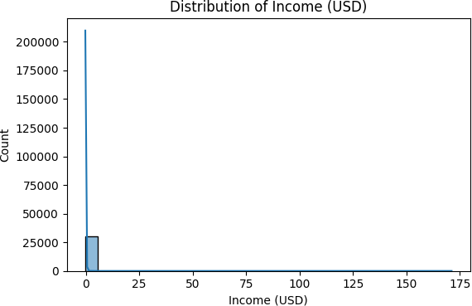

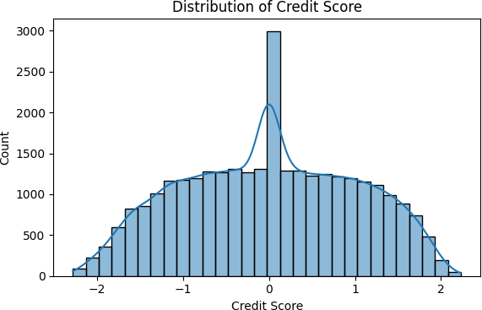

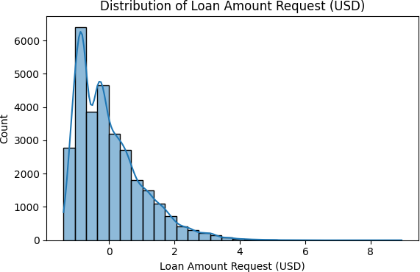

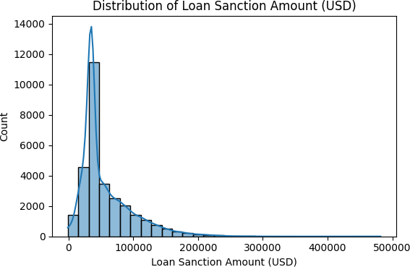

Scatter Plot
- :
# Income vs Loan Sanction Amount
sns.scatterplot(data=df, x='Income (USD)', y='Loan Sanction Amount (USD)') plt.title('Income vs Loan Sanction Amount')
plt.show()
# Credit Score vs Loan Sanction Amount
sns.scatterplot(data=df, x='Credit Score', y='Loan Sanction Amount (USD)') plt.title('Credit Score vs Loan Sanction Amount')
plt.show()

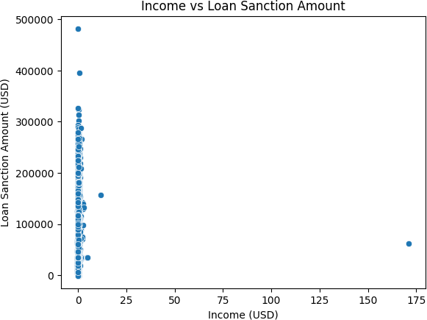

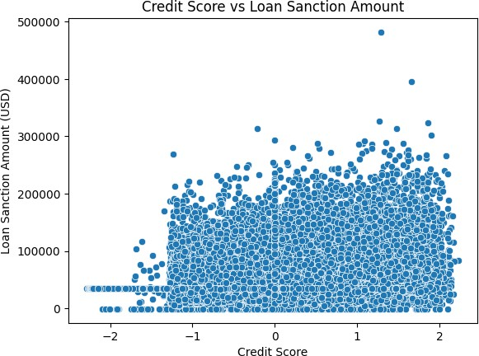

Correlation heatmap
- :
plt.figure(figsize=(12, 8))
sns.heatmap(df.corr(), annot=True, cmap='coolwarm', fmt=".2f") plt.title('Correlation Heatmap')
plt.show()

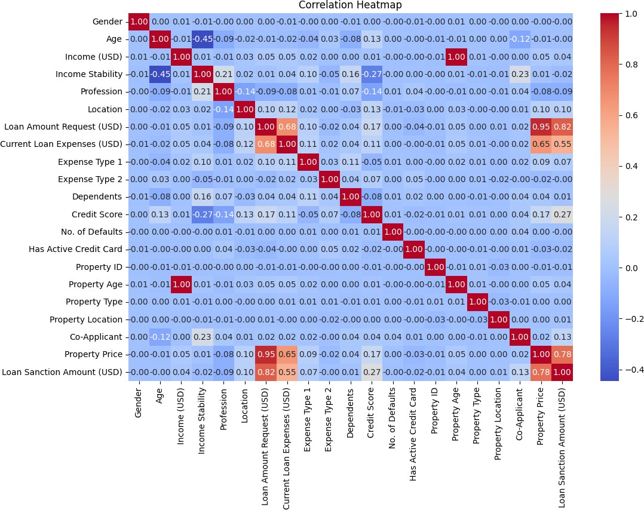

BoxPlot
- :
# Boxplot for Income sns.boxplot(x=df['Income (USD)']) plt.title('Boxplot of Income') plt.show()
# Boxplot for Loan Amount Request sns.boxplot(x=df['Loan Amount Request (USD)']) plt.title('Boxplot of Loan Amount Request') plt.show()

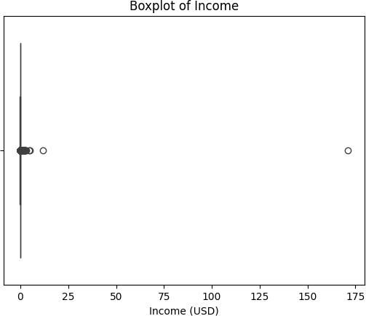

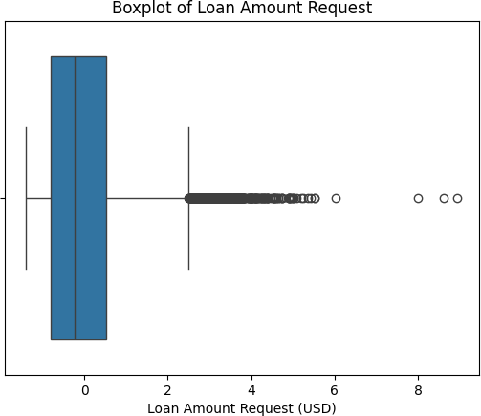

Train Test Split
- :
from sklearn.model_selection import train_test_split
# Define target variable
target = 'Loan Sanction Amount (USD)'
# Define feature columns
X = df.drop(columns=[target]) y = df[target]
# Split into train and test sets (80% train, 20% test)
X_train, X_test, y_train, y_test = train_test_split(X, y, test_size=0.2,␣
𝗌random_state=42)

Model Training
- :
from sklearn.linear_model import LinearRegression
from sklearn.metrics import mean_squared_error, r2_score,mean_absolute_error
# Initialize and train the model

model = LinearRegression() model.fit(X_train, y_train)
# Predict on test set
y_pred = model.predict(X_test)

# Evaluation Metrics
mse = mean_squared_error(y_test, y_pred) rmse = np.sqrt(mse)
mae = mean_absolute_error(y_test, y_pred) r2 = r2_score(y_test, y_pred)
# Print results
print(f"Mean Squared Error (MSE): {mse:.2f}") print(f"Root Mean Squared Error (RMSE): {rmse:.2f}") print(f"Mean Absolute Error (MAE): {mae:.2f}") print(f"R² Score: {r2:.2f}")

- :
Mean Squared Error (MSE): 527445271.77 Root Mean Squared Error (RMSE): 22966.18 Mean Absolute Error (MAE): 13803.42
R² Score: 0.69
from sklearn.model_selection import KFold, cross_val_score

import numpy as np

# Define K-Fold with 5 splits
kf = KFold(n_splits=5, shuffle=True, random_state=42)
# Custom scoring functions
mse_scores = cross_val_score(model, X, y, scoring='neg_mean_squared_error',␣
𝗌cv=kf)
mae_scores = cross_val_score(model, X, y, scoring='neg_mean_absolute_error',␣
𝗌cv=kf)
r2_scores = cross_val_score(model, X, y, scoring='r2', cv=kf)
# Convert negative MSE/MAE to positive
mse_scores = -mse_scores mae_scores = -mae_scores rmse_scores = np.sqrt(mse_scores)
# Print metrics per fold
print("Fold-wise Metrics:")
for i in range(len(mse_scores)): print(f"Fold {i+1}:")
print(f" MSE : {mse_scores[i]:.2f}")

print(f" RMSE: {rmse_scores[i]:.2f}")
print(f" MAE : {mae_scores[i]:.2f}")
print(f" R² : {r2_scores[i]:.2f}") print()
# Print average performance
print("Average Metrics Across Folds:") print(f"Average MSE : {mse_scores.mean():.2f}") print(f"Average RMSE: {rmse_scores.mean():.2f}") print(f"Average MAE : {mae_scores.mean():.2f}") print(f"Average R² : {r2_scores.mean():.2f}")
Fold-wise Metrics:
Fold 1:
MSE : 527445271.77
RMSE: 22966.18
MAE : 13803.42
R² : 0.69
Fold 2:
MSE : 493351608.13
RMSE: 22211.52
MAE : 13779.90
R² : 0.70
Fold 3:
MSE : 544801753.47
RMSE: 23340.99
MAE : 14030.71
R² : 0.67
Fold 4:
MSE : 513654615.80
RMSE: 22663.95
MAE : 14044.93
R² : 0.70
Fold 5:
MSE : 440761214.18
RMSE: 20994.31
MAE : 13347.16
R² : 0.73
Average Metrics Across Folds: Average MSE : 504002892.67 Average RMSE: 22435.39 Average MAE : 13801.23 Average R² : 0.70

Actual vs Predicted values
- :
import matplotlib.pyplot as plt import seaborn as sns
from sklearn.metrics import r2_score
# Predict values
y_pred = model.predict(X_test)
# Plot
plt.figure(figsize=(8, 6)) sns.scatterplot(x=y_test, y=y_pred, alpha=0.7)
plt.plot([y_test.min(), y_test.max()], [y_test.min(), y_test.max()],␣
𝗌color='red', linestyle='--') plt.xlabel("Actual Loan Sanction Amount") plt.ylabel("Predicted Loan Sanction Amount")
plt.title(f"Actual vs Predicted (R² = {r2_score(y_test, y_pred):.2f})") plt.grid(True)
plt.show()

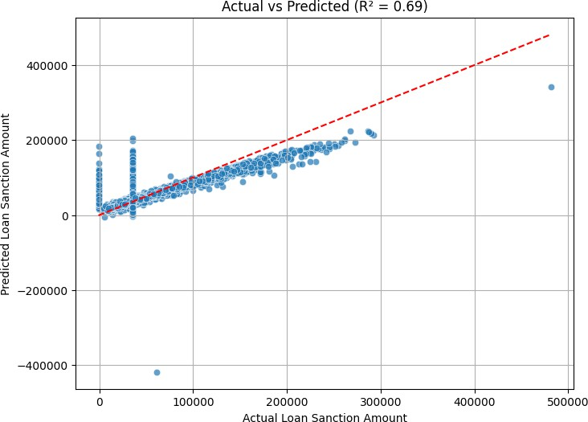

- :
# Create a DataFrame for coefficients
coeff_df = pd.DataFrame({ 'Feature': X_train.columns, 'Coefficient': model.coef_
}).sort_values(by='Coefficient', key=abs, ascending=False)
# Plot
plt.figure(figsize=(10, 6))
sns.barplot(x='Coefficient', y='Feature', data=coeff_df, palette='coolwarm') plt.title("Linear Regression Feature Coefficients")
plt.tight_layout() plt.show()

- :
# Residual plot
residuals = y_test - y_pred plt.scatter(y_pred, residuals) plt.axhline(y=0, color='r', linestyle='--') plt.xlabel("Predicted Values")
/tmp/ipykernel_7636/3484898736.py:9: FutureWarning:
Passing `palette` without assigning `hue` is deprecated and will be removed in v0.14.0. Assign the `y` variable to `hue` and set `legend=False` for the same effect.
sns.barplot(x='Coefficient', y='Feature', data=coeff_df, palette='coolwarm')
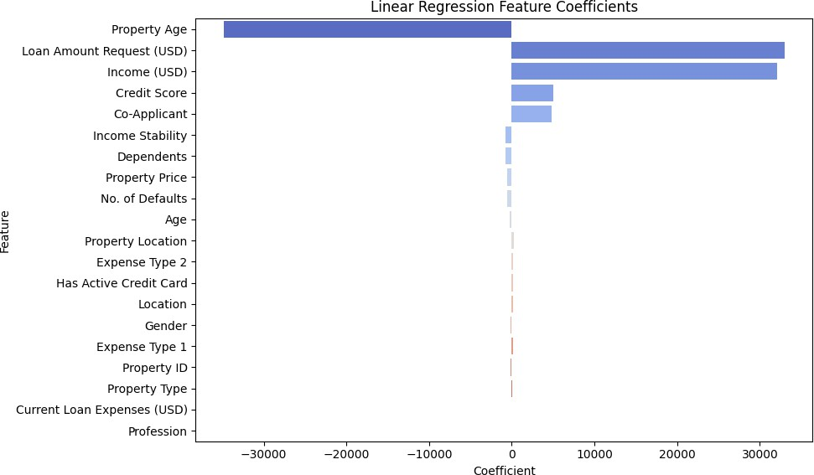

plt.ylabel("Residuals") plt.title("Residual Plot") plt.show()
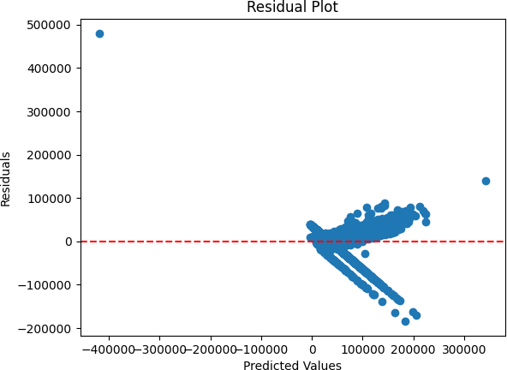

- :
from sklearn.linear_model import LassoCV
lasso = LassoCV(cv=5, random_state=42) lasso.fit(X_train, y_train)
# Get features with non-zero coefficients
lasso_features = X_train.columns[lasso.coef_ != 0] print(" Features selected by Lasso:\n", lasso_features)

Features selected by Lasso:
Index(['Gender', 'Age', 'Income Stability', 'Location',
'Loan Amount Request (USD)', 'Expense Type 2', 'Dependents', 'Credit Score', 'No. of Defaults', 'Has Active Credit Card', 'Property ID', 'Property Location', 'Co-Applicant'], dtype='object')

Included Plots:
- Heatmap: Displays the correlation between features to identify strong positive or negative linear relationships.
- Boxplot: Visualizes the spread, median, and potential outliers in numerical variables, useful for detecting skewness or extreme values.
- Scatter Plot: Shows the relationship between two numerical variables, helping to identify trends or clusters.
- Histogram: Illustrates the frequency distribution of a variable, showing how data points are spread across intervals.

Best Practices Followed
- Consistent Data Preprocessing: Ensured all features were cleaned, encoded, and stan- dardized uniformly before feeding into the model. This helps in improving model performance and generalizability.
- Model Validation with Cross-Validation: Used 5-fold cross-validation to evaluate the model’s robustness across different subsets of the data, reducing the chances of overfitting or bias due to a specific data split.

Learning Outcomes
- End-to-End Workflow Understanding: Gained hands-on experience with the full ma- chine learning pipeline including EDA, preprocessing, feature selection, training, evaluation, and visualization.
- Interpretation of Model Performance: Learned how to use statistical metrics like MAE, MSE, RMSE, and R² Score to evaluate regression models and interpret residual plots for diagnosing model fit.

SVR Code:

23

loan_amount_prediction_svm

September 3, 2025

[1]:
import numpy as np import pandas as pd
import matplotlib.pyplot as plt import seaborn as sns
from sklearn.svm import SVR
from sklearn.model_selection import train_test_split, GridSearchCV
from sklearn.metrics import mean_squared_error, mean_absolute_error, r2_score

[2]:
df=pd.read_csv('train.csv') df.head()

- : Customer ID Name Gender Age Income (USD) Income Stability \
0 | C-36995 | Frederica Shealy |  |  | F 56 | 1933.05 | Low
1 | C-33999 | America Calderone |  |  | M 32 | 4952.91 | Low
2 | C-3770 | Rosetta Verne |  |  | F 65 | 988.19 | High
3 | C-26480 | Zoe Chitty |  |  | F 65 | NaN | High
4 | C-23459 | Afton Venema |  |  | F 31 | 2614.77 | Low
Profession |  | Type of Employment |  |  | Location | Loan Amount | Request (USD) | \
0 Working |  | Sales staff |  |  | Semi-Urban |  | 72809.58
1 Working |  | NaN |  |  | Semi-Urban |  | 46837.47
2 Pensioner |  | NaN |  |  | Semi-Urban |  | 45593.04
3 Pensioner |  | NaN |  |  | Rural |  | 80057.92
4 Working |  | High skill tech staff |  |  | Semi-Urban |  | 113858.89
… Credit Score No. of Defaults Has Active Credit Card Property ID \
0 … | 809.44 |  | 0 |  | NaN |  | 746
1 … | 780.40 |  | 0 |  | Unpossessed |  | 608
2 … | 833.15 |  | 0 |  | Unpossessed |  | 546
3 … | 832.70 |  | 1 |  | Unpossessed |  | 890
4 … | 745.55 |  | 1 |  | Active |  | 715
Property Age Property Type Property Location Co-Applicant \
0 | 1933.05 |  | 4 | Rural |  | 1
1 | 4952.91 |  | 2 | Rural |  | 1
2 | 988.19 |  | 2 | Urban |  | 0
3 | NaN |  | 2 | Semi-Urban |  | 1
4 | 2614.77 |  | 4 | Semi-Urban |  | 1

Property Price Loan Sanction Amount (USD)
0 | 119933.46 | 54607.18
1 | 54791.00 | 37469.98
2 | 72440.58 | 36474.43
3 | 121441.51 | 56040.54
4 | 208567.91 | 74008.28

- :

- :
[5 rows x 24 columns]
df.info()
<class 'pandas.core.frame.DataFrame'> RangeIndex: 30000 entries, 0 to 29999 Data columns (total 24 columns):
# Column Non-Null Count Dtype

- Customer ID 30000 non-null object
- Name 30000 non-null object
- Gender 29947 non-null object
- Age 30000 non-null int64
- Income (USD) 25424 non-null float64
- Income Stability 28317 non-null object
- Profession 30000 non-null object
- Type of Employment 22730 non-null object
- Location 30000 non-null object
- Loan Amount Request (USD) 30000 non-null float64
- Current Loan Expenses (USD) 29828 non-null float64
- Expense Type 1 30000 non-null object
- Expense Type 2 30000 non-null object
- Dependents 27507 non-null float64
- Credit Score 28297 non-null float64
- No. of Defaults 30000 non-null int64
- Has Active Credit Card 28434 non-null object
- Property ID 30000 non-null int64
- Property Age 25150 non-null float64
- Property Type 30000 non-null int64
- Property Location 29644 non-null object
- Co-Applicant 30000 non-null int64
- Property Price 30000 non-null float64
- Loan Sanction Amount (USD) 29660 non-null float64 dtypes: float64(8), int64(5), object(11)
memory usage: 5.5+ MB
df['Co-Applicant'].unique()

[4]: array([ 1, 0, -999])

[5]:
df['Has Active Credit Card'].unique()
[5]: array([nan, 'Unpossessed', 'Active', 'Inactive'], dtype=object) [6]:
#Removing unnecessary columns
df = df.drop(columns=["Customer ID", "Name"])
[7]:
# Replace -999 with NaN
df['Co-Applicant'] = df['Co-Applicant'].replace(-999, np.nan)
# Option 1: Impute missing values (e.g., assume no co-applicant)
df['Co-Applicant'] = df['Co-Applicant'].fillna(0)

[8]:
# Fill NaN with 'Unknown'
df['Has Active Credit Card'] = df['Has Active Credit Card'].fillna('Unknown')
# Optional: Encode as ordinal
credit_card_map = { 'Unpossessed': 0,
'Inactive': 1,
'Active': 2,
'Unknown': -1
}
df['Has Active Credit Card'] = df['Has Active Credit Card'].map(credit_card_map)

[9]:
df.isnull().sum()

[9]: | Gender | 53
 | Age | 0
 | Income (USD) | 4576
 | Income Stability | 1683
 | Profession | 0
 | Type of Employment | 7270
 | Location | 0
 | Loan Amount Request (USD) | 0
 | Current Loan Expenses (USD) | 172
 | Expense Type 1 | 0
 | Expense Type 2 | 0
 | Dependents | 2493
 | Credit Score | 1703
 | No. of Defaults | 0
 | Has Active Credit Card | 0
 | Property ID | 0
 | Property Age | 4850
 | Property Type | 0
 | Property Location | 356
 | Co-Applicant | 0

[10]:
Property Price 0
Loan Sanction Amount (USD) 340
dtype: int64
#Filling null values
df['Gender']=df['Gender'].fillna(df['Gender'].mode()[0])
df['Income (USD)']=df['Income (USD)'].fillna(df['Income (USD)'].median()) df['Income Stability']=df['Income Stability'].fillna(df['Income Stability'].
𝗌mode()[0])

[11]:
#Dropping this column due to presence of more null values and may categories
df['Type of Employment'].unique() df=df.drop(columns=['Type of Employment'])

[12]:

[13]:
#Current Loan Expenses (USD) – Numeric → fill with median
df['Current Loan Expenses (USD)'] = df['Current Loan Expenses (USD)'].
𝗌fillna(df['Current Loan Expenses (USD)'].median())
#Dependents – Numeric → fill with mode (likely a small integer like 1 or 2)
df['Dependents'] = df['Dependents'].fillna(df['Dependents'].mode()[0])
#Credit Score – Numeric → fill with median
df['Credit Score'] = df['Credit Score'].fillna(df['Credit Score'].median())
#Property Age – Numeric → fill with median
df['Property Age'] = df['Property Age'].fillna(df['Property Age'].median())
#Property Location – Categorical → fill with mode
df['Property Location'] = df['Property Location'].fillna(df['Property␣
𝗌Location'].mode()[0])
# Loan Sanction Amount (USD) - Numeric → fill with median
df['Loan Sanction Amount (USD)'] = df['Loan Sanction Amount (USD)'].
𝗌fillna(df['Loan Sanction Amount (USD)'].median())
df['Loan Sanction Amount (USD)'] = df['Loan Sanction Amount (USD)'].replace(0,␣
𝗌df['Loan Sanction Amount (USD)'].median())
df.isnull().sum()

- : Gender 0
Age 0
Income (USD) 0
Income Stability 0
Profession 0
Location 0
Loan Amount Request (USD) 0

- :
Current Loan Expenses (USD) 0
Expense Type 1 0
Expense Type 2 0
Dependents 0
Credit Score 0
No. of Defaults 0
Has Active Credit Card 0
Property ID 0
Property Age 0
Property Type 0
Property Location 0
Co-Applicant 0
Property Price 0
Loan Sanction Amount (USD) 0
dtype: int64
Encoding of variables with values
from sklearn.preprocessing import LabelEncoder
# List of categorical columns
cat_cols = [
'Gender', 'Income Stability', 'Profession', 'Expense Type 1', 'Expense Type 2',
'Has Active Credit Card', 'Property Type', 'Property Location','Location'
]
# Create a label encoder instance
le = LabelEncoder()
# Apply label encoding to each column
for col in cat_cols:
df[col] = le.fit_transform(df[col])

Standardization of Features
- :
from sklearn.preprocessing import StandardScaler
# Identify numeric columns (excluding categorical and target)
numeric_cols = df.select_dtypes(include=['float64', 'int64']).columns.tolist()
# Optionally exclude target column (e.g., 'Loan Sanction Amount (USD)')
numeric_cols.remove('Loan Sanction Amount (USD)')
# Initialize scaler
scaler = StandardScaler()
# Fit and transform numeric features

df[numeric_cols] = scaler.fit_transform(df[numeric_cols])
- :
df.head(10)

[16]: | Gender | Age |  | Income (USD) | Income Stability | Profession |  | Location | \
0 | -1.007092 | 0.991451 |  | -0.061266 | 0.305833 | 0.834973 |  | 0.142149
1 | 0.992958 | -0.504355 |  | 0.229972 | 0.305833 | 0.834973 |  | 0.142149
2 | -1.007092 | 1.552379 |  | -0.152389 | -3.269763 | -0.686548 |  | 0.142149
3 | -1.007092 | 1.552379 |  | -0.033357 | -3.269763 | -0.686548 |  | -1.762481
4 | -1.007092 | -0.566680 |  | 0.004480 | 0.305833 | 0.834973 |  | 0.142149
5 | -1.007092 | 1.240752 |  | -0.128594 | 0.305833 | -0.306168 |  | -1.762481
6 | 0.992958 | 0.181223 |  | -0.019940 | 0.305833 | 0.834973 |  | 0.142149
7 | -1.007092 | 0.305874 |  | -0.033357 | 0.305833 | -0.306168 |  | 0.142149
8 | -1.007092 | -0.130403 |  | -0.122697 | 0.305833 | 0.834973 |  | -1.762481
9 | 0.992958 | -1.376908 |  | -0.098577 | 0.305833 | 0.834973 |  | -1.762481
Loan Amount Request (USD) Current Loan Expenses (USD) Expense Type 1 \
0 | -0.269027 |  |  |  | -0.660358 |  | -0.749241
1 | -0.705269 |  |  |  | 0.392886 |  | -0.749241
2 | -0.726171 |  |  |  | -0.946193 |  | -0.749241
3 | -0.147279 |  |  |  | -0.422775 |  | -0.749241
4 | 0.420461 |  |  |  | 0.374693 |  | -0.749241
5 | -0.913593 |  |  |  | -0.906788 |  | -0.749241
6 | 1.070530 |  |  |  | 1.227526 |  | 1.334685
7 | 2.544436 |  |  |  | 1.682224 |  | -0.749241
8 | -0.901713 |  |  |  | -1.012348 |  | -0.749241
9 | -0.784989 |  |  |  | 0.411038 |  | -0.749241
Expense Type 2 … Credit Score No. of Defaults Has Active Credit Card \
0 | -1.433524 |  | … | 0.992493 | -0.490502 | -2.096903
1 | 0.697582 |  | … | 0.578136 | -0.490502 | -1.001762
2 | 0.697582 |  | … | 1.330799 | -0.490502 | -1.001762
3 | 0.697582 |  | … | 1.324379 | 2.038728 | -1.001762
4 | 0.697582 |  | … | 0.080879 | 2.038728 | 1.188520
5 | -1.433524 |  | … | -0.795636 | 2.038728 | 0.093379
6 | 0.697582 |  | … | -1.463830 | -0.490502 | -1.001762
7 | -1.433524 |  | … | 1.032730 | -0.490502 | 1.188520
8 | 0.697582 |  | … | -0.493571 | 2.038728 | 1.188520
9 | -1.433524 |  | … | -1.806987 | -0.490502 | -1.001762
Property ID Property Age Property Type Property Location Co-Applicant \
0 | 0.846998 | -0.060969 | 1.376731 | -1.214540 | 0.419205
1 | 0.368086 | 0.230298 | -0.411309 | -1.214540 | 0.419205
2 | 0.152923 | -0.152102 | -0.411309 | 1.283229 | -2.385467
3 | 1.346732 | -0.032979 | -0.411309 | 0.034344 | 0.419205
4 | 0.739417 | 0.004783 | 1.376731 | 0.034344 | 0.419205
5 | -0.037948 | -0.128305 | -0.411309 | -1.214540 | 0.419205

6 -0.954127 | -0.019639 | -1.305329 | 0.034344 | 0.419205
7 -0.652204 | -0.032979 | -0.411309 | 1.283229 | 0.419205
8 -0.905541 | -0.122407 | 1.376731 | -1.214540 | 0.419205
9 1.322440 | -0.098284 | -0.411309 | 1.283229 | 0.419205
Property Price | Loan Sanction | Amount (USD)
0 -0.126419 |  | 54607.180
1 -0.822772 |  | 37469.980
2 -0.634103 |  | 36474.430
3 -0.110298 |  | 56040.540
4 0.821057 |  | 74008.280
5 -0.947245 |  | 22382.570
6 0.954495 |  | 35209.395
7 2.878533 |  | 168218.240
8 -0.821570 |  | 22842.290
9 -0.681642 |  | 35209.395

- :
[10 rows x 21 columns]
EDA
Histogram
import seaborn as sns
import matplotlib.pyplot as plt

# Plot distributions for selected numeric columns
cols_to_plot = ['Income (USD)', 'Credit Score', 'Loan Amount Request (USD)',␣
𝗌'Loan Sanction Amount (USD)']
for col in cols_to_plot: plt.figure(figsize=(6, 4)) sns.histplot(df[col], kde=True, bins=30) plt.title(f'Distribution of {col}') plt.tight_layout()
plt.show()









Scatter Plot
- :
# Income vs Loan Sanction Amount
sns.scatterplot(data=df, x='Income (USD)', y='Loan Sanction Amount (USD)') plt.title('Income vs Loan Sanction Amount')
plt.show()
# Credit Score vs Loan Sanction Amount
sns.scatterplot(data=df, x='Credit Score', y='Loan Sanction Amount (USD)') plt.title('Credit Score vs Loan Sanction Amount')
plt.show()





Correlation heatmap
- :
plt.figure(figsize=(12, 8))
sns.heatmap(df.corr(), annot=True, cmap='coolwarm', fmt=".2f") plt.title('Correlation Heatmap')
plt.show()



BoxPlot
- :
# Boxplot for Income sns.boxplot(x=df['Income (USD)']) plt.title('Boxplot of Income') plt.show()
# Boxplot for Loan Amount Request sns.boxplot(x=df['Loan Amount Request (USD)']) plt.title('Boxplot of Loan Amount Request') plt.show()





- :
# Define target variable
target = 'Loan Sanction Amount (USD)'
# Define feature columns
X = df.drop(columns=[target]) y = df[target]
# Split into train and test sets (80% train, 20% test)
X_train, X_test, y_train, y_test = train_test_split(X, y, test_size=0.2,␣
𝗌random_state=42)

0.0.1 Grid Search
[23]:
# Define the parameter grid
param_grid = {
'kernel': ['linear', 'rbf'],
'C': [0.1, 1, 10],
'gamma': ['scale', 0.1]
}

# Split into train (80%) and test (20%)
X_train, X_test, y_train, y_test = train_test_split(X, y, test_size=0.2,␣
𝗌random_state=42)
# Initialize SVR model
svr = SVR()
# Grid Search with 5-fold cross-validation
grid_search = GridSearchCV( estimator=svr, param_grid=param_grid, scoring='r2',
cv=5, n_jobs=-1, verbose=0
)
# Fit on training set
grid_search.fit(X_train, y_train)
# Best parameters and score
print("Best Parameters:", grid_search.best_params_) print("Best CV Score (R²):", grid_search.best_score_)

[25]:
# Define target variable
target = 'Loan Sanction Amount (USD)'
# Define feature columns
X = df.drop(columns=[target]) y = df[target]
# Split into train and test sets (80% train, 20% test)
X_train, X_test, y_train, y_test = train_test_split( X, y, test_size=0.2, random_state=42
)
# Train SVR with best parameters on the training set best_svr = grid_search.best_estimator_ best_svr.fit(X_train, y_train)
# Predictions on test set
y_pred = best_svr.predict(X_test)
# Evaluation metrics
Best Parameters: {'C': 10, 'gamma': 'scale', 'kernel': 'linear'} Best CV Score (R²): 0.6543903124032083

mse = mean_squared_error(y_test, y_pred) mae = mean_absolute_error(y_test, y_pred) r2 = r2_score(y_test, y_pred)
print("\nModel Evaluation on Test Set:") print(f"Mean Squared Error (MSE): {mse:.4f}") print(f"Mean Absolute Error (MAE): {mae:.4f}") print(f"R² Score: {r2:.4f}")

Model Evaluation on Test Set:
Mean Squared Error (MSE): 552578763.6120 Mean Absolute Error (MAE): 11951.5667
R² Score: 0.6708

GitHub Link

Results Table

Table 1: Model Summary: Loan Amount Prediction
Field | Answer
Description Student’s Result | Predicting sanctioned loan amount based on applicant’s in- come, credit, and asset details.
Dataset Size (after preprocess- ing) | 30000 records
Train/Test Split Ratio | 80:20 (i.e., (test size=0.2))
Feature(s) Used for Prediction | Age, Income Stability, Loan Amount Request (USD), Depen- dents, Credit Score, No. of Defaults, Has Active Credit Card, Property Location, Co-Applicant
Model Used | Linear Regression
Cross-Validation Used? (Yes/No) | Yes
If Yes, Number of Folds (K) | 5
Reference to CV Results Table | See Table 2
Mean Absolute Error (MAE) | 13803.42
Mean Squared Error (MSE) | 527445271.77
Root Mean Squared Error (RMSE) | 622966.18
R² Score | 0.71
Adjusted R² Score | Not calculated
Most Influential Feature(s) | Loan amount request and Income Stability (features with higher positive coefficient)
Observations from Residual Plot | Residuals are fairly spread with slight underestimation for higher values
Interpretation of Predicted vs Actual Plot | Follows an upward trend, but deviations increase with higher amounts
Any Overfitting or Underfitting Observed? | Slight underfitting
Justification | Training and cross-validation scores are similar. There is no strong pattern, but large errors (residuals) on both ends sug- gest the model isn’t fitting complex relationships well.

Table 2: Cross-Validation Results (K = 5)
Fold | MAE | MSE | RMSE | R² Score
Fold 1 | 13803.42 | 527445271.77 | 22966.18 | 0.69
Fold 2 | 13779.90 | 493351608.13 | 22211.52 | 0.70
Fold 3 | 14030.71 | 544801753.47 | 23340.99 | 0.67
Fold 4 | 14044.93 | 513654615.80 | 22663.95 | 0.70
Fold 5 | 13347.16 | 440761214.18 | 20994.31 | 0.73
Average | 13801.23 | 504002892.67 | 22435.39 | 0.70

  - Best Practices
  - Handle missing values carefully to avoid data loss
  - Scale numeric features to improve model performance
  - Split dataset into train/test/validation sets for fair evaluation
  - Use visualization to interpret model behavior

  - Learning Outcomes
  - Learned how to preprocess and clean data for ML
  - Implemented Linear Regression using Scikit-learn
  - Evaluated model performance using key metrics
  - Visualized insights using Matplotlib

