⚡ STORE OWNER'S VISUAL MANUAL (NO TECHNICAL JARGON)
VGL RETAIL POS (MANICKAM STORES) — VISUAL GUIDE
Simple, Touch-First Retail Billing in Tamil & English with WhatsApp Digital Receipts
Tested Live at: https://pos-project-li2v.onrender.com/pos | Developed by Vignesh Growth Lab (VGL)

5 Seconds  Average Bill Time  Tap items & done | 100% Tamil  English & தமிழ்  1-Click instant switch | WhatsApp  Digital Invoices  Save ₹3,000/mo on paper | 1-Click  Night Cash Balance  Zero cash drawer loss | Any Device  Phone / Tablet / PC  No heavy PC required

POV 1 1. Visual Overview: The 6 Core Modules of the Shop
Everything required to run a busy store is packaged into 6 clean, colorful screens. Cashiers learn it in 2 minutes with zero IT training.
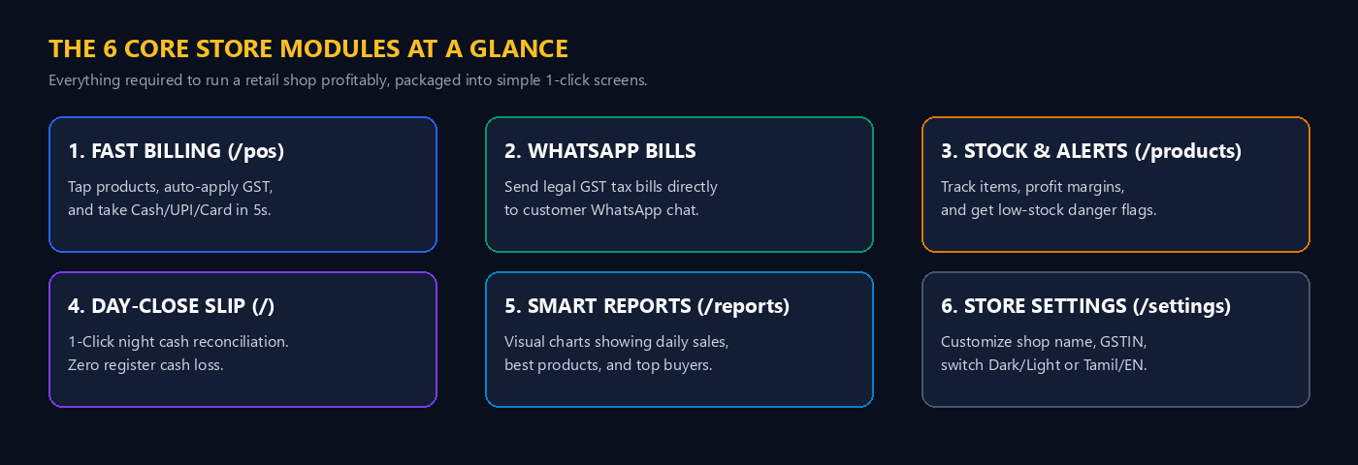
Visual POV: The 6 Core Modules at a Glance (Infographic Map)
POV 2 2. Visual Comparison: Old Billing PC vs Modern VGL POS
Here is why modern retail shop owners across Tamil Nadu are dumping old desktop computers and switching to VGL Cloud POS:
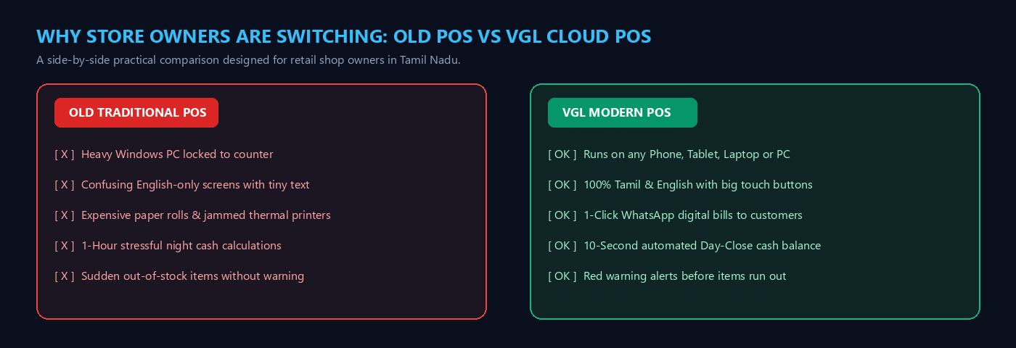
Visual POV: Direct Comparison: Old Traditional POS vs VGL Cloud POS
POV 3 3. The 3-Step Counter Billing Flow (Under 10 Seconds)
During festival and evening rush hours, speed is everything. Here is how a cashier finishes a customer bill in just 3 quick taps:
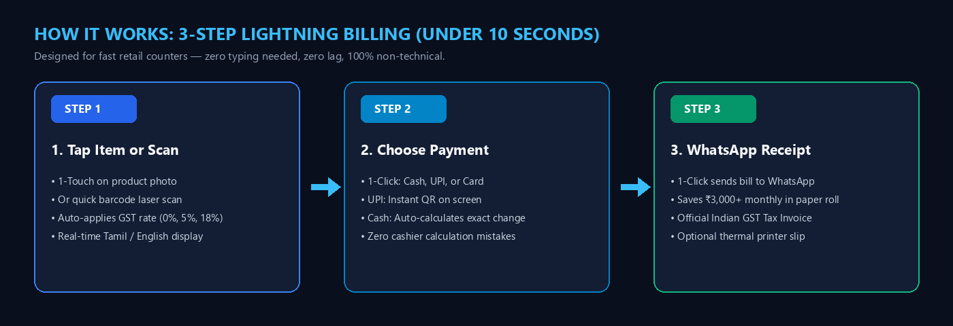
Visual POV: How It Works: 3-Step Lightning Billing Flow
POV 4 4. The POS Billing Terminal in Action (/pos)
The cashier screen is wide, bright, and completely visual. Products are shown with big buttons, photos, prices, and stock numbers.
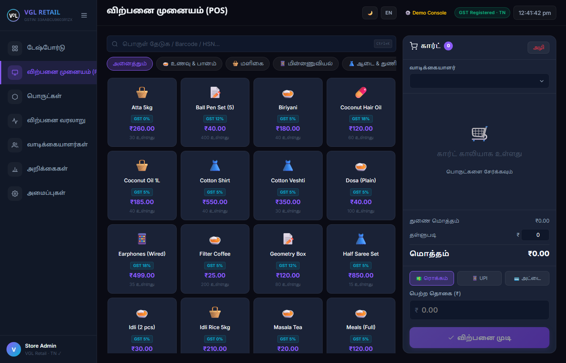
Visual POV: Cashier Billing Terminal in Default Tamil Nadu Tamil Language Mode
🛒 WHAT IT DOES (SIMPLE WORDS) | 💰 WHY STORE OWNERS LOVE IT | 🎯 KEY ON-SCREEN CONTROLS
• Big touch buttons for all items  • 1-Touch category filters (Food, Grocery, Electronics, Clothes)  • Live cart on the right side  • Shows exact item price & GST rate | • Cashiers make ZERO typing mistakes  • Customer lines move 3x faster  • Works on touchscreens, iPads, or PCs  • Tells cashier exact change to return | • 🌙☀️ Light/Dark mode toggle  • தமிழ் / EN Language switch  • 💵 Cash / 📱 UPI / 💳 Card buttons  • ⚡ Complete Sale (விற்பனை முடி)

Need the screen in English? Click the 'EN' button at the top, and the entire screen switches to English in 0.1 seconds:
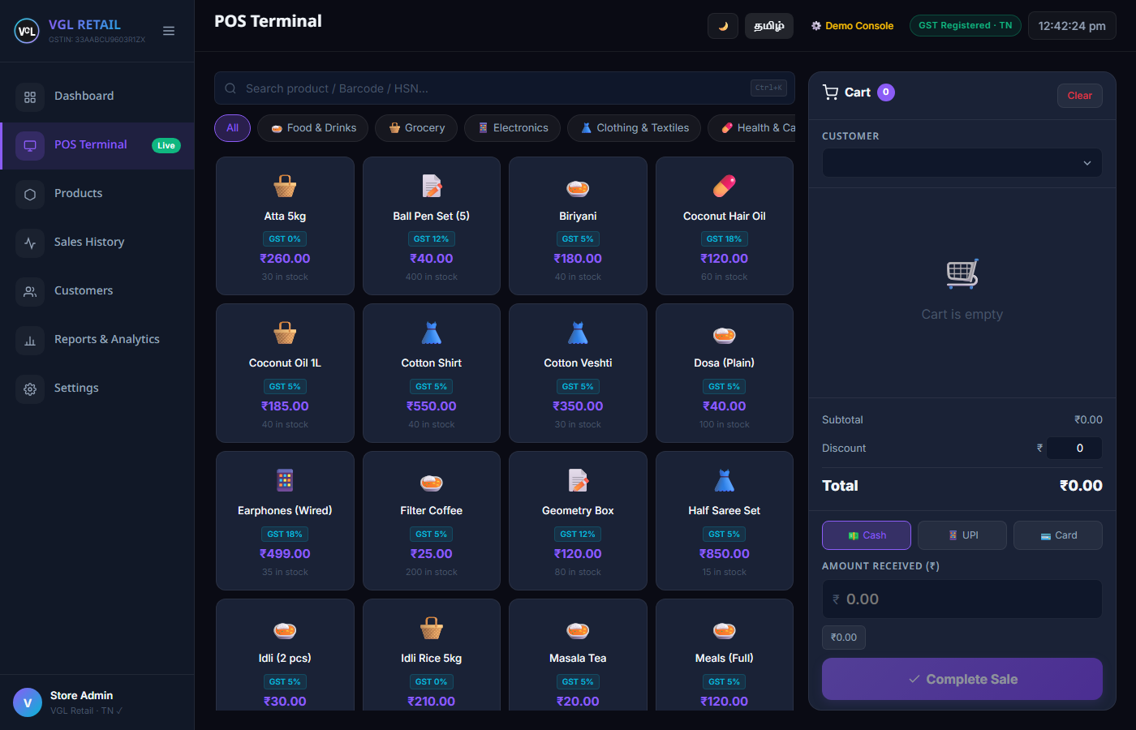
Visual POV: Cashier Billing Terminal in Clean English Interface Mode
POV 5 5. Official Indian GST Tax Receipt & WhatsApp Dispatch
When you click 'Complete Sale', the customer's legal GST tax invoice pops up instantly. You can print it or send it directly to their WhatsApp with 1 tap.
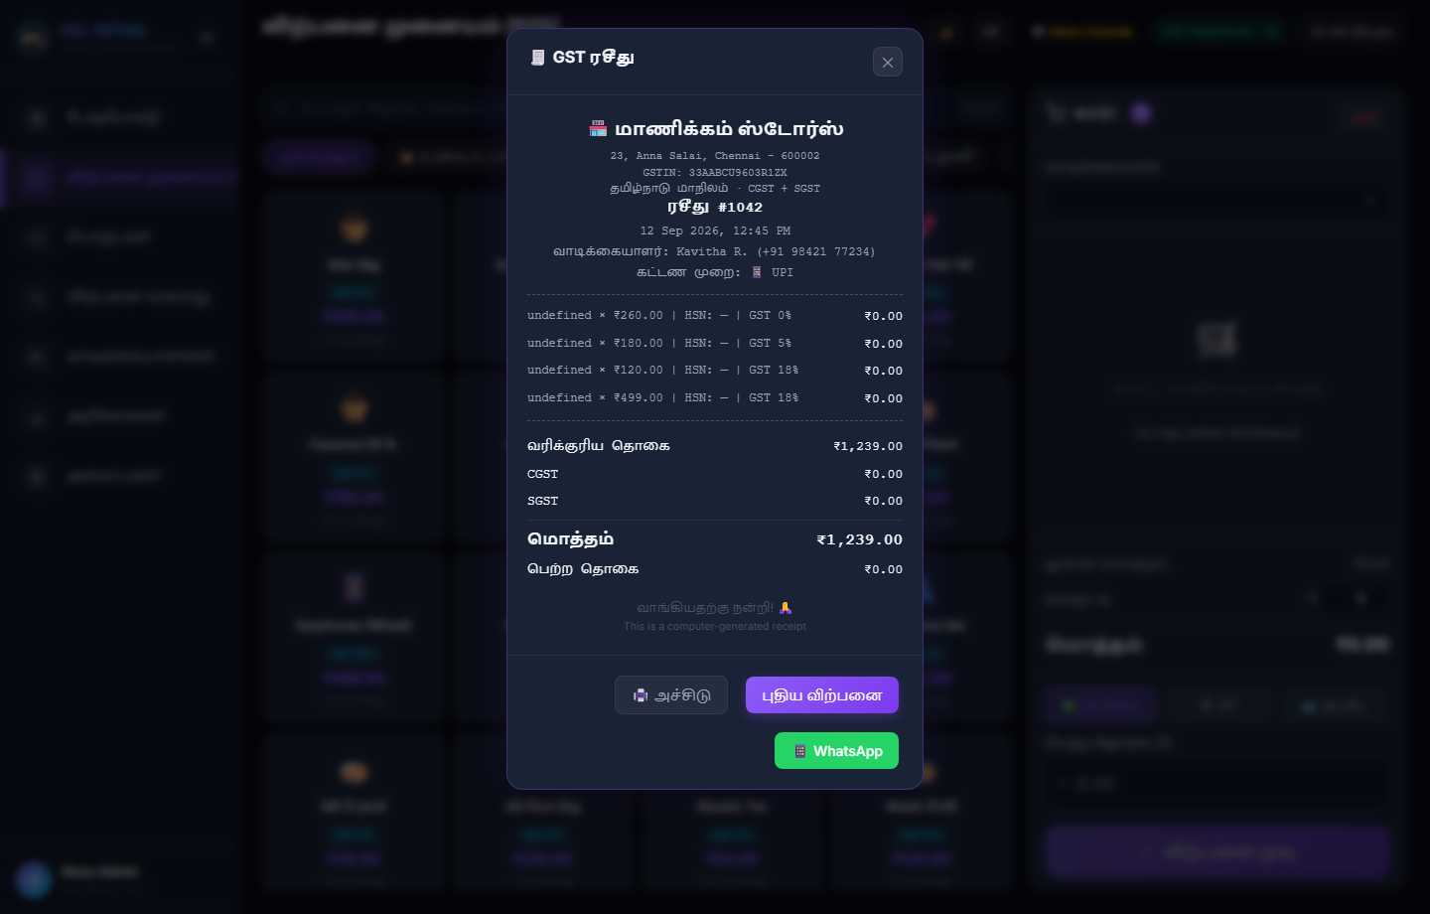
Visual POV: Official Indian GST Receipt Modal with Direct WhatsApp Button
🛒 WHAT IT DOES (SIMPLE WORDS) | 💰 WHY STORE OWNERS LOVE IT | 🎯 KEY ON-SCREEN CONTROLS
• Auto-splits GST into CGST & SGST  • Shows store name & GSTIN number  • Prints on any 2-inch or 3-inch thermal printer  • 1-Click WhatsApp sends bill to customer phone | • Saves ₹3,000+ every month on paper rolls  • Customers love digital bills on WhatsApp  • 100% compliant with Tamil Nadu GST laws  • Customer phone numbers auto-saved for CRM | • 📱 WhatsApp (Send bill to phone)  • 🖨️ Print / அச்சிடு (Thermal slip)  • New Sale / புதிய விற்பனை  • Close (✕)

POV 6 6. Product Inventory & Profit Margin Visibility (/products)
Never guess your store profits again. The inventory screen shows exact cost price, selling price, and profit margin for every single product.
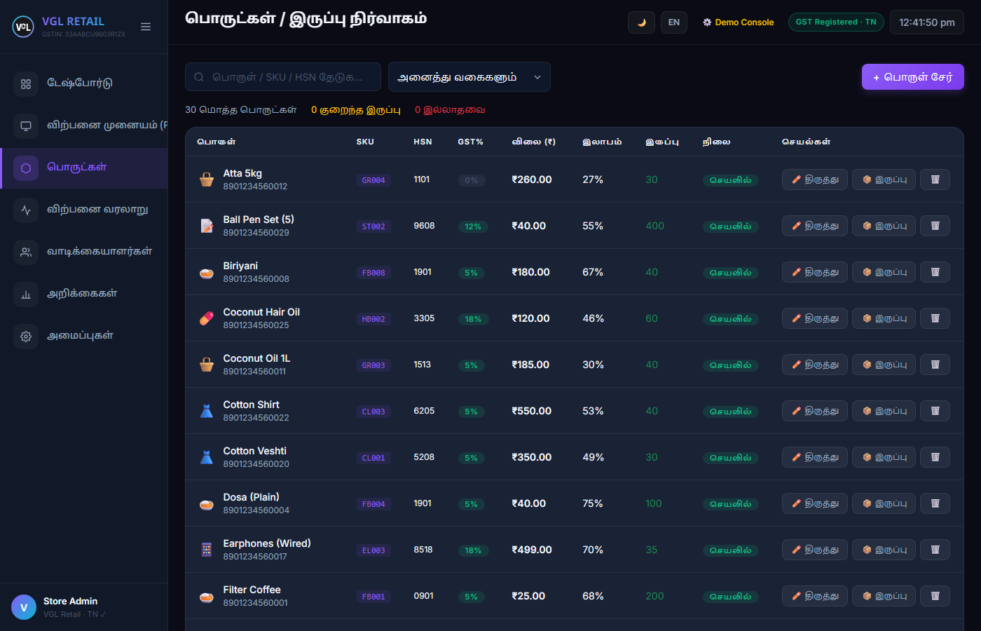
Visual POV: Product Catalog Grid showing HSN, GST%, Prices, Margins and Stock
🛒 WHAT IT DOES (SIMPLE WORDS) | 💰 WHY STORE OWNERS LOVE IT | 🎯 KEY ON-SCREEN CONTROLS
• Lists all items with photos & codes  • Shows exact profit margin % per item  • Real-time stock counts that decrease with every sale  • Red warning tags when items run low | • Instantly spot high-profit items to sell more  • Reorder goods BEFORE they run out of stock  • Adjust stock for damaged items in 1 click  • Stop theft and missing store items | • Add Product (பொருள் சேர்)  • 📦 Stock Adjust (இருப்பு திருத்தம்)  • Search Bar (Filter by name/code)  • Edit & Delete Actions

POV 7 7. Stop Night Cash Shortages: 1-Click Day-Close Slip (/)
No more staying up until 11:00 PM counting coins and comparing receipts. At store closing, click 'Day Close Slip' and the system audits everything.
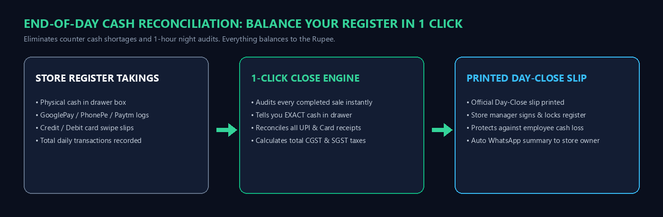
Visual POV: End-of-Day Cash Balancing Workflow (Reconciliation in 1 Click)
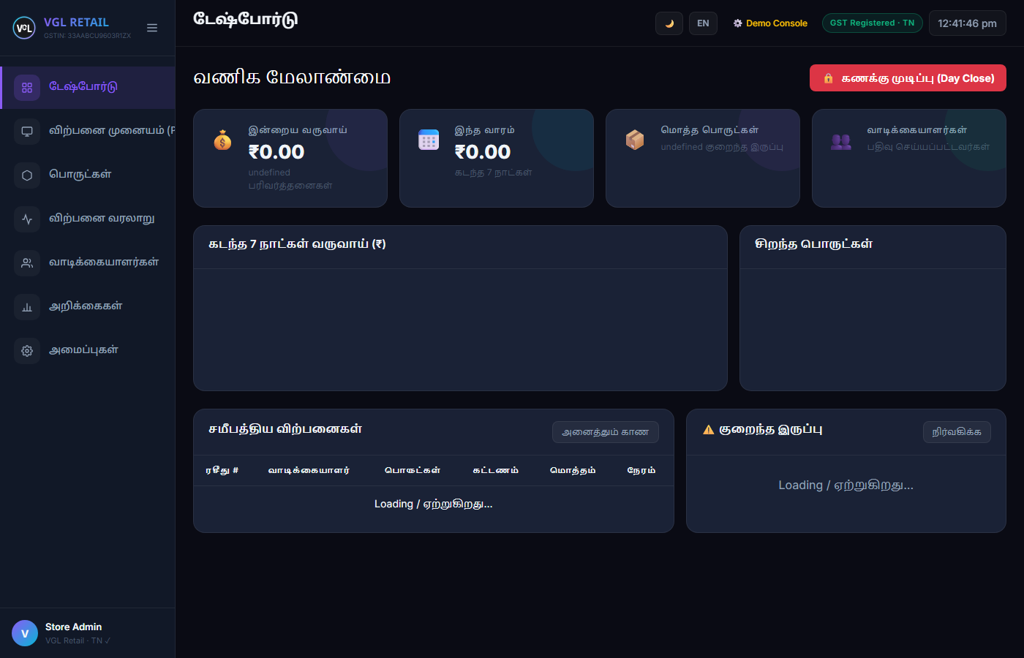
Visual POV: Store Dashboard with Real-Time Revenue and Printable Day-Close Slip
🛒 WHAT IT DOES (SIMPLE WORDS) | 💰 WHY STORE OWNERS LOVE IT | 🎯 KEY ON-SCREEN CONTROLS
• Audits all transactions for the day  • Tells you EXACT Cash in drawer  • Reconciles total UPI (GPay/PhonePe)  • Reconciles all Card swipe receipts | • Cashiers cannot hide or steal cash  • Cash drawer balances to the exact rupee  • Print slip, manager signs, audit done in 2 mins  • Automatic daily summary to store owner phone | • 🔒 Day Close Summary (கணக்கு முடிப்பு)  • 🖨️ Print Day-Close Slip  • Today's Revenue (இன்றைய வருவாய்)  • Weekly Revenue Trend Chart

POV 8 8. Visual Business Reports & Best Sellers (/reports)
See your store's sales health at a glance with colorful, easy-to-understand charts. You don't need an accounting degree to understand these numbers.
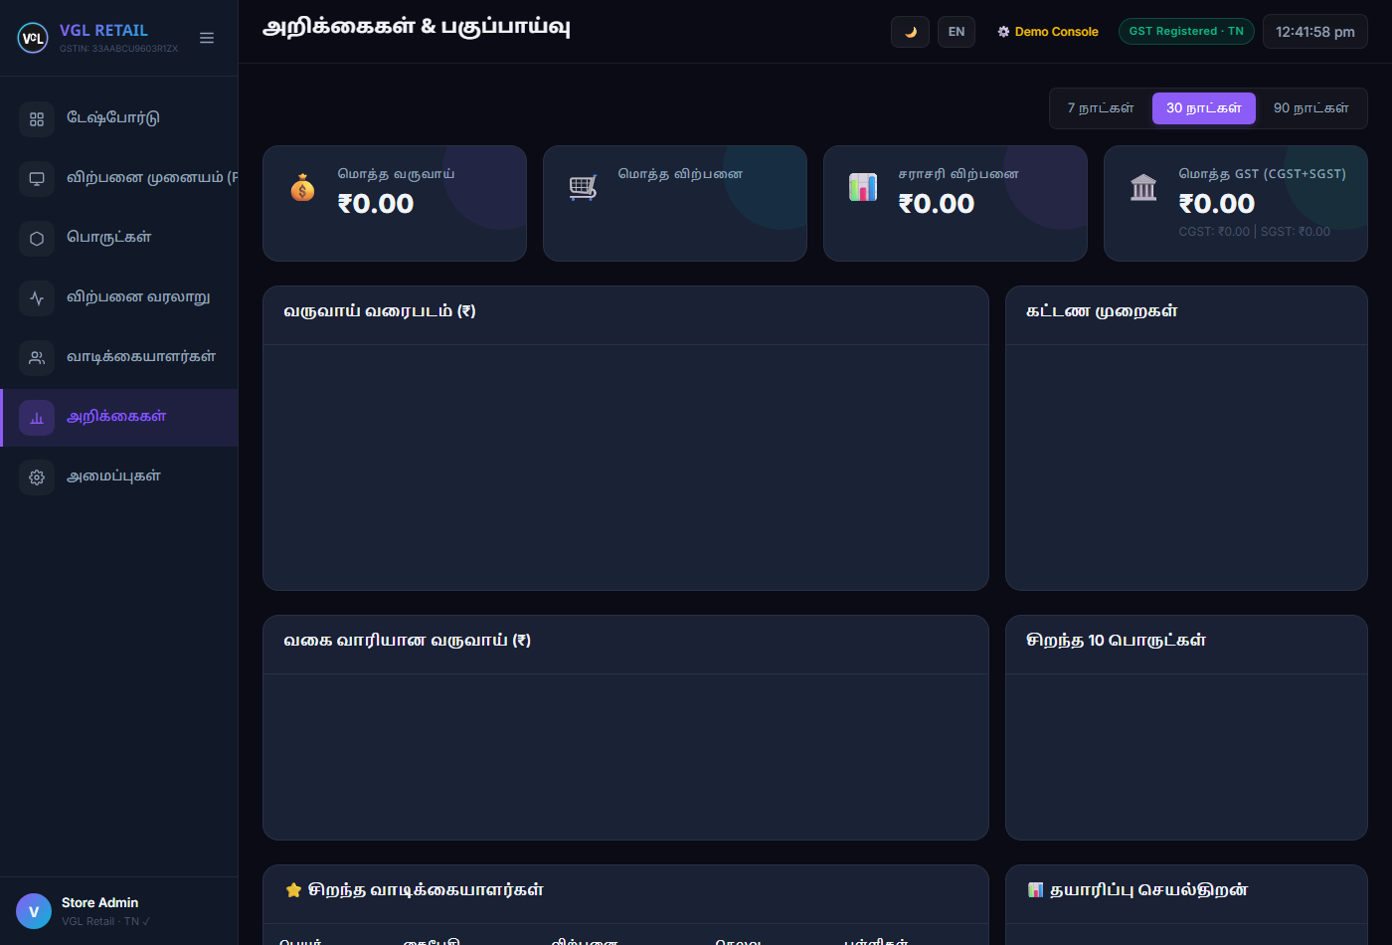
Visual POV: Reports & Analytics Dashboard showing Weekly Revenue, Payment Split and Top 10 Items
🛒 WHAT IT DOES (SIMPLE WORDS) | 💰 WHY STORE OWNERS LOVE IT | 🎯 KEY ON-SCREEN CONTROLS
• 7-Day sales curve showing daily income  • Payment split donut chart (Cash vs UPI vs Card)  • Category sales bar chart (Grocery vs Clothes)  • Top 10 best-selling items ranking | • Know which products bring in the most money  • Track if UPI payments are increasing  • Spot slow-moving items and clear them with discounts  • Reward top loyal customers | • Date Range Filter (Today, Week, Month)  • Top Selling Products tab  • Best Customers CRM table  • Export CSV / Print Report

POV 9 9. Store Customization & Interactive Demo Console (/settings)
Configure your shop details, GSTIN tax registration, and language. Plus, a built-in Demo Console allows you to simulate live sales for staff training.
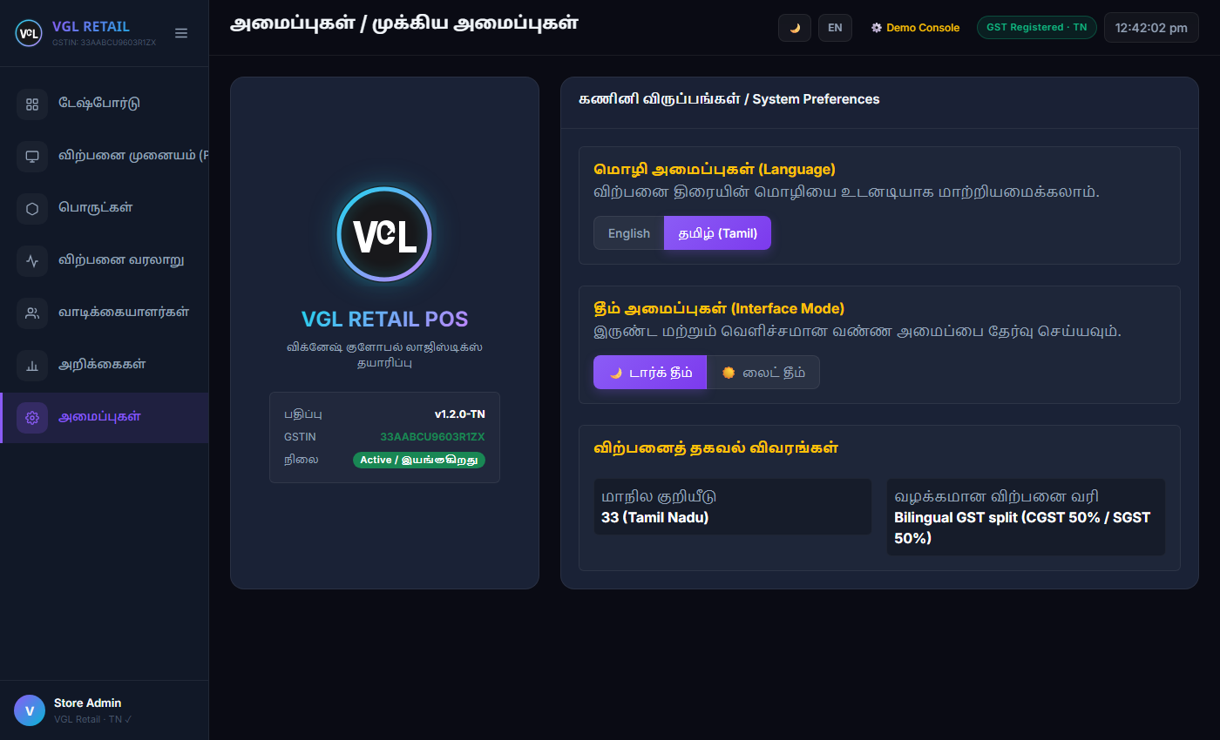
Visual POV: Settings Screen with Store Branding, GSTIN Configuration and Diagnostic Tools
🛒 WHAT IT DOES (SIMPLE WORDS) | 💰 WHY STORE OWNERS LOVE IT | 🎯 KEY ON-SCREEN CONTROLS
• Set your shop name, address & phone  • Add your official 15-digit GSTIN number  • Choose Dark Theme or Light Theme  • Demo console to practice fake sales for practice | • Your receipts carry your exact store branding  • Train new staff in 5 minutes using Demo mode  • Dark theme reduces eye strain during 12-hour shifts  • Zero risk: Reset button wipes test sales instantly | • ⚙️ Demo Console button  • ⚡ Simulate Random Sale (லைவ் விற்பனை)  • 🚨 Full Reset Demo Data (தரவு மீட்டமை)  • Save Store Settings

POV 10 10. Behind the Scenes: GitHub & Cloud Reliability
For store owners and managers who want to ensure their store system is safe, secure, and reliable:
• Secure Private GitHub Repository: The core software engine is maintained in a private repository named 'pos-project' by Vignesh Growth Lab (VGL).
• Public Architecture Case Study: Publicly documented at https://github.com/Vignesh-10032000/vigneshgrowthlab-portfolio (Commit 8ec396d verified).
• 99.9% Cloud Uptime: Hosted on Render enterprise cloud with automated SSL security, meaning zero virus risk and zero data loss even if your store tablet breaks.
• Tested for Festival Rush: Load-tested to 600 simultaneous shoppers with under 300 millisecond response times. It will never freeze during Deepavali or Pongal sales rush.

