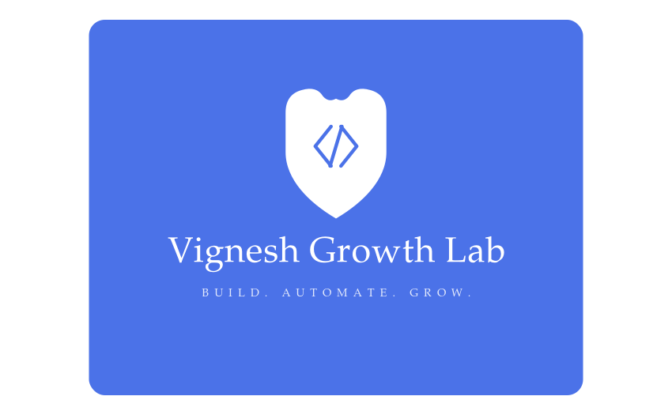 | WHOLESALE ERP  Feature Overview & Reference Demonstration  A connected business platform for inventory, purchase, sales, finance, GST, banking and management reporting.
SEPARATE DEMO ENVIRONMENT • SAMPLE DATA ONLY • NO LIVE CLIENT INFORMATION
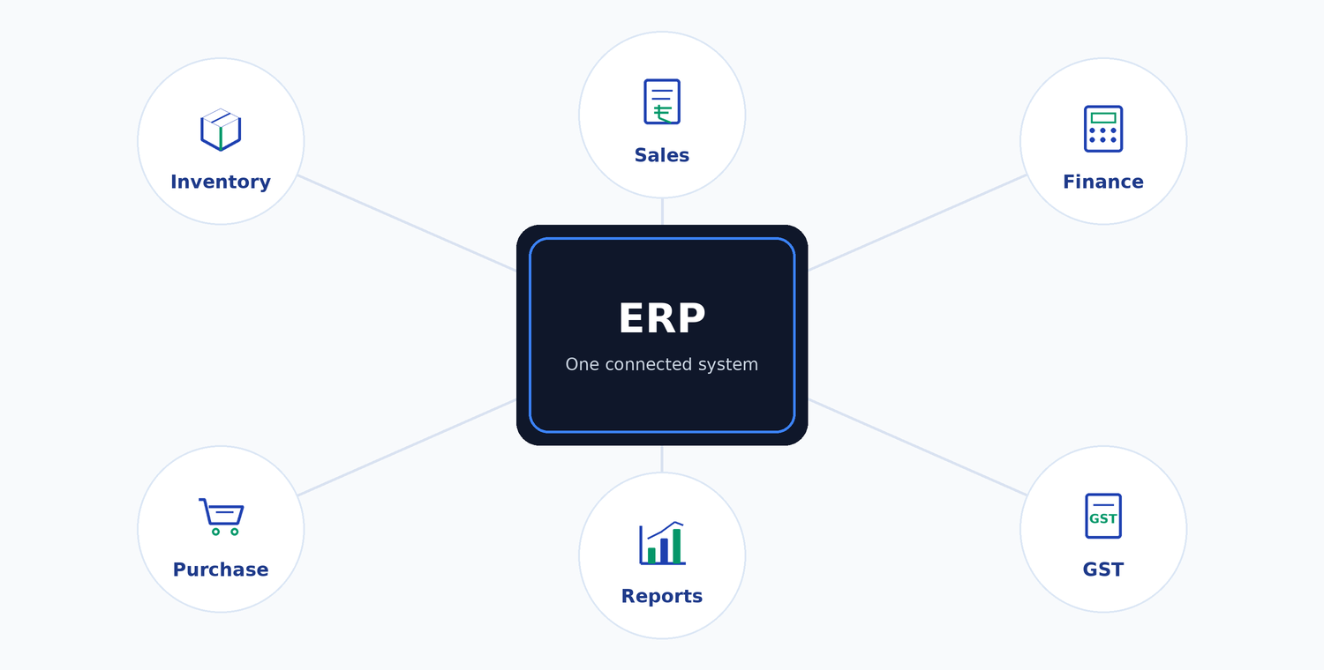
 Products & Stock |  Purchases & Vendors |  Sales & Customers
 Accounts & Finance | 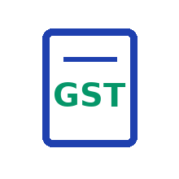 GST & Compliance |  Reports & Controls

CONNECTED WORKFLOW  Purchase → Stock → Sales → Accounts → GST → Reports | ROLE-BASED ACCESS  Admin, Accounts, Sales, Warehouse and Management views | BUSINESS VISIBILITY  Stock, outstanding, profit, cash/bank and management KPIs

WHAT THIS DEMO HELPS YOU REVIEW  - How core departments connect in one ERP  - How business entries affect stock and accounts  - How reporting and controls support management | DESIGNED FOR  - Wholesale distributors and stockists  - Multi-location / multi-warehouse trading businesses  - Companies needing billing, finance and compliance together

Reference demo access & requirement discussion • vigneshgrowthlab@gmail.com • WhatsApp / Call: 820034139

01 | Complete ERP Module Overview  Ten connected modules covering business setup, stock, purchase, sales, accounting, tax, banking, reporting and security.

- Company, GSTIN, bank, financial year and document numbering  - Branding, user permissions and page-level access | - Categories, HSN, B2B/B2C/MRP price levels and bulk upload  - FIFO batch-wise stock costing, valuation and margin alerts
   | 01 Master Settings
  02 Products & Inventory
- Multiple warehouses / stock locations and opening balances  - Inter-warehouse transfers, adjustments, write-offs and DC flow | - Vendor master, purchase orders, purchase bills and vendor dues  - GST handling; purchase entry updates stock and accounting
   | 03 Warehouse & Logistics
  04 Purchases & Vendors
- Customer master, quotations, credit limits, receipts and collections  - B2B/B2C invoices, Delivery Challans, credit notes and returns | - Automatic double-entry posting from business transactions  - Expenses, ageing, daily closing, adjustments and trial balance
  05 Sales & Customers
  06 Accounting & General Ledger
- CGST, SGST and IGST transaction handling  - E-invoice / E-way bill workflow and GSTR preparation | - Bank accounts, cheque lifecycle and bank reconciliation support  - Stock statement / Drawing Power reporting
  07 GST & E-Invoice / E-Way Bill
   | 08 Banking & Treasury
- Live KPIs, P&L, stock valuation and sales/purchase analysis  - Customer/vendor statements, day book and management reports | - Role/warehouse-based access, session and password controls  - Activity logs and traceability for important business changes
  09 Reports & Business Intelligence
   | 10 Security & Audit Controls

STOCK  FIFO valuation | SALES  Billing + credit | FINANCE  Ledgers + ageing | CONTROL  GST + audit

02 | Workflow, Requirement Discussion & Next Step  The demo is a reference system. Your final ERP can be mapped to your actual workflow, reports, approvals and business rules.

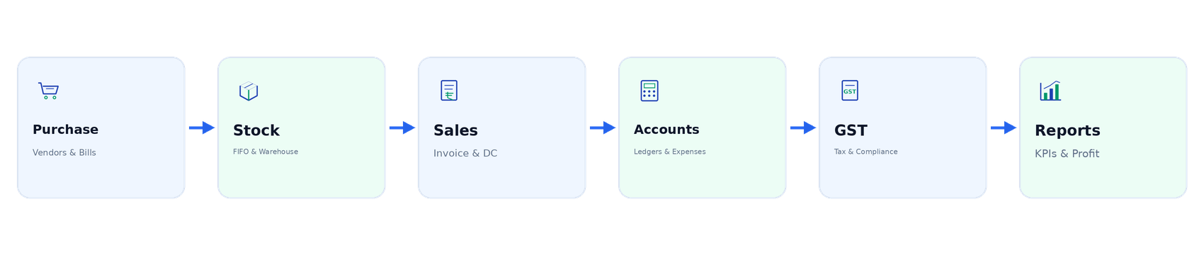
ADMIN  Full control | ACCOUNTS  Finance & GST | SALES  Customers & billing | WAREHOUSE  Stock & dispatch | MANAGEMENT  KPIs & reports

1  VIEW THE DEMO  Review screens, workflow and available modules. | 2  SHARE REQUIREMENTS  Share process, reports, approvals and special needs. | 3  MAP & PROPOSE  We map the scope, customization and proposal.

TYPICAL CUSTOMIZATION AREAS  - Approval workflows and user roles  - Custom invoice / DC / quotation formats  - Additional dashboards, reports and integrations  - Special product, serial or warehouse logic | WHAT WE NEED FROM YOUR TEAM  - Current business process / workflow  - Required modules, users and approval levels  - Sample documents, reports and existing data  - Priority features and expected timeline

DEMO & DATA PRIVACY  - Reference demo uses sample data only.  - Live client servers and client business data remain separate and are not exposed.  - Final scope is confirmed after requirement review. | VIGNESH GROWTHLAB  ERP Development & Business Automation  vigneshgrowthlab@gmail.com  WhatsApp / Contact: 820034139  BUILD. AUTOMATE. GROW.

NEXT STEP: Review the demo, share your requirements, and we will map the ERP to your business process.

FOR THE REQUIREMENT DISCUSSION, KEEP THESE READY
Current Workflow | Sample Invoice / DC | User Roles | Required Reports | Priority Integrations

