OUTPUTS
Bronze Layer
Catalog: brazillian_e_commerce
Schema: bronze
Table_name: bronze_orders
Orders:
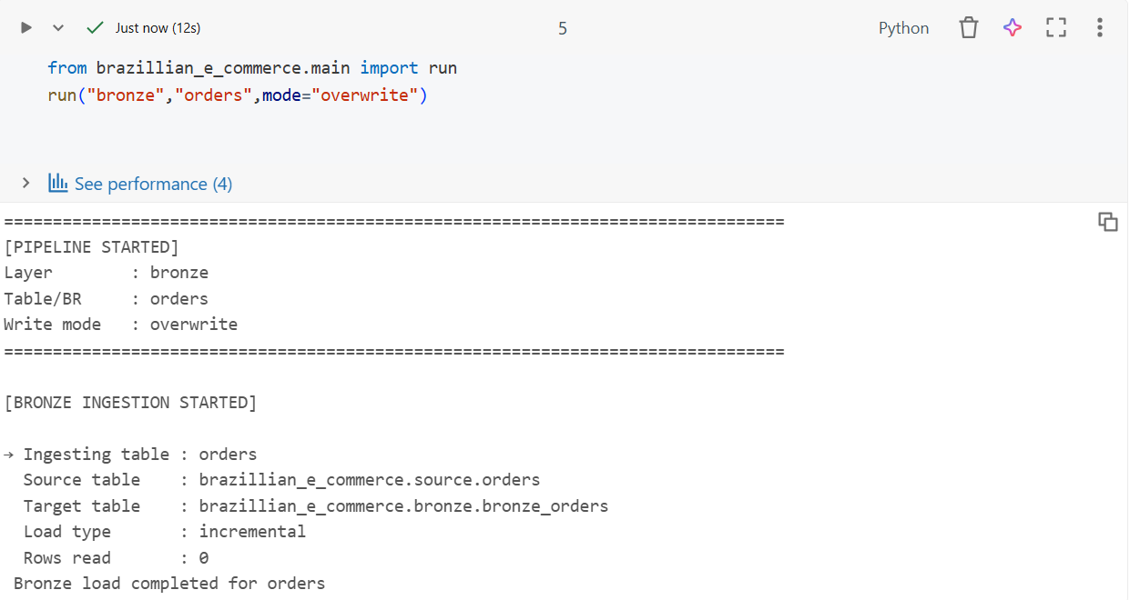

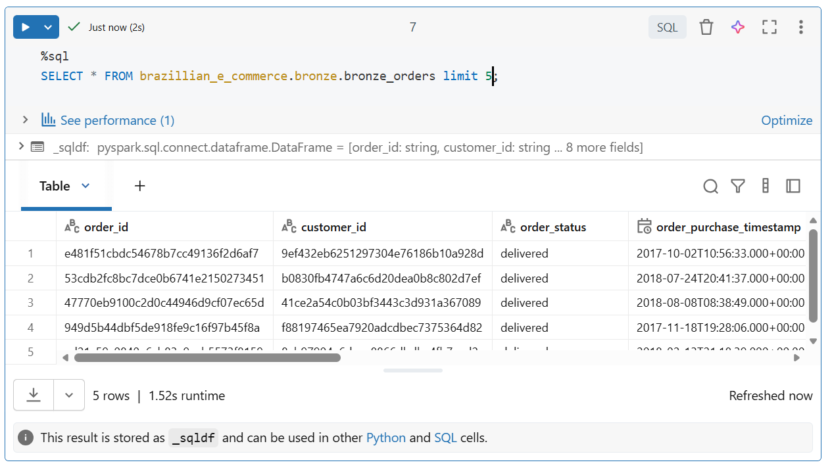

SILVER LAYER
Catalog: brazillian_e_commerce
Schema: silver
Table_name: silver_orders
Orders:
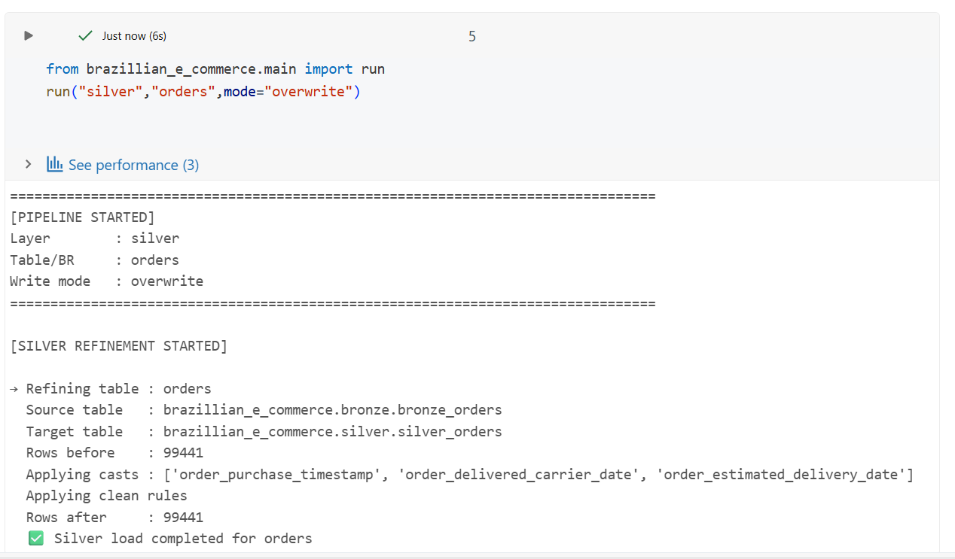
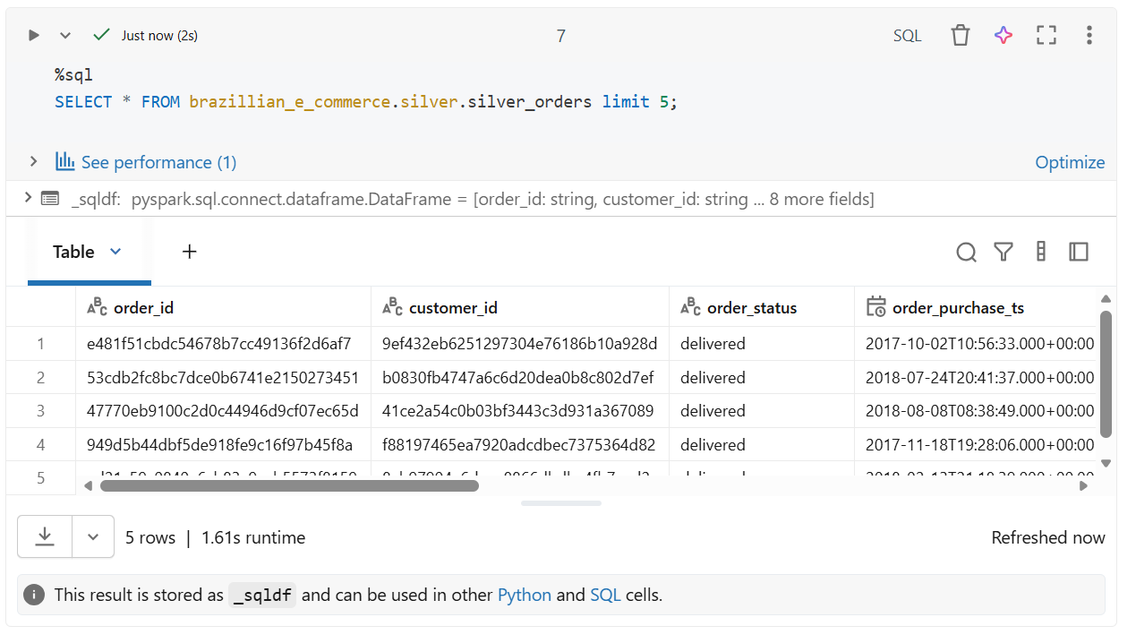

GOLD (Fact)
Catalog: brazillian_e_commerce
Schema: gold
Type: fact
Table_name: fact_orders
Orders:
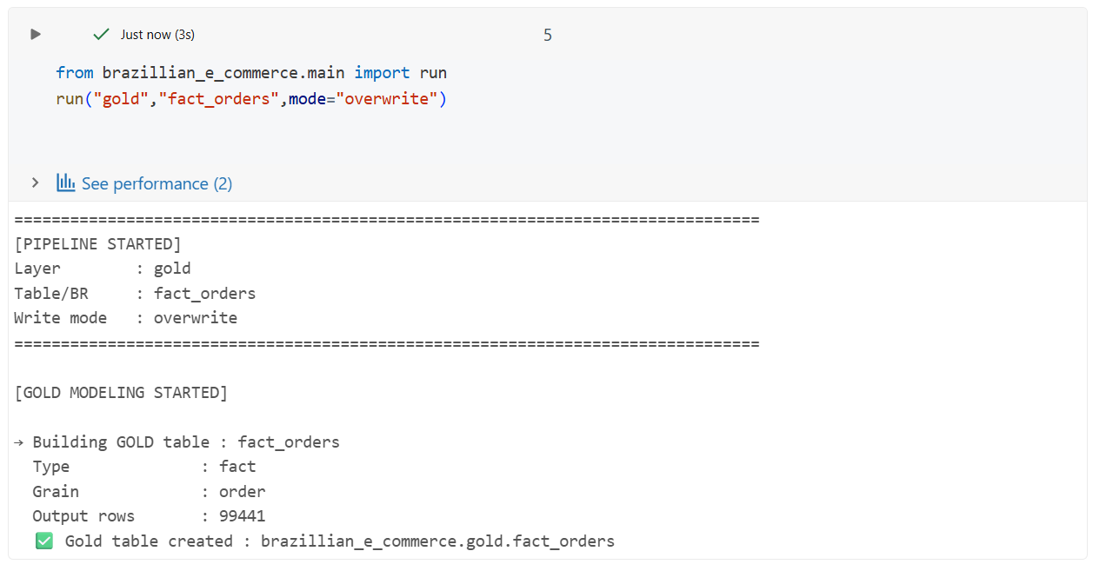
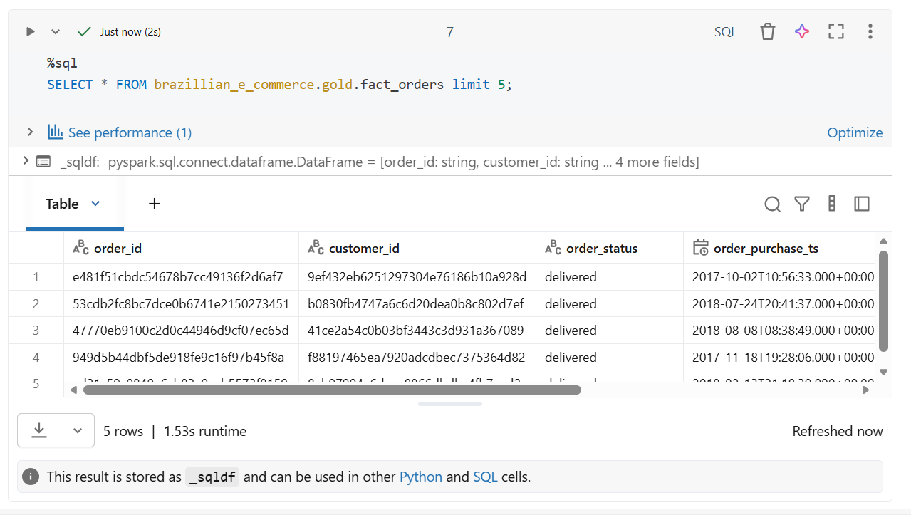

GOLD (Dim)
Catalog: brazillian_e_commerce
Schema: gold
Type: dim
Table_name: dim_sellers
Sellers:
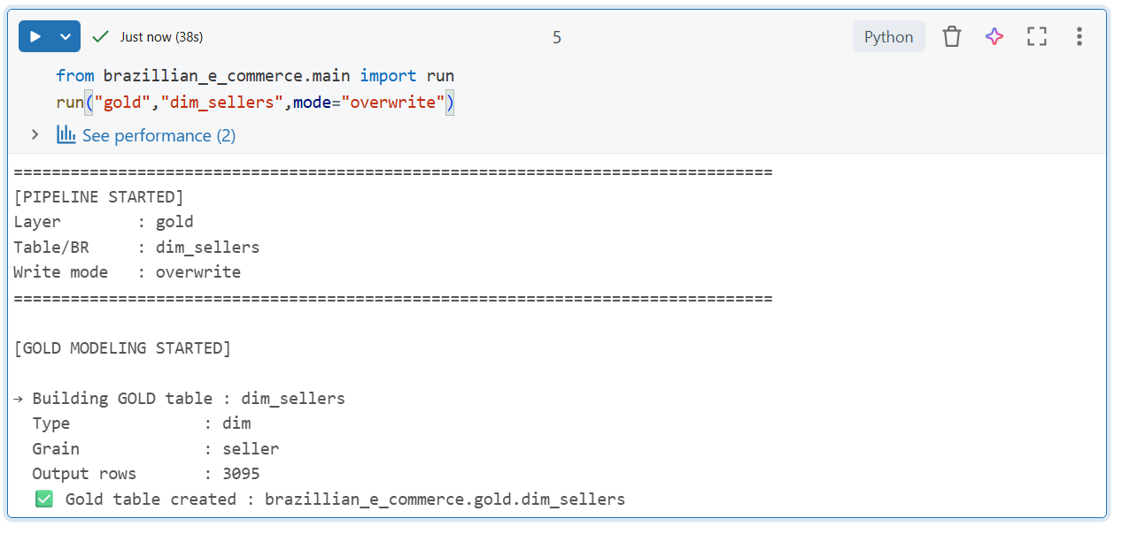
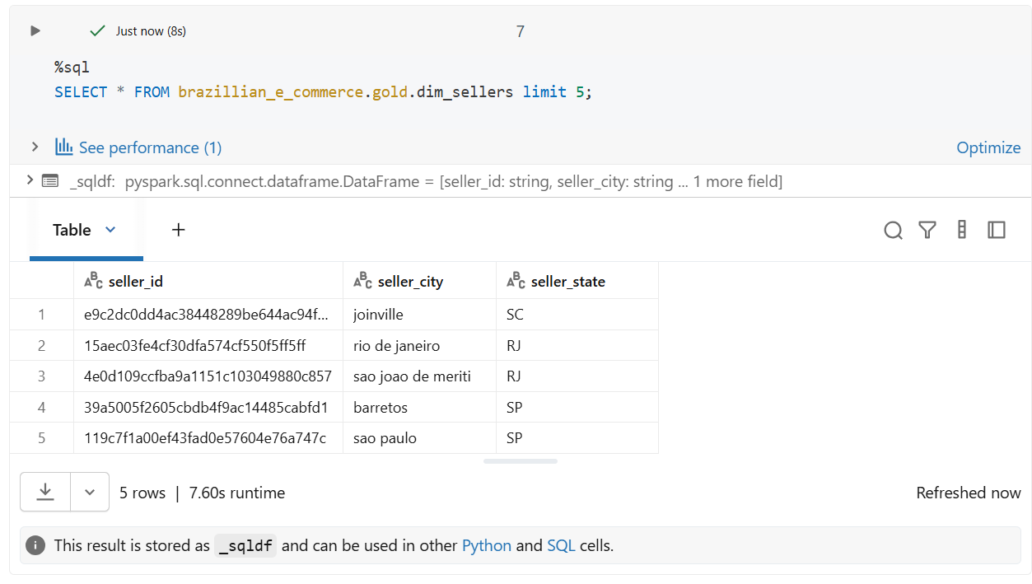

MART
Catalog: brazillian_e_commerce
Schema: final
Table_name: sales_performance
Sales_Performance:
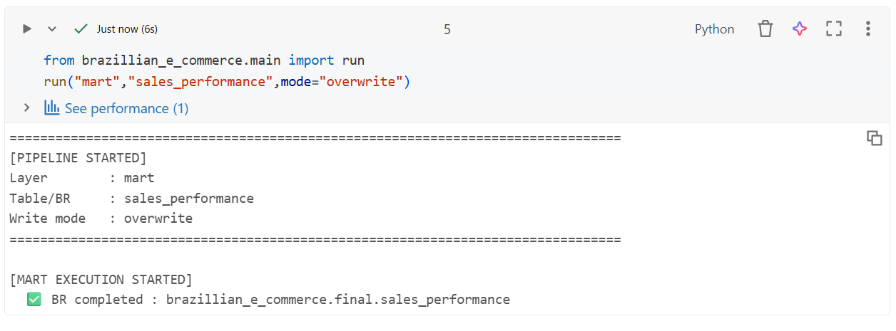

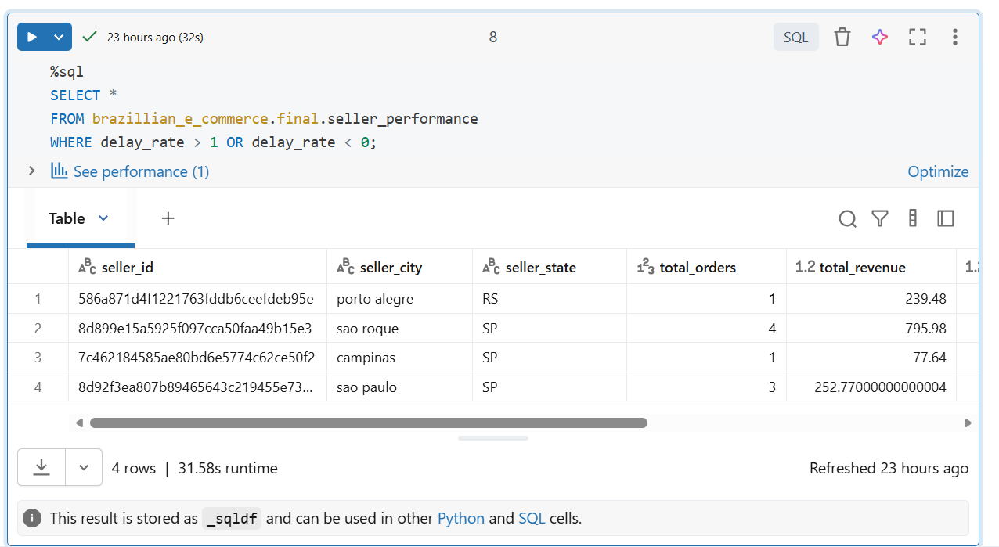

Jobs
Python Script (successful):
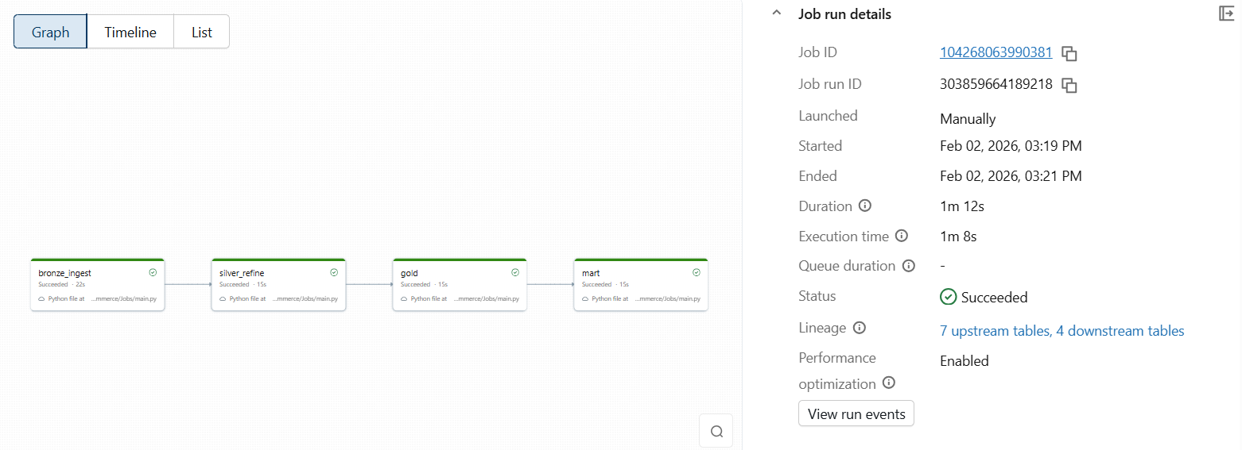

Notebook (Bronze):
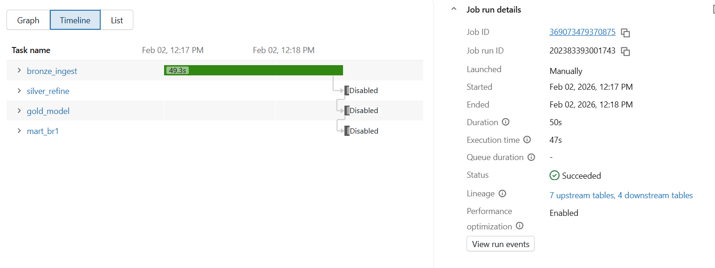

Notebook (Silver):
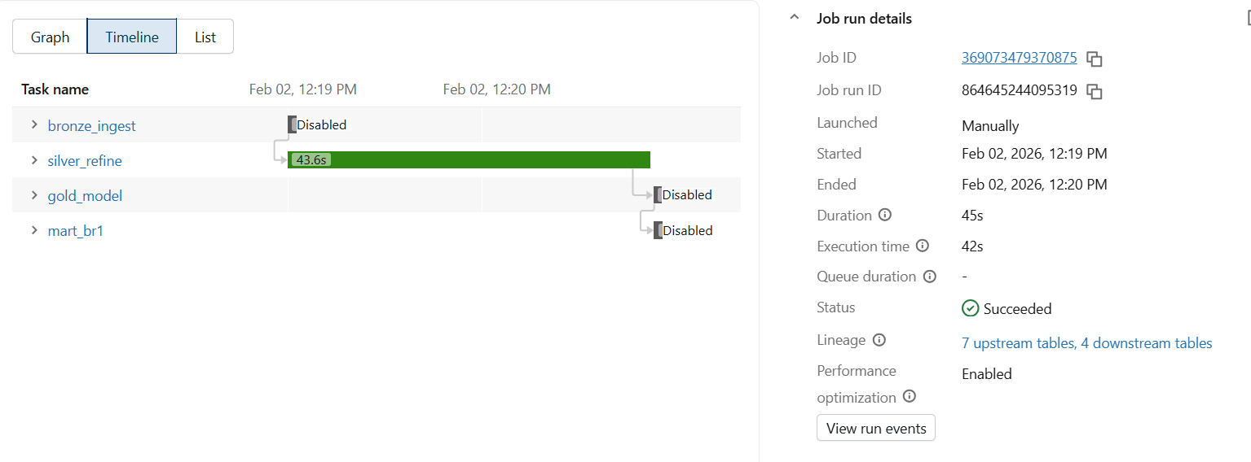

Notebook (Gold):
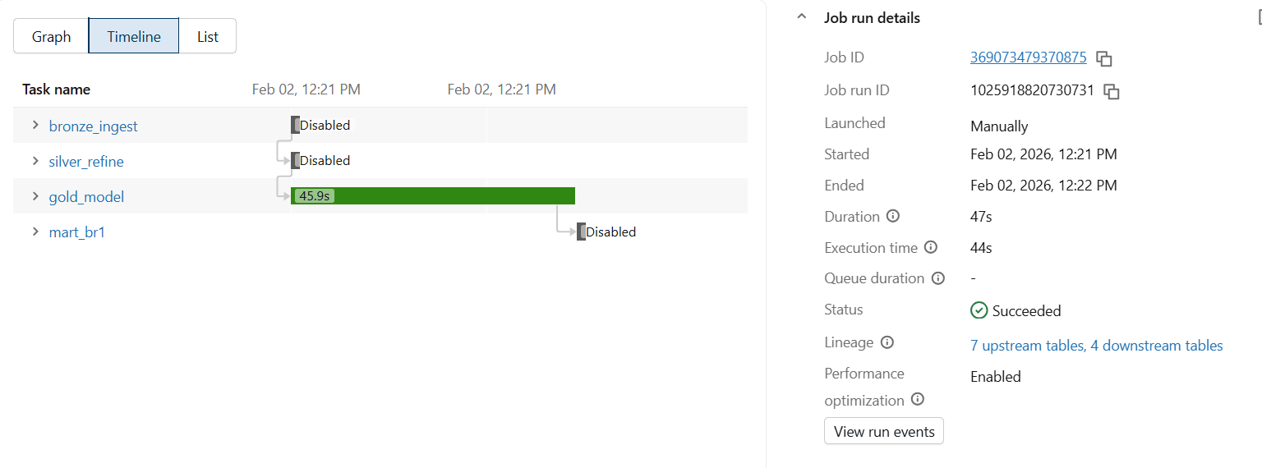

Notebook (Mart):
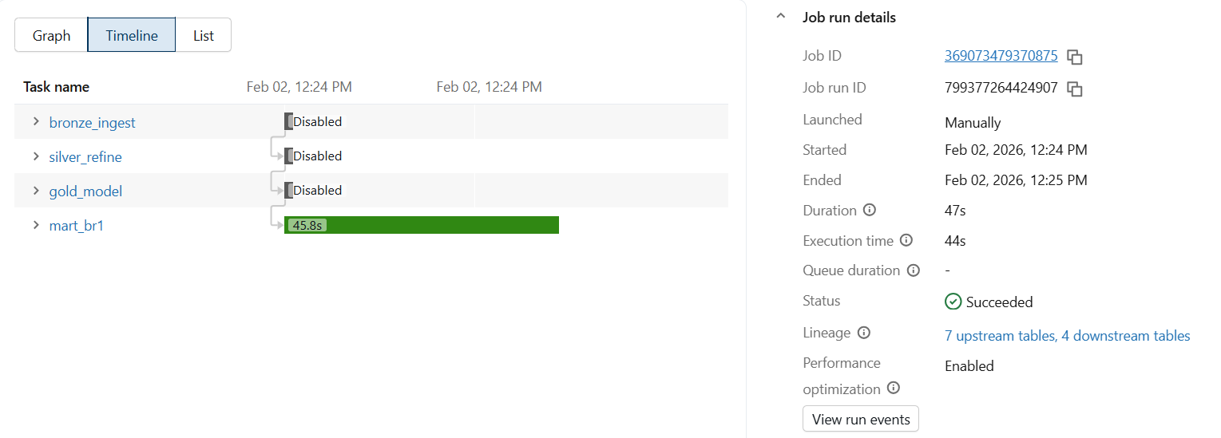

DATA LINEAGE
Brazillian_e_commerce.final.sales_performence:
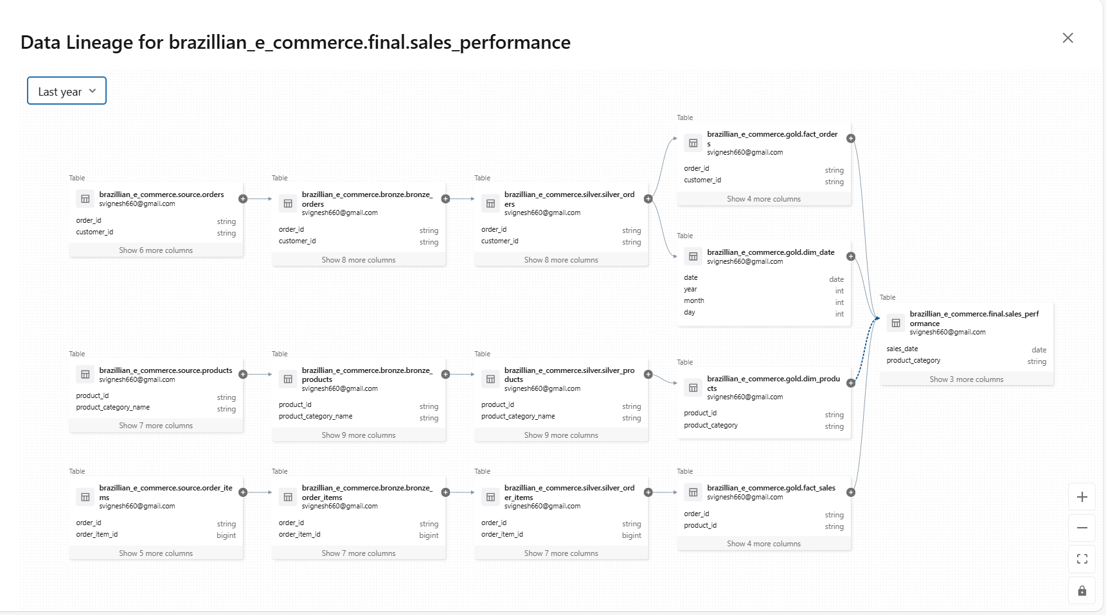

Seaborn Visualization
Sales_Performance:
- How is Revenue Changing over Time.

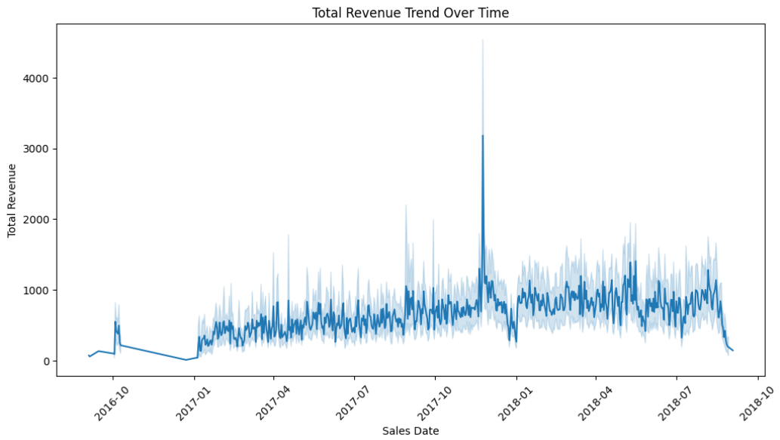
This chart shows how sales growth trend over time
- Which Product Categories Generated more revenue.
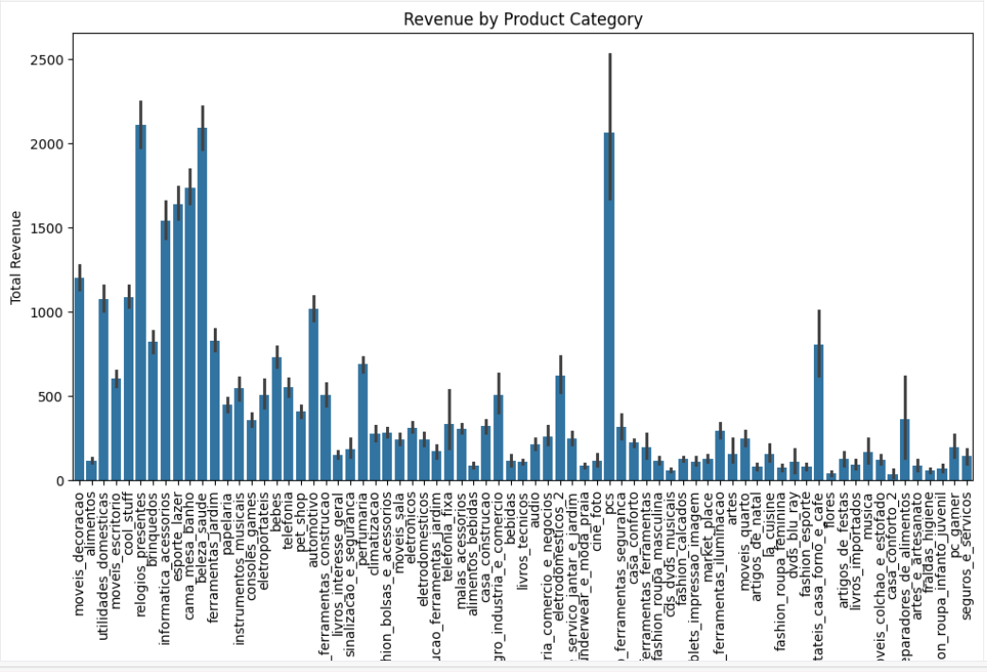

- Average Order Value Per Category
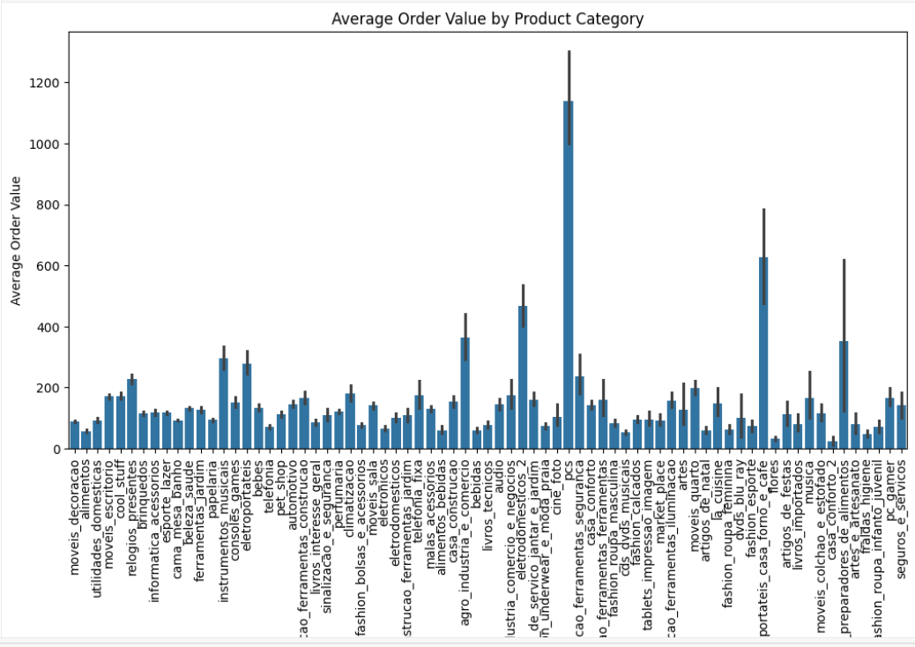

- Orders Trend
