PROFESSIONAL TRAINING REPORT – I

Entitled

TITLE OF THE PROJECT

Submitted in partial fulfillment of the requirements for the award of Bachelor of Engineering degree in Computer Science and Engineering with specialization

By

Name1(Reg.No–43111252)
Name2(Reg.No–43110732)



DEPARTMENT OF COMPUTER SCIENCE AND ENGINEERING SCHOOL OF COMPUTING

SATHYABAMA

INSTITUTE OF SCIENCE AND TECHNOLOGY (DEEMED TO BE UNIVERSITY)
CATEGORY-1 UNIVERSITY BY UGC
Accredited “A++” by NAAC I Approved by AICTE
JEPPIAAR NAGAR, RAJIVGANDHI SALAI CHENNAI-600119
NOV-2026


DEPARTMENT OF COMPUTER SCIENCE AND ENGINEERING

BONAFIDE CERTIFICATE

This is to certify that this Professional Training I Report is the bonafide work of Name1 (43111252) and Name2(43111252) who carried out the Project Phase-1 entitled “NEURAL CONSENSUS INTELLIGENCE ORCHESTRATOR” under my supervision from June 2026 to August 2026.

Internal Guide
Dr.D.SARAVANAN, M.Tech, Ph.D.,

Head of the Department
Dr.L.LAKSHMANAN,M.E.,Ph.D.,

Submitted for Professional Training I Viva Voce Examination held on

Internal Examiner External Examiner

DECLARATION
I, Name 1 (Reg. No- 43110253), hereby declare that the Professional Training-1 Report entitled “NEURAL CONSENSUS INTELLIGENCE ORCHESTRATOR” done by me under the guidance of Dr D Saravanan,M.Tech., Ph.D.,is submitted in partial fulfillment of the requirements for the award of Bachelor of Engineering degree in Computer Science and Engineering.

DATE:

PLACE: Chennai SIGNATURE OF THE CANDIDATE

ACKNOWLEDGEMENT

I am pleased to acknowledge my sincere thanks to BOARD OF MANAGEMENT of Sathyabama Institute of Science and Technology for their kind Department encouragement in doing this project and for completing it successfully. I am grateful to them.
I convey my thanks to Dr. L. Lakshmanan, M.E., Ph.D., Dean and Head, School of Computing, Department of Computer Science and Engineering for providing me with necessary support and details at the right time during the progressive reviews.
I would like to express my sincere and deep sense of gratitude to my Project Guide Dr. D. Saravanan, M.Tech, Ph.D., for her valuable guidance, suggestions, and constant encouragement paved the way for the successful completion of my project work.
I wish to express my thanks to all Teaching and Non-teaching staff members of the Department of Computer Science and Engineering who were helpful in many ways for the completion of the project.

TRAINING CERTIFICATE

ABSTRACT

Heart disease remains one of the leading causes of death worldwide, and early identification of high-risk individuals can significantly improve the chances of timely treatment. This project presents the Heart Disease Risk Prediction System, a web-based screening application that estimates a person's risk of heart disease from thirteen routinely available clinical parameters such as age, sex, chest-pain type, resting blood pressure, serum cholesterol, maximum heart rate, ST depression and the number of major vessels. The system is built as a three-tier application. A static HTML, CSS and JavaScript frontend collects the inputs and displays results through a Chart.js dashboard; a Flask REST API performs authentication, validation and prediction; and MongoDB Atlas stores user accounts and prediction history. Inputs are validated against fixed ranges, arranged in a fixed feature order, standardised with a pre-fitted StandardScaler and passed to a pre-trained Random Forest classifier, which returns the probability of heart disease. The probability is converted into a Low (0-39%), Medium (40-69%) or High (70-100%) risk category together with the five most influential model features. User passwords are hashed and every prediction endpoint is protected with JSON Web Tokens, so each user can view only their own records. A training scaffold that compares Logistic Regression, Random Forest and SVM models is also provided for retraining the model on a UCI-style dataset. The application is intended for educational screening only and is not a medical diagnosis. Its modular design allows additional disease predictors to be added in future versions.

v

TABLE OF CONTENTS

Chapter No. | Title |  |  | Page No.
 | ABSTRACT |  |  | v
 | LIST OF FIGURES |  |  | vii
1 | INTRODUCTION |  |  | 1
2 | LITERATURE SURVEY |  |  | 3
 | 2.1 | Inferences from Literature Survey |  | 4
 | 2.2 | Open Problems in Existing System |  | 4
3 | REQUIREMENTSANALYSIS |  |  | 5
 | 3.1 |  | Feasibility Studies/ Risk Analysis of the Project | 5
 | 3.2 |  | Software Requirements Specification Document | 7
4 | DESCRIPTIONOFPROPOSEDSYSTEM |  |  | 9
 | 4.1 |  | Selected Methodology or Process Model | 9
 | 4.2 |  | Architecture/ Overall Design of Proposed System | 9
 | 4.3 |  | Description of Software Implementation and Testing plan of the Proposed Model/System | 11
 | 4.4  4.5  4.6 |  | Project Management Plan  Financial report on estimated costing (If applicable)  Transition/Software to Operations Plan (as applicable) | 16  17  17
 | REFERENCES |  |  | 18

vi

LIST OF FIGURES

FIGURE NO.
FIGURENAME PAGE
NO.

  - System Architecture 10
  - User Workflow of the System 10
  - MongoDB Data Model 11
  - Risk Categorisation Bands 11
  - Feature Importance of the Random Forest Model 13

vii

LIST OF TABLES

TABLE NO. | TABLENAME | PAGE NO.
3.1 | Risk Assessment and Mitigation | 6
3.2 | Software and Hardware Requirements | 7
3.3 | Functional Requirements | 8
4.1 | Input Features and Allowed Values | 12
4.2 | REST API Endpoints | 14
4.3 | Test Plan | 15
4.4 | Project Schedule | 16
4.5 | Estimated Cost & Implementation Overheads | 17

viii

CHAPTER 1 INTRODUCTION

Cardiovascular diseases (CVD) are among the most common causes of death across the world, and their burden continues to grow with ageing populations, sedentary lifestyles and rising rates of hypertension, diabetes and obesity Benjamin, E.J. [2]. Many heart problems develop silently over years and are often detected only after a serious event such as a heart attack. Routine risk assessment by a physician requires clinical visits, laboratory tests and expert interpretation, which are not always easily accessible, especially in rural and semi-urban areas.
Machine learning (ML) offers a practical way to support early screening. By learning patterns from historical patient records, ML models can estimate the likelihood of heart disease from a small set of clinical measurements such as age, blood pressure, cholesterol and electrocardiogram findings. Studies on the widely used UCI heart-disease data and on large electronic health records show that ensemble models such as Random Forests perform well on this kind of tabular clinical data Breiman, L. [3]; Weng, S.F. [14].
Despite this progress, most published work stops at a trained model inside a notebook or a script. A patient or a health worker cannot directly use such a model, and there is usually no secure way to store results, review earlier assessments or present the outcome in an understandable form. A usable screening tool therefore needs more than a model: it needs an input form with validation, a secure back end, persistent storage, and a clear explanation of the result.
The Heart Disease Risk Prediction System developed in this project closes this gap. It wraps a pre-trained Random Forest model and its StandardScaler in a Flask REST API, stores users and predictions in MongoDB Atlas, and provides a responsive web interface with registration, login, a 13-field health form, a results page, a prediction history page and a dashboard with a Chart.js risk-distribution chart. Every prediction is returned as a probability, a Low / Medium / High risk category and the most influential features of the model.
The scope of Version 1 is deliberately limited to heart disease. The system gives an educational risk estimate and does not replace the advice of a qualified healthcare professional. The code base is organised into separate modules for authentication, prediction, user profile, database access and machine-learning logic, so that predictors for other diseases can be added later without redesigning the application.
This report is organised as follows. Chapter 2 reviews the literature and identifies open problems in existing systems. Chapter 3 presents the feasibility study, risk analysis and software requirements. Chapter 4 describes the proposed system, including the methodology, architecture, software modules, testing plan, project plan, cost estimate and the transition plan, and is followed by the list of references.

CHAPTER 2

LITERATURE SURVEY

Heart-disease prediction has been studied for more than three decades. Detrano, R. [5] reported one of the earliest international evaluations of a probability algorithm for diagnosing coronary artery disease using clinical and exercise-test data collected at several medical centres. The patient records from these centres later became the well-known UCI heart-disease dataset, whose thirteen attributes are the same inputs used by this project.
Several authors have applied modern ML techniques to this problem. Mohan, S. [11] proposed a hybrid model that combines Random Forest with a linear method and reported an accuracy of 88.7% on heart-disease data. Ali, M.M. [1] compared a number of supervised classifiers with feature selection and hyper-parameter optimisation, showing that careful preprocessing and tuning have a strong effect on performance. Weng, S.F. [14] used routine clinical data from a large primary-care population and showed that ML models can outperform a standard guideline-based cardiovascular risk score. A meta-analysis by Krittanawong, C. [10] concluded that ML is promising for CVD prediction, but that results vary widely between studies and need careful validation.
From the algorithmic side, Breiman, L. [3] introduced Random Forests, an ensemble of decision trees trained on bootstrap samples with random feature selection. The method resists over-fitting and provides feature-importance scores, which helps to explain a clinical prediction. Hastie, T. [8] covers the statistical background of standardisation and ensembles, Pedregosa, F. [12] presents the scikit-learn library used here, and Rajkomar, A. [13] discusses the opportunities and cautions of ML in medicine, such as validation, transparency and clinician oversight.
On the software side, the system follows well-established web technologies. Fielding, R.T. [6] defines the REST architectural style used for the API, Jones, M. [9] specifies JSON Web Tokens (RFC 7519) used for stateless authentication, Grinberg, M. [7] describes the Flask micro-framework, and Chodorow, K. [4] describes the document-oriented MongoDB database used to store users and predictions.
2.1 INFERENCES FROM LITERATURE SURVEY
The literature leads to the following inferences. First, thirteen routinely available clinical attributes are enough for a useful baseline risk model, so data entry stays small. Second, Random Forests give strong, stable performance on tabular clinical data and expose feature importance, which helps in showing the most influential factors.
Third, reported performance depends heavily on the dataset, preprocessing and validation strategy; a deployed tool must therefore keep the feature order and scaling identical to training and clearly state that its output is only an estimate. Fourth, clinicians expect ML tools to support, not replace, medical judgement, so the application carries an explicit disclaimer and makes no unsupported accuracy claims.
2.2 OPEN PROBLEMS IN EXISTING SYSTEM

1. | Many existing heart-risk models are available only as research code or notebooks and cannot be used directly by non-technical users.
2. | Many online calculators do not store assessments, so users cannot review changes over time.
3. | Input validation is often weak: out-of-range values, missing fields or wrongly encoded categories silently produce unreliable predictions.
4. | Most tools show only a yes/no result or raw probability, without a risk category or influential features.
5. | Many demonstration systems lack authentication, password hashing and a defined feature order for the model and scaler.

CHAPTER 3

REQUIREMENTS ANALYSIS

3.1 FEASIBILITY STUDIES/ RISK ANALYSIS OF THE PROJECT

3.1.1 Feasibility
The feasibility study evaluates whether the proposed system can be successfully developed and implemented based on technical, economic, operational and legal factors.
3.1.1.1 Technical Feasibility
The Heart Disease Risk Prediction System is technically feasible because it relies only on mature and well-supported technologies. The back end uses Python with the Flask framework, PyJWT for tokens, PyMongo for database access, and scikit-learn and joblib for loading the trained model and scaler. The front end uses plain HTML, CSS and JavaScript with the Chart.js library, so no complex build tools are needed. The supplied model (a Random Forest with 100 trees) and the StandardScaler load without any change, and prediction for a single patient takes a fraction of a second on an ordinary laptop. MongoDB Atlas provides a managed cloud database, so no local database server has to be installed.
3.1.1.2 Economic Feasibility
The project is economically feasible because all development tools and libraries are open source. No new model has to be trained from scratch, and the database can run on the free tier of MongoDB Atlas during development and demonstration. The only possible costs are hosting for a public deployment and a domain name, which are modest for a screening tool of this size. Section 4.5 gives the estimated cost table.
3.1.1.3 Operational Feasibility
The system is designed to be simple for the end user. A user registers, logs in, fills one form with thirteen fields and immediately receives a risk category with the main contributing factors. The application starts on Windows with a single batch file (start_project.bat) that launches the back end, serves the front end and opens the browser, which keeps installation and demonstration easy.
3.1.1.4 Legal and Ethical Feasibility
Health data is sensitive. The system stores only the minimum information needed (account details and the thirteen inputs with the result), hashes passwords, protects every prediction route with JWT authentication and restricts each query to the records of the logged-in user. The result page always shows a notice that the output is an educational estimate and not a medical diagnosis, and the model log collection is restricted to aggregate metrics without patient information.

3.1.2 Risk Assessment
Although the project is feasible, certain risks must be considered during development and deployment. The most important technical risk is a mismatch between the training pipeline and the prediction pipeline, for example a different feature order or scaling, which silently degrades predictions. Security risks include weak secret keys and exposure of the database connection string, and there is an ethical risk that users may treat the estimate as a diagnosis. Table 3.1 lists the main risks and the measures taken in the project.
Table 3.1: Risk Assessment and Mitigation
Risk | Impact | Mitigation in the project
Feature order or scaling mismatch | Wrong predictions | Fixed FEATURES list; scaler applied before every prediction
Invalid or missing user input | Unreliable result | Server-side validation of type, integer rule and range for all 13 fields
Model / scikit-learn version mismatch | Load errors or warnings | Pinned scikit-learn 1.6.1 in requirements.txt; service returns 503 if model cannot load
Unauthorised access to records | Privacy breach | Password hashing, JWT with expiry, queries filtered by user_id
Database unavailable | No login or history | Clear 503 error; API still reports health status
Result misunderstood as diagnosis | Ethical risk | Disclaimer on result page and in API message

3.2 SOFTWARE REQUIREMENTS SPECIFICATION DOCUMENT

3.2.1 Software Requirements
The development of the Heart Disease Risk Prediction System requires a suitable software and hardware environment. The recommended operating systems are Windows, Linux or macOS with Python 3.10 or higher. Flask is used as the back-end framework, MongoDB Atlas as the database, and pip with a requirements file for dependency management. Development can be carried out with Visual Studio Code or any Python IDE, communication between the browser and the server takes place through REST APIs with JSON payloads, and Git is used for version control. Table 3.2 lists the software and hardware requirements.
Table 3.2: Software and Hardware Requirements
Item | Requirement
Operating system | Windows 10/11, Linux or macOS
Language and runtime | Python 3.10+; JavaScript (ES6) in browser
Back-end libraries | Flask 3.0.3, Flask-Cors 4.0.1, PyJWT 2.9.0, python-dotenv 1.0.1, PyMongo 4.8.0, Werkzeug 3.0.4
ML libraries | scikit-learn 1.6.1, NumPy 2.1.1, joblib 1.4.2
Database | MongoDB Atlas (cloud) with users and predictions collections
Front end | HTML5, CSS3, JavaScript, Chart.js
Testing | pytest
Hardware | Dual-core processor, 4 GB RAM, 1 GB free disk, internet connection
Browser | Any modern browser (Chrome, Edge, Firefox)

3.2.2 Software Specifications
The Heart Disease Risk Prediction System is designed as a scalable and modular software system that provides an educational heart-disease risk estimate. The software is organised so that authentication, user profile, prediction, database access and machine-learning logic live in separate modules. This supports flexibility, maintainability and future extension to other diseases. The specification is divided into functional and non-functional requirements.
Functional requirements
The functional requirements are summarised in Table 3.3. They cover the complete user journey from account creation to viewing historical assessments.
Table 3.3: Functional Requirements
ID | Requirement
FR1 | The system shall allow a user to register with name, e-mail and a password of at least 8 characters.
FR2 | The system shall authenticate users and issue a JWT valid for 24 hours.
FR3 | The system shall accept 13 clinical inputs and reject missing, non-numeric or out-of-range values.
FR4 | The system shall scale the inputs and predict the probability of heart disease with the supplied model.
FR5 | The system shall classify the probability as Low (0-39%), Medium (40-69%) or High (70-100%).
FR6 | The system shall return the top five important model features when the model exposes them.
FR7 | The system shall store each prediction against the user and allow the user to view the history and a single record.
FR8 | The system shall show a dashboard with total assessments and a risk-distribution chart.
FR9 | The system shall allow users to view and update their profile name.

Non-functional requirements
Security: passwords are stored only as Werkzeug hashes, tokens are signed with HS256 using a secret from the environment, and each query is filtered by the authenticated user. Performance: the model and scaler are loaded once and reused. Reliability: clear errors when the database or model is unavailable. Usability: labelled fields, drop-downs and numeric limits. Maintainability and extensibility: separate packages for api, core, database, schemas and ml_engine, with configuration kept in environment variables so that thresholds, model paths and the database can be changed without code changes.

CHAPTER 4

DESCRIPTION OF PROPOSED SYSTEM

4.1 SELECTED METHODOLOGY OR PROCESS MODEL
The Heart Disease Risk Prediction System follows an iterative, modular development methodology. The work is divided into independent components - authentication, input validation, machine-learning engine, prediction API, database layer and web front end - which are developed and tested separately and then integrated through a REST interface. Each iteration adds one working capability, for example login first, then prediction, then history and the dashboard, so that the system is always in a runnable state.
The process followed these stages: (1) requirement analysis and selection of the 13-feature input set; (2) integration of the supplied model and scaler with a fixed feature order; (3) design of the validation rules and risk categories; (4) implementation of the Flask API with JWT security; (5) design of the MongoDB collections and indexes; (6) development of the front-end pages and the Chart.js dashboard; (7) unit testing of validation and API behaviour; and (8) documentation and a one-click start script.
This structured approach keeps the machine-learning logic isolated from the web layer. The model and scaler can therefore be replaced together, or new disease predictors can be added behind separate endpoints, without any change to authentication or the database layer.

4.2 ARCHITECTURE /OVERALL DESIGN OF PROPOED SYSTEM
The system uses a three-tier architecture, shown in Fig 4.1. The presentation tier is a static web front end that talks only to the Flask REST API. The application tier consists of the Flask API, a validation layer and the ML engine, which loads the StandardScaler and the Random Forest model. The data tier is MongoDB Atlas, which is accessed only by the server so that database credentials are never exposed to the browser.
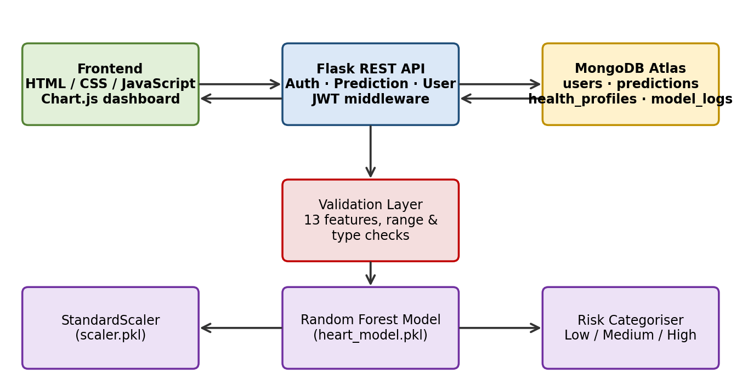

Fig 4.1: System Architecture
A request passes through the following path. The browser sends a JSON request with the JWT in the Authorization header. The API verifies the token, validates the thirteen inputs, orders them in the fixed feature order, scales them with the scaler and obtains the probability from the model. The risk categoriser maps the probability to a category, the record is saved to the predictions collection, and the result is returned to the browser. Fig 4.2 shows the complete user workflow from registration to the stored result.
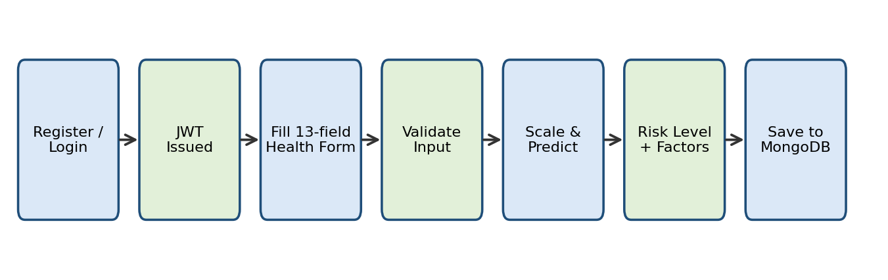

Fig 4.2: User Workflow of the System
The data model is kept simple, as shown in Fig 4.3. The users collection holds the name, a unique e-mail, the password hash and the creation time. The predictions collection holds the user reference, the thirteen inputs, the predicted class, probability, risk level, important factors, model name, model version and timestamp. The health_profiles collection is reserved for future profile data and model_logs is reserved for aggregate model metrics only. Indexes are created on users.email (unique) and on predictions (user_id, created_at descending) so that the history query is fast.
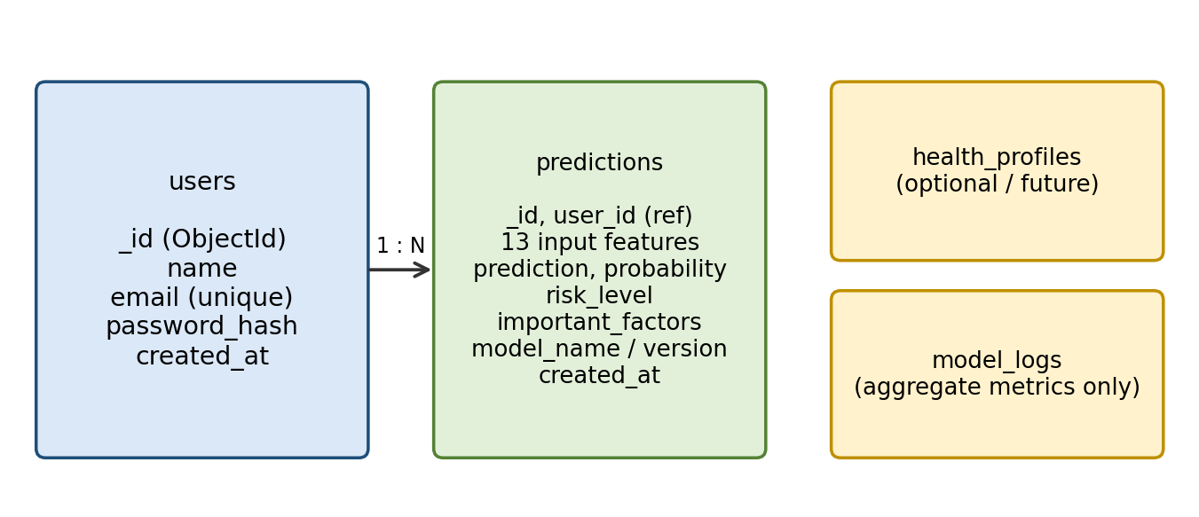

Fig 4.3: MongoDB Data Model
The risk categories used by the application are shown in Fig 4.4. They are application-level categories and not clinical thresholds; they can be changed through the LOW_RISK_MAX and MEDIUM_RISK_MAX environment variables.
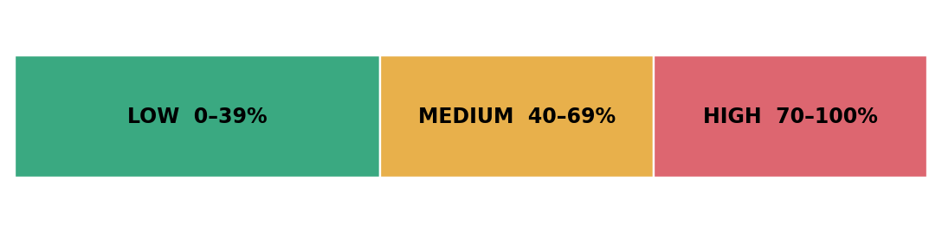

Fig 4.4: Risk Categorisation Bands

4.3 DESCRIPTION OF SOFTWARE FOR IMPLEMENTATION AND TESTING PLAN OF THE PROPOSED MODEL /SYSTEM
The proposed system consists of several modules that work together to generate a reliable and secure risk estimate. Each module is described below together with its implementation and testing plan.
4.3.1 Authentication and User Module
This module (api/auth and api/user) provides registration, login, logout, the current-user endpoint and profile view and update. During registration the name, e-mail and password are checked (valid e-mail and at least 8 characters) and the password is stored as a Werkzeug hash; a duplicate e-mail is rejected with HTTP 409 because of the unique index. During login the hash is verified and a JWT signed with HS256 is returned with the user details. The token carries the user id and expires after the configured number of hours (24 by default). The auth_required decorator reads the Bearer token, decodes it and stores the user id for the request, returning HTTP 401 for a missing, invalid or expired token.
4.3.2 Input Validation Module
The preprocessing module defines the ordered list of thirteen features and the allowed range of each. validate_input() rejects a body that is not a JSON object, a missing field, a non-numeric value, a value outside the range and a fractional value for any feature except oldpeak. Valid values are converted to integers (or float for oldpeak), and to_vector() arranges them in the fixed order expected by the scaler. Table 4.1 lists the features and their allowed values.
Table 4.1: Input Features and Allowed Values
Feature | Description | Allowed values
age | Age in years | 18 - 120
sex | Sex | 0 = female, 1 = male
cp | Chest-pain type | 0 - 3 (typical, atypical, non-anginal, asymptomatic)
trestbps | Resting blood pressure (mmHg) | 70 - 250
chol | Serum cholesterol (mg/dL) | 50 - 700
fbs | Fasting blood sugar | 0 = no, 1 = yes
restecg | Resting ECG result | 0 - 2
thalach | Maximum heart rate achieved | 40 - 250
exang | Exercise-induced angina | 0 = no, 1 = yes
oldpeak | ST depression (decimal allowed) | 0 - 10
slope | Slope of peak exercise ST segment | 0 - 2
ca | Major vessels coloured | 0 - 3
thal | Thalassemia | 0 - 3

4.3.3 Machine-Learning Prediction Module
The HeartPredictor class loads heart_model.pkl and scaler.pkl once with joblib. For each request it scales the vector, calls predict() and predict_proba(), and maps the probability of the positive class to a risk level: Low up to 0.39, Medium up to 0.69 and High above that. If the estimator exposes feature_importances_, the five features with the highest importance are returned as the important factors. The supplied model was inspected and is a scikit-learn RandomForestClassifier with 100 trees and random_state 42. Its feature importances are shown in Fig 4.5, where maximum heart rate (thalach), chest-pain type (cp), ST depression (oldpeak), number of major vessels (ca) and age are the five most important features.
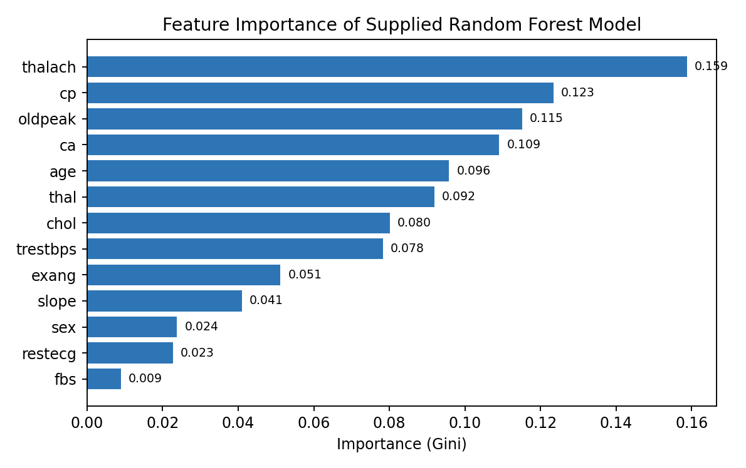

Fig 4.5: Feature Importance of the Random Forest Model
4.3.4 Prediction and History API Module
The prediction blueprint exposes POST /api/prediction/heart, GET /api/prediction/history and GET /api/prediction/<id>. A successful prediction stores the validated inputs, the result, the model name and version and a UTC timestamp, and returns HTTP 201 with the record id, the probability, the risk level, the important factors and the educational disclaimer. History is sorted by newest first, and both history and detail queries are restricted to the authenticated user. If the model cannot be loaded the API returns 503, and invalid input returns 400 with a message naming the field. Table 4.2 lists the endpoints.
Table 4.2: REST API Endpoints
Method | Endpoint | Purpose
POST | /api/auth/register | Create a new account
POST | /api/auth/login | Log in and receive a JWT
POST | /api/auth/logout | Logout (protected)
GET | /api/auth/me | Current user details
GET / PUT | /api/user/profile | View or update profile name
POST | /api/prediction/heart | Validate, predict and store a result
GET | /api/prediction/history | List the user's predictions
GET | /api/prediction/<id> | Single prediction of the user
GET | /api/health | Service health check

4.3.5 Front-End Module
The front end consists of static pages: a landing page, registration and login pages, the health form, the results page, the history page and the dashboard. api.js wraps fetch() and automatically attaches the stored token; form.js converts the form values to numbers and posts them; results.js shows the probability, the risk level, the important factors and the disclaimer; and dashboard.js counts the Low, Medium and High assessments and draws a Chart.js doughnut chart. Form fields use drop-downs for categorical values and numeric limits for measurements so that most invalid input is prevented before it reaches the server.
4.3.6 Model Training Scaffold
The train.py module reads a UCI-style CSV with the thirteen features and a binary target column, splits it 80/20 with stratification, fits a StandardScaler on the training part and trains Logistic Regression, Random Forest and SVM candidates. It reports accuracy, precision, recall, F1 and ROC-AUC for each model, selects the model with the highest ROC-AUC and saves the model and scaler together. No performance claim is made for the supplied artifacts in this report because the dataset used for their training is not part of the project.
4.3.7 Testing Plan
Testing focuses on the parts of the system that can run without a live database. The pytest suite checks that valid input is normalised (for example oldpeak 1.2), that out-of-range values for age, cholesterol and chest-pain type are rejected, that an empty body is rejected and that the /api/health endpoint returns success. Integration tests with a live MongoDB Atlas instance are planned for registration, login, prediction and history. Table 4.3 summarises the test cases.
Table 4.3: Test Plan
Test case | Input / action | Expected result
Valid input | Sample 45-year-old record | Values accepted and normalised
Age below 18 | age = 17 | ValueError (rejected)
Cholesterol above 700 | chol = 701 | ValueError (rejected)
Invalid chest pain code | cp = 4 | ValueError (rejected)
Missing fields | Empty JSON {} | ValueError (rejected)
Health check | GET /api/health | HTTP 200, success true
No token | POST /api/prediction/heart without header | HTTP 401
Prediction (integration) | Sample input from data/sample_input.json | HTTP 201 with risk level

4.3.8 Results and Discussion
To check the end-to-end behaviour, the sample record supplied with the project (age 65, male, chest-pain type 1, resting BP 150, cholesterol 300, fasting blood sugar 1, resting ECG 1, maximum heart rate 120, exercise angina 1, ST depression 3.5, slope 2, two major vessels, thalassemia 2) was scaled and passed to the supplied model. The model returned a probability of 0.75 for heart disease, which the application classifies as High risk. This is consistent with the clinical profile, which combines advanced age, raised blood pressure and cholesterol, a low maximum heart rate, exercise angina, marked ST depression and two diseased vessels.
The result also shows the benefit of presenting risk bands instead of only a class label: the user sees the estimated probability, the High category and the five most influential features, which are maximum heart rate, chest-pain type, ST depression, number of major vessels and age for this model. The discussion has two limits. First, the report does not claim any accuracy, precision or recall for the supplied model because it was not evaluated on a held-out dataset here; the train.py scaffold is provided for such an evaluation. Second, the supplied artifacts were saved with scikit-learn 1.6.1, so the version in requirements.txt is pinned to avoid compatibility warnings.

4.4 PROJECT MANAGEMENT PLAN
The project management plan of the Heart Disease Risk Prediction System defines the phases, deliverables and schedule of the work done between June 2026 and August 2026. The project followed an iterative plan in which each phase produced a working increment that was tested before the next phase started. Requirements and scope were fixed first, followed by the machine-learning integration, the back-end API, the database layer, the front end and finally testing and documentation. Progress was reviewed regularly with the project guide, and risks such as model compatibility and database connectivity were tracked as described in Section 3.1.2. Table 4.4 shows the plan.
Table 4.4: Project Schedule
Phase | Activities | Period
1. Requirements | Problem study, literature survey, feature set and scope | June 2026 (weeks 1-2)
2. ML integration | Load model and scaler, fixed feature order, risk categories | June 2026 (weeks 3-4)
3. Back end | Flask app, auth, JWT, prediction and user routes | July 2026 (weeks 1-2)
4. Database | MongoDB Atlas collections, indexes, history queries | July 2026 (weeks 3-4)
5. Front end | Pages, form, results, history and dashboard | August 2026 (weeks 1-2)
6. Testing and report | pytest suite, start script, documentation, report | August 2026 (weeks 3-4)

4.5 FINANCIAL REPORT ON ESTIMATED COSTING
The proposed system can be implemented using open-source software tools, so the development cost is very low. Table 4.5 lists the tools and their cost. A public deployment would add a small recurring hosting charge, which depends on the provider and the expected traffic.
Table 4.5: Estimated Cost & Implementation Overheads
Serial no | Software Name | Cost
1 | Python and Flask | Free (Open Source)
2 | scikit-learn, NumPy, joblib | Free (Open Source)
3 | MongoDB Atlas (development tier) | Free tier available
4 | Visual Studio Code / Git | Free
5 | Chart.js and pytest | Free (Open Source)
6 | Public hosting and domain (optional) | Depends on provider

4.6 TRANSITION / SOFTWARE TO OPERATIONS PLAN
The transition plan defines how the application moves from the development environment to operation. For the demonstration setup the user creates a virtual environment, installs the requirements, copies .env.example to .env and sets MONGO_URI and a long random SECRET_KEY, and confirms that MODEL_PATH and SCALER_PATH point to the compatible artifacts. The back end is then started with run.py and the front end is served as static files, or both are started with the start_project.bat script.
For a public deployment the debug server should be replaced by a production WSGI server behind HTTPS, FRONTEND_ORIGIN should be restricted to the real front-end address, and the database user should be limited to the heart_risk_db database. Operational tasks include database backups, rotating the secret key, monitoring /api/health, and replacing the model and scaler together when the model is retrained.

REFERENCES

- Ali, M.M., Paul, B.K., Ahmed, K., et al.: Heart disease prediction using supervised machine learning algorithms: Performance analysis and comparison. Computers in Biology and Medicine 136, 104672 (2021)
- Benjamin, E.J., Muntner, P., Alonso, A., et al.: Heart disease and stroke statistics - 2019 update. Circulation 139(10), e56-e528 (2019)
- Breiman, L.: Random forests. Machine Learning 45(1), 5-32 (2001)
- Chodorow, K.: MongoDB: The Definitive Guide, 3rd edn. O'Reilly Media (2019)
- Detrano, R., Janosi, A., et al.: International application of a new probability algorithm for the diagnosis of coronary artery disease. American Journal of Cardiology 64(5), 304-310 (1989)
- Fielding, R.T.: Architectural styles and the design of network-based software architectures. Doctoral dissertation, UC Irvine (2000)
- Grinberg, M.: Flask Web Development, 2nd edn. O'Reilly Media (2018)
- Hastie, T., Tibshirani, R., Friedman, J.: The Elements of Statistical Learning, 2nd edn. Springer, New York (2009)
- Jones, M., Bradley, J., Sakimura, N.: JSON Web Token (JWT). RFC 7519, IETF (2015)
- Krittanawong, C., Virk, H.U.H., et al.: Machine learning prediction in cardiovascular diseases: a meta-analysis. Scientific Reports 10, 16057 (2020)
- Mohan, S., Thirumalai, C., Srivastava, G.: Effective heart disease prediction using hybrid machine learning techniques. IEEE Access 7, 81542-81554 (2019)
- Pedregosa, F., Varoquaux, G., Gramfort, A., et al.: Scikit-learn: Machine learning in Python. Journal of Machine Learning Research 12, 2825-2830 (2011)
- Rajkomar, A., Dean, J., Kohane, I.: Machine learning in medicine. New England Journal of Medicine 380(14), 1347-1358 (2019)
- Weng, S.F., Reps, J., Kai, J., et al.: Can machine-learning improve cardiovascular risk prediction using routine clinical data? PLoS ONE 12(4), e0174944 (2017)

