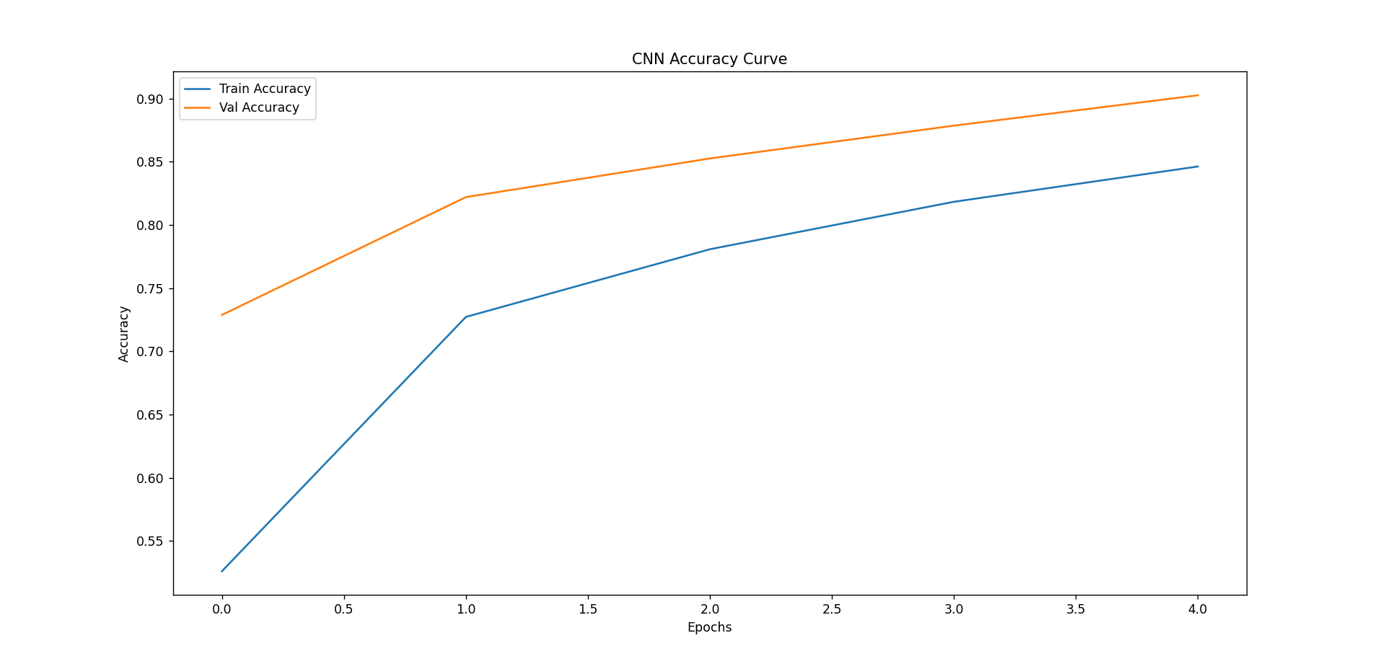

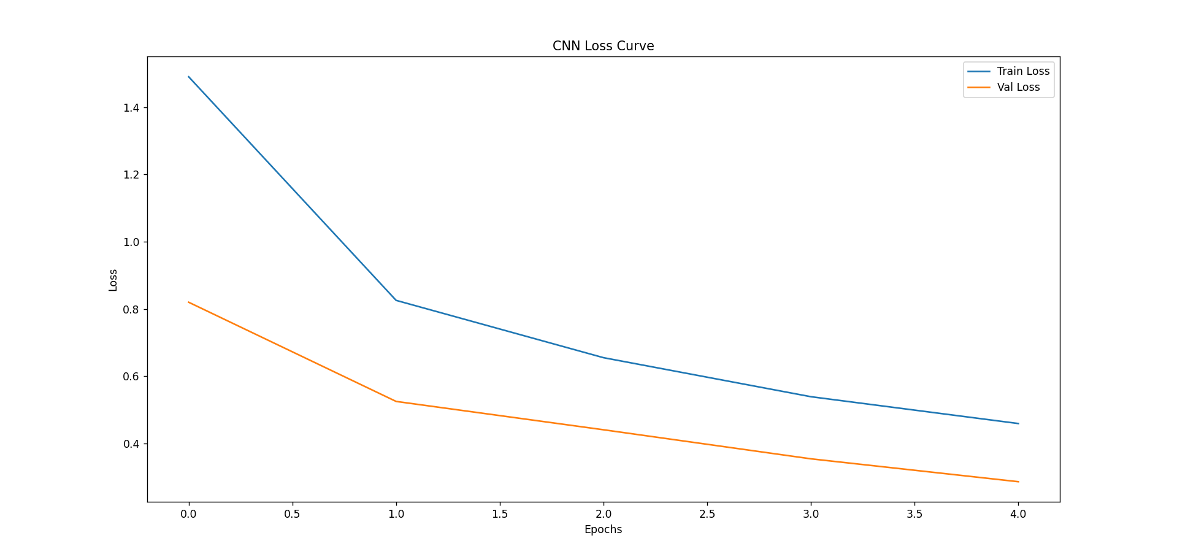

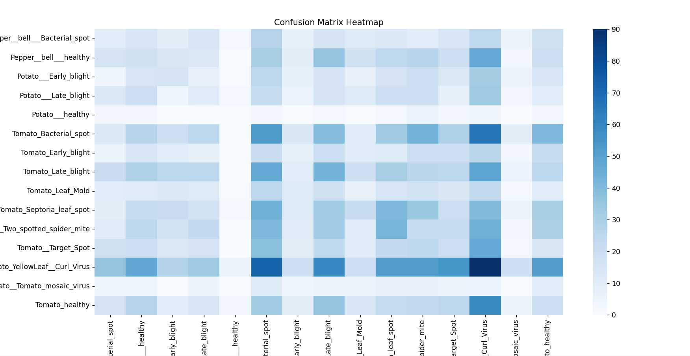

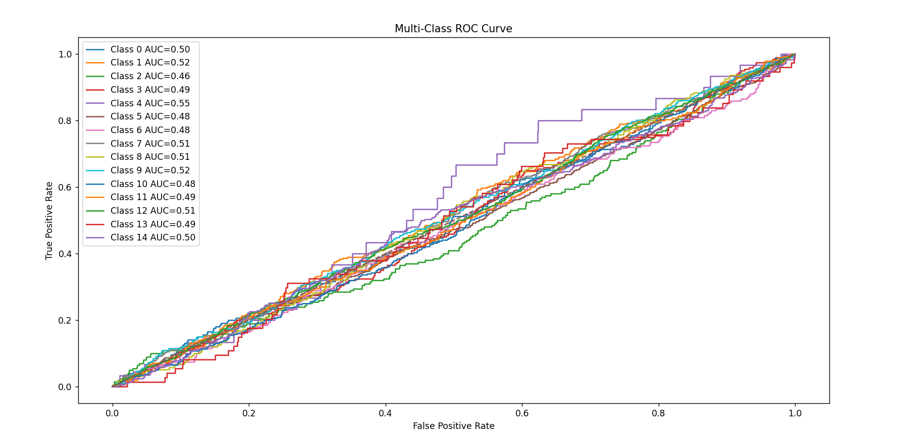

precision recall f1-score support
Pepper__bell___Bacterial_spot 0.052910 0.050251 0.051546 199.000000
Pepper__bell___healthy 0.060201 0.061017 0.060606 295.000000
Potato___Early_blight 0.080000 0.080000 0.080000 200.000000
Potato___Late_blight 0.048458 0.055000 0.051522 200.000000
Potato___healthy 0.000000 0.000000 0.000000 30.000000
Tomato_Bacterial_spot 0.107287 0.124706 0.115343 425.000000
Tomato_Early_blight 0.057554 0.040000 0.047198 200.000000
Tomato_Late_blight 0.108312 0.112861 0.110540 381.000000
Tomato_Leaf_Mold 0.038889 0.036842 0.037838 190.000000
Tomato_Septoria_leaf_spot 0.116147 0.115819 0.115983 354.000000
Tomato_Spider_mites_Two_spotted_spider_mite 0.062500 0.065672 0.064047 335.000000
Tomato__Target_Spot 0.068493 0.071429 0.069930 280.000000
Tomato__Tomato_YellowLeaf__Curl_Virus 0.152284 0.140406 0.146104 641.000000
Tomato__Tomato_mosaic_virus 0.000000 0.000000 0.000000 74.000000
Tomato_healthy 0.062305 0.062893 0.062598 318.000000
accuracy 0.087094 0.087094 0.087094 0.087094
macro avg 0.067689 0.067793 0.067550 4122.000000
weighted avg 0.086949 0.087094 0.086817 4122.000000

📌 Plotting ROC Curve...

✅ Final Evaluation Summary Table:

Metric Value
0 Accuracy 0.087094
1 Macro Precision 0.067689
2 Macro Recall 0.067793
3 Macro F1-Score 0.067550

Original Image
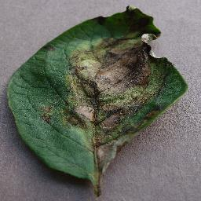
Prediction Probability:
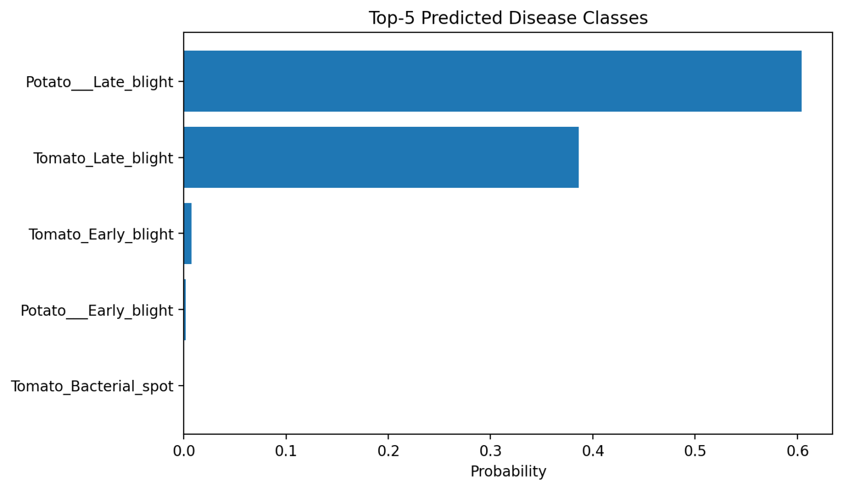
Severity Level: 87.26%

Severity in Gray shade:

Grad CAM
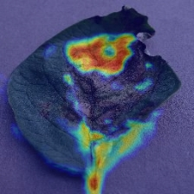
Recommendation: Use certified fungicide spray and isolate infected plants.

