DIGITAL NURTURE 4.0 JavaFSE
WEEK 2
PL/SQL
Exercise 1: Control Structures
Scenario 1: The bank wants to apply a discount to loan interest rates for customers above 60 years old.
Question: Write a PL/SQL block that loops through all customers, checks their age, and if they are above 60, apply a 1% discount to their current loan interest rates.

CREATE TABLE Customers (
CustomerID NUMBER PRIMARY KEY,
Name VARCHAR2(100),
Age NUMBER,
Balance NUMBER(10,2),
IsVIP CHAR(1) DEFAULT 'N' -- 'Y' or 'N'
);
INSERT INTO Customers VALUES (1, 'John Doe', 65, 12000.00, 'N');
INSERT INTO Customers VALUES (2, 'Alice Smith', 45, 8000.00, 'N');
INSERT INTO Customers VALUES (3, 'Bob Johnson', 70, 15000.00, 'N');
INSERT INTO Customers VALUES (4, 'Sara Lee', 30, 3000.00, 'N');

BEGIN
FOR rec IN (
SELECT c.CustomerID, l.LoanID
FROM Customers c
JOIN Loans l ON c.CustomerID = l.CustomerID
WHERE c.Age > 60
) LOOP
UPDATE Loans
SET InterestRate = InterestRate - 1
WHERE LoanID = rec.LoanID;
END LOOP;

COMMIT;
END;
OUTPUT:
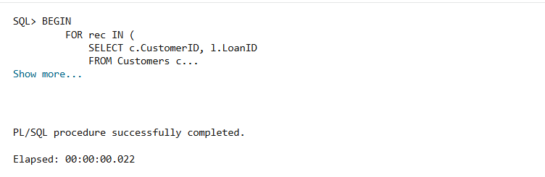
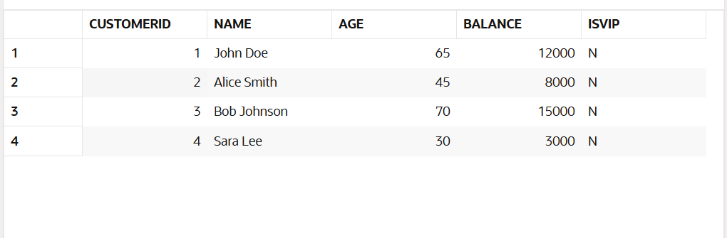
Scenario 2: A customer can be promoted to VIP status based on their balance.
Question: Write a PL/SQL block that iterates through all customers and sets a flag IsVIP to TRUE for those with a balance over $10,000.
CREATE TABLE Loans (
LoanID NUMBER PRIMARY KEY,
CustomerID NUMBER,
InterestRate NUMBER(5,2), -- in percent
DueDate DATE,
FOREIGN KEY (CustomerID) REFERENCES Customers(CustomerID)
);
INSERT INTO Loans VALUES (101, 1, 8.5, SYSDATE + 10);
INSERT INTO Loans VALUES (102, 2, 9.0, SYSDATE + 40);
INSERT INTO Loans VALUES (103, 3, 7.5, SYSDATE + 5);
INSERT INTO Loans VALUES (104, 4, 10.0, SYSDATE + 15);

BEGIN
FOR rec IN (SELECT CustomerID FROM Customers WHERE Balance > 10000) LOOP
UPDATE Customers
SET IsVIP = 'Y'
WHERE CustomerID = rec.CustomerID;
END LOOP;

COMMIT;
END;
OUTPUT:
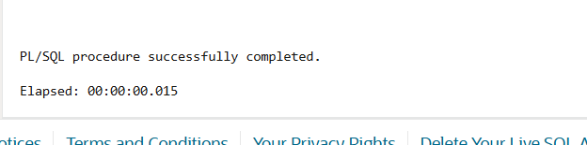
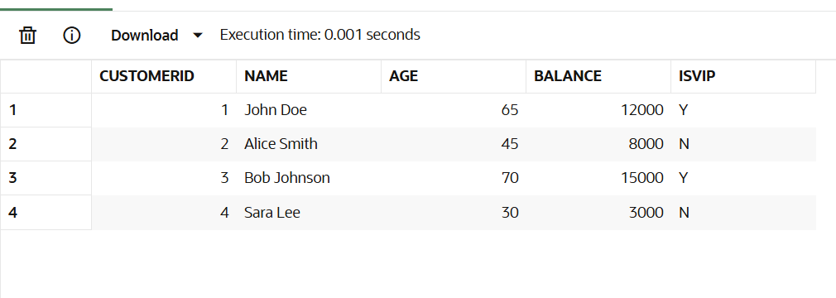
Scenario 3: The bank wants to send reminders to customers whose loans are due within the next 30 days.
Question: Write a PL/SQL block that fetches all loans due in the next 30 days and prints a reminder message for each customer.

BEGIN
FOR rec IN (
SELECT c.Name, l.LoanID, l.DueDate
FROM Loans l
JOIN Customers c ON l.CustomerID = c.CustomerID
WHERE l.DueDate BETWEEN SYSDATE AND SYSDATE + 30
) LOOP
DBMS_OUTPUT.PUT_LINE('Reminder: Loan ID ' || rec.LoanID ||
' for customer ' || rec.Name ||
' is due on ' || TO_CHAR(rec.DueDate, 'DD-MON-YYYY'));
END LOOP;
END;
OUTPUT:
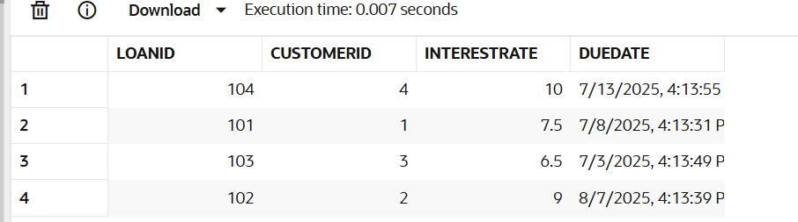

Exercise 3:
Stored Procedures:
Scenario 1:
The bank needs to process monthly interest for all savings accounts.

Question: Write a stored procedure ProcessMonthlyInterest that calculates and updates the balance of all savings accounts by applying an interest rate of 1% to the current balance.

Table Creation:
CREATE TABLE SavingsAccounts (
AccountID NUMBER PRIMARY KEY,
CustomerID NUMBER,
Balance NUMBER(10,2)
);
INSERT INTO SavingsAccounts (AccountID, CustomerID, Balance)
VALUES (101, 1, 5000.00);
INSERT INTO SavingsAccounts (AccountID, CustomerID, Balance)
VALUES (102, 2, 10000.00);
INSERT INTO SavingsAccounts (AccountID, CustomerID, Balance)
VALUES (103, 3, 2000.00);
PL/SQL Query:
CREATE OR REPLACE PROCEDURE ProcessMonthlyInterest IS
BEGIN
FOR acc IN (SELECT AccountID, Balance FROM SavingsAccounts) LOOP
UPDATE SavingsAccounts
SET Balance = Balance + (Balance * 0.01)
WHERE AccountID = acc.AccountID;
END LOOP;
COMMIT;
END;
BEGIN
ProcessMonthlyInterest;
END;
SELECT * FROM SavingsAccounts;
OUTPUT:
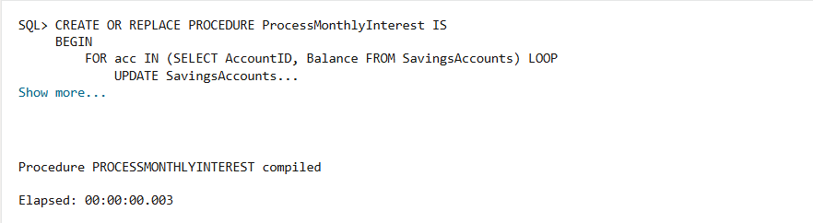

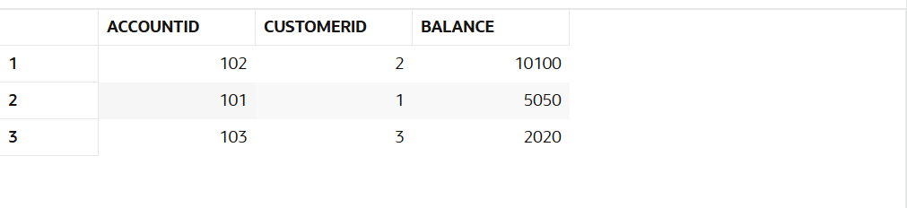

Scenario 2:
A customer can be promoted to VIP status based on their balance.
Question: Write a PL/SQL block that iterates through all customers and sets a flag IsVIP to TRUE for those with a balance over $10,000.

CREATE TABLE Employees {
EmpID NUMBER PRIMARY KEY,
Name VARCHAR2(100),
Department VARCHAR2(50),
Salary NUMBER(10,2)
);

INSERT INTO Employees (EmpID, Name, Department, Salary)
VALUES (201, 'Alice', 'HR', 40000);
INSERT INTO Employees (EmpID, Name, Department, Salary)
VALUES (202, 'Bob', 'Finance', 45000);
INSERT INTO Employees (EmpID, Name, Department, Salary)
VALUES (203, 'Charlie', 'HR', 50000);

Query:
CREATE OR REPLACE PROCEDURE UpdateEmployeeBonus (
p_department IN VARCHAR2,
p_bonus_percent IN NUMBER
) IS
BEGIN
UPDATE Employees
SET Salary = Salary + (Salary * (p_bonus_percent / 100))
WHERE Department = p_department;

COMMIT;
END;

BEGIN
UpdateEmployeeBonus('HR', 10);
END;

SELECT * FROM Employees;

OUTPUT:
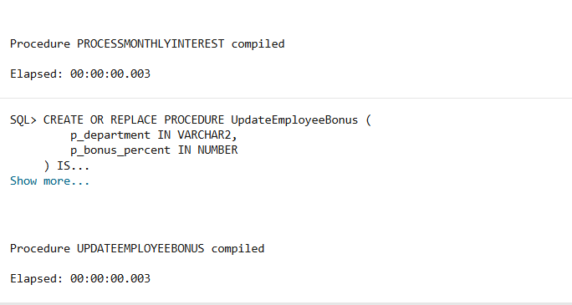

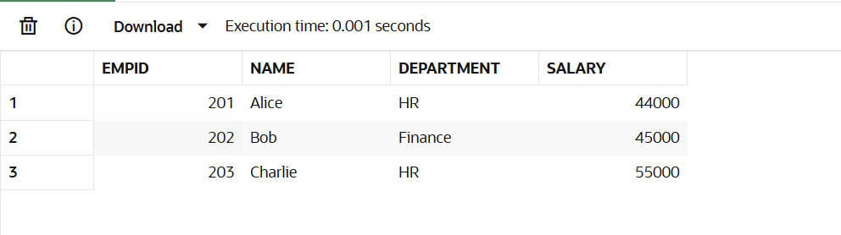
Scenario 3:
The bank wants to send reminders to customers whose loans are due within the next 30 days.
Question: Write a PL/SQL block that fetches all loans due in the next 30 days and prints a reminder message for each customer.
CREATE TABLE BankAccounts (
AccountID NUMBER PRIMARY KEY,
CustomerID NUMBER,
Balance NUMBER(10,2)
);
INSERT INTO BankAccounts (AccountID, CustomerID, Balance)
VALUES (301, 1, 8000.00);

INSERT INTO BankAccounts (AccountID, CustomerID, Balance)
VALUES (302, 2, 3000.00);

QUERY:
CREATE OR REPLACE PROCEDURE TransferFunds (
p_source_account IN NUMBER,
p_target_account IN NUMBER,
p_amount IN NUMBER
) IS
v_balance NUMBER;
BEGIN

SELECT Balance INTO v_balance
FROM BankAccounts
WHERE AccountID = p_source_account;

IF v_balance < p_amount THEN
RAISE_APPLICATION_ERROR(-20001, 'Insufficient balance in source account.');
END IF;

UPDATE BankAccounts
SET Balance = Balance - p_amount
WHERE AccountID = p_source_account;

UPDATE BankAccounts
SET Balance = Balance + p_amount
WHERE AccountID = p_target_account;

COMMIT;
END;
BEGIN
TransferFunds(301, 302, 2000);
END;
SELECT * FROM BankAccounts;

OUTPUT:

