IN THE PARTIAL FULFILMENT OF
Master of Science – MSc IT Sem 5



L.J School of Computer Applications, LJKU

CODE QUEST

DEVELOPED BY: Saravana, Vignesh, Rahul GUIDED BY: Laja Mam

L.J. INSTITUTE OF COMPUTER APLLICATIONS

Near Nagdev Kalyan Mandir, Near Sanand Cross Roads, Serkhej-Gandhinagr Highway Ahmedabad – 382210
Ph. No.: 9099063417

Master of Science – MSc IT Sem 5


L.J School of Computer Applications, LJKU

CERTIFICATE

Enrollment No:22004500210250 Seat No:

This is to certify that RAHUL SHUKLA of Master of Science (MScIT), Semester V, Roll No __55___ has satisfactorily completed his/her Project titled CODE QUEST in Django under the supervision of internal guide.

Internal Guide: HOD:
Name of the internal guide Dr. Jignesh Doshi

Date of Submission:

Master of Science – MSc IT Sem 5


L.J School of Computer Applications, LJKU

CERTIFICATE

Enrollment No:22004500210134 Seat No:

This is to certify that VIGNESH MUDALIYARof Master of Science (MScIT), Semester V, Roll No __30___ has satisfactorily completed his/her Project titled CODE QUEST in Django under the supervision of internal guide.

Internal Guide: HOD:
Name of the internal guide Dr. Jignesh Doshi

Date of Submission:

Master of Science – MSc IT Sem 5


L.J School of Computer Applications, LJKU

CERTIFICATE

Enrollment No:22004500210133 Seat No:

This is to certify that SARAVANA MUDALIYARof Master of Science (MScIT), Semester V, Roll No __29__ has satisfactorily completed his/her Project titled CODE QUEST in Django under the supervision of internal guide.

Internal Guide: HOD:
Name of the internal guide Dr. Jignesh Doshi

Date of Submission:

Plagiarism Declaration

To whom so ever it may concern

I/ We, the project team, confirm that this Project (document/PPT or Code) is my/our own work, is not copied from any other person's work (published or unpublished or generated using CHATGPT/AI), and has not previously submitted for assessment either at University or elsewhere. I/We confirm that I/we have read and understood the rules regulations on plagiarism in LJ University.

Enrollment no | Name | Sign
22004500210250 | Rahul Shukla
22004500210133 | Saravana Mudaliyar
22004500210134 | Vigenesh Mudaliyar

Date:

Sr.  No. | TABLE OF CONTENTS | Page No.
1. | INTRODUCTION | 6-10
 | 1.1 Existing System | 7
 | 1.2 Need for the New System | 7
 | 1.3 Objective of the New System | 7
 | 1.4 Problem Definition | 8
 | 1.5 Core Components | 8
 | 1.6 Project Profile | 9
 | 1.7 Assumptions and Constraints | 10
 | 1.8 Advantages and Limitations of the Proposed System | 10
2. | REQUIREMENT DETERMINATION & ANALYSIS | 11-12
 | 2.1 Requirement Determination | 11
 | 2.2 Targeted Users | 12
3. | SYSTEM DESIGN | 13-24
 | 3.1 Use Case Diagram | 13
 | 3.2 Class Diagram | 14
 | 3.3 Interaction Diagram | 15
 | 3.4 Activity Diagram | 18
 | 3.5 Data Dictionary | 21
4. | DEVELOPMENT | 25-30
 | 4.1 Coding Standard | 25
 | 4.2 Screenshots | 26
5. | AGILE DOCUMENTATION | 31-38
 | 5.1 Agile Project Charter | 31
 | 5.2 Agile Roadmap / Schedule | 32
 | 5.3 Agile Project Plan | 33
 | 5.4 Agile User Story (Minimum 3 Tasks) | 34
 | 5.5 Agile Release Plan | 35
 | 5.6 Agile Sprint Backlog | 36
 | 5.7 Agile Test Plan | 37
 | 5.8 Earned-value and burn charts | 38
6. | PROPOSED ENHANCEMENTS | 39
7. | CONCLUSION | 40
8. | BIBLIOGRAPHY | 41

Introduction

In today’s fast-paced educational environment, managing coding practice and assessments effectively is more important than ever for both students and educators. Traditional systems often fall short, offering limited language support and fragmented workflows, which can make the learning process inefficient and awkward. Code Quest was created to solve these problems by providing an all-in-one platform that simplifies coding practice, testing, and management.
Built on Django, Code Quest caters to three main user roles: students, teachers, and superadmins. The platform supports multiple programming languages, including C, C++, Java, and Python, to meet the diverse needs of modern learners. For students, it offers an organized workspace to practice coding and take tests. Teachers can easily create, schedule, and grade assignments, while superadmins manage users and courses, ensuring the platform runs smoothly and efficiently.
By combining all these features into one unified system, Code Quest transforms the way coding is taught and learned. It enhances the learning experience for students, streamlines administrative tasks for educators, and promotes a supportive environment where coding excellence can thrive.

  - ​Existing System

Managing coding assessments and practice sessions is often a messy and time-consuming process in many educational settings. Educators use a mix of disconnected tools and manual steps, making tasks like scheduling, grading, and organizing tests harder than they need to be. Most traditional coding platforms lack proper integration, leaving students and educators to deal with clunky interfaces and limited language support.

  - Need for New System

With the growing demand for coding skills, the need for a structured and comprehensive platform is more important than ever. A modern system should make managing coding tests and practice sessions easier while improving the user experience.
This is where Code Quest comes in. It offers an all-in-one solution that simplifies test management, supports multiple programming languages, and provides a smooth, user-friendly experience for both students and educators.

  - Objective Of New System

The goal of Code Quest is to create a platform that is efficient, user-focused, and tailored to the needs of modern coding education. Its objectives include:
- Empowering Students: Provide a dedicated workspace for students to practice coding and take tests in languages like C, C++, Java, and Python.
- Supporting Teachers: Offer tools for teachers to create, schedule, and grade tests easily, with features to manage test content and track student performance.
- Streamlining Administration: Equip superadmins with the ability to manage users (students and teachers), oversee courses, and handle system-wide administrative tasks.
- Improving User Experience: Deliver an intuitive interface with integrated functionalities that make the platform easy to use for everyone involved.

  - Project Definition

Current coding assessment systems face several problems:
- Disconnected Processes: Managing tests is often messy and inefficient.
- Limited Features: Many platforms only support a few programming languages and have clunky, hard-to-use interfaces.
- Difficult Data Management: Keeping user info, test content, and resources up to date can be time-consuming and error-prone.
Code Quest is built to solve these issues. It’s an all-in-one platform that makes managing coding tests and practice sessions easy. With support for multiple programming languages and simple tools for organizing everything, Code Quest offers a smooth experience for students, teachers, and administrators.

  - ​Core Components

Built on the Django framework, Code Quest is structured around three main components:
- Student Page:
A dedicated coding workspace where students can practice programming and take tests in C, C++, Java, and Python. This page offers an interactive environment for solving coding challenges, submitting solutions, and increacse their skills.
- Teacher Page:
Designed to make life easier for educators, this page allows teachers to create, schedule, and add assignment. It includes tools for managing test content, tracking student progress, and providing actionable feedback.
- Superadmin Page:
This page serves as the control centre for the platform. Superadmins can manage users (adding, updating, or deleting teachers and students), oversee courses, and ensure the smooth operation of the entire system.

1.5 Project Profile

Project Name | CodeQuest
Developed by | Vignesh Mudaliyar (30)  Saravana Mudaliyar (29)  Rahul Shukla (55)
Front-End | - Technology: HTML5, CSS3, JavaScript, Ajax  - Frameworks/Libraries: Bootstrap, jQuery  - Features: Responsive design, interactive user interface, automate test grading.
Back-End | - Technology: Django Framework (Python)  - Features: MVC architecture, RESTful API endpoints, database management, authentication and authorization.
Server | - Database Administration Tool: SQL  - Configuration: Deployment configurations, security settings, and performance optimization.

  - Assumptions and Constraints

Assumptions:
- Users should have a basic knowledge of the programming languages supported by the platform.
- The platform will mainly be accessed via a web browser.
- Admin users, like teachers and superadmins, will have the proper permissions and understand their roles.
Constraints:
- The platform supports only four programming languages: C, C++, Java, and Python.
- A stable internet connection is needed to use the platform.
- New users may need some time to get used to the system’s features.

  - Advantages and Limitations of the Proposed System

Advantages:
- Provides a centralized platform for managing coding assessments and practice sessions.
- Simplifies tasks like test creation, scheduling, and grading, making them easier for educators.
- Supports multiple programming languages, allowing students to practice and take tests on one platform.
- Offers a user-friendly, unified interface for a better overall experience.
Limitations:
- Currently supports only four programming languages, which may not meet the needs of all users.
- Requires internet access, which could be a challenge in areas with poor connectivity.
- Some users may take time to get comfortable with the platform’s features.

- REQUIREMENT DETERMINATION & ANALYSIS

  - Requirement Determination

To make sure Code Quest meets user needs, its features and functionalities are clearly defined and organized into functional and non-functional requirements based on the project's goals.

Functional Requirements

Student Workspace:
- Take coding tests in C, C++, Java, and Python.
- Submit code solutions directly on the platform.
- Use a dedicated practice area to improve coding skills.
- Submit assignments on time.
- Pay penalties online for missed deadlines.
Teacher Interface:
- Easily create and manage coding tests.
- Schedule tests and assignments based on course timelines.
- Add questions with input and output options.
- View marks and download them as Excel files.
Superadmin Dashboard:
- Manage users (add, update, or delete students and teachers).
- Oversee course management, including adding, updating, and deleting courses.
- Access tools and settings to oversee the platform.

Non-Functional Requirements

Usability:
- Provide a user-friendly interface for students, teachers, and superadmins.
- Ensure the platform works well on desktops, tablets, and smartphones.
Performance:
- Offer fast load times and smooth performance, even during heavy usage.
- Use scalable architecture to handle growth in users and data.
Security:
- Use secure authentication and role-based permissions to protect user data.
- Encrypt sensitive data and enable secure communication.
Compatibility:
- Work on all major web browsers and operating systems.
- Allow integration with other tools and services when needed.

Maintainability:
- Build a modular, well-documented codebase for easy updates and maintenance.
- Include error handling and clear logs for quick problem-solving.

  - Targeted Users

Code Quest is designed for three main user groups, each with unique needs and features:
Students:
- Needs: A flexible platform to practice coding, take tests, and submit assignments. They need a workspace that supports multiple programming languages to enhance their learning and skills.
- Functionalities: Access to a coding workspace, test submission, assignment submission, and a dedicated practice area.
Teachers:
- Needs: Tools to create and schedule tests and assignments, automate grading, and track student progress. They require an easy-to-use interface to manage content and administrative tasks efficiently.
- Functionalities: Test creation, assignment scheduling, automated grading, and student progress tracking.
Superadmins:
- Needs: Complete control of the platform to manage users, courses, and system settings. They need tools to configure and oversee the platform's overall functionality.
- Functionalities: User and course management, system configuration, and administrative oversight.

- System Design

  - User Case Diagram
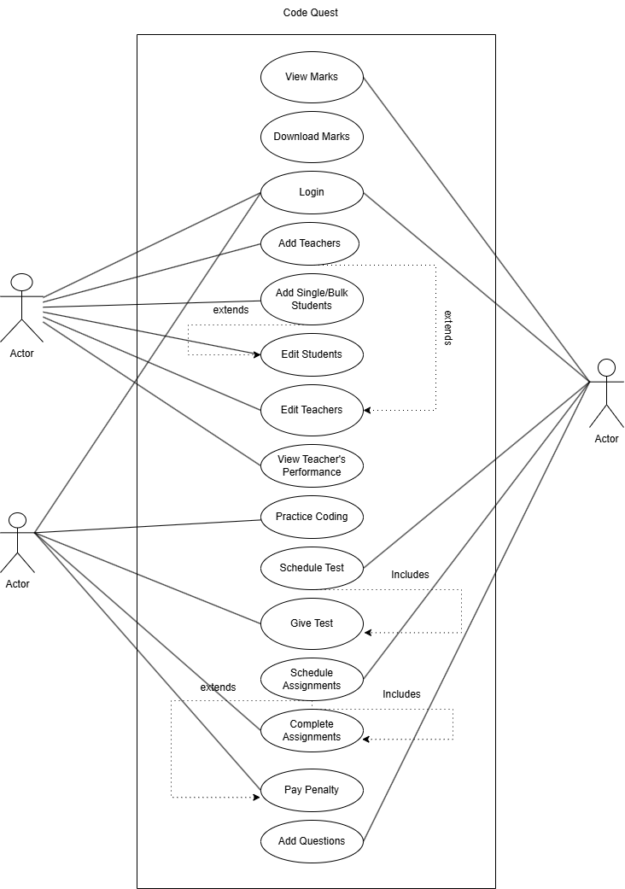
Teacher
Student
Superadmin

  - Class Diagram
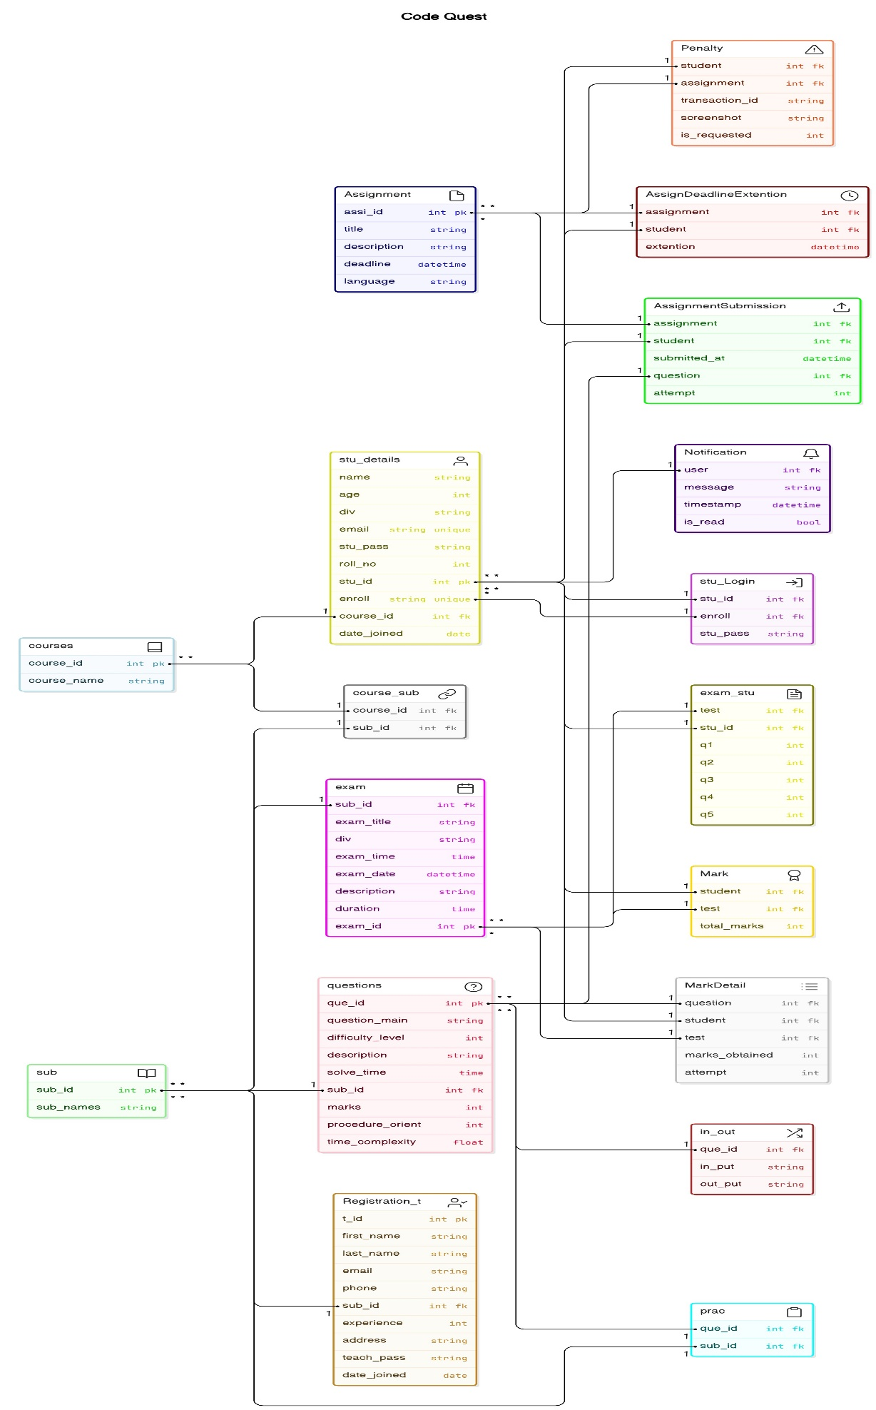

  - Sequence Diagram

Actor: Teacher Admin:

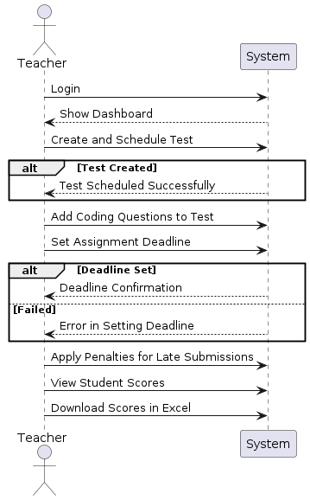

Actor: SuperAdmin:

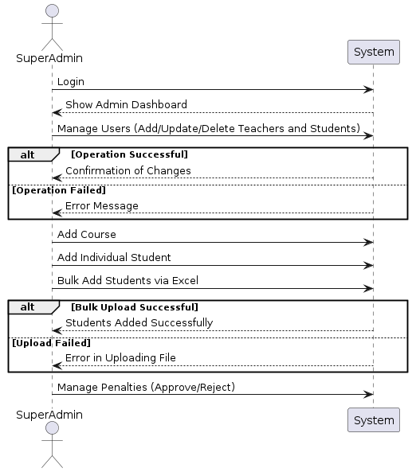

Actor: Student:
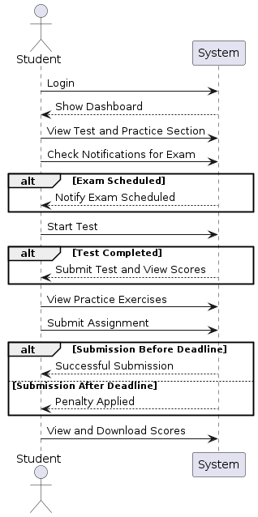

  - Activity Diagram

Actor: Student:

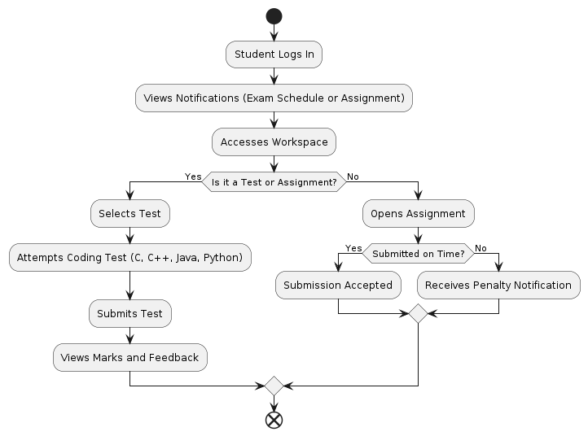

Actor: TeacherAdmin

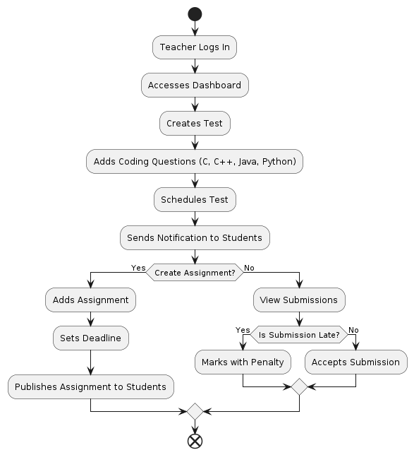

Actor: SuperAdmin:

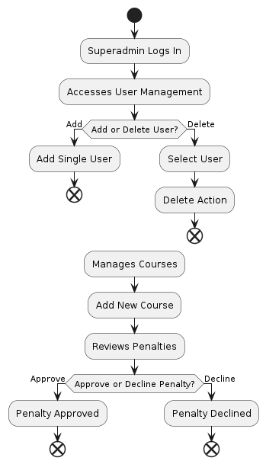

  - Data Dictionary

Table: courses
Field Name | DataType | Constraint
course_id | AutoField | primary_key
course_name | CharField (100)
Table: sub
Field Name | DataType | Constraint
sub_id | AutoField | primary_key
sub_names | CharField (100)
Table: course_sub
Field Name | DataType | Constraint
course_id | ForeignKey (courses) | on_delete=CASCADE
sub_id | ForeignKey (sub) | on_delete=CASCADE
Table: stu_details
Field Name | DataType | Constraint
stu_id | AutoField | primary_key
name | CharField (75)
age | IntegerField | validators=[MinValueValidator (18), MaxValueValidator(50)]
div | CharField (2)
enroll | CharField (15) | unique=True
email | EmailField (150) | unique=True, null=True
stu_pass | CharField (128) | null=True
roll_no | IntegerField
course_id | ForeignKey | on_delete=CASCADE
Table: Registration_t
Field Name | DataType | Constraint
t_id | AutoField | primary_key
first_name | CharField (50)
last_name | CharField (50)
email | EmailField
phone | CharField (15)
sub_id | ForeignKey | on_delete=CASCADE
experience | PositiveIntegerField
address | TextField
teach_pass | CharField (128) | null=True
Table: Admin_log
Field Name | DataType | Constraint
a_id | AutoField | primary_key
admin_id | CharField (10) | unique=True, default='1234@'
admin_pass | CharField (128) | default='admin123'
Table: stu_Login
Field Name | DataType | Constraint
stu_id | ForeignKey | on_delete=CASCADE, related_name='logins_by_stu_id', null=True
enroll | ForeignKey | on_delete=CASCADE, related_name='logins_by_enroll', null=True
stu_pass | CharField (128)
Table: profess
Field Name | DataType | Constraint
prof_id | AutoField | primary_key
name | CharField (75)
prof_login_id | CharField (50)
prof_pass | CharField (128)
Table: questions
Field Name | DataType | Constraint
que_id | AutoField | primary_key
question_main | TextField
difficulty_level | IntegerField | choices=Difficulty.choices, default=Difficulty.EASY
description | TextField | null=True
solve_time | TimeField
sub_id | ForeignKey | on_delete=CASCADE, null=True
marks | IntegerField | null=True
procedure_orient | IntegerField | default=0
time_complexity | FloatField | default=0
Table: in_out
Field Name | DataType | Constraint
que_id | ForeignKey | on_delete=CASCADE
in_put | CharField (50)
out_put | CharField (50)
Table: prac
Field Name | DataType | Constraint
que_id | ForeignKey | on_delete=CASCADE
sub_id | ForeignKey | on_delete=CASCADE
Table: exam
Field Name | DataType | Constraint
exam_id | AutoField | primary_key
sub_id | ForeignKey | on_delete=CASCADE
exam_title | TextField | null=True
div | TextField | null=True
exam_time | TimeField
exam_date | DateTimeField | auto_now_add=True
description | TextField | null=True
duration | TimeField | default="20:00"
Table: exam_stu
Field Name | DataType | Constraint
test | ForeignKey (exam) | on_delete=models. CASCADE
stu_id | ForeignKey (stu_details) | on_delete=models. CASCADE
q1 | IntegerField | null=True
q2 | IntegerField | null=True
q3 | IntegerField | null=True
q4 | IntegerField | null=True
q5 | IntegerField | null=True
Table: assignment
Field Name | DataType | Constraint
assi_id | AutoField | primary_key
title | CharField | max_length=200, null=True
description | TextField | null=True
deadline | DateTimeField | auto_now_add=True
language | CharField | max_length=50, null=True
Table: AssignmentSubmission
Field Name | DataType | Constraint
assi_id | ForeignKey | on_delete=CASCADE
sub_id | ForeignKey | on_delete=CASCADE
submitted_at | DateTimeField | null=True, blank=True
question | ForeignKey | FK to questions, related_name='assignment_questions', null=True
attempt | IntegerField | default=0
Table: AssignDeadlineExtention
Field Name | DataType | Constraint
assi_id | ForeignKey | on_delete=CASCADE
sub_id | ForeignKey | on_delete=CASCADE
extention | DateTimeField | null=True, blank=True
Table: penalty
Field Name | DataType | Constraint
student | ForeignKey | on_delete=CASCADE
assignment | ForeignKey | on_delete=CASCADE
screenshot | ImageField | upload_to='penalty_screenshots/', null=True, blank=True
is_requested | IntegerField | default=0
Table: marks
Field Name | DataType | Constraint
stu_id | ForeignKey | on_delete=CASCADE
sub_id | ForeignKey | on_delete=CASCADE
total_marks | IntegerField
Table: MarkDetail
Field Name | DataType | Constraint
question | ForeignKey | FK to questions
student | ForeignKey | FK to stu_details, default=False
test | ForeignKey | FK to exam, default=False
marks_obtained | IntegerField
attempt | IntegerField | default=0
Table: Notification
Field Name | DataType | Constraint
user | ForeignKey | FK to stu_details
message | TextField
timestamp | DateTimeField | auto_now_add=True
is_read | BooleanField | default=False

- Development
4.1 Coding Standards
1.Language-Specific Guidelines
Python:
- Use clear and descriptive names for variables and functions to enhance code readability.
- Include docstrings for functions and classes to provide context and documentation.
C/C++:
- Follow the Google C++ Style Guide or similar widely accepted conventions.
- Maintain consistent naming conventions for variables, functions, and classes.
- Add comments to explain complex logic, making the code easier to understand and maintain.

2. Project Structure
Django Project Structure:
- Organize the codebase into modular apps (e.g., student, teacher, superadmin) for better separation of concerns.
- Keep models, views, and templates in their respective folders to maintain clarity and organization.
- Leverage Django’s built-in features, adhering to best practices for database design and query optimization to ensure efficient performance.

3. Code Review
- Conduct regular code reviews to identify and address potential issues early.
- Use automated tools like linters (e.g., flake8 for Python) and formatters (e.g., black for Python, clang-format for C/C++) to enforce consistent styling and formatting rules across the project.

4. Testing
- Write unit tests to verify the functionality of individual components, such as models and views.
- Implement integration tests to ensure smooth interaction between different parts of the application.
- Test edge cases and potential failure points to improve overall robustness and reliability.

  - Screenshots

1.Login page(for all)

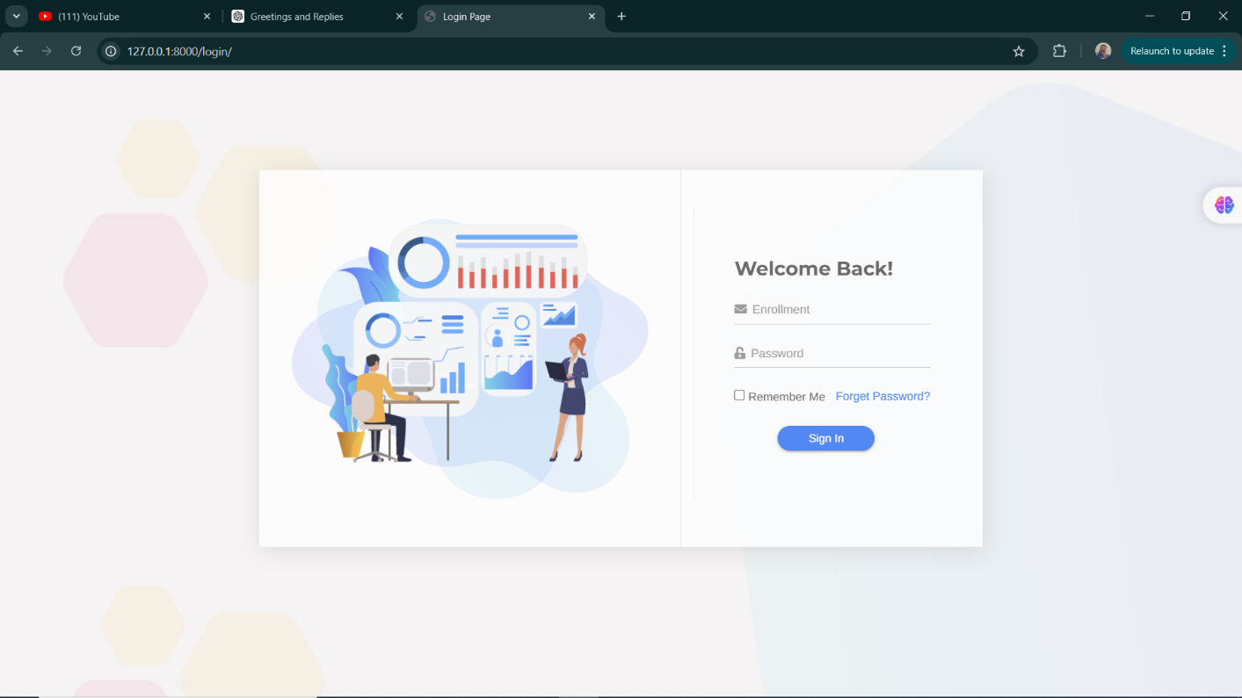
2.Student Page

  - Workspace:
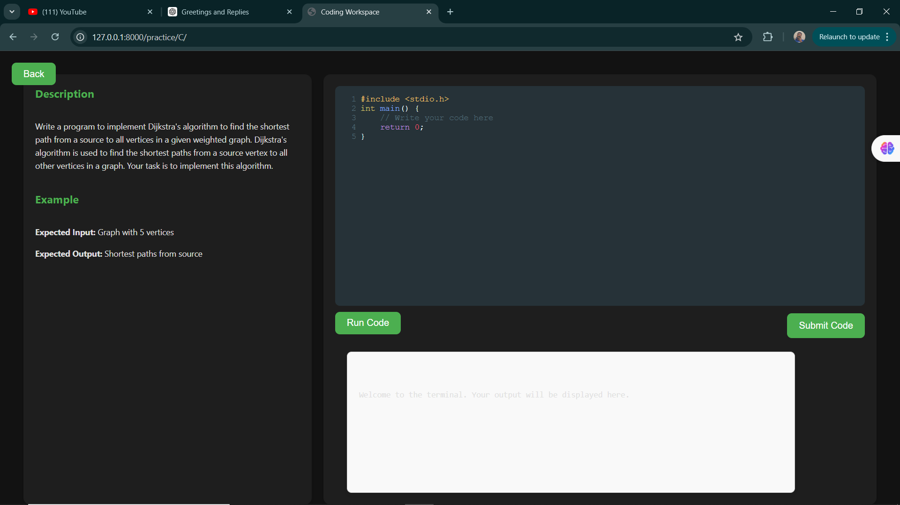
  - Practice Page:

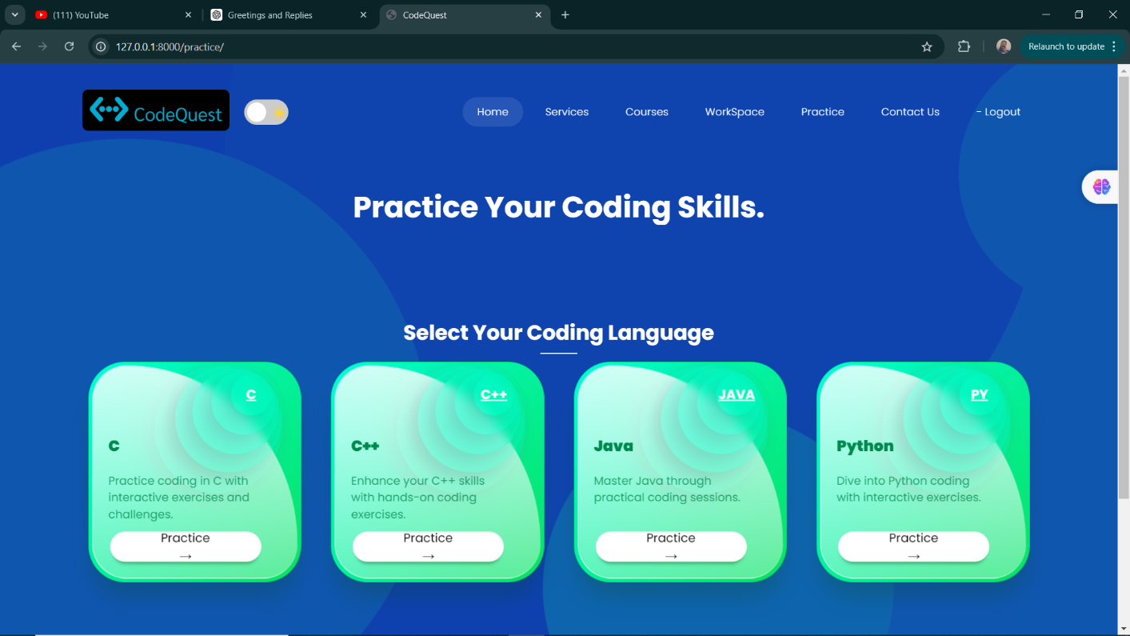
3.Teacher Page

  - Add Test page:
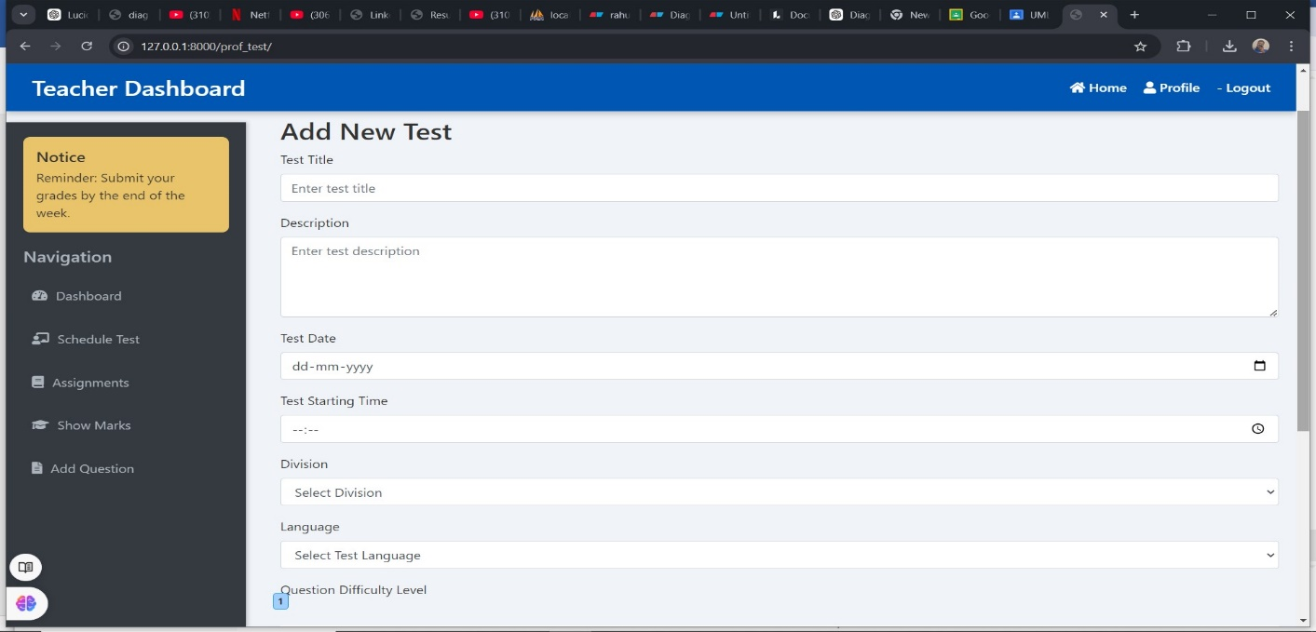
  - Show Marks:

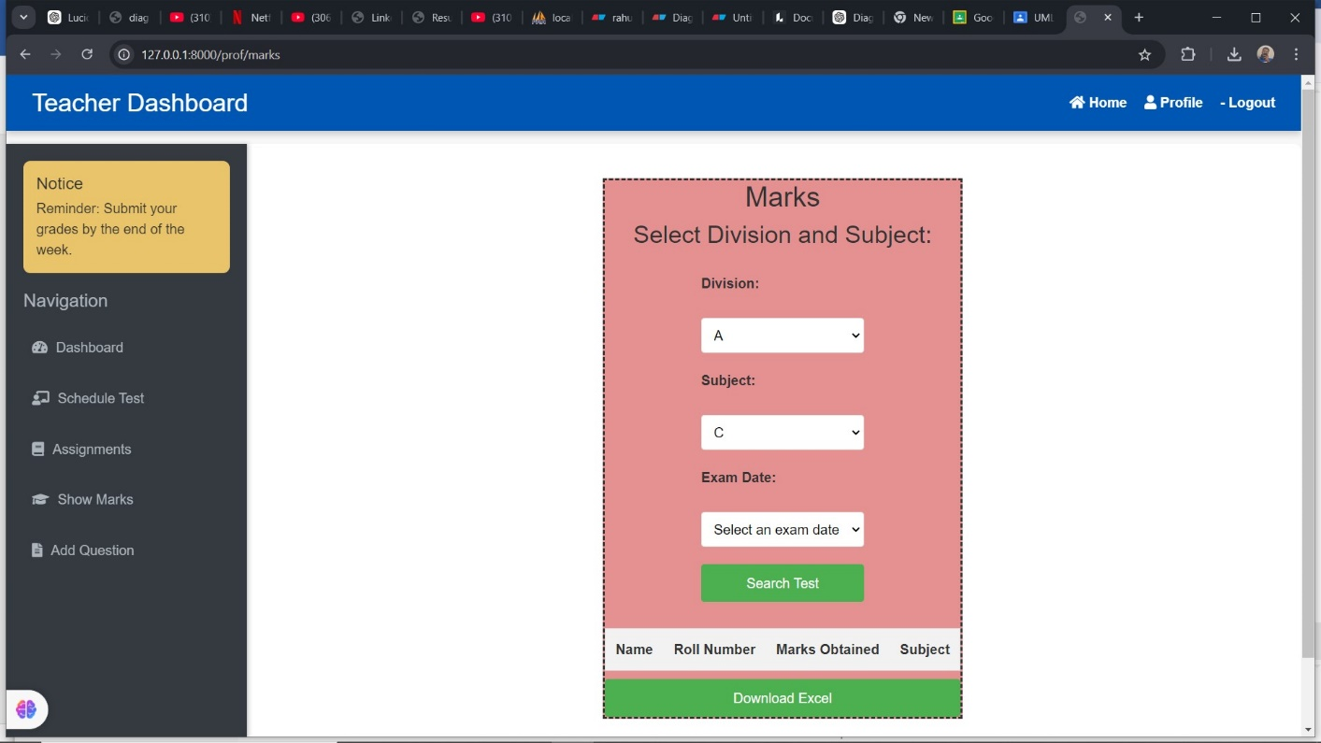

4.SuperAdmin Page

  - Teacher Management:

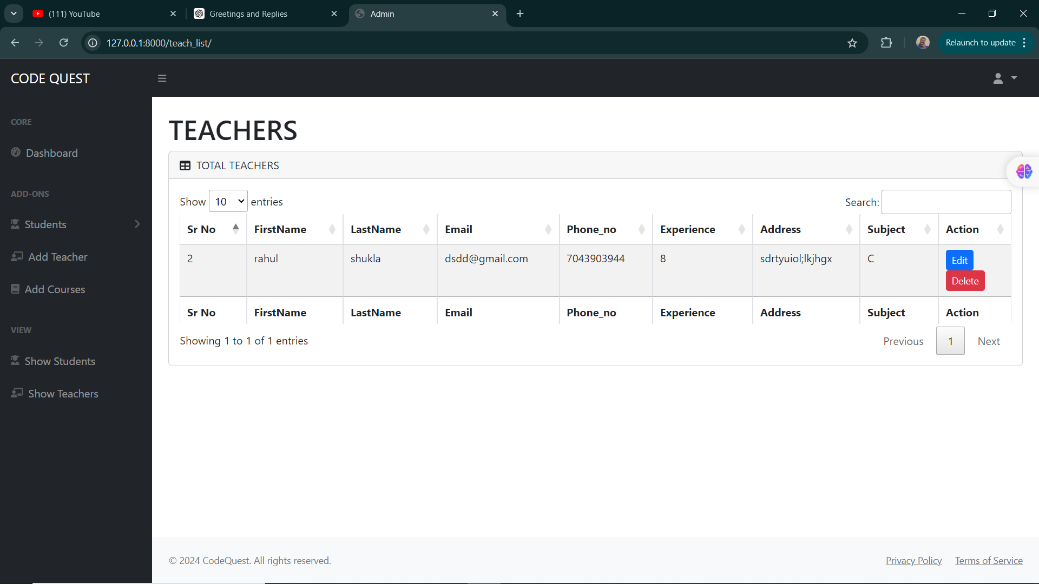

  - Student Management:

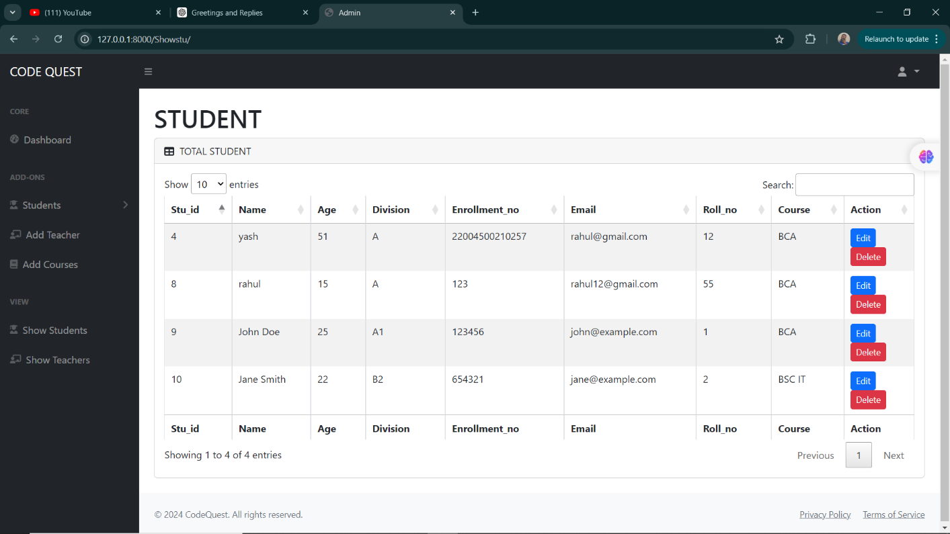

  - Course Management:

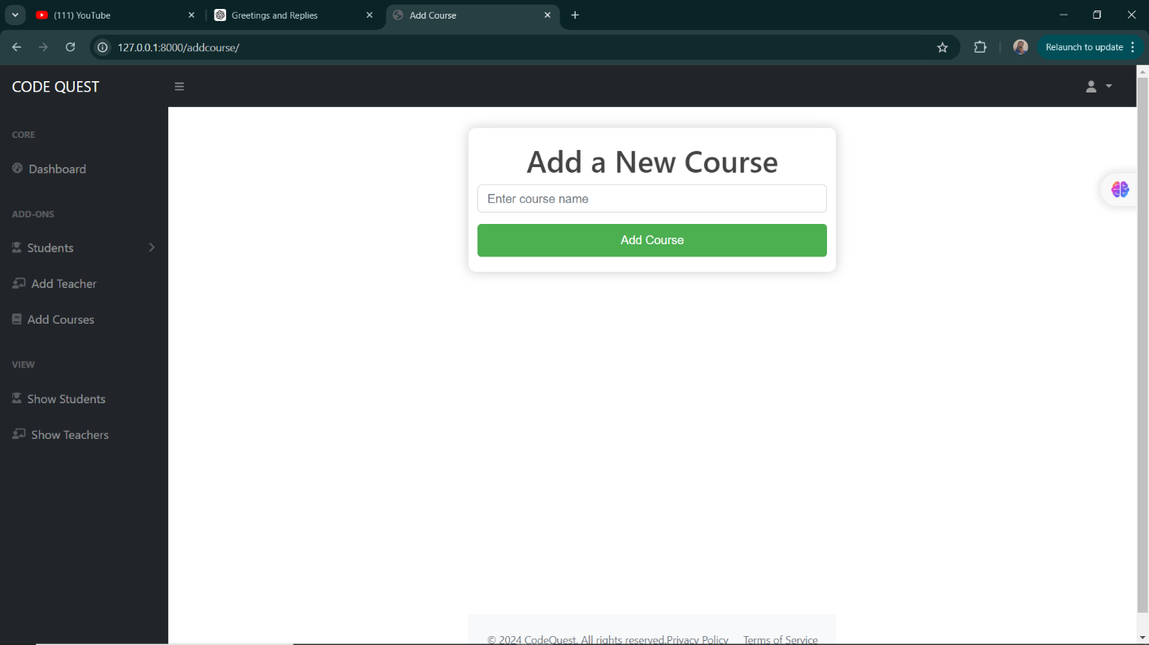

- Development
5.1 Agile Project Charter

5.2 Agile Roadmap / Schedule

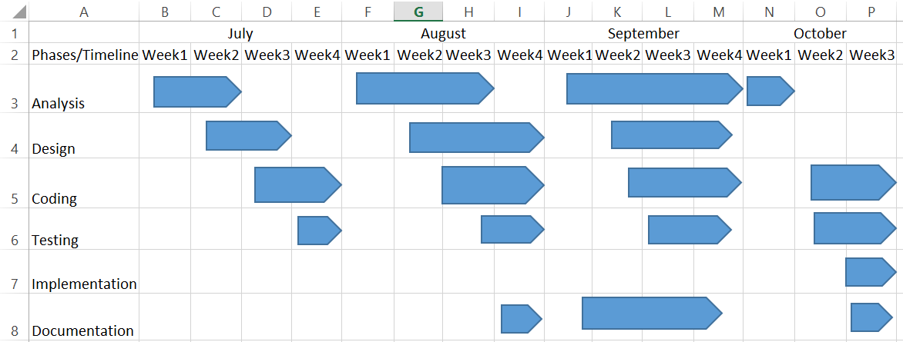

5.3 Agile Project Plan

Sprint | Task Name | Duration | Start Date | End Date | Status
Sprint 1 | Set up the Django project structure | 15 days | 01-Jul-24 | 15-Jul-24 | Completed
 | Create basic models for Student, Teacher, and Superadmin | 15 days | 01-Jul-24 | 15-Jul-24 | Completed
 | Implement user authentication and roles | 15 days | 01-Jul-24 | 15-Jul-24 | Completed
Sprint 2 | Develop the Student workspace for coding tests | 15 days | 16-Jul-24 | 31-Jul-24 | Completed
 | Integrate support for C, C++, Java, and Python | 15 days | 16-Jul-24 | 31-Jul-24 | Completed
 | Add a practice page for coding exercises | 15 days | 16-Jul-24 | 31-Jul-24 | Completed
Sprint 3 | Implement the Teacher's ability to create, schedule test | 15 days | 01-Aug-24 | 15-Aug-24 | Completed
 | Add assignment functionality with deadlines | 15 days | 01-Aug-24 | 15-Aug-24 | Completed
 | Set up email notifications for exam scheduling | 15 days | 01-Aug-24 | 15-Aug-24 | Completed
 | Add functionality to show test results and export them to Excel | 15 days | 01-Aug-24 | 15-Aug-24 | Completed
Sprint 4 | Create Superadmin functionalities for managing students and teachers | 15 days | 16-Aug-24 | 31-Aug-24 | Completed
 | Implement individual and bulk student additions via Excel upload | 15 days | 16-Aug-24 | 31-Aug-24 | Completed
Sprint 5 | Develop a feature to list penalties with options to accept or decline | 15 days | 01-Sep-24 | 15-Sep-24 | Completed
 | Improve the UI for navigation between Student, Teacher, and Superadmin pages | 15 days | 01-Sep-24 | 15-Sep-24 | Completed
Sprint 6 | Testing and bug fixes | 15 days | 16-Sep-24 | 30-Sep-24 | Completed
 | Prepare the system for user testing and release | 15 days | 16-Sep-24 | 30-Sep-24 | Completed
Sprint 7 | Finalize project features | 25 days | 01-Oct-24 | 25-Oct-24 | Completed
 | Deploy and gather feedback for future enhancements | 25 days | 01-Oct-24 | 25-Oct-24 | Completed

5.4 Agile User Story (Minimum 3 Tasks)
User Story ID | As a <Type of User> | I Want to <Perform Some Task> | So That I Can <Achieve Some Goal> | Priority
1 | As a student | I want to attempt coding tests in C, C++, Java, or Python | So that I can showcase my programming skills | High
2 | As a student | I want to practice coding problems | So that I can improve my skills before the test | High
3 | As a student | I want to view | So that I can track my progress over time | Medium
1 | As a teacher | I want to create and schedule coding tests for students | So that they can participate at the specified time | High
2 | As a teacher | I want to assign coding assignments with deadlines | So that students can practice specific problems | High
3 | As a teacher | I want to download test results in Excel format | So that I can analyze student performance | Medium
1 | As a superadmin | I want to add teachers and students, both individually and in bulk | So that I can manage users efficiently | High
2 | As a superadmin | I want to add, update, and delete courses | So that the course list stays updated | Medium
3 | As a superadmin | I want to accept or decline penalties for students | So that I can enforce rules effectively | Medium

5.5 Agile Release Plan

Sprint Number | Task Number | Task | Start Date | End Date | Duration | Status | Goal
Sprint 1 | Task 1 | Core functionality for students to take tests and practice coding exercises | 01-Jul-24 | 31-Jul-24 | 30 days | Completed | Allow students to take tests and practice coding
Sprint 1 | Task 2 | Teachers can create tests and assignments, with marks downloadable in Excel format | 01-Jul-24 | 31-Jul-24 | 30 days | Completed | Provide teachers tools to manage tests and assignments
Sprint 1 | Task 3 | Superadmin can add teachers/students and manage penalties | 01-Jul-24 | 31-Jul-24 | 30 days | Completed | Enable superadmin to manage users and penalties
Sprint 2 | Task 1 | Enhanced features for bulk student addition via Excel upload | 01-Aug-24 | 15-Aug-24 | 15 days | Completed | Simplify student addition via bulk upload
Sprint 2 | Task 2 | Email notifications for scheduled tests | 01-Aug-24 | 15-Aug-24 | 15 days | Completed | Notify students about scheduled tests
Sprint 2 | Task 3 | Bug fixes and performance improvements | 01-Aug-24 | 15-Aug-24 | 15 days | Completed | Improve stability and performance
Sprint 3 | Task 1 | Full deployment with finalized student, teacher, and admin features | 16-Aug-24 | 05-Sep-24 | 20 days | Completed | Finalize deployment and features
Sprint 3 | Task 2 | UI enhancements for better navigation | 16-Aug-24 | 05-Sep-24 | 20 days | Completed | Improve user experience
Sprint 3 | Task 3 | Final performance optimization and testing | 16-Aug-24 | 05-Sep-24 | 20 days | Completed | Ensure optimal performance and stability
Sprint 4 | Task 1 | Final release and feedback gathering | 06-Sep-24 | 25-Oct-24 | 40 days | Completed | Release final product and gather user feedback

5.6 Agile Product Backlog

Task Name (with Sprint) | Story | Sprint Ready | Priority | Status | Story Points | Assigned to Sprint
Set up student test workspace (Sprint 1) | Create a workspace for coding tests. | Yes | High | Completed | 8 | Yes
Implement coding language support (Sprint 1) | Support coding in C, C++, Java, and Python. | Yes | High | Completed | 8 | Yes
Develop basic practice page (Sprint 1) | Create a practice page to improve coding skills. | Yes | Medium | Completed | 5 | Yes
Teacher functionality for tests and assignments (Sprint 2) | Enable adding tests and assignments. | Yes | High | Completed | 8 | Yes
Implement backend scheduling and notifications (Sprint 2) | Automate email notifications for scheduled tests. | Yes | High | Completed | 8 | Yes
Set up Excel download for marks (Sprint 2) | Allow downloading students' marks in Excel format. | Yes | Medium | Completed | 5 | Yes
Superadmin functionality for managing users (Sprint 3) | Enable management of teachers and students. | Yes | High | Completed | 8 | Yes
Bulk student addition via Excel (Sprint 3) | Allow adding students in bulk via Excel upload. | Yes | Medium | Completed | 5 | Yes
Penalty management interface (Sprint 3) | Manage penalties by approving or rejecting requests. | Yes | Medium | Completed | 5 | Yes
Full system testing (Sprint 4) | Ensure the system functions properly. | Yes | High | Completed | 8 | Yes
Beta deployment and bug fixing (Sprint 4) | Release a beta version and fix issues. | Yes | High | Completed | 8 | Yes
Implement feedback and optimization (Sprint 4) | Optimize the platform based on user feedback. | Yes | Medium | Completed | 5 | Yes
Final deployment (Sprint 5) | Deploy the final version of the platform. | Yes | High | Completed | 8 | Yes
Post-deployment monitoring and support (Sprint 5) | Monitor the platform for stability after deployment. | Yes | Medium | Completed | 5 | Yes
Documentation and project closure (Sprint 6) | Document features and close the project. | Yes | Medium | Completed | 5 | Yes
Additional feature refinements (Sprint 7) | Refine features based on post-launch feedback. | Yes | Medium | Completed | 8 | Yes
Post-launch optimizations and fixes (Sprint 7) | Optimize performance and address issues post-launch. | Yes | High | Completed | 8 | Yes
Final post-deployment support (Sprint 8) | Provide final support to ensure smooth functioning. | Yes | Medium | Completed | 5 | Yes
Final documentation and closure (Sprint 8) | Complete final documentation and officially close the project. | Yes | Medium | Completed | 5 | Yes

5.7 Agile Test Plan

Project Name | CODE QUEST | Browser: | Chrome , MicroSoft Edge
Test Case ID | 101 | Version:
Written By: | Rahul Shukla | Description:
Tested By: | Saravan , Vignesh ,Rahul | Tested On: | 18-10-2024
Test # | Action | Expected Results | Actual Results | Pass?
1 | Logging in | Should get to home screen | User directed to different page | Yes
2 | Signing up for webinar | Get confirmation email | Confirmation email received | Yes
3 | Set up student test workspace | Workspace for coding tests is functional | Workspace is functional | Yes
4 | Implement coding language support (C, C++, Java, Python) | All four languages are supported in the student workspace | All four languages supported | Yes
5 | Add test functionality for teachers | Teachers can add, schedule, and manage coding tests | Test functionality added | Yes
6 | Implement email notification for test scheduling | Students receive email notifications for scheduled tests | Email notifications sent successfully | Yes
7 | Perform full system testing | No critical issues found, system runs smoothly | No critical issues found | Yes
8 | Final deployment | System goes live without issues | System live without issues | Yes

  - Earned-value and Burn Charts

- Proposed Enhancements

- Advanced Coding Features
- Real-time Collaboration: Allow students to collaborate on coding tasks in real-time, promoting teamwork and peer learning.
- Code Review System: Enable teachers or peers to review and give feedback on submitted code.
- Integrated Development Environment (IDE): Enhance the workspace with features like syntax highlighting, auto-completion, and debugging tools for a more IDE-like experience.
- Extended Language Support
- Additional Languages: Add support for languages like JavaScript, Ruby, or PHP based on user demand.
- Enhanced User Experience
- Responsive Design: Ensure the platform is fully functional on tablets, smartphones, and desktops.
- Personalized Dashboards: Allow students and teachers to customize their dashboards to display assignments, schedules, and performance.
- Automated Testing and Feedback
- Automated Test Cases: Implement automatic testing of student submissions, providing instant feedback on errors and performance.
- Detailed Analytics: Offer advanced analytics to track student progress and test results.
- Improved Communication Features
- In-App Messaging: Add a messaging system for better communication between students, teachers, and admins.
- Notifications: Improve notifications to keep users updated on deadlines, schedules, and important announcements.
- Scalability and Performance
- Database Optimization: Optimize database operations to handle growing user activity.
- Cloud Integration: Host the platform on cloud servers for better scalability and performance.

- Conclusion

Code Quest is designed to revolutionize coding education by providing a feature-rich platform that caters to the needs of students, teachers, and administrators. With a focus on supporting coding practice and assessments in C, C++, Java, and Python, it aims to deliver a seamless and efficient learning experience.

Future enhancements, such as real-time collaboration, advanced analytics, and expanded language support, will elevate the platform further, making it a comprehensive solution for coding education.

The success of Code Quest will rely on the thoughtful integration of its core features, adherence to coding best practices, and continuous innovation driven by user feedback and technological advancements. By prioritizing user needs and maintaining high standards, Code Quest has the potential to become an indispensable resource in the modern educational landscape.

- Bibliography

Books
- Django for Beginners by William S. Vincent
- Two Scoops of Django 3.x by Daniel Roy Greenfeld and Audrey Roy Greenfeld
- Python Programming: An Introduction to Computer Science by John Zelle
Online Resources
- Django Documentation
- Python Official Documentation
- C++ Reference
- Java Documentation
Tools and Libraries
- Git
- XAMPP

