**SGPA And CGPA Calculator**

**Introduction**

### In the academic journey of postgraduate students, especially in technical courses like MCA (Master of Computer Applications), tracking academic performance plays a crucial role. Under the Visvesvaraya Technological University (VTU) 2024 Scheme, students receive grades based on a credit and grade point system that determines their SGPA (Semester Grade Point Average) and CGPA (Cumulative Grade Point Average).

### Manually calculating these scores every semester can be time-consuming, prone to error, and often confusing, especially when aiming for a specific academic target. To address this problem, this project presents a web-based SGPA, CGPA, and SGPA Target Finder tool, specially designed for VTU MCA 2024 Scheme students.

### ****Abstract****

### The primary goal of this project is to simplify and automate these calculations through an interactive and responsive website. Built using HTML, CSS, JavaScript, and Bootstrap, the platform provides a clean and intuitive user experience, requiring no installations or login credentials.

### The tool supports three major functionalities:

### SGPA Calculator – Computes SGPA based on subject credits and grade points.

### CGPA Calculator – Calculates cumulative performance across multiple semesters.

### SGPA Target Finder – Helps students estimate the SGPA needed in upcoming semesters to reach their academic goals.

### ****Scope:****

* SGPA Calculator based on subject credits and grade points as per VTU 2024 scheme.
* CGPA Calculator that considers SGPA scores and respective credit weightage across semesters.
* SGPA Target Finder that determines the SGPA required to meet a user-defined target CGPA.
* Responsive design compatible with desktops, tablets, and smartphones.
* No login or backend — runs entirely on the client side using JavaScript.
* Helpful for both regular and lateral entry students (with appropriate input adjustments).

### ****Functional Requirements****

### **The system shall fulfill the following functional requirements to meet the needs of VTU MCA 2024 Scheme students:**

### **1. **SGPA Calculator****

### **The system shall allow the user to enter:**

### **Subject-wise Marks.**

### **The system shall calculate the SGPA using the formula:**

### **SGPA = (Sum of (Credit × Grade Point)) / (Total Credits)**

### 2. CGPA Calculator

### The system shall allow the user to input:

### SGPA for completed semesters.

### SGPA of current semester.

### The system shall calculate the CGPA using the formula: CGPA = (Sum of (SGPA × Semester Credits)) / (Total Credits)

### The system shall display the CGPA based on provided semester data.

### 3. Target SGPA Finder

### The system shall allow the user to enter:

### Current CGPA.

### Target CGPA.

### Current Semester

### The system shall calculate the required SGPA for the remaining semesters using a reverse calculation formula.

### The system shall inform the user if the target is unrealistic (e.g., if the required SGPA exceeds 10.0).

### ****Implementation****

**The project has been implemented using standard front-end web technologies with no server-side or database components, making it lightweight, fast, and accessible.**

**Technologies Used:**

**Technology Purpose**

**HTML5 : Structuring the layout of the web pages**

**CSS3 : Styling elements and making the UI visually appealing**

**JavaScript : Handling the logic for SGPA, CGPA, and target calculations**

**Interface:**

**The application uses simple input fields and buttons.**

**Results are shown in real-time after clicking the Calculate button.**

* **User-friendly**: Clear labels, step-by-step input fields, and simple buttons.
* **Clean Layout**: Uses Bootstrap's grid system for organized sections.
* **Responsive**: Fully functional across devices—desktops, tablets, and mobile phones.
* **Instant Feedback**: Results are shown immediately after pressing "Calculate"
* Use of alert boxes or modals for invalid inputs.
* Visual separators or cards for each section.
* Smooth transitions or animations when results appear.

**ScreenShots:**

**Fig 1:**

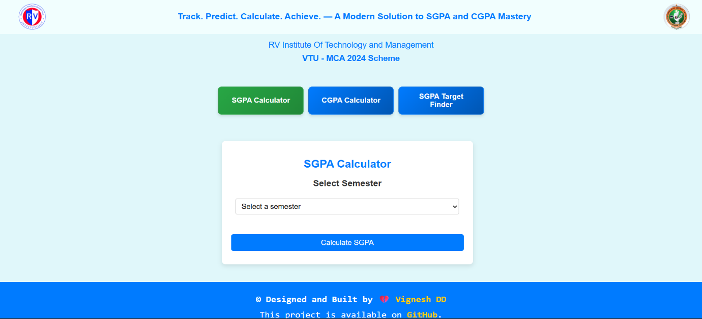

**Fig 2:**

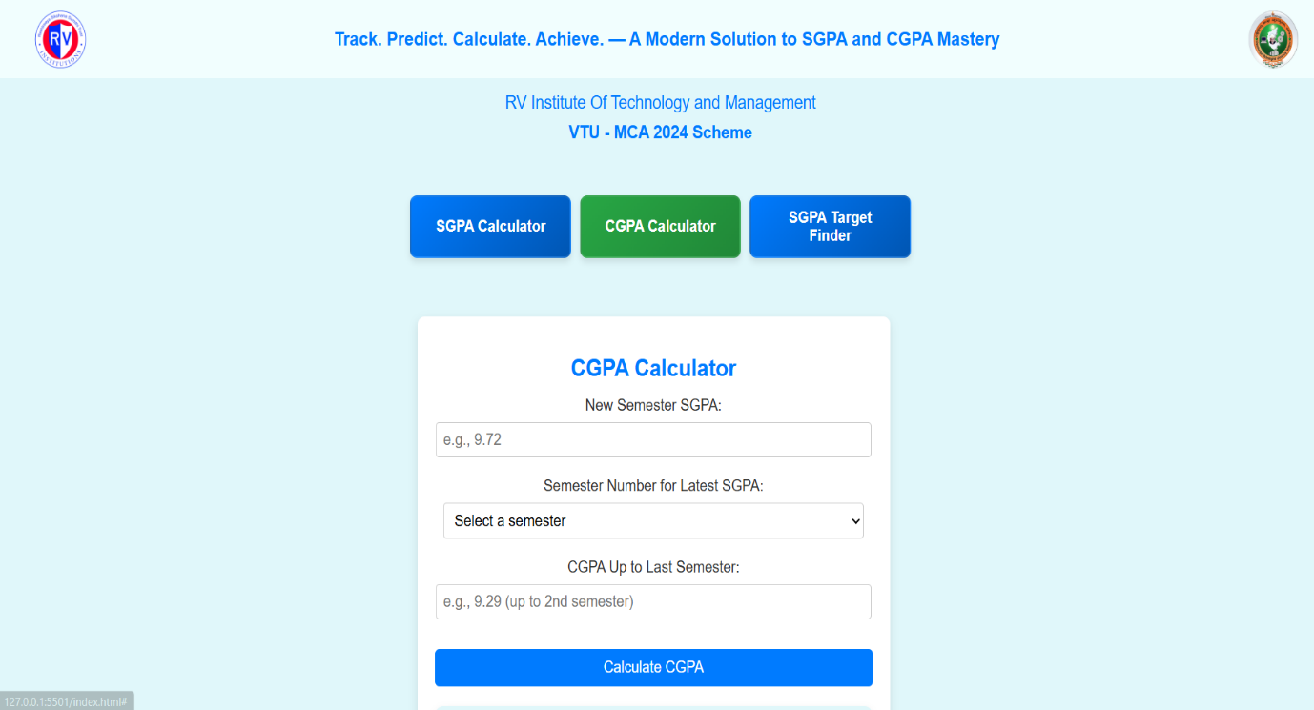

**Fig 3:**

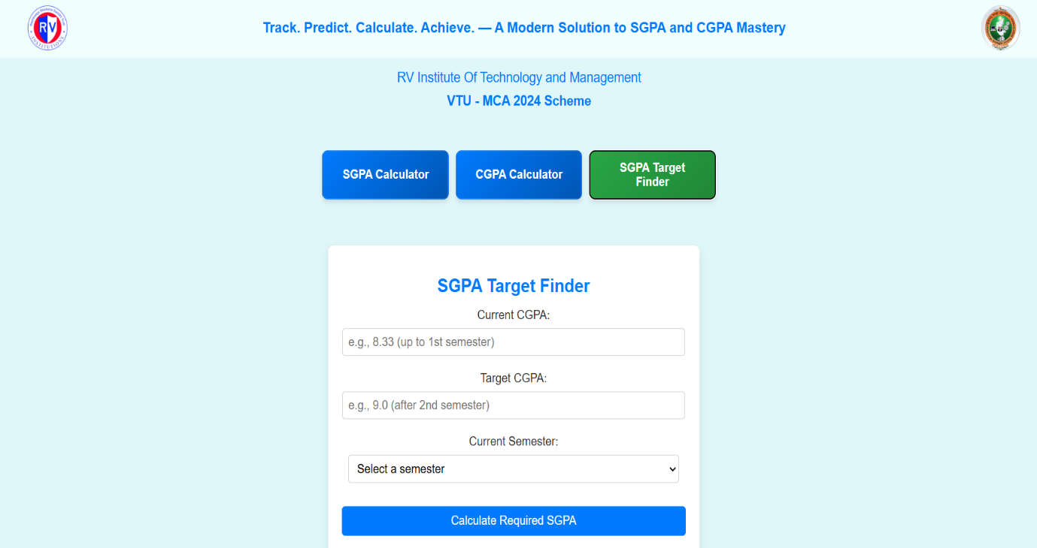

### ****Future Enhancements****

### While the current version of the SGPA, CGPA, and Target Finder website effectively meets the core requirements of VTU MCA 2024 Scheme students, there is significant potential to enhance its functionality, flexibility, and usability. The following future enhancements can be considered:

### 1. Support for Other VTU Schemes and Courses

### Extend the tool to support other VTU programs like B.E., B.Tech., MBA, etc.

### Add options for custom grading scales based on different department or year-wise schemes.

### 2. Export & Download Results

### Allow users to download PDF reports of their SGPA/CGPA calculations.

### Add print-friendly views for academic records or self-assessment reports.

### 3. User Authentication and Data Saving

### Implement a login/signup system to let users save their semester data.

### Store past semester performance to track CGPA progress over time.

### 4. Progress Tracking Dashboard

### Provide a dashboard with visual charts and graphs showing grade trends.

### Display progress bars for credit completion, GPA targets, and more.

### 5. Percentage Converter

### Add a utility to convert CGPA into percentage format, as required for placement or government forms.

### These enhancements will make the project more powerful, widely usable, and future-ready. They can also serve as the foundation for a more comprehensive student academic management platform.

### ****Conclusion****

This project, **SGPA, CGPA & Target Finder for VTU MCA 2024 Scheme Students**, successfully addresses a common academic need by providing a simple, reliable, and accessible solution for calculating and tracking academic performance. By automating the computation of SGPA and CGPA, and enabling students to estimate the required SGPA to reach their target CGPA, the platform reduces manual effort, minimizes errors, and enhances academic planning.

Developed using core web technologies such as HTML, CSS, JavaScript ,the application is fully client-side, ensuring fast performance and ease of access without the need for user authentication or complex installations. Its clean interface and responsive design make it suitable for use on any device—desktop, tablet, or mobile.

This project not only improves student productivity but also encourages self-monitoring and goal setting among learners. With potential future enhancements like PDF export, saved user sessions, visual dashboards, and support for other VTU programs, the application can evolve into a more comprehensive academic toolkit.

In summary, this tool stands as a modern, lightweight, and student-focused academic companion tailored to the needs of **VTU MCA 2024 Scheme** students.

.