**PDE4431 – Robot Manipulator**

**Coursework 2 (CW2)**

Report Submitted by:

|  |  |
| --- | --- |
| Name: Vignesh Lakshmanasamy | MISIS No: M01026685 |
| Email : vl223@live.mdx.ac.uk | Course : M.Sc Robotics |

Module taught by:

|  |
| --- |
| Professor Mr. Bittu Scaria & Professor Dr. [Judhi Prasetyo](https://mdx.mrooms.net/user/profile.php?id=78624) |

**Activity undertaken in the coursework:**

* Importing the Cad files into the Robodk environment and placing the robot in the reference frame.
* Keeping the robot in appropriate location and height.
* Creating proper target points.
* Creating python program for the process.
* Generating the RoboDK function into Epson RC codes.
* Running the task in the Epson RC with VT6 robot.
* Calculating the forward kinematics and DH parameters for the robot.
* Creating a python file to execute and review the target points.

**DH parameter for the Robot:**

|  |  |  |  |  |
| --- | --- | --- | --- | --- |
| Joints | Theta (deg) | d(mm) | a(mm) | Alpha (deg) |
| Joint1 | -90 | 412 | 100 | -90 |
| Joint2 | -90 | 0 | 420 | -90 |
| Joint3 | 0 | 0 | 0 | -90 |
| Joint4 | 90 | 400 | 0 | -90 |
| Joint5 | -90 | 0 | 0 | -90 |
| Joint6 | 0 | 80 | 0 | 0 |

**Target point:**

|  |  |  |  |  |  |  |
| --- | --- | --- | --- | --- | --- | --- |
|  | X(mm) | Y(mm) | Z(mm) | U(deg) | V(deg) | w(deg) |
| Expected Value | 615 | -340 | 270 | 90 | 0 | -180 |
| Obtained Value | 501 | -415 | 306 | 35 | 58 | 150 |

**Screen Shot of RoboDk environment:**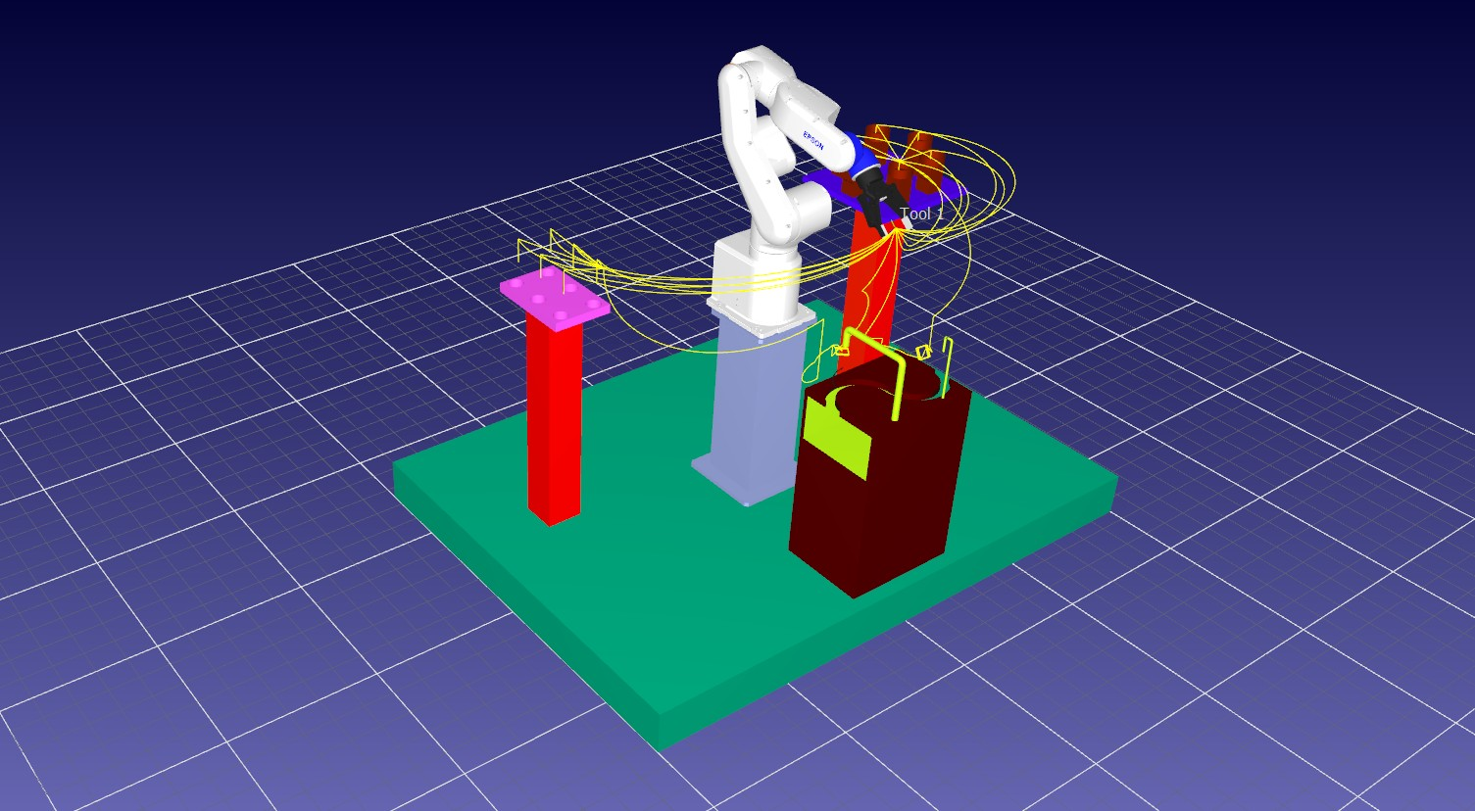

**Screen Shot of EpsonRC environment:**

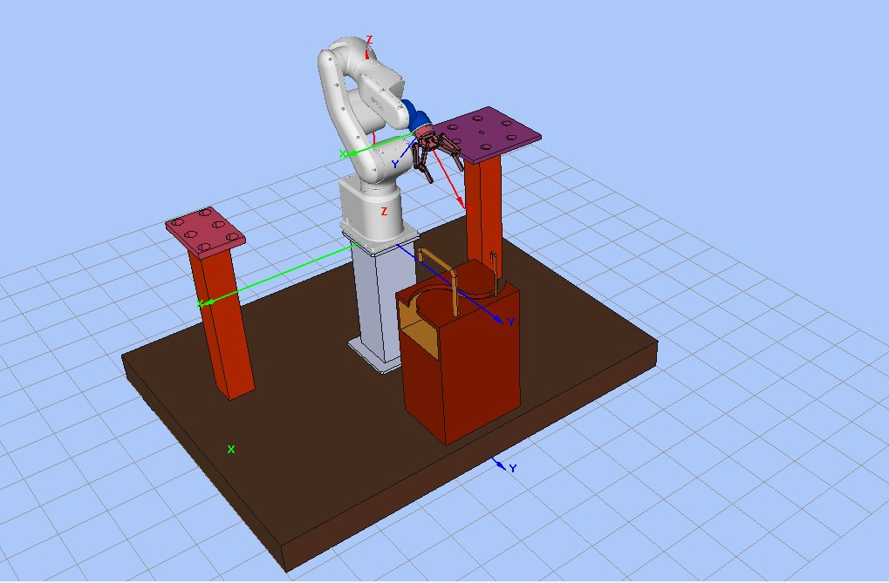

**Explanation Video link:** https://youtu.be/H-ZIBlhEMA8

**RoboDK Screen Recording:** https://youtu.be/DmaROOXROz8

**EpsonRc Screen Recording :** https://youtu.be/KtB8aWExPVQ

**Github link:**

**3D working Simulation :** Inside the folder of the coursework – RoboDK 🡪 Full1_program_3d_animation