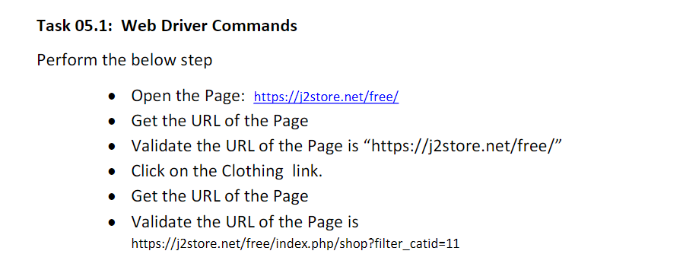

package com.day5;

import org.openqa.selenium.By;

import org.openqa.selenium.WebDriver;

import org.openqa.selenium.chrome.ChromeDriver;

import org.openqa.selenium.chrome.ChromeOptions;

import io.github.bonigarcia.wdm.WebDriverManager;

public class CE_1 {

public static void main(String[] args) {

// TODO Auto-generated method stub

ChromeOptions co = new ChromeOptions();

co.addArguments("--remote-allow-origins=*");

WebDriverManager.chromedriver().setup();

WebDriver driver = new ChromeDriver();

String url="https://j2store.net/free/";

driver.get(url);

driver.manage().window().maximize();

String curl=driver.getCurrentUrl();

if(url.equals(curl))

{

System.out.println("Matched");

driver.findElement(By.partialLinkText("Clothing (5)")).click();

String url1="https://j2store.net/free/index.php/shop?filter_catid=11";

driver.get(url1);

String curl1=driver.getCurrentUrl();

if(url1.equals(curl1))

{

System.out.println("Matched the clothing page");

}

else

{

System.out.println("Not matched the clothing");

}

}

else

{

System.out.println("Not Matched");

}

}

}

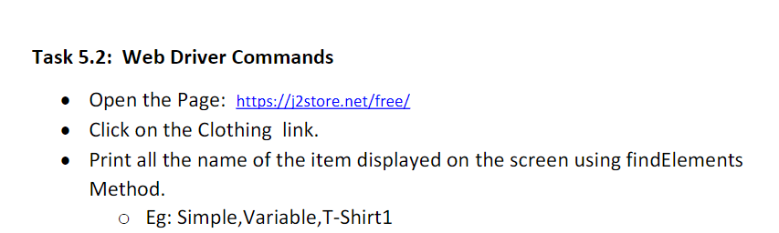

package com.day5;

import java.util.List;

import org.openqa.selenium.By;

import org.openqa.selenium.WebDriver;

import org.openqa.selenium.WebElement;

import org.openqa.selenium.chrome.ChromeDriver;

import org.openqa.selenium.chrome.ChromeOptions;

import io.github.bonigarcia.wdm.WebDriverManager;

public class CE_2 {

public static void main(String[] args) {

ChromeOptions co=new ChromeOptions();

co.addArguments("--remote-allow-origins=*");

WebDriverManager.chromedriver().setup();

WebDriver driver = new ChromeDriver();

String url="https://j2store.net/free/";

driver.get(url);

driver.manage().window().maximize();

driver.findElement(By.partialLinkText("Clothing (5)")).click();

List<WebElement> m=driver.findElements(By.xpath("//h2[@itemprop='name']"));

for(int i=0;i<m.size();i++)

{

String s=m.get(i).getText();

System.out.println("The Items ="+s);

}

}

}